Aim:
To study component composition in React and demonstrate how data is passed from a parent component to child components using props, including single values, objects, arrays of objects, and default prop values.
Theory:
- Props: Short for "properties" — a read-only object used to pass data from a parent component to a child component. Props make components reusable and configurable.
- Destructuring Props: Instead of accessing props.name, props.age, etc., the values can be destructured directly, either inside the function body (const { name, age } = props) or in the function's parameter list (function Greet({ name, age })), for cleaner code.
- Passing an Object as a Prop: A single JavaScript object can be passed as one prop and its fields accessed inside the child component (e.g. props.names.email).
- Passing an Array of Objects: An array can be passed as a prop and iterated inside the child component using Array.prototype.map() to render a list of elements.
- defaultProps: A React component property used to set default values for props. If a prop is not passed by the parent, the default value defined in defaultProps is used instead.
Procedure:
- Create a Greet component that accepts name, age, and address as props and displays a welcome message.
- Render multiple instances of Greet from App.js, passing different values each time.
- Create a Person component that receives a single object as a prop and displays its fields.
- Create an Employee component that receives an array of objects as a prop and renders one line per object using map().
- Create a DefComp component that defines defaultProps, and render it with some props omitted to verify the defaults are used.
1. Passing Individual Props — Greet.js
import React from 'react'

function Greet(props) {
// Destructure the props object to extract name, age and address
const { name, age, address } = props;
return (
<div>
Welcome {name}, you are {age} years old and live at {address}.
</div>
)
}

export default Greet
Props can also be destructured directly within the function's parameter list:
function Greet({ name, age, address }) {
return (
<div>
Welcome {name}, you are {age} years old and live at {address}.
</div>
)
}
Rendering multiple Greet components with different props from App.js:
<Greet name="John" age={25} address="123 Main St" />
<Greet name="Jane" age={30} address="456 Oak Ave" />
<Greet name="Bob" age={35} address="789 Pine Rd" />
2. Passing a Single Object as a Prop — Person.js
import React from 'react'

function Person(props) {
return (
<div>
<p>Email: {props.names.email}</p>
<p>Gender: {props.names.gender}</p>
<p>Full Name: {props.names.fullname}</p>
</div>
)
}

export default Person
Passed from App.js as:
const nameList = {
email: 'abc@gmail.com',
gender: 'Male',
fullname: 'Rose Dawson'
}

<Person names={nameList} />
3. Working with an Array of Objects — Employee.js
import React from 'react'

function Employee(props) {
return (
<div>
{props.data.map((person) => (
<p key={person.id}>
Name: {person.name}, Age: {person.age}
</p>
))}
</div>
)
}

export default Employee
Passed from App.js as:
const persondata = [
{ id: 101, name: 'JOHN', age: 23 },
{ id: 102, name: 'ROSE', age: 25 },
{ id: 103, name: 'JASMINE', age: 26 },
{ id: 104, name: 'KERRY', age: 22 }
]

<Employee data={persondata} />
4. Default Prop Values — DefComp.js
defaultProps lets a component fall back to preset values whenever the parent does not supply a particular prop.
import React from "react";

export default function DefComp(props) {
return (
<div>
<p>Name: {props.name}</p>
<p>EyeColor: {props.eyeColor}</p>
<p>Age: {props.age}</p>
</div>
);
}

DefComp.defaultProps = {
name: "Mukhtar",
eyeColor: "seagreen",
age: "100",
};
Rendered from App.js with some props deliberately omitted, to confirm defaultProps fills in the missing values:
<DefComp name="kapil" eyeColor="blue" age="23"></DefComp>
<DefComp eyeColor="blue"></DefComp>
<DefComp name="Nikhil" age="23"></DefComp>
<DefComp eyeColor="green" age="23"></DefComp>
Output:
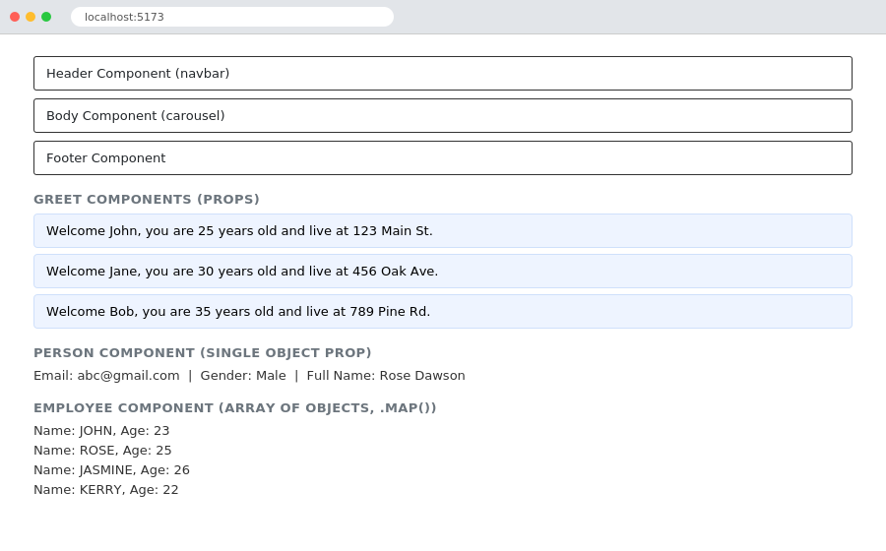
Greet, Person and Employee components rendering data received through props
Conclusion:
Component composition and props handling in React were successfully studied and demonstrated. Data was passed from parent to child components as individual values, as a single object, and as an array of objects rendered with map(), and defaultProps was used to supply fallback values for props that were not explicitly passed.

