Aim:
To understand and implement Event Handling and Conditional Rendering in React by creating interactive applications that respond to user actions such as button clicks, form inputs, and conditional display of UI elements.
Objectives:
- Understand event handling in React.
- Handle user events like button clicks, keyboard input, and form submission.
- Learn different ways of attaching events to React components.
- Understand conditional rendering.
- Display or hide UI elements based on conditions.
- Build interactive React applications.
Prerequisites:
- Basic knowledge of HTML, CSS, and JavaScript
- React installed using Vite or Create React App
- Knowledge of JSX
- Basic understanding of the useState Hook
Theory:
Modern web applications are interactive — users click buttons, enter text, submit forms, and press keyboard keys. React provides a clean and efficient way to respond to these actions through Event Handling, and lets developers display different content depending on conditions using Conditional Rendering.
Event Handling: the process of executing a function when a user performs an action such as clicking a button, typing in a textbox, moving the mouse, pressing a key, or submitting a form. React listens for these events and executes the associated handler function.
Real-life analogy: pressing the "Up" button in an elevator — the elevator receives the event, processes the request, and moves up. React events work the same way.
Common React Events
Event | Description
onClick | Mouse click
onChange | Input value changes
onSubmit | Form submission
onMouseOver / onMouseOut | Mouse enters / leaves an element
onDoubleClick | Double click
onKeyDown / onKeyUp | Key pressed / released
onFocus / onBlur | Input gains / loses focus

Procedure:
- Create state variables (useState) for each form field that needs to be tracked.
- Attach onChange handlers to input/select elements to update state as the user types or selects.
- Attach an onSubmit handler to the <form> element; call event.preventDefault() inside it to stop the page from reloading.
- Validate the field values inside the submit handler before accepting the form.
- Use a boolean state value together with conditional (ternary) rendering to switch between the form view and a success/result view.
Part 1 — Form Event Handling: Register.jsx
import React from 'react';
import { useState } from 'react';

function Register() {
const [name, setName] = useState("");
const [email, setEmail] = useState("");
const [course, setCourse] = useState("");
const [submitted, setSubmitted] = useState(false);

function handleSubmit(event) {
event.preventDefault();
if (name.trim() === "" || email.trim() === "" || course === "") {
alert("Please fill all fields");
return;
}
setSubmitted(true);
}

function handleReset() {
setName(""); setEmail(""); setCourse(""); setSubmitted(false);
}

return (
<div>
<h1>Student Registration</h1>
{!submitted ? (
<form onSubmit={handleSubmit}>
<div>
<label>Name: </label>
<input type="text" value={name}
onChange={(event) => setName(event.target.value)} />
</div><br />
<div>
<label>Email: </label>
<input type="email" value={email}
onChange={(event) => setEmail(event.target.value)} />
</div><br />
<div>
<label>Course: </label>
<select value={course}
onChange={(event) => setCourse(event.target.value)}>
<option value="">Select Course</option>
<option value="Computer Engineering">Computer Engineering</option>
<option value="Information Technology">Information Technology</option>
<option value="AI & Data Science">AI & Data Science</option>
</select>
</div><br />
<button type="submit">Register</button>
</form>
) : (
<div>
<h2>Registration Successful!</h2>
<p><strong>Name:</strong> {name}</p>
<p><strong>Email:</strong> {email}</p>
<p><strong>Course:</strong> {course}</p>
<button onClick={handleReset}>Register Another Student</button>
</div>
)}
</div>
)
}

export default Register
Why event.preventDefault()? Submitting an HTML form normally causes the browser to reload or navigate. Since React handles the submission itself, event.preventDefault() stops that default browser behaviour so the state-driven logic can take over.
Part 2 — Conditional Rendering: App.jsx
Conditional rendering displays different JSX depending on the current value of a state variable, using a ternary operator inside the JSX.
import { useState } from "react";

function App() {
const [login, setLogin] = useState(false);
return (
<div>
<h1>{login ? "Welcome User" : "Please Login"}</h1>
<button onClick={() => setLogin(!login)}>Toggle</button>
</div>
);
}

export default App;
Practice Tasks
- Task 1 — Student Attendance Status: Create a React application where the user can mark a student as Present or Absent. The application should dynamically display the student's attendance status.
- Task 2 — Login System with Role-Based Dashboard: Create a React login application that accepts a username, password, and role. After successful login, display a different dashboard depending on whether the user is an Admin, Faculty, or Student.
Output:
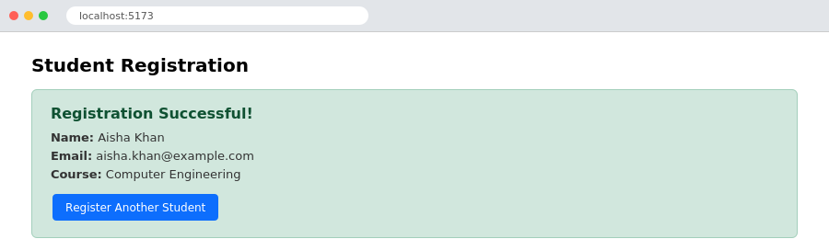
Registration form submitted successfully — conditional rendering switches from the form view to the success view
Conclusion:
Event handling and conditional rendering in React were successfully studied and implemented. A registration form demonstrated handling onChange and onSubmit events together with input validation and event.preventDefault(), while a login toggle demonstrated switching the displayed UI based on state using conditional rendering.

