Aim:
To study lifecycle management in React functional components using the useEffect Hook, and to implement side effects such as timers, API calls, and browser storage synchronization.
Theory:
What is a Side Effect? an operation that happens outside the normal process of calculating and displaying UI — for example, fetching data from an API, updating the document title, setting up a timer, adding event listeners, reading/writing browser storage, or running code when a component mounts or updates.
useEffect() Hook: used in React functional components to perform side effects. It accepts two arguments — a callback function containing the side-effect logic, and an optional dependency array.
import { useEffect } from "react";

useEffect(() => {
// code to execute
}, [dependencies]);
The dependency array controls when the effect runs:
Dependency array | When the effect runs
Not provided | After every render
Empty array [ ] | Once, only after the initial render
[prop, state, ...] | After the initial render, and again whenever any listed value changes

A function returned from inside useEffect() is called a cleanup function — React runs it before the component unmounts, or before the effect runs again (useful for clearing timers or removing listeners).
Procedure:
- Import useEffect (and useState, where needed) from 'react'.
- Call useEffect(callback, [dependencies]) inside the functional component, above the return statement.
- Write the side-effect logic (API call, timer, storage access, etc.) inside the callback function.
- Choose the dependency array carefully: [] for a one-time effect on mount, or [value] to re-run only when value changes.
- Where the effect sets up a subscription or timer, return a cleanup function from the callback to clear it.
- Run the application and verify, using the browser console/network tab, that the effect executes at the expected time.
1. Effect Timing — Empty Dependency Array
import { useEffect, useState } from "react";

function App() {
const [count, setCount] = useState(0);

useEffect(() => {
console.log("Component rendered");
}, []); // runs only once, after the initial render

return (
<div>
<p>Count: {count}</p>
<button onClick={() => setCount(count + 1)}>Increment</button>
</div>
);
}

export default App;
2. Fetching Data from an API
import { useEffect, useState } from "react";

function App() {
const [users, setUsers] = useState([]);

useEffect(() => {
fetch("https://jsonplaceholder.typicode.com/users")
.then(response => response.json())
.then(data => { setUsers(data); });
}, []); // fetch once, when the component mounts

return (
<div>
<h1>Users</h1>
{users.map(user => (
<p key={user.id}>{user.name}</p>
))}
</div>
);
}

export default App;
3. Timer with Cleanup
useEffect() can also be used to create timers. The function returned from the callback is the cleanup function, and clears the interval so it does not keep running after the component unmounts.
import { useEffect, useState } from "react";

function App() {
const [seconds, setSeconds] = useState(0);

useEffect(() => {
const timer = setInterval(() => {
setSeconds(prev => prev + 1);
}, 1000);

return () => {
clearInterval(timer); // cleanup: runs on unmount
};
}, []);

return (
<div>
<h1>Timer: {seconds} seconds</h1>
</div>
);
}

export default App;
4. Synchronizing State with localStorage
Writing to localStorage whenever a dependency changes:
import { useEffect, useState } from "react";

function App() {
const [name, setName] = useState("");

useEffect(() => {
localStorage.setItem("username", name);
}, [name]); // runs every time "name" changes

return (
<div>
<h1>Local Storage Example</h1>
<input type="text" value={name} placeholder="Enter your name"
onChange={(e) => setName(e.target.value)} />
<p>Welcome {name}</p>
</div>
);
}

export default App;
Reading back from localStorage when the component first mounts:
import { useEffect, useState } from "react";

function App() {
const [name, setName] = useState("");

useEffect(() => {
const savedName = localStorage.getItem("username");
if (savedName) {
setName(savedName);
}
}, []);

return (
<div>
<h1>Welcome</h1>
<h2>{name}</h2>
</div>
);
}

export default App;
Output:
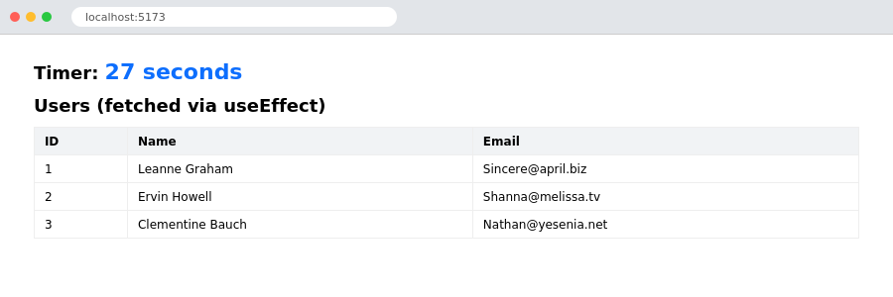
A running timer (setInterval inside useEffect) and a user list fetched from an API on mount
Conclusion:
Lifecycle management using the useEffect Hook was successfully studied and implemented. The behaviour of the dependency array (no array, an empty array, and an array with values) was demonstrated, along with practical side effects — an API fetch, a self-cleaning timer, and reading/writing browser localStorage — showing how React functional components can perform work outside the normal render cycle.

