Aim:
To install and integrate the Bootstrap CSS framework into a React (Vite) application and use its ready-made components to style the UI.
Theory:
- Bootstrap: A free, open-source CSS framework that provides pre-built components (navbars, buttons, cards, alerts, carousels, etc.) and a responsive grid system, allowing consistent styling without writing CSS from scratch.
- Why use Bootstrap with React: React handles the component logic and state, while Bootstrap supplies ready-made, responsive styling classes, so a working, good-looking UI can be built quickly.
- npm install: Adds the bootstrap package to node_modules and records it as a dependency in package.json.
Procedure:
Step 1: Install Bootstrap
Make sure Bootstrap is installed inside the project folder:
npm install bootstrap
Step 2: Import Bootstrap CSS
Import the Bootstrap stylesheet in src/main.jsx (or src/index.js) so it applies globally:
import 'bootstrap/dist/css/bootstrap.min.css';
Step 3: Example — main.jsx
import React from 'react';
import ReactDOM from 'react-dom/client';
import 'bootstrap/dist/css/bootstrap.min.css';
import './index.css';
import App from './App';

const root = ReactDOM.createRoot(document.getElementById('root'));

root.render(
<React.StrictMode>
<App />
</React.StrictMode>
);
Step 4: Use Bootstrap Classes in a Component
Bootstrap's utility and component classes (e.g. btn, btn-primary, alert, alert-success, container) can now be applied directly to JSX elements:
function App() {
return (
<div className="container mt-4">
<div className="alert alert-success">
Bootstrap loaded successfully
</div>
<button className="btn btn-primary me-2">Primary Button</button>
<button className="btn btn-outline-primary">Outline Button</button>
</div>
);
}

export default App;
Step 5: Run the Application
npm run dev
Open http://localhost:5173 in the browser to confirm that the Bootstrap-styled elements render correctly.
Output:
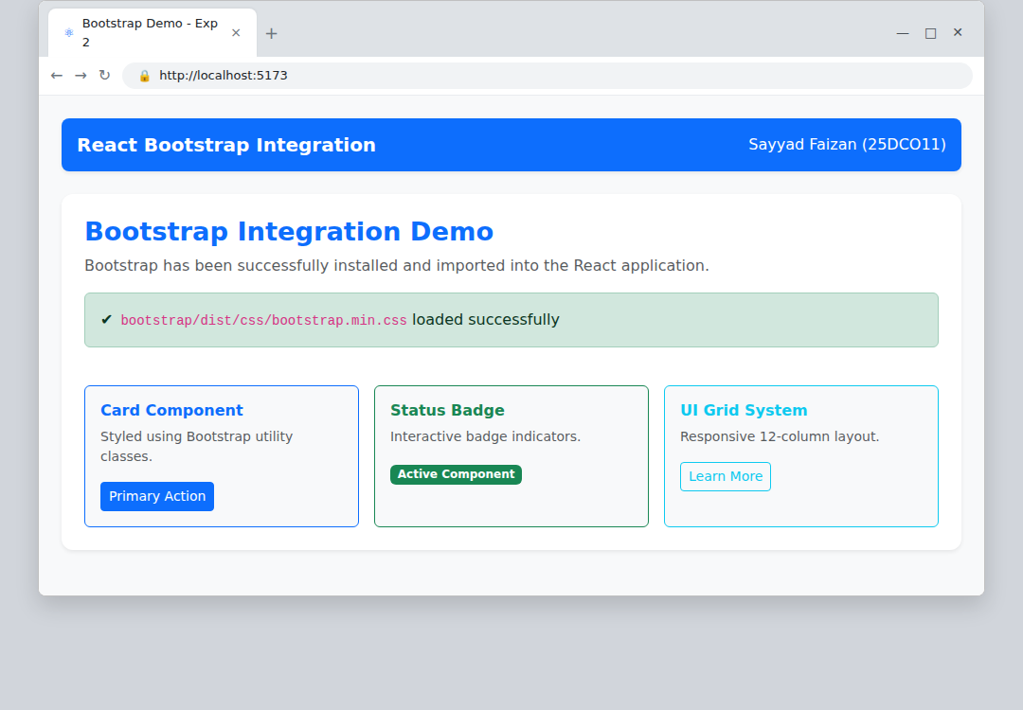
Bootstrap successfully integrated — styled alert and buttons rendered in the browser
Conclusion:
Bootstrap was successfully installed and integrated into the React application via npm and a single CSS import. Its utility classes and pre-built components could then be used directly inside JSX to style the UI without writing custom CSS.

