Aim:
To understand how to render lists dynamically in React JS using the JavaScript map() method, and to understand the importance of keys for efficiently identifying and updating list elements.
Theory:
Most real-world applications work with collections of data — a list of students, a catalogue of products, or a set of to-do tasks. Instead of manually writing HTML for every item, React allows UI elements to be generated directly from an array. This is called list rendering.
The map() method: a JavaScript array method that creates a new array by applying a function to every element of an existing array. React uses the same concept to generate JSX — instead of writing one <h2> per item by hand, an array can be mapped straight into JSX elements.
const students = ["Ali", "Rahul", "Priya", "Sneha"];

students.map(student => (
<h2>{student}</h2>
))
This approach makes the application dynamic, reusable, easier to maintain, and scalable.
Why Keys Are Needed — Reconciliation
React maintains an internal representation of the UI and compares it with the next render — a process called reconciliation. A key is a special string attribute that helps React identify which items have changed, been added, or been removed between renders, instead of re-rendering the entire list every time.
Conceptually, if a previous render shows items A, B, C and the next render shows A, B, C, D — keys let React recognise that A, B and C are unchanged, and only D is new, so only D needs to be added to the DOM.
Best choice for a key: a stable, unique identifier from the data itself (e.g. a database id), not the array index, since index-based keys can cause incorrect UI updates when items are reordered, inserted, or deleted.
const students = [
{ id: 101, name: "Ali" },
{ id: 102, name: "Rahul" },
{ id: 103, name: "Priya" }
];

{students.map((student) => (
<li key={student.id}>{student.name}</li>
))}
Procedure:
- Prepare the data as a JavaScript array (of strings or of objects) inside the component or as a state variable via useState.
- Use the array's .map() method inside the JSX to transform each element into a React element.
- Assign a unique key prop (ideally a stable id) to the outermost element returned for each item.
- For dynamic lists, provide functions that use .filter() to remove an item and the spread operator (...) with useState to add an item.
- Use conditional rendering to show an empty-state message when the list has no items.
1. Basic List Rendering — App.jsx
function App() {
const fruits = ["Apple", "Mango", "Orange", "Banana"];
return (
<div>
<h1>Fruit List</h1>
<ul>
{fruits.map((fruit) => (
<li key={fruit}>{fruit}</li>
))}
</ul>
</div>
);
}

export default App;
2. Rendering a List of Objects
function App() {
const students = [
{ id: 101, name: "Ali", department: "Computer Engineering" },
{ id: 102, name: "Rahul", department: "Information Technology" },
{ id: 103, name: "Priya", department: "AI & Data Science" }
];
return (
<div>
<h1>Student List</h1>
<ul>
{students.map((student) => (
<li key={student.id}>
<strong>{student.name}</strong>{" - "}{student.department}
</li>
))}
</ul>
</div>
);
}

export default App;
Expected Output: Student List — • Ali - Computer Engineering • Rahul - Information Technology • Priya - AI & Data Science

3. Deleting Items from a List (filter())
import { useState } from "react";

function App() {
const [students, setStudents] = useState([
{ id: 1, name: "Ali" }, { id: 2, name: "Rahul" }, { id: 3, name: "Priya" }
]);

function deleteStudent(id) {
setStudents(students.filter(student => student.id !== id));
}

return (
<div>
<h1>Student List</h1>
{students.map((student) => (
<div key={student.id}>
<span>{student.name}</span>{" "}
<button onClick={() => deleteStudent(student.id)}>Delete</button>
</div>
))}
</div>
);
}

export default App;
4. Complete Todo List Application
This example combines useState, event handling, list rendering, keys, map(), filter(), and conditional rendering into one working application.
import { useState } from "react";

function App() {
const [tasks, setTasks] = useState([
{ id: 1, title: "Study React", completed: false },
{ id: 2, title: "Complete Assignment", completed: true }
]);
const [task, setTask] = useState("");

function addTask() {
if (task.trim() === "") return;
const newTask = { id: Date.now(), title: task, completed: false };
setTasks([...tasks, newTask]);
setTask("");
}

function deleteTask(id) {
setTasks(tasks.filter(task => task.id !== id));
}

function toggleTask(id) {
setTasks(tasks.map(task =>
task.id === id ? { ...task, completed: !task.completed } : task
));
}

return (
<div style={{ padding: "30px" }}>
<h1>Todo List</h1>
<input type="text" placeholder="Enter task" value={task}
onChange={(event) => setTask(event.target.value)} />
<button onClick={addTask}>Add Task</button>
<hr />
{tasks.length === 0 ? (
<p>No tasks available.</p>
) : (
<ul>
{tasks.map((task) => (
<li key={task.id}>
<span style={{ textDecoration: task.completed ? "line-through" : "none" }}>
{task.title}
</span>{" "}
<button onClick={() => toggleTask(task.id)}>
{task.completed ? "Undo" : "Complete"}
</button>{" "}
<button onClick={() => deleteTask(task.id)}>Delete</button>
</li>
))}
</ul>
)}
</div>
);
}

export default App;
Output:
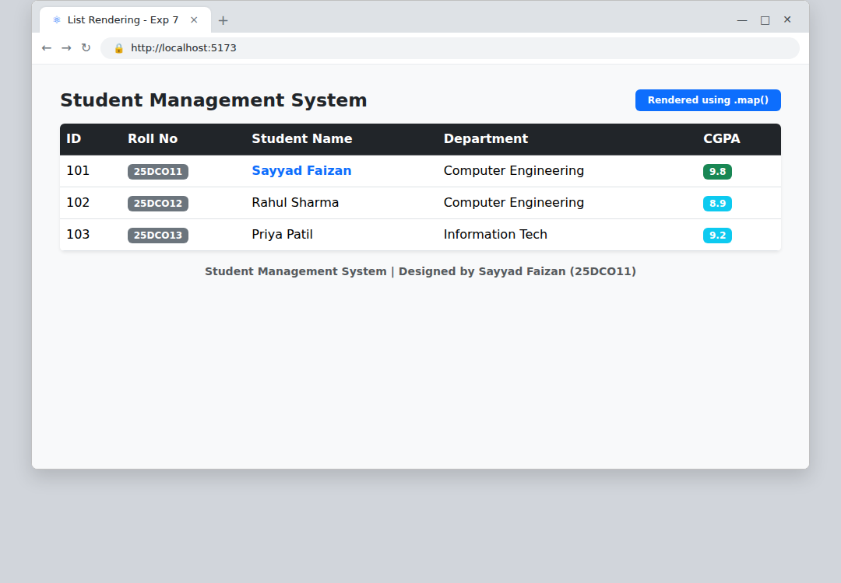
Todo List application — tasks rendered from an array with map(), each list item keyed by its id
Conclusion:
List rendering using the map() method and the role of keys in React's reconciliation process were successfully studied and implemented. A complete Todo List application demonstrated adding items with the spread operator, removing items with filter(), and toggling item state with map(), bringing together useState, event handling, list rendering, and conditional rendering in a single working component.

