Aim:
To understand the concept of State in React and implement dynamic user interfaces using the useState Hook.
Objectives:
- Understand what State is in React.
- Understand the difference between Props and State.
- Learn the syntax of the useState() Hook.
- Update state dynamically and handle user interactions.
- Build interactive React applications.
- Understand React's re-rendering process.
Theory:
What is State? State is a built-in object in React that stores data which can change over time. Whenever the state changes, React automatically updates (re-renders) the UI.
Real-life analogy: a digital clock's display (12:30 PM → 12:31 PM → 12:32 PM) changes automatically over time, just as a bank balance changes after every deposit or withdrawal. React State behaves the same way — it is the changing data behind a dynamic UI.
What is the useState Hook? useState is a Hook introduced in React 16.8 that allows functional components to maintain and update state. Before Hooks, only class components could store state.
Syntax:
const [stateVariable, setStateVariable] = useState(initialValue);
Example:
const [count, setCount] = useState(0);
// count = 0
setCount(5);
// count = 5, and React automatically re-renders the UI
Importing useState:
import { useState } from "react";
Procedure:
- Import the useState Hook from 'react' in the component file.
- Declare a state variable and its updater function using array destructuring: const [value, setValue] = useState(initialValue).
- Use the state variable inside the JSX returned by the component to display dynamic data.
- Attach an event handler (e.g. onClick, onChange) that calls the updater function to change the state.
- Observe that the UI re-renders automatically whenever the state changes.

1. Increment and Decrement Counter
import React, { useState } from 'react'

function Counter() {
const [count, setCount] = useState(0)
return (
<div style={{ textAlign: 'center' }}>
<h1>Counter</h1>
<p>Count: {count}</p>
<button onClick={() => setCount(count + 1)}>Increment</button>
<button onClick={() => setCount(count - 1)}>Decrement</button>
</div>
)
}

export default Counter
2. Like Button
import React, { useState } from 'react'

function LikeButton() {
const [likes, setLikes] = useState(0);
return (
<div style={{ textAlign: 'center' }}>
<h1>Like Counter</h1>
<h2>Likes : {likes}</h2>
<button onClick={() => setLikes(likes + 1)}>❤️ Like</button>
</div>
)
}

export default LikeButton
3. Background Colour Changer
import React, { useState } from 'react'

function ColorChanger() {
const [color, setColor] = useState("white");
return (
<div style={{ backgroundColor: color, height: "10vh", textAlign: "center", paddingTop: "50px" }}>
<button onClick={() => setColor("yellow")}>Yellow</button>
<button onClick={() => setColor("lightblue")}>Blue</button>
<button onClick={() => setColor("lightgreen")}>Green</button>
</div>
)
}

export default ColorChanger
4. Student Attendance Toggle
import React, { useState } from 'react'

function Attendance() {
const [present, setPresent] = useState(false);
return (
<div style={{ textAlign: 'center' }}>
<h2>{present ? "Present" : "Absent"}</h2>
<button onClick={() => setPresent(!present)}>Mark Attendance</button>
</div>
)
}

export default Attendance
5. Controlled Input Box
import React, { useState } from 'react'

function Registration() {
const [name, setName] = useState("");
return (
<div style={{ textAlign: 'center' }}>
<h1>Student Registration</h1>
<input
type="text"
placeholder="Enter Name"
value={name}
onChange={(e) => setName(e.target.value)}
/>
<h2>Hello {name}</h2>
</div>
)
}

export default Registration
State vs Props
Feature | State | Props
Mutable | Yes | No
Controlled by | Same component | Parent component
Can change | Yes | No
Triggers re-render | Yes | Yes (when parent passes new props)
Purpose | Store dynamic data | Pass data between components

Output:
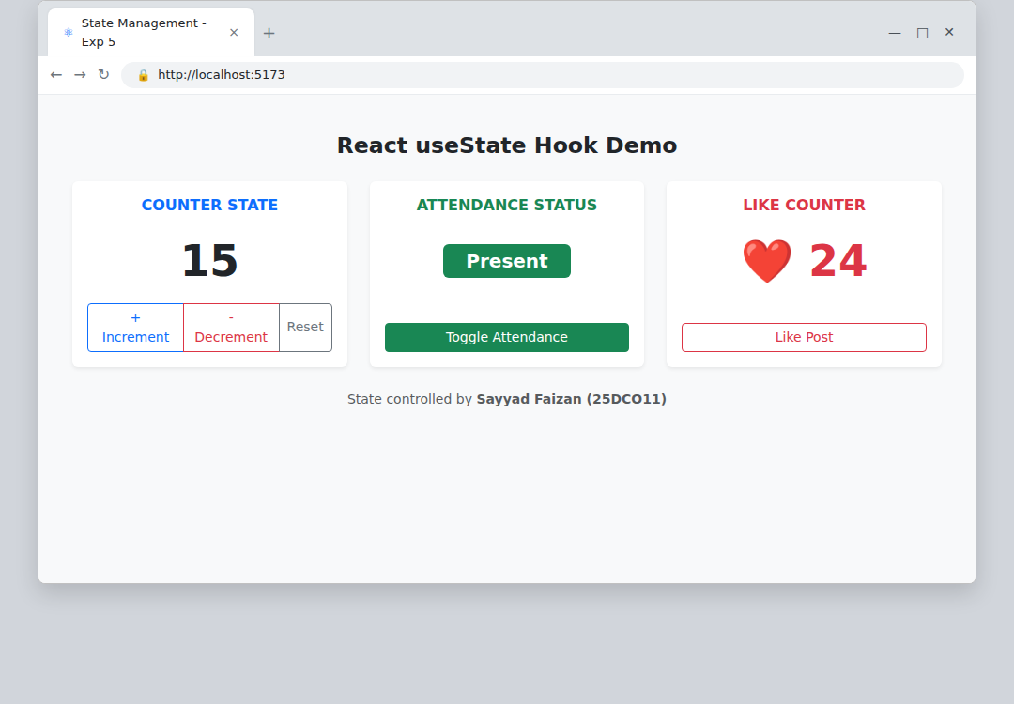
Counter, Like button, background changer and attendance toggle updating the UI through useState
Conclusion:
The concept of State and the useState Hook were successfully studied and implemented. Several small components (a counter, a like button, a background colour changer, an attendance toggle, and a controlled input box) were built to demonstrate how state changes automatically trigger React to re-render the UI, and the key differences between State and Props were understood.

