Data Analytics Assignment - Supermarket Sales Visualization

# Bar Chart: Total Sales by Product Line

This bar chart displays total sales across different product lines.

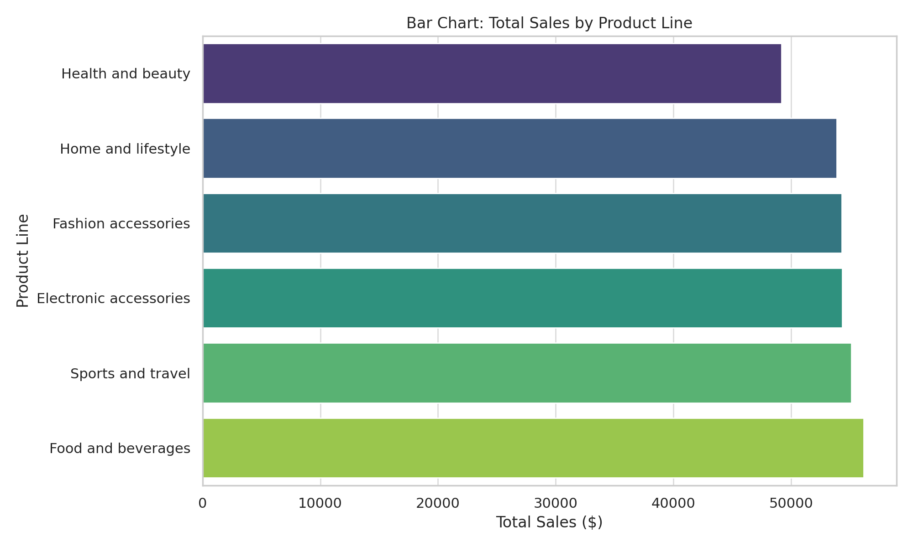

# Pie Chart: Payment Method Distribution

This pie chart shows the percentage distribution of payment methods used by customers.

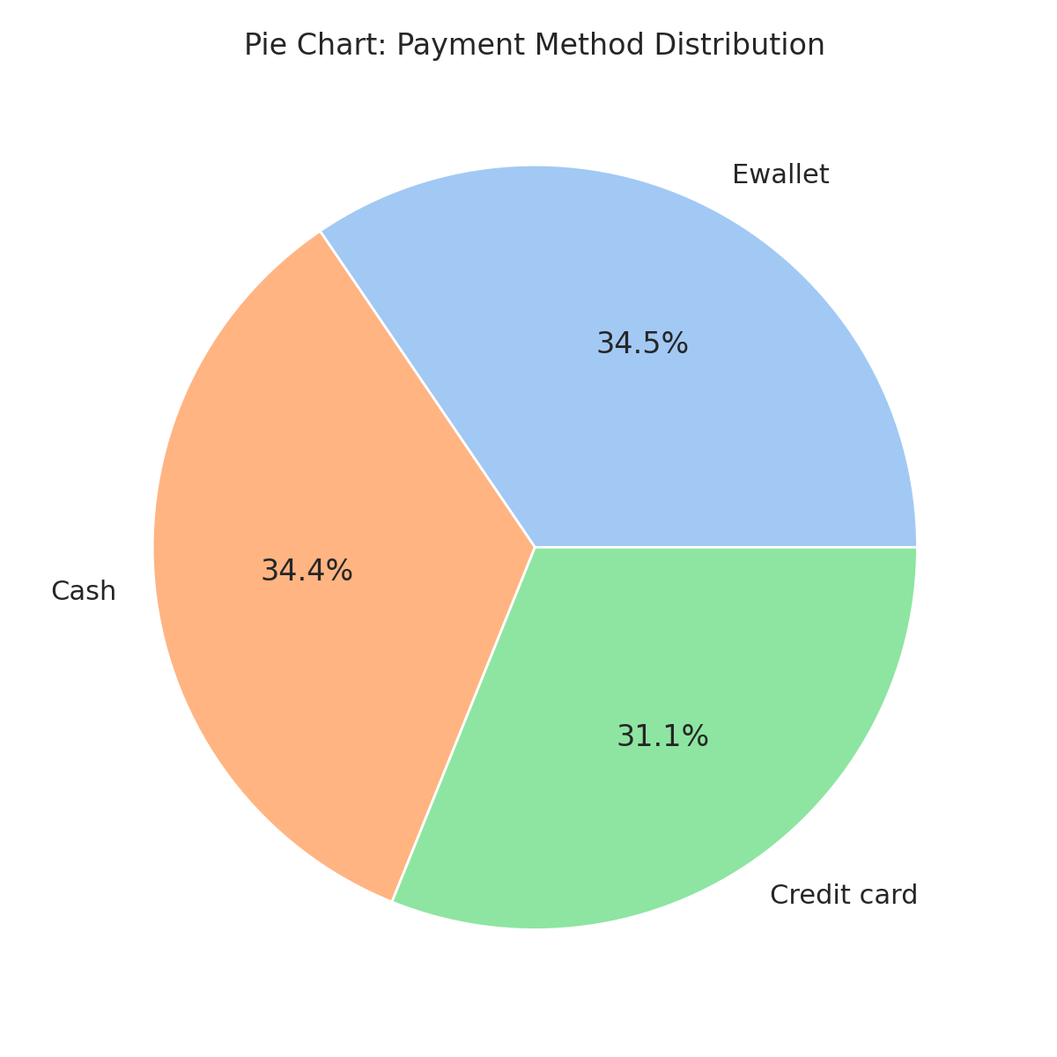

# Stacked Bar Chart: Sales by Branch and Gender

This stacked bar chart visualizes total sales segmented by gender within each branch.

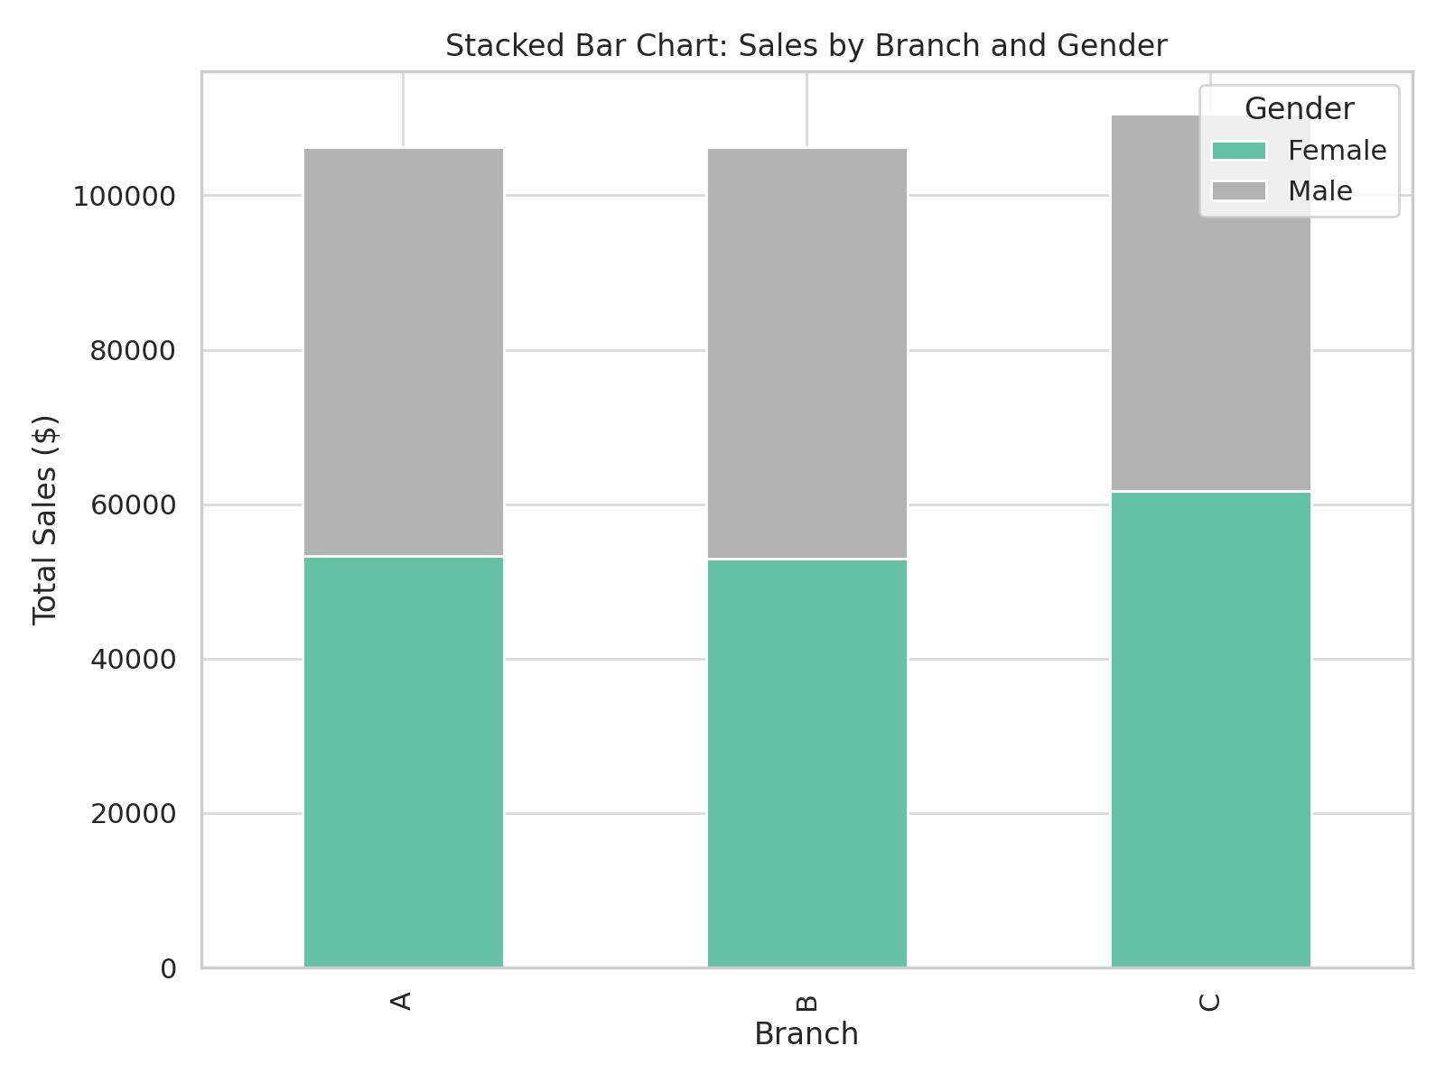

# Line Chart: Total Sales Over Time

This line chart illustrates daily total sales from January to March 2019.

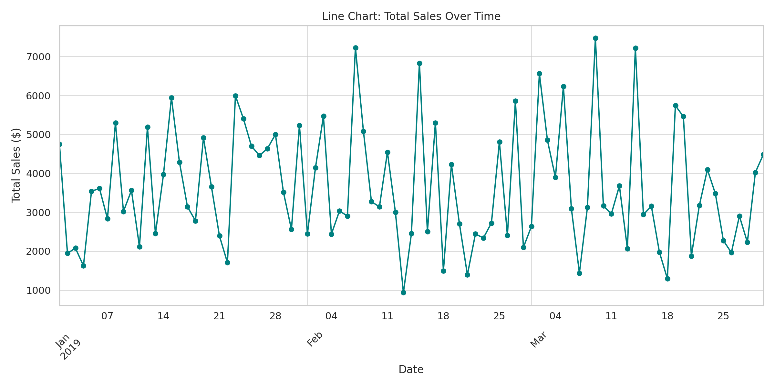

# Bubble Chart: Gross Income vs Product Line

This bubble chart represents gross income for each product line with bubble size indicating quantity sold.

