Personal Portfolio Website – AWS Serverless Architecture Documentation

1. Project Overview
This project is a modern, fully responsive personal portfolio website built to showcase professional skills, projects, experience, and certifications. It leverages AWS serverless services to implement:
- Dynamic “Message Me” form using AWS Lambda + SES
- Cost-optimized temporary website hosting using AWS Lambda + EventBridge Scheduler, allowing the website to activate for 30 minutes per session
- SNS notifications to alert the portfolio owner whenever the website is started
This architecture demonstrates scalable, cost-efficient cloud design while providing a professional portfolio experience.

2. Objectives
- Showcase professional portfolio with a modern, interactive UI
- Implement serverless backend functionality:
  - Contact form submission
  - Temporary website activation
- Reduce hosting costs by limiting S3 website uptime
- Notify the portfolio owner each time the website is accessed
- Maintain a secure and professional environment for visitors

3. Architecture & Workflow
3.1 Website Activation Flow
- Visitor clicks the resume link
- StartWebsite Lambda:
  - Activates the S3 static website hosting
  - Publishes a message to SNS, notifying the portfolio owner
  - Creates a temporary EventBridge schedule to stop the site in 30 minutes
- StopWebsite Lambda: Disables the S3 hosting after 30 minutes
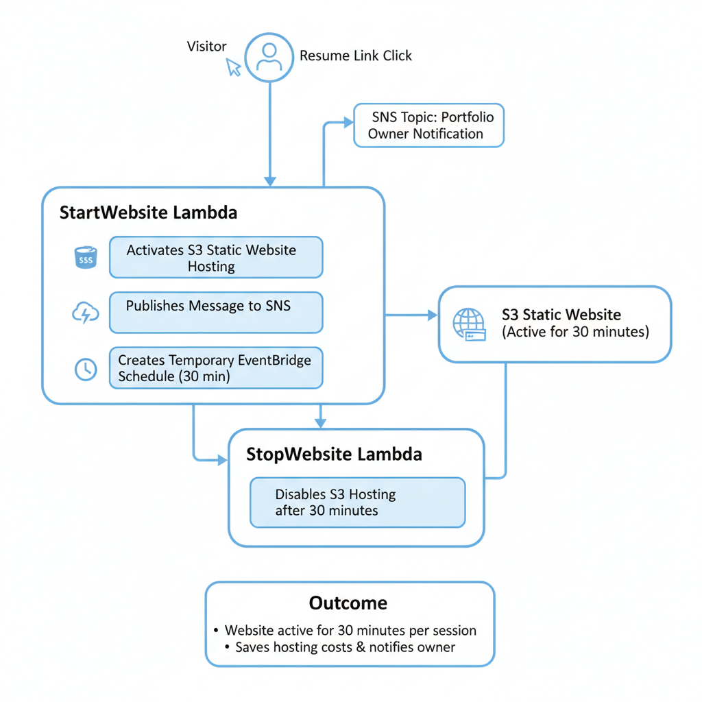
- Outcome: Website is only active for 30 minutes per session, saving hosting costs and notifying the owner

3.2 Contact Form Flow
- Visitor fills out the contact form
- API Gateway receives the request and triggers Lambda
- Lambda sends an email via AWS SES to the portfolio owner
- Emails include the visitor’s input (name, email, message)
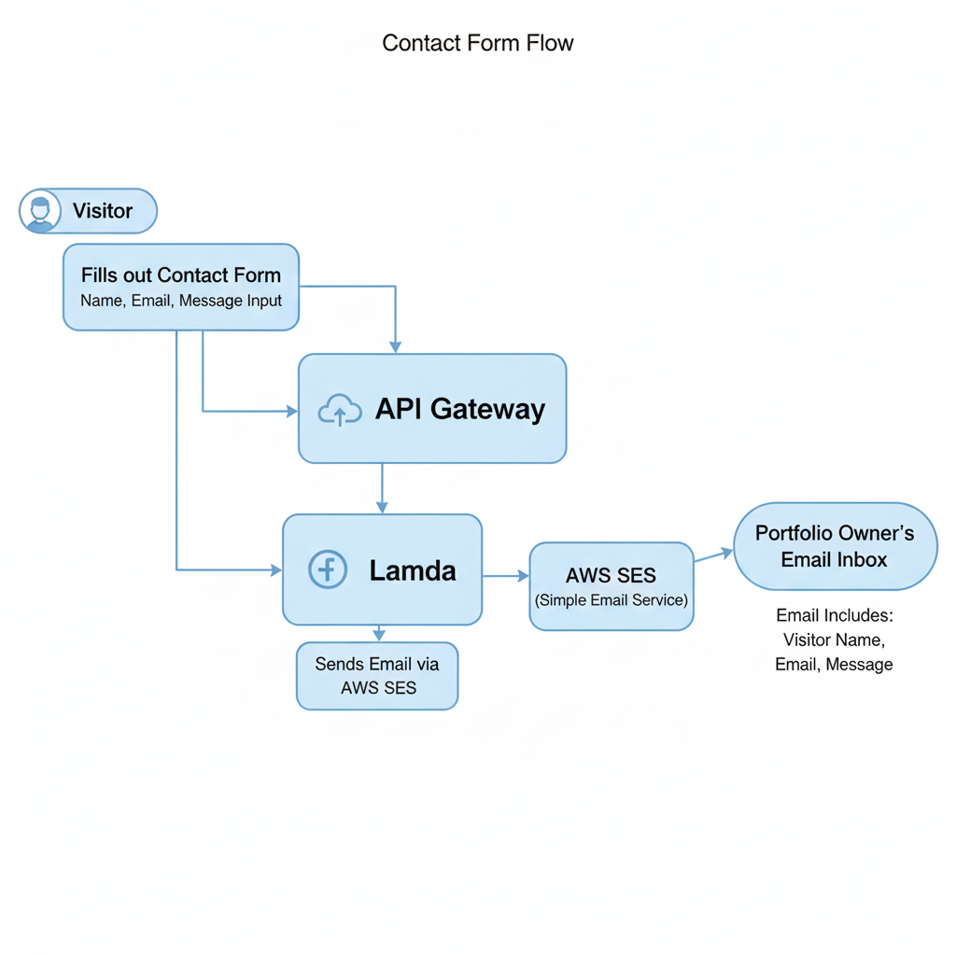

4. AWS Services & Roles
Service | Purpose | Key Configurations / Notes
S3 | Hosts static portfolio files | Public bucket with website hosting enabled
Lambda | Handles contact form & website activation | Two main functions: startWebsite & stopWebsite
EventBridge Scheduler | Automates website stop after 30 minutes | Schedules stopWebsite Lambda dynamically
API Gateway | Exposes HTTP endpoint for contact form | Handles CORS, routes requests to Lambda
SES | Sends emails from contact form | Verified email/domain required
SNS | Sends notification emails to owner | Triggered by startWebsite Lambda

5. Security & Cost Optimization
- IAM Roles: Restricted permissions for Lambda functions (least privilege)
- EventBridge Scheduler: Automates stop to prevent unnecessary S3 costs
- S3 Free Tier: 5 GB storage + 20K GET requests/month
- SNS Free Tier: 1 million publishes/month + 1,000 email notifications/month
- SES: Verified domain ensures secure and reliable email delivery
- Temporary Hosting: Website only active when accessed via resume link

6. Features
- Temporary Portfolio Website Hosting (30 min/session)
- Automatic activation and deactivation of S3 hosting
- Dynamic Contact Form integrated with SES
- SNS notifications to portfolio owner on site access
- Modern UI/UX: Dark/Light mode, typing animation, scroll-based progress, interactive cards
- Modular, serverless architecture for easy maintenance

7. Implementation Steps (GUI-Based)

7.1 S3 Setup
- AWS Console → S3 → Create bucket → Name it uniquely (e.g., sameerm3-portfolio)
- Enable static website hosting → Index document: index.html
- Upload all portfolio files (HTML, CSS, JS, images)
- Set bucket policy → Allow public read access
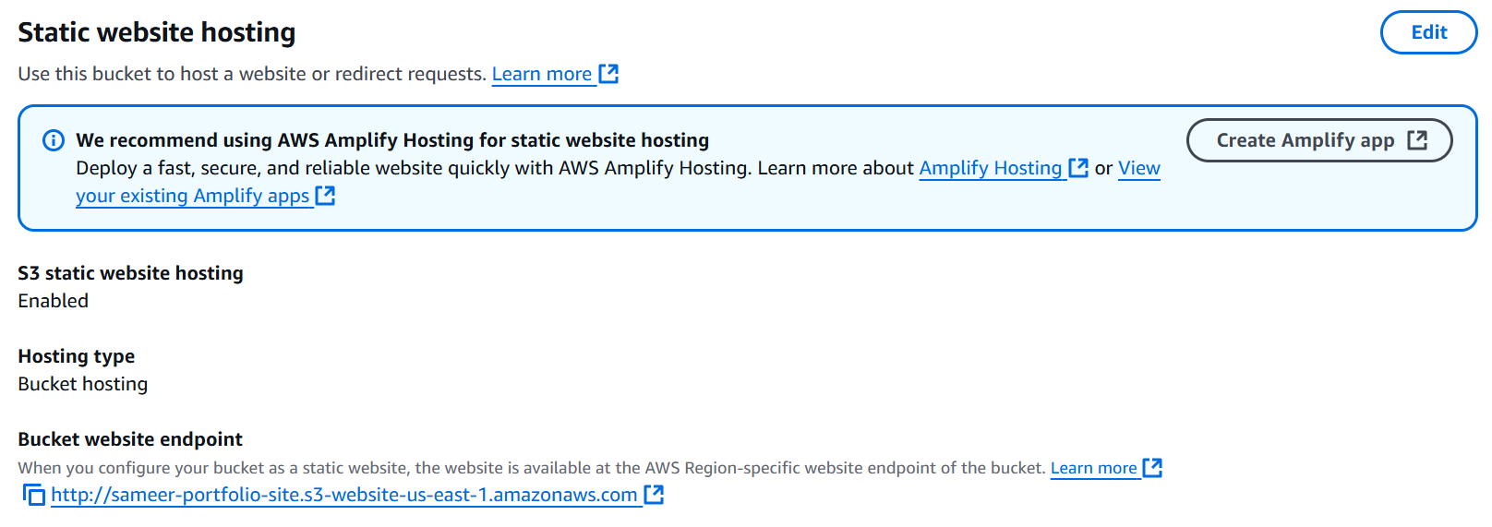
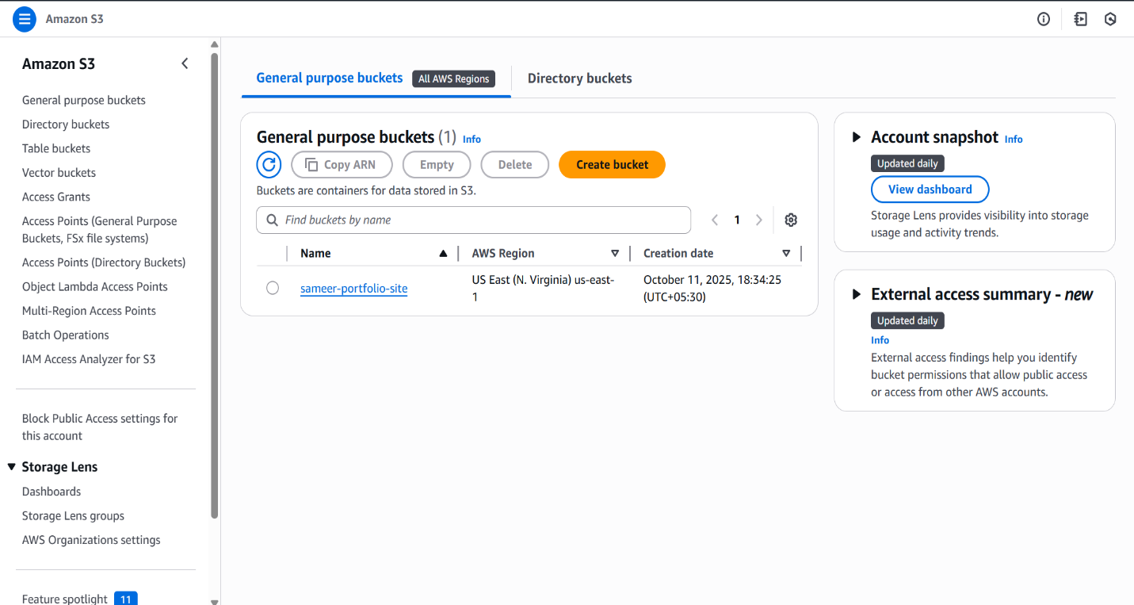

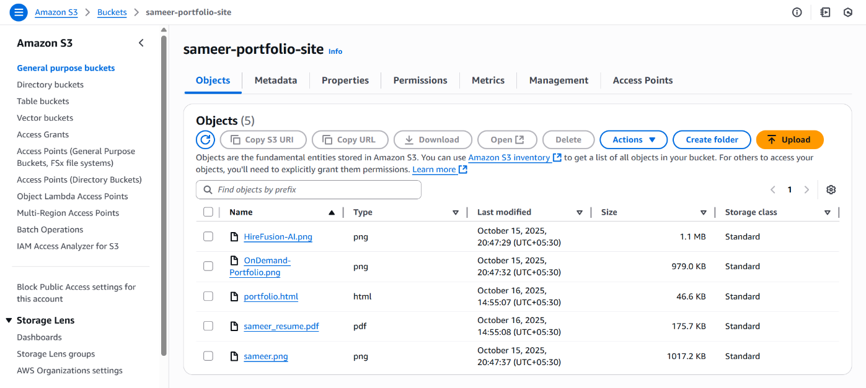

7.2 Create IAM Roles
Lambda Execution Role (SiteControlLambdaRole)
- Trusted entity: Lambda
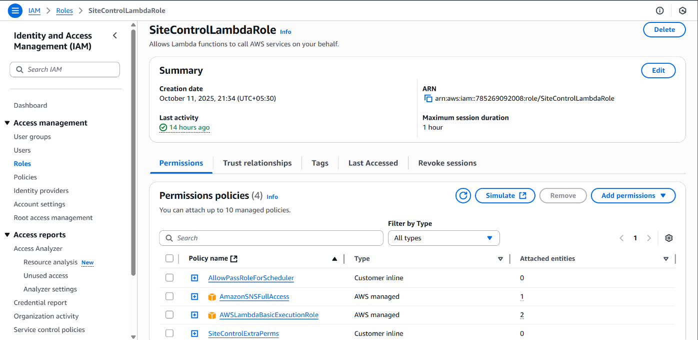
- Attach policies: AWSLambdaBasicExecutionRole, AmazonSNSFullAccess

Create inline policies: AllowSchedulerRolePass (
{
"Version": "2012-10-17",
"Statement": [
{
"Sid": "AllowSchedulerRolePass",
"Effect": "Allow",
"Action": [
"iam:PassRole"
],
"Resource": "arn:aws:iam::<Account_Id>:role/SchedulerInvokeLambdaRole"
},
{
"Sid": "AllowSchedulerAndS3",
"Effect": "Allow",
"Action": [
"scheduler:CreateSchedule",
"scheduler:DeleteSchedule",
"s3:PutBucketPolicy",
"s3:DeleteBucketPolicy"
],
"Resource": "*"
}
]
} ),
SiteControlExtraPerms (
{
"Version": "2012-10-17",
"Statement": [
{
"Effect": "Allow",
"Action": [
"s3:PutBucketPolicy",
"s3:DeleteBucketPolicy"
],
"Resource": "arn:aws:s3:::sameer-portfolio-site"
},
{
"Effect": "Allow",
"Action": [
"scheduler:CreateSchedule",
"scheduler:DeleteSchedule"
],
"Resource": "*"
}
]
} ).
EventBridge Scheduler Role (EventSchedulerInvokeRole)
- Trusted entity: Custom trust policy → Lambda can assume role
{
"Version": "2012-10-17",
"Statement": [
{
"Effect": "Allow",
"Principal": {
"Service": "scheduler.amazonaws.com"
},
"Action": "sts:AssumeRole"
}
]
}
- Create inline policy: invokelambda (
{
"Version": "2012-10-17",
"Statement": [
{
"Effect": "Allow",
"Action": "lambda:InvokeFunction",
"Resource": "*"
}
]
}
).
SES Role (MessageLambdaRole)
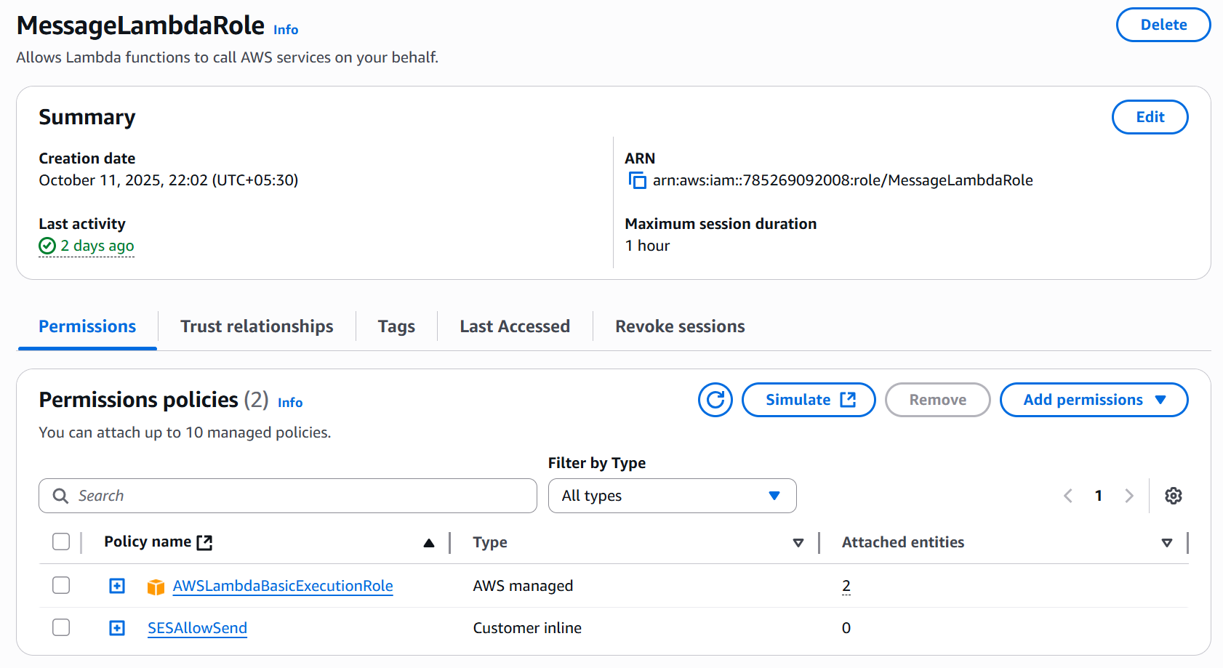
- Trusted entity: Lambda
- Attach policies: AWSLambdaBasicExecutionRole
- Create inline policy: SESAllowSend (
{
"Version": "2012-10-17",
"Statement": [
{
"Effect": "Allow",
"Action": "ses:SendEmail",
"Resource": "*"
}
]
}
).

7.3 Lambda Functions
startWebsite Lambda
- Create Lambda → Name: startWebsite → Runtime: Python 3.10
- Role: SiteControlLambdaRole
- Paste code to:
  - Enable S3 website
  - Schedule StopWebsite Lambda via EventBridge
  - Publish SNS notification
  - Code (
import boto3, json, os, uuid
from datetime import datetime, timedelta, timezone

sns = boto3.client('sns')
s3 = boto3.client('s3')
scheduler = boto3.client('scheduler')

BUCKET = os.environ['BUCKET']
SITE_URL = os.environ['SITE_URL']
STOP_LAMBDA_ARN = os.environ['STOP_LAMBDA_ARN']
SCHEDULER_ROLE_ARN = os.environ['SCHEDULER_ROLE_ARN']

def lambda_handler(event, context):
# make site public
policy = {
"Version": "2012-10-17",
"Statement": [{
"Sid": "PublicReadGetObject",
"Effect": "Allow",
"Principal": "*",
"Action": ["s3:GetObject"],
"Resource": [f"arn:aws:s3:::{BUCKET}/*"]
}]
}
s3.put_bucket_policy(Bucket=BUCKET, Policy=json.dumps(policy))

# schedule stop in 30 min
run_time = datetime.now(timezone.utc) + timedelta(minutes=30)
schedule_name = f"stop-website-{uuid.uuid4().hex[:8]}"
scheduler.create_schedule(
Name=schedule_name,
ScheduleExpression=f"at({run_time.strftime('%Y-%m%dT%H:%M:%S')})",
FlexibleTimeWindow={'Mode':'OFF'},
Target={
'Arn': STOP_LAMBDA_ARN,
'RoleArn': SCHEDULER_ROLE_ARN
}
)

sns.publish(
TopicArn='arn:aws:sns:us-east-1:785269092008:PortfolioSiteStarted',
Message='Someone just started your portfolio website!',
Subject='Portfolio Notification'
)

# redirect
return {
"statusCode":302,
"headers":{"Location":SITE_URL},
"body":json.dumps({"message":"Redirecting"})
}
).

- Add environment variables:
  - BUCKET → your S3 bucket name
  - REGION → your AWS region
  - STOP_LAMBDA_ARN → stopWebsite Lambda ARN
  - SCHEDULER_ROLE_ARN → EventSchedulerInvokeRole ARN
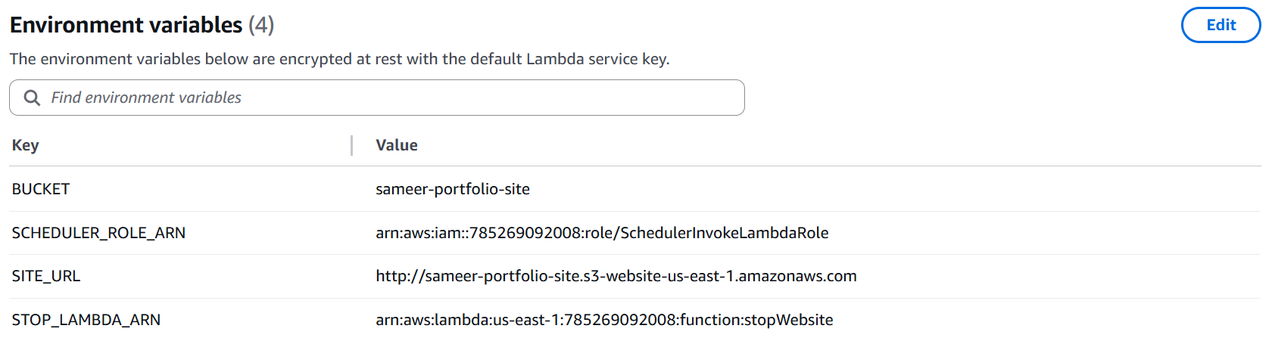
stopWebsite Lambda
- Creates Lambda → Name: stopWebsite → Runtime: Python 3.10
- Role: PortfolioLambdaExecRole
- Paste code to disable S3 website hosting
- Code (
import boto3, os, json
s3 = boto3.client('s3')
BUCKET = os.environ.get('BUCKET')

def lambda_handler(event, context):
try:
s3.delete_bucket_policy(Bucket=BUCKET)
except:
pass
return {"statusCode":200,"body":json.dumps({"message":"Website stopped"})}
).
- Add environment variables:
  - BUCKET → your S3 bucket name
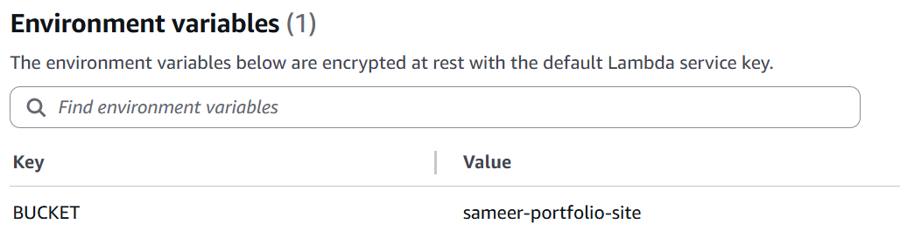

SESMessage Lambda
- Creates Lambda → Name: SendMessageSES → Runtime: Python 3.10
- Role: MessageLambdaRole
- Paste code to disable S3 website hosting
- Code (
import boto3
import json
import os
from botocore.exceptions import ClientError

# SES client (update region if needed)
ses = boto3.client('ses', region_name='us-east-1')

# Environment variables
FROM = os.environ['FROM'] # Must be verified in SES
TO = os.environ['TO'] # Your email, any recipient in production mode

def lambda_handler(event, context):
try:
# Parse the incoming POST body
body = json.loads(event.get('body', '{}'))
name = body.get('name', 'Anonymous')
email = body.get('email', 'No Email')
message = body.get('message', 'No Message')

# Compose email content
subject = f"Portfolio Message from {name}"
email_body = f"Name: {name}\nEmail: {email}\n\nMessage:\n{message}"

# Send email via SES
response = ses.send_email(
Source=FROM,
Destination={'ToAddresses':[TO]},
Message={
'Subject': {'Data': subject},
'Body': {'Text': {'Data': email_body}}
}
)

# Success response
return {
'statusCode': 200,
'body': json.dumps({'message': 'Message sent successfully!'})
}

except ClientError as e:
# SES error
print(f"SES Error: {e.response['Error']['Message']}")
return {
'statusCode': 500,
'body': json.dumps({
'error': 'Failed to send message via SES',
'details': e.response['Error']['Message']
})
}

except Exception as e:
# General error
print(f"Error: {str(e)}")
return {
'statusCode': 500,
'body': json.dumps({'error': 'Internal server error', 'details': str(e)})
}
).
- Add environment variables:
  - From → Mail verified in SES
  - To → Recipient mail
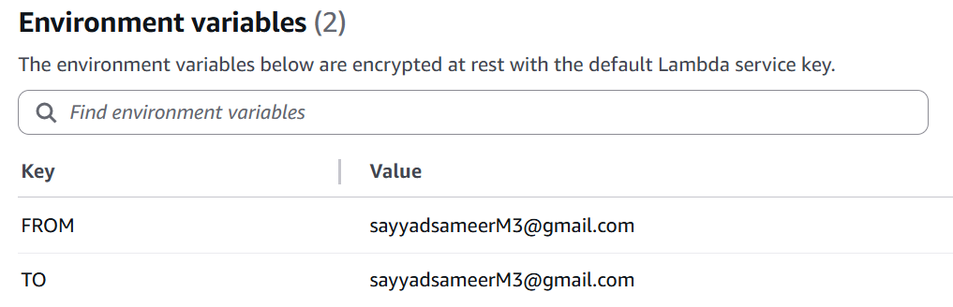

7.4 API Gateway
- Create HTTP API → Add integrations → startWebsite Lambda, sendMessageSES Lambda
- Route: /start (method GET), /contact(method POST)
- Enable CORS
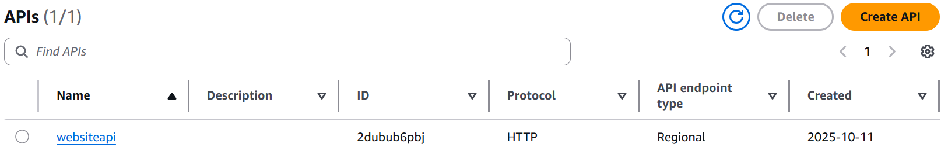
- Deploy → Note Invoke URL

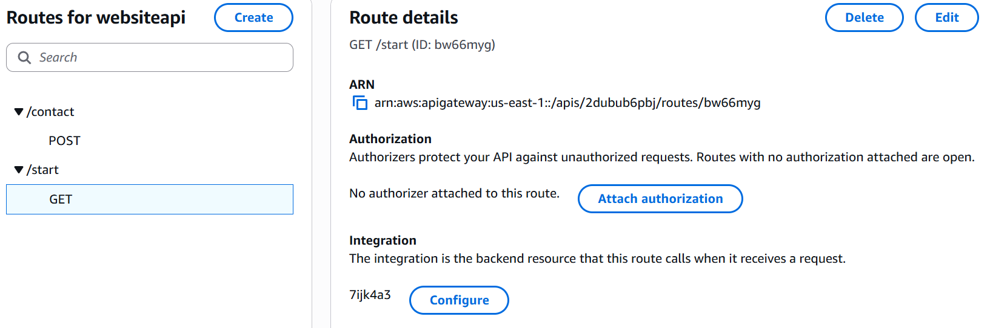
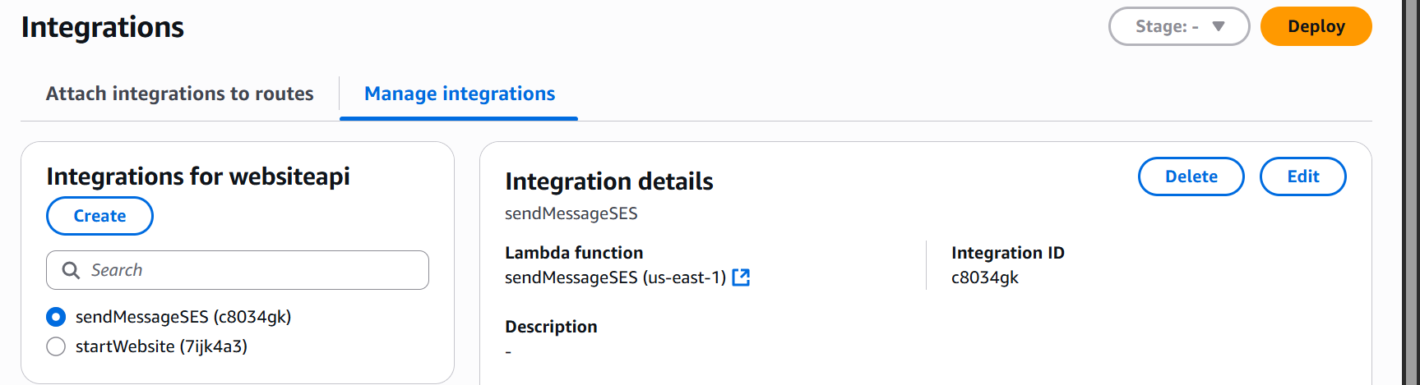
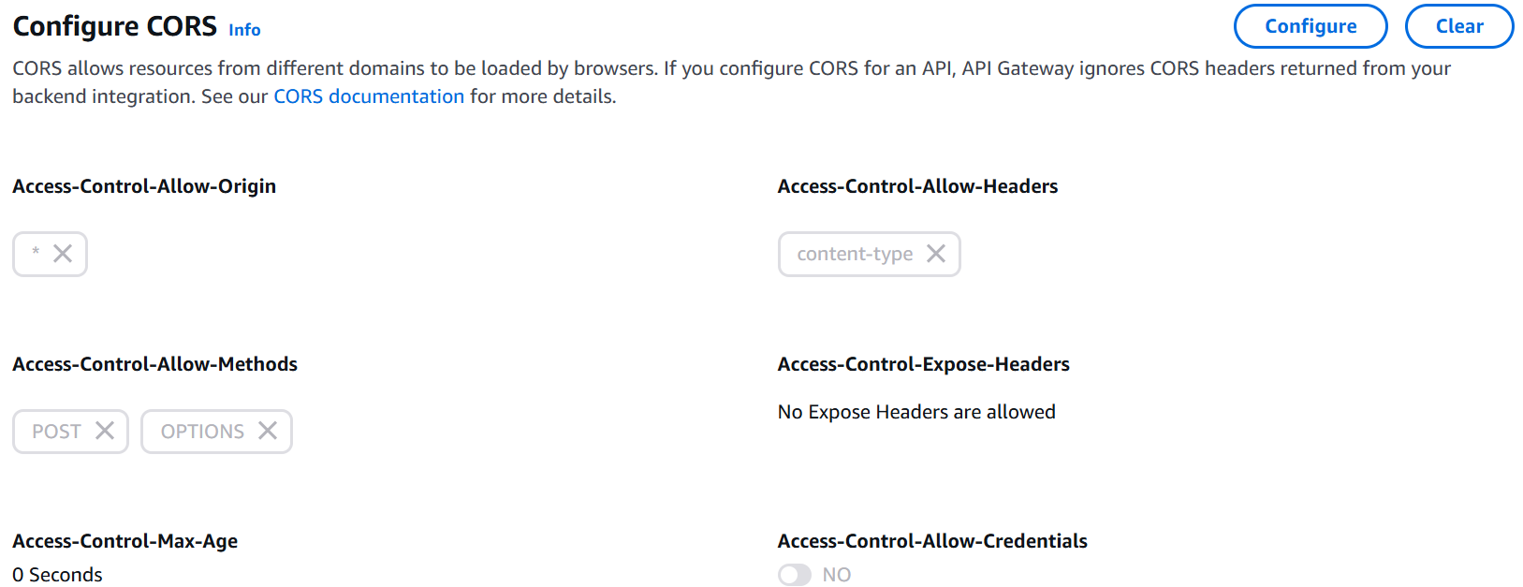
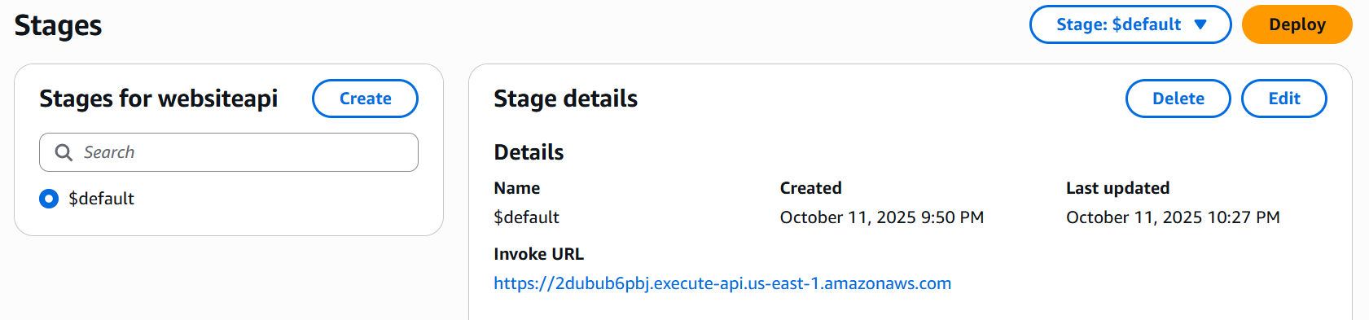

7.5 EventBridge Scheduler
Lambda creates a schedule for it to trigger another Lambda later

7.6 SNS Notifications
- Create SNS Topic → PortfolioAccessTopic
- Add Email subscription → confirm in inbox
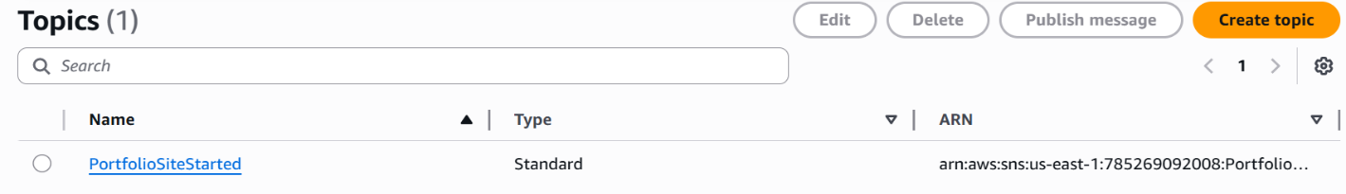
- startWebsite Lambda publishes message to this topic whenever website starts
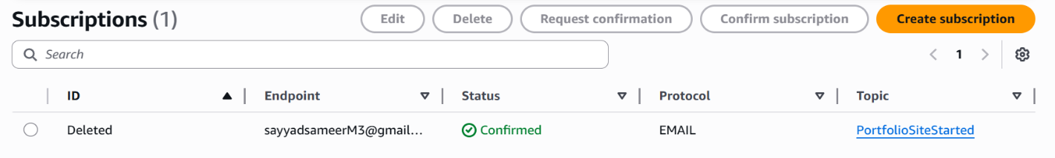

7.7 SES Configuration
- Verify your email/domain
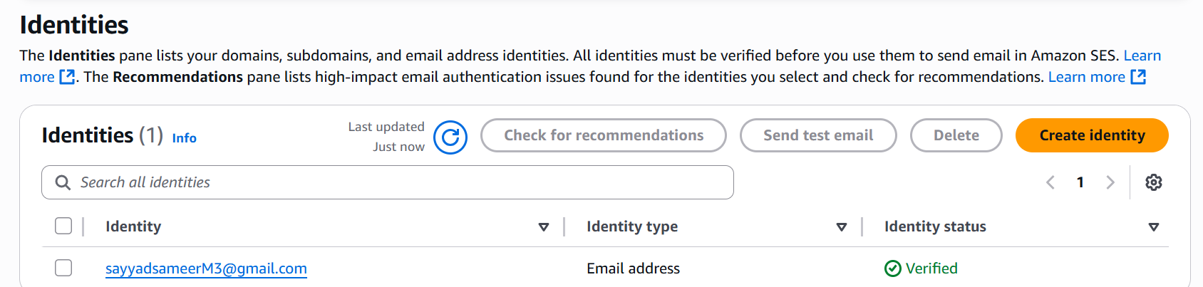
- Lambda uses SES sendEmail API for contact form submissions

7.8 Testing & Debugging
- Click resume link → S3 website starts
- Check SNS email → notification received
- Wait 30 minutes → website stops automatically
- Submit contact form → email delivered via SES
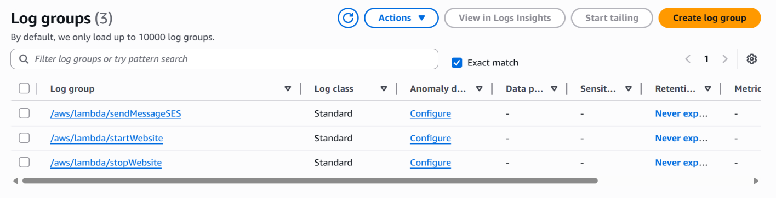
- Debugging and Monitoring → via Cloud Watch

8. Advantages
- Cost-efficient: Runs only when needed
- Serverless & Scalable: Lambda and EventBridge manage backend without servers
- Recruiter-friendly: Anyone can access and submit forms without AWS account
- Secure & Reliable: SES verified domain, SNS notifications, IAM roles
- Maintainable: Modular architecture allows easy updates or expansion

