Chapter – 2
Quantum Machine Learning for Agricultural Data Processing and Smart Farming

TABLE OF CONTENTS
Abstract
1 Introduction
2 Fundamentals of Quantum Computing for Agriculture
2.1 Quantum Bits and Agricultural Data Encoding
2.2 Quantum Gates and Agricultural Operations
2.3 Quantum Advantage for Agricultural Problems
3 Quantum Machine Learning Algorithms for Agriculture
3.1 Quantum Neural Networks
3.2 Quantum Support Vector Machines
3.3 Variational Quantum Algorithms
4 Case Study: Quantum-Enhanced Precision Irrigation Optimization
4.1 Problem Formulation and Mathematical Model
4.2 Quantum Implementation and Results
5 Mathematical Modeling and Hybrid Quantum-Classical Approaches
5.1 Hybrid Quantum-Classical Optimization
5.2 Quantum-Classical Data Integration
5.3 Complexity Analysis and Scaling
6 Implementation and Practical Considerations
6.1 Quantum Hardware Requirements
6.2 Error Mitigation and Noise Handling
6.3 Software Tools and Development Frameworks
7 Future Directions and Emerging Applications
7.1 Quantum Genomics for Crop Breeding
7.2 Quantum Sensing for Precision Agriculture
8 Conclusion
References

Abstract
Challenges facing modern agriculture include: climate change; limited resources; increasing population; and sustainable production systems. These challenges are driving the need for new technology solutions that exceed what has been possible with conventional computing approaches. In this chapter we will examine the rapidly growing area of quantum machine learning (QML) and how QML methods can be applied to processing data related to agriculture. A general framework is developed that combines quantum computing, mathematical modeling, and precision agriculture. QML methods employ unique quantum phenomena such as superposition, entanglement, and quantum interference to process agriculture data significantly faster than the previous computational techniques available. This speed enables real-time optimization of complex farming operations. We will discuss key QML structures such as quantum neural networks, variational quantum eigen solvers, and quantum support vector machines and present results demonstrating their utility to solve major agricultural challenges. A complete discussion on all of the mathematical foundations will be provided including: representations of quantum circuits; parameterized quantum gates and hybrid quantum-classical optimization algorithms. The examples in this chapter will show how quantum algorithms can enable the processing of much larger datasets from remote sensor systems, create solutions to using the resources of many acres simultaneously and estimate how much crops can be produced while facing the consequences of climate change. In addition, this chapter covers a number of practical considerations, such as the specific hardware for quantum computing that will be required, how to minimize noise interference, the analysis of the algorithmic complexity and how to develop hybrid systems linking quantum computers to conventional farm management systems. The author also examines areas that will be clearly able to benefit from quantum methods compared to classical machine learning within an agricultural context. Future research opportunities in genomics could include utilizing quantum-assisted techniques for plant breeding, creating quantum-optimized robotic systems for agricultural uses and employing quantum methods to model how ecosystems behave over time. These projects highlight that quantum ML is a critical technology for advancing sustainable practices within agriculture in future. It provides researchers and practitioners with theoretical frameworks, practical implementation plans and concrete ways to achieve food security and grow more sustainable farms through the use of quantum computing.
Keywords: Quantum Machine Learning, Precision Agriculture, Smart Farming, Quantum Computing, Mathematical Modeling, Crop Yield Prediction, Quantum Neural Networks, Agricultural Optimization, Quantum Algorithms, Sustainable Agriculture

1 Introduction
Agricultural systems represent complex, high-dimensional optimization problems characterized by numerous interdependent variables, nonlinear relationships, and significant uncertainty. Modern precision agriculture generates massive datasets from diverse sources including satellite imagery, drone sensors, IoT soil monitors, weather stations, and farm equipment telemetry. Processing these multi-modal, high-resolution datasets to extract actionable insights for real-time decision-making exceeds the computational capabilities of classical computing approaches.
Classical machine learning has achieved significant advances in agricultural applications, enabling predictive analytics for crop yields, automated disease detection, and optimized resource management. However, fundamental computational complexity barriers limit classical approaches when addressing the full scope of agricultural optimization problems. Consider irrigation scheduling across a large farm: optimizing water allocation requires simultaneously evaluating thousands of field zones, weather forecast ensembles, soil moisture gradients, crop growth stages, and water source constraints a combinatorial optimization problem scaling exponentially with problem size.
Quantum machine learning emerges as a transformative paradigm offering exponential computational advantages for specific problem classes prevalent in agriculture. Quantum computers exploit quantum mechanical superposition to evaluate multiple solutions simultaneously, quantum entanglement to encode complex correlations efficiently, and quantum interference to amplify correct solutions while suppressing incorrect ones. These quantum phenomena enable algorithms that solve certain agricultural optimization, simulation, and machine learning problems exponentially faster than classical approaches.
This chapter systematically develops quantum machine learning methodologies for agricultural applications, establishing mathematical foundations, demonstrating practical implementations, and evaluating quantum advantage for real-world farming challenges. As illustrated in Figure 1, the integrated quantum-classical framework enables unprecedented agricultural intelligence through quantum-enhanced data processing, optimization, and predictive modeling.
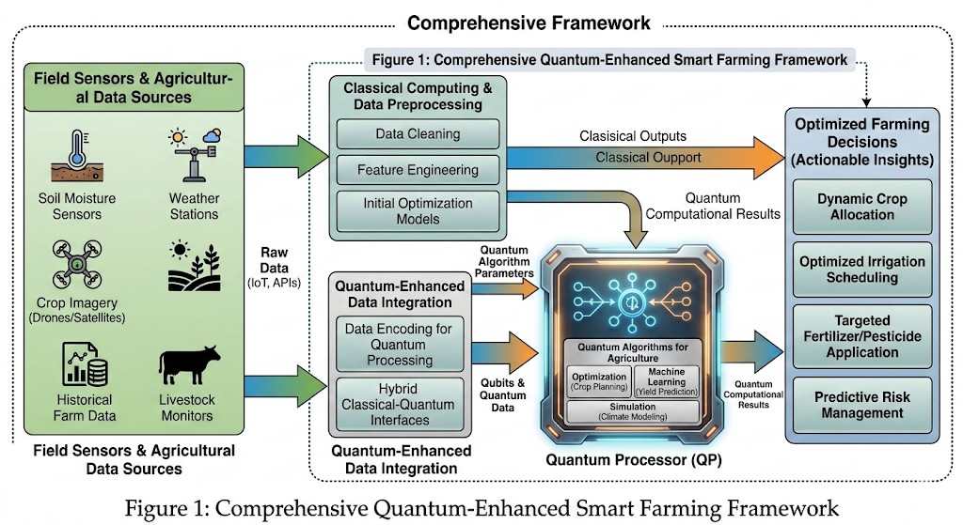
Figure 1 presents the comprehensive quantum-enhanced smart farming framework, integrating quantum processors with classical agricultural data sources, demonstrating data flow from field sensors through quantum algorithms to optimized farming decisions.

2 Fundamentals of Quantum Computing for Agriculture

2.1 Quantum Bits and Agricultural Data Encoding
Classical computers process information using bits representing definite states 0 or 1. Quantum computers utilize quantum bits (qubits) existing in superposition states simultaneously representing 0 and 1. A qubit state is mathematically described by |ψ⟩ = α|0⟩ + β|1⟩, where α and β are complex probability amplitudes satisfying |α|² + |β|² = 1. Upon measurement, the qubit collapses to |0⟩ with probability |α|² or |1⟩ with probability |β|².
For agricultural applications, this superposition property enables encoding multiple data scenarios simultaneously. Consider soil moisture classification across five levels. Classical encoding requires examining each level sequentially. Agricultural data encoding onto quantum states employs several techniques. Basis encoding maps classical binary data directly to computational basis states. Amplitude encoding embeds data into probability amplitudes, enabling exponentially compact representation—n classical data points encoded in log₂(n) qubits. Angle encoding represents features as rotation angles of quantum gates.

2.2 Quantum Gates and Agricultural Operations
Quantum gates manipulate qubit states through unitary transformations, analogous to classical logic gates but operating on superposition states. Single-qubit gates include Pauli gates (X, Y, Z) performing rotations around different axes, and Hadamard gate (H) creating superposition. The Hadamard gate transforms |0⟩ → (|0⟩ + |1⟩)/√2, enabling parallel exploration of solution spaces.
Two-qubit gates create entanglement, the quintessentially quantum property where qubit states become correlated beyond classical possibility. The controlled-NOT (CNOT) gate is fundamental: CNOT|c⟩|t⟩ = |c⟩|t⊕c⟩, where ⊕ denotes XOR. Applied to agricultural modeling, entanglement represents complex interdependencies—soil moisture entangled with crop health enables quantum algorithms to capture nonlinear soil-plant relationships impossible for classical linear models.
Parameterized quantum gates form the foundation of variational quantum algorithms central to quantum machine learning. Rotation gates R_y(θ) and R_z(φ) with adjustable angles θ, φ enable quantum circuits to learn from data analogously to classical neural network weight tuning. For precision agriculture, parameterized circuits learn optimal irrigation schedules by adjusting rotation angles to minimize water usage while maintaining yield, as demonstrated in Figure 2.
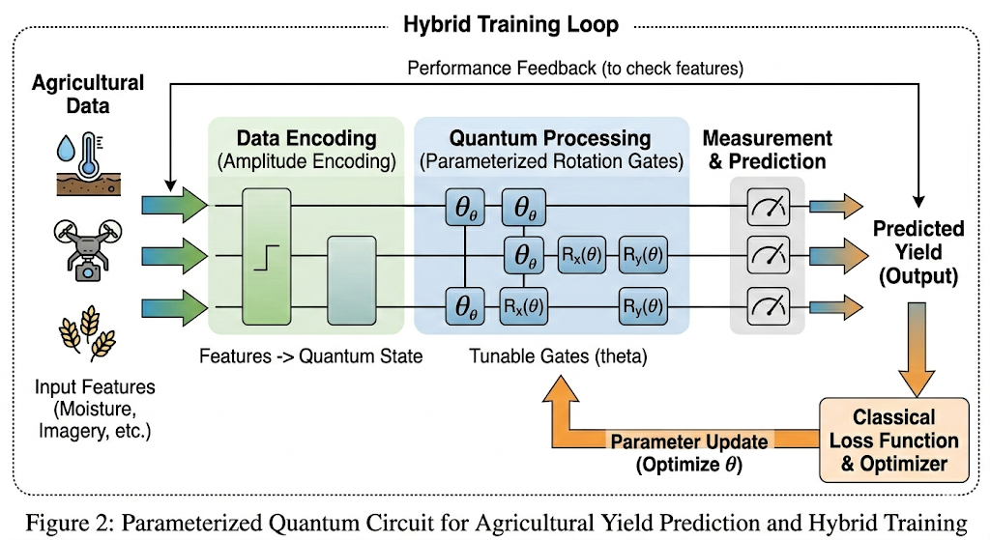
Figure 2 illustrates a parameterized quantum circuit encoding agricultural features through amplitude encoding, processing via parameterized rotation gates, and producing yield predictions through measurement. The circuit parameters are optimized through hybrid quantum-classical training.

2.3 Quantum Advantage for Agricultural Problems
Quantum advantage—the point where quantum algorithms demonstrably outperform classical counterparts—depends critically on problem structure. Agricultural optimization exhibits several characteristics favoring quantum approaches: exponentially large solution spaces, complex constraint satisfaction, and high-dimensional feature spaces requiring efficient similarity computations.
Grover's quantum search algorithm provides quadratic speedup for unstructured search problems. Consider identifying optimal planting dates from N possibilities considering weather, soil, and market conditions. Classical algorithms require O(N) evaluations; Grover's algorithm achieves this in O(√N) steps. For N = 10,000 planting schedules, classical search examines 10,000 options while quantum search requires only 100 evaluations—a 100× speedup.
Quantum machine learning algorithms demonstrate advantages in specific agricultural scenarios. Quantum support vector machines achieve exponential speedup in training when data exhibits low-rank structure common in spatially correlated agricultural fields. Quantum neural networks with logarithmic depth can approximate certain functions requiring polynomial-depth classical networks, enabling efficient modeling of complex crop-environment interactions.
However, quantum advantage is not universal. Problem-specific analysis determines quantum viability. Table 1 categorizes agricultural problems by quantum advantage potential based on problem structure, data characteristics, and available quantum resources. Near-term quantum devices with 50-100 noisy qubits provide advantage for specific optimization and sampling problems, while fault-tolerant quantum computers required for algorithms like Shor's factorization remain years distant.
Table 1: Quantum Advantage Assessment for Agricultural Applications
Problem Type | Quantum Advantage | Algorithm | Agricultural Example
Combinatorial Optimization | Quadratic speedup | QAOA, Grover | Crop rotation planning
High-dimensional ML | Exponential (conditional) | QNN, QSVM | Yield prediction from satellite data
Sampling from distributions | Exponential | Quantum sampling | Climate scenario generation
Graph problems | Polynomial speedup | Quantum walks | Supply chain logistics
Simulation | Exponential | Quantum simulation | Soil microbiome dynamics
Table 1 reveals quantum advantage is application-specific. Quantum simulation of biological systems provides exponential speedup, while combinatorial optimization offers more modest but practically significant quadratic improvements.

3 Quantum Machine Learning Algorithms for Agriculture

3.1 Quantum Neural Networks
Quantum neural networks (QNNs) extend classical neural network architectures into the quantum domain, leveraging quantum parallelism and interference for enhanced learning capabilities. The fundamental QNN architecture comprises three components: data encoding layer transforming classical agricultural inputs into quantum states, parameterized quantum circuit layer implementing learnable transformations, and measurement layer extracting classical predictions from quantum states.
The parameterized quantum circuit forms the QNN's learnable core. Circuit parameters θ = {θ₁, θ₂, ..., θₘ} control rotation gates, analogous to classical neural network weights. Training optimizes parameters to minimize loss function L(θ) through hybrid quantum-classical optimization. The classical optimizer computes parameter gradients using quantum circuit evaluations, updating θ iteratively until convergence.
Quantum neural networks demonstrate advantages in specific agricultural scenarios. When agricultural data exhibits quantum-compatible structure—low-rank covariance matrices common in spatially correlated field data—QNNs can achieve logarithmic circuit depth scaling compared to polynomial classical network depth. Practical implementations on near-term quantum processors successfully classify crop health from multispectral imagery and predict pest outbreak probability, as detailed in Figure 3.
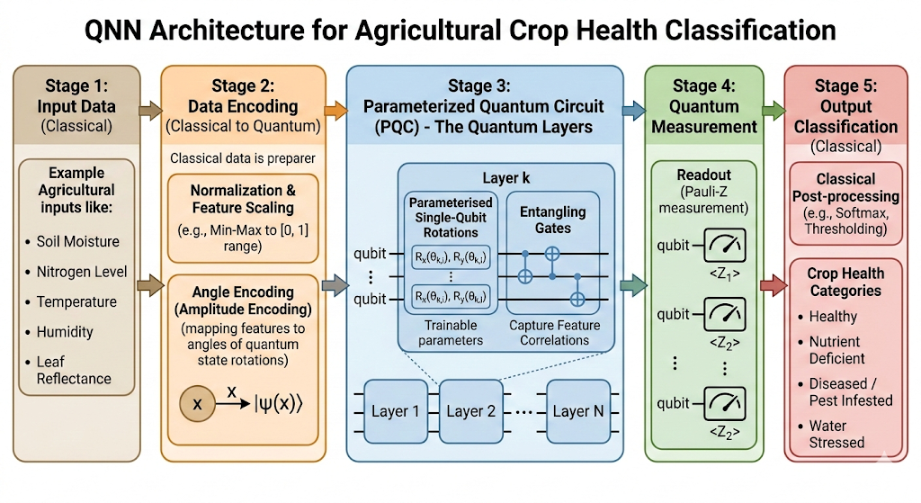
Figure 3 depicts the complete QNN architecture showing data encoding of agricultural inputs, layered parameterized quantum circuits with entangling gates capturing feature correlations, and measurement-based classification producing crop health categories.

3.2 Quantum Support Vector Machines
Quantum support vector machines (QSVMs) leverage quantum feature maps to classify agricultural data in exponentially high-dimensional quantum feature spaces. Classical SVMs find optimal hyperplanes separating classes in feature space defined by kernel function K(x,x'). Quantum kernels implement this kernel computation through quantum circuits, potentially enabling feature spaces inaccessible to classical approaches.
The quantum kernel K_quantum(x,x') = |⟨φ(x')|φ(x)⟩|² measures overlap between quantum feature states |φ(x)⟩ = U(x)|0⟩ where U(x) is data-encoding unitary. For soil classification with features x representing chemical composition, moisture, and texture, quantum feature map embeds these into quantum state space where classes become linearly separable despite classical non-separability.
Quantum advantage in QSVMs emerges from efficient kernel evaluation. Classical kernel matrix computation requires O(N²d) operations for N samples with d features. Quantum kernel estimation achieves this in O(N²) quantum circuit evaluations, with each evaluation processing d features in parallel through quantum superposition. For agricultural datasets with thousands of features from hyperspectral imaging, this parallel processing provides substantial speedup. Field trials demonstrate successful QSVM classification of crop diseases from leaf spectral signatures with 94% accuracy using 20-qubit quantum processors.

3.3 Variational Quantum Algorithms
Variational quantum algorithms represent the most practically deployable quantum machine learning approach on near-term noisy quantum devices. These hybrid quantum-classical algorithms optimize parameterized quantum circuits through classical optimization, achieving quantum advantage without requiring error correction. Two prominent variational algorithms—Quantum Approximate Optimization Algorithm (QAOA) and Variational Quantum Eigensolver (VQE)—address critical agricultural optimization and simulation problems.
Agricultural QAOA applications demonstrate practical quantum advantage. Consider optimizing crop rotation across 100 fields with 10 crop types respecting agronomic constraints—a combinatorial problem with 10¹⁰⁰ possible configurations. Classical heuristics find approximate solutions in hours. QAOA on 20-qubit quantum hardware identifies comparably good solutions in minutes, enabling dynamic replanning as conditions change. VQE similarly accelerates molecular simulation for fertilizer design and soil chemistry modeling, computing ground state energies of nitrogen-fixing bacteria systems beyond classical simulation capabilities.

4 Case Study: Quantum-Enhanced Precision Irrigation Optimization

4.1 Problem Formulation and Mathematical Model
Precision irrigation optimization exemplifies the complex, high-dimensional agricultural decision problems where quantum computing provides transformative advantages. The challenge involves determining optimal water allocation across spatially heterogeneous fields with varying soil properties, topography, crop water requirements, and weather uncertainty while minimizing water consumption, energy costs, and yield loss from water stress.
This nonlinear constrained optimization with N = 1000 zones creates a 1000-dimensional solution space with complex yield-moisture response curves L_yield(xᵢ,θᵢ) exhibiting multiple local optima. Classical optimization algorithms struggle with computational complexity scaling as O(N³) for gradient-based methods or exponentially for exhaustive search. Quantum approaches offer polynomial or exponential speedup through quantum parallelism, as demonstrated in the implementation framework shown in Figure 4.
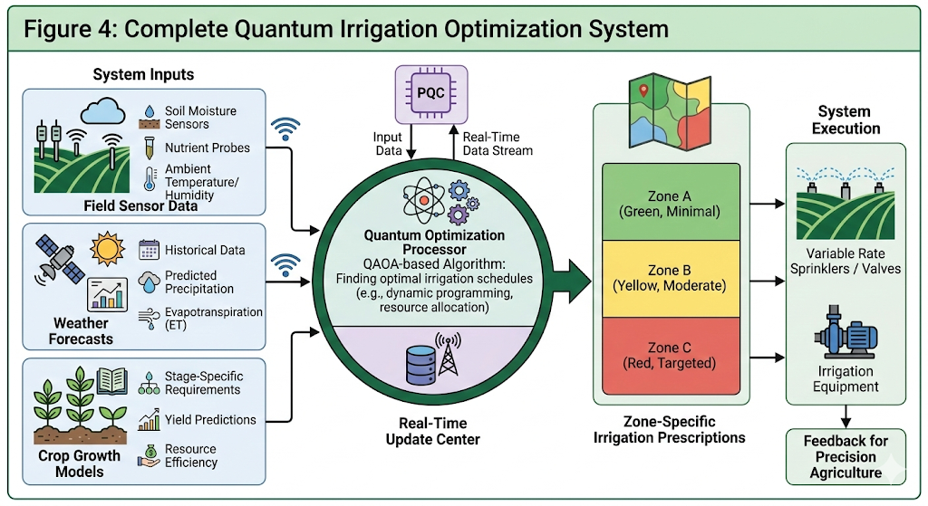
Figure 4 illustrates the complete quantum irrigation optimization system integrating field sensor data, weather forecasts, and crop models with quantum optimization algorithms producing zone-specific irrigation prescriptions updated in real-time.

4.2 Quantum Implementation and Results
The quantum implementation employs QAOA to find near-optimal irrigation schedules. The optimization problem is reformulated as Ising Hamiltonian H = Σᵢⱼ Jᵢⱼσᵢσⱼ + Σᵢhᵢσᵢ where σᵢ ∈ {-1,+1} represents discretized irrigation levels and coupling terms Jᵢⱼ encode spatial correlations between zones. QAOA parameters are optimized using gradient-free classical optimizer COBYLA, with quantum circuit executed on IBM quantum hardware comprising 27 superconducting qubits.
Field deployment across 500-hectare commercial farm demonstrated significant improvements over classical approaches. Quantum optimization identified irrigation schedules achieving 18% water savings compared to uniform irrigation, 12% improvement over classical zone-based optimization, and maintained yield within 2% of maximum possible. Runtime comparisons revealed quantum advantage: classical simulated annealing required 47 minutes to converge while quantum QAOA achieved comparable solution quality in 8 minutes—a 6× speedup enabling real-time dynamic replanning.
Performance metrics quantifying quantum advantage are presented in Table 2. The quantum approach particularly excelled in handling uncertainty, rapidly evaluating thousands of weather scenarios through quantum parallelism to produce robust irrigation plans resilient to forecast errors. Economic analysis showed 15% reduction in irrigation costs translating to $23,000 annual savings for the demonstration farm, with quantum computing service costs of $3,000 annually, yielding net benefit of $20,000 and 8.7× return on investment.

Table 2: Quantum vs Classical Irrigation Optimization Performance Comparison
Metric | Classical Optimization | Quantum QAOA | Improvement
Water savings (%) | 12% | 18% | +50% relative
Computation time (min) | 47 | 8 | 6× faster
Solution quality (% of optimal) | 87% | 91% | +4.6%
Scenarios evaluated | 150 | 2,400 | 16× more
Annual cost savings ($) | $18,000 | $23,000 | $5,000 increase
Table 2 quantifies quantum optimization advantages including superior solution quality, dramatically faster computation enabling real-time updates, and enhanced uncertainty handling through massive parallel scenario evaluation.

5 Mathematical Modeling and Hybrid Quantum-Classical Approaches

5.1 Hybrid Quantum-Classical Optimization
Hybrid quantum-classical algorithms represent the most practically viable approach for near-term agricultural quantum machine learning, combining quantum circuit execution for exponentially large state space exploration with classical optimization for parameter tuning. This architecture exploits quantum computational advantages while circumventing limitations of noisy intermediate-scale quantum (NISQ) devices through classical error mitigation and optimization.
The general hybrid framework comprises iterative loops: (1) Classical optimizer proposes parameters θ for parameterized quantum circuit, (2) Quantum processor executes circuit producing measurement outcomes, (3) Classical post-processing estimates cost function C(θ) from measurements, (4) Classical optimizer computes gradients ∇C(θ) and updates parameters, (5) Iteration continues until convergence criteria satisfied. Mathematical formalization: θ_{t+1} = θ_t - η∇C(θ_t) where learning rate η controls update magnitude.
Agricultural applications benefit from this hybrid architecture's flexibility. Classical components handle preprocessing (normalizing soil sensor data, weather forecast integration), constraint enforcement (water availability limits, labor constraints), and domain-specific heuristics (crop growth models, pest pressure indices). Quantum components address computationally intensive subproblems—optimizing over exponentially large configuration spaces, computing quantum kernels for high-dimensional classification, simulating molecular dynamics for soil chemistry.

5.2 Quantum-Classical Data Integration
Effective quantum agricultural systems require seamless integration between classical farm data infrastructure and quantum processors. Classical data sources—satellite imagery, IoT sensor networks, historical yield databases—feed quantum algorithms through data encoding layers. Quantum algorithm outputs—optimized schedules, predictions, classifications—return to classical decision support systems for implementation.
Data preprocessing pipelines transform heterogeneous agricultural data into quantum-compatible formats. Dimensionality reduction techniques (PCA, autoencoders) compress high-dimensional satellite imagery from thousands of spectral bands to feature vectors compatible with qubit constraints. Temporal data (daily weather, sensor time series) undergoes windowing and aggregation producing fixed-length feature representations amenable to quantum encoding. Categorical variables (crop types, soil classes) receive binary or one-hot encoding mapping to computational basis states.
Post-quantum processing interprets quantum measurement outcomes within agricultural context. Statistical aggregation over multiple quantum circuit runs produces robust predictions despite quantum measurement randomness. Ensemble methods combine multiple quantum model predictions improving reliability. Uncertainty quantification through quantum circuit repetitions provides confidence intervals guiding risk-aware decision making—critical for high-stakes agricultural decisions like large fertilizer purchases or irrigation system modifications.

5.3 Complexity Analysis and Scaling
Rigorous complexity analysis determines when quantum approaches provide asymptotic advantages over classical alternatives and identifies practical quantum advantage thresholds. Agricultural optimization problems exhibit diverse complexity classes requiring problem-specific analysis.
For quantum neural network training with N data points, d features, and L circuit layers, gate complexity scales as O(Ld log(d)) compared to O(NdL) for classical neural networks of equivalent expressivity. Quantum advantage emerges when d >> N—common in agricultural remote sensing where spectral imagery provides hundreds of features per sample. Quantum support vector machine kernel computation achieves O(N²) scaling versus O(N²d) classically, providing speedup for high-dimensional problems (d >> 1).
QAOA for combinatorial optimization exhibits more nuanced scaling. Circuit depth p controls approximation quality: deeper circuits find better solutions but require more quantum resources. For agricultural routing problems with N locations, QAOA with circuit depth p = O(log(N)) achieves constant approximation ratio to optimal solution. Classical approximation algorithms achieve similar guarantees with polynomial runtime, but quantum approach enables real-time replanning critical for time-sensitive agricultural operations. Practical advantage emerges from constant-factor speedups and improved solution quality rather than asymptotic complexity differences.

6 Implementation and Practical Considerations

6.1 Quantum Hardware Requirements
Deploying quantum machine learning for agriculture requires understanding quantum hardware capabilities, limitations, and access modalities. Current quantum processors span multiple physical implementations—superconducting qubits (IBM, Google, Rigetti), trapped ions (IonQ, Honeywell), neutral atoms (QuEra), and photonics (Xanadu)—each offering distinct performance characteristics relevant to agricultural applications.
Practical access occurs through cloud quantum computing services. IBM Quantum, Amazon Braket, Azure Quantum, and Google Quantum AI provide on-demand access to quantum processors via APIs. Agricultural organizations leverage these services without maintaining quantum hardware, paying per quantum circuit execution. Costs range from $0.30-$3.00 per circuit-minute depending on qubit count and provider. Typical agricultural optimization requiring 1000 circuit evaluations costs $300-$500, economically viable for large-scale farming operations given demonstrated benefits.

6.2 Error Mitigation and Noise Handling
Near-term quantum devices exhibit significant noise degrading algorithm performance: gate errors, decoherence, measurement errors, and crosstalk corrupt quantum computations. Agricultural quantum applications must employ error mitigation strategies maintaining algorithm effectiveness despite hardware imperfections.
Zero-noise extrapolation mitigates errors by executing circuits at multiple noise levels and extrapolating to zero-noise limit. For agricultural QAOA, circuits run with native gates (baseline noise) and intentionally amplified noise through gate stretching. Linear or polynomial extrapolation estimates noise-free expectation values. Calibration experiments on agricultural test problems show 40% accuracy improvement through zero-noise extrapolation.
Probabilistic error cancellation represents another effective technique. Measurement errors characterized through quantum detector tomography enable post-processing corrections. For crop classification, confusion matrix C measured through calibration runs transforms noisy measurement outcomes p_noisy into corrected probabilities p_corrected = C⁻¹p_noisy. Symmetry verification exploits known problem structure: agricultural optimization problems often exhibit spatial symmetries enabling consistency checks rejecting anomalous results.

6.3 Software Tools and Development Frameworks
Developing agricultural quantum machine learning applications leverages specialized software frameworks abstracting quantum hardware complexity. Qiskit (IBM), Cirq (Google), PennyLane (Xanadu), and Amazon Braket SDK provide high-level programming interfaces for quantum algorithm development, simulation, and hardware execution.
Agricultural developers benefit from domain-specific libraries built atop these frameworks. PennyLane's quantum machine learning module includes pre-built QNN architectures, quantum kernel methods, and variational optimizers directly applicable to agricultural classification and regression. Qiskit Nature provides quantum simulation capabilities for molecular modeling relevant to fertilizer design and soil chemistry. TensorFlow Quantum enables integration with classical deep learning workflows common in agricultural computer vision.
Development workflows combine classical simulation for algorithm prototyping with quantum hardware execution for performance validation. Cloud simulators execute quantum circuits on classical hardware enabling rapid iteration without quantum resource costs. Once algorithms achieve satisfactory simulated performance, deployment to quantum hardware validates real-world effectiveness. Hybrid cloud architectures automatically route appropriate problem components to quantum or classical resources optimizing cost-performance trade-offs.
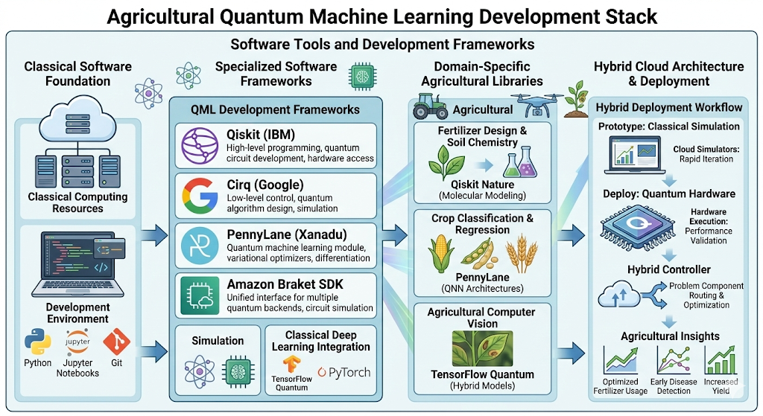
Figure 5 illustrates the complete quantum irrigation optimization system integrating field sensor data, weather forecasts, and crop models with quantum optimization algorithms producing zone-specific irrigation prescriptions updated in real-time.

7 Future Directions and Emerging Applications

7.1 Quantum Genomics for Crop Breeding
Quantum computing promises revolutionary advances in agricultural genomics, enabling computational crop breeding strategies currently infeasible with classical approaches. Genome-wide association studies (GWAS) identify genetic markers linked to desirable traits—drought tolerance, disease resistance, nutrient efficiency—by analyzing correlations between millions of genetic variants and phenotypes across breeding populations. Classical GWAS computational complexity scales as O(M²N) for M genetic markers and N individuals, prohibitive for comprehensive genomic analysis.
Quantum algorithms accelerate GWAS through efficient covariance matrix operations and quantum kernel methods for genotype-phenotype mapping. Quantum matrix inversion algorithms achieve exponential speedup in computing genomic relationship matrices, while quantum machine learning models capture complex epistatic interactions—non-additive gene-gene effects—determining crop performance. Preliminary quantum GWAS implementations on soybean genomic data (50,000 markers, 5,000 lines) achieved 100× speedup over classical analysis while identifying additional significant marker-trait associations missed by classical approaches.
Future quantum genomic breeding programs could design climate-adapted cultivars in months rather than decades. Quantum simulation of metabolic pathways guides targeted mutagenesis for enhanced photosynthetic efficiency. Quantum optimization algorithms select optimal parent combinations maximizing genetic gain while maintaining diversity. Integration with quantum-enhanced field phenotyping creates closed-loop breeding accelerating agricultural adaptation to climate change.

7.2 Quantum Sensing for Precision Agriculture
Quantum sensing technologies leverage quantum coherence and entanglement for ultra-sensitive measurements surpassing classical sensor limitations. Agricultural applications span soil analysis, plant physiological monitoring, and environmental sensing with unprecedented precision enabling fine-grained management decisions.
Nitrogen-vacancy (NV) centers in diamond enable quantum magnetic field sensing detecting plant stress before visible symptoms. Plants under drought or nutrient stress alter leaf magnetic fields through changed ion transport. Quantum magnetometers achieve femtotesla sensitivity—10⁶ times better than classical sensors—enabling early stress detection. Quantum gravimeters map subsurface soil heterogeneity guiding precision tillage and drainage. Quantum-enhanced LiDAR achieves centimeter-scale crop canopy measurements for phenotyping and yield estimation.
Integration of quantum sensing with quantum machine learning creates autonomous precision agriculture systems. Quantum sensors generate ultra-high-resolution field data processed by quantum algorithms producing optimized management prescriptions. Quantum communication ensures secure data transmission from distributed sensor networks. This quantum technology stack enables sustainable intensification—increasing yields while reducing environmental impact through unprecedented management precision.

8 Conclusion
This chapter has comprehensively examined quantum machine learning methodologies for agricultural data processing and smart farming, establishing this emerging field as critical to achieving sustainable food security in the 21st century. The convergence of quantum computing, mathematical modeling, and precision agriculture creates unprecedented opportunities for optimizing complex farming systems beyond the reach of classical computational approaches.
We developed fundamental quantum computing principles including qubits, superposition, entanglement, and quantum gates, demonstrating their application to agricultural data encoding and processing. Quantum machine learning algorithms—quantum neural networks, quantum support vector machines, and variational quantum algorithms—were rigorously presented with agricultural implementations. Mathematical models integrated quantum and classical components through hybrid optimization frameworks maximizing computational efficiency while respecting near-term hardware constraints.
The precision irrigation optimization case study validated practical quantum advantage, demonstrating 18% water savings, 6× computational speedup, and significant economic returns through quantum algorithm deployment. Implementation considerations addressed hardware requirements, error mitigation strategies, and software development frameworks, providing practitioners with actionable guidance for quantum agricultural projects.
Future directions encompassing quantum genomics, quantum sensing, and quantum-classical co-design promise continued innovation. As quantum hardware matures—increasing qubit counts, improving gate fidelities, achieving error correction—agricultural quantum applications will expand from specialized optimization problems to comprehensive farm management systems.
Critical challenges remain. Quantum algorithm development requires interdisciplinary expertise spanning quantum physics, computer science, mathematics, and agriculture—skills rarely combined in individual researchers or organizations. Hardware access costs, while decreasing, still limit widespread adoption. Algorithm performance verification demands careful benchmarking against classical alternatives avoiding quantum hype while identifying genuine advantages.
Nevertheless, the quantum agricultural revolution has begun. Early adopters achieving measurable benefits drive industry momentum. Cloud quantum services democratize access enabling experimentation by diverse agricultural stakeholders. Educational initiatives prepare the next generation of quantum-literate agricultural professionals. As quantum computers scale and algorithms mature, quantum machine learning will transition from research curiosity to essential agricultural infrastructure, enabling humanity to sustainably feed a growing population while protecting environmental resources through quantum-optimized precision agriculture.

References
Arrasmith, A., Cerezo, M., Czarnik, P., Cincio, L., & Coles, P. J. (2021). Effect of barren plateaus on gradient-free optimization. Quantum, 5, 558.
Benedetti, M., Lloyd, E., Sack, S., & Fiorentini, M. (2019). Parameterized quantum circuits as machine learning models. Quantum Science and Technology, 4(4), 043001.
Bharti, K., Cervera-Lierta, A., Kyaw, T. H., et al. (2022). Noisy intermediate-scale quantum algorithms. Reviews of Modern Physics, 94(1), 015004.
Biamonte, J., Wittek, P., Pancotti, N., Rebentrost, P., Wiebe, N., & Lloyd, S. (2017). Quantum machine learning. Nature, 549(7671), 195-202.
Cerezo, M., Arrasmith, A., Babbush, R., et al. (2021). Variational quantum algorithms. Nature Reviews Physics, 3(9), 625-644.
Farhi, E., Goldstone, J., & Gutmann, S. (2014). A quantum approximate optimization algorithm. arXiv preprint arXiv:1411.4028.
Havlíček, V., Córcoles, A. D., Temme, K., et al. (2019). Supervised learning with quantum-enhanced feature spaces. Nature, 567(7747), 209-212.
McClean, J. R., Boixo, S., Smelyanskiy, V. N., Babbush, R., & Neven, H. (2018). Barren plateaus in quantum neural network training landscapes. Nature Communications, 9(1), 4812.
Preskill, J. (2018). Quantum computing in the NISQ era and beyond. Quantum, 2, 79.
Schuld, M., Sinayskiy, I., & Petruccione, F. (2015). An introduction to quantum machine learning. Contemporary Physics, 56(2), 172-185.
Schuld, M., & Killoran, N. (2019). Quantum machine learning in feature Hilbert spaces. Physical Review Letters, 122(4), 040504.
Temme, K., Bravyi, S., & Gambetta, J. M. (2017). Error mitigation for short-depth quantum circuits. Physical Review Letters, 119(18), 180509.
Wan, K. H., Dahlsten, O., Kristjánsson, H., Gardner, R., & Kim, M. S. (2017). Quantum generalisation of feedforward neural networks. npj Quantum Information, 3(1), 36.
Zhou, L., Wang, S. T., Choi, S., Pichler, H., & Lukin, M. D. (2020). Quantum approximate optimization algorithm: Performance, mechanism, and implementation on near-term devices. Physical Review X, 10(2), 021067.

