Project Report

On

[**Project Name**]

[Application Type]

Using [Tech Stack]

[logo]

Designed and Developed

By

**Mr. [Your Name]**

TYBSc CS [Rollno]

2022-2023

And Guided By

Prof [Guide Name]

Submitted in partial fulfillment of academic project

[Bachelor of Computer Science]

University of Mumbai



**DEPARTMENT OF COMPUTER SCIENCE**

Class: TYBSc                                                                                                        Roll. No.  40

                                                                                                                               Seat No._______

**Certificate**

Certified that **Sayyed Salman** of T.Y.BSc Semester-VI has

successfully completed the project as prescribed by the University of

Mumbai on **FireChat** as partial fulfillment of requirement for completing

Bachelor’s Degree in Computer Science during the academic year 2022-2023.

Signature of Project Guide

Date: ________________

Signature of Examiner

Date: ______________

                   H.O.D

Dept. of Computer Science

**ACKNOWLEDGEMENT**

I would also like to extend my appreciation to all the faculty members of the Computer Science department who have played a vital role in shaping my academic career. Their insightful guidance, valuable feedback, and constructive criticism have been instrumental in enabling me to develop a better understanding of the subject matter and to enhance my problem-solving skills.

I would like to express my gratitude to my classmates who have been a constant source of motivation and support throughout the project. Their valuable inputs and suggestions have helped me to refine my ideas and to improve the quality of my work.

I would like to thank my friends and colleagues for their encouragement and support during the project. Their unwavering belief in my abilities and their willingness to lend a helping hand whenever needed have been crucial in keeping me motivated and focused.

I would like to acknowledge the invaluable support and assistance provided by the staff of the Royal College of Arts, Commerce & Science. Their cooperation and prompt response to my requests have made the project a smooth and hassle-free experience.

I would also like to extend my heartfelt thanks to Prof. [**Anushka Padhye**], who has been a constant source of inspiration, guidance, and support throughout the project. Her unwavering faith in my abilities and her constructive feedback have been instrumental in shaping my ideas and refining my work. Her invaluable inputs and suggestions have helped me to develop a better understanding of the subject matter and to enhance my skills.

I would also like to express my gratitude to the entire Computer Science department for their support and encouragement during the project. Their expertise and experience have been invaluable in helping me to overcome challenges and to achieve my goals. Their willingness to share their knowledge and to provide me with the resources I needed has been crucial in enabling me to complete this project successfully.

I would like to thank my family for their unwavering support, motivation, and encouragement throughout the project. Their belief in me and their constant encouragement have been my guiding light, and I could not have completed this project without their love and support. Their sacrifices and unwavering faith in me have been the cornerstone of my success, and I am truly grateful to them for everything they have done for me.

Finally, I would like to thank the almighty for blessing me with the strength, perseverance, and determination to complete this project successfully. Without His grace and guidance, this accomplishment would not have been possible.

**Salman Sayyed**

**DECLARATION**

I, Mr.[Salman Sayyed] hereby confirm that the project titled "Design and Implementation of ChemBreak" is the result of my independent work and that I have not used any unauthorized assistance or material in the completion of this project. The project has been undertaken as part of my course curriculum for the Bachelor's Degree in Computer Science at Mumbai University.

Throughout the project, I have personally designed the system architecture, developed the programming logic, and performed the required testing and validation. I have made sure to incorporate all the necessary features and functionalities required to meet the project objectives and to ensure a seamless user experience.

Moreover, I acknowledge that the project may require modifications in the future as per the user's requirements or due to changes in the technological landscape. In this regard, I have incorporated flexibility in the system design to enable any necessary modifications or updates. I am confident that I can make the required changes by modifying the file design or the program code, if necessary, to ensure the system's continued smooth operation.

I would also like to state that I have taken all necessary precautions to ensure that the system design and implementation are secure and comply with industry standards. I have followed best practices in data protection, authentication to ensure that user data remains secure and confidential.

I have developed a deep understanding of the system's underlying technology and functionality throughout the project's development, and I am confident that I can handle any modifications or updates that may be required in the future. I have created the system with a modular and scalable design, enabling me to incorporate changes or enhancements without disrupting the system's overall functioning.

Finally, I affirm that this project report represents my own work, and all sources used have been duly cited and referenced. Any resemblance to other works is purely coincidental.

**Index**

**INDEX**

|  |  |  |
| --- | --- | --- |
| **Sr no** | **Topic** | **Page no** |
| 1. | Introduction |  |
| 2. | Proposed System and Advantages |  |
| 3. | System Requirements |  |
| 4. | Phase Title |  |
| 5. | Gantt Chart |  |
| 6. | Class Diagram |  |
| 7. | Event Table |  |
| 8. | Use Case Diagram |  |
| 9. | Sequence Diagram |  |
| 10. | System Coding |  |
| 11. | Snapshots |  |
| 12. | Future Enhancements |  |
| 13. | Reference and Bibliography |  |

**Preliminary**

**Investigation**

**Introduction**

Chembreak is a modern and innovative app designed to streamline the process of recording and managing damages that occur in chemistry laboratories. The primary objective of Chembreak is to provide a comprehensive and efficient solution to manage breakage reports, record incidents of broken apparatus and charge the respective students in an automated way. The app is an essential tool that eliminates the need for manual documentation of incidents, reduces the workload on lab staff, and ensures a smooth and efficient workflow in the lab.

The need for Chembreak arises from the increasing frequency of damages that occur in chemistry labs and the cumbersome process of managing the records. Chembreak simplifies the task of documentation by providing a user-friendly interface that enables users to create, manage, and share breakage reports in real-time. With Chembreak, lab staff can easily track and monitor breakages, identify the culprits responsible for the damages and charge them accordingly. Moreover, the app generates comprehensive reports that help in analyzing trends and identifying areas of improvement. In summary, Chembreak is an essential tool for any chemistry lab that seeks to enhance its efficiency and productivity by automating the process of managing breakages.

**Proposed System and Advantages**.

Chembreak is a digital solution that simplifies the process of recording and managing damages that occur in chemistry labs. The app is designed to replace the traditional pen-and-paper method of documenting breakages and incidents. Chembreak allows users to record incidents of broken apparatus and generate breakage reports with just a few clicks. The app also automates the process of charging students for damages, eliminating the need for manual calculations and record-keeping. With Chembreak, lab staff can easily monitor and manage breakages in real-time, ensuring a smooth workflow and efficient operation of the lab.

Advantages of Chembreak:

1) Improved Efficiency: Chembreak streamlines the process of recording and managing breakages, reducing the workload on lab staff and enhancing the overall efficiency of the lab.

2) Real-time Monitoring: With Chembreak, lab staff can monitor breakages in real-time, ensuring that damages are quickly identified and addressed.

3) Automated Charging: Chembreak automates the process of charging students for damages, eliminating the need for manual calculations and record-keeping.

4) Comprehensive Reporting: The app generates comprehensive reports that help in analyzing trends and identifying areas of improvement.

5) User-friendly Interface: Chembreak has a user-friendly interface that enables users to create, manage, and share breakage reports with ease.

6) Cost-effective: Chembreak is a cost-effective solution that eliminates the need for manual documentation and record-keeping, reducing the overall operational costs of the lab.

In summary, Chembreak is a modern and innovative solution that enhances the efficiency and productivity of chemistry labs by automating the process of managing breakages. With its real-time monitoring, automated charging, and comprehensive reporting, Chembreak is a valuable tool that simplifies the task of documentation and enhances the overall performance of the lab.

**System Requirements**.

Hardware:

* Processor: 1.5 GHz or higher
* RAM: 2 GB or higher
* Storage: 50 MB or more free disk space

Software:

* Operating System: Any platform that supports Python3, such as Windows, Linux, or macOS
* Python: Version 3.6 or higher
* Flask: Version 2.0.2 or higher
* SQLAlchemy: Version 1.4.0 or higher
* SQLite: Version 3.36.0 or higher

Other Required Libraries:

* Jinja2: Version 3.0.1 or higher
* WTForms: Version 3.0.0 or higher
* Flask-WTF: Version 1.0.0 or higher
* Werkzeug: Version 2.0.2 or higher

Cloud Hosting:

* Any cloud hosting platform that supports Python applications and SQLite databases, such as Amazon Web Services, Google Cloud Platform, or Microsoft Azure.

TYBSC Computer Science Semester 6

2022 -2023

|  |  |  |  |
| --- | --- | --- | --- |
| **Phase Title** | **Expected Date of Completion** | **Actual Time of Completion with Guide’s Signature** | **Remarks** |
| **I. Preliminary Investigation** |  |  |  |
| (i) Organizational Overview |  |  |  |
| (ii) Present System and its advantages | 10/12/2022 |  |  |
| (iii) System Requirements |  |  |  |
| (iv) Feasibility Study |  |  |  |
| (v) Fact Finding Methods |  |  |  |
| (vi) Phase Title | 20/12/2022 |  |  |
| (vii) Gantt Chart |  |  |  |
| **II. System Analysis** |  |  |  |
| (i) Event Table |  |  |  |
| (ii) Use Case Diagram | 09/01/2023 |  |  |
| (iii) ERD |  |  |  |
| (iv) Class Diagram |  |  |  |
| **III. System Design** |  |  |  |
| (i) Sequence Diagram |  |  |  |
| **IV. System Coding** |  |  |  |
| (i) System Coding | 06/02/2023 |  |  |
| (ii) Form Layouts |  |  |  |
| (iii) Report Layouts |  |  |  |
| **V. Future Enhancements** |  |  |  |
| **VI. Reference and Bibliography** | 20/03/2023 |  |  |

Student Name: Sayyed Salman Roll no: 40

**Gantt Chart**

|  |  |  |  |  |  |  |  |  |  |  |  |  |  |  |  |  |  |  |
| --- | --- | --- | --- | --- | --- | --- | --- | --- | --- | --- | --- | --- | --- | --- | --- | --- | --- | --- |
| **TYBSc Computer Science Semester 6 Project Gantt Chart** | | | | **Time Requirement** | | Year 2019 - 20 | | | | | | | | | | | | |
| Weeks | | | | | | | | | | | | |
| December | | January | | | | February | | | | March | | |
| W3 | W4 | W1 | W2 | W3 | W4 | W1 | W2 | W3 | W4 | W1 | W2 | W3 |
| **I** | **Preliminary Investigation** | | | Estimated | |  |  |  |  |  |  |  |  |  |  |  |  |  |
| Actual | |  |  |  |  |  |  |  |  |  |  |  |  |  |
| **II** | **Requirement Gathering** | | | Estimated | |  |  |  |  |  |  |  |  |  |  |  |  |  |
| Actual | |  |  |  |  |  |  |  |  |  |  |  |  |  |
| **III** | **System Analysis** | | | Estimated | |  |  |  |  |  |  |  |  |  |  |  |  |  |
| Actual | |  |  |  |  |  |  |  |  |  |  |  |  |  |
| **IV** | **System Design** | | | Estimated | |  |  |  |  |  |  |  |  |  |  |  |  |  |
| Actual | |  |  |  |  |  |  |  |  |  |  |  |  |  |
| **V** | **System Coding** | | | Estimated | |  |  |  |  |  |  |  |  |  |  |  |  |  |
| Actual | |  |  |  |  |  |  |  |  |  |  |  |  |  |
| **VI** | **Testing** | | | Estimated | |  |  |  |  |  |  |  |  |  |  |  |  |  |
| Actual | |  |  |  |  |  |  |  |  |  |  |  |  |  |
| **VII** | **Implementation** | | | Estimated | |  |  |  |  |  |  |  |  |  |  |  |  |  |
| Actual | |  |  |  |  |  |  |  |  |  |  |  |  |  |
| **VIII** | **Deployment** | | | Estimated | |  |  |  |  |  |  |  |  |  |  |  |  |  |
| Actual | |  |  |  |  |  |  |  |  |  |  |  |  |  |
|  |  |  |  | |  |  |  |  |  |  |  |  |  |  |  |  |  |  |  |  |
|  | Estimated |  | |  | |  |  |  |  |
|  | Actual |  | |  | |  |  |  |  |

**System Analysis**

**Class Diagram**

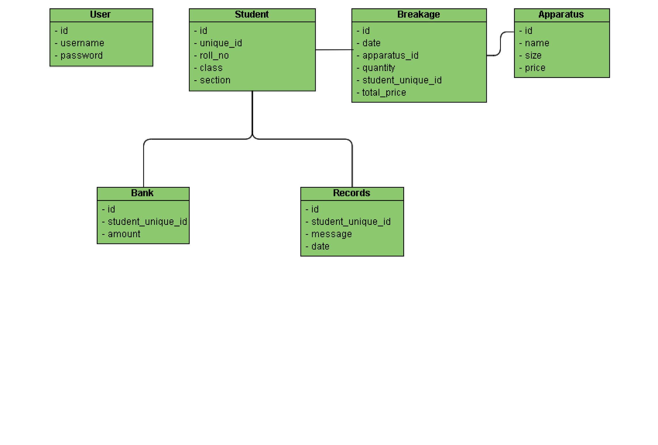

**Event Table**

|  |  |  |
| --- | --- | --- |
| **Event Id** | **Event Name** | **Description** |
| 1 | User Login | A user has logged into the  application. |
| 2 | Apparatus Created | A new apparatus has been added to the system |
| 3 | Apparatus Edited | An existing apparatus has been edited in the system |
| 4 | Apparatus Deleted | An existing apparatus has been deleted from the system |
| 5 | Breakage Added | A new breakage has been recorded for a specific apparatus. |
| 6 | Report Printed | A specific report has been printed by a user of the system |

**Use Case**

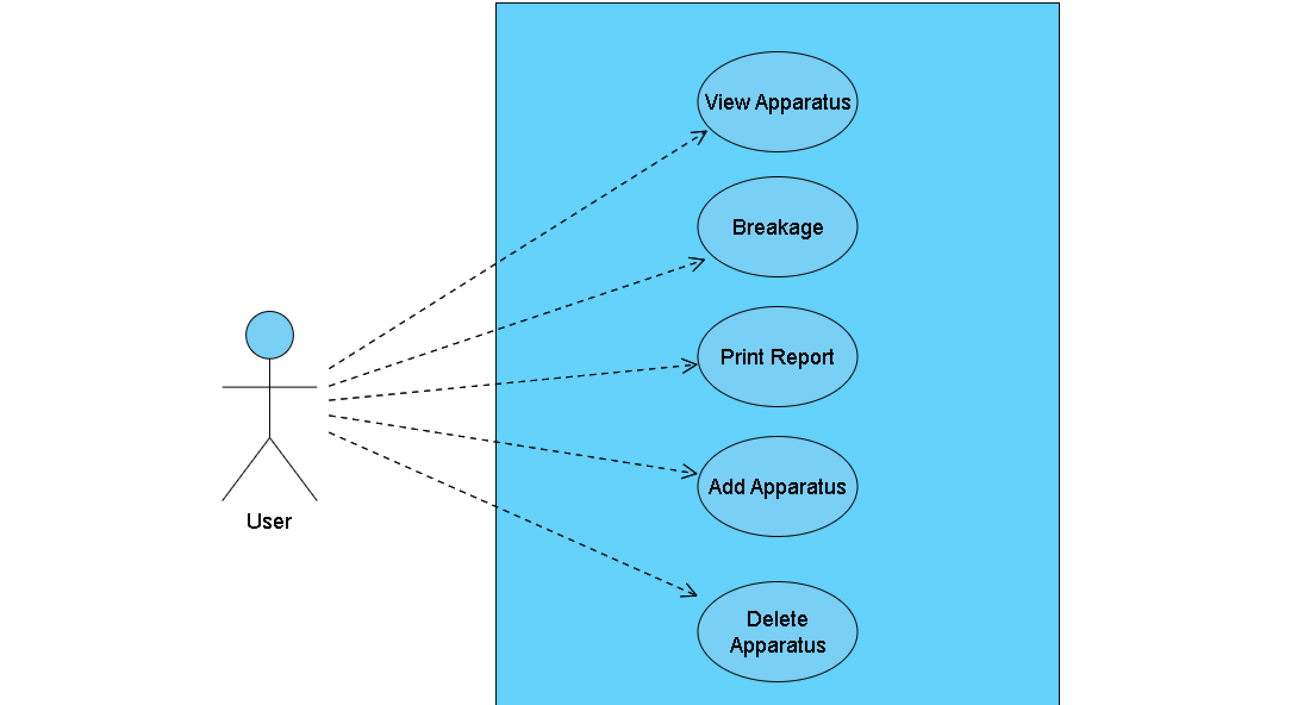

**System Design**

**Sequence Diagram**

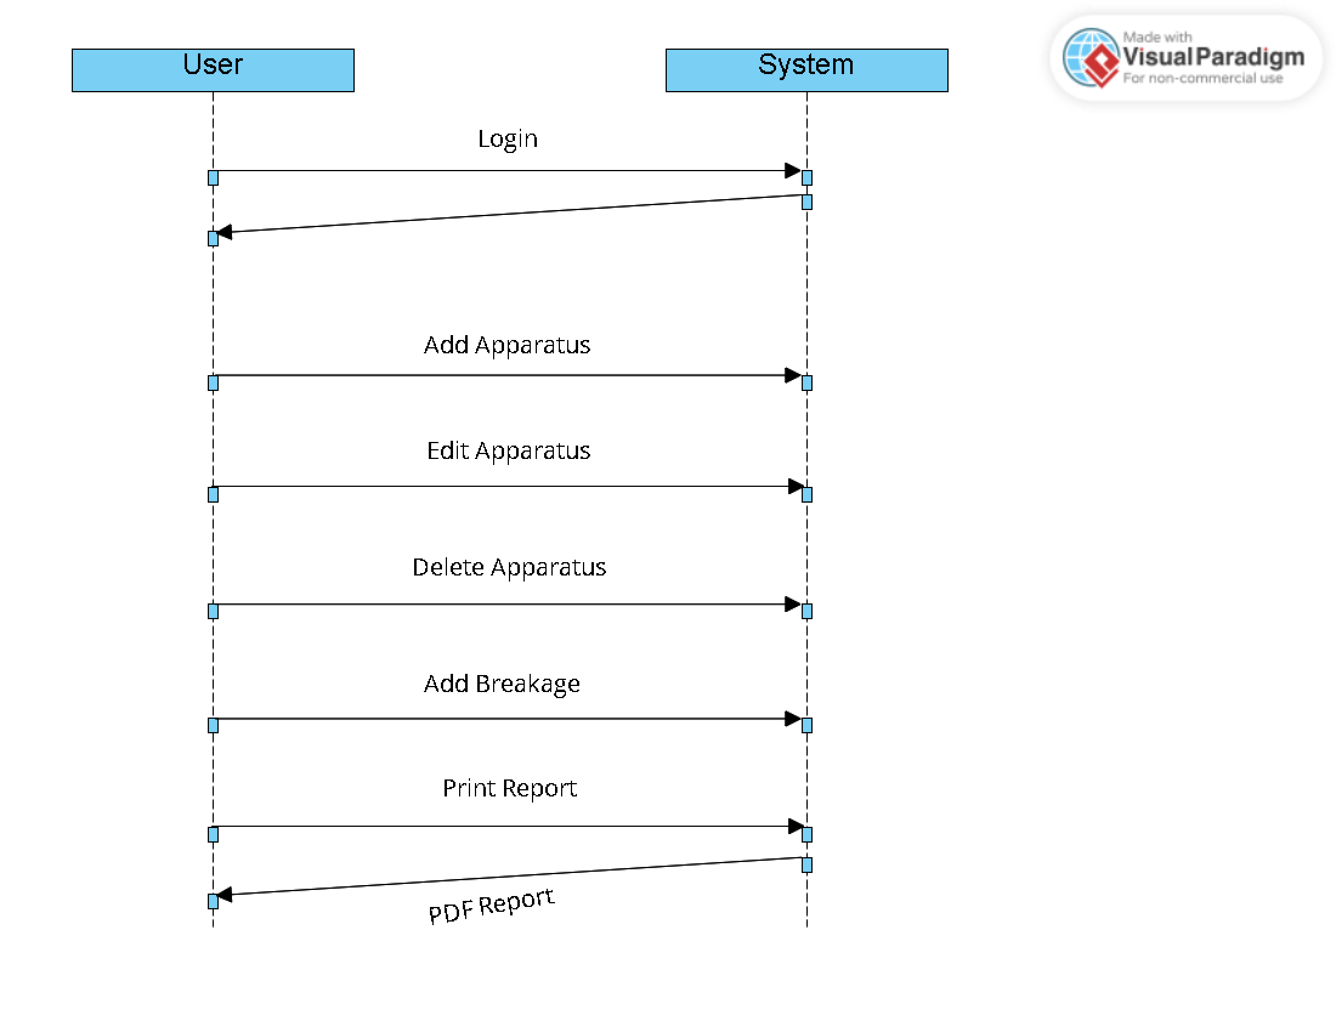

**System Coding**

**Wsgi.py**

from app import create_app

from config import Config

app = create_app(config=Config)

if __name__ == '__main__':

app.run()

app/__init__.py

from flask import Flask

from flask_sqlalchemy import SQLAlchemy

from flask_login import LoginManager

db = SQLAlchemy()

def create_app(config=None):

app = Flask(__name__)

if config:

app.config.from_object(config)

db.init_app(app)

login_manager = LoginManager()

login_manager.login_view = 'auth.login'

login_manager.init_app(app)

with app.app_context():

from app.models import User, Breakage, Student, Apparatus, Record, Bank

db.create_all()

from app.models import User

@login_manager.user_loader

def load_user(user_id):

return User.query.get(int(user_id))

# register blueprints

from .auth import auth as auth_blueprint

app.register_blueprint(auth_blueprint)

from .routes import main as main_blueprint

app.register_blueprint(main_blueprint)

return app

**app/models.py**

from app import db

from flask_login import UserMixin

from datetime import datetime

class User(db.Model, UserMixin):

"""

User Model for authentication

parms:

id: user id

username: user name

password: user password

"""

id = db.Column(db.Integer, primary_key=True)

username = db.Column(db.String(15), unique=True, nullable=False)

password = db.Column(db.String(80), nullable=False)

def __repr__(self):

return f"User('{self.username}')"

def check_password(self, password):

return self.password == password

class Breakage(db.Model):

"""

Breakage Model

parms:

id: breakage id

date: date of breakage

item_id: item that broke (apparatus id)

quantity: quantity of item that broke

student_unique_id: student unique id

"""

__tablename__ = "breakage"

id = db.Column(db.Integer, primary_key=True)

date = db.Column(db.DateTime, nullable=False, default=datetime.utcnow)

item_id = db.Column(db.Integer, db.ForeignKey(

"apparatus.id"), nullable=False)

quantity = db.Column(db.Integer, nullable=False)

student_unique_id = db.Column(db.Integer, db.ForeignKey(

"student.unique_id"), nullable=False)

total_ammount = db.Column(db.Integer, nullable=False, default=0)

student = db.relationship(

'Student', backref='breakage', lazy=True)

apparatus = db.relationship(

'Apparatus', backref='breakage', lazy=True)

def __repr__(self) -> str:

return f"Breakage('{self.date}', '{self.item_id}', '{self.quantity}', '{self.student_unique_id}', '{self.total_ammount}')"

def __init__(self, item_id, quantity, student_unique_id, total_ammount, date):

self.item_id = item_id

self.quantity = quantity

self.student_unique_id = student_unique_id

self.total_ammount = total_ammount

self.date = date

def get_dd_mm_yyyy(self):

utc_datetime = datetime.datetime.strptime(

self.date, "%Y-%m-%d %H:%M:%S.%f")

date_str = utc_datetime.strftime("%d-%m-%Y")

return date_str

class Student(db.Model):

"""

Student Model

parms:

id: student id

unique_id: student unique id

roll_no: student roll number

class: student class (fy, sy, ty)

section: department section (Chemistry)

"""

__tablename__ = "student"

id = db.Column(db.Integer, primary_key=True)

unique_id = db.Column(db.String(100), unique=True, nullable=False)

roll_no = db.Column(db.String(10), nullable=False)

class_ = db.Column(db.String(10), nullable=False)

section = db.Column(db.String(10), nullable=False, default="Chemistry")

total_amount = db.relationship('Bank', backref='student', lazy=True)

def __repr__(self) -> str:

return f"Student('{self.unique_id}', '{self.roll_no}', '{self.class_}', '{self.section}')"

def __init__(self, unique_id, roll_no, class_, section):

self.unique_id = unique_id

self.roll_no = roll_no

self.class_ = class_

self.section = section

class Apparatus(db.Model):

"""

Apparatus Model

parms:

id: apparatus id

name: apparatus name

size: apparatus size

price: apparatus price

"""

__tablename__ = "apparatus"

id = db.Column(db.Integer, primary_key=True)

name = db.Column(db.String(100), nullable=False)

size = db.Column(db.String(100), nullable=False)

price = db.Column(db.Integer, nullable=False)

apparatus = db.relationship(

'Breakage', backref='breakage', lazy=True, cascade='all, delete-orphan')

def __repr__(self) -> str:

return f"Apparatus('{self.name}', '{self.size}', '{self.price}')"

def __init__(self, name, size, price):

self.name = name

self.size = size

self.price = price

class Record(db.Model):

"""

Record Model

parms:

id: record id

date: date of record

message: message of record

student_unique_id: student unique id

"""

__tablename__ = "record"

id = db.Column(db.Integer, primary_key=True)

date = db.Column(db.DateTime, default=datetime.utcnow)

message = db.Column(db.String(100), nullable=False)

student_unique_id = db.Column(db.String(100), db.ForeignKey(

"student.unique_id"), nullable=False)

def __repr__(self) -> str:

return f"Record('{self.date}', '{self.message}', '{self.student_unique_id}')"

def __init__(self, message, student_unique_id):

self.message = message

self.student_unique_id = student_unique_id

class Bank(db.Model):

"""

Bank Model

parms:

id: bank id

amount: amount of money

student_unique_id: student id

"""

__tablename__ = "bank"

id = db.Column(db.Integer, primary_key=True)

amount = db.Column(db.Integer, nullable=False, default=0)

unique_student_id = db.Column(db.String(100), db.ForeignKey(

"student.unique_id"), nullable=False)

def __repr__(self) -> str:

return f"Bank('{self.amount}', '{self.unique_student_id})"

def __init__(self, amount, unique_student_id):

self.amount = amount

self.unique_student_id = unique_student_id

app/routes.py

from flask import Blueprint, send_file, send_from_directory

from flask import render_template, redirect, url_for, request, flash, abort

from flask_login import login_required

from app.models import Apparatus, Breakage, Bank, Student, Record, User

from app.view_classes import ViewRecord, CollectMoney

from app import db

import datetime

import pytz

from sqlalchemy import and_

main = Blueprint('main', __name__)

@main.route('/')

def index():

return redirect(url_for('auth.login'))

@main.route('/admin/create', methods=['GET', 'POST'])

def create_admin():

if request.method == 'POST':

username = request.form['username']

password = request.form['password']

user = User(username=username, password=password)

db.session.add(user)

db.session.commit()

return redirect(url_for('auth.login'))

return render_template('create_account.html')

@main.route('/home')

@login_required

def home():

"""

List all modules.

"""

return render_template('home.html')

@main.route('/home/breakage')

@login_required

def breakage():

"""

Add records

"""

apparatus_list = Apparatus.query.all()

display_name_list = [apparatus.name + " " + apparatus.size

for apparatus in apparatus_list]

return render_template('breakage.html', id_dname=zip(apparatus_list, display_name_list))

@main.route('/home/breakage', methods=['POST'])

@login_required

def post_breakage():

"""

Add Breakage records

"""

if request.method == 'POST':

item = request.form['apparatus_id']

quantity = request.form['quantity']

roll_no = request.form['roll_no']

s_class = request.form['class']

section = request.form['section']

date_ = request.form['date']

total_ammount = int(quantity) * int(Apparatus.query.get(item).price)

print(date_)

# convert date to datetime

date_obj = datetime.datetime.strptime(

date_, "%Y-%m-%d").astimezone(pytz.utc)

print(date_obj)

print(datetime.datetime.utcnow())

# check if student exists with roll_no and class

student = Student.query.filter_by(roll_no=roll_no,

class_=s_class).first()

# if student does not exist, create a new student

if student is None:

student = create_student(roll_no, s_class, section)

breakage = Breakage(item_id=item,

quantity=quantity, student_unique_id=student.unique_id, total_ammount=total_ammount, date=date_obj)

record_message = student.unique_id + " " + str(breakage.quantity) + " " + Apparatus.query.get(

breakage.item_id).name + " " + Apparatus.query.get(breakage.item_id).size

create_record(record_message, student.unique_id)

create_bank(total_ammount, student.id, student.unique_id)

db.session.add(breakage)

db.session.commit()

return redirect(url_for('main.breakage'))

def create_student(rollno, s_class, section):

"""

Create a new student.

"""

year = str(datetime.datetime.now().year)

unique_id = str(s_class) + str(rollno) + "Y" + str(year[2:])

student = Student(unique_id=unique_id, roll_no=rollno,

class_=s_class, section=section)

db.session.add(student)

db.session.commit()

return student

def create_record(message, student_id):

"""

Create a new record.

"""

record = Record(

message=message, student_unique_id=student_id)

db.session.add(record)

db.session.commit()

return record

def create_bank(amount, student_id, unique_id):

"""

Create a new bank record.

"""

# check if unique_id exists

bank = Bank.query.filter_by(unique_student_id=unique_id).first()

if bank is not None:

bank.amount = int(bank.amount) + int(amount)

db.session.commit()

return bank

bank = Bank(amount=amount,

unique_student_id=unique_id)

db.session.add(bank)

db.session.commit()

return bank

@main.route('/home/report')

@login_required

def report():

"""

Print report from a selected range of dates from a calendar.

Possilbe inputs :

class (fy, sy, ty)

date (by default generate a months data.)

"""

return render_template('print_report.html')

@main.route("/home/records")

@login_required

def records():

"""

List all records.

Three subsections :

1. Fy

2. Sy

3. Ty

"""

return render_template('records.html')

@main.route('/home/help')

@login_required

def help():

"""

Help page.

"""

return render_template('help.html')

@main.route('/home/apparatus')

@login_required

def apparatus():

"""

Add / Update / Delete apparatus.

"""

return render_template('apparatus.html', apparatuses=Apparatus.query.all())

@main.route("/home/apparatus", methods=['POST'])

@login_required

def new_apparatus():

"""

Add new apparatus.

"""

if request.method == 'POST':

name = request.form['name']

size = request.form['size']

price = request.form['price']

apparatus = Apparatus(name=name, size=size, price=price)

db.session.add(apparatus)

db.session.commit()

return redirect(url_for('main.apparatus'))

@main.route("/home/apparatus/<int:id>", methods=['GET', 'POST'])

@login_required

def update_apparatus(id):

"""

Update apparatus.

"""

if request.method == 'GET':

return render_template('update_apparatus.html', apparatus=Apparatus.query.get(id))

if request.method == 'POST':

name = request.form['name']

size = request.form['size']

price = request.form['price']

apparatus = Apparatus.query.get(id)

apparatus.name = name

apparatus.size = size

apparatus.price = price

db.session.commit()

return redirect(url_for('main.apparatus'))

@main.route("/home/apparatus/<int:id>/delete", methods=['POST'])

@login_required

def delete_apparatus(id):

"""

Delete apparatus.

"""

if request.method == 'POST':

apparatus = Apparatus.query.get(id)

db.session.delete(apparatus)

db.session.commit()

return redirect(url_for('main.apparatus'))

@main.route("/home/records/<string:class_name>")

@login_required

def class_records(class_name):

"""

List all records from a specific class.

Three subsections :

1. Fy

2. Sy

3. Ty

"""

valid_classes = ['fy', 'sy', 'ty']

if class_name.lower() not in valid_classes:

abort(404)

class_students = Student.query.filter_by(class_=class_name.lower()).all()

class_records = []

for student in class_students:

utc_date_str = str(Breakage.query.filter_by(

student_unique_id=student.unique_id).first().date)

utc_datetime = datetime.datetime.strptime(

utc_date_str, "%Y-%m-%d %H:%M:%S.%f")

date_str = utc_datetime.strftime("%d-%m-%Y")

# only getting a single student record

item_id = Breakage.query.filter_by(

student_unique_id=student.unique_id).first().item_id

new_record = ViewRecord(

date=date_str,

roll_no=student.roll_no,

class_=student.class_,

section=student.section,

apparatus=Apparatus.query.get(item_id).name,

quantity=Breakage.query.filter_by(

student_unique_id=student.unique_id).first().quantity,

price=Apparatus.query.get(item_id).price,

total_ammount=Breakage.query.filter_by(

student_unique_id=student.unique_id).first().total_ammount,

)

class_records.append(new_record)

sorted_records = sorted(class_records, key=lambda x: x.roll_no)

return render_template('class_records.html', records=sorted_records, class_name=class_name.upper())

@main.route("/test/home/records/<string:class_name>")

@login_required

def test_class_records(class_name):

valid_classes = ['fy', 'sy', 'ty']

if class_name.lower() not in valid_classes:

abort(404)

class_students = Student.query.filter_by(class_=class_name.lower()).all()

view_records = []

for student in class_students:

breakages = Breakage.query.join(Apparatus).filter(

and_(Breakage.student_unique_id == student.unique_id)).all()

# loop through breakages and create view records

for breakage in breakages:

view_record = ViewRecord(

date=breakage.date.strftime('%d/%m/%Y'),

roll_no=student.roll_no,

class_=student.class_,

section=student.section,

apparatus=breakage.apparatus.name + " " + breakage.apparatus.size,

quantity=breakage.quantity,

price=breakage.apparatus.price,

total_ammount=breakage.quantity * breakage.apparatus.price

)

view_records.append(view_record)

sorted_records = sorted(view_records, key=lambda x: x.roll_no)

return render_template('class_records.html', records=sorted_records, class_name=class_name.upper())

@main.route("/home/records/getMoney/<string:class_name>")

@login_required

def getMoney(class_name):

valid_classes = ['fy', 'sy', 'ty']

if class_name.lower() not in valid_classes:

abort(404)

class_students = Student.query.filter_by(class_=class_name.lower()).all()

class_records = []

for student in class_students:

bank = Bank.query.filter_by(

unique_student_id=student.unique_id).first().amount

collect_money = CollectMoney(

rollno=student.roll_no,

total_cash=bank,

)

class_records.append(collect_money)

sorted_records = sorted(class_records, key=lambda x: x.rollno)

return render_template('collect_money.html', collect_money_list=sorted_records, class_name=class_name.upper())

@main.route("/home/reset_and_bakup")

@login_required

def reset_and_bakup():

return render_template('reset_and_backup.html')

@main.route('/download_backup', methods=['POST'])

@login_required

def download_backup():

return send_file('../app.db', as_attachment=True)

@main.route('/empty_user_table', methods=['POST'])

@login_required

def empty_user_table():

db.session.query(User).delete()

db.session.commit()

return "User table has been emptied"

@main.route('/empty_breakage_table', methods=['POST'])

@login_required

def empty_breakage_table():

db.session.query(Breakage).delete()

db.session.commit()

flash("Breakage table has been emptied", "success")

return render_template('reset_and_backup.html')

@main.route('/empty_student_table', methods=['POST'])

@login_required

def empty_student_table():

db.session.query(Student).delete()

db.session.commit()

flash("Student table has been emptied", "success")

return render_template('reset_and_backup.html')

@main.route('/empty_apparatus_table', methods=['POST'])

@login_required

def empty_apparatus_table():

db.session.query(Apparatus).delete()

db.session.commit()

flash("Apparatus table has been emptied", "success")

return render_template('reset_and_backup.html')

@main.route('/empty_records_table', methods=['POST'])

@login_required

def empty_records_table():

db.session.query(Record).delete()

db.session.commit()

flash("Records table has been emptied", "success")

return render_template('reset_and_backup.html')

@main.route('/empty_bank_table', methods=['POST'])

@login_required

def empty_bank_table():

db.session.query(Bank).delete()

db.session.commit()

flash("Bank table has been emptied", "success")

return render_template('reset_and_backup.html')

@main.route('/complete_reset', methods=['POST'])

@login_required

def complete_reset():

db.session.query(Breakage).delete()

db.session.query(Student).delete()

db.session.query(Record).delete()

db.session.query(Bank).delete()

db.session.commit()

flash("All tables have been emptied", "success")

return render_template('reset_and_backup.html')