Белорусский государственный технологический университет

Кафедра Информационных Систем и Технологий

**Курс «Операционные системы и системное программирование»**

**Лабораторная работа 5. Создание оконных приложений. Окно с кнопкой**

Выполнил: Сазановец Я.И.

ФИТ 3 курс 4 группа

Минск 2018

Цель: Научиться создавать и конфигурировать оконные приложения win32

**ЗАДАНИЕ.**

На основе материала предыдущей лабораторной, где создавался диалог написать программу, в главном окне которой разместить две кнопки

* Первая кнопка для запуска диалога пользователя
* Вторая кнопка для закрытия приложения (cобытие WM_DESTROY).

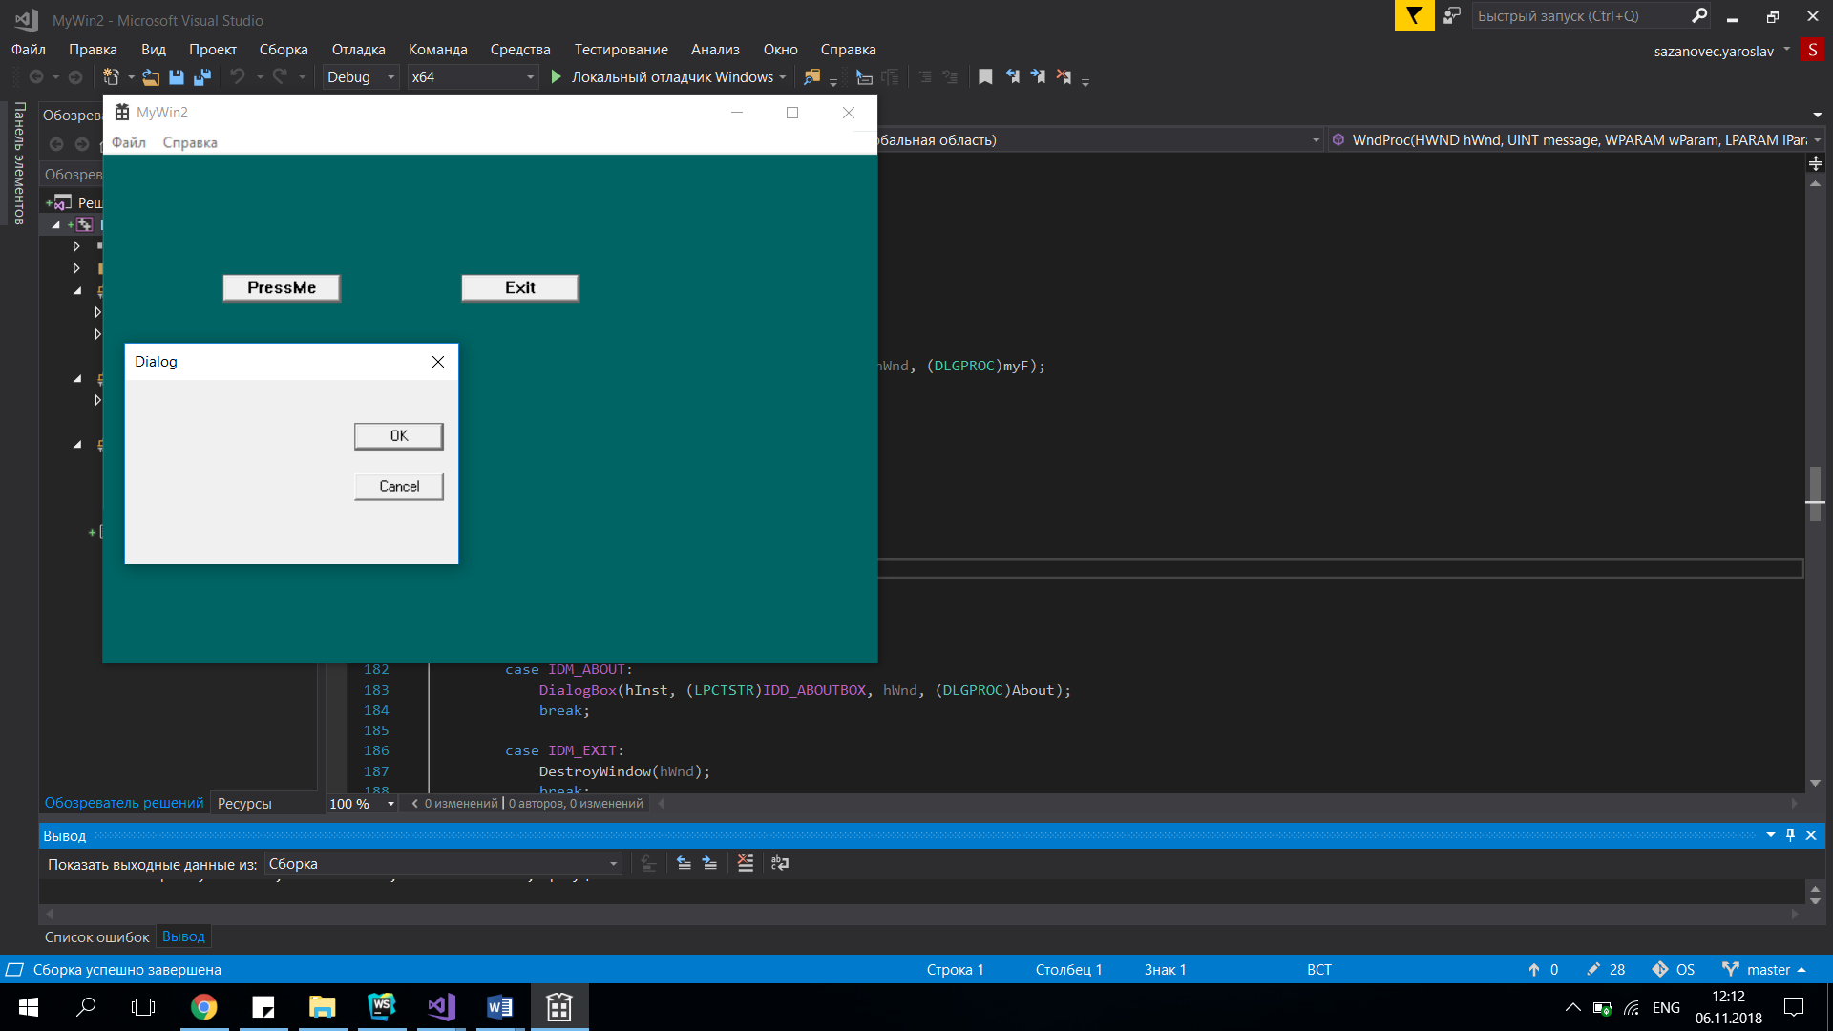

Код программы

#include "stdafx.h"

#include <string>

#include <stdio.h>

#include "Resource.h"

#define MAX_LOADSTRING 100

// Global Variables:

HINSTANCE hInst; // current instance

TCHAR szTitle[MAX_LOADSTRING]; // The title bar text

TCHAR szWindowClass[MAX_LOADSTRING]; // the main window class name

int dx = 8;

int dy = 8;

// Forward declarations of functions included in this code module:

HWND hPressMeBtn;

HWND hExitBtn;

ATOM MyRegisterClass(HINSTANCE hInstance);

BOOL InitInstance(HINSTANCE, int);

LRESULT CALLBACK WndProc(HWND, UINT, WPARAM, LPARAM);

INT_PTR CALLBACK About(HWND, UINT, WPARAM, LPARAM);

LRESULT CALLBACK myF(HWND, UINT, WPARAM, LPARAM);

int row = 1, column = 1;

int APIENTRY _tWinMain(HINSTANCE hInstance,

HINSTANCE hPrevInstance,

LPTSTR lpCmdLine,

int nCmdShow)

{

UNREFERENCED_PARAMETER(hPrevInstance);

UNREFERENCED_PARAMETER(lpCmdLine);

// TODO: Place code here.

MSG msg;

HACCEL hAccelTable;

// Initialize global strings

LoadString(hInstance, IDS_APP_TITLE, szTitle, MAX_LOADSTRING);

LoadString(hInstance, IDC_MYWIN2, szWindowClass, MAX_LOADSTRING);

MyRegisterClass(hInstance);

// Perform application initialization:

if (!InitInstance(hInstance, nCmdShow))

{

return FALSE;

}

hAccelTable = LoadAccelerators(hInstance, MAKEINTRESOURCE(IDC_MYWIN2));

// Main message loop:

while (GetMessage(&msg, NULL, 0, 0))

{

if (!TranslateAccelerator(msg.hwnd, hAccelTable, &msg))

{

TranslateMessage(&msg);

DispatchMessage(&msg);

}

}

return (int)msg.wParam;

}

ATOM MyRegisterClass(HINSTANCE hInstance)

{

WNDCLASSEX wcex;

wcex.cbSize = sizeof(WNDCLASSEX);

wcex.style = CS_HREDRAW | CS_VREDRAW;

wcex.lpfnWndProc = WndProc;

wcex.cbClsExtra = 0;

wcex.cbWndExtra = 0;

wcex.hInstance = hInstance;

wcex.hIcon = LoadIcon(hInstance, MAKEINTRESOURCE(IDI_MYWIN2));

wcex.hCursor = LoadCursor(NULL, IDC_ARROW);

wcex.hbrBackground = (HBRUSH)(COLOR_WINDOW + 1);

wcex.lpszMenuName = MAKEINTRESOURCE(IDC_MYWIN2);

wcex.lpszClassName = szWindowClass;

wcex.hIconSm = LoadIcon(wcex.hInstance, MAKEINTRESOURCE(IDI_SMALL));

return RegisterClassEx(&wcex);

}

BOOL InitInstance(HINSTANCE hInstance, int nCmdShow)

{

HWND hWnd;

hInst = hInstance; // Store instance handle in our global variable

hWnd = CreateWindow(szWindowClass, szTitle, WS_OVERLAPPEDWINDOW,

CW_USEDEFAULT, 0, CW_USEDEFAULT, 0, NULL, NULL, hInstance, NULL);

if (!hWnd)

{

return FALSE;

}

HBRUSH brush = CreateSolidBrush(RGB(0, 100, 100));

SetClassLongPtr(hWnd, GCLP_HBRBACKGROUND, (LONG)brush);

ShowWindow(hWnd, nCmdShow);

UpdateWindow(hWnd);

return TRUE;

}

LRESULT CALLBACK WndProc(HWND hWnd, UINT message, WPARAM wParam, LPARAM lParam)

{

int wmId, wmEvent;

PAINTSTRUCT ps;

HDC hdc;

TCHAR szHello[MAX_LOADSTRING];

TCHAR str[] = TEXT("BIG MAG");

LoadString(hInst, IDS_HELLO, szHello, MAX_LOADSTRING);

switch (message)

{

case WM_CREATE:

// create PressButton

hPressMeBtn = CreateWindowEx(NULL,

L"BUTTON",

L"PressMe",

WS_TABSTOP | WS_VISIBLE |

WS_CHILD | BS_DEFPUSHBUTTON,

100,

100,

100,

24,

hWnd,

HMENU(IDC_PressMeButton),

hInst,

NULL);

ShowWindow(hPressMeBtn, 1);

// create ExitButton

hExitBtn = CreateWindowEx(NULL,

L"BUTTON",

L"Exit",

WS_TABSTOP | WS_VISIBLE |

WS_CHILD | BS_DEFPUSHBUTTON,

300,

100,

100,

24,

hWnd,

HMENU(IDC_ExitButton),

hInst,

NULL);

ShowWindow(hExitBtn, 1);

break;

case WM_COMMAND:

wmId = LOWORD(wParam);

wmEvent = HIWORD(wParam);

// if PressButton has been clicked

if (LOWORD(wParam) == IDC_PressMeButton &&

HIWORD(wParam) == BN_CLICKED &&

(HWND)lParam == hPressMeBtn)

{

DialogBox(hInst, (LPCTSTR)IDD_DIALOG1, hWnd, (DLGPROC)myF);

}

// if ExitButton has been clicked

if (LOWORD(wParam) == IDC_ExitButton &&

HIWORD(wParam) == BN_CLICKED &&

(HWND)lParam == hExitBtn)

{

DestroyWindow(hWnd);

}

// Parse the menu selections:

switch (wmId)

{

case IDM_ABOUT:

DialogBox(hInst, (LPCTSTR)IDD_ABOUTBOX, hWnd, (DLGPROC)About);

break;

case IDM_EXIT:

DestroyWindow(hWnd);

break;

default:

return DefWindowProc(hWnd, message, wParam, lParam);

}

break;

case WM_RBUTTONDOWN:

DialogBox(hInst, (LPCTSTR)IDD_DIALOG1, hWnd, (DLGPROC)myF);

break;

case WM_KEYDOWN:

hdc = GetDC(hWnd);

InvalidateRect(hWnd, 0, TRUE);

UpdateWindow(hWnd);

SetBkColor(hdc, RGB(255, 0, 0));

SetTextColor(hdc, RGB(255, 255, 255));

switch (wParam)

{

case VK_DOWN:

TextOut(hdc, column, row += dy, str, 7);

break;

case VK_UP:

TextOut(hdc, column, row -= dy, str, 7);

break;

case VK_RIGHT:

TextOut(hdc, column += dx, row, str, 7);

break;

case VK_LEFT:

TextOut(hdc, column -= dx, row, str, 7);

break;

default:

TextOut(hdc, column, row, str, sizeof(str) / sizeof(TCHAR));

break;

}

case WM_PAINT:

hdc = BeginPaint(hWnd, &ps);

// TODO: Add any drawing code here...

EndPaint(hWnd, &ps);

break;

case WM_DESTROY:

PostQuitMessage(0);

break;

default:

return DefWindowProc(hWnd, message, wParam, lParam);

}

return 0;

}

LRESULT CALLBACK myF(HWND hDlg, UINT message, WPARAM wParam, LPARAM lParam)

{

//static HBRUSH testBrush;

static HDC dcOne = NULL;

UNREFERENCED_PARAMETER(lParam);

switch (message)

{

case WM_INITDIALOG:

//testBrush = CreateSolidBrush(RGB(0, 0, 255));

return (INT_PTR)TRUE;

case WM_CTLCOLORDLG:

//return (INT_PTR)(testBrush);

case WM_CTLCOLORBTN:

//return (INT_PTR)testBrush;

case WM_COMMAND:

if (LOWORD(wParam) == IDOK)

{

MessageBoxEx(NULL, TEXT("HELLO"), TEXT("DialogWin"), MB_OK, 0x0459);

EndDialog(hDlg, LOWORD(wParam));

return (INT_PTR)TRUE;

}

else if (LOWORD(wParam) == IDCANCEL)

{

EndDialog(hDlg, LOWORD(wParam));

return (INT_PTR)TRUE;

}

break;

}

return (INT_PTR)FALSE;

}

// Message handler for about box.

INT_PTR CALLBACK About(HWND hDlg, UINT message, WPARAM wParam, LPARAM lParam)

{

static HBRUSH testBrush;

UNREFERENCED_PARAMETER(lParam);

switch (message)

{

case WM_INITDIALOG:

testBrush = CreateSolidBrush(RGB(90, 100, 255));

return (INT_PTR)TRUE;

case WM_CTLCOLORDLG:

return (INT_PTR)testBrush;

case WM_CTLCOLORBTN:

return (INT_PTR)testBrush;

case WM_COMMAND:

if (LOWORD(wParam) == IDOK || LOWORD(wParam) == IDCANCEL)

{

EndDialog(hDlg, LOWORD(wParam));

return (INT_PTR)TRUE;

}

break;

}

return (INT_PTR)FALSE;

}