Python Project Report
Project Title | ReliefLink – Disaster Relief & Shelter Manegement System
Students Name | Borshon Debnath,Anurag Sarkar,Sazid Ahmed Ekram,Kanij Fatema
Students ID | 23-55078-3,23-55049-3, 23-53105-3, 23-54901-1
Course / Section | PROGRAMMING IN PYTHON/D
Instructor | MD. TANZEEM RAHAT
Date of Submission | 25/07/26

1. Executive Summary
ReliefLink is a python based system which helps organizations or individuals to do their activities more efficiently during the natural calamities. It provides great tracking features allowing CRUD operation to keep the system up to time. Thus the margin of error becomes so low. The system consists of several modules like Family Management, Relief Inventory, Shelter Management, Relief Distribution etc. Family management apply CRUD operation for adding ,searching, updating and deleting family and all from the system. Inventory management is applicable for inventory item details also perform CRUD with a feature low stock alert which indicates there is low quantity in inventory. Shelter family is a unique and effective feature which performs CRUD and thus it makes it easier for them to identify the allocation. Relief distribution can be used for proper resource allocation and ensures everyone get the minimum needed items. Also Report gives a overview of the system and Statistics calculate some features where needed. Overall, the system is effective for those who suffers in such circumstances.

2. Introduction and Project Objectives
Natural disasters like flood, cyclone is very common problem we face every year. Many lost home, become financially weak and can not provide their family what is actually needed. Thus they need shelter which provide basic needs. Sometimes the organizations or the management team who are operating in a particular shelter zone makes mistake because they do it by manually. That’s why we think of a system which will reduce the errors by tracking everything up to time. It will be also useful and user-friendly for the organizations.
Item | Your Content
Dataset name | Dummy Data
Dataset source | No source
Main project goal | Ensure fair distribution of goods by tracking everything within the system
Research Question 1 | Is there any alarm system in inventory which will indicate there is low amount of good?
Research Question 2 | How a family will be allocated in the shelter zone?

2.Feature list and target users
Feature List
ReliefLink provides a set of features to support disaster relief operations efficiently. The major features of the system are described below:
1. Family Management
The system allows relief workers to manage records of affected families through complete CRUD (Create, Read, Update, Delete) operations. Users can:
- Register new affected families.
- View all registered family records.
- Search families by Family ID, name, or phone number.
- Update existing family information.
- Delete family records when necessary.
- Prevent duplicate Family ID registration.
- Validate user input to ensure data accuracy.
2. Relief Inventory Management
The application helps maintain the stock of relief materials required during disaster response. It supports:
- Adding new relief items.
- Viewing available inventory.
- Updating item quantities.
- Deleting inventory items.
- Displaying low-stock warnings when quantities fall below the minimum threshold.
The inventory can include items such as:
- Rice
- Water
- Blanket
- Medicine
- Baby food
- Clothes
- Hygiene kits
3. Shelter Management
The shelter management module assists in organizing temporary accommodations for affected families. Users can:
- Add new shelters.
- View all available shelters.
- Search shelters by ID or name.
- Update shelter information.
- Delete shelter records.
- Allocate families to shelters based on available capacity.
- Remove families from shelters.
- View families currently staying in each shelter.
4. Relief Distribution
The system streamlines the relief distribution process by:
- Searching registered families.
- Selecting and distributing relief packages.
- Automatically updating inventory after each distribution.
- Preventing duplicate relief distribution.
- Recording distribution history for future reference.
5. Reports
ReliefLink generates several reports to help monitor disaster relief activities, including:
- Total number of registered families.
- Number of families served.
- Number of families still waiting for relief.
- Families grouped by district.
- Families categorized by damage level.
- Remaining inventory status.
- Shelter occupancy information.
- Distribution history.
6. Statistical Analysis
The project uses the NumPy library to analyze relief data and generate useful statistics, such as:
- Average family size.
- Maximum number of family members.
- Minimum number of family members.
- Total affected population.
- Percentage of families served.
- Number of high-priority families.
- Shelter occupancy rate.
- Average remaining inventory.
7. Data Persistence
All project data is stored permanently using JSON files. The application automatically loads existing records when it starts and saves updated information before exiting, ensuring that no data is lost between sessions.
8. Input Validation and Error Handling
The system includes validation and exception handling mechanisms to improve reliability by handling:
- Invalid menu selections.
- Invalid numeric inputs.
- Duplicate Family IDs.
- Missing or corrupted JSON files.
- Empty JSON files.
- Negative inventory quantities.
- Shelter capacity overflow.
- Invalid phone number formats.

Target Users
ReliefLink is designed for organizations and individuals who are willing to do sacrifice themselves in this great work of humanity.
- Relief Organizations: NGO’s can use the system to manage registration, relief distribution, and time allocation.
- Volunteers: Volunteers can register affected families, distribute relief materials, and update records.
- Disaster Management Teams:Private disaster response teams can monitor relief operations, manage shelters, and generate statistical reports for decision-making.

3. Dataset Description
The dataset we worked with is dummy dataset. We took some user input at first later the input were saved as json files. No public dataset were used here. We have four json files: distribution, families, inventory and shelters.

3.1 Basic Dataset Information
Property | Value
Number of rows | Depends on the json file entry
Number of columns | Depends on the json file entry
Data types present | Numerical, Boolean
Target or key variable(s) | Family ID, Item ID, Shelter ID, Distribution ID
Potential issues observed at first glance | No missing values since it is dummy data

3.2 Initial Observations
We worked with dummy dataset. So no initial observations were needed.

4. Data structure explanation:
In our project we used list and dictionaries in several places. In our json data file: families, inventory, shelters, distribution list were to used to categorize things. Dictionaries were used to access values.

5. OOP design: class name, attributes, and methods

Class Name | Attributes | Methods
Family | familyId, headName, phone, district, upazila, village, members, children, elderly, disabledMembers, damageLevel, shelterNeeded, receivedRelief | __init__(), to_families_json(), display()
InventoryItem | itemId, itemName, quantity, unit, minimumStock | __init__(), to_inventory_json()
ShelterManagement | shelterId, shelterName, district, capacity, currentOccupancy, families | __init__(), to_shelter_json()

6. File handling and exception handling explanation
The ReliefLink system uses JSON file handling to store data permanently, ensuring that information is not lost when the program is closed. All file operations are managed in the file_handler.py module, which contains reusable functions such as load_json() and save_json(). These functions are used by specific functions like load_families(), save_families(), load_inventory(), save_inventory(), load_shelters(), save_shelters(), load_distribution(), and save_distribution() to manage the data stored in families.json, inventory.json, shelters.json, and distribution.json. This approach reduces code duplication and keeps the program organized and easy to maintain.
To make the application more reliable, the project implements exception handling using try-except blocks. The program handles common errors such as FileNotFoundError when a JSON file is missing, JSONDecodeError when a file contains invalid or corrupted data, and other unexpected exceptions. Instead of terminating the program, appropriate error messages are displayed and safe default values are returned, allowing the application to continue running smoothly and providing a better user experience.

7. Analysis and Visualizations

7.1 Research Question 1
Is there any alarm system in inventory which will indicate there is low amount of good?
The ReliefLink system includes a Low Stock Alert feature in the Inventory Management module. The system compares the current quantity of each inventory item with its minimum stock level. If the available quantity is less than or equal to the minimum stock value, the item is displayed as a Low Stock Item.
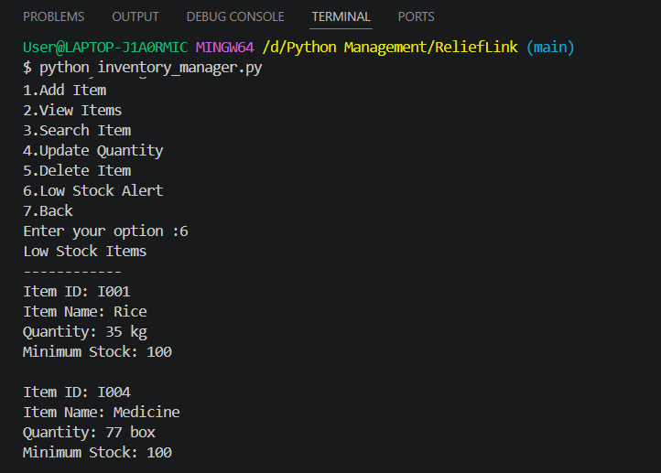
Figure 1. Showing which products are in low stock

7.2 Research Question 2
How a family will be allocated in the shelter zone?
A family is allocated to a shelter through the Allocate Family feature. The user enters the Shelter ID and the Family ID. Thus one family is allocated.
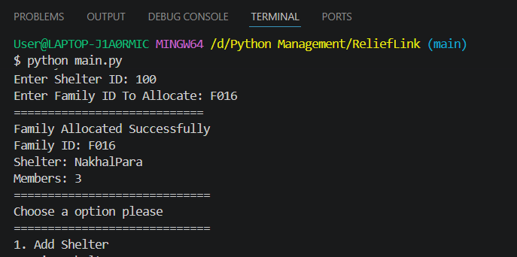
Figure 2. Family Allocation by Shelter and Family ID

8. Library/module use: NumPy
The project uses the NumPy library to make statistical calculations simple and efficient. Instead of writing lengthy calculations manually, NumPy provides built-in functions that process the stored data quickly. In the statistics.py module, functions such as np.mean(), np.max(), np.min(), and np.sum() are used to calculate the average family size, maximum and minimum family members, total affected people, and average inventory remaining. These statistics provide a clear summary of the relief data and help users better understand the overall situation during disaster management.

9. Screenshots and sample input/output

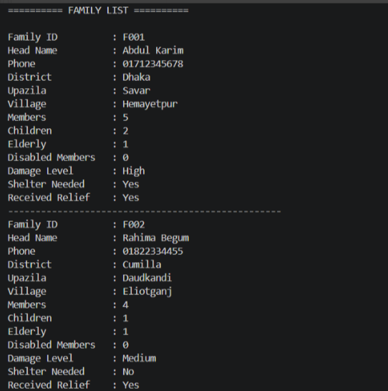
Fig : Family list
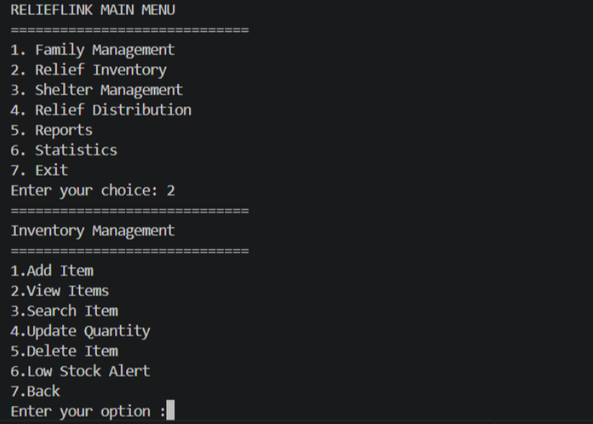
Fig : Inventory Management
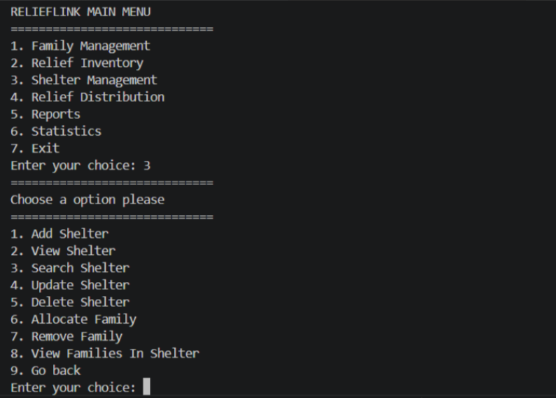
Fig : Shelter Management

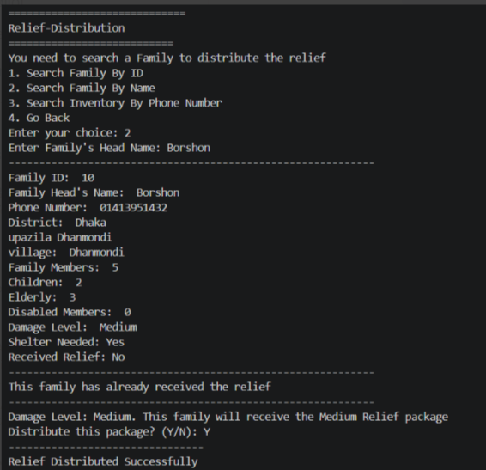
Fig : Relief Distribution
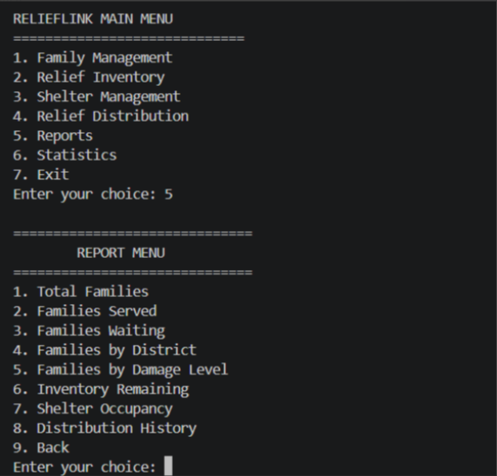
Fig : Reports
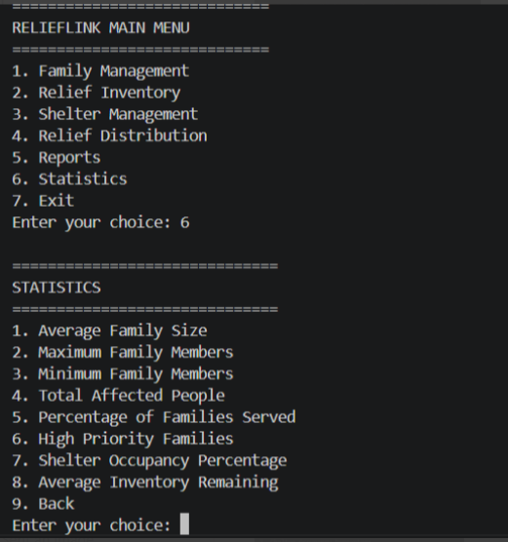
Fig : Statistics

10. Limitations and possible future improvements
For our project of ReliefLink, we used dummy data initially to test everything is working fine or not. Our database was only the json files and not stored in database which is a limitation for bigger data. The project is still not used in graphical or web level which makes it difficult for non-tech people to understand.
We can work on future with real dataset providing meaningful insight and also a proper database for big data. One application or web application can be built around with all working functionalities. We can further use real time disaster and shelter information using online API.
It will be beneficial for everyone suffering if we can reach our system in a national level. Thus the system will fulfill it’s objective.

