**Introduction**

**Sexual selection and Differing Reproductive strategies**

Understanding how sexual selection affects the evolution of wild populations is a key goal of evolutionary biology (Brouwer and Griffith, 2019). Males produce sperm, which are small, cheap to produce and unlimited (Trivers, 1972). Females produce eggs which are large, costly to make, and due to limitations in reproductive physiology, are limited in number that can be made (Bateman, 1948). Therefore, the optimal reproductive strategies for males and females are predicted to differ; with males investing in traits that maximize opportunities for additional matings and females investing in traits that help select partners that increase their fitness through the genetic quality of their offspring (Trivers, 1972). Phenotypes maximizing these sex-specific optimal reproductive strategies should be under strong sexual selection, resulting in pronounced sexual dimorphism in reproductive traits (Poissant et al., 2006). However, this rarely occurs in natural populations, with males and females displaying similar traits (Poissant et al., 2006; Bonduriansky and Chenoweth, 2009).

**Female promiscuity in socially monogamous populations**

An example of this is the occurrence of female promiscuity in socially monogamous populations. Social monogamy is a mating system where individuals from opposite sexes form stable breeding pairs lasting at least one breeding cycle, and both individuals coordinate and synchronize bi-parental care (Shultz and Dunbar, 2010; Maldonado-Chapporo et al., 2018).Social monogamy in birds is vast and widespread, with 81% bird species estimated to be socially monogamous (Cockburn, 2006). Socially monogamous species were assumed to be genetically monogamous (Lack, 1968) but paternity analysis of broods shows across socially monogamous populations not all offspring are sired by the male breeding partner (Brouwer and Griffith, 2019). This is termed extra pair reproduction (EPR) but can also be referred to as extra pair behaviour (EPB), extra pair copulation (EPC), extra pair mating (EPM) or extra pair paternity (EPP). EPR rates vary between and within socially monogamous species and populations as shown in Table 1 (Brouwer and Griffith, 2019; Lifjeld et al., 2019).

Table 1: a collection of EPR rates in socially monogamous species demonstrating how EPR rates can vary across species, between populations and within populations over time.

|  |  |  |  |
| --- | --- | --- | --- |
| Species | Location | % EPO | Paper |
| Brown thornbill | New South Wales, Australia | 6.2 | Geen and Cockburn (2004) |
| Cooper’s hawk | Wisconsin, USA | 19.3 | Rosenfield et al. 2015) |
| Marsh warbler | Germany | 3.1 | Leisler and Wink (2000) |
| South polar skua | Antartica | 7.1 | Millar et al. (1997) |
| Acadian flycatcher | Pennsylvania, USA | 57.1 | Hung et al. (2009) |
| Acadian flycatcher | Ontario, Canada | 13.8 | Evans et al. (2009) |
| Acadian flycatcher | Pennsylvania, USA | 40.6 | Woolfenden et al. (2005) |
| jabiru | Brazil | 2.9 | Lopes et al., (2013) |
| Crimson breasted shrike | South Africa | 18.9 | Van den Heuvel et al., (2014) |
| Bluethroat | Norway | 25.7 | Johnsen et al., (2012) |
| Bluethroat | Algeria | 42.0 | Questiau et al., (1999) |
| Dusky warbler | Eastern Russia | 45.1 | Forstmeier and Kempenaers (2002) |
| Black-browed reed warbler | Japan | 6.4 | Hamao and Saito |
| Yellow rumped flycatcher | Jilin, China | 22.2 | Gong et al., (2017) |

Variation in EPR between and within species has been linked to many factors- including breeding density and habitat quality (Maldonado-Chaparro et al., 2018; Brouwer and Griffith, 2019). However, a substantial amount of variance is due to family and order, suggesting EPR has a quantitative genetic component comprised of thousands of genes of small effect, defined as additive genetic variance, and is an evolved trait (Brouwer and Griffith, 2019; Lifjeld et al., 2019; Hill et al., 2008; Falconer and Mackay 1996; Lynch and Walsh 1998).

The benefits to EPR for males are obvious: as males can increase the number of offspring produced through siring extra pair offspring (EPO) (Trivers, 1972; Albrecht et al. 2007; Webster et al. 2007). This is not the case for females, who replace within pair offspring (WPO) with EPO (Trivers, 1972). EPR is costly to females in socially monogamous mating systems- possibly resulting in decreased provisioning by the partner (Dixon et al., 1994; Matysioková and Remeš, 2013; Hsu et al., 2016), punishment by the social partner (Valera et al., 2003), breeding failure via polyspermy (Forstmeier and Ellegren, 2010) and risk of disease transmission (Poiani and Wilks, 2000). Despite the associated costs, females have been shown to actively pursue EPCs (Lifjeld and Robertson 1992; Birkhead and Moller 1993; Forstmeier 2007), which has led to scientists to determine why female EPR evolved and continues to persist in socially monogamous populations.

A popular theory is that female EPR is adaptive, with females receiving indirect genetic benefits from mating with extra pair males and ultimately increase their fitness through the increased fitness of their EPO as shown in figure 1 . (Forstmerier et al., 2014). Possible indirect genetic benefits include the male being of superior genetic quality and being less closely related to the female than the social pair male (Forstmerier et al., 2014). The indirect genetic benefits hypothesis has been explored in many socially monogamous populations(Arc et al., 2015; Hsu et al., 2015). However, evidence that EPR directly provides indirect genetic benefits to females is inconsistent (Hsu et al. 2015) with most studies finding either no evidence for female EPR providing indirect genetic benefits (Grinkov et al., 2022) or evidence for female EPR causing indirect genetic costs rather than benefits (Hsu et al., 2014; **Reid and Sardell, 2012; Sardell et al., 2012; Schmoll et al., 2009).** Therefore, alternative explanations for how female EPR evolved and continues to persist in socially monogamous populations are required.

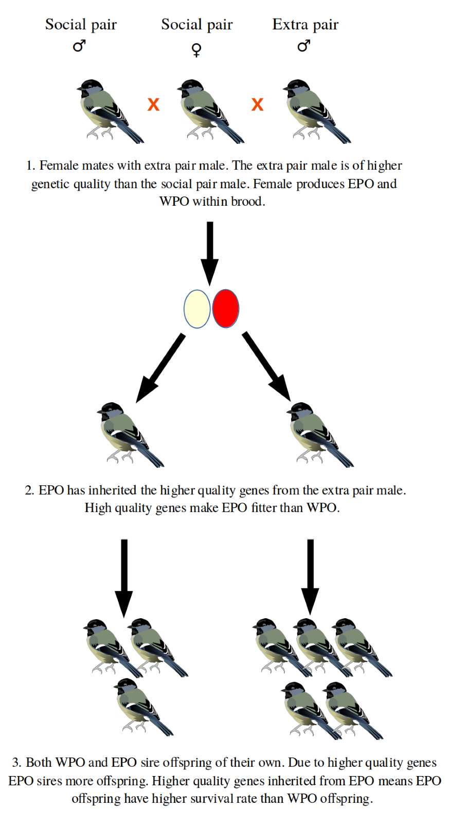

Figure 1: a diagram demonstrating how female EPR may persist in socially monogamous populations through aquiring Indirect genetic benefits from extra pair male. Shape depicts WPO and Shapedepicts EPO. Arrows indicate sequentially occurring events.

An alternative, less investigated theory is that female EPR is maladaptive, and evolved in socially monogamous populations via Intersexual Antagonistic Pleiotropy. Female and male EPR may be controlled by the same or associated sets of genes and are under strong positive selection in males as they increase male lifetime reproductive success through siring EPO (Halliday and Arnold 1987; Forstmerier et al., 2014; Reid and Wolak, 2018). This strong selection results in EPR evolving in both sexes despite being costly to females as shown in Figure 2. Male and female EPR must also be positively genetically correlated (Forstmerier et al., 2014). There is some evidence that female EPR could evolve indirectly through selection on male EPR: positive between-sex genetic correlations are commonly found in behaviour traits (Forstmerier et al., 2014) and are associated with reduced sexual dimorphism (Poisson et al., 2006). Male and female behaviour in socially monogamous populations are more like each other than in other mating systems, with phylogenetic studies suggesting that social monogamy evolved from polygamy simultaneously in both sexes (Forstmerier et al., 2014). Traits that increase lifetime reproductive success are under strong selection in males () and male EPR can contribute substantially to lifetime reproductive success (). Models simulating the evolution of female EPR predict that even if female promiscuity reduces female fitness, it can still evolve through associations with male reproductive success (Lyu et al. 2018).

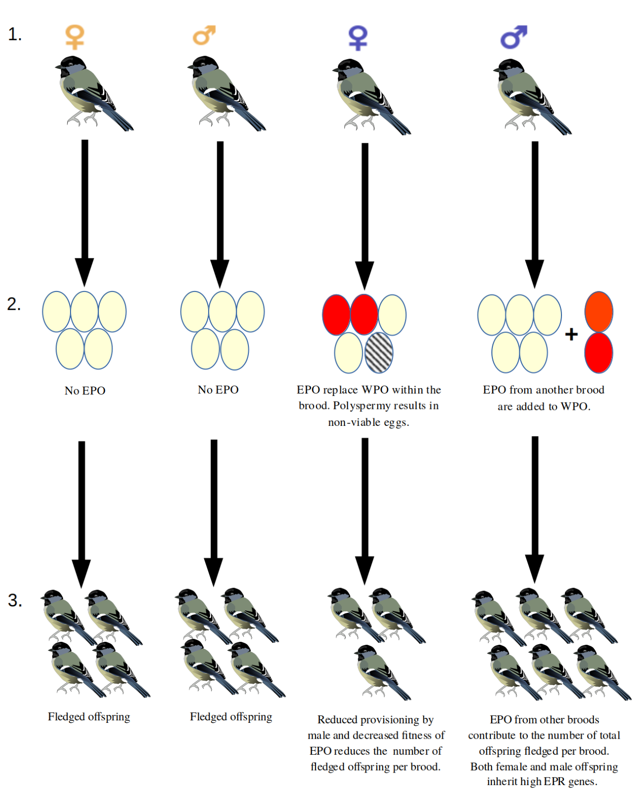

Figure 2: Diagram illustrating how female EPR may persist in socially monogamous populations through between- sex genetic correlations. From left to right is a female with low EPR genes, male with low EPR genes, female with high EPR genes, male with high EPC genes. Shape depicts WPO and Shapedepicts EPO. Arrows indicate sequentially occurring events.

However, in order to understand how female EPR evolved in socially monogamous populations, and if male and female EPR are genetically correlated, the heritability of both male and female EPR must be determined (Villemereuil et al., 2013). Heritability is defined as the proportion of the total phenotypic variation in a trait that is due to additive genetic variance (Wilson et al. 2010; Villemereuil et al., 2013). The magnitude of heritability determines the strength of selection on traits: with low heritability resulting in selection not being strong enough for traits to evolve (Grinkov et al., 2020). (Zietch et al., 2015; **Grinkov et al., 2020**). So far, heritability estimates for male EPR and female EPR across different socially monogamous species are either low or negligable (Reid and Wolak, 2018; Reid et al. 2011a, Reid et al. 2011b, Reid et al., 2010; Grinkov et al., 2020), while studies investigating intersexual antagonistic pleiotropy have found no evidence for positive cross-sex genetic correlations (Zietch et al., 2015; Reid and Wolak, 2018; Wang et al., 2020). This lack of evidence questions whether female EPR could evolve as a byproduct of selection on male EPR, and the assumption that female and male EPR are evolved traits.

**The social environment and Indirect genetic Effects**

The social environment is defined as a network of interactions between individuals within populations- through these interactions, an individual can influence, or be influenced by, other individuals(Maldonado-Chaparro et al., 2018). These interactions can change trait phenotypes in individuals, groups of individuals and even entire populations: social interactions can parental care **(Wong et al., 2013)** and dispersal patterns in insects (**Wey et al., 2015**) and can also lead to changes in life history traits in other individuals such as survival probability **(**Silk et al., 2003) and reproductive success (Archie et al., 2014; Ilhe et al., 2015; Maldonado-Chaparro et al., 2021)

Through these social interactions an individual’s genes can affect trait phenotypes in other individuals: these are called indirect genetic effects (IGEs) (Wolf et al., 1998; Bijma, 2011). IGEs can affect both related and unrelated individuals and can originate from the same or different traits as the phenotype in question (Bijma, 2011). Essentially, IGEs are a genetic effect which originates from the social environment and because they are a genetic effect they can be added to the total additive genetic variance of a trait (Bijma, 2011). Most additive genetic variance and heritability estimates are calculated using direct genetic effects, that is, the effect of an individual's own genes on their own expression of a trait. Therefore, accounting for the effect of IGEs on phenotypes can potentially change heritability and genetic correlation estimates which in turn can change the magnitude and direction of selection on traits (Bijma, 2011; Wilson et al., 2018; Thomson et al., 2018; Schroeder et al., 2019). If IGEs have a large effect phenotypic traits still have the potential for rapid evolution even when heritability for direct genetic effects alone is negligible (Moore et al., 1997; Bijma, 2011; Schroeder et al., 2019). Positive or negative covariance between direct and indirect genetic effects can also further accelerate or restrain the evolution of the focal trait respectively (Moore et al., 1997; Bijma, 2011, 2013; schroeder et al., 2019). The effect of IGEs are thought to be large and vast across both wild and experimental populations. (Bijma, 2011; schroeder et al., 2019). Examples of IGEs and how they can affect the evolutionary trajectories of traits are listed in Table 2.

Table 2: A collection of studies that show IGEs can change trait phenotypes and change the evolutionary trajectory of traits.

|  |  |  |  |
| --- | --- | --- | --- |
| Paper | Study system | Individual/ Individuals the IGEs originate from | Effect of IGEs on trait evolutionary trajectory |
| Muir, 1996, 1995 | Chickens | Unrelated individuals in same group | Mortality |
| Brotherstone et al., 2011 | Tree species | Unrelated individuals in same group | Growth related traits |
| Wilson et al., 2011 | Red deer  *Cervus ephalus* | Individual in a dyadic interaction | Restricts the evolution of social dominance |
| Wolf et al. 2011 | Arabidopsis | Unrelated individuals in same group | Developmental and growth-related traits |
| Schroeder et al., 2019 | House sparrows | Social Pair Partner | Increase heritability of male and female parental provisioning |

The social environment can affect male and female EPR in socially monogamous populations: particularly interactions between individuals and their social and extra pair partners (Maldonado-Chaparro et al., 2018; Roth et al., 2019).

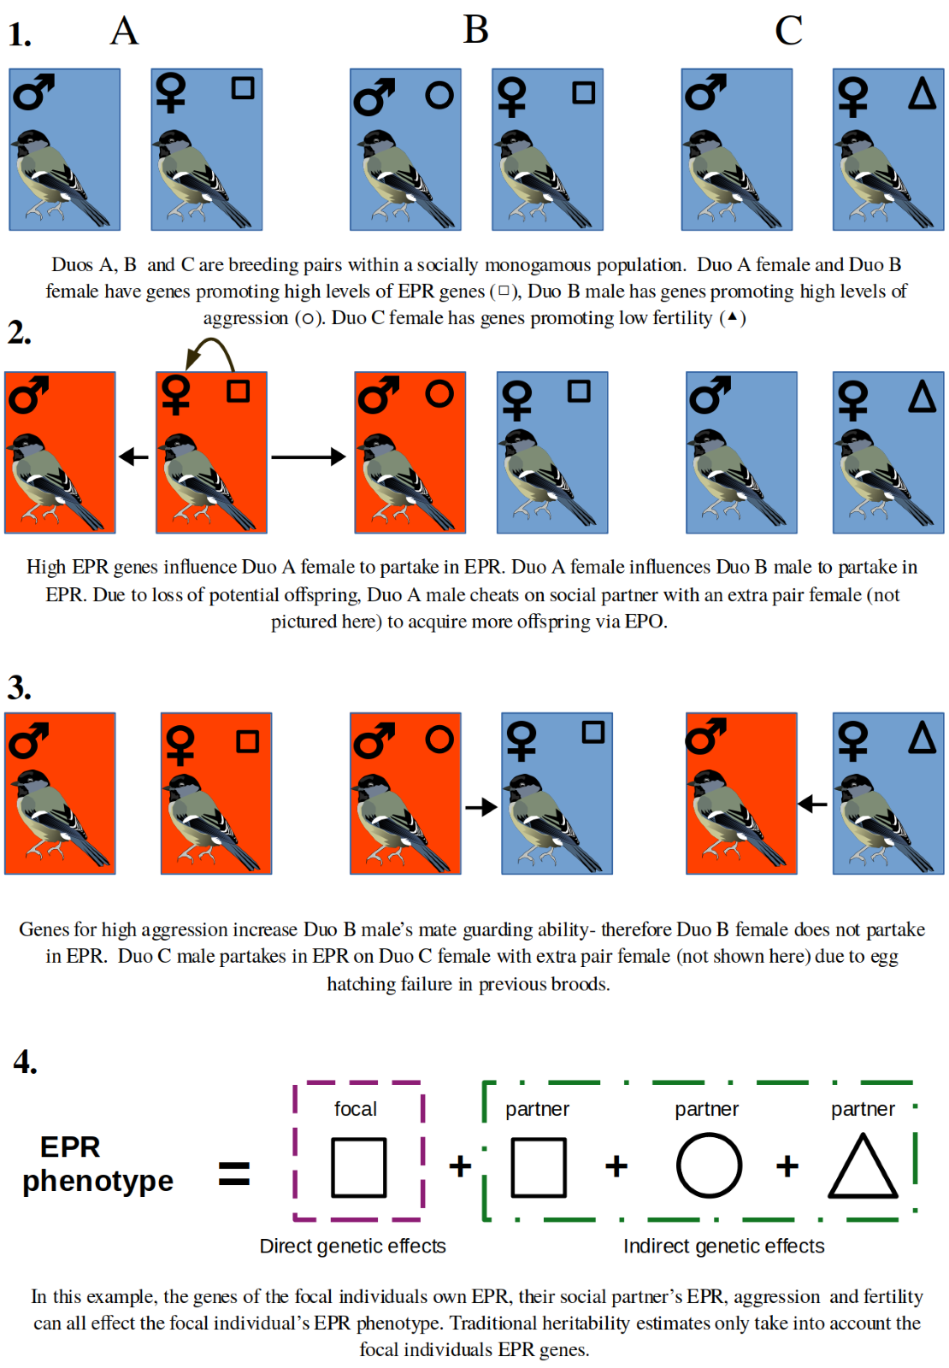  
Figure 3: a diagram showing how EPR phenotype may be influenced by direct genetic effects from the focal indiviual and indirect genetic effects from the social partner. Arrows indicate the direction of influence.

Male and female EPR can be affected by the social environment in socially monogamous populations: especially from interactions between social partners are of particular interest (Maldonado-Chaparro et al., 2018; Roth et al., 2019). Previous EPR by the partner (Maldonado-Chaparro et al., 2018), the partner being of low genetic quality (Gerach et al., 2012), the mate guarding ability of the male (Forstemeir et al., 2014), the partner having low fertility () and being behaviorally incompatible with the partner (Ihle et al., 2015) may all affect probability of individuals partaking in EPR in socially monogamous populations. If these traits are genetically determined social IGEs may affect the EPR of other individuals as shown in Figure 3.

Social partner IGEs could potentially increase the total heritable variation available for female and male EPR and alter genetic correlation estimates between male and female EPR. This allows male and female EPR to evolve in socially monogamous populations even if the heritability of the direct genetic effects is low. Social pairs form due to high behavioral compatibility between partners, that is the behaviors they display are more similar (Ilhe et al., 2015) therefore EPR rate between partners may similar which could indicate positive genetic covariance between the genetics of the focal individual and their partner, which could further accelerate the evolution of male and female EPR.

Despite the large of effects of the social environment on male and female EPR in socially monogamous populations. No previous study has explicitly measured social partner IGEs in male and female EPR, therefore measuring IGEs may increase heritability estimates for female EPR and male EPR compared to direct heritability estimates and change genetic correlation estimates between male and female EPR (Bijma, 2011; Forstmerier et al., 2014).

Using long term data from an insular socially monogamous population of house sparrows *Passer domesticus* I will try to answer the following questions*:* (1): Does accounting for social partner IGEs increase heritability estimates for male and female EPR. (2): Does accounting for social partner IGEs change between-sex genetic correlation estimates between male and female EPR, and are these estimates positive?

*Study Population:*

The house sparrow population are located on the isle of Lundy, an island off the west coast of Southwest England, UK (51°10’N, 4°40’W). The population first naturally established on Lundy in 1972. In 1996-1997 the population plummeted due to poisoned food, and subsequently 50 individuals from a Yorkshire population were introduced to supplement the population. Nest boxes were introduced in 1990 and since 1996 the house sparrows mainly use the nest boxes to breed (Schroeder et al., 2019). The population breeds from April- August within a ~400 ft area, each individual averaging 2-3 clutches per year, with switching social partners between breeding attempts common (Ockendon et al., 2009). All birds are ringed an individual combination metal ring from the British Trust for Ornithology and coloured rings for identification (Hsu et al. 2015; Schroeder et al. 2015) and both blood and tissue samples are taken for parentage analysis. Annual resightings of individuals are 91%–96%, and migration to and from mainland UK is rare (Schroeder et al., 2011). Therefore, the complete life histories and pedigree of each bird present on the island is known from 2000 onwards (Hsu et al. 2015; Schroeder et al. 2015).

EPR rates in the lundy house sparrow populations were originally low (Griffith et al., 1999) but now occur at intermediate levels after individuals from Yorkshire were transplanted, with 17.5% of offspring being EPO and 38% of broods containing EPO (Ockendon et al., 2009; Hsu et al., 2015). These rates seem to be unaffected by conventional environmental effects such as breeding density (Griffith et al., 19 99; Ockendon et al., 2009). Females actively solicit EPR () and seems to be costly, resulting in reduced parental provisioning by males (Hsu et al. 2016). Hypotheses that females received indirect genetic benefits from EPR have been previously investigated in this population. However, female extra pair partners tend to be neighbouring males rather than any specific male (Dunning, unpublished) and were found to be no more closely related to the females than the social partners (Ockendon et al., 2009). EPO were not more genetically diverse than WPO (Ockendon et al., 2009) and were less fit compared to WPO (Hsu et al., 2014). This all suggests females accrue indirect genetic costs from EPR in the Lundy house sparrow population, ruling out any adaptive hypotheses for why female EPR persists in this population.

The heritability of male and female EPR in the Lundy house sparrow population are not known, and maladaptive hypotheses for why female EPR persists have not been explored. IGEs seem to play an important role in the evolution of the Lundy house sparrow population, substantially increasing estimates for heritability of parental care in males and females (Schroeder et al., 2019). However, their role in the evolution of male and female EPR is unknown. This makes the Lundy sparrow population ideal for testing whether female EPR can be maintained in socially monogamous population via intersexual antagonistic pleiotropy, and how IGEs from social partners effect heritability and genetic correlation estimates.

*Genetic Pedigree:*

A pedigree of the Lundy house sparrow population was constructed using 15 microsatellites using the method described by Schoeder et al. (2012). The pedigree is composed of ___ individuals, born from 2000 – 2019. The pedigree for the sparrows on lundy is near complete which allows for genetic effects to be accurately measured (**Grinkov et al., 2020**).

*Determining male and female EPR*

The social male and female of each brood were determined by identifying the individual birds (male and female) using video recordings and colored rings (Nakagawa et al. 2007; Schroeder et al. 2013).

I defined Female EPR as a binary trait- assigning a 0 or 1 if EPO or no EPO had been conceived by each female per brood respectively. EPO were determined by whether the social male appeared as the parent in the genetic pedigree in the offspring (Schroeder et al. 2012; Hsu et al. 2014). I measured female EPR in this way because EPO replace WPO in a brood (Trivers, 1972). Extra pair fertilisations are also dependant on the age of the extra pair male, meaning that females with more EPO per brood have not necessarily had more EPCs and vice versa (Grindt et al., 2015).

I measured Male EPR as the number of EPO each male produced per brood. The number of EPO produced per brood by males was calculated by determining (1) if the male was assigned as the genetic father to the offspring but not as the social father to the EPO (2) if the offspring was conceived during the nesting, brooding and provisioning phases of a brood the male had with the social female. I measured males EPR in this way because males can produce unlimited offspring and their fitness is mainly reliant on how many offspring they can produce across their lifetime (Trivers, 1972); making this measurement of male EPR biologically relevant to the house sparrow population.

*Statistical Analysis*

I estimated sex specific EPR heritability and genetic correlations between male and female EPR using animal models. Animal models are a type of mixed effect model that can be used to disentangle genetic and environmental influences on phenotypic traits using a pedigree, allowing heritability and genetic correlations between traits to be easily estimated (WIlson et al., 2010). Animal models are used often to determine the genetic architecture of traits in wild populations for several reasons (1) the locations of the genes of interest do not need to be known (2) they can use complex, unbalanced pedigrees- which are common in wild populations (3) they can fit non-direct genetic influences on the variation of phenotypic traits, allowing for estimation and comparison of multiple environmental and genetic influences simultaneously, which generates more precise estimates of heritability and genetic correlations (Kruuk et al. 2008; de Villemereuil et al., 2013 ). Animal models are also ideal for measuring the variance of IGEs in wild populations, as it allows us to quantify IGEs just using both EPR data and the knowledge of which individuals interact with each other irrespective of whether the IGE originates from that specific trait or from other traits (Bijma, 2013).

I ran animal models using the MCMCglmm package (Hadfield, 2010) in R, which uses the Bayesian Markov chain Monte Carlo method to estimate variance components in mixed effect models (Hadfield, 2010). This allows MCMCglmm to estimate heritability and genetic correlations in messy, non-gaussian data using the often-complex pedigrees found in wild populations (de Villemereuil et al., 2013; Grinkov et al., 2020).

*Model Specifications and Parameters*

I ran both univariate, where only one response is specified in the model (either male EPR or female EPR), and bivariate models, where two responses are specified in the model (both male and female EPR) to determine sex specific heritability for EPR and genetic correlations between male and female EPR respectively. I fitted the models using 2 priors with specifications listed in Table S__.

I included the age of the focal individual as a fixed effect across all models as older house sparrow males have an increased likelihood of siring EPO due to sperm competition (Grindt et al., 2015). Within and Extra pair paternity success have also been shown to have different age trajectoires in males, meaning that males may be more likely to partake in EPCs at certain ages (Hsu et al., 2017). I ran models with differing random effects as specified in table 3 to determine how the addition of social effects and covariance between social partner IGEs and direct genetic effects change heritability and genetic correlation estimates for male and female EPR (schroeder et al., 2019). These included the identity of the focal individual twice- one linked to a pedigree-based relatedness matrix to estimate the direct additive genetic variance (or direct geentic effects), the other to estimate the focal individuals’ permanent environment on the focal individual’s EPR per brood : which can be defined as _____(**Kruuk, 2007**). I also included the identity of the social partner twice- once linked to a pedigree-based relatedness matrix to estimate social partner IGEs, the other to estimate the effect of the social partner’s permanent environment on the EPR per brood of the focal individual. Due to MCMCglmm package limitations I could not model the covariation between direct genetic effects and social partner IGEs in bivariate models, and so could not determine how covariation between direct and indirect genetic effects effected genetic correlations between female and male EPR. I also initially included brood year as a random effect to account for the effect of annual stochastic events such as differing food availability (Hoi-Leitner et al., 1999) and for possible environmental covariation between the social partners (Reid et al., 2011). However, preliminary analysis showed that the year had little variance, did not change heritability estimates and did not improve model effect (Table S__). Therefore, to simplify the models I subsequently removed year as a random effect from all models.

Table 3: Model specifications for univariate and bivariate models. Responses and fixed effect specifications are universal across all models. Random effects are specified with different parameters for different models. DGE, PE, Partner PE and Partner IGE represent direct genetic effects, individual permanent environment, social partner permanent environment and social partner indirect genetic effects respectively. cov() denotes models where covariation between parameters were modelled.

|  |  |
| --- | --- |
| **Model Parameters** | **Inputs** |
| **Response** | **Univariate:** male EPR or female EPR  **Bivariate:** male EPR and female EPR |
| **Fixed effects** | **Univariate:** age  **Bivariate:** male and female age |
| **Random effects** | **Univariate:** DGE + PE  **Bivariate:** us(female DGE+ male DGE) + PE |
| **Random effects** | **Univariate:** DGE +PE + Partner PE  **Bivariate:** cov(female DGE+ male DGE) + PE + Partner PE |
| **Random effects** | **Univariate:** DGE + PE + Partner PE + Partner IGE  **Bivariate:** cov(female DGE+ male DGE) + PE+ Partner PE + cov(female partner IGE + male partner IGE) |
| **Random effects** | **Univariate:** cov(Partner IGE and DGE)+ PE + Partner PE |

*Checking model assumptions and fit*

All models were deemed to have converged when autocorrelation was less than 0.1 and when trace and density plots were normally distributed (Hadfield, 2010). How well each model fits the data was determined using the DIC value of each model, where a decrease in value indicates a better fit (Hadfield, 2010).

*Estimating heritability and genetic correlations*

I measured sex specific heritability estimates and genetic correlation estimates between male and female EPR from all models on both latent and observed scales which allows my estimates to be comparable to other heritability estimates across the literature. I calculated heritability, total heritable variation and genetic correlation estimates using the equations listed in Table 4.

Variance estimates on latent and the observed scales are not the same, therefore, it can be difficult to estimate heritability and genetic correlations for traits with non-gaussian data on the observed scale (Morrisey et al., 2013). Fixed effects (Age) further complicate matters as the variance of fixed effects cannot be estimated in non-gaussian models, making measuring total phenotypic variance, and therefore heritability and genetic correlations difficult (Table 4, De Villemereuil et al., 2016; **De Villemereuil et al., 2018**). Therefore, heritability and genetic correlation estimates were calculated from models on the observed scale using the QGglmm package (De Villemereuil et al., 2016) in R, with the equations listed in Table 4. QGglmm uses the predicted response values from the model to account for the variance of the fixed effects when estimating total phenotypic variance which allows for heritability and genetic correlations to be estimated correctly (Villemereuil et al., 2016; Villemereuil et al., 2018). I then compared the bivariate and univariate model sex specific heritability estimates to see if they agreed with each other.

Table 4: list of equations used to calculate heritability and genetic correlation estimates on the latent and observed scale adapted from Bijma (2011) and Schroeder et al (2019). Where Vp is the total phenotypic variation, Vrandom is the combined variance of the random effects, Vfixed is the combined variance of the fixed effects, VDE is the direct additive genetic variance, VIGE is the additive genetic variance of partner indirect genetic effects, Cov(VfDE* VmDE) is the covariance between Female and Male direct genetic effects, Cov(Va * VIGE) is the covariance between the direct and indirect genetic effects. Vfa and Vma are the variances of the female and male direct genetic effects respectively. Latent estimates were calculated as shown below. Observed estimates were calculated using back transformed Va, VP, VIGE, Cov(fDE * fDE), Vfa andVma estimates using QGglmm.

|  |  |  |
| --- | --- | --- |
| **Calculation estimate** | **Equation** | **Applicable models** |
| Total phenotypic variation (Vp) | *Vp* = *Vrandom*+ *Vfixed* | All models |
| Direct Heritability (Hd) | *HD*=*VaDEVPHD=VaDEVP* | All models |
| Total Heritable Variation (VTHV) | *VTHV*= *VaDE* + *VaIGEVTHV= VaDE + VaIGE* | In models where indirect genetic effects from the social partner were measured |
| Total Heritability (Ht) | *HT*=*VTHVVPHT=VTHVVP* | models where covariance between the direct genetic effects and indirect genetic effects from the partner ***are not*** measured |
| Total sex specific Heritability (Ht) | *HT*=*VTHV*+2*Cov*(*VDE* ∗*VIGE*)*VPHT=VTHV+2CovVDE ∗VIGEVP* | models where covariance between the direct genetic effects and indirect genetic effects from the partner ***are*** measured. |
| Genetic Correlation (VgDE) | *Vg* = *Cov*(*VfDE*∗*VmDE*)(*VfDE*+*VmDE*)−−−−−−−−−−−−√*Vg = CovVfDE∗VmDEVfDE+VmDE* | Bivariate models where indirect genetic effects from the partner ***are not*** measured |
| Genetic Correlation (VgTHV) | *Vg* = *Cov*(*VfTHV* ∗*VmTHV*)(*VfTHV*+*VmTVH*)−−−−−−−−−−−−−−√*Vg = CovVfTHV ∗VmTHVVfTHV+VmTVH* | Bivariate models where indirect genetic effects from the partner ***are*** measured |

**Results**

*Dataset*

My analysis was comprised of 3233 observations over 18 years from 776 individuals. 1721 observations from 410 females and 1512 observations from 366 males. I sampled 1923 broods originating from 793 unique breeding pairs. EPR is common across the population: 20% of male observations and 41% of female observations being EPR while 41% of broods contained EPO as reported previously (Ockendon et al., 2009). I sampled 6774 offspring in total: 18.95% were EPO. Changing social partners was common, with 47% of individuals having more than 1 social partner across their lifetime- with similar rates in both males and females. The number of breeding cycles or ‘broods’ an individual had with a specific social partner varied.

*Female and Male EPR*

All model outputs for bivariate and univariate models are listed in tables S __ and S__. Model estimates did not differ between different priors or between univariate and bivariate models (Table S__). All models detected high levels of residual variation for both male and female EPR (Table S_). Variance in Female EPR was mainly explained by individual permanent environment and Male EPR was mainly explained by individual permanent environment effects in models, but in subsequent models was mainly determined by social partner IGEs (Figure 5).

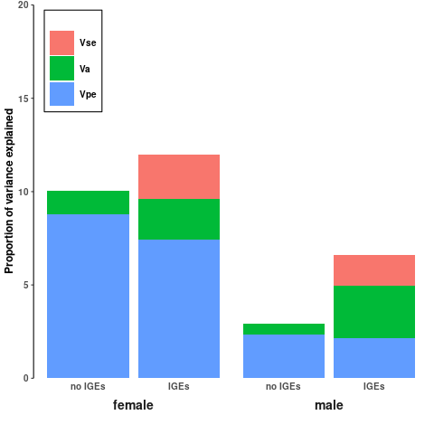  
  
Figure 5: proportion of variance in EPR in males and females on the observed scale. Vse, Va, Vpe represents social partner permanent environment variance, additive genetic variance and direct permanent environment variance. Proportion of variance explanied by residual variation is not shown here. Bars with no IGE represent Va calculated solely from direct additive genetic variance, Bars with IGE represent Va calculated using direct additive genetic variance and social partner IGEs. Va is calculated using outputs from model 1 and model 3 in bars without IGEs and with IGEs respectively.

*Male and EPR heritability estimates*

Heritability and genetic correlation estimates on latent and observed scales are listed in Table 5. The effect of social partner IGEs on total heritable variation and heritability estimates are shown in Figures 4 and 5. I will refer to estimates on the observed scale to allow me to directly compare estimates between male and female EPR. Direct additive genetic variance and direct heritability estimates for both male EPR male and female EPR were close to zero (Table 5) although direct heritability estimates for female EPR was slighter greater than estimates for Male EPR, these estimates did not vary significantly across models (Figure 5). Inclusion of social genetics effects in EPR animal models increased model fit for male and female EPR (Table 5). Female EPR heritability increased slightly when IGEs were included but CIs were still close to zero (Figure 5). Social Partner IGEs accounted for more additive genetic variance in males than direct genetic effects (Table S_, Figure 5) and increased Male EPR heritability estimates although CIs were still close to zero (Table 5, Figure 5). Covariation between direct and indirect genetic effects for male and female EPR were both moderately negative but overlapped 0 () and reduced total heritability estimates for both male and female EPR (Figure 5).

Table 5: Heritability estimates and 95% CIs from prior1 univariate models, genetic correlation estimates and 95% CIs from prior1 bivariate models. Hd, Ht and Vg stand for direct heritability, total heritability and genetic correlations respectively.

|  |  |  |  |  |  |
| --- | --- | --- | --- | --- | --- |
| **Model** | **Parameters** | **H2 + 95% CI** | | **Vg + 95% CI** | |
|  |  | Observed scale | Latent scale | Observed scale | Latent scale |
| **1** | **DGE + PE** | Male: 0.004  <0.001 – 0.016  Female: 0.012  <0.001 – 0.042 | **Male:** 0.024  <0.001 – 0.096  Female: 0.02  <0.001 – 0.067 | 0.09  (-0.84) - 0.94 | 0.089  (-0.84) - 0.943 |
| **2** | **DGE + PE + Partner PE** | **Male:**  0.006  <0.001 – 0.02  **Female:** 0.014  <0.001 – 0.044 | **Male:** 0.04  <0.001 – 0.129  **Female:** 0.023  <0.001 – 0.071 | 0.045  (-0.81) - 0.97 | 0.045  (-0.81) - 0.97 |
| **3** | **DGE + PE**  **+ Partner PE + Partner IGE** | Male: 0.028  <0.001 –0.056  Female: 0.022  <0.001 – 0.056 | Male: 0.14  0.016 - 0.29  Female: 0.035  <0.001 – 0.088 | 0.066  (-0.67) -(0.55) | 0.066  (-0.68) - (0.55) |
| **4** | **cov(Partner IGE and DGE)+ PE + Partner PE** | **Male:** 0.017  <0.001 - 0.040  Female: 0.019  <0.001 - 0.052 | Male: 0.114  0.001 - 0.276  Female: 0.029  <0.001 - 0.083 | _______ | _______ |

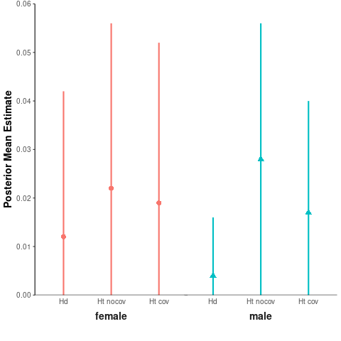

Figure 5: Male and Female Heritability estimates calculated from univariate MCMCglmm models. The points present the posterior mean estimates and the lines represent the scope of the 95% CIs. Hd is the direct heritability estimated from model 1, Ht nocov is the totality heritability estimated from model 3 and Ht cov is the total heritability calculated from model 4.

*Genetic correlation estimates between Male and Female EPR*

Genetic correlation estimates are listed in Table 5. Genetic correlation estimates between male and female EPR were slightly positive but CIs greatly overlapped zero as shown in Figure 6. The addition of IGEs to genetic correlation estimates produced slightly negative correlations, but CI still overlapped zero (Figure 6).

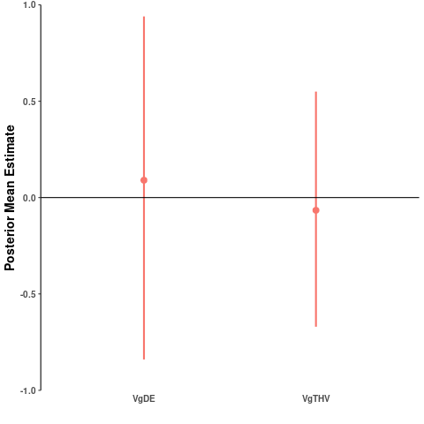

Figure 6: genetic correlation estimates calculated from MCMCglmm bivariate models. The points present the posterior mean estimates and the lines represent the scope of the 95% CIs. VgDE is the genetic correlation derived from the direct additive genetic variance from male and female EPR. VgTHV is the gene correlation dervied from the total heritable variation from male and female EPR. VgDE is calculated from model 1, VgTHV is calculated from model 3.

**Discussion**

*The effect of social IGEs on Female and Male EPR Heritability*

My models suggest that additive genetic variance and direct heritability for male and female EPR are negligible in the Lundy house sparrow populations, which are similar findings to what has been found in other socially monogamous populations (**Grinkov et al., 2020; Reid 2011 etc**). While the addition of social partner IGEs did slightly increase heritability estimates, they also increased the uncertainty of both male and female heritability estimates. Therefore, total heritable variation and total heritability estimates for male and female EPR remained negligible. These findings suggest that it is unlikely that there is enough heritable variation in male and female EPR for selection to act on (**Jennions and Petrie 2000; Evans and Simmons 2008**). There are several possibilities for why low Va and heritabilty were estimated.

(1) the complexity of the models I used meant they were unable to precisely detect social partner IGEs in the data available. This could be the case as increasing the complexity of the models resulted in an increase in the uncertainty in variance estimates. However, simulations suggest that data comprising of 700 + unique groups is enough to detect IGEs using animal models (Bijma et al. 2013). However, my dataset contained 793 unique breeding pairs and the pedigree I used includes almost all the birds that have lived on Lundy since 2000, which makes estimating Va in the animal models very precise (**Grinkov et al., 2020**). Therefore, this explanation is unlikely.

(2) EPR is not genetically determined in the Lundy House Sparrow Population. EPR could be a behavioural biproduct of genes facilitating other reproductive behaviours for both sexes (Grinkov et al., 2020; 2022) and only occur when the opportunity arises in very context specific situations (Beck et al., 2020). Negligible EPR heritability is commonly found across different socially monogamous populations (Grinkov et al., 2020; Wang et al., 2020; Forstiemer et al., 2011, Reid, 2011) and low within individual repeatability of EPR for both males and females has also been reported (Beck et al., 2020). High residual variation in my own male and female EPR in mine and other studies’ models indicate that the trait is very flexible (Grinkov et al., 2020; Wang et al., 2020).

(3) I estimated the heritability of EPR instead of EPCs. Genes will directly influence EPCs instead of EPR for both males and females and not all EPC results in EPR in the lundy house sparrow population (Grindt et al., 2017), therefore while EPC may very commonly take place in the population, this remains undetected in EPR estimates (Beck et al., 2020). This means that EPR variance estimates may be biased downwards compared to EPC variance estimates, which in turn affects heritability estimates. Studies in a captive population of zebra finches where the EPR heritability in males and female are comparable to that of the lundy sparrows, EPC and EPB heritability estimates are more substantial and significantly higher than estimates of EPR in both males and females (Forstemeir et al., 2011; Wang et al., 2020). However, while measuring EPC rates may give us a better representation of genes influencing EPR, EPCs are incredibly difficult/ impossible to record in natural populations (Beck et al., 2020), and EPR measurements in wild populations are more evolutionary relevant than EPC measurements in captive populations as genes are passed on to the next generation through EPR rather than EPC and individuals in captive environments may not undergo the assortive mating that individuals in wild populations undergo which may skew EPR and EPC heritability estimates (Reid and Wolak, 2018; Wang et al., 2020).

Despite not significantly increasing heritability estimates, models containing social IGEs increased model fit across male and female EPR models, which suggests that social IGEs do contribute to male and female EPR. Therefore, due to this and possible underestimation in both male and female heritability I will still consider the effect the addition of social partner IGEs had on EPR heritability estimates despite these changes not being significant or great in magnitude.

While social partner IGEs increased and contributed to total female heritability, they contributed more substantially to total male EPR heritability, accounting for more total additive genetic variance than male direct genetic effects and explained the largest proportion phenotypic variation in male EPR. Males can be greatly influenced by their social partner. This is not surprising as males whose social partners partake in EPC are not only losing out on siring offspring, but also suffer an energetic cost from parental provisioning and so adjusting their own behaviour in response to the female may be a strategy to protect against this (Roth et al., 2019). It has been shown that in social pairs males can change their behaviour in response to the behaviour of the female: this includes decreased parental provisioning in response to male EPR (Hsu et al., 2016), **other examples.** EPR behavior in males can be sensitive to social environment effects at large: with increased male EPO siring success being associated with increased social interactions with neighbouring females (Becks et al., 2021), and decreased competitive ability of nearby male neighbours (Becks et al., 2020). However, no social environment effects were found to affect EPR rates in females (Becks et al., 2021). This suggests social partner IGEs do can contribute substantially to male EPR heritability estimates specifically and that both environmental and genetic aspects of the social environment should be accounted for when estimating both male and female EPR.

*The effect of social partner IGEs on genetic correlation estimates between male and female EPR.*

I detected no evidence genetic correlations between male and female EPR using direct additive genetic variance, which echos findings in other socially monogamous study systems (Reid and Wolak, 2018; Wang et al., 2020). The addition of social IGEs did not change this but did decrease uncertainty in those estimates. Between-sex genetic correlations are notoriously difficult to estimate, especially in wild populations (), and previous attempts at measuring between-sex genetic correlations have reflected this (Reid and Wolak, 2018). Its possible that this high degree of uncertainty is due to the negligible variation available for male and female EPR , which makes any genetic correlations between female and male EPR improbable and difficult to estimate **(Falconer and Bush, 1998; Travers et al., 2016**). High degree of uncertainty may possibly hide weak positive or negative genetic correlations exist between female and male EPR (**Reid and Wolak, 2018**). Further genetic correlation simulations on dummy datasets could help shed light on this (**Reid and Wolak, 2018**).

Even if positive genetic correlations between male and female EPR existed, this does not automatically mean that female EPR remains in the population due to additonal pleotropic benefits to male lifetime reproductive success as male EPR may not increase lifetime reproductive success. For example, in pursuit of extra pair matings males may mate guard less, resulting in less WPO being sired (). Genes associated with siring EPO are also associated with siring WPO, which could mean that the mating strategies are interchangeable and do not change the overall fitness of the male (Reid and Wolak, 2018). EPO has been shown to have reduced fitness compared to WPO (Hsu et al., 2015) which could male EPR could be detrimental to male lifetime reproductive success. Therefore, it seems unlikely that female EPR is maintained in socially monogamous populations due to additional pleiotropic effects on male lifetime reproductive success. Therefore, alternative maladaptive hypotheses for why female EPR persists in socially monogamous populations should be considered. The first is that female EPR is linked with other female reproductive traits in the female (Forstemier et al., 2014), evidence for which has been detected for in captive populations (Wang et al., 2020).

*Limitations*

Total heritability estimates may have been underestimated due to extra pair partner IGEs not being included in models, as they can also influence the EPB of individuals alongside the social partner (Maldonado-Chaparro et al., 2018; Beck et al., 2020). However, I could not include these in the models because not all EPC result in EPR reproduction (Grindt et al., 2015), therefore not all extra pair partners could be known for every individual. Due to constraints with the MCMCglmm package, I was unable to estimate covariation between direct and indirect genetic effects in bivariate models, however univariate models showed no evidence of covariation for both males and females. Therefore, it seems likely that modelling covariation in a bivariate model would have also produced the same results. The quality of the breeding location has been identified as affecting female EPR in other socially monogamous populations and the addition of this affect did effect EPR estimates and decrease heritability estimates (Grinkov et al., 2020; 2022). Therefore, this could explain a proportion of the residual variation in my models. However, the Lundy house sparrow population all breed within a very condensed location (~300m2) compared to other socially monogamous populations (Grinkov et al., 2022). The measurements from which they determine breeding territory are larger than the total area where the Lundy house sparrow population breeds. Therefore, I deemed this effect unlikely to affect the Lundy house sparrow population. While the two priors I used were made to suit the data and the resulting bivariate and univariate estimates agreed with each other -it is still possible that the priors were biasing the model estimates. This could be checked by doing gene drops simulations (Reid and Wolak, 2018; Grinkov et al., 2020). However, due to time constraints I could not do this.

*Wider Implications*

My investigation shines light on the genetic basis and the role of social environment on EPR, and how female EPR may be maintained in socially monogamous populations. My findings suggest that the inclusion of social partner IGEs effect can increase male and female EPR heritability estimates, especially males. While EPR heritability estimates overall remained negligable, inclusion of social IGEs using EPC measurements may give more conclusive results. While inclusion of social partner IGEs in genetic correlation estimates between female and male EPR did not change genetic correlation estimates, it did give more precise estimates, possibly due to the increase in total heritable variation, which could lead to less vague conclusions. This first study to my knowledge that considers the effect of IGEs on male and female EPR, and their effect on genetic correlations between male and female EPR. Future studies investigating should consider investigating the intrasexual pleiotropy hypothesis while considering social IGEs.