60 sec, 167 user 🡪

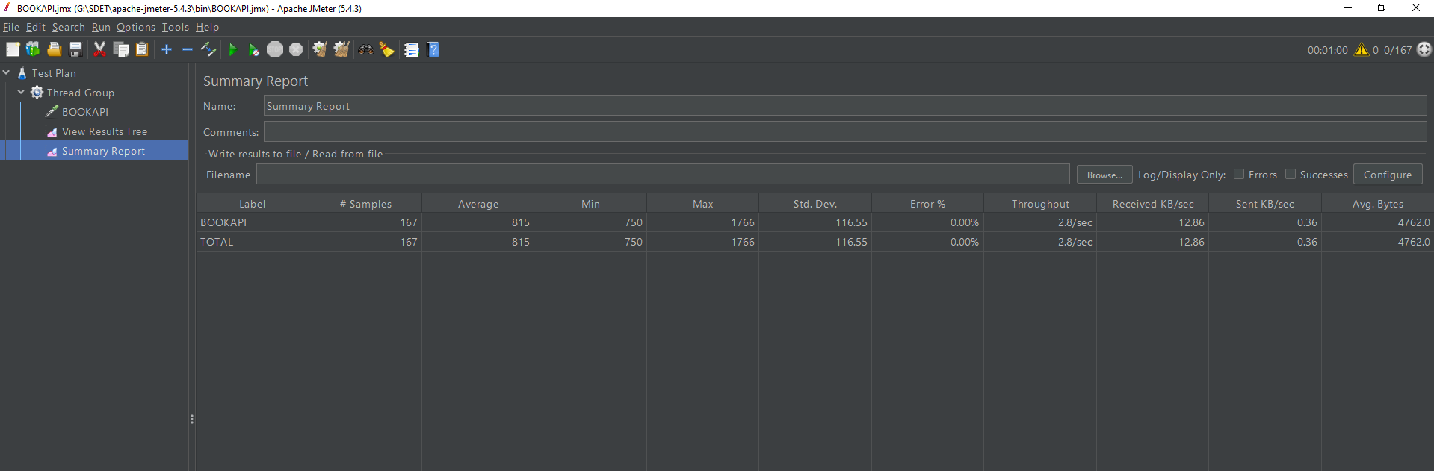

300 sec, 833 user 🡪

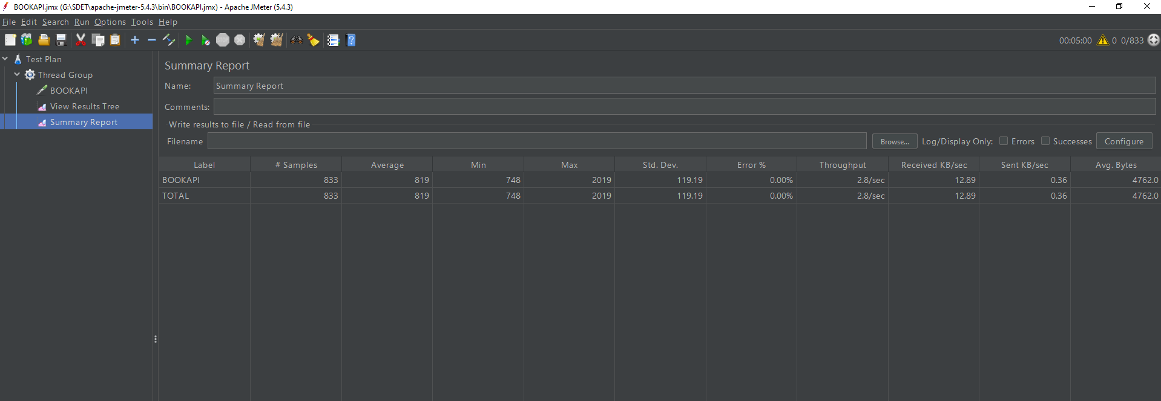

650 sec,1667 user 🡪

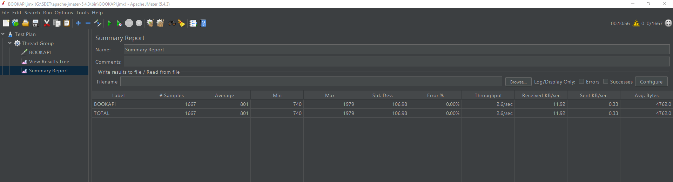

980 sec, 2500 user 🡪

