Hybrid Model

A hybrid model using Free Space Optics (FSO) in data communication combines the advantages of optical communication with wireless transmission.

FSO utilizes laser beams to transmit data through the air, offering high bandwidth and low latency.

In the hybrid model, FSO complements traditional wired or wireless networks, extending connectivity in scenarios where laying cables or deploying radio towers is impractical.

FSO is particularly useful for point-to-point communication over short to medium distances, offering a secure and interference-free transmission.

The hybrid approach integrates FSO links into existing network infrastructure, providing flexibility and redundancy for data transmission.

Here are some additional details:

**High Bandwidth:** FSO technology offers high bandwidth capabilities, making it suitable for transmitting large volumes of data quickly and efficiently.

**Low Latency:** With minimal signal propagation delay, FSO provides low latency communication, which is crucial for applications requiring real-time data transfer, such as video streaming or financial transactions.

**Line-of-Sight Communication:** FSO requires a clear line of sight between transmitter and receiver, which limits its applicability in environments with obstacles like buildings or foliage. However, in situations where line-of-sight conditions can be maintained, FSO provides reliable and secure communication.

**Secure Transmission:** FSO communication is inherently secure since it operates using narrow laser beams that can be easily directed and secured. This makes it suitable for applications where data privacy and security are paramount.

**Interference-Free Operation:** Unlike radio frequency-based wireless communication technologies, FSO operates in the infrared spectrum and is immune to electromagnetic interference. This ensures reliable communication even in congested electromagnetic environments.

**Deployment Flexibility:** FSO can be deployed rapidly without the need for extensive infrastructure setup, such as laying cables or obtaining spectrum licenses. This makes it particularly useful for temporary or emergency communication needs.

**Cost Considerations:** While FSO offers advantages in terms of bandwidth and latency, it may require significant initial investment for equipment and installation. Moreover, ongoing maintenance and alignment of FSO links may incur additional costs.

Hybrid Model Design

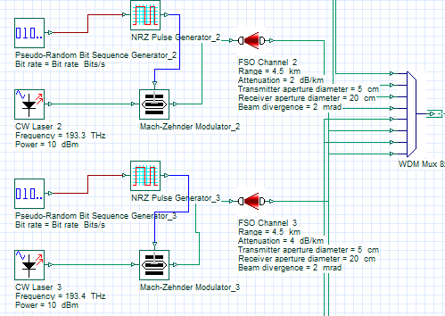**Transmitter Part (Tx):**

**Channel:**

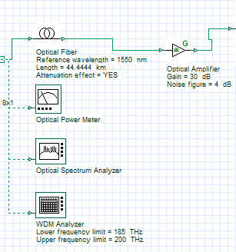

**Receiver Part (Rx):**

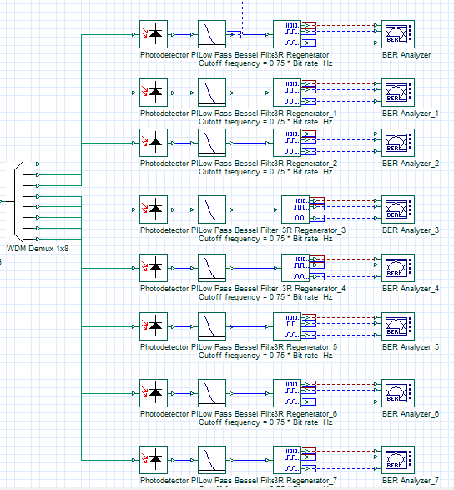

**Full Model:**

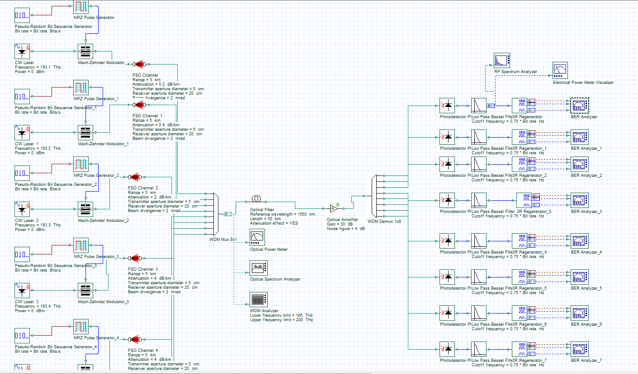

Ber Analyzer Scenario

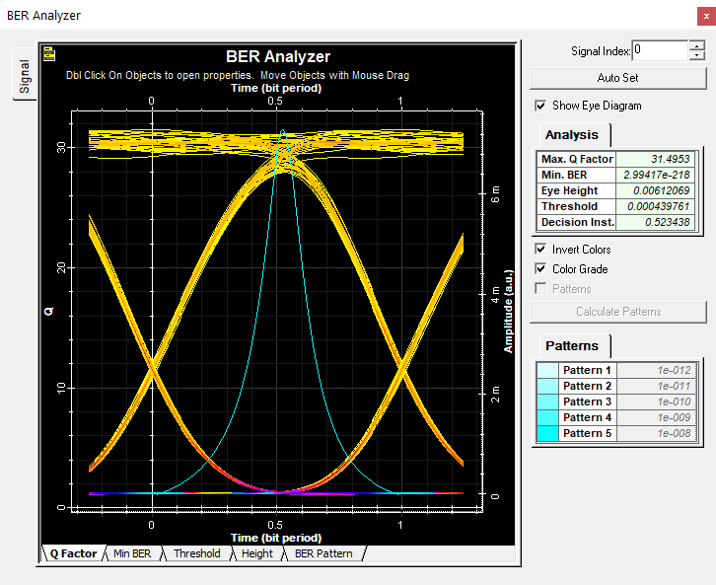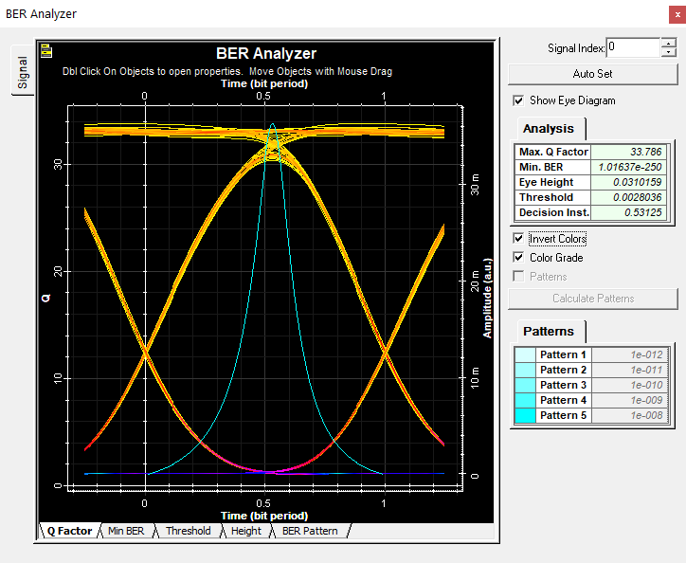

2nd Iteration Q. Factor

1st Iteration Q. Factor

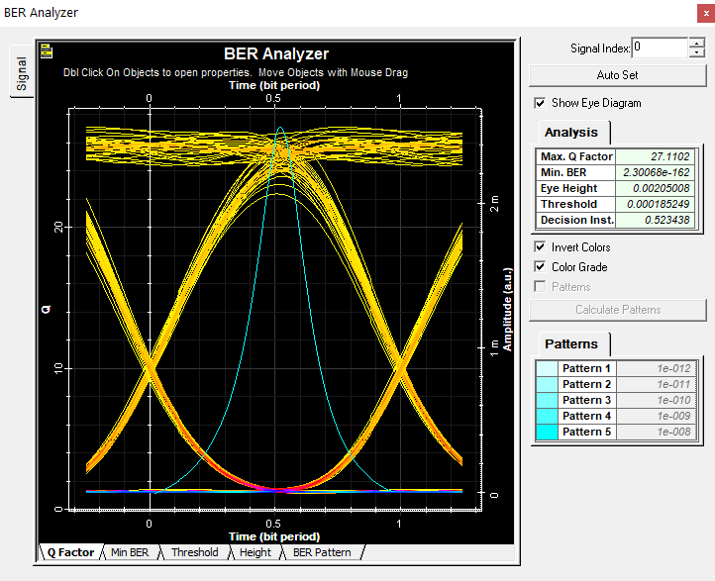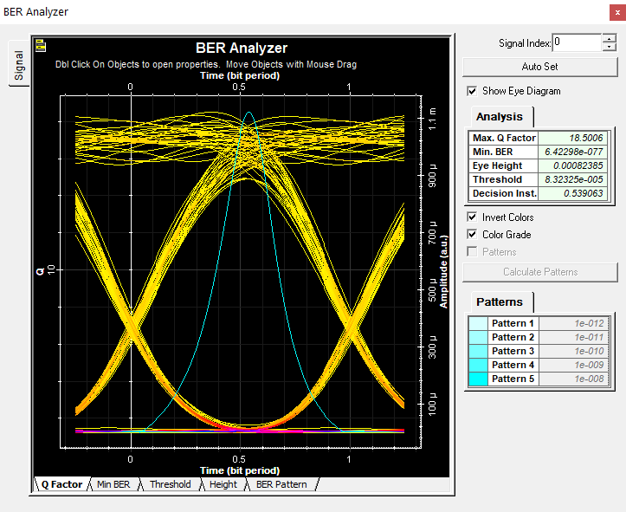

3rd Iteration Q. Factor

4th Iteration Q. Factor

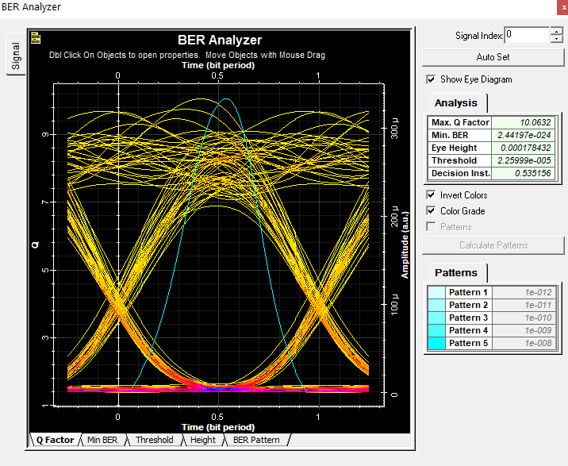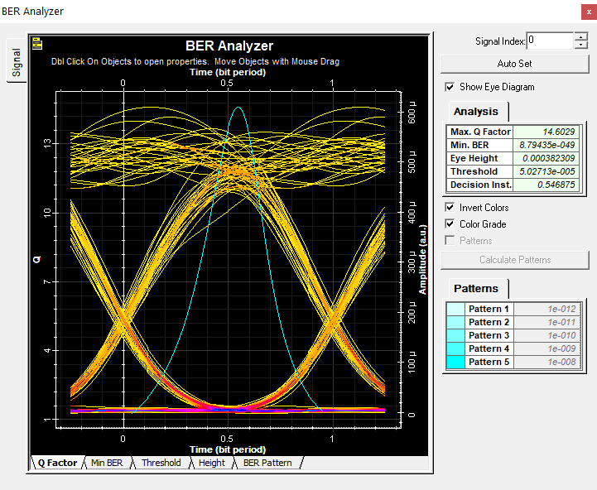

6th Iteration Q. Factor

5th Iteration Q. Factor

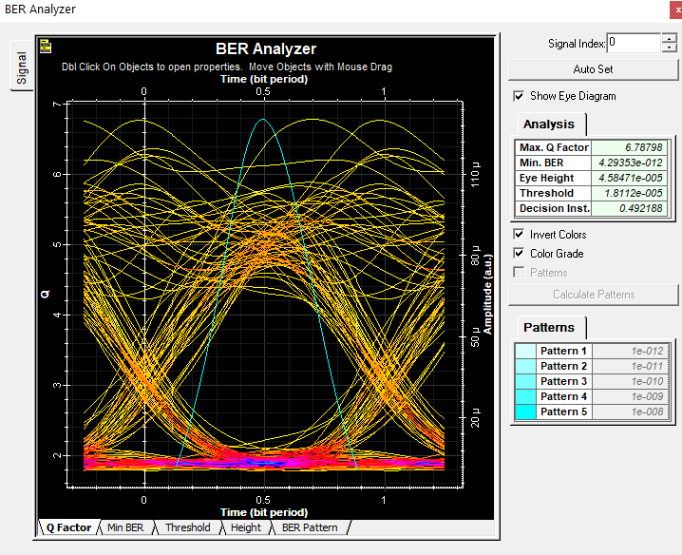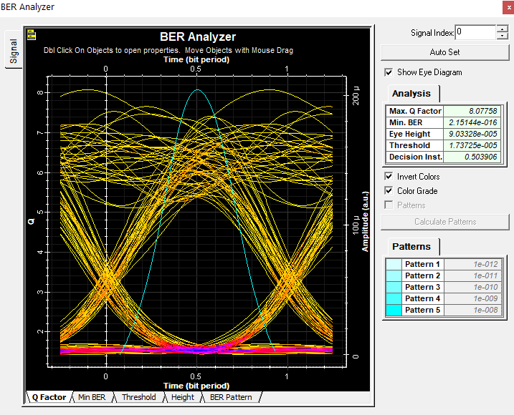

8th Iteration Q. Factor

7th Iteration Q. Factor

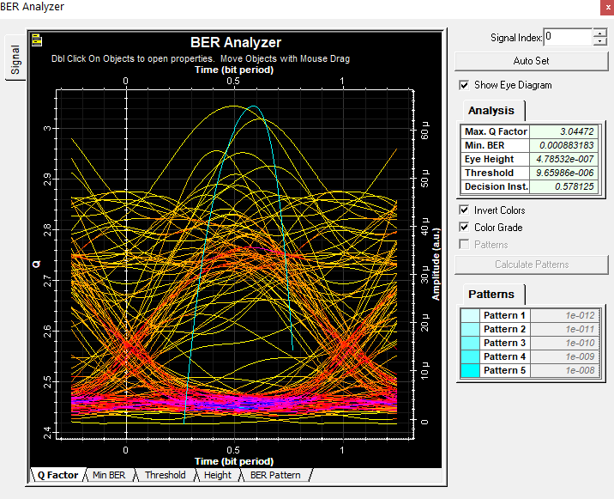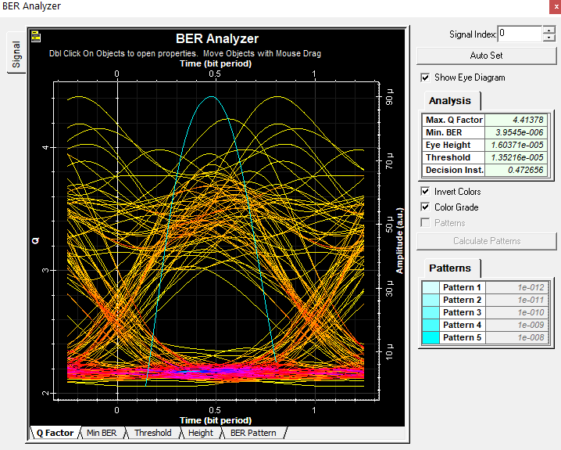

9th Iteration Q. Factor

10th Iteration Q. Factor

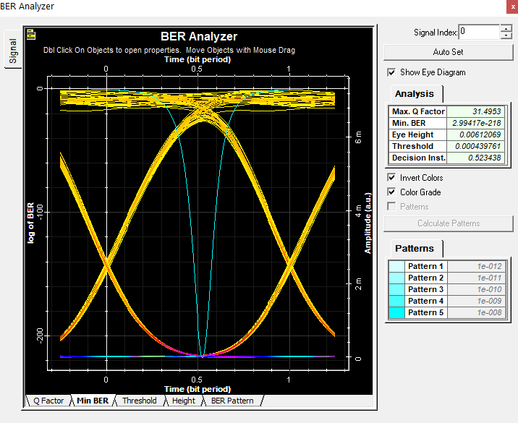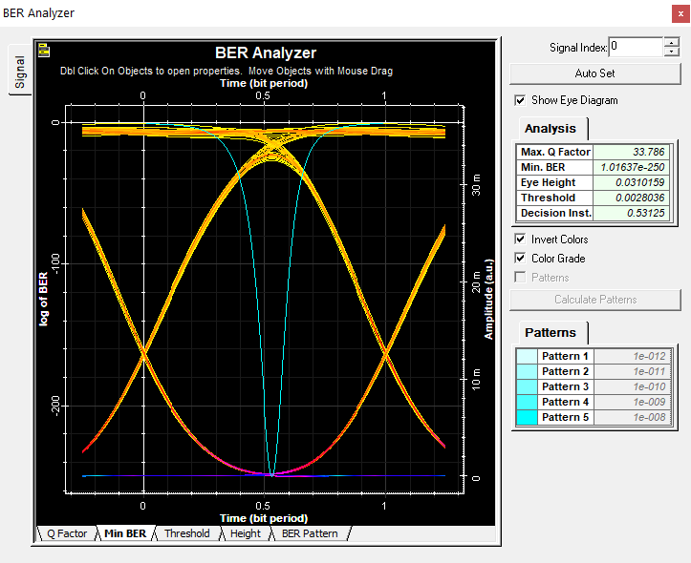

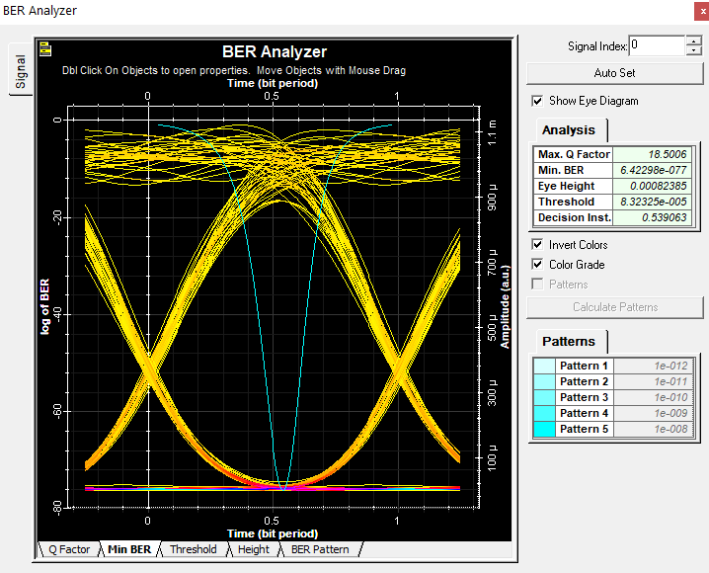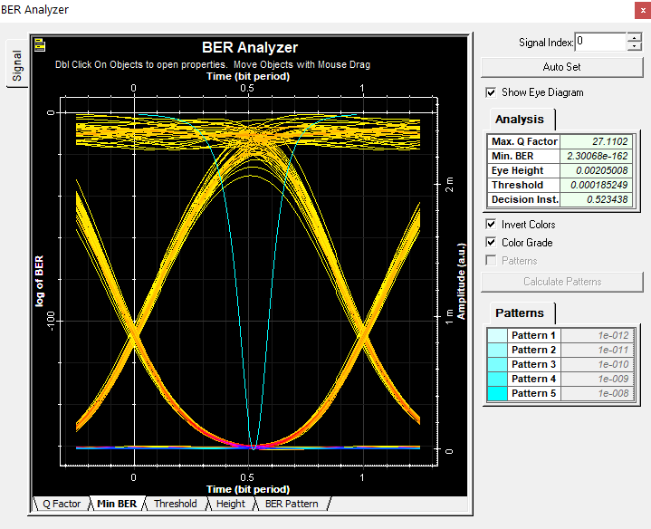

4th Iteration Min BER

3rd Iteration Min BER

2nd Iteration Min BER

1st Iteration Min BER

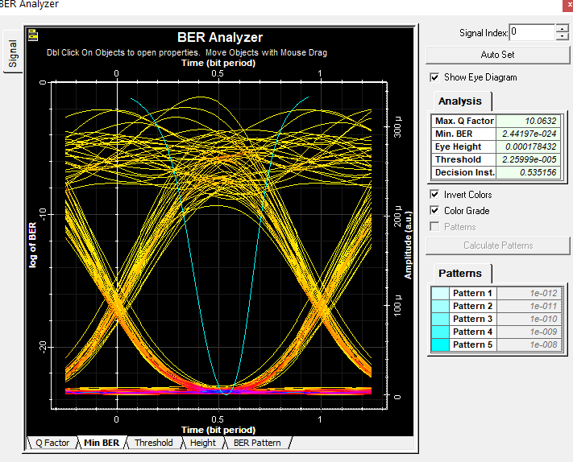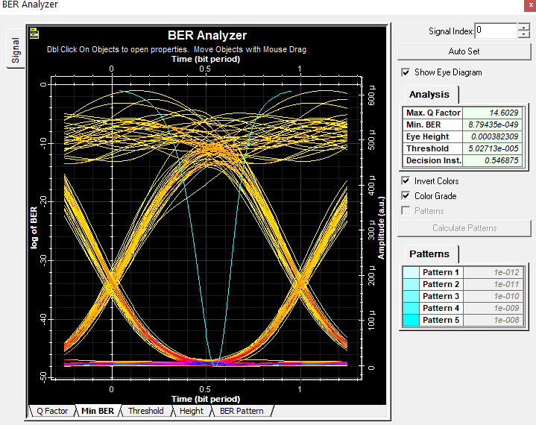

6th Iteration Min BER

5th Iteration Min BER

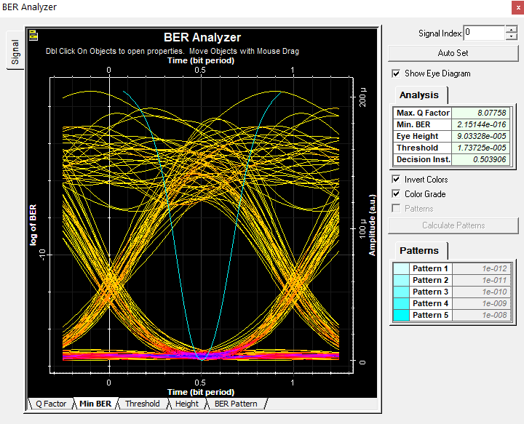

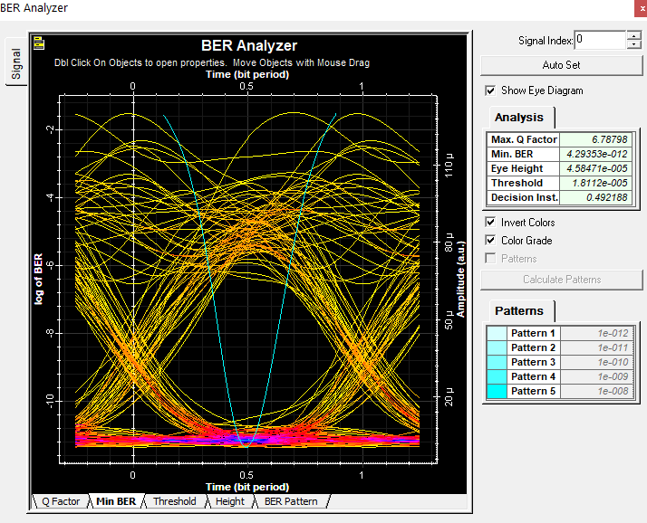

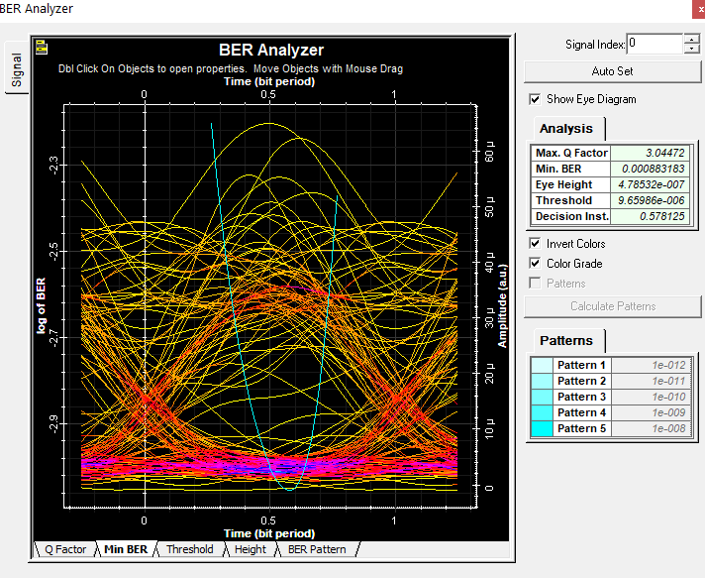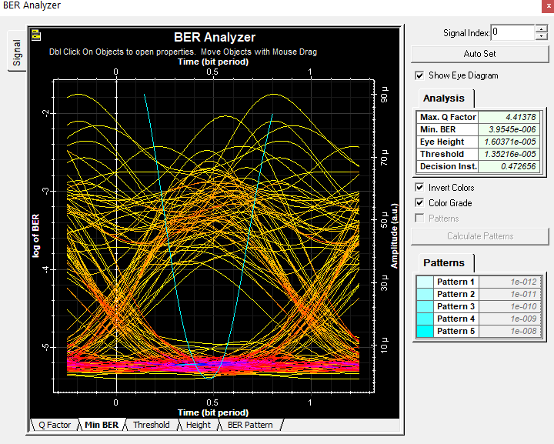

10th Iteration Min BER

9th Iteration Min BER

8th Iteration Min BER

7th Iteration Min BER

WDM Analyzer Scenario

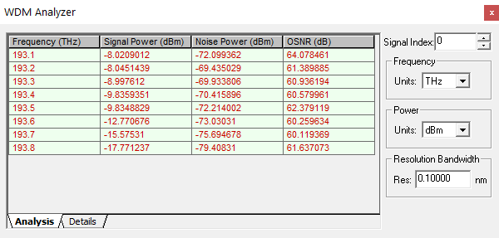

Optical Spectrum Analyzer

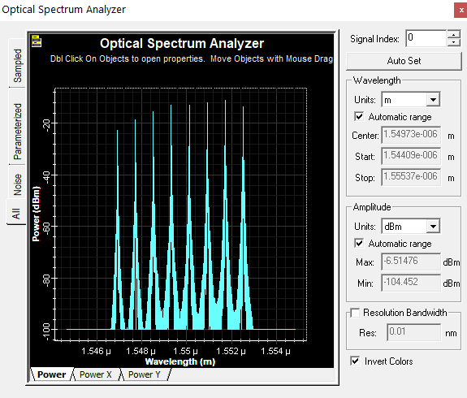

1st Iteration Scenario

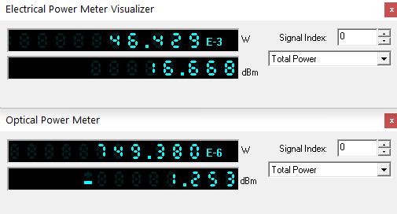Electrical & Optical Power Meter

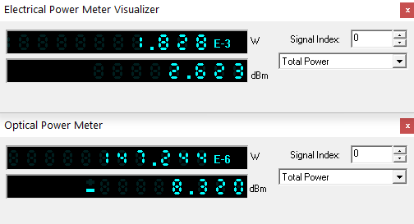

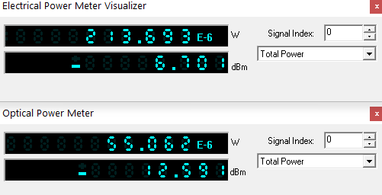

2nd Iteration

1st Iteration

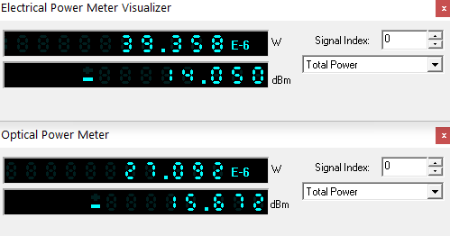

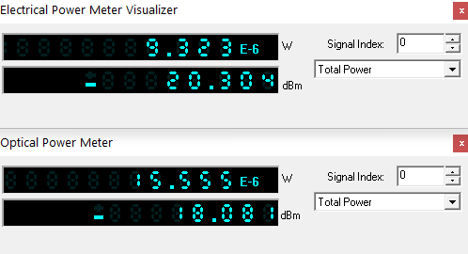

4th Iteration

3rd Iteration

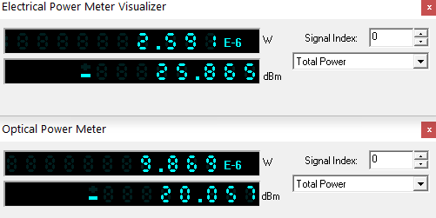

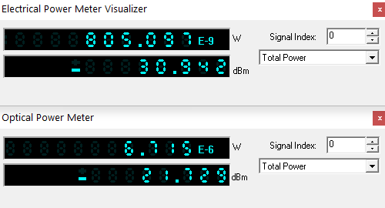

6th Iteration

5th Iteration

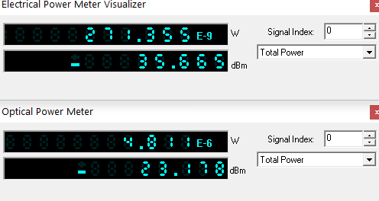

8th Iteration

7th Iteration

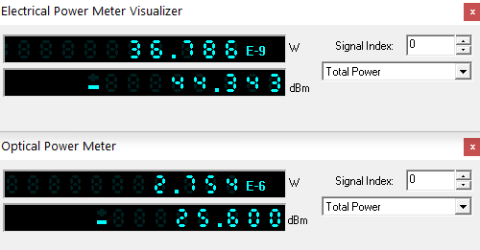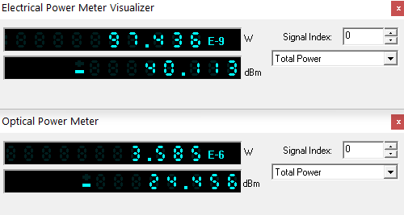

10th Iteration

9th Iteration

RF Spectrum Analyzer

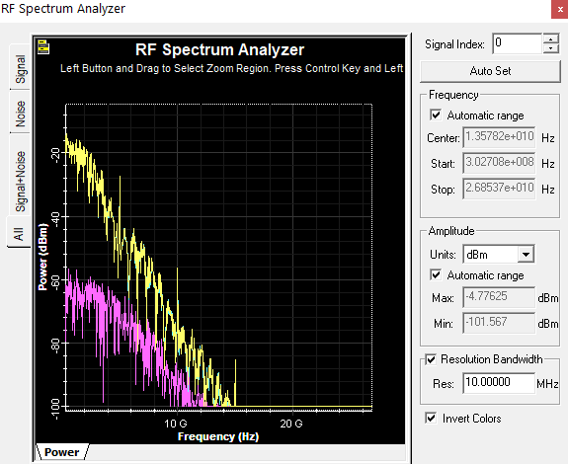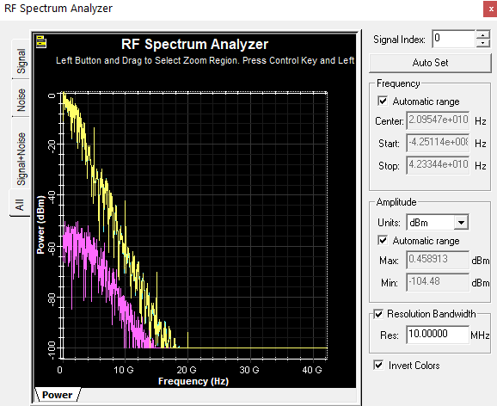

2nd Iteration

1st Iteration

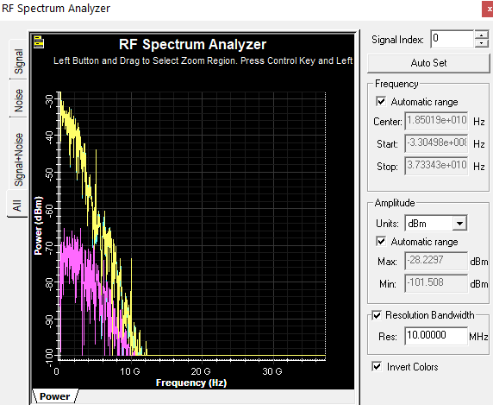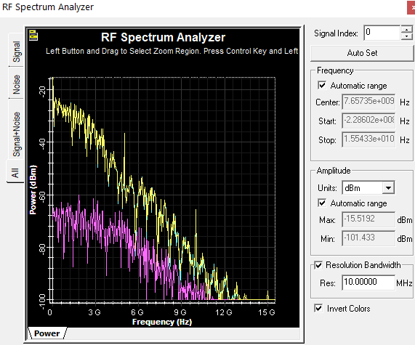

4th Iteration

3rd Iteration

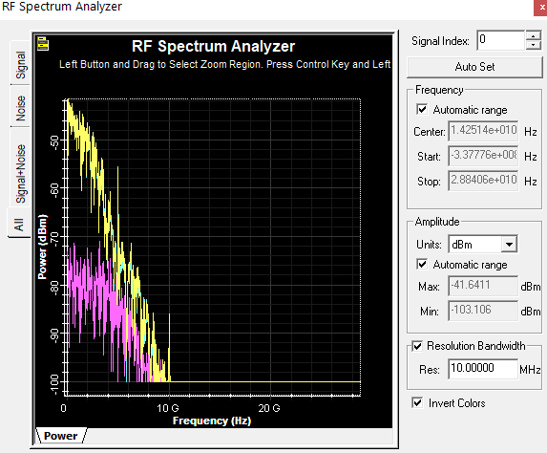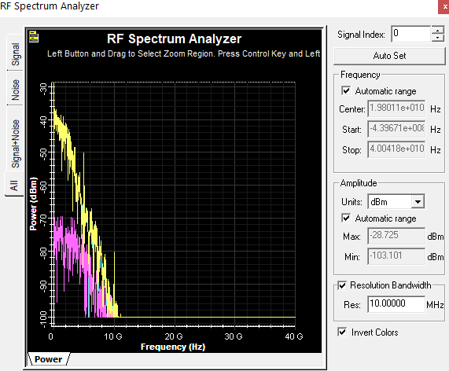

6th Iteration

5th Iteration

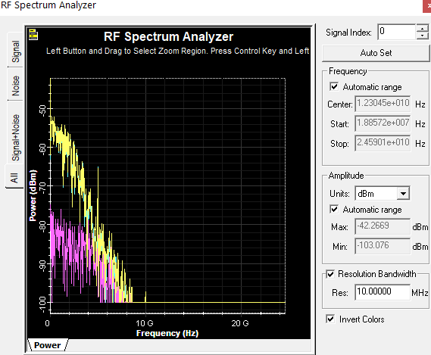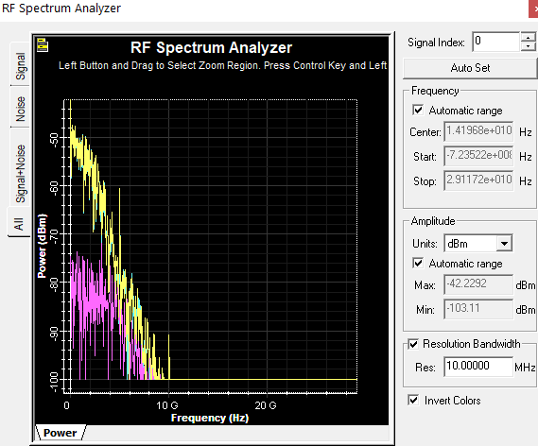

8th Iteration

7th Iteration

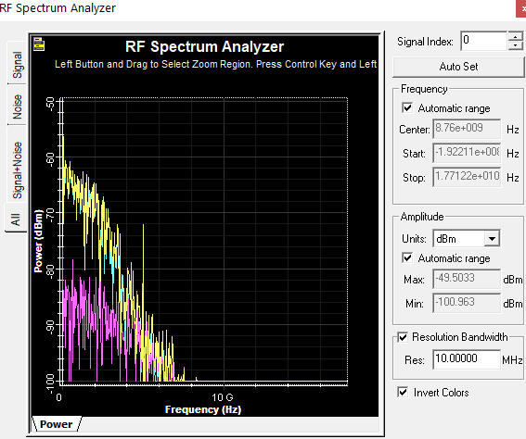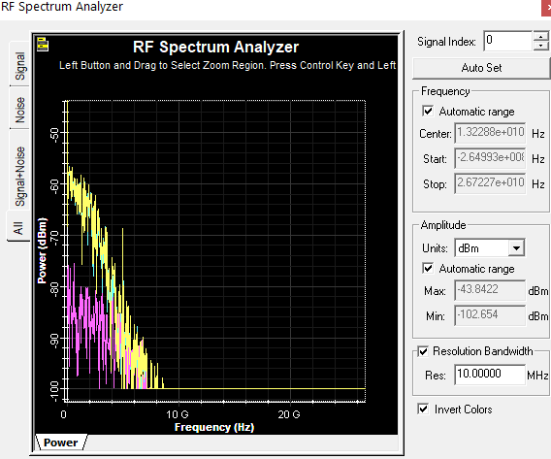

10th Iteration

9th Iteration

Data Table

|  |  |  |  |
| --- | --- | --- | --- |
| Iteration no. | Length(km) | Q.Factor | Log of (Min BER) |
| 1 | 0 | 33.786 | 2.398 |
| 2 | 5.55 | 31.4953 | 2.338 |
| 3 | 11.11 | 27.1102 | 2.209 |
| 4 | 16.67 | 18.5006 | 1.886 |
| 5 | 22.22 | 14.6029 | 1.690 |
| 6 | 27.78 | 10.0632 | 1.380 |
| 7 | 33.33 | 8.07758 | 1.204 |
| 8 | 38.89 | 6.78798 | 1.079 |
| 9 | 44.44 | 4.41378 | 0.778 |
| 10 | 50 | 3.04472 | 0.602 |

