**Prepared for,**

Dr. Muhammad Towfiqur Rahman

Assistant Professor

Department of CSE

University of Asia Pacific

**Prepared By,**

Sadman Bin Khorhsed Amio

ID: 21201201

Section: D2

Department: CSE

Basic Optical Communication Model

Report

Date: 08/02/2024

Introduction

Optical communication refers to the transmission of information using light as the carrier signal. This method of communication relies on optical fibers or free-space optics to transmit data over long distances with high bandwidth and minimal signal loss. Here's a brief background on optical communication:

**Historical Context:** The concept of using light for communication dates back to ancient times when smoke signals, signal fires, and beacon towers were used to convey messages over long distances. However, modern optical communication as we know it today began to take shape in the late 19th and early 20th centuries with the invention of devices like the photophone by Alexander Graham Bell.

**Invention of Optical Fibers:** In the 1960s, the development of low-loss optical fibers revolutionized communication technology. These thin strands of glass or plastic could transmit light over long distances with minimal signal degradation. This breakthrough paved the way for the widespread adoption of optical communication systems.

**Advantages over Electrical Communication:** Optical communication offers several advantages over traditional electrical communication methods, such as coaxial cables or copper wires. These advantages include higher bandwidth, lower signal attenuation, immunity to electromagnetic interference, and greater security due to the difficulty of tapping into optical signals.

**Key Components:** Optical communication systems consist of various components, including lasers or light-emitting diodes (LEDs) as light sources, optical fibers as the transmission medium, photodetectors to convert light signals back into electrical signals, and optical amplifiers to boost signal strength for long-distance transmission.

Overall, optical communication has revolutionized the way information is transmitted, enabling faster, more reliable, and more secure communication networks essential for the modern digital age.

Related Works

In 1880 Alexander Graham Bell and his assistant Charles Sumner Tainter created a very early precursor to fiber-optic communications, the Photophone, at Bell's newly established Volta Laboratory in Washington, D.C. Bell considered it his most important invention. The device allowed for the transmission of sound on a beam of light. The Photophone's first practical use came in military communication systems many decades later.

The second generation of fiber-optic communication was developed for commercial use in the early 1980s, operated at 1.3 μm and used InGaAsP semiconductor lasers. These early systems were initially limited by multi-mode fiber dispersion, and in 1981 the single-mode fiber was revealed to greatly improve system performance, however practical connectors capable of working with single mode fiber proved difficult to develop. Canadian service provider SaskTel had completed construction of what was then the world's longest commercial fiber optic network, which covered 3,268 km (2,031 mi) and linked 52 communities.[11] By 1987, these systems were operating at bit rates of up to 1.7 Gb/s with repeater spacing up to 50 km (31 mi).

Third-generation fiber-optic systems operated at 1.55 μm and had losses of about 0.2 dB/km. This development was spurred by the discovery of indium gallium arsenide and the development of the indium gallium arsenide photodiode by Pearsall.

The fourth generation of fiber-optic communication systems used optical amplification to reduce the need for repeaters and wavelength-division multiplexing (WDM) to increase data capacity. The introduction of WDM was the start of optical networking, as WDM became the technology of choice for fiber-optic bandwidth expansion.

The focus of development for the fifth generation of fiber-optic communications is on extending the wavelength range over which a WDM system can operate. The conventional wavelength window, known as the C band, covers the wavelength range 1525–1565 nm, and dry fiber has a low-loss window promising an extension of that range to 1300–1650 nm

In the late 1990s through 2000, industry promoters, and research companies such as KMI, and RHK predicted massive increases in demand for communications bandwidth due to increased use of the Internet, and commercialization of various bandwidth-intensive consumer services, such as video on demand.

System Model Design

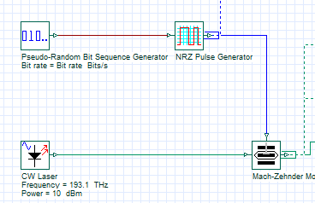Transmitter [Tx]

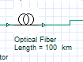Channel [Ch]

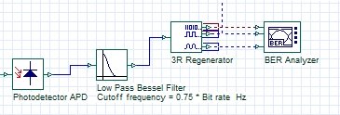Receiver [Rx]

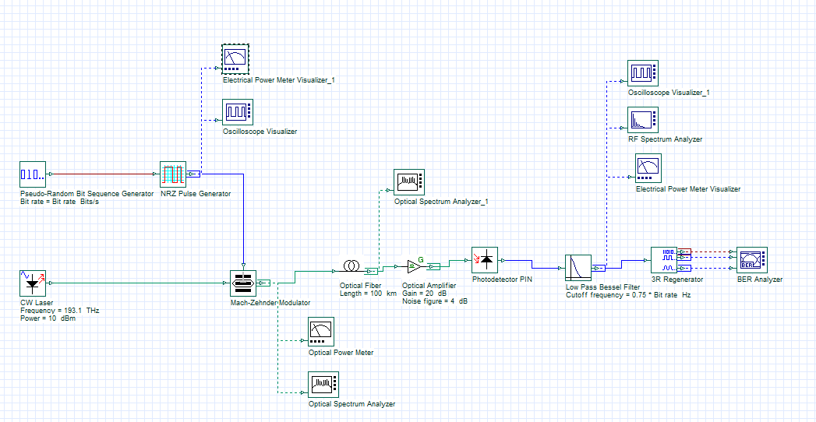Complete Model

Optical Spectrum Analyzer

The Optical Spectrum Analyzer (OSA) feature in OptiSystem plays a crucial role in the design, simulation, and optimization of optical communication systems by providing detailed spectral analysis and insights into signal characteristics. It shows the power(dBm) vs wavelength(m) graph. 10 iteration OSA graph is given below:

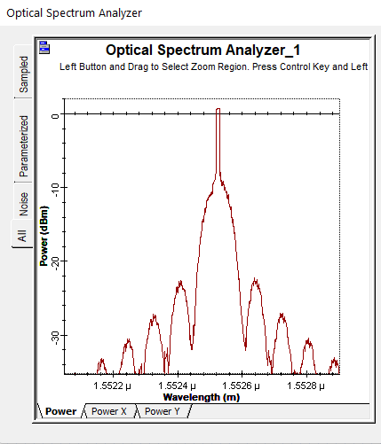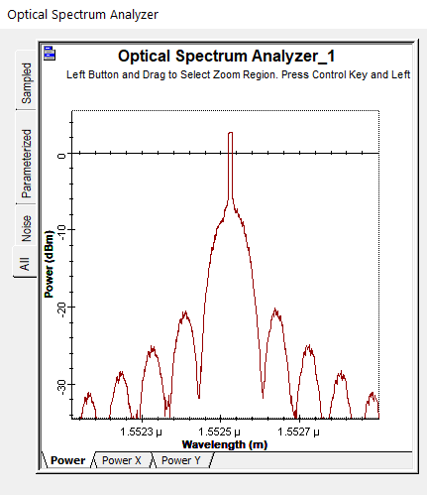

2nd Iteration

1st Iteration

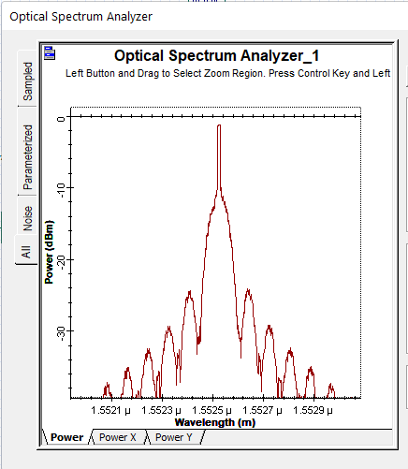

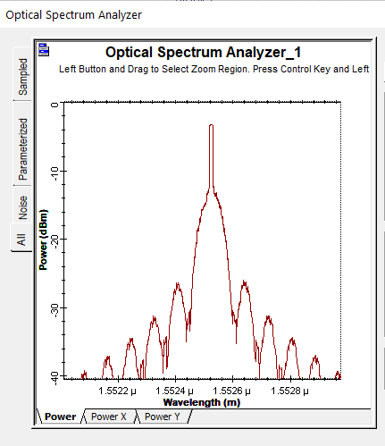

4th Iteration

3rd Iteration

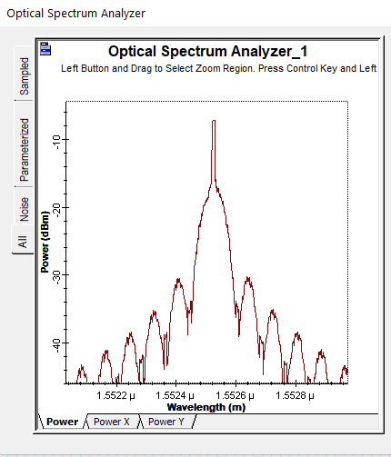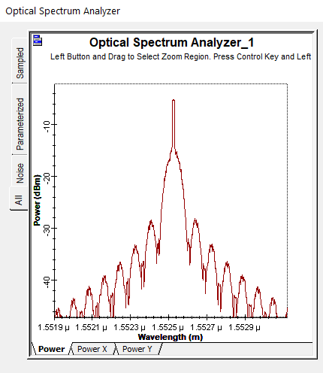

6th Iteration

5th Iteration

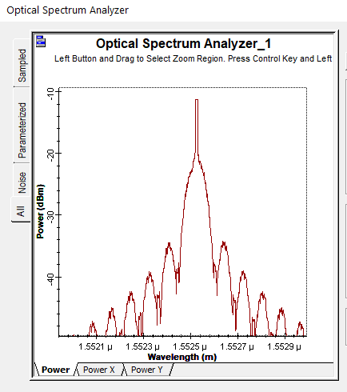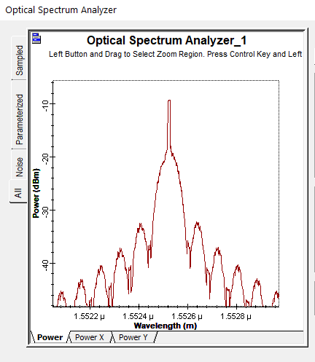

8th Iteration

7th Iteration

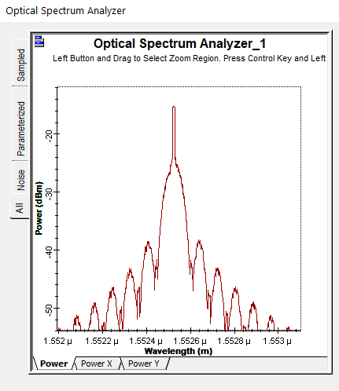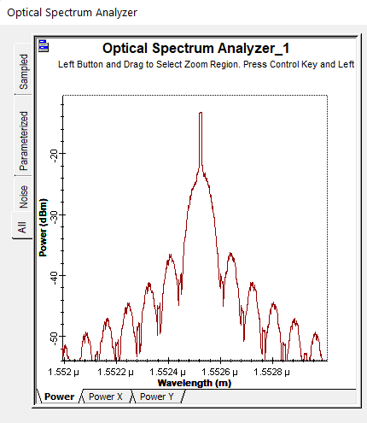

10th Iteration

9th Iteration

Oscilloscope Visualizer

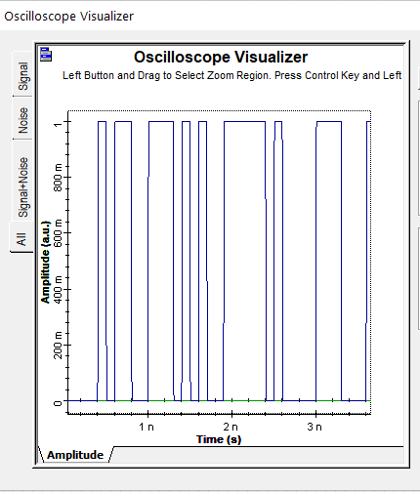The oscilloscope functionality in OptiSystem provides valuable insights into the temporal behavior of optical signals, enabling users to analyze signal quality, optimize system performance, and troubleshoot potential issues in optical communication systems. It shows the signal level how much affected by the other medium. Here given 10 iteration result:

Transmitted Signal

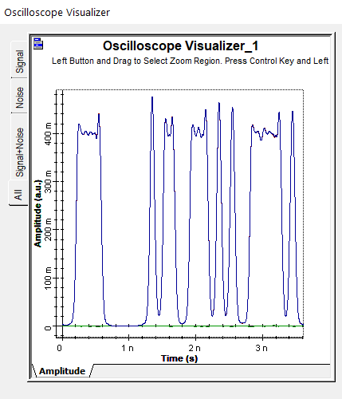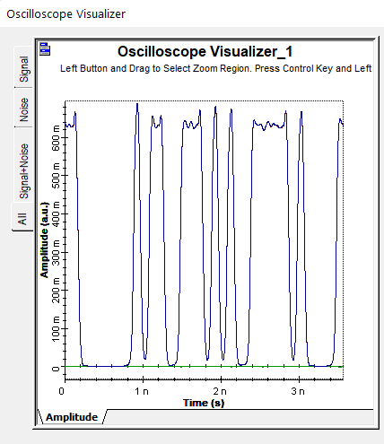

2nd Iteration Signal

1st Iteration Signal

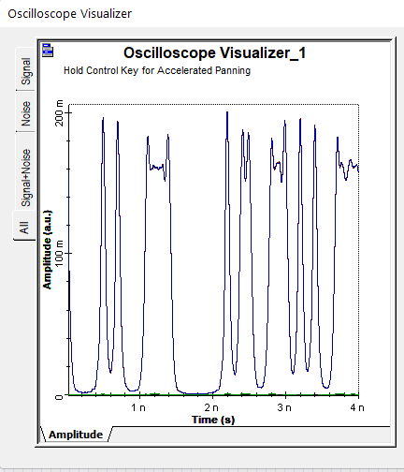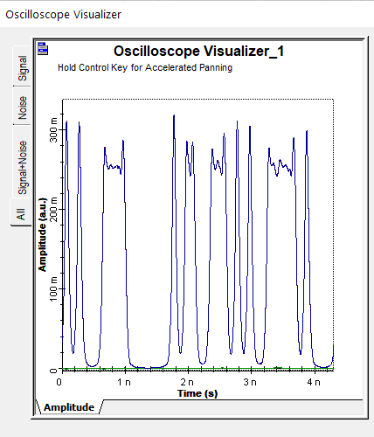

4th Iteration Signal

3rd Iteration Signal

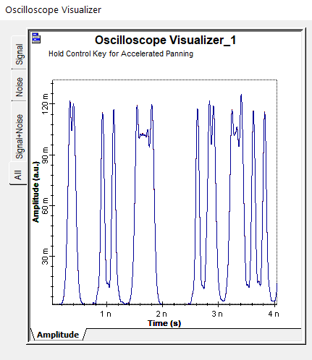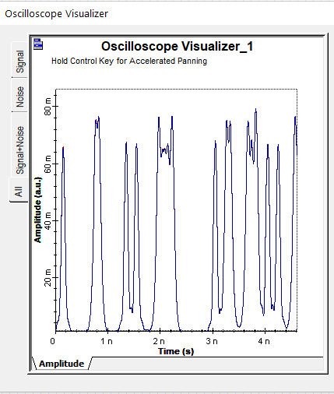

6th Iteration Signal

5th Iteration Signal

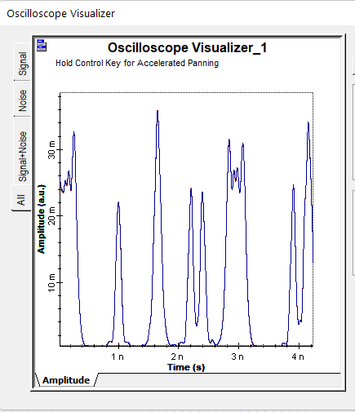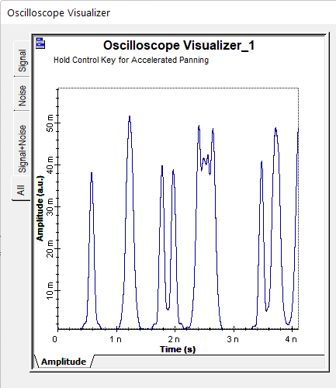

8th Iteration Signal

7th Iteration Signal

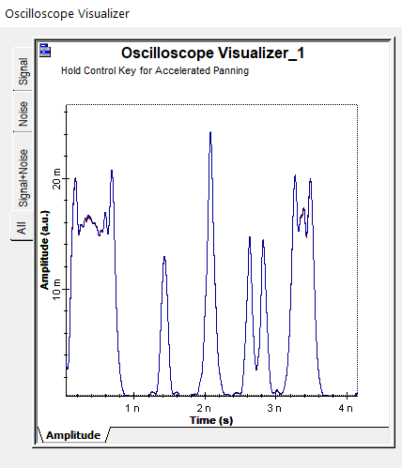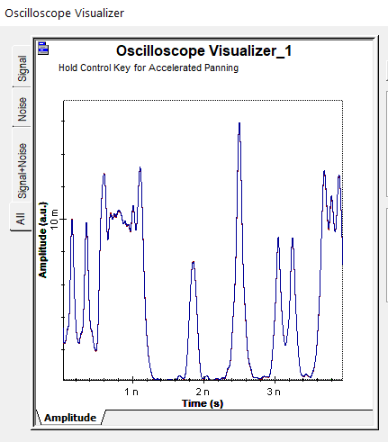

10th Iteration Signal

9th Iteration Signal

Transmitted Power & Received Power [Tx, Rx] (Power Loss)

Electrical Power Meter measure the electrical Power of the model. From where we can measure the power loss. Here are the 10 Iteration power outputs:

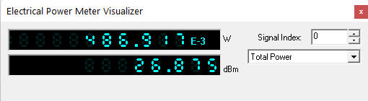

Transmitted Power

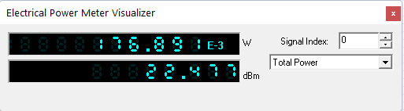

Power Loss = 26.875 – 22.477 = 4.395

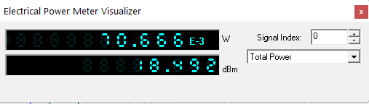

Power Loss = 26.875 –18.492= 8.383

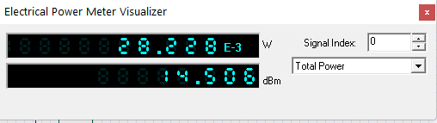

Power Loss = 26.875 – 14.506= 12.369

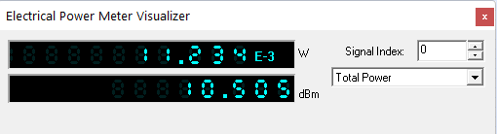

Power Loss = 26.875 – 10.505 = 16.37

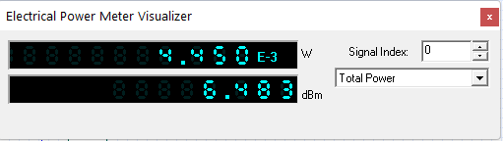

Power Loss = 26.875 – 6.483 = 20.392

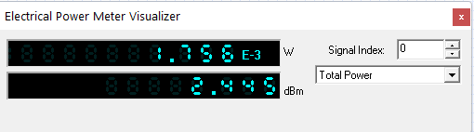

Power Loss = 26.875 – 2.445 = 24.43

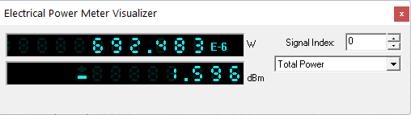

Power Loss = 26.875 +1.596 = 28.471

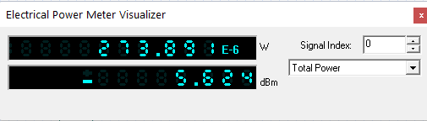

Power Loss = 26.875 + 5.624 = 32.499

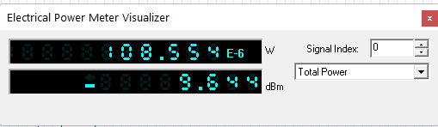

Power Loss = 26.875 + 9.644 = 36.519

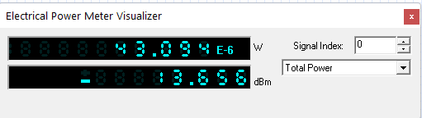

Power Loss = 26.875 + 13.656 = 40.531

RF Spectrum Analyzer (Bandwidth)

A radio frequency (RF) spectrum analyzer is a device used to analyze the frequency spectrum of radio frequency signals. It detects and displays the amplitude (strength) of various frequency components in the signal.

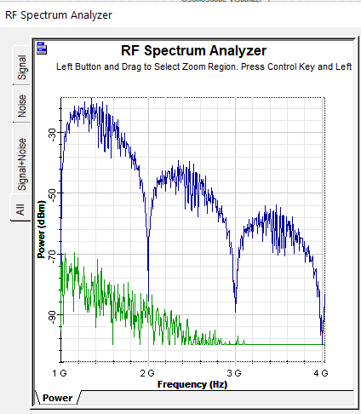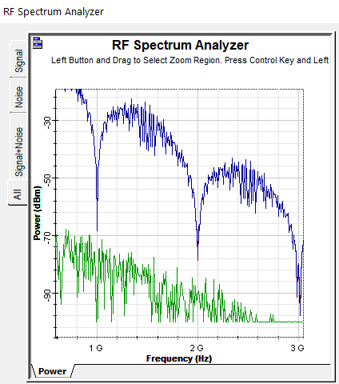

Distance = 20 KM

Distance = 10 KM

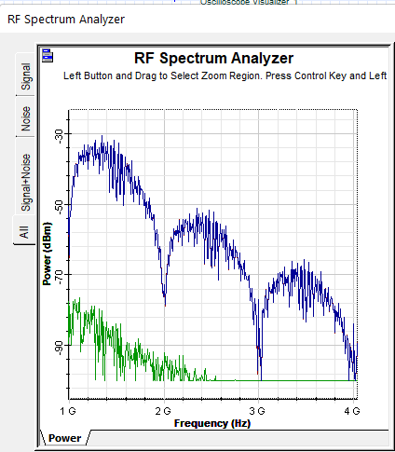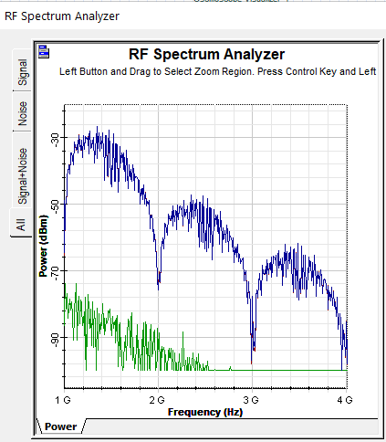

Distance = 40 KM

Distance = 30 KM

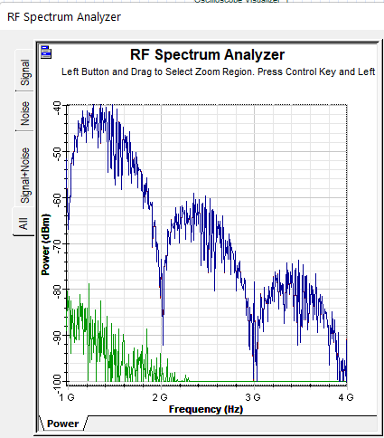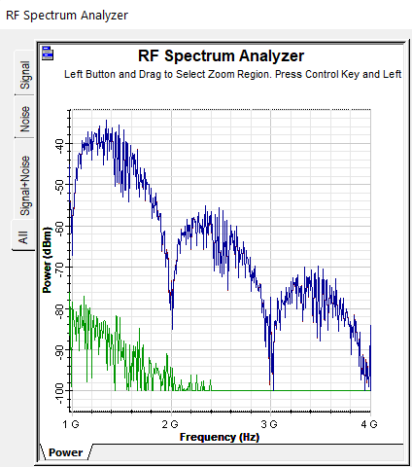

Distance = 60 KM

Distance = 50 KM

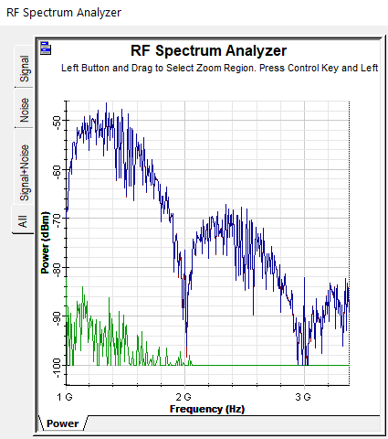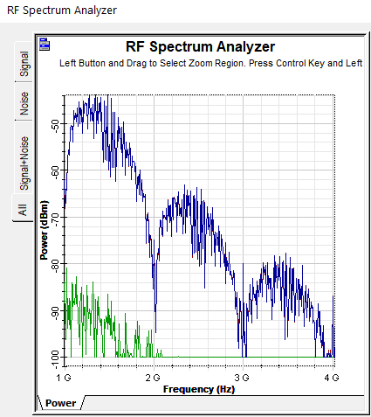

Distance = 80 KM

Distance = 70 KM

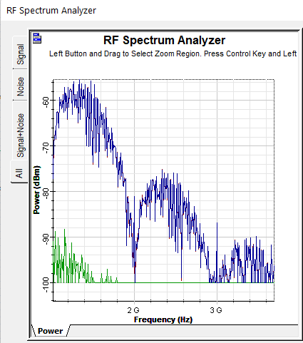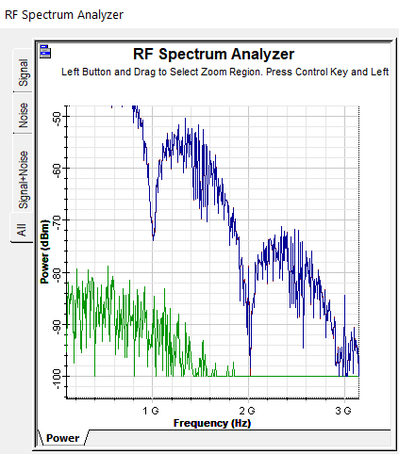

Distance = 100 KM

Distance = 90 KM

BER Analyzer

A Bit Error Rate (BER) Analyzer is a specialized instrument used to measure the bit error rate of digital communications systems. The BER is a key metric that quantifies the number of bit errors occurring in a transmission relative to the total number of transmitted bits. It's a critical parameter for evaluating the performance and reliability of digital communication links. Utilizing the BER Analyzer with an Eye Diagram feature, the aim is to measure the bit error rate. Begin by configuring the bit rate to 10 Gbps (10000000000 bits per second). The iterations of the analysis are presented below.

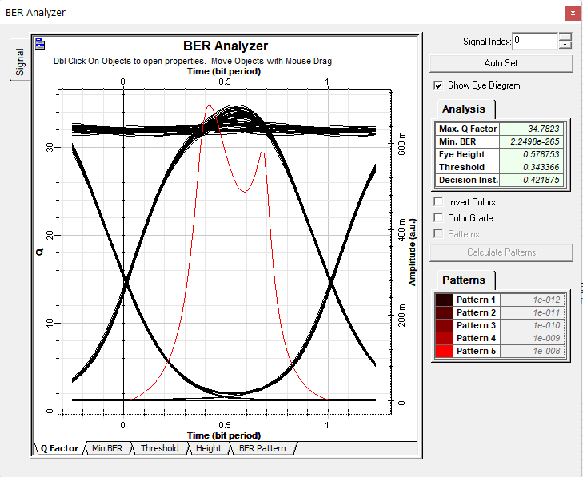

Distance = 10 KM

Max Q. Factor = 34.7823

Min. BER = 2.2498e-265

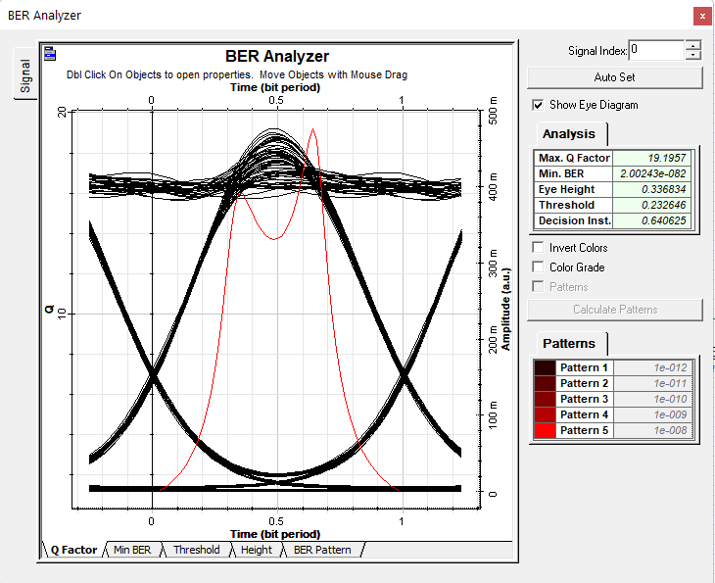

Distance = 20 KM

Max Q. Factor = 19.1957

Min. BER = 2.00243e-082

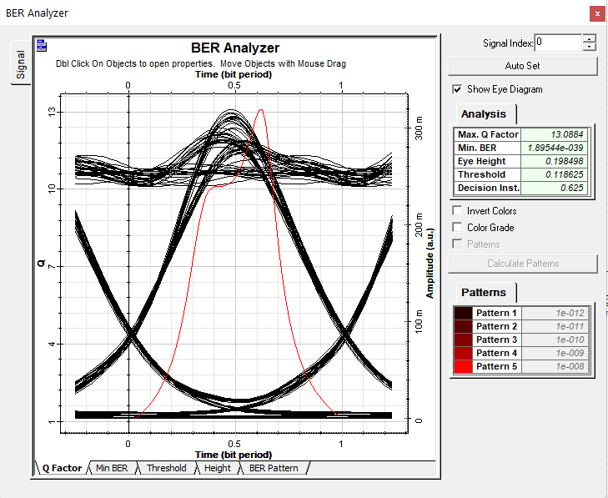

Distance = 30 KM

Max Q. Factor = 13.0884

Min. BER = 1.89544e-039

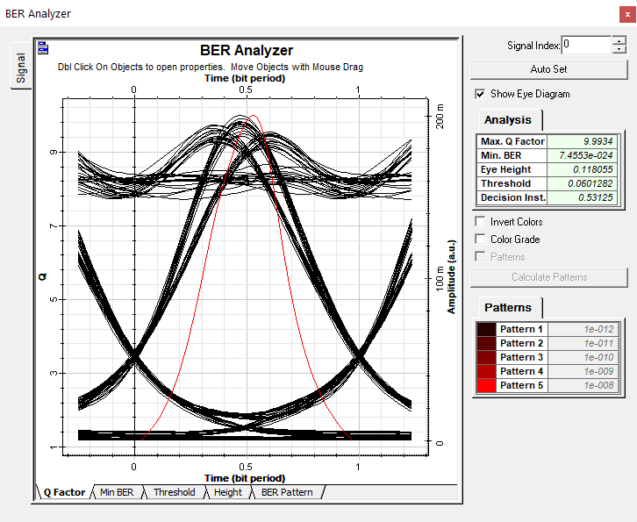

Distance = 40 KM

Max Q. Factor = 9.9934

Min. BER = 7.4553e-024

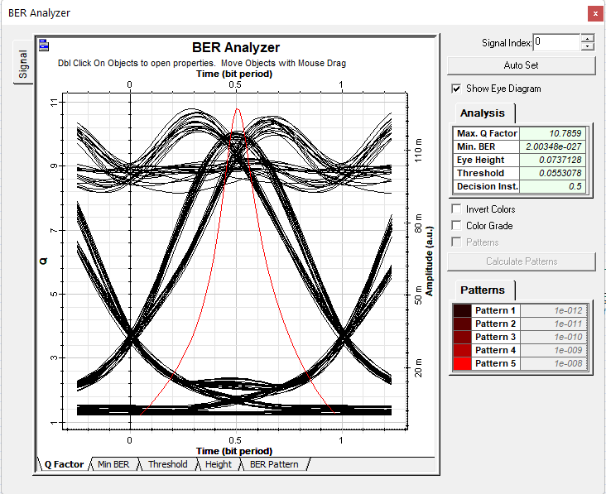

Distance = 50 KM

Max Q. Factor = 10.7859

Min. BER = 2.00348e-027

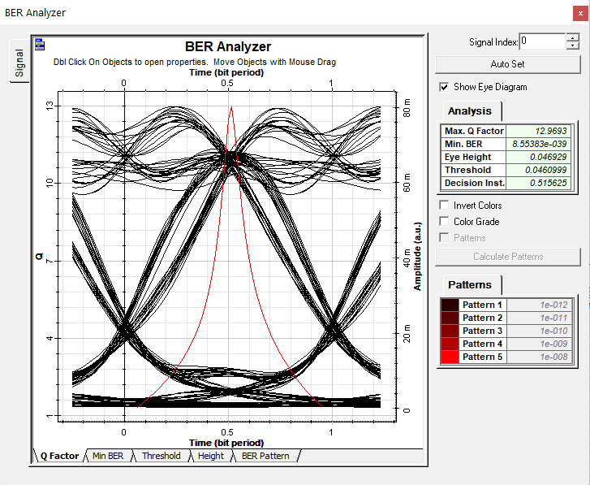

Distance = 60 KM

Max Q. Factor = 12.9693

Min. BER = 8.55383e-039

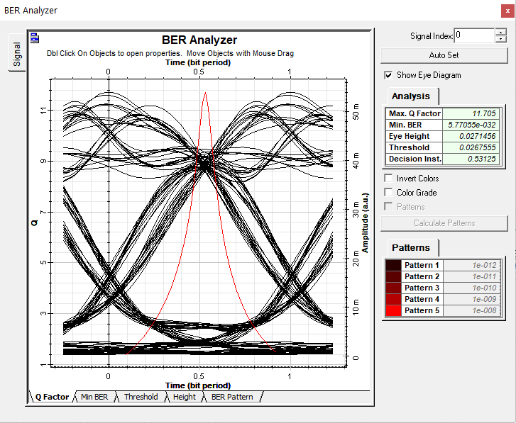

Distance = 70 KM

Max Q. Factor = 11.705

Min. BER = 5.77055e-032

Starting from Iteration 8, we aim to achieve a minimum Bit Error Rate (BER) of e0. Ensuring a power level of 0 dBm in the Continuous Wave (CW) Laser is imperative. Additionally, the bit rate is set to 1000000000.

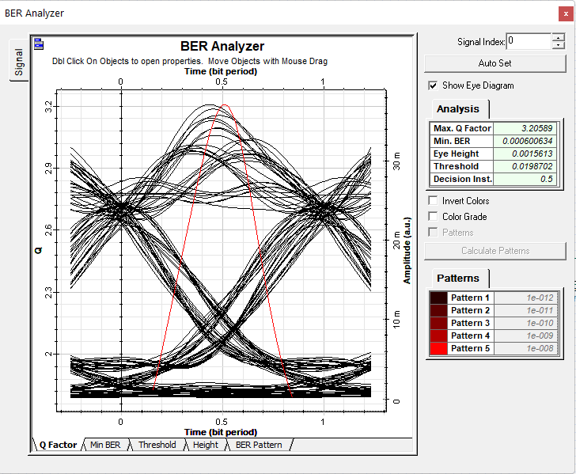

Distance = 80 KM

Max Q. Factor = 3.20589

Min. BER = 0.000600634

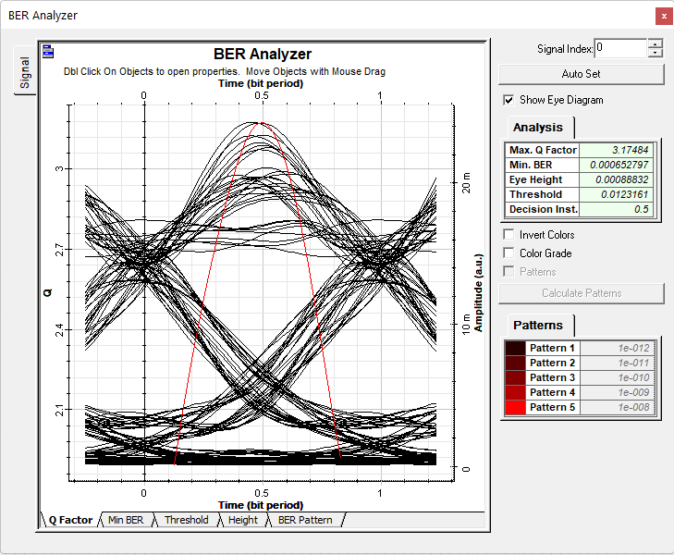

Distance = 90 KM

Max Q. Factor = 3.17464

Min. BER = 0.000652797

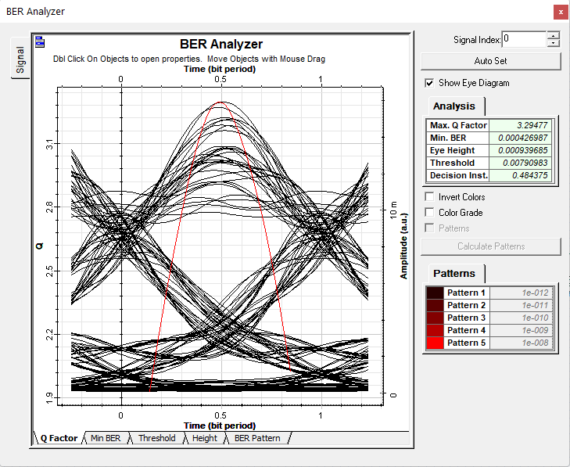

Distance = 100 KM

Max Q. Factor = 3.29477

Min. BER = 0.000426987

Data Table

|  |  |  |  |
| --- | --- | --- | --- |
| Distance (KM) | Q. Factor | Log of BER | Received Power (dBm) |
| 10 | 34.7823 | 265 | 22.477 |
| 20 | 19.1957 | 82 | 18.492 |
| 30 | 13.0884 | 39 | 14.506 |
| 40 | 9.9934 | 24 | 10.505 |
| 50 | 10.7859 | 27 | 6.483 |
| 60 | 12.9693 | 39 | 2.445 |
| 70 | 11.705 | 32 | -1.596 |
| 80 | 3.20589 | -4 | -5.624 |
| 90 | 3.17464 | -4 | -9.644 |
| 100 | 3.2947 | -4 | -13.656 |

Graphs

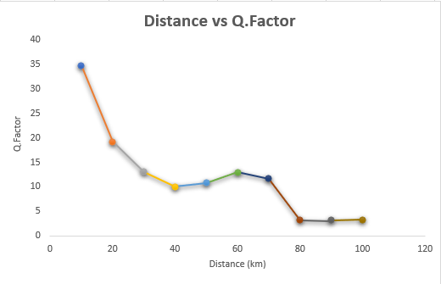

**Distance vs Log of BER**

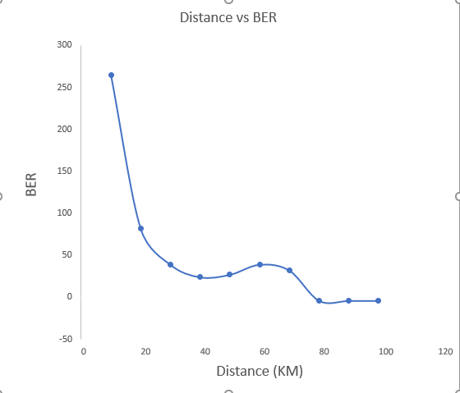

**Log of**

