Shorty (Re-Programable Macro Board)

**Components Hardware Required:**

1. Raspberry pi Pico ([here](https://datasheets.raspberrypi.com/pico/pico-datasheet.pdf))
2. Cherry MX Style Switch’s ([here](https://cdn.sparkfun.com/datasheets/Components/Switches/MX%20Series.pdf))
3. General Purpose led ([here](https://learn.adafruit.com/all-about-leds/what-is-an-led))
4. Our PCB (here)

**Specifications For Shorty:**

Contain 9 re-programmable key for your macro, keys are laid out in 3x3 matrix.

1. **Switch:** Key switch with fixation pins (1 pole), hot swappable (should contain same mount point as mentioned).
2. **Keycap’s:** can be 3d printed using given model or can pe purchased online.

**Note:**

Match keycap size before purchasing, supported keycap are alphabetic caps.

1. **Size:** x = 93.47mm, y = 62.99 mm
2. **Mounting:** can be mounted using 5 2.1mm mounting bits.
3. **Connection:** micro-B USB.

**Programing Specification:**

1. micro-python, supported firmware and installation guide is [here](https://projects.raspberrypi.org/en/projects/getting-started-with-the-pico/3).
2. circuit-python, supported native and recommend to use.
3. C/C++, can be uploaded using Arduino ide. (isn’t compatible completely).
4. QMK firmware.

**Circuit Symantec (fig 1)**

(Fig 1)

Each switch is connectedto a 3.3-volt power pin and outing that to a GPIO pin.

Also contains a led which you can use to show a status or anything you desire.

Buttons are connected in such a way each button have its own GPIO pin, why?

Because is contained only 9 switches and it would be useless to reduce the number of pin use to 6 because it will rise the complexity on the connection and increase number of components use as well increasing the code complexity.

*Complete information about RP2040 can be found* [*here*](https://datasheets.raspberrypi.com/pico/pico-datasheet.pdf)

**PCB Symantec (fig 2)**

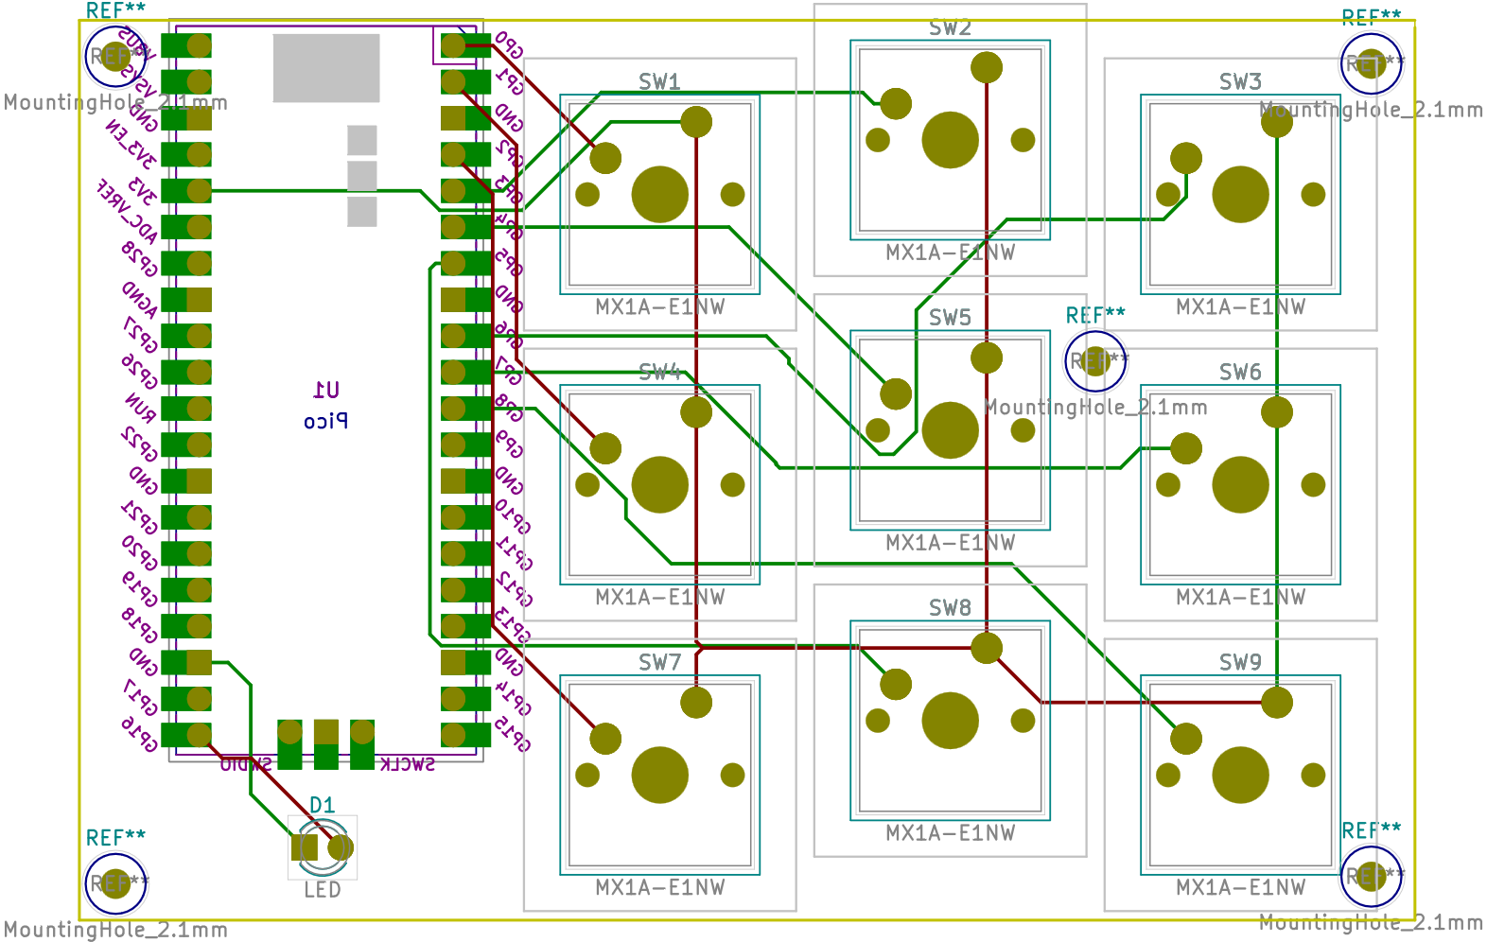

(Fig 2)

All the details about PCB can be found on the GitHub, just open the PCB folder in KiCad.

PCB can be printed by [JLCPCB](https://cart.jlcpcb.com/) just upload the Gerber zip file on JLCPCB website.

**3d Renders for PCB and components**

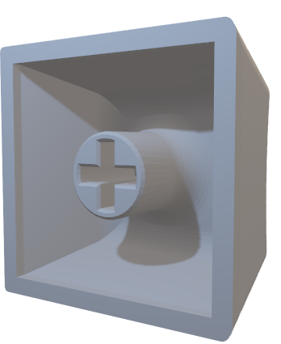

**CHERRY MX + KEYCAPS’**

Stander alphabetical keycap without any legends can be printed using translucent materials or solid material like PLA

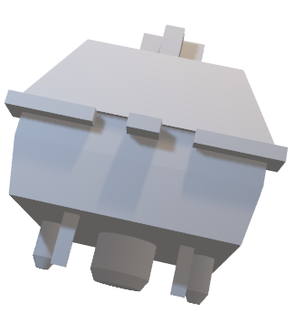

**CHERRY MX SWITCH**

You can use any switch like blue, jade, etc. as

Long as you have same mounting point shown

Int the 3D model to be precise 1 pole without led

Connections, with fixation point.

Details can be found [here](https://cdn.sparkfun.com/datasheets/Components/Switches/MX%20Series.pdf)

**Additional use case:**

Can be use with the script included in “shorty.py” which help you to set keyboard shortcut in your device and then you can program your macro pad to send those specific commands to your device, this way you can swiftly change your macros.