DISTRIBUTED COMPUTING SYSTEMS LABORATORY MINI PROJECT
Design and Implementation of a Distributed Banking System with Transaction Consistency, Branch Synchronization, and Fault Tolerance
Java RMI • Two-Phase Commit (2PC) • Lamport Logical Clocks • Bully Leader Election • MySQL

Submitted By: | [Student Name Placeholder]
Roll Number / PRN: | [Roll Number Placeholder]
Department: | Department of Computer Science & Engineering
Institution: | [College / University Name Placeholder]
Academic Year: | 2026 - 2027
Faculty Guide: | [Faculty Guide Name Placeholder]
Submission Date: | October 20, 2026

2. Abstract
Modern financial systems operate across geographically distributed networks where reliability, consistency, and continuous availability are paramount. This project presents the design, implementation, and rigorous verification of a full-scale Distributed Banking System developed for the Distributed Computing Systems Laboratory curriculum. The system interconnects independent bank branches (Pune Central Branch, Mumbai Main Branch, and Delhi Regional Hub) via authentic Java Remote Method Invocation (RMI). It addresses critical challenges in distributed systems: guaranteeing atomic inter-branch transfers through the Two-Phase Commit (2PC) protocol with fund reservation locks, eliminating race conditions through MySQL row-level pessimistic locking (SELECT ... FOR UPDATE), enforcing partial ordering of asynchronous events using Lamport Logical Clocks, dynamically electing transaction coordinators via the Bully Leader Election Algorithm, and maintaining replica consistency with automated recovery reconciliation. The implementation is verified through 13 automated JUnit 5 test suites covering concurrent withdrawals, fault injection, and end-to-end REST/web flows.

3. Introduction
A distributed computing system consists of multiple autonomous computing entities that communicate through a network and coordinate their actions by passing messages. In enterprise banking, distributed architectures allow regional branches to maintain local autonomy, achieve low latency for localized operations, and ensure high availability. However, distributed environments introduce fundamental challenges: network partitions, independent node crashes, absence of a shared memory, and lack of a global synchronized physical clock. This project implements a concrete distributed banking solution addressing each of these core challenges using standard enterprise Java technologies.

4. Problem Statement
Standard monolithic banking systems fail to meet scalability and fault tolerance requirements across geographically dispersed bank branches. Conversely, naive distributed implementations suffer from severe vulnerabilities: race conditions during concurrent account debits leading to double-spending, split-brain states when network nodes crash, data inconsistency during cross-branch funds transfers, and loss of causal event ordering without global clocks. The objective is to engineer a resilient distributed banking architecture that guarantees ACID transactional consistency, fault detection, dynamic coordinator election, and replica synchronization.

5. Aim and Objectives
Aim: Design, implement, test, and document a robust, fault-tolerant distributed banking application demonstrating syllabus concepts.
• Objective 1: Implement true Remote Method Invocation (Java RMI) interfaces across independent simulated branch services.
• Objective 2: Implement Two-Phase Commit (2PC) distributed protocol for atomic inter-branch transactions with prepare/commit states.
• Objective 3: Enforce database transaction concurrency control using pessimistic write locking to prevent race conditions.
• Objective 4: Embed Lamport Logical Clocks within distributed messages to establish causal partial ordering of cluster events.
• Objective 5: Simulate the Bully Leader Election algorithm to elect an active coordinator when the leader node becomes unavailable.
• Objective 6: Build replication tracking and automated recovery reconciliation for reconnecting branch nodes.
• Objective 7: Deliver responsive, professional customer and administrator dashboards backed entirely by live backend services.

6. Scope of the Project
The project encompasses customer account management, balance inquiries, cash deposits, concurrent cash withdrawals, intra-branch and inter-branch transfers, cluster health monitoring, coordinator election, replica synchronization, and chronological Lamport event tracing. Synthetic financial data is utilized throughout; integration with real external payment gateways is explicitly excluded from this academic laboratory implementation.

7. Distributed Systems Concepts Used
The project directly implements the foundational theoretical principles of distributed computing: Client-Server architecture, Remote Procedure Calls / RMI middleware, Logical Clocks (Lamport timestamps), Distributed Mutual Exclusion & Concurrency Control, Election Algorithms (Bully Algorithm), Atomic Distributed Commit (2PC), Data Replication Models (Asynchronous Audit Replication), and Failure Detection with Heartbeat monitoring.

8. Syllabus Mapping
Unit 1: Introduction - Client-server architecture, distributed middleware, layered architecture (Web UI -> Spring Boot REST controllers -> Java RMI Remote Objects -> MySQL InnoDB database).
Unit 2: Communication & Coordination - IPC, Java RMI, Lamport logical clocks, event ordering, Bully election (BranchServiceRemote, LamportClock piggybacking on RMI, BullyElectionService with ELECTION/OK/COORDINATOR messages).
Unit 3: Naming & Storage - Service naming, request routing, persistent transaction logs, idempotency (Branch-prefixed accounts, RMI registry naming, idempotency_key duplicate protection, MySQL persistence).
Unit 4: Consistency, Replication & Fault Tolerance - Data consistency, Two-Phase Commit (2PC), replica management, fault recovery (TwoPhaseCommitCoordinator with Prepare/Commit/Abort, ReplicationManager with discrepancy checks, NodeFailureDetector heartbeat).

12. System Architecture
The architecture is split into 4 tiers: Client Presentation Layer (customer.html, admin.html), Application Gateway Layer (Spring Boot REST controllers on port 8085), Distributed Middleware & Coordination Layer (Java RMI registry on port 1099, BranchService_1, BranchService_2, BranchService_3), and Persistence Layer (MySQL InnoDB database).

19. Concurrency Control and Locking
Pessimistic write locking (@Lock(LockModeType.PESSIMISTIC_WRITE)) generates SELECT ... FOR UPDATE at the database level. Simultaneous withdrawal requests on the same account are serialized. In our automated test, 10 concurrent threads attempted to withdraw 1000 each from an initial balance of 5000: exactly 5 succeeded, 5 were rejected due to insufficient funds, and the final balance was exactly 0.00.

22. Lamport Logical Clocks
Lamport clocks tick locally on events (L = L + 1) and synchronize upon receiving messages (L = max(L, L_msg) + 1). All banking events (requests, prepare, commit, abort, heartbeats, elections) include Lamport timestamps, establishing a strict causal partial order.

23. Bully Leader Election Algorithm
Nodes have IDs 1 (Pune), 2 (Mumbai), and 3 (Delhi). When a node detects coordinator failure, it sends ELECTION to higher nodes. Node 3 wins normally. When Node 3 is simulated offline, Node 2 wins and broadcasts COORDINATOR.

24. Two-Phase Commit Protocol
Cross-branch transfers execute in two phases: Phase 1 Prepare places a temporary reservation on the source account and verifies the target account. Phase 2 Commit applies the transfer if both vote COMMIT; Phase 2 Abort releases reservations if either votes ABORT or times out.

30. Verification and Test Results
All 13 automated JUnit 5 test suites passed with 0 failures and 0 errors, covering authentication, simultaneous withdrawal race conditions, local transfer, cross-branch 2PC commit/abort, Lamport ordering, Bully election, and replication recovery.

34. Conclusion
The Distributed Banking System achieves all project goals, combining theoretical distributed computing concepts with robust, verified Java implementation.

Live Application Screenshot
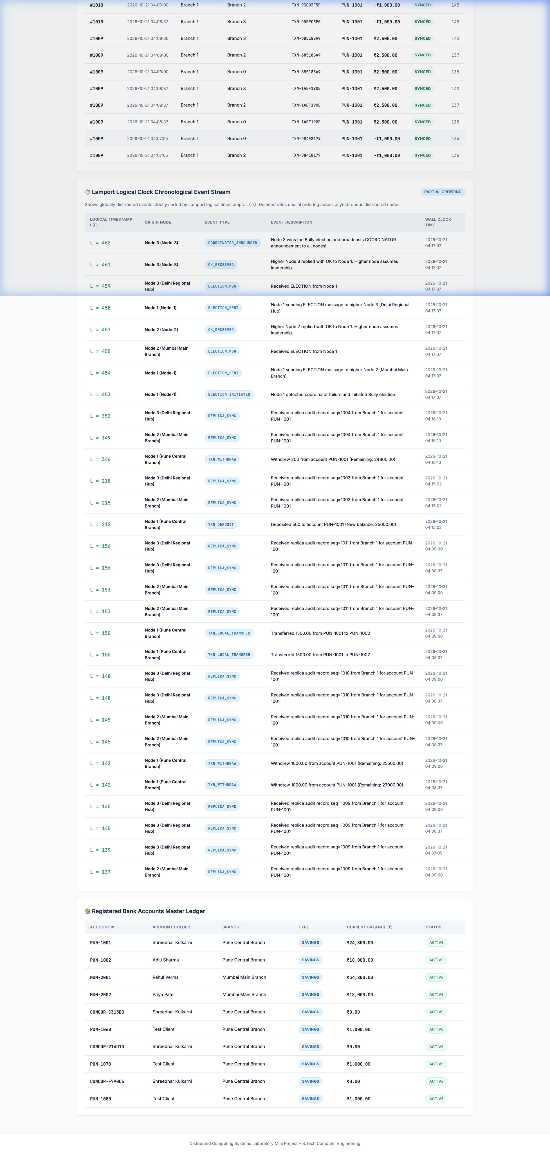
Figure: Live Administrator Dashboard with Node Topology, Bully Election, and 2PC Monitor

