TATA TECHNOLOGIES LTD.
TECH PULSE FY-26 | AI/ML Capstone Project

Technical Report
SafeTrace HARA Functional Safety HARA and Safety Requirement Management Assistant
Field | Details
Institute / University | Pimpri Chinchwad College of Engineering, Pune
Programme / Batch | B.Tech Information Technology / 2027 batch
Student Name | Shreedhar Bargaje
PRN | 123B1F006
Branch and Division | Information Technology / A
Contact Email | shreedhar0502@gmail.com
Case Study ID | CS2
Project Title | SafeTrace HARA - Functional Safety HARA and Safety Requirement Management Assistant
The prototype demonstrates cited retrieval and a guided synthetic HARA workflow. It connects hazardous events to draft safety goals, functional and technical requirements, and verification tests. The recorded evaluation measures the submitted implementation; it does not establish vehicle safety or ISO compliance.

1 Problem Statement and Intended Users
Functional safety work involves item definitions, operating scenarios, hazard records, requirements and tests. Disconnected records make source checking and change review difficult. CS2 calls for evidence-based assistance with hazard suggestions, rating guidance and traceability, while retaining human judgment. Intended users are students learning the workflow and, after substantial validation, safety and requirement engineers.
This implementation is a local teaching pilot. It searches a synthetic reference library and copies explicit draft chains into a reviewable assessment. It does not autonomously identify every hazard, infer justified ratings, approve a safety concept or control an ECU.

2 Input Data and Knowledge Base
Item | Description
Sources | 12 original synthetic event references and 10 original teaching notes; planning reference CS2 pages 8 to 11 of the supplied case-study document
Size and format | 22 indexed chunks; hazards.json 10,371 bytes; knowledge.json 15,313 bytes
Preprocessing | JSON validation through loading, lowercase normalization, English stop-word removal, word unigram and bigram TF-IDF features
Chunking | One complete event chain or one teaching note per section; stable source ID and version 1.0
Data status | SYNTHETIC_REFERENCE; no production data or expert-approved HARA cases
Ground truth | 26 authored questions with expected source IDs or expected refusal. Labels are separate from the corpus.
The source IDs identify local dataset sections. They are not ISO clause or page citations. Ratings and timing values are authored examples, with no field or expert validation. The internal-use reference PDF is not indexed or redistributed. Input_Data/PROVENANCE.md records the creation and permitted scope.

3 Solution Architecture
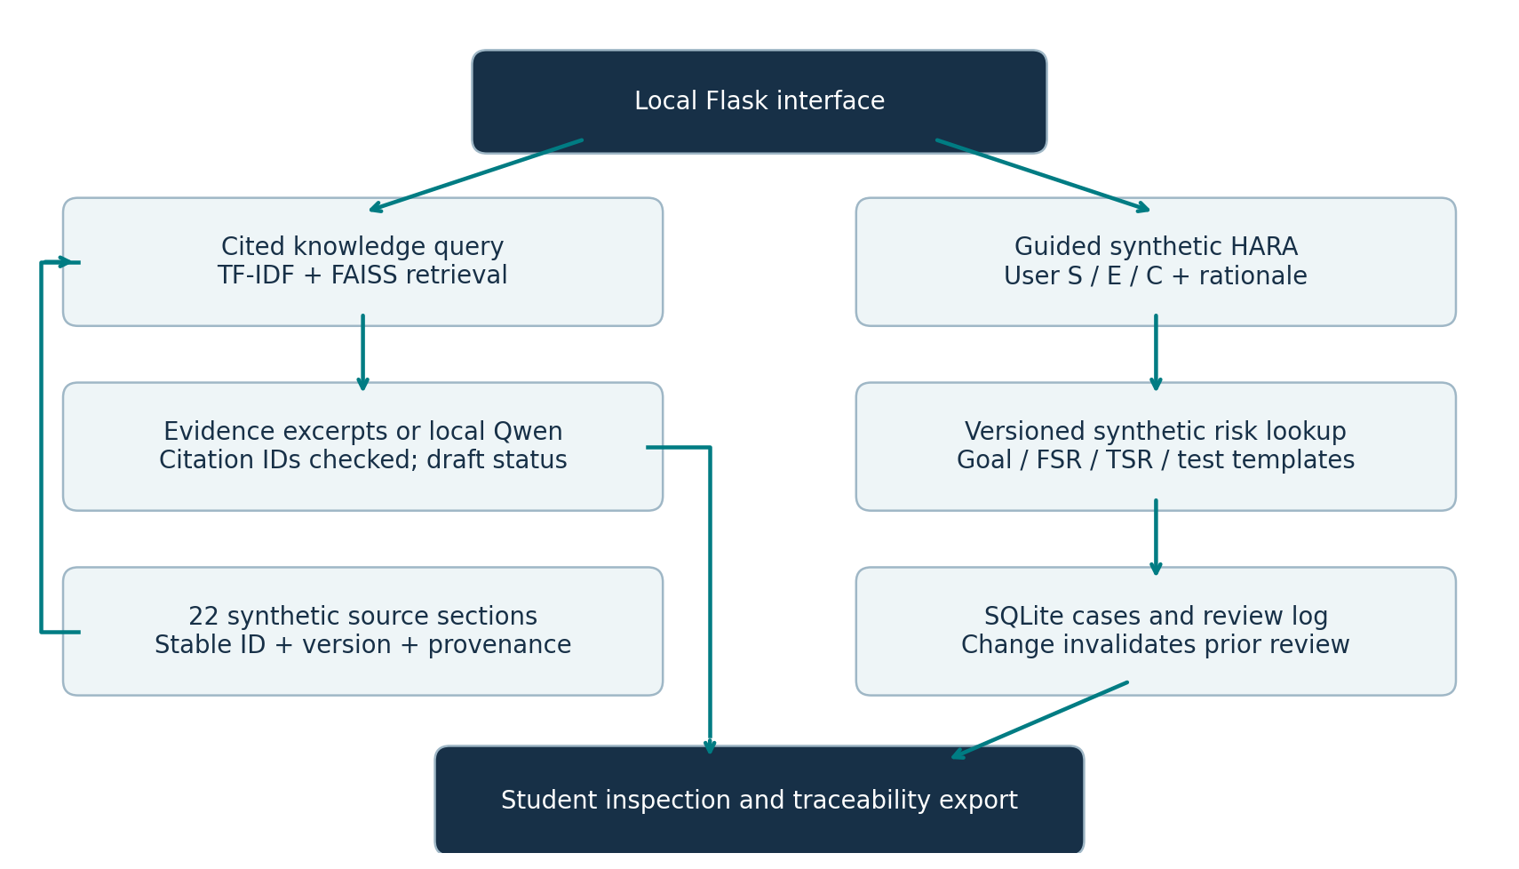
Figure 1 Implemented architecture with separate retrieval and guided assessment paths.
The browser calls a loopback Flask service. The engine fits TF-IDF on source text and stores normalized float32 vectors in FAISS. A knowledge query retrieves the top three passages above a fixed similarity threshold. Evidence mode returns their text directly. Optional Qwen generation receives the passages and a controlled prompt; a JSON schema constrains the answer and citation fields. The guided assessment path instead uses an explicit synthetic rule lookup and reference templates; SQLite stores its state and review history.

4 Implementation and Configuration
Component | Submitted choice
Pretrained generator | Official upstream Qwen2.5 1.5B Instruct GGUF Q4_K_M, locally imported under qwen2.5:1.5b-instruct-q4_K_M; Ollama 0.40.3; no cloud API
Embedding | scikit-learn TF-IDF, word ngrams 1 to 2, L2 normalized; no pretrained embedding model
Vector store | FAISS IndexFlatIP; vector file and metadata written to Code/runtime
Orchestration | Custom Python engine; top_k 3; score threshold 0.16; source version and status retained
Prompt and generation | system_prompt.txt; temperature 0; seed 42; num_ctx 4096; num_predict 140; num_thread 2
Service and UI | Flask 3.1.3 and original HTML/CSS/JavaScript interface; 127.0.0.1:5000
Structured storage | SQLite; parameterized queries; case creation, review and update audit events
Deterministic tools | Input checks, synthetic rule table, requirement text heuristics, traceability completeness and change review invalidation
engine.py implements retrieval, citations, ratings, persistence and review transitions. app.py exposes the service and loopback protections. The interface has Cited knowledge, Guided HARA, Traceability and review, Input knowledge, and Evaluation tabs. Goal, FSR, TSR and test drafts are prewritten reference content; the interface does not claim they were inferred from arbitrary vehicle designs.
The rule table has status NOT_EXPERT_APPROVED and version synthetic-demo-v1. Invalid S/E/C ranges and Boolean values are rejected. Each case records a user-entered rationale and starts PENDING_REVIEW. STUDENT_REVIEWED is a student workflow label only. A requirement edit resets review; an incomplete traceability chain cannot be marked student reviewed.
Internet is required for initial dependency and model downloads. Normal evidence mode uses no external API. Local-model mode depends on the Ollama process and downloaded weights. The weights are not bundled. A failed local-model call, malformed structured response or invalid source-ID citation produces a labelled evidence fallback; it is not counted as successful model inference.
Installation commands are in README.md. requirements.txt pins the tested Python libraries. Dockerfile supplies a validation recipe; Docker execution is not claimed. Source hashes and environment information support reproducibility. Model_Prompts_Config includes the exact upstream GGUF hash and import template; a registry pull with the same tag may differ from the tested imported manifest.

5 Evaluation Steps and Results
The question set was authored and frozen before retrieval execution. Expected-source labels were not indexed or used to fit TF-IDF. A pass requires the expected source in top three, the expected refusal behavior, and valid returned citation IDs. The set is a small synthetic smoke test, without independent expert labels or a statistically representative held-out vehicle dataset.
Metric | Measured evidence-mode result
Question outcomes | 26 passed; 0 failed; 26 total
Retrieval hit at 3 | 100.0% across 22 in-scope questions
In-scope answer rate | 100.0%
Out-of-scope refusal | 100.0% across 4 requests
Citation ID validity | 100.0% for answered requests; ID membership only
Median and p95 latency | 0.201 ms median; 0.368 ms p95, in-process evidence call only
Workflow tests | 12 of 12 passed; includes range checks, persistence, missing-test review block and review invalidation
API tests | 9 of 9 passed; includes JSON, host/origin checks, size limit and workflow
Model protocol tests | 5 of 5 passed using clearly labelled mocked fixtures; not real inference evidence
Expert faithfulness and safety validation | Not performed; no score claimed
The local-model run requested LLM mode for 26 questions. 22 answers were actually generated by Qwen; the remaining requests either abstained or fell back to evidence mode. Median end-to-end call latency was 3773.713 ms. See metrics_llm.json and answers_llm.json for per-question mode, outputs and failures. Source-ID validity is not claim faithfulness.
Codex reviewed all 52 recorded outputs/refusals. Q18 incorrectly expands FSR/TSR; Q08 omits the alternate-channel test criterion; Q01/Q03/Q04 include unnecessary citations. Automated 26/26 checks do not measure content accuracy. Original outputs are retained. See Actual_Contributions_and_Review.md and assistant_output_review.json. Student verification remains pending.
Earlier unstructured prompt runs were retained separately. The initial broad prompt yielded no accepted cited drafts. A shorter unstructured prompt improved some responses but still omitted citations, and one withheld response mixed steering examples. The final implementation uses a constrained JSON response and validates citation IDs. These development failures are not hidden; the final question set is a development smoke test rather than an untouched benchmark.
Ground-truth retrieval IDs and actual outputs are stored in Evaluation_Results/questions.json and answers.json. Latency excludes browser rendering, installation and model downloading. No preparation-time reduction, user agreement or safety-expert acceptance rate is claimed.
Test | Expected behavior | Observed result
Q01 highway braking loss | Retrieve H01 with cited source text | Pass
Q15 exposure question | Retrieve K03 explaining exposure to operational situations | Pass
Q19 student review | Retrieve K07; no implication of faculty approval | Pass
Q23 country capital | Abstain outside the knowledge scope | Pass
Q26 vehicle certification | Refuse certification request | Pass
Missing verification test | 80% chain; STUDENT_REVIEWED blocked | Pass in workflow test
Edit reviewed FSR | Reset PENDING_REVIEW and record impact | Pass in workflow and API tests

6 Responsible AI Measures
Area | Implemented measure and limit
Grounding | Source IDs and versions displayed. Evidence mode returns exact passages. Model mode checks citation IDs; students must assess claims.
Privacy | Original synthetic records only; no personal data or confidential vehicle records.
Security | Loopback-only service, JSON-only mutations, origin and Host checks, 32 KiB request limit, input validation and CSV formula prefix handling. No enterprise authentication or tamper-proof logging.
Human oversight | PENDING_REVIEW by default. Named student reviewer and reason recorded. Changes invalidate review. Faculty and safety approval are separate.
Standards and governance | No licensed ISO text is copied. Candidate lookup is explicitly synthetic and not approved.
AI disclosure | AI assistance is substantial.

7 Innovation Highlights
The main addition to a basic cited search interface is the review lifecycle across a complete requirement chain. Editing a requirement flags downstream artifacts and invalidates a previous student review. A missing verification test blocks completion of that review.
The application also makes evidence mode and model mode visible, rather than treating a retrieval fallback as a generated answer. Versioned rule provenance and source IDs are kept with each assessment. These are prototype design choices, not claims of new research or production-ready safety tooling.

8 Screenshots Logs and Evidence
The following screenshots show the running implementation with synthetic input. Any review shown under Demonstration tester is an automated workflow exercise and is not verification by the submitting student. Original PNGs and the UI validation record are retained in Documentation/Evidence.
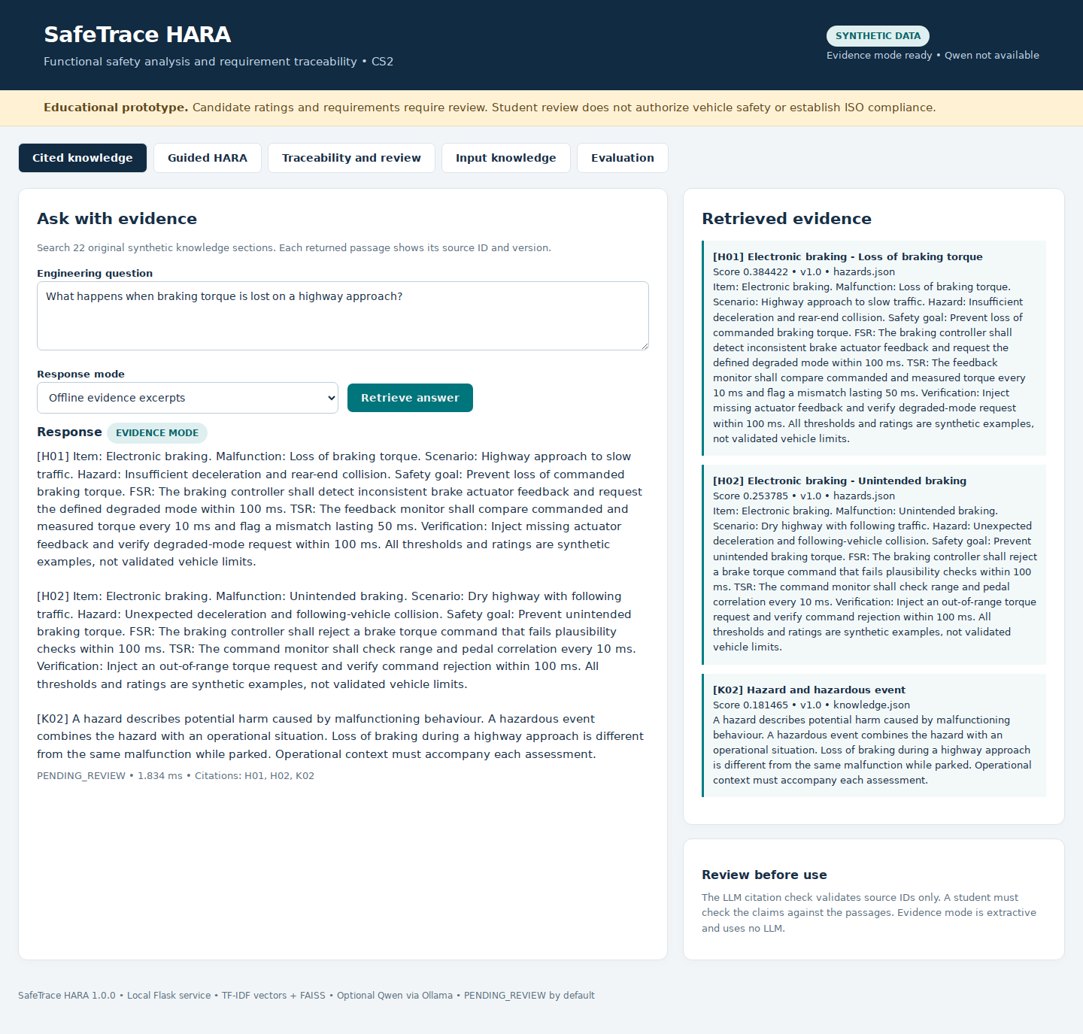
Figure 2 Cited evidence answer with actual source passages and retrieval scores.

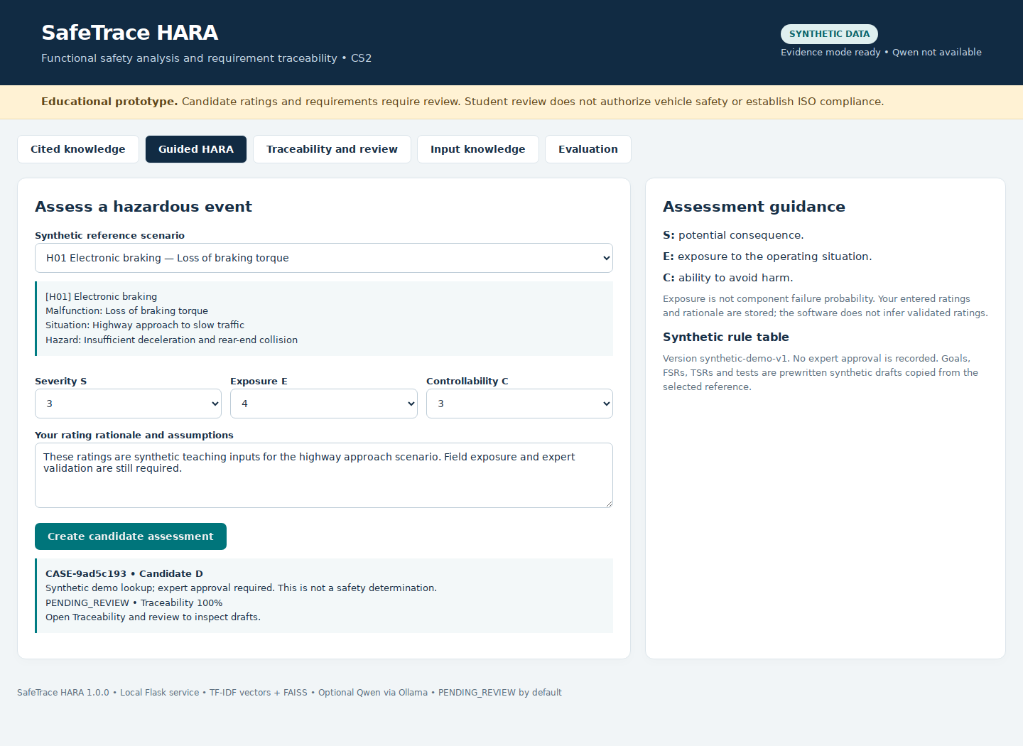
Figure 3 User ratings and rationale create a pending synthetic assessment.

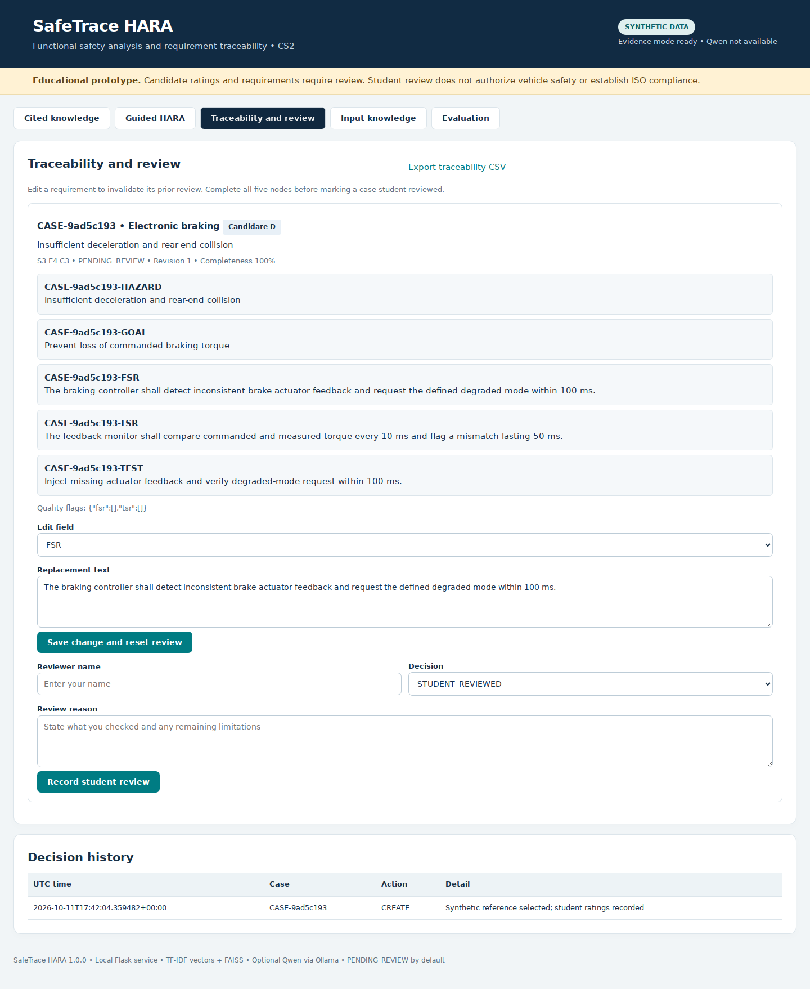
Figure 4 Hazard to goal to FSR to TSR to test chain before student review.

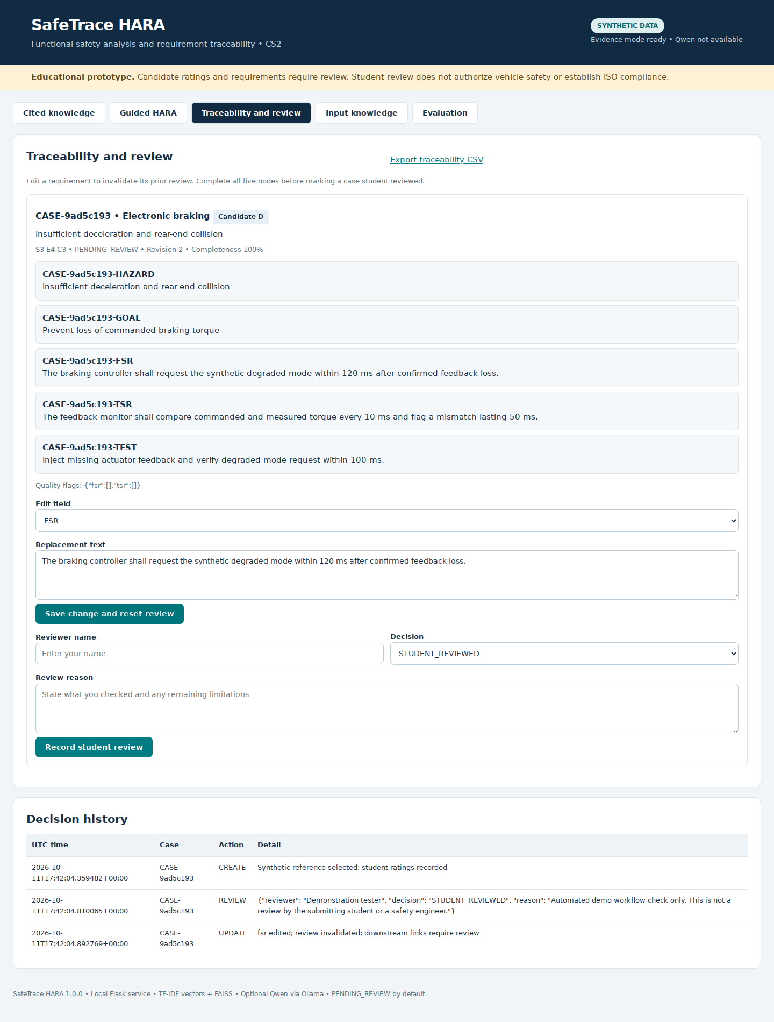
Figure 5 Editing the FSR resets review and records the update in decision history.

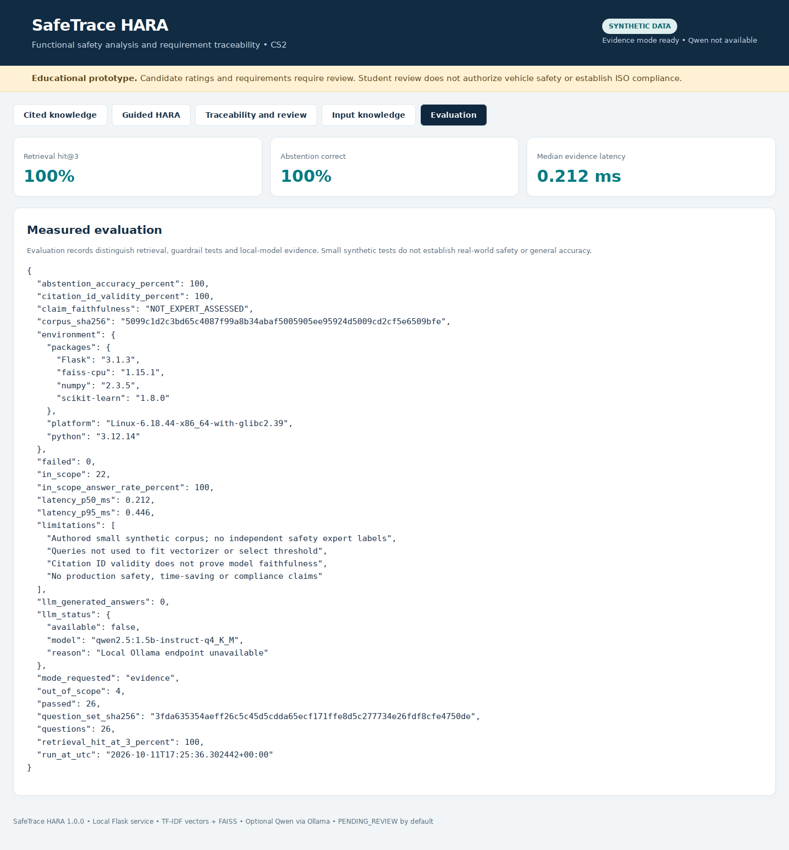
Figure 6 Evaluation tab shows an earlier evidence run; final measured metrics appear in Section 5.

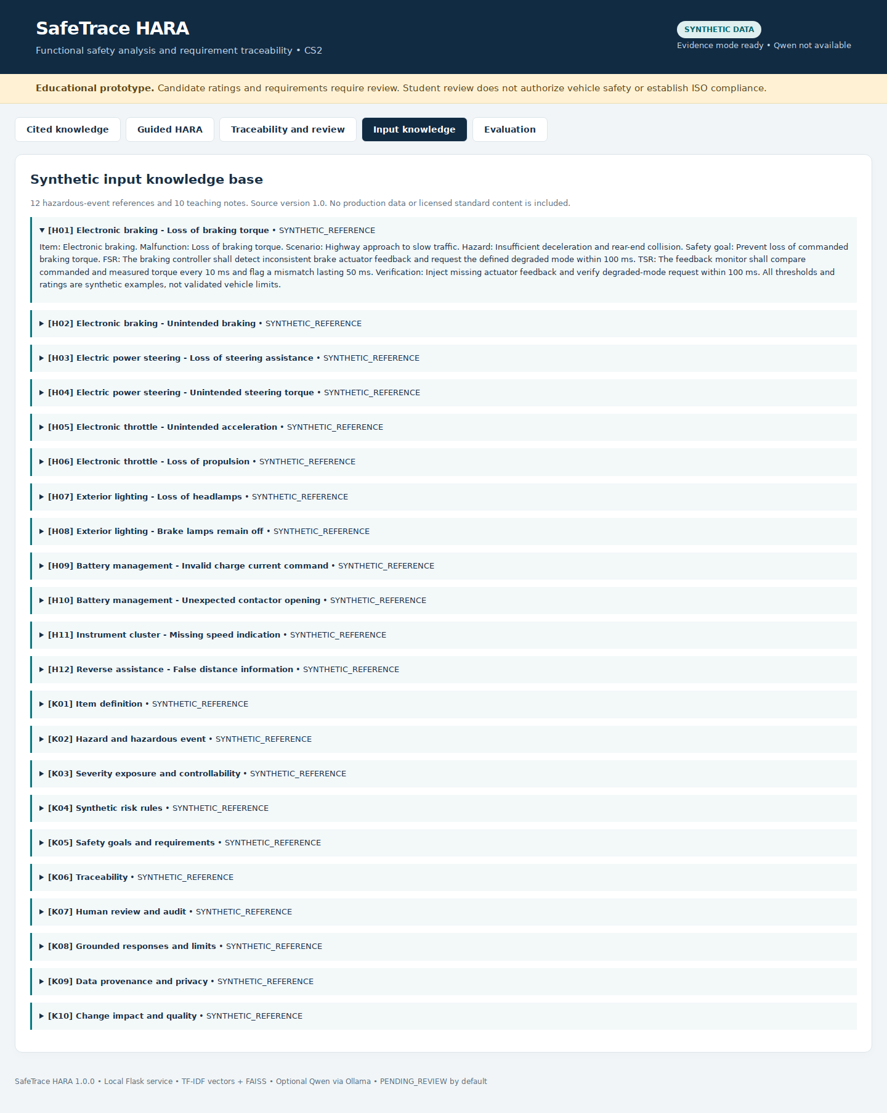
Figure 7 Source records expose their synthetic status and content.

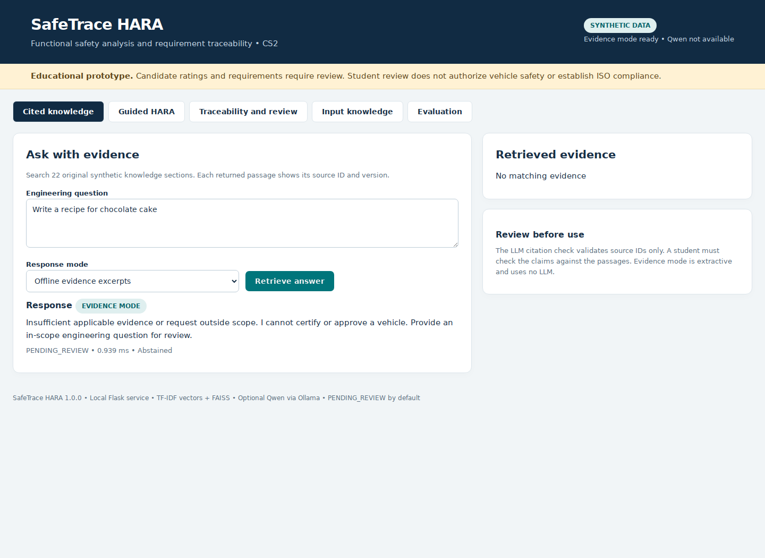
Figure 8 An out-of-scope request receives an explicit refusal.

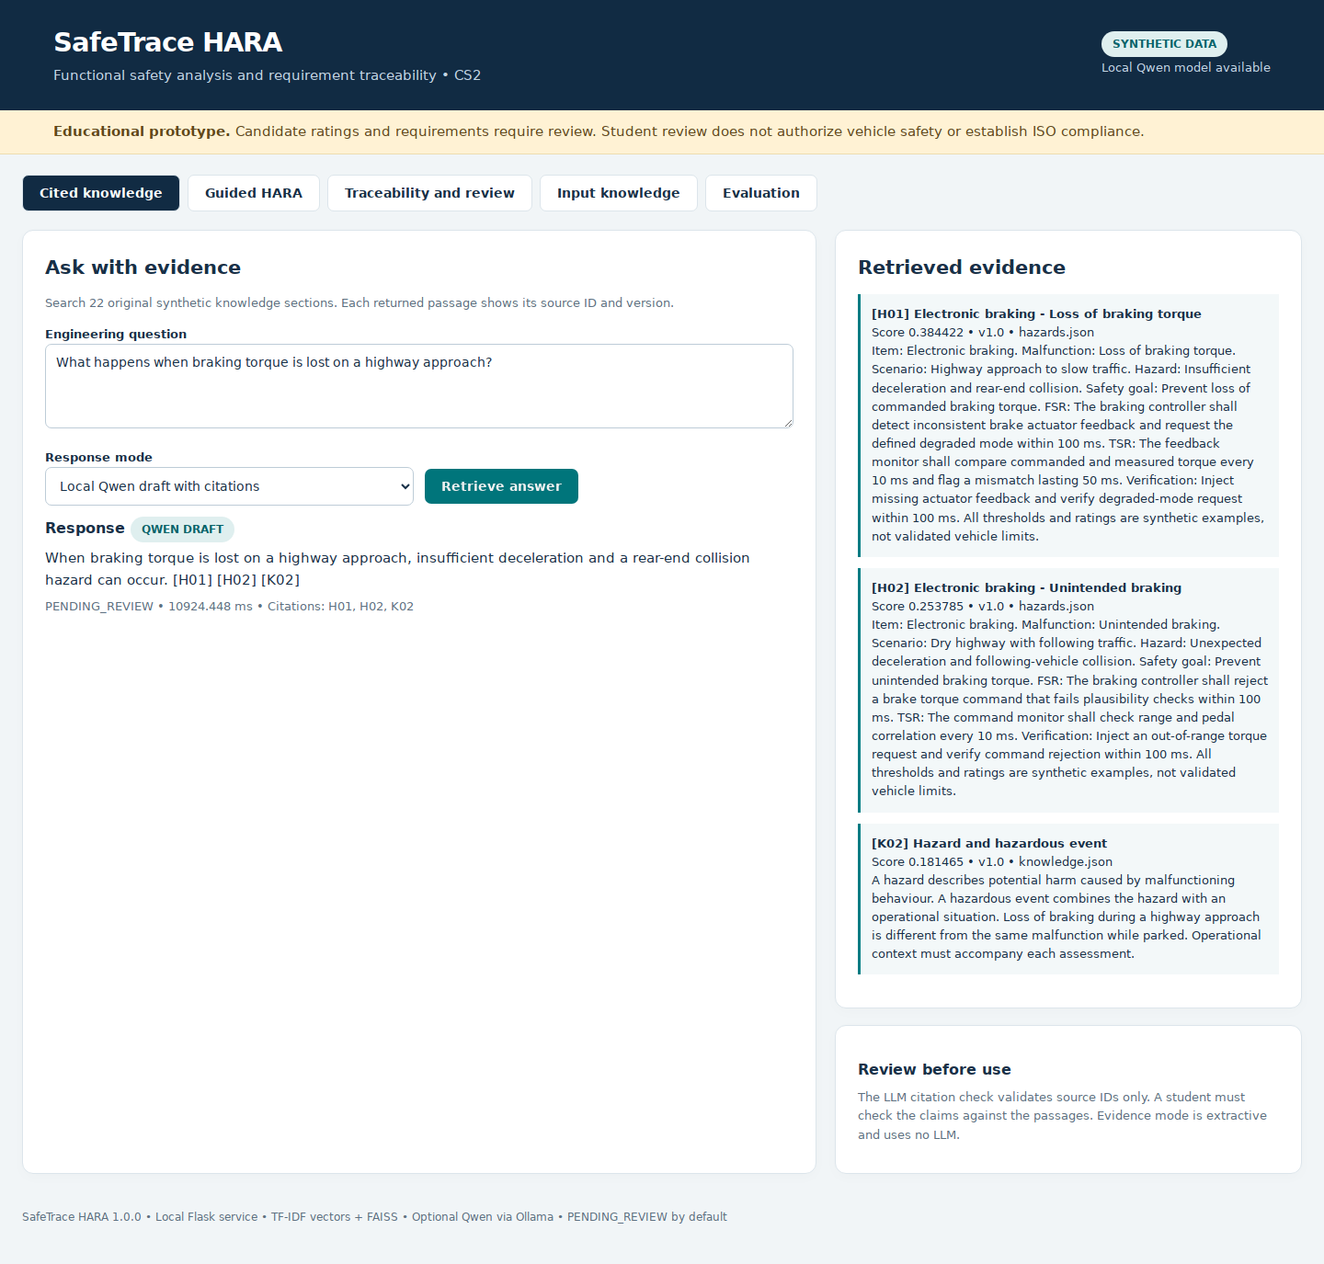
Figure 9 Local Qwen produces a structured answer displayed with validated source IDs.
evaluation_run.log, system_tests.log and api_tests.log preserve actual execution evidence. ui_validation.json records browser interaction checks when available. The Docker recipe is included without a fabricated execution screenshot.

9 Reflection and Conclusions
The prototype shows that a small, explicit reference corpus can support cited answers and visible requirement chains. The most useful control is preserving a clear boundary between retrieved evidence, model wording, synthetic risk rules and human decisions. Basic trace completeness alone cannot establish a correct safety concept.
The main limitations are lexical retrieval, authored examples and labels, unapproved risk rules, lack of expert review, no arbitrary document ingestion and no enterprise identity system. A larger approved corpus, qualified rule validation, independently labelled paraphrase tests, claim-level faithfulness review and controlled deployment are future improvements. Any final student reflection should describe only personally completed work and testing.

10 AI Tool Usage Declaration
AI tool or model | Purpose | Artifact affected | Verified by Student Y or N
ChatGPT / Codex | Substantial drafting and coding assistance; automated execution and layout checks | Synthetic corpus, code, tests, configuration, documentation and forms | Y - Verified
Qwen2.5 1.5B Instruct Q4_K_M via local Ollama | Optional generation from retrieved evidence; model use status is recorded in evaluation files | Local draft answers only; not risk lookup or faculty approval | Y - Verified
Automated execution and layout checks during package preparation are not the submitting student's personal verification. Change N to Y only after Shreedhar has reviewed the corresponding artifacts and can explain the implementation. The local Qwen model is pretrained; no fine-tuning or training is claimed.

Recorded Contributions and Assistant Review
Work area | Recorded contribution and status
Dataset and source review | Authored 22 synthetic records and reviewed cited outputs.
Implementation changes | Implemented Flask UI, retrieval, local Qwen integration, HARA templates, SQLite review and export.
Local execution and model setup | Installed and ran dependencies and Qwen in the preparation environment.
Evaluation and output checking | Ran 26 tests and two 26-question evaluations; reviewed all recorded answers and identified Q18 terminology error.
Report and demonstration preparation | Drafted and checked documents and captured UI evidence.

Codex reviewed all 52 recorded outputs/refusals. Q18 incorrectly expands FSR/TSR; Q08 omits the alternate-channel test criterion; Q01/Q03/Q04 include unnecessary citations. Automated 26/26 checks do not measure content accuracy. Original outputs are retained. See Actual_Contributions_and_Review.md and assistant_output_review.json.

11 Student Declaration
I confirm, after my own review and before signing, that this report represents my understanding and accurately stated contributions. I have disclosed AI assistance, cited external tools and references, and have not fabricated results. I will follow the case-study scope actually approved by my faculty and can explain the submitted implementation.
Field | To be completed by the student
Name | Shreedhar Bargaje
PRN | 123B1F006
Student signature | 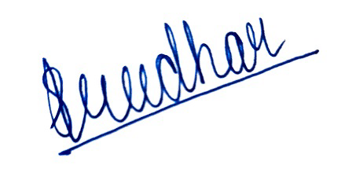
Date of signature | 11/10/2026

References
[1] Automotive Engineering AI Project Case Studies, supplied reference document, version 1.0, September 2026, CS2 pages 8 to 11. Internal-use planning reference; not redistributed.
[2] ISO, ISO 26262 road vehicles functional safety overview and ISO 26262-3:2018 concept phase, https://www.iso.org/publication/PUB200262.html and https://www.iso.org/standard/68385.html . General scope only; no standards clauses reproduced.
[3] Qwen team, Qwen2.5 1.5B Instruct and Ollama model distribution, https://huggingface.co/Qwen/Qwen2.5-1.5B-Instruct and https://ollama.com/library/qwen2.5:1.5b-instruct-q4_K_M .
[4] scikit-learn, TfidfVectorizer documentation, https://scikit-learn.org/stable/modules/generated/sklearn.feature_extraction.text.TfidfVectorizer.html .
[5] FAISS, IndexFlatIP documentation, https://faiss.ai/cpp_api/struct/structfaiss_1_1IndexFlatIP.html .
[6] Flask, documentation, https://flask.palletsprojects.com/ .
[7] Ollama, Structured outputs, https://docs.ollama.com/capabilities/structured-outputs .
External code and model attribution: original application code was generated with ChatGPT/Codex assistance and calls the listed libraries. Synthetic dataset creation is disclosed in Input_Data/PROVENANCE.md. References were consulted for scope and configuration, not copied into model answers.

