TATA TECHNOLOGIES LTD.
TECH PULSE FY-26 | AI/ML Capstone Project

Project Synopsis
SafeTrace HARA Functional Safety HARA and Safety Requirement Management Assistant
Field | Details
Institute / University | Pimpri Chinchwad College of Engineering, Pune
Programme / Batch | B.Tech Information Technology / 2027 batch
Student Name | Shreedhar Bargaje
PRN | 123B1F006
Branch and Division | Information Technology / A
Contact Email | shreedhar0502@gmail.com
Case Study ID | CS2
Project Title | SafeTrace HARA - Functional Safety HARA and Safety Requirement Management Assistant

1 Case Study ID and Project Title
CS2 - SafeTrace HARA - Functional Safety HARA and Safety Requirement Management Assistant

2 Objectives
- Provide source-cited access to a synthetic hazardous-event reference library.
- Guide S/E/C entry and demonstrate a versioned candidate risk lookup with explicit limitations.
- Maintain reviewable hazard, safety goal, FSR, TSR and test links.
- Evaluate source retrieval, out-of-scope refusal, input validation and review transitions with recorded tests.

3 Scope

In Scope
Original synthetic knowledge records; local TF-IDF and FAISS retrieval; cited evidence mode; optional local Qwen drafting; ratings and rationale form; prewritten draft requirement chains; review logging; change impact and CSV export.

Out of Scope
Autonomous safety approval, ISO compliance certification, expert-validated ASIL rules, production ECU operation, confidential or licensed standard content, enterprise authentication, arbitrary PDF/OCR ingestion and real-world productivity claims.

4 Proposed Approach
Component | Approach
Pretrained model | Qwen2.5 1.5B Instruct Q4_K_M through local Ollama; generation verification status recorded separately
Embedding model | TF-IDF lexical baseline; no pretrained embedding model
Vector store | FAISS IndexFlatIP on L2-normalized float32 vectors
RAG pipeline | Stable sections and source metadata; top three above similarity threshold; constrained prompt; citation-ID check; disclosed evidence fallback
Service layer and UI | Local Flask service and original HTML/CSS/JavaScript interface
Tools | Versioned synthetic risk table, requirement text checker, trace completeness, SQLite review log and update invalidation
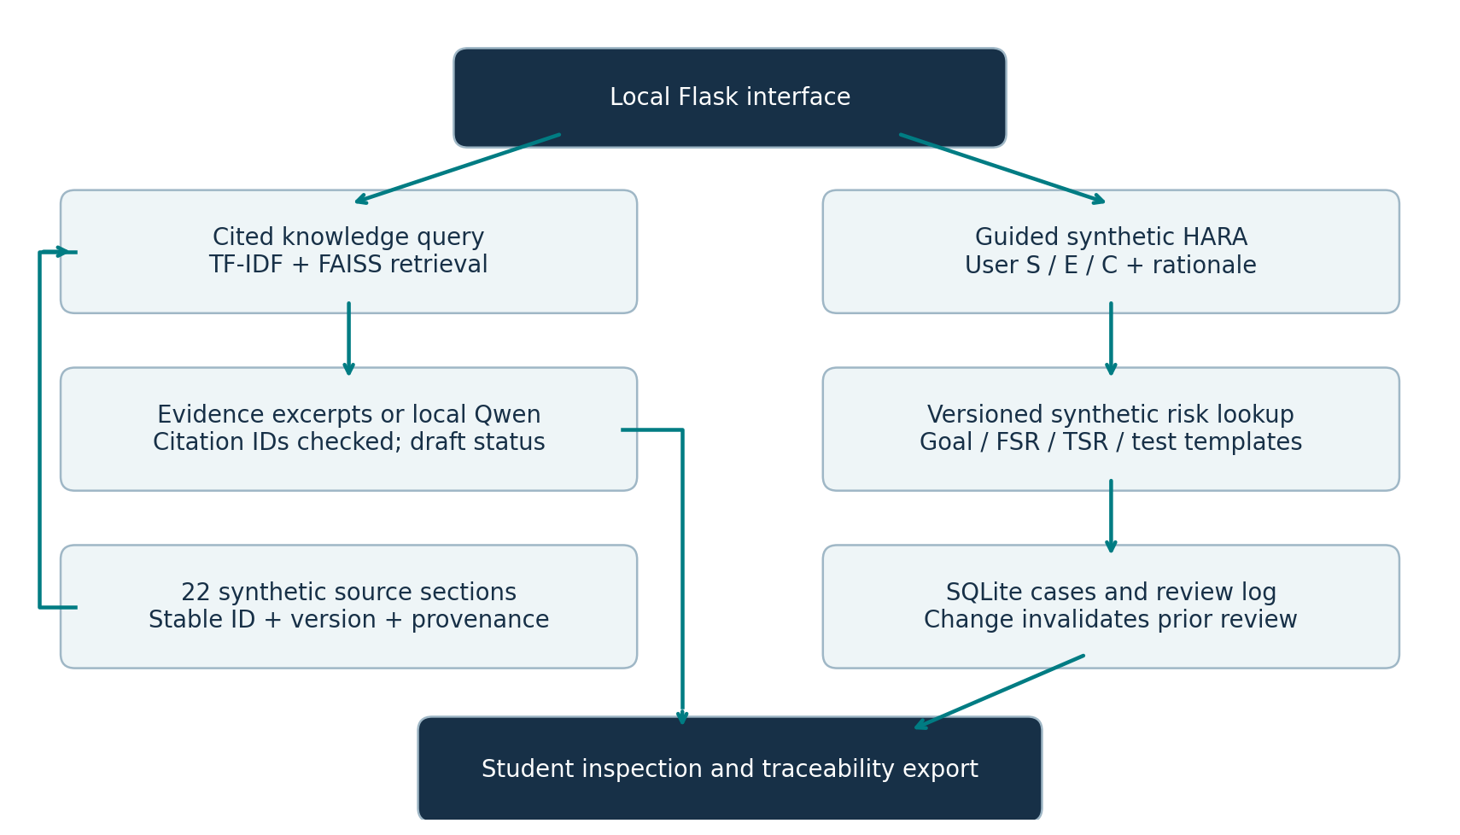
Figure 1 Proposed and implemented local pilot architecture.

5 Input Data and Knowledge Base
Only original synthetic records are used as retrieval input: 12 event/goal/FSR/TSR/test references and 10 teaching notes in JSON. The supplied case-study document defines CS2 scope but is not embedded or redistributed. Preprocessing uses normalized source text and lexical features; labels stay outside the corpus. Stable IDs, version 1.0 and SYNTHETIC_REFERENCE status accompany each chunk.

6 Expected Outcomes and Evaluation Plan
Expected outputs are cited passages or local-model drafts, candidate event assessments, template requirements, complete trace chains, review records and CSV exports. The evaluation plan uses 22 in-scope questions, four out-of-scope requests and workflow/API tests. Report retrieval hit at three, refusal accuracy, citation-ID validity, observed latency and actual failures; do not infer safety correctness from these metrics.
Grounding and synthetic input protect provenance. Every assessment starts PENDING_REVIEW. The submitting student must check outputs; qualified safety approval is outside the pilot. Initial dependency/model downloads need internet; installed runtime remains local. Versioned configuration, environment records, source hashes and a Docker validation recipe support reproducibility. Docker validation is pending.

7 Planned AI Tool Usage
AI tool or model | Purpose | Artifact affected | Verified by Student Y or N
ChatGPT / Codex | Substantial drafting and coding assistance; automated execution and layout checks | Synthetic corpus, code, tests, configuration, documentation and forms | Y – Verified
Qwen2.5 1.5B Instruct Q4_K_M via local Ollama | Optional generation from retrieved evidence; model use status is recorded in evaluation files | Local draft answers only; not risk lookup or faculty approval | Y - Verified
Actual contribution record: Codex authored and tested the implementation, synthetic data and documents; the student supplied scope, personal details and repository. Full records are in Documentation/Actual_Contributions_and_Review.md. Assistant output review completed; personal student verification remains pending.
AI assistance has affected substantial parts of this package. Personal student verification is pending. A signed declaration must accurately describe the student's reviewed, modified and tested contributions.

Student Declaration
By signing after my review, I confirm that I will not change the approved scope or major methodology without faculty approval, that I understand my contribution and that I am responsible for explaining the submitted implementation. AI assistance is disclosed.
Field | To be completed by the student
Name | Shreedhar Bargaje
PRN | 123B1F006
Student signature | 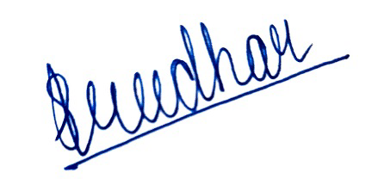
Date of signature | 11/10/2026

Faculty Approval Record
Approval status is pending. This page is to be completed and signed by the actual faculty reviewer after reviewing the synopsis. No faculty approval or signature has been generated.
Approval field | To be completed by faculty
Student | Shreedhar Bargaje - PRN 123B1F006
Case study | CS2
Project | SafeTrace HARA - Functional Safety HARA and Safety Requirement Management Assistant
Faculty name and designation | -
Department | -
Decision | Approved / Revision required / Not approved
Conditions or remarks | -
Approved methodology and scope | -
Faculty signature | -
Approval date | -
Institute stamp if required | -

