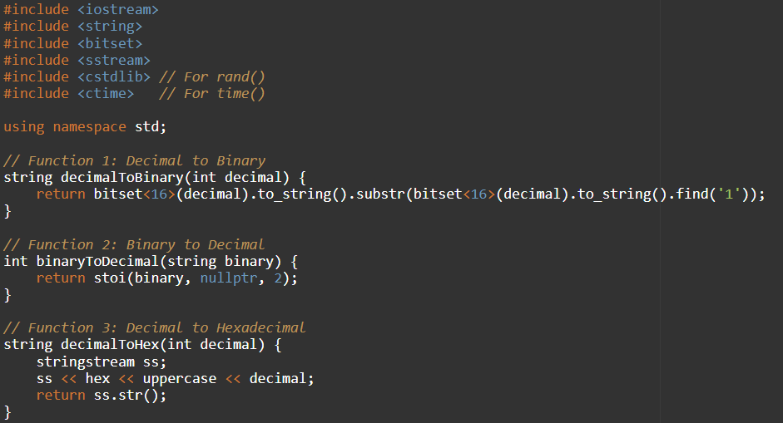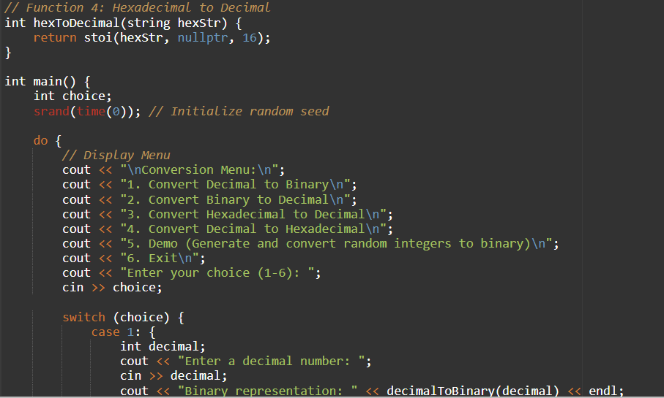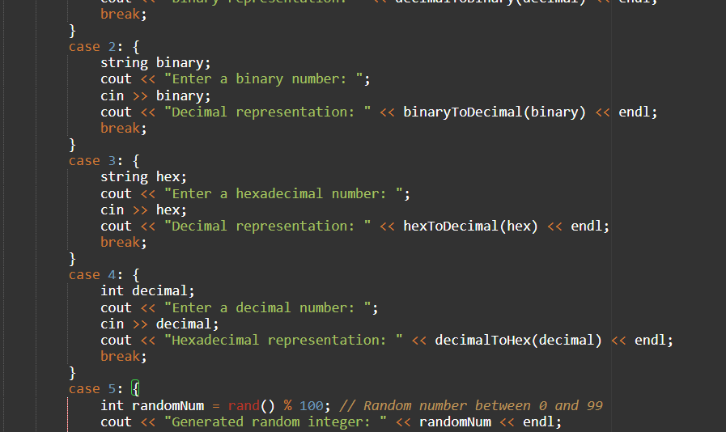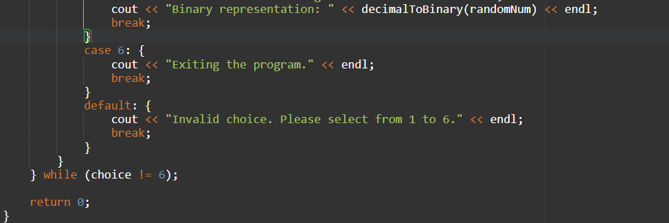

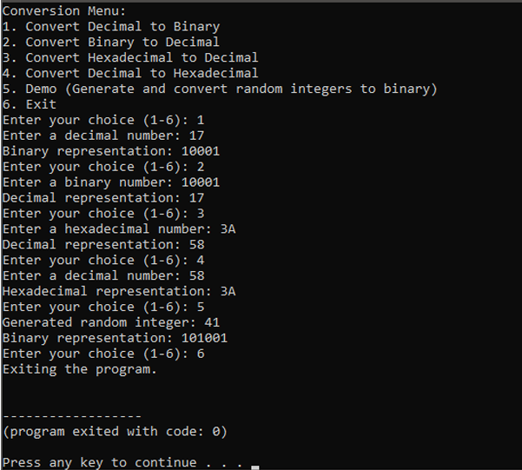

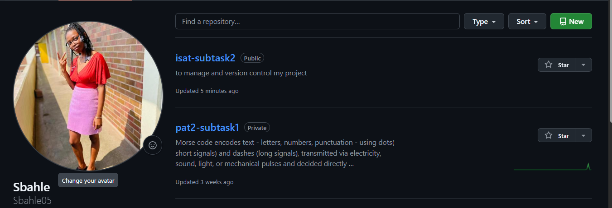

Link

https://github.com/Sbahle05/isat-subtask2.git

Modified Converter Program

The modified converter program includes the new functions and a user-friendly menu system. The program allows users to convert decimal numbers to binary, binary numbers to decimal, decimal numbers to hexadecimal, and hexadecimal numbers to decimal. Additionally, it includes a demo option that generates a random decimal number and converts it to binary.

New Functions and Menu System

The new functions include:

- decimalToHexadecimal: converts a decimal number to its hexadecimal equivalent

- hexadecimalToDecimal: converts a hexadecimal number to its decimal equivalent

- demo: generates a random decimal number and converts it to binary

The menu system allows users to select the conversion option they want to use. The program uses a switch statement to handle the different menu options.

Challenges Encountered

One challenge encountered during the modification was ensuring that the program handled invalid user input correctly. For example, if a user enters a non-numeric value when prompted for a decimal number, the program should handle the error and prompt the user to enter a valid value.

Commits

I made the following commits to my repository:

1. Initial Commit: Initialized project structure and basic conversion functions.

2. Added Decimal to Hexadecimal Function: Implemented decimalToHexadecimal function.

3. Added Hexadecimal to Decimal Function: Implemented hexadecimalToDecimal function.

4. Implemented Menu System: Added user-friendly menu system to select conversion options.

5. Added Demo Option: Implemented demo function to generate random decimal number and convert it to binary.

These commits reflect the progress and changes made to the program during the modification process.