Blood AI Classification

<https://zindi.africa/competitions/bloodsai-blood-spectroscopy-classification-challenge>

# Data-Preprocessing:

* Label Encoding
* K-mean Clustering (K=3 and added to train data for overfitting)
* Label Binarization

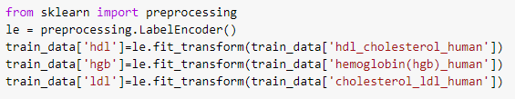

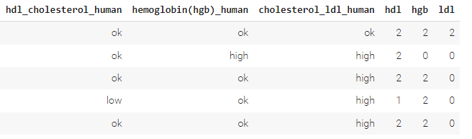

Fig 1. Label encoding for target class

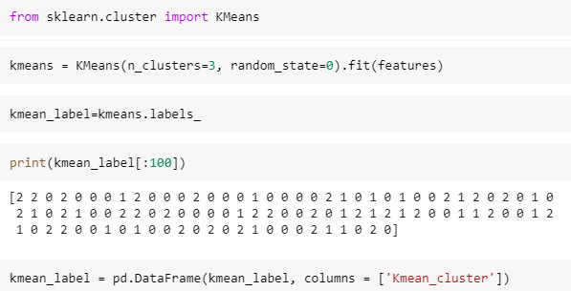

Fig2. K-mean clustering

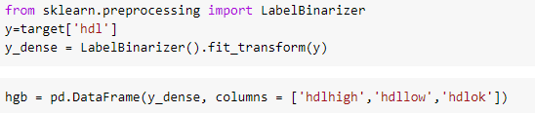

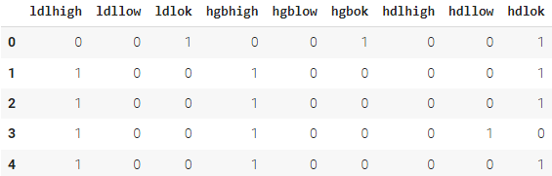

Fig 3. Label Binarizing data for binary categories

# Classifiers used:

* OneVsRest Classifier (SVC)
* Multi-layer Perceptron classifier (MLP)
* Classifier Chain (using ANN)

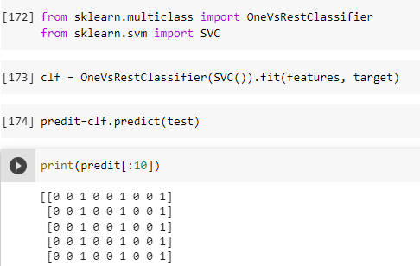

Fig1. OneVsRest Classifier

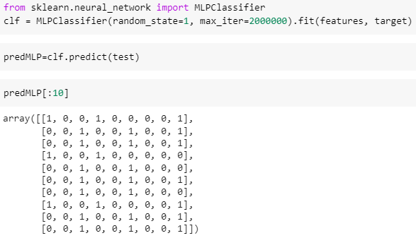

Fig2. Multi-Layer Perceptron

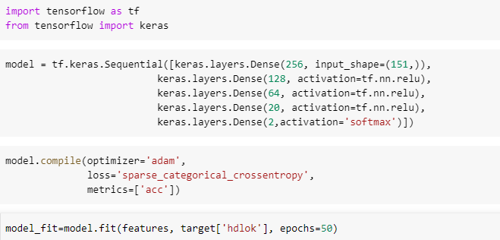

Fig3. Classifier Chain (using ANN)

# Outcome:

* OneVsRest classifier is not suitable for this particular data due to its unpredictable data classification in similar classes as seen in fig1 that this classifier due to unknown reason just classifies whole data into one class
* MLP perform and outperforms all but to converge it took a lot more than required iterations due to data complexity.
* Chain method (prediction of one class becomes feature for 2nd class prediction and so on) seems to perform average but it also has ambiguous data that may be questioned as the multiple classes for same category was seen high in some value.

# Prediction results:

* Prediction results for two classifiers are attached i.e. MLP and chain method using ANN. Please look for predicted result in attachment with the file please.