# Chapter 1

## Introduction

As we all know it is difficult to manage time for daily needs in this fast-moving world. With this case there is a need for change in a technological field, there's an urgent must embrace and appreciate the power of innovative technology. So there is a vital situation to manage one in all the essential need that's a shelter or home for survival. If we are not known to an individual in some cities and want to rent a house, room, apartment as well as shop then it's difficult to hunt out suitable aim time. Hence, there's a requirement to develop a “Gharbeti” App that will simplify the work for the rental managers and tenants so all their works are often done efficiently and effectively. It's also difficult to hunt out the renter on time, for the owner and property managers. This App will provide the whole knowledge about houses and apartment which is accessible for Rent. It will make easy to hunt out the position of Houses, need of rooms and other facts by the renter. Using this app the Landlords even have provision to post or update their property details whenever they want.

* GharBeti App is fully static and effective app. It'll provide the knowledge to the tenants about the homes which are accessible for Rent. They can easily search for their needs using keywords like property type, location, etc.
* On the other side, the Landlord has the facility to post or modify their property details with admin approval.
* It can be helpful to easily upload the position, phone number, Expected rent, No. of rooms, Facilities and other information by the

**Modules used in this project**

This project has two major modules that are:

**Landlord:**

* Registration by the landlord: First, the owner of the house should register their land with their name, location, contact No, expected rent, No. of rooms, Facilities and other information.
* Login by Landlord: the owner uses the app by login into the app with their login credentials.
* Add Tenants: New Tenant is added by the landlord by entering Tenant personal details with verification ID.
* Update availability: Owner can moderate or update no. Of rooms, area,
* Generate the rent invoice: Monthly bill is generated for the renters.
* Payment status: View payment status and easily detects which tenant has paid, not paid and have balance.

**Tenants:**

Registration by the tenants: First, the tenant should register themselves by their names and private details like id, contact,

Login by the tenants: The Tenant uses the app by login into the app with their login credentials.

Add Requirements: Tenants can upload their requirements to appear house as per their choice.

Search houses location: they will search about feasible lands and placement in their budget.

Handling Payment: Payment details can be viewed, the status of payment, and submit

## Problem Statement

In Nepal, there does not have online rental management system for who wants to rent get a lot of trouble to find place for rent even the place is available.

There is no properly allocate place and the system is not easily arrange according to their user interest. The rental management system almost done through the manual system.

The administrative system does not have the facility to make rental Management system through online and the most time the work done through illegal intermediate person without awareness of the administrative and this make more complex and more cost to find room for the customer. This leads customer to face more trouble, cost, dishonest and time wastage. The problem found in the current system:

* Complexity of finding home is not easy and more tedious.
* Need Extra money to find home.
* The system needs power that is more human.
* The user cannot get information about home when they need.
* There is too match time consumption find home.
* Complexity of the system for payment.
* An emergency repair is required when something in the rental unit has broken and the health or safety of the tenant is in danger or the building or property is at risk until repairs can made.

Management has become difficult because of issues that include:

**i. Data growth:**

Data increase day to day. Storing and maintaining all data manually is very difficult.

**ii. Lack of computerized system**

Currently most landlords/property managers use the manual system in recording and maintaining their property and customers data

**iii. Data security is not assure**

In a manual way, data is record on books/papers, which may easily be damage leading to loss of data.

**iv. There is no database to store information**

Potential of data loss or damage is very high because data is stored on tangible files. Lack of these crucial requirements makes management of the tenants and houses very difficult as some tenants may end up not paying rent.

## Objectives

* To facilitate tenants record keeping for who wants room and for administrative management system.
* To prepare an online rental system for the room, apartment and shop finders.
* To make tenants and landlord easy to know the record.

## Significance of project

* It helps the owner to find the tenants easily.
* This app verify both owner and the tenants before they contacts each other by using the document which verify them as a real person.
* It helps the tenants to find the room easily without searching from one home to another.
* It provide the actual location of the rental house.
* The tenant and owner easily able to update modify and delete their detail and no. of room and house.
* We are able to contact the owner without the agent.

## Project Feature

Some of the useful and important features of “GharBeti” are-

* Admin, landlord and user has log into the system.
* Landlord and user have to register before login into the system.
* It has ability to add & remove different rental detail
* Admin panel
* Landlord add , update and remove personal as well as rent detail
* Tenant edit & add the rent.
* Admin is able to manage landlord and tenant.
* Type of room/rental place show with their price.
* Admin and landlord can view the report

## Assignment of role and responsibility

We assigned the roles and responsibilities equally among all members of the group. There are various phases during the project such as analysis, coding, testing, debugging, documentation etc. The coding phase itself involves frontend and backend development as well as data entry. As team members, we shared all the work and regularly communicated and helped each other for the successful completion of the project.

## Project Documentation

Documentation is an important part of any software project. It informs both software developers and users. The documentation for our project was develop throughout the life cycle of the project. The documentations have been separate into different steps.

# Chapter 2: Literature Survey

## 2.1. Literature Review

Literature review is a text written by someone to consider the critical points of current knowledge including substantive findings as well as theoretical and methodological contributions to a particular topic. Main goals are to situate the current study within the body of literature and to provide context for the particular reader

**99ACRES**  
Created by the popular property search portal 99acres.com, this app offers the same user experience as the website, on the go. The app, which is free for Android users, allows you to browse properties for rent, along with high quality pictures, videos and maps. It is best known for the numerous options it provides, with listings of around 10 lakh properties across the country. It also promises instant contact between landlords and interested tenants through phone calls, text or email.

**NOBROKER**  
This app stands for what everyone looking to rent wants to do: cut the broker out of the equation. It lets us find and rent a house without paying any brokerage. Most of us feel that having to pay a hefty brokerage fee is unfair. The No-Broker app resolves this by letting home owners list their properties easily and then putting them in touch with potential tenants. We can contact the homeowner directly through the app after shortlisting a property.

**FLATCHAT**  
This app provides a platform where homeowners and potential tenants can share their location, find contacts in their vicinity and chat with them. It also allows you to sign up to find suitable flat mates to share a rental with. This can make the otherwise difficult process hassle free, since you can find people with the same budget and location preference as you, as well similar hobbies and habits. So far, the app is only functional in Bengaluru, Mumbai, Pune, and Delhi.

**NESTAWAY**  
This app’s appeal lies in the fact that it offers many fully furnished rental options with standardized amenities, and Nest Away takes responsibility for making sure that these are in working order. Once we shortlist a property, we can schedule a visit through the app, saving the trouble of calling and coordinating with owner or agent. The app stores important documents like rental agreements and receipts for easy access. It also allows us to book prefer.

## 2.2. Existing System

At present, the people of our country suffer a lot for want of accommodation

according to their demand. They've to run to and fro for their desired house to

buy/rent. They have to go through every corner of society to get information about the

house/land that is available. Similarly, a landlord/house owner also has to suffer

sometime when he wants to rent/sell his properties. He has to expose the subject

people to people to get his desired client. To solve these types of problems, we're

going to introduce HOUSE RENTAL system.

At present, the people of our country suffer a lot for want of accommodation

according to their demand. They've to run to and fro for their desired house to

buy/rent. They have to go through every corner of society to get information about the

house/land that is available. Similarly, a landlord/house owner also has to suffer

sometime when he wants to rent/sell his properties. He has to expose the subject

people to people to get his desired client. To solve these types of problems, we're

going to introduce HOUSE RENTAL system.

At present, the people of our country suffer a lot for want of accommodation

according to their demand. They've to run to and fro for their desired house to

buy/rent. They have to go through every corner of society to get information about the

house/land that is available. Similarly, a landlord/house owner also has to suffer

sometime when he wants to rent/sell his properties. He has to expose the subject

people to people to get his desired client. To solve these types of problems, we're

going to introduce HOUSE RENTAL system

At present, the people of our country suffer a lot for want of accommodation

according to their demand. They've to run to and fro for their desired house to

buy/rent. They have to go through every corner of society to get information about the

house/land that is available. Similarly, a landlord/house owner also has to suffer

sometime when he wants to rent/sell his properties. He has to expose the subject

people to people to get his desired client. To solve these types of problems, we're

going to introduce HOUSE RENTAL system

At present, the people of our country suffer a lot for want of accommodation

according to their demand. They've to run to and fro for their desired house to

buy/rent. They have to go through every corner of society to get information about the

house/land that is available. Similarly, a landlord/house owner also has to suffer

sometime when he wants to rent/sell his properties. He has to expose the subject

people to people to get his desired client. To solve these types of problems, we're

going to introduce HOUSE RENTAL system

At present, the people of our country suffer a lot from rental place of accommodation according to their demand. They have to run back and forth for their desired house/room/flat/apartment to rent. They have to go through every corner of society to get information about the house/room/flat/apartment that is available. Similarly, a landlord/house owner also suffer when he/she wants to rent their properties. They have to expose the subject people to get desired client. To solve these types of problems, we introduced Gharbeti application.

## 2.3. Analysis of issue

In Nepal there doesn’t have online home, apartment and shop rental management system for who wants to rent home, apartment and shop get a lot of trouble to find room even the room is available. There is no properly allocate room and the system easily which arranges according to the user interest. The rental process also go through the manual way.

The administrative system does not have the facility to make rental Management system through online and the most time the work done through illegal intermediate person without awareness of the administrative and this make more complex and more cost to find room for the customer. This leads customer to face more trouble, cost, dishonest and time wastage. The problem found in the current system:

* Complexity of finding home is not easy and more tedious.
* Need Extra money to find home.
* The system needs power that is more human.
* The user cannot get information about home when they need.
* There is too match time consumption find home.
* Complexity of the system for payment.
* An emergency repair is required when something in the rental unit has broken and the health or safety of the tenant is in danger or the building or property is at risk until repairs the system.

Management has become difficult because of issues that include:

**i. Data growth:**

Data increase day to day. Storing and maintaining all data manually is very difficult.

**ii. Lack of computerized system**

Currently most landlords/property managers use the manual system in recording and maintaining their property and customers data

**iii. Data security is not assure**

In a manual way, data is record on books/papers, which may easily be damage leading to loss of data.

**iv. There is no database to store information**

Potential of data loss or damage is very high because data is stored on tangible files. Lack of these crucial requirements makes management of the tenants and houses very difficult as some tenants may end up not paying rent.

## 2.4. Solution

# Chapter 3: System Analysis

## 3.1. System Development model

# Chapter 4: Design Specification and Implementation

## 4.1. System Architecture

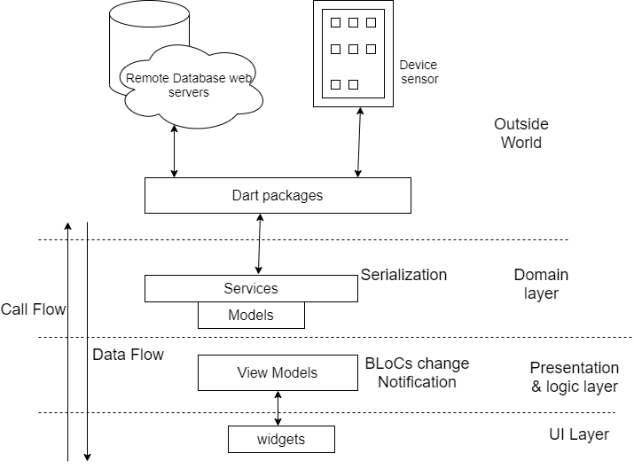

## 4.2. Data Flow Diagram (DFD)

## 4.2.1. Context Diagram

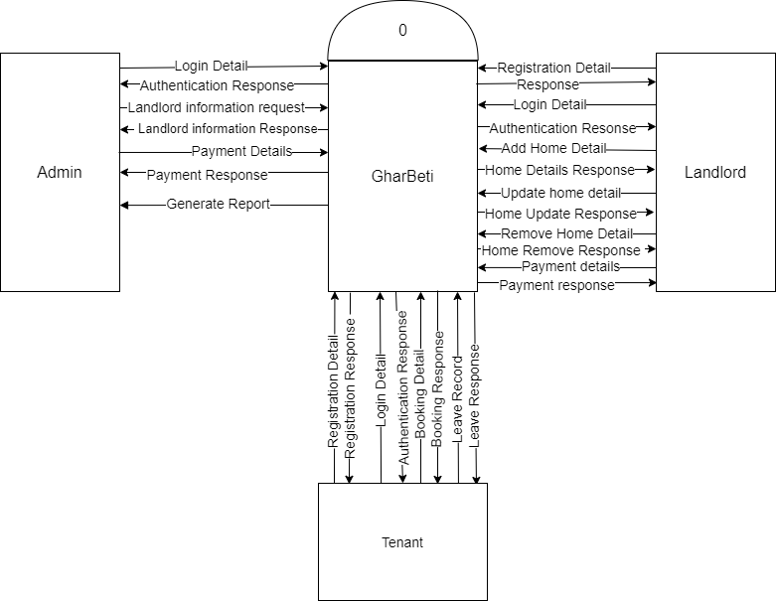

## 4.2.2. DFD Level 1

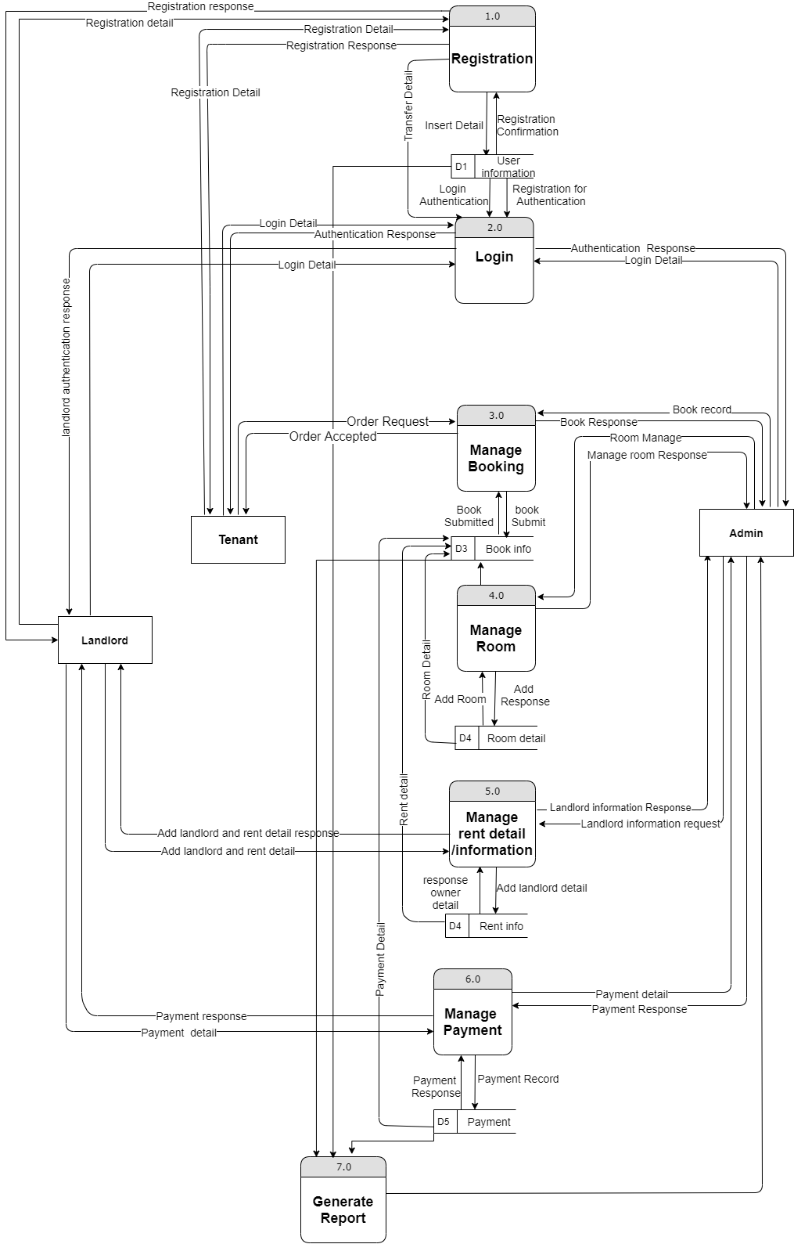

## 4.3. Data Dictionary

The data dictionary is useful in case of development.

**Table Name:** Admin

**Primary Key:** Admin ID

**Description:** To store the details of admin

|  |  |  |  |
| --- | --- | --- | --- |
| **Serial No.** | **Field** | **Datatype** | **Description** |
| 1. | Admin ID | Integer | Primary Key |
| 2. | Name | Varchar |  |
| 3. | Email ID | Varchar |  |
| 4. | Contact No. | Integer | Multiple contacts can exist for a single admin |
| 5. | Address | Varchar |  |

**Table Name:** User Master

**Primary Key:** User ID

**Description:** To store the detail of Users

|  |  |  |  |
| --- | --- | --- | --- |
| **Serial No.** | **Field** | **Datatype** | **Description** |
| 1. | User ID | Integer | Primary Key |
| 2. | Name | Varchar |  |
| 3. | Email ID | Varchar |  |
| 4. | Contact No. | Integer | Multiple contacts can exist for a single admin |
| 5. | Address | Varchar |  |

**Table Name:** Property Master

**Primary Key:** Property ID

**Description:** To store the detail of Property

|  |  |  |  |
| --- | --- | --- | --- |
| **Serial No.** | **Field** | **Datatype** | **Description** |
| 1. | Property ID | Integer | Primary Key |
| 2. | Owner ID | Integer | Foreign key to user master |
| 3. | Location | Varchar |  |
| 4. | Status | Varchar | Available, rented, etc. |
| 5. | Total value | Float |  |

**Table Name:** Book Master

**Primary Key:** Book ID

**Description:** To store the detail of Booking

|  |  |  |  |
| --- | --- | --- | --- |
| **Serial No.** | **Field** | **Datatype** | **Description** |
| 1. | Book ID | Integer | Primary Key |
| 2. | Property ID | Integer | Foreign key to Property Master. |
| 3. | Owner ID | Integer | Foreign key to Owner Master. |
| 5. | User ID | Integer | Foreign key to User Master. |

**Table Name:** Payment Master

**Primary Key:** Payment ID

**Description:** To store the detail of Booking

|  |  |  |  |
| --- | --- | --- | --- |
| **Serial No.** | **Field** | **Datatype** | **Description** |
| 1. | Payment ID | Integer | Primary Key |
| 2. | Book ID | Integer | Foreign key to Book Master. |
| 3. | Transaction no. | Varchar | Transaction number |

## 4.4. Working Procedure

## 4.5. Flowchart Diagram

## 4.6. Use Case Diagram

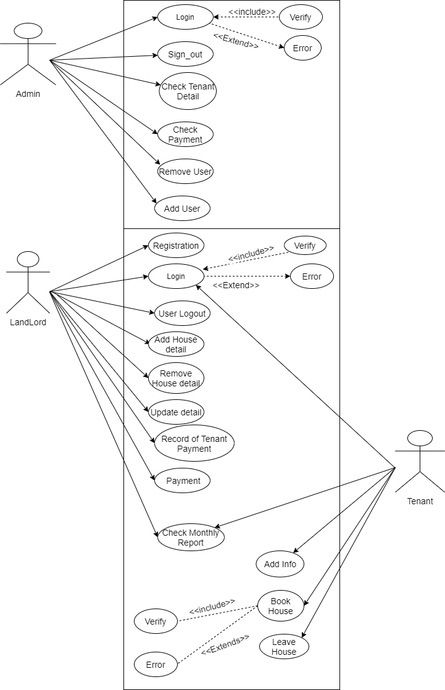

# Chapter 5 Experimental Result and Analysis

## 5.1. Scenario

## 5.2. Experiment

## 5.3. Experiment Result with Analysis

### 5.3.1. Testing

Each component is tested independently, without other system components interfering. This process is concerned with finding errors. It is also concerned with validating that the system meets its functional & non-functional requirements.

### 5.3.2. Expected Result

* Application will be a service which will connect Renters and Landlords and vice versa.
* It will save the physical hard work and invaluable time to find room/flat/shop.
* It will save Resources for search the rooms/house/flats/shop.
* It will be an Open Source Application which can be freely Install in android smart Phones.
* Application will make easy to find rooms/flats/houses/shops for the tenants and upload the location and other information by landlord/room-master.

# Chapter 6

## 6.1. Conclusion

Online rental business has emerged with a new possibilities compared to the experience where every activity concerning rental business was limited to a physical location only. Even though the physical search for houses has not been totally eradicated; the nature of functions and how these functions are achieved has been reshaped by the power of internet. Nowadays, renters can reserve houses online once the customer is a registered member of the application. The app based house rental system has offered an advantage to both landlords as well as the tenants efficiently and effectively just with the click of a button.

## 6.2. Future Work

**Reference**

[**https://pdfcoffee.com/a-project-on-online-house-rental-management-pdf-free.html**](https://pdfcoffee.com/a-project-on-online-house-rental-management-pdf-free.html)

[**https://www.slideshare.net/FNISHA/apartment-management-system-project**](https://www.slideshare.net/FNISHA/apartment-management-system-project)

**Bibliography**

**Appendixes**