Zi Beacham
February 13, 2026
Mod 8.2 Assignment

- 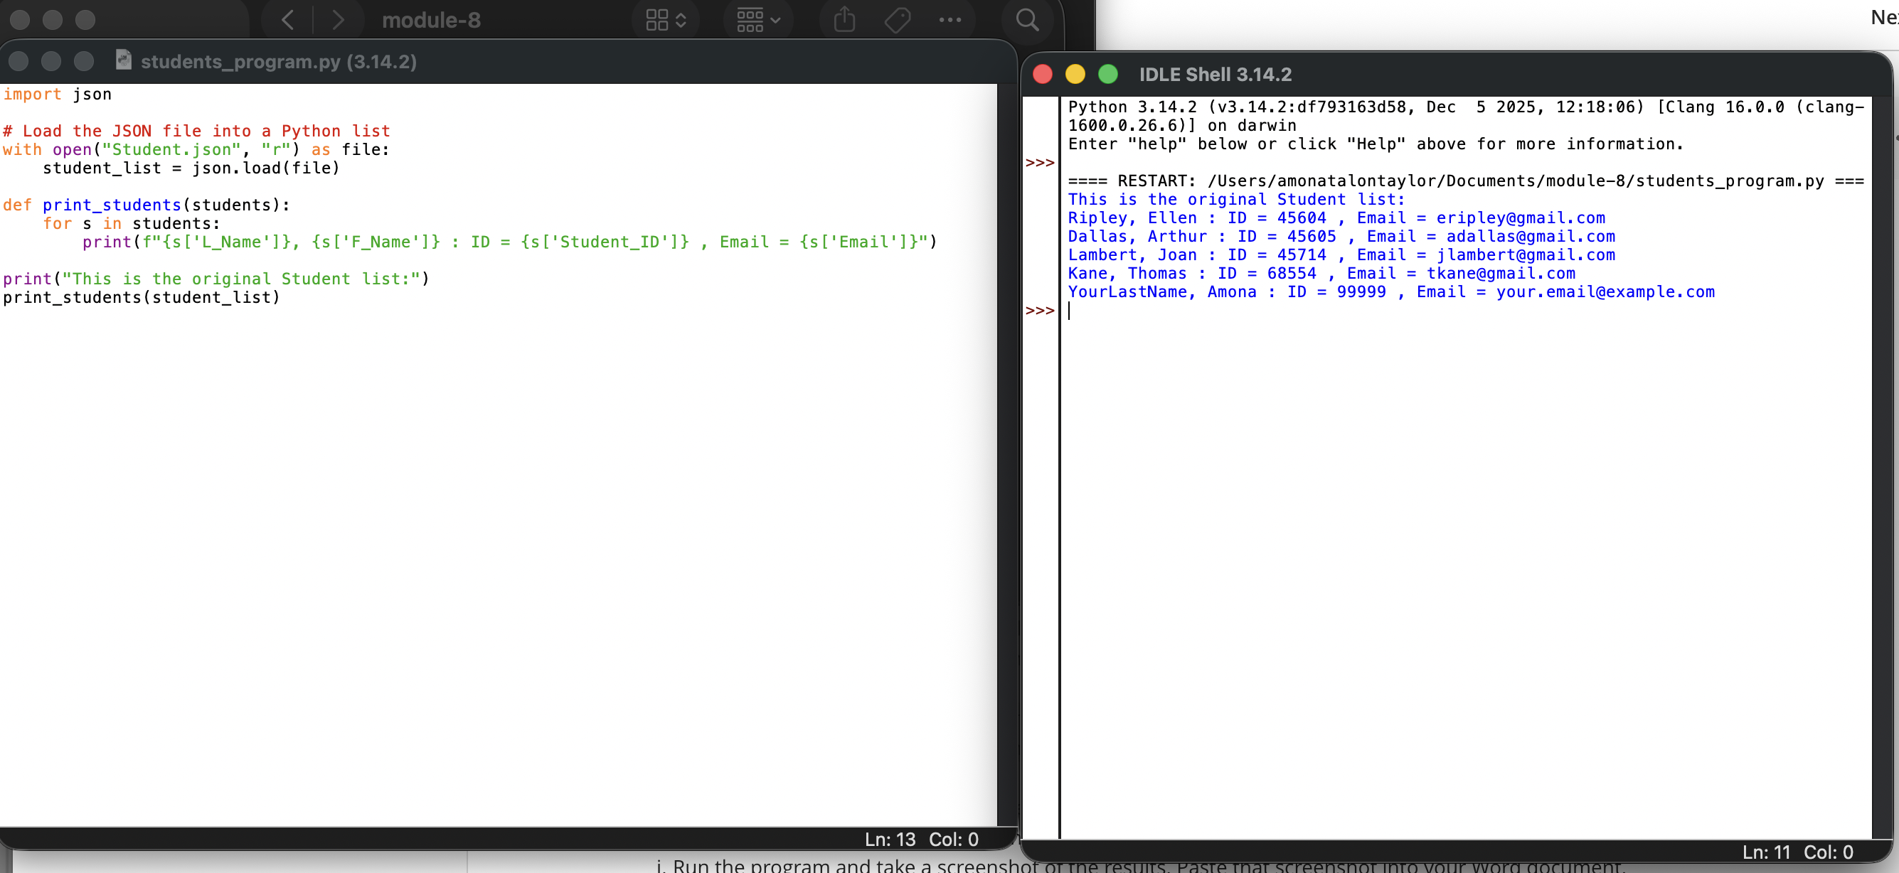
- 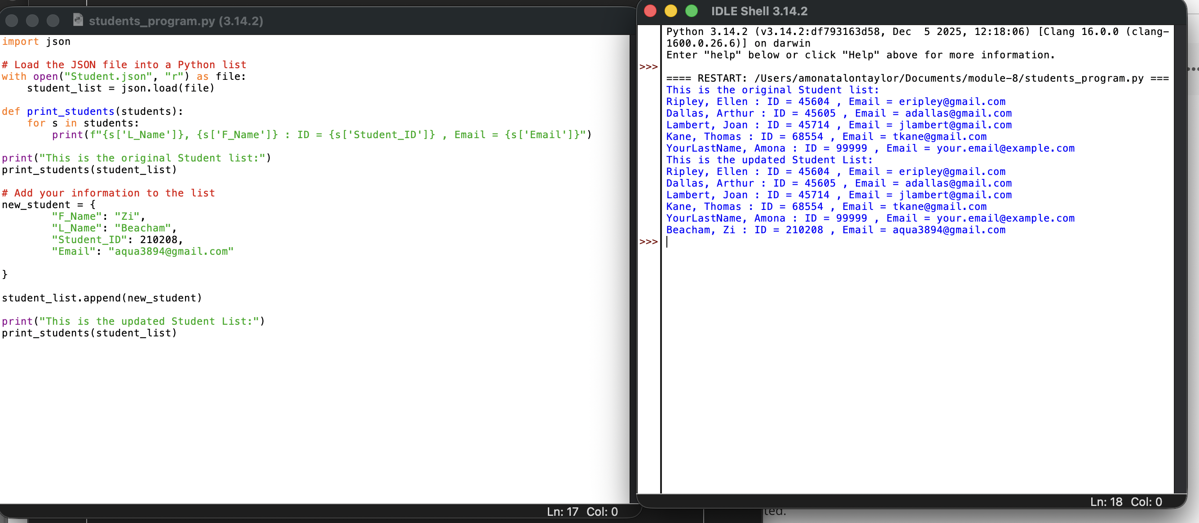
- 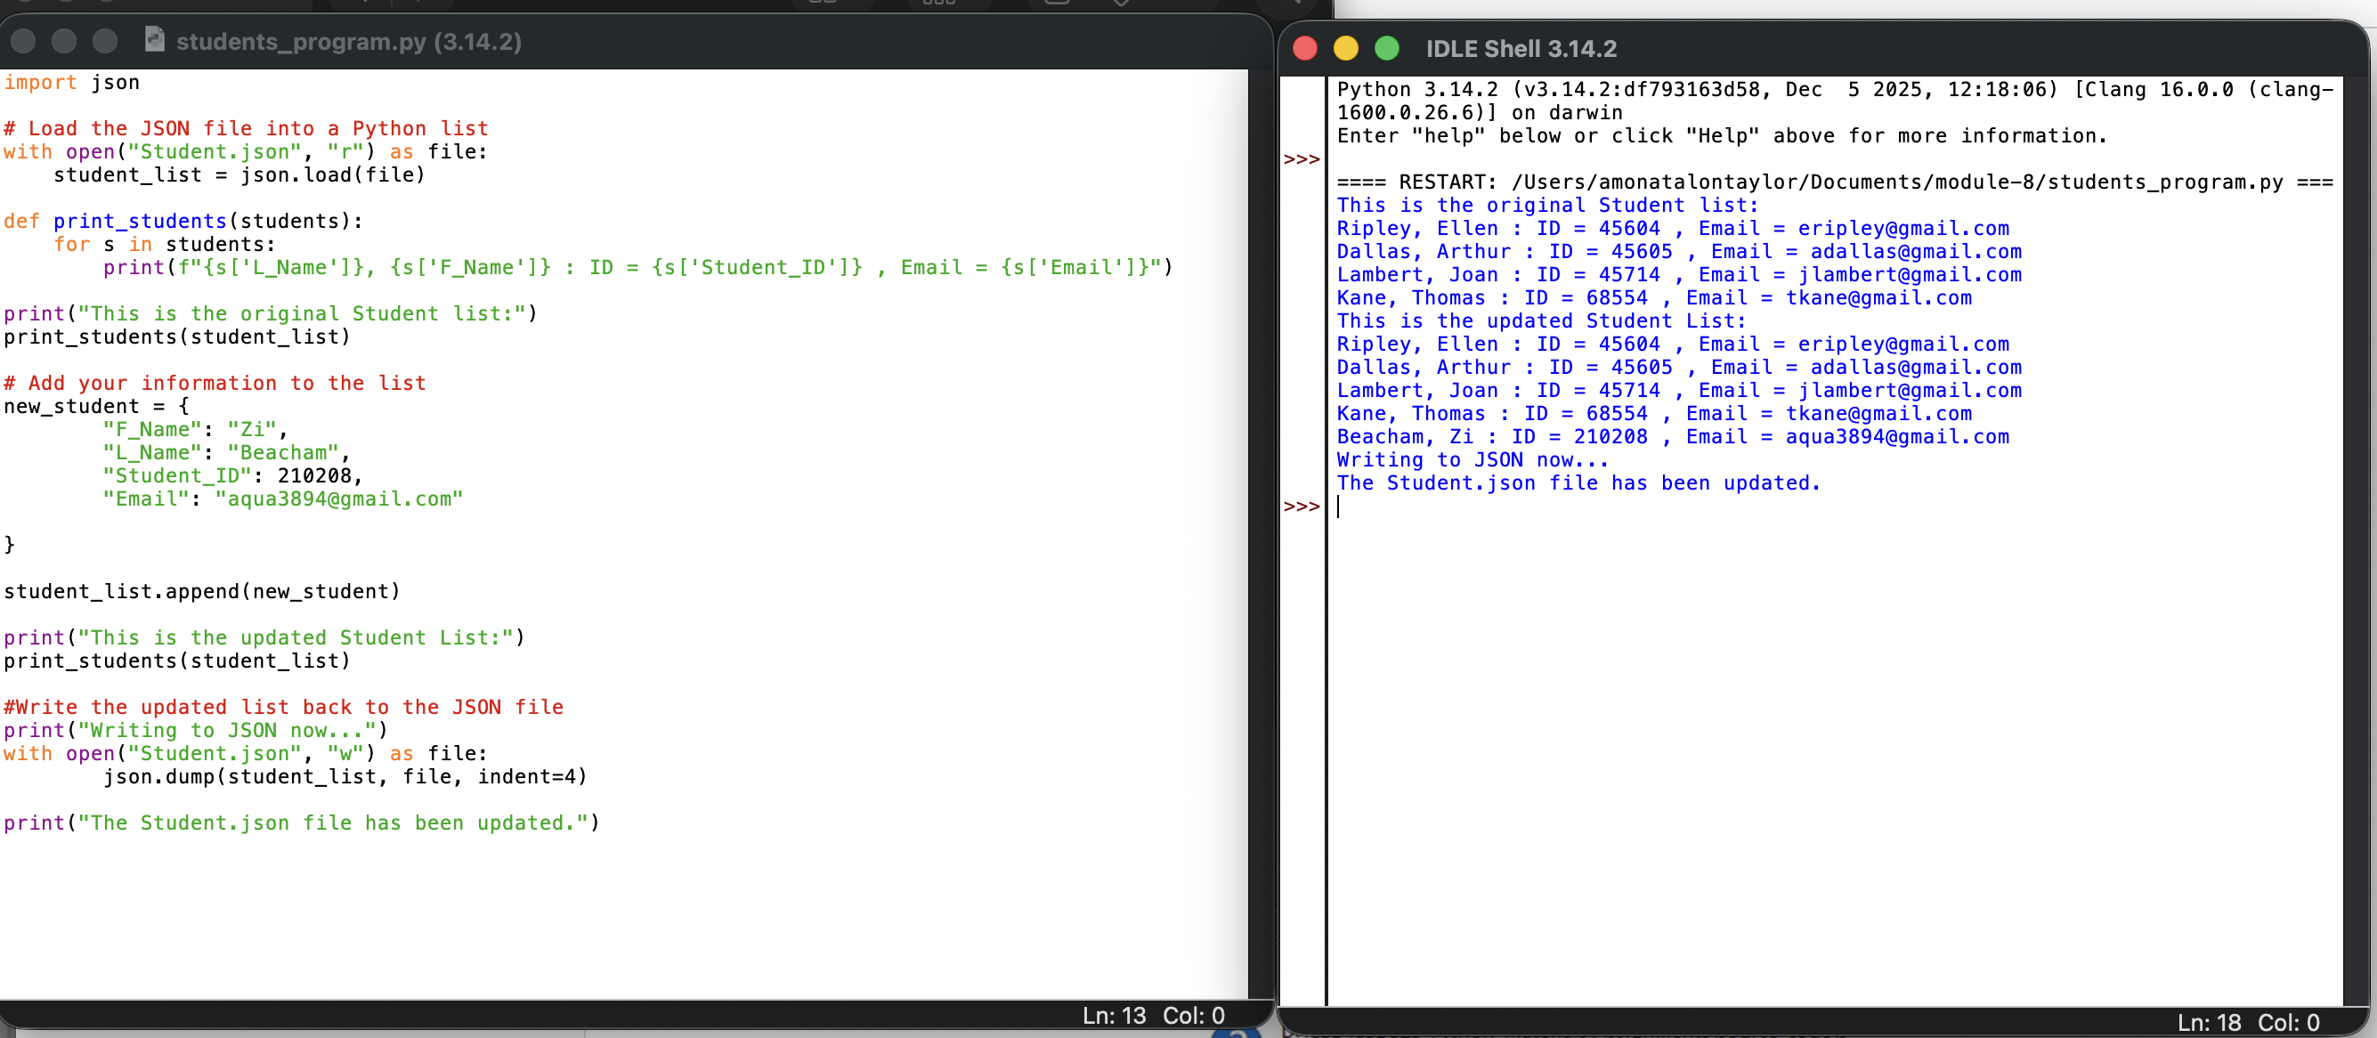

The system did not give a pop-up that the JSON file had been changed or updated. I had to do it a different way by closing and reopening the file to see the difference and update the changes made, removing the ‘Amona’ information.

