
Tribhuvan University
Faculty of Humanities and Social Sciences

A PROJECT REPORT

ON

Social Networking and Gigs Platform

(ProConnect)

Submitted to
Department of BCA
Everest College

In partial fulfillment of the requirements for the Bachelors in Computer Application

Submitted By
Subham Bhandari, 6-2-355-29-2021
Utsav Karki, 6-2-355-33-2021
BCA 6th Semester, III Year

Under the Supervision of
Mr. Kamal Pathak
Tribhuvan University
Faculty of Humanities and Social Sciences
Everest College

SUPERVISOR’S RECOMMNEDATION
I hereby recommend that this project prepared under my supervision by SUBHAM BHANDARI, 6-2-355-29-2021 and UTSAV KARKI, 6-2-355-33-2021 entitled “Social
Networking and Gigs Platform (ProConnect)” in partial fulfillment of the requirements for the degree of Bachelor of Computer Applications is recommended for the final evaluation.

Name of the Supervisor:
Kamal Pathak

Signature of the Supervisor

BCA 6th Semester, III Year
Department of BCA
Everest College, Thapathali
Tribhuvan University
Faculty of Humanities and Social Sciences Everest College

LETTER OF APPROVAL
This is to certify that this project prepared by SUBHAM BHANDARI, 6-2-355-29-2021 and UTSAV KARKI, 6-2-355-33-2021 entitled “Social Networking and Gigs Platform (ProConnect)” in partial fulfillment of the requirements for the degree of Bachelor in Computer Application has been evaluated. In our opinion it is satisfactory in the scope and quality as a project for the required degree.

SUPERVISOR  Mr. Kamal Pathak  Department of BCA  Everest College | HOD/CO-ORDINATOR  Mr. Kamal Pathak  Department of BCA  Everest College
INTERNAL EXAMINER  Name: Kamal Pathak  Date: | EXTERNAL EXAMINER  Name:  Date:

ABSTRACT

ProConnect is a dynamic web-based platform designed to foster professional networking and gig opportunities for developers and IT professionals. Addressing the growing need for streamlined collaboration and skill-based job discovery, especially in emerging markets like Nepal, the platform provides a centralized space for users to connect, share, and collaborate. ProConnect features a social feed for posting updates, a developer-focused job board, and user profile customization. The system supports core social media interactions including likes, comments, saves, and reports. Advanced search enables users to explore jobs, users, and posts efficiently. An authentication system ensures secure access, while future enhancements aim to incorporate personalized suggestions and messaging. Built using Laravel Blade for the frontend and Tailwind CSS for design, the backend is powered by PHP and MySQL, with version control via Git and GitHub. The system follows a structured development process including system analysis, design, implementation, and testing. ProConnect aims to promote a professional tech ecosystem through efficient networking, skill-sharing, and freelance engagement tailored to the evolving needs of IT communities.

Keywords: HTML, CSS, Laravel, PHP, Blade, JavaScript, Tailwind CSS, MySQL, Vite, Git, GitHub, SDLC, ER Diagram, Figma.

ACKNOWLEDGEMENT
After a rigorous and continuous efforts, we are glad to present this project report as our project report on “Social Networking and Gigs Platform (ProConnect)” We express our sincere gratitude to those helping hands that came forward and directed us towards the success of the whole project with the desired output.
We extend our genuine thankfulness to our project supervisor Mr. Kamal Pathak for his valuable and great support and guidance in all the happenings regarding the project. We must express our thanks to Mr. Kamal Pathak, HOD, for his encouragement and guidance throughout the project.
We are indebted to the Department of BCA for providing support to add on our venture. Last but not least, we would like to thank our teachers and colleagues who have been knowingly or unknowingly part of this project and lent support and views during the entire development time.

Table of Contents

SUPERVISOR’S RECOMMNEDATION i
LETTER OF APPROVAL ii
ABSTRACT iii
ACKNOWLEDGEMENT iv
LIST OF FIGURES vii
LIST OF TABLES. viii
LIST OF ABBREVIATIONS ix
CHAPTER 1: PROJECT INTRODUCTION 10
1.1 Introduction 10
1.2 Problem Statement 11
1.3 Objectives 12
1.4 Scope and Limitation Scope 12
1.5 Report Organization 14
CHAPTER 2: BACKGROUND STUDY AND LITEREATURE REVIEW 15
2.1 Background Study 15
2.2 Literature Review 15
2.3 Existing System 16
2.4 Proposed system 17
CHAPTER 3: SYSTEM ANALYSIS AND DESIGN 18
3.1 System Analysis 18
3.1.1 Requirement Analysis 19
3.1.2 Feasibility Study 22
3.1.2.1 Operational Feasibility 23
3.1.2.2 Economic Feasibility 23
3.1.2.3 Technical Feasibility 23
3.1.2.4 Schedule Feasibility 23
3.1.3 Object Modeling: Object & Class Diagram 25
3.1.4 Dynamic Modeling: State & Sequence Diagram 27
3.1.5 Process Modeling: Activity Diagram 28
3.2 System Design 29
3.2.1 Architectural Design 29
3.2.2 Refinement of Classes and Object 31
3.2.3 Component Diagram 33
3.3 Algorithm Details 34
CHAPTER 4: IMPLEMENTATION AND TESTING.. 37
4.1 Implementation 37
4.1.1 Tools Used 37
4.1.2 Implementation Details of Modules 38
4.2 Testing 45
4.2.1 Test Cases for Unit Testing 45
4.2.2 Test Cases for System Testing 58
CHAPTER 5: CONCLUSION AND FUTURE RECOMMENDATIONS 59
5.1 Lesson Learnt/Outcome 59
5.2 Conclusion 60
5.3 Future Recommendations 60
APPENDICES 62
Project Screenshots 62
REFERENCES 71

LIST OF FIGURES
Figure 1: Waterfall Model for Social Networking and Gigs Platform (ProConnect)........... 19
Figure 2: Use-Case Diagram of Social Networking and Gigs Platform (ProConnect).... 20
Figure 3: Gantt-Chart of Social Networking and Gigs Platform (ProConnect) 24
Figure 4: Class Diagram of Social Networking and Gigs Platform (ProConnect) 25
Figure 5: State Diagram of Social Networking and Gigs Platform (ProConnect) 26
Figure 6: Sequence Diagram of Social Networking and Gigs Platform (ProConnect) 27
Figure 7: Activity Diagram of User in Social Networking and Gigs Platform (ProConnect) 28
Figure 8: Architecture Design of Social Networking and Gigs Platform (ProConnect) 30
Figure 9: Refinement of Class Diagram of Social Networking and Gigs Platform 32
Figure 10: Component Diagram of Social Networking and Gigs Platform 33
Figure 11: Test evidence 1.1 47
Figure 12: Test evidence 2.1 48
Figure 13: Test evidence 3.1 49
Figure 14: Test evidence 4.1 50
Figure 15: Test evidence 4.2 51
Figure 16: Test evidence 4.3 51
Figure 17: Test evidence 4.4 52
Figure 18: Test evidence 5.1 53
Figure 19: Test evidence 5.2 54
Figure 20: Test evidence 5.3 54
Figure 21: Test evidence 5.4 55
Figure 22: Test evidence 6.1 56
Figure 23: Test evidence 6.2 57
Figure 24: Test evidence 6.3 57

LIST OF TABLES
Table 1: Project Schedule for Social Networking and Gigs Platform ...........................................24
Table 2: Test Cases for Unit Testing .........................................................................................45

LIST OF ABBREVIATIONS

API: Application Programming Interface
CRUD: Create Read Update and Delete
CSS: Cascading Style Sheet
HTML: Hyper Text Markup Language
IT: Information Technology
JS: JavaScript
PHP: Hypertext Preprocessor
UI: User Interface
UX: User Experience

CHAPTER 1: PROJECT INTRODUCTION

Introduction
ProConnect is a Social Networking and Gigs Platform designed to connect IT professionals, freelancers, and technology enthusiasts in a dynamic and collaborative environment. This web-based platform integrates essential features including a social feed for posts, job board functionality tailored for tech gigs, secure user authentication, profile management, and admin control. With an intuitive and responsive design powered by Laravel Blade and Tailwind CSS, ProConnect provides a seamless user experience for interacting, networking, and showcasing professional expertise.
The primary objective of ProConnect is to serve as a centralized space where developers and IT professionals can share updates, discover freelance or part-time jobs, and build professional relationships. It bridges the gap between social interaction and professional growth by combining community engagement with practical work opportunities. Key functionalities include creating and interacting with posts, liking, commenting, saving, and reporting, as well as searching for jobs, users, or relevant content.
ProConnect is structured into well-defined modules to support smooth operation. These include the posts module for creating and interacting with developer-centric content; the job board module for listing and applying to gigs such as API development, UI/UX design, and project management; and the user module that manages registration, login, and personalized profiles. The admin panel allows for efficient moderation, content management, and user oversight to ensure platform quality and security.
Users can register using secure authentication credentials, with role-based access for users and administrators. Profiles include educational background, technical skills, and work history to enhance networking opportunities. The platform also supports advanced search and filtering tools, making it easier for users to find relevant jobs, posts, or connections.
Although chat and notification systems are part of the future roadmap, the current version emphasizes content interaction and gig discovery. Planned enhancements include implementing recommendation algorithms to suggest posts, jobs, and potential connections based on user behavior and interests.
The ProConnect project report presents a detailed breakdown of the platform’s development process, covering analysis, design, implementation, and testing phases. It explains how the system is built to support data storage, processing, and communication between modules while adhering to modern development standards.
In summary, ProConnect aims to empower developers and IT professionals by creating a focused digital ecosystem that supports freelance engagement, collaboration, and professional visibility. Through its social and gig-driven features, the platform aspires to contribute to the growing tech workforce in emerging markets like Nepal and beyond.

Problem Statement
The " Social Networking and Gigs Platform" (ProConnect) is designed to address several critical challenges faced by aspiring developers, freelancers, and IT professionals— particularly in emerging tech markets like Nepal. The platform seeks to provide comprehensive solutions to the following key issues:
- Lack of centralized platforms for developers to connect, collaborate, and showcase their skills.
- Difficulty in finding short-term or freelance IT gigs suited to specific technical expertise.
- Limited access to community-driven content, technical discussions, and job opportunities in a single ecosystem.
- Absence of tailored networking spaces for local developers to grow their careers and build professional relationships.
By solving these challenges, ProConnect aims to foster a more connected and opportunity- rich digital environment for tech professionals. It streamlines access to freelance jobs, professional content, and community support—all within an intuitive and accessible platform.

Objectives
This applied research aims to design, develop, and deploy an online Social Networking and Gigs Platform, ProConnect, with the following objectives:
- To Develop and launch a social networking platform tailored for developers and IT professionals.
- To Integrate a jobs and gigs section focused on short-term, freelance, and skill-based opportunities.
- To Build social media–like features including post creation, interaction (like, comment, save), and user profiles.
- To Ensure the platform is responsive, user-friendly, and accessible across various devices.

Scope and Limitation Scope
The Social Networking and Gigs Platform, ProConnect is envisioned as a comprehensive digital solution to support developers, freelancers, and IT professionals—especially in emerging markets like Nepal. The platform includes a broad range of features aimed at enhancing collaboration, visibility, and access to professional opportunities. The scope of the platform includes:
- The platform provides a dynamic gigs and job listings system for freelance jobs, short-term contracts, and skill-specific tasks in areas like web development, UI/UX design, and project management.
- It allows developers to connect, follow, and engage with each other by sharing updates, posts, project highlights, and professional experiences.
- It supports an admin dashboard for managing users, gigs, categories, posts, and reported content, ensuring smooth platform oversight.
- It enables users to create, like, comment, save, and report posts, fostering meaningful dialogue and knowledge sharing.
- It provides advanced search and discovery tools to find relevant posts, users, and gigs using keywords, categories, and filters.
- It is designed to be responsive and user-friendly, ensuring seamless access across desktops, tablets, and smartphones.
- It is built with Laravel, Blade templating, and Tailwind CSS, offering a secure, maintainable, and scalable architecture.
- It fosters a community-driven environment with public profiles, job feedback, and collaborative opportunities for developers.

Limitation
While the Social Networking and Gigs Platform, ProConnect aims to provide a robust solution for connecting developers and enhancing professional opportunities, there are inherent limitations to consider:
- The platform requires stable internet access, which may be limited or inconsistent in certain regions, especially outside urban centers.
- It may pose challenges for users with varying levels of technical proficiency, particularly newcomers to online freelancing or networking.
- It relies on integrated online payment systems, which could be difficult for users without access to banking or digital payment facilities.
- The availability and quality of gigs depend on external clients and companies, affecting user engagement and trust.
- It lacks a built-in dispute resolution or escrow system, requiring users to handle payment or contract disagreements independently.

By acknowledging these limitations, ProConnect aims to continuously refine its features and expand its capabilities, addressing challenges and improving the overall experience for the developer community.

Report Organization
The material presented in the main report on the Developer Networking and Gigs Platform (ProConnect) is structured to provide a comprehensive overview of the project from inception to conclusion. The material is organized into five main chapters, each addressing distinct aspects of the project’s development and implementation. Chapter 1 starts with project introduction. Chapter 2 describes background study and literature review performed during and before starting this project. Chapter 3 provides an account of the system analysis and design. The system analysis of this chapter includes requirement analysis, feasibility analysis, data modeling, process modeling, and the system design includes architecture design, database schema design, interface design, and physical DFD. Chapter 4 incorporates the implementation and testing part of this project.And finally, Chapter 5 includes the conclusion of the project with lessons, outcomes, and the future recommendations for the project. Each chapter is designed to build upon the previous one, providing a logical flow of information that guides the reader through the project’s development process from background research to final outcomes and recommendations.

CHAPTER 2: BACKGROUND STUDY AND LITEREATURE REVIEW

Background Study
To develop an effective Social Networking and Gigs Platform, ProConnect, an extensive background study was conducted, integrating data collection through analyzing existing research. The data analysis involved reviewing academic journals, professional networking studies, gig economy reports, and case studies of existing digital networking platforms. This review provided insights into global collaboration challenges, the role of digital tools in professional networking, and the impact of online platforms on career growth and project engagement. Notable sources included research on the integration of technology in professional networking and detailed case studies of platforms such as LinkedIn and Fiverr. These platforms, although beneficial, revealed gaps in providing a unified space that combines networking, skill showcasing, and gig opportunities in a seamless manner. Concurrently, primary data was collected through interviews with developers, freelancers, and industry professionals from various regions. These interviews highlighted the practical difficulties faced by professionals, such as limited exposure to relevant opportunities, unreliable sources of project information, and the lack of a collaborative environment tailored to their needs. Furthermore, consultations with industry experts provided professional insights into the shortcomings of current networking and gig platforms, as well as essential features needed in a modern, all-in-one solution. This combined analysis underscored the need for a web-based solution like ProConnect, which can provide timely, reliable, and comprehensive networking, collaboration, and gig-matching services for professionals.

Literature Review
The literature review for ProConnect focused on exploring the importance and impact of integrated social networking and gig platforms, along with their various components, specifically those relevant to ProConnect’s feature set. Modern networking and gig platforms are increasingly recognized for their ability to provide scalable, timely, and targeted professional connections by leveraging technologies such as AI-driven recommendations, big data analytics, and secure digital communication tools. These systems have been shown to significantly improve collaboration, career growth, and project matching for professionals across industries. Additionally, the integration of gig marketplaces within networking platforms is transformative. Platforms like ProConnect that enable both professional networking and direct gig engagement can eliminate unnecessary intermediaries, streamline the hiring process, and increase earning opportunities for freelancers. Literature suggests that such platforms empower users by expanding their reach to a broader range of potential clients or collaborators while ensuring more efficient project acquisition and execution. Furthermore, blogs, community forums, and online resource libraries play a crucial role in skill development and professional growth. They serve as continuous learning and networking tools, offering insights into industry best practices, emerging technologies, career guidance, and market trends. Research indicates that professionals with access to regularly updated, high-quality content and discussion spaces are better equipped to expand their expertise, strengthen their networks, and seize new opportunities. Thus, the integration of these features into a cohesive platform like ProConnect represents a significant step forward in the evolution of digital networking and the gig economy.

Existing System
Current social networking and gig platforms like LinkedIn [1] and Fiverr[2] provide valuable services but often lack a comprehensive feature set that fully supports professionals’ needs. LinkedIn [1], for example, focuses on professional networking and career profiles but does not offer a fully integrated gig marketplace, limiting its ability to facilitate direct project engagement between clients and freelancers. Similarly, Fiverr [2] provides a marketplace for freelance services but lacks robust community-driven networking tools or a platform for continuous professional knowledge sharing. These limitations are common among existing systems, which often separate networking from gig opportunities, preventing seamless collaboration and relationship building. Moreover, traditional freelance and networking systems typically require professionals to juggle multiple platforms for finding work, connecting with peers, and accessing industry insights, leading to inefficiencies and missed opportunities. The absence of integrated networking, gig marketplaces, and professional learning resources in a single cohesive platform highlights the need for a more holistic solution like ProConnect.

Proposed system
The proposed Social Networking and Gigs Platform, ProConnect, aims to address the limitations of existing systems by offering a comprehensive set of features. ProConnect will support professionals through an integrated gigs marketplace, enabling them to offer and hire services across various industries. The platform will support secure online payment options, providing a convenient and reliable way for users to conduct transactions. Additionally, ProConnect will feature a robust blogging and knowledge-sharing section where platform owners and industry experts can share insights on best practices, emerging trends, and technological innovations relevant to different professional fields. This knowledge-sharing component will serve as a continuous learning resource for users, helping them stay competitive and informed. The system's user-friendly interface will facilitate easy profile creation, service listing, and project management, eliminating the need to juggle multiple platforms and allowing for immediate access to all essential tools in one place. By maintaining comprehensive digital records of gigs, collaborations, and professional interactions, ProConnect ensures that valuable information is preserved and easily accessible. Designed to be scalable, ProConnect can expand its features and services as needed, integrating new technologies and adapting to changing market demands. By combining networking, gig opportunities, and continuous learning into a single user- friendly platform, ProConnect aims to enhance professional growth, foster collaboration, and bridge the gap between traditional networking systems and modern digital solutions.

CHAPTER 3: SYSTEM ANALYSIS AND DESIGN

System Analysis
System analysis is a crucial phase in the development of any project, involving the detailed examination of the system requirements and functionalities. For the Social Networking and Gigs Platform (ProConnect), the system analysis process is guided by the Software Development Life Cycle (SDLC) framework. This structured approach ensures the project's objectives are met through a systematic and phased methodology.

Software Development Life Cycle (SDLC)
For the development of the Social Networking and Gigs Platform (ProConnect), a Waterfall methodology was employed to accommodate evolving requirements and ensure continuous improvement throughout the project lifecycle.

Waterfall Model
The Waterfall methodology was chosen for developing the Social Networking and Gigs Platform (ProConnect) due to its suitability for projects with well-defined and stable requirements, which is critical in the context of professional networking and gig management systems. This approach ensured thorough documentation and detailed requirement gathering from the outset, minimizing the need for iterative changes. The structured sequential process of Waterfall, from requirement analysis through to deployment, allowed for systematic progress and clear milestones, ensuring the platform met stakeholder expectations effectively. Overall, Waterfall's emphasis on fixed requirements and clear deliverables aligned well with the need for precise functionality and reliable services in connecting professionals and managing gigs.
Waterfall model phases is given below:

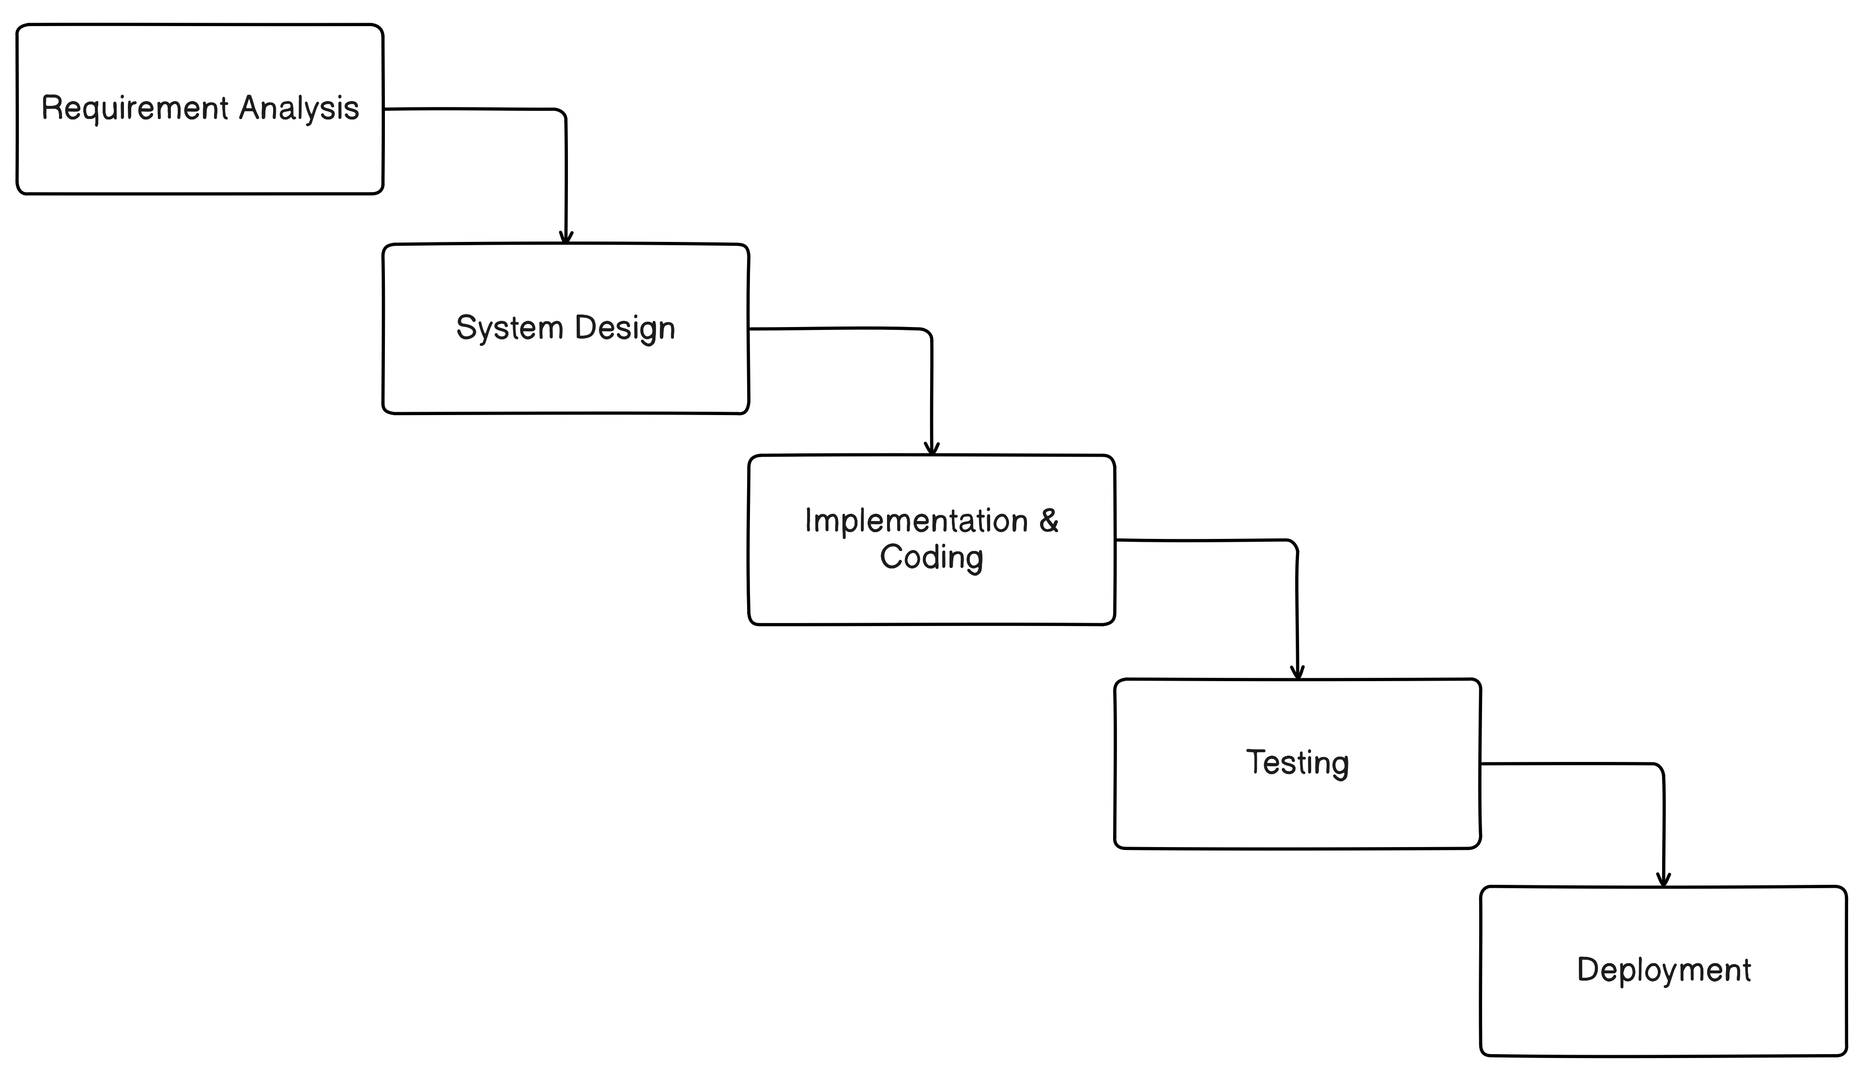

Figure 1: Waterfall Model for Social Networking and Gigs Platform (ProConnect)

Requirement Analysis
Requirement analysis for ProConnect was conducted to identify and document the needs and functionalities that the platform must fulfill. The requirements were gathered through a combination of stakeholder interviews, surveys with developers and freelancers, and analysis of existing professional networking and gig platforms. This process helped in defining the key features of ProConnect:

Functional Requirements:
- Developer Gigs and Job Listings: Enables users to browse, search, and apply for freelance jobs and short-term contracts.
- Social Networking for Developers: Provides a platform for sharing updates, posts, and professional experiences.
- User Authentication: Supports secure login, registration, and logout functionalities.
- Admin Dashboard: Allows administrators to manage users, gigs, categories, posts, and reported content.
- Interactive Post System: Facilitates liking, commenting, saving, and reporting posts.
- Search Functionality: Enables users to search for gigs, posts, and other users easily.

Use Case Diagram

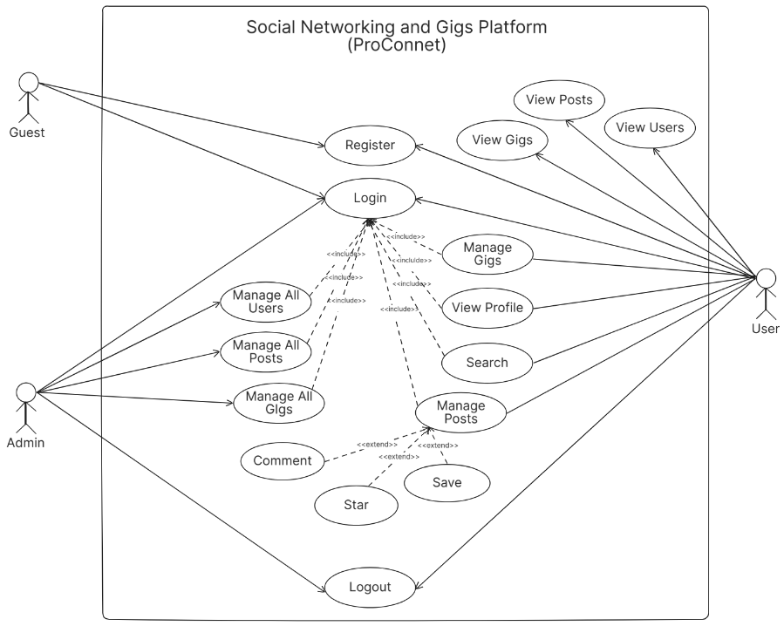

Figure 2: Use-Case Diagram of Social Networking and Gigs Platform (ProConnect)

A use case diagram visually represents the interactions between different actors. This diagram showcases how different actors interact with the Social Networking and Gigs Platform, delineating their specific actions and interactions within the system. In the case of Social Networking and Gigs Platform involves users and admins. Explanation of the main interactions are as follows:

Actors:
- Users: Individuals logged in to the platform viewing posts, users and gigs.
- Admins: Administrators managing the platform.

Use case for users:
- Register: Users can register themselves on the platform.
- Login: Users can log into the system with their credentials.
- Logout: Users can log out of the system.
- View Posts: Users can view recommended posts.
- View Users: Users can view following and suggested users
- View Gigs: Users can view gigs for job opportunities.
- Add Gigs: Users can add gigs.
- Add Star: Users can star a post.
- Add Save: Users can save a post.
- Add Comment: Users can add comments on posts.

Use case for admins:
Admins are able to perform every action that a normal user is able to with following admin privileges:
- Login: Admins can log into the system with their credentials.
- Logout: Admins can log out of the system.
- Manage Posts: Admins can manage posts, including updating, or deleting posts.
- Manage Users: Admins can manage user by adding, updating and deleting.
- Manage Gigs: Admins can add, update and delete gigs.

Relationships:

- Users: They interact with the system to register, login, view posts, view gigs, view users, star and save a post, add comment, search for users and post and follow other users.
- Admin: They manage the overall system, including users, posts and gigs.
- Both users and admins can log in and log out of the system.

Non-Functional Requirements:
In developing a Social Networking and Gigs Platform (ProConnect), non-functional requirements play a crucial role in shaping the system's overall performance, security, maintainability, and reliability. Security measures must ensure the confidentiality and integrity of user data, employing robust access controls and encryption protocols to safeguard sensitive information. Performance expectations include swift response times for user interactions and the ability to support concurrent users seamlessly, with the user interface loading promptly to enhance user experience. Maintainability focuses on designing the platform for ease of updates and enhancements, supported by clear documentation and modular architecture. Reliability is paramount, necessitating consistent operation and resilience against disruptions, ensuring uninterrupted service availability and data integrity. By addressing these non-functional requirements comprehensively, ProConnect aims to provide a secure, high-performance, and dependable platform for developers and professionals to connect, collaborate, and access gig opportunities effectively.

Feasibility Study
Conducting a feasibility study is critical in the system engineering process to assess the viability and practicality of developing a Social Networking and Gigs Platform (ProConnect). The primary objective is to justify the need for the software among users, its adaptability to change, and adherence to established standards. The feasibility study considers various constraints that the system must operate within, including computing resources, manpower availability, and cost implications. It aids in making informed decisions regarding software selection, hardware requirements, and other critical aspects of system implementation.

Operational Feasibility
The platform utilizes straightforward technologies and is designed to be user-friendly, ensuring ease of use for developers, freelancers, and clients. The system meets all specified requirements without compromising functionality, making it operationally feasible for deployment and use.

Economic Feasibility
The platform employs open-source technologies for both software development and hardware infrastructure, eliminating the need for additional software or costly proprietary systems. As a result, ProConnect incurs minimal recurring costs, limited primarily to internet connectivity and operational expenses.

Technical Feasibility
ProConnect leverages existing off-the-shelf technologies for its design and implementation. This approach ensures there are no significant technological barriers during development, as the chosen technologies are well-established and readily available.

Schedule Feasibility
The development of ProConnect is based on well-understood technologies and follows a structured development plan. This approach minimizes uncertainties and ensures that the project can be completed within the established timeframe, adhering to the schedule without delays.

Gantt Chart
A Gantt chart serves as a powerful tool for scheduling, managing, and tracking tasks and resources within a project. It visually represents a list of tasks through horizontal bars, each indicating the progress and duration of specific activities. These bars span across a timeline, depicting the sequence of tasks, their start and end dates, and the overall project timeline.
Table 1: Project Schedule for Social Networking and Gigs Platform

SN | Phases | Task Duration
1 | Requirement Analysis | 9 Days
2 | System Design | 29 Days
3 | Implementation | 20 Days
4 | Testing | 4 Days

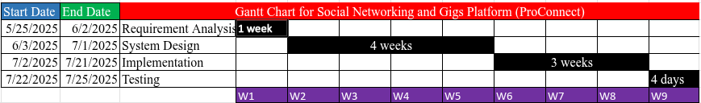

Figure 3: Gantt-Chart of Social Networking and Gigs Platform (ProConnect)

The Gantt Chart for the Social Networking and Gigs Platform (ProConnect) outlines a detailed timeline for the project development process. The project starts on May 25, 2025, and ends on July 25, 2025, spanning approximately two months. The first phase is Requirement Analysis, lasting one week from May 25 to June 2. Following this, the System Design phase takes place over four weeks, from June 3 to July 1. Implementation then occurs over three weeks, from July 2 to July 21. Finally, the Testing phase is scheduled for four days, from July 22 to July 25.

Object Modeling: Object & Class Diagram
In the diagram, the main entities include Post, User, Gig, and Comment. The relationships reflect the core interactions: users can create multiple posts and gig listings, forming one-to-many associations. Each post can have multiple comments, linked through an association with Comments, while each comment is authored by a user. Gigs are also associated with users. This structure captures the flow of content creation, interaction, and job posting, offering a clear representation of how the platform’s components are connected and how users engage with its features.

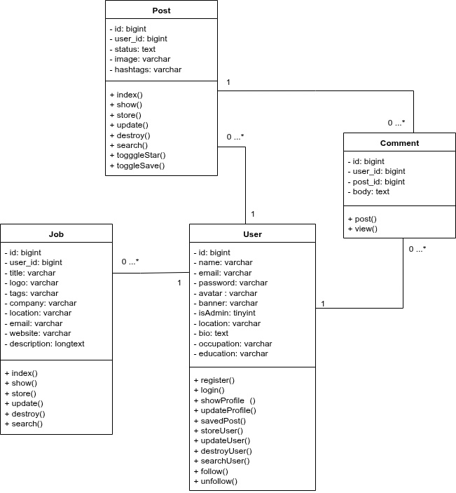

Figure 4: Class Diagram of Social Networking and Gigs Platform (ProConnect)

Dynamic Modeling: State & Sequence Diagram
- State Diagram
In the Social Networking and Gigs Platform, the state diagram illustrates the different stages a user can go through while interacting with the platform. After successfully logging in, the user can either continue as normal user or as admin to browse and manage post, jobs and users. The system maintains these transitions until the user logs out, at which point the state returns to the initial logged-out stage, completing the cycle of interaction.

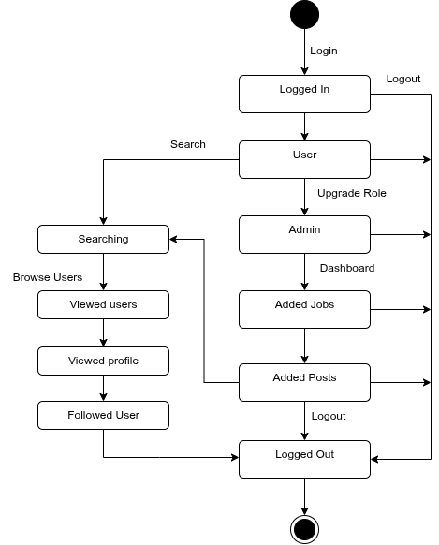

Figure 5: State Diagram of Social Networking and Gigs Platform (ProConnect)
- Sequence Diagram
In the Social Networking and Gigs Platform, the sequence diagram illustrates the step-by-step flow of interactions between user, admin, server, and the database. The process begins with user authentication, where login credentials are verified before granting access. Once logged in, readers can browse and retrieve posts from the database, uesrs can create new posts that are stored through the system. Administrators oversee both user management and post management. This diagram highlights the order and coordination of these interactions throughout the platform.
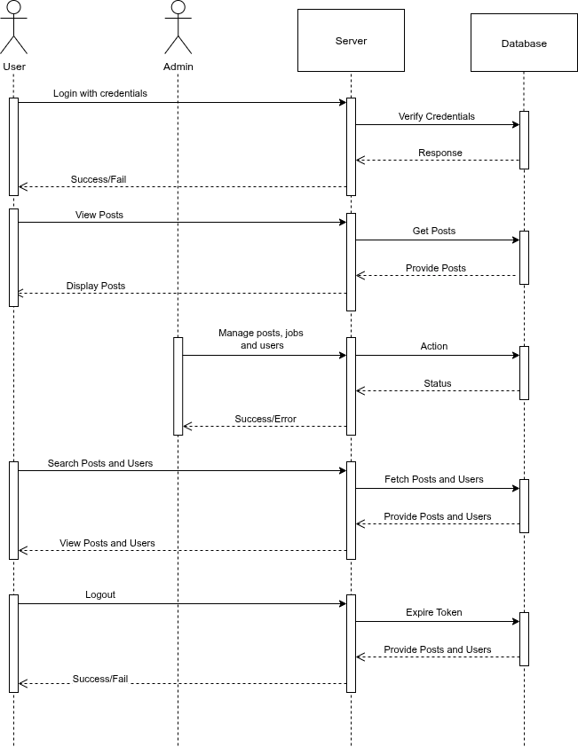

Figure 6: Sequence Diagram of Social Networking and Gigs Platform (ProConnect)

Process Modeling: Activity Diagram
In the Social Networking and Gigs Platform, the activity diagram represents the step-by-step workflow an user follows to browse posts and jobs. The user can either go to post or jobs and perform crud operation with additional activities like star a post, save a post and add a comment in a post marking the end of the activity. This diagram clearly shows the sequence of actions and decision points involved in the system.

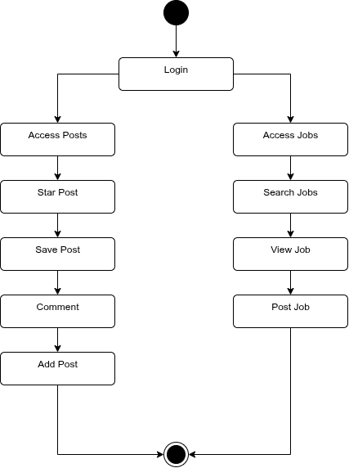

Figure 7: Activity Diagram of User in Social Networking and Gigs Platform (ProConnect)

System Design
In the System Design stage, the architecture of ProConnect was carefully planned to utilize modern technologies and frameworks to ensure scalability, performance, and user engagement. Each phase of the design process is detailed below:

Architectural Design
ProConnect is designed as a modern web application built using the Laravel framework, Blade templating engine, and Tailwind CSS for styling. This combination provides a strong, scalable, and maintainable foundation for building a platform that supports both social networking and gig-based job listings.
Laravel works as the backend framework, managing routing, authentication, business logic, and database interactions with MySQL. The Blade templating engine is used to dynamically generate HTML content, creating a clean separation between application logic and presentation. Tailwind CSS provides a responsive utility-first approach to styling, allowing rapid interface development while maintaining performance and consistency.
The platform follows a client server architecture. The client layer which includes HTML, CSS, and JavaScript interacts with the Laravel backend through HTTP requests. The backend processes these requests, communicates with the MySQL database, and returns either structured data or fully rendered views. This approach ensures quick data retrieval for features such as user profiles, gig listings, messaging, and job applications.
The development process uses Git and GitHub for version control and collaboration, enabling smooth teamwork and the ability to track or revert changes when necessary. Vite is used as the build tool to provide fast development, hot module replacement, and optimized builds for production.
For future scalability, ProConnect can expose RESTful APIs from the backend. This allows integration with modern frontend frameworks such as React or Next.js to support features
that require server side rendering and improved SEO. This approach ensures the platform can evolve into a fully API driven ecosystem without requiring a complete rebuild.
Security is handled using Laravel features such as CSRF protection, hashed password storage, and validation rules to protect user data. The system is built to manage multiple IT related gig categories such as web development, UI and UX design, API integration, logo and graphic design, animation, and project management.
This architecture ensures that ProConnect meets modern development standards while offering scalability, security, and a smooth user experience. It also provides a reliable foundation for expansion into mobile applications and more advanced web technologies in the future.

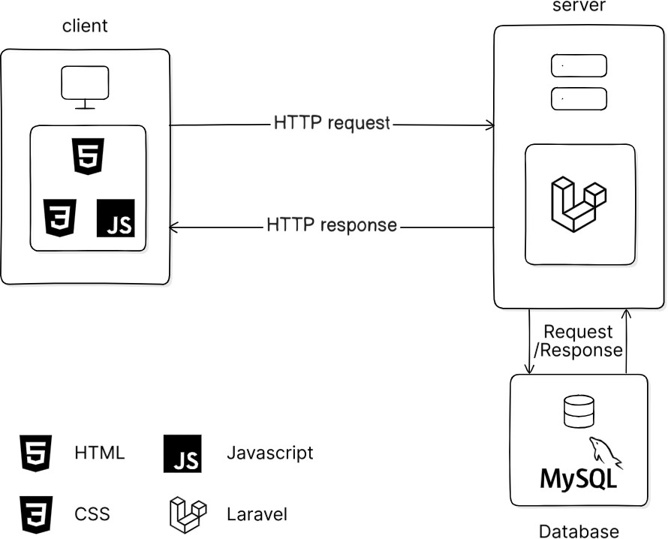

Figure 8: Architecture Design of Social Networking and Gigs Platform (ProConnect)

Refinement of Classes and Object

The refinement of classes and objects is the process of evolving an initial high-level design into a more detailed and implementation-ready model. During this stage, attributes, methods, and relationships are thoroughly specified, data types and access levels are defined, and the way objects interact is carefully adjusted to match the system’s requirements. This step transforms a conceptual design into a blueprint for coding, reducing ambiguity and improving the clarity and maintainability of the final system.
In the refined class diagram of the Social Networking and Gigs Platform, the classes Post, Job, User, and Comment are described in detail with well-defined attributes and methods. Each class specifies its required, unique, and default attributes to maintain data integrity and ensure proper functionality. Methods are defined with clear return types to convey the expected results, improving the understanding of system behavior. For instance, the Post class includes attributes such as id, user_id, status, image, and hashtags, along with methods to fetch or update a post. Likewise, the other classes are structured to accurately reflect their real-world roles within the platform, with precise data management and interactions, making the design fully prepared for seamless implementation.

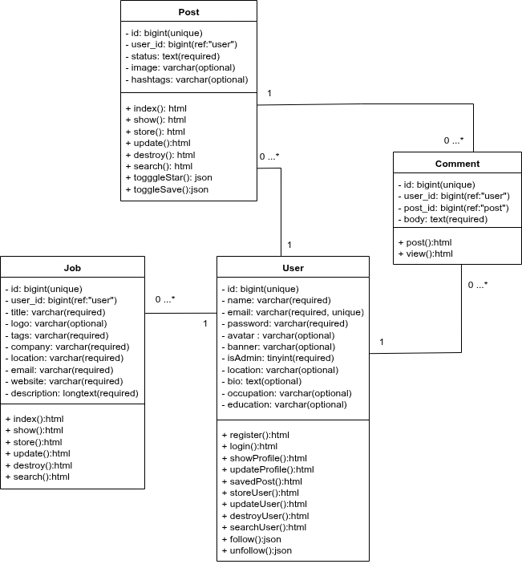

Figure 9: Refinement of class diagram of Social Networking and Gigs Platform (ProConnect)

    - Component Diagram
The component diagram highlights the application’s architecture across the frontend, backend, and database layers. The frontend, built with Blade templates, includes the user interface, user homepage, and admin dashboard, which communicate with the backend via HTTP requests. The backend, developed in Laravel, handles essential modules such as user management, post management, job management, star/save/comment handling, post recommendation, and profile management. These backend modules interact with the MySQL database through Eloquent queries, working with specific tables such as users, posts, jobs, and comments. This diagram offers a clear overview of each component’s responsibilities and how data flows through the system.

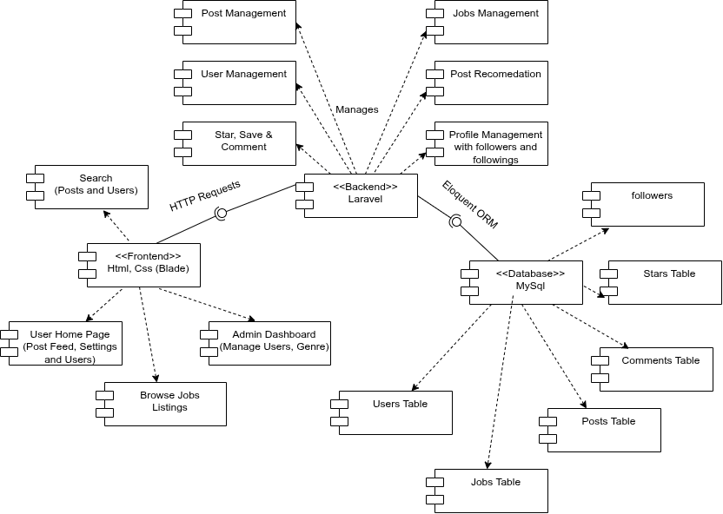

Figure 10: Component diagram of Social Networking and Gigs Platform (ProConnect)
  - Algorithm Details
Cosine Similarity algorithm is used for the post feed recommendation feature that suggests posts to users, we have implemented a content-based filtering approach. This method uses a text vector representation to model both user preferences and post attributes, applying the Cosine Similarity algorithm to measure how closely posts match a user’s interests. The algorithm is used to recommend posts in the auto-load scroll area, similar to Facebook’s feed.

1. Cosine Similarity Algorithm
Cosine similarity is a metric that measures the similarity between two vectors by calculating the cosine of the angle between them. In this context, it compares the user’s profile vector with each post’s text vector, producing a score between 0 and 1, where 1 indicates identical content orientation (high similarity) and 0 indicates no similarity.
Key Characteristics of this algorithm are:
- Similarity Range: Generates a score from 0 to 1, indicating how closely items match.
- Direction Focused: Compares the orientation of vectors rather than their magnitude.
- Vector Representation: Works on numerical representations of user preferences and items.
- Flexible Across Domains: Can be applied wherever items can be encoded as vectors, such as text, hashtags, or categories.
- Computationally Lightweight: Simple to calculate and effective even with high-dimensional sparse data.
- Easy to Interpret: Higher scores reflect stronger similarity between the compared elements.

Formula:
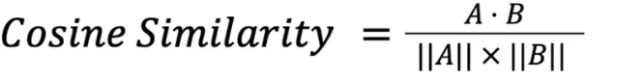
Working Steps of the Algorithm:

- Check if the user is logged in; if not, return chronological posts for guests.
- Fetch posts excluding those created by the authenticated user.
- Build the user profile vector based on posts they have created, starred, or saved.
- Convert each candidate post’s text and hashtags into a numerical vector.
- Compute cosine similarity between the user profile vector and each post vector.
- Sort posts by similarity in descending order and select the top 10 for display.
- If there are fewer than 10 posts, fill remaining slots with the most recent posts.
- For auto-load scrolling, repeat steps 2–7 for subsequent batches of posts, skipping

Code Implementation:
<?php
namespace App\Services;
class PostRecommendationService {
public function cosineSimilarity(array $vec1, array $vec2) {
$dotProduct = 0; $magnitude1 = 0; $magnitude2 = 0;
foreach ($vec1 as $key => $value) {
$dotProduct += $value * ($vec2[$key] ?? 0);
$magnitude1 += $value ** 2;
}

foreach ($vec2 as $value) {
$magnitude2 += $value ** 2;
}
if ($magnitude1 == 0 || $magnitude2 == 0) {
return 0;
}
return $dotProduct / (sqrt($magnitude1) * sqrt($magnitude2));
}
public function textToVector(string $text) {
$tokens = preg_split('/\s+/', strtolower($text));
$vector = [];
foreach ($tokens as $token) {
$vector[$token] = ($vector[$token] ?? 0) + 1;
}
return $vector;
}
public function buildUserProfileVector($user) {
$userPosts = $user->stars()->get()->merge($user->saves()->get())->merge($user->posts);
$profileVector = [];
foreach ($userPosts as $post) {
$text = $post->status . ' ' . $post->hashtags;
$vec = $this->textToVector($text);
foreach ($vec as $word => $count) {
$profileVector[$word] = ($profileVector[$word] ?? 0) + $count;
}
}
return $profileVector;
}
}

CHAPTER 4: IMPLEMENTATION AND TESTING

Implementation
The system has been implemented using a modern stack of technologies to ensure efficiency, scalability, and ease of development. The programming languages used in this project are HTML, CSS and JavaScript. The technologies used in this project are Blade, Vite and TailwindCSS for the frontend, Laravel for the backend and MySql for the database. By leveraging this comprehensive technology stack, the system achieved a balance of performance, flexibility, and ease of maintenance.

Tools Used

For the development of the project, the following technologies have been used:
- CASE Tools:
Following CASE tools were used during the development of the system.
- Design Tools
- Figma: Used for creating wireframes and UI/UX design prototypes.
- Excalidraw (Eraser.io): Used for creating conceptual and architectural diagrams.
- Version Control Tools
- GitHub: GitHub was used as version control tool for the development of the project.
- Project Management & Collaboration Tools
- Trello: Used for task management and sprint planning.
- Discord: Used for team communication and collaboration.

- Programming Languages
Following programming languages were used during the development of the system.
- HTML, CSS, JavaScript, PHP were used for implementing the functionalities of the platform.

- Database
Following database was used during the development of the system.
- MySQL: Used as the database platform for storing and managing application data.

Implementation Details of Modules
- Registration module
In the Registration module, users are required to sign up to access the platform’s core features. The registration process collects essential information such as full name, email address, and password. Once successfully registered, users are automatically logged in and can start engaging with the platform by creating posts, browsing job listings, and exploring users. Registered members also gain access to protected routes, allowing them to apply for jobs, star or save posts, comment, and manage their personal profiles.
Registration Controller:
public function store(Request $request){
$formFields = $request->validate([
'name' => ['required', 'min:3', 'max:255'],
'email' => ['required', 'email', Rule::unique('users', 'email')],
'password' => [
'required',
'string',
'confirmed',
'min:8',
'regex:/^(?=.*[a-z])(?=.*[A-Z])(?=.*\d)(?=.*[\W_]).+$/',
],
], [
'password.regex' => 'Password must contain at least one uppercase letter, one lowercase letter, one number, and one special character.',
]);
$formFields['password'] = bcrypt($formFields['password']);
$user = User::create($formFields);
Auth::login($user);
return redirect('/')->with('message', 'User Created and Logged In');
}

Login module
The Login module enables existing users to securely access their accounts by providing their registered email address and password. After a successful login, users can create and manage posts, browse and apply for jobs, star or save interesting posts, and comment on existing content. They also gain full access to member-only features and protected pages. This module ensures that only authenticated users can perform content creation, job applications, and other platform interactions.
public function auth(Request $request){
$formFields = $request->validate([
'email' => 'required|email',
'password' => [
'required',
'string',
'min:8',
'regex:/^(?=.*[a-z])(?=.*[A-Z])(?=.*\d)(?=.*[\W_]).+$/',
],
], [
'password.regex' => 'Password must contain at least one uppercase letter, one lowercase letter, one number, and one special character.',
]);
if (Auth::attempt($formFields)) {
$request->session()->regenerate();
return redirect('/')->with('message', 'Logged In');
}
return back()->withErrors([
'email' => 'The provided credentials do not match our records.',
])->onlyInput('email');
}

Post Module
The Post module allows users to share updates, ideas, and media on the platform. Users can create new posts, add images, and include hashtags for discoverability. Other users can interact with posts by starring, saving, or commenting on them. Posts can be edited or deleted by their authors, and all post data is stored in the database for persistent access. This module is central to fostering community interaction and engagement.
Post Create Controller:
public function store(Request $request){
$formFields = $request->validate([
'status' => 'required',
]);
if ($request->hasFile('image')) {
$formFields['image'] = $request->file('image')->store('post_images', 'public');
}
if ($request->has('hashtags') && ! empty($request->input('hashtags'))) {
$formFields['hashtags'] = $request->input('hashtags');
}
$formFields['user_id'] = Auth::id();
Post::create($formFields);
return redirect('/')->with('success', 'Post created!');
}

Job/Gig Module
The Job/Gig module enables users to post job opportunities or gigs for others to view and apply for. Users or Admin can create detailed job listings with descriptions, requirements, and other information. Other users can browse open opportunities and contact the poster. Jobs can be updated and remove once expired. This module bridges professional networking with job-seeking functionality.
Job Create Controller:
public function store(Request $request){
$formFields = $request->validate([
'title' => 'required',
'company' => ['required', Rule::unique('job_listings', 'company')],
'location' => 'required',
'description' => 'required',
'tags' => 'required',
'email' => ['required', 'email'],
'website' => 'required',
]);
if ($request->hasFile('logo')) {
$formFields['logo'] = $request->file('logo')->store('logos', 'public');
}
$formFields['user_id'] = Auth::id();
JobListing::create($formFields);
return redirect('/')->with('message', 'Job listing created!');
}

Profile Management Module
The Profile Management module allows users to maintain and customize their personal information. Users can update their avatar, banner, location, bio, occupation, and education details. This module supports displaying profile information publicly on user pages and helps personalize the social networking experience.
Profile View Controller:
public function show(User $user){
return view('users.profile', [
'user' => $user,
'posts' => Post::where('user_id', $user->id)->orderBy('created_at', 'desc')->take(10)->get(),
'showFooter' => false,
]);
}

- Post Recommendation Module
The Post Recommendation module enhances content discovery by suggesting relevant posts to users based on their interests, activity, and interactions. It uses algorithms such as cosine similarity to match posts with user preferences, improving engagement and keeping the feed relevant.
Post View Controller:
public function index(Request $request, PostRecommendationService $recommendationService){
if ($request->user()) {
$authUser = $request->user();
$followingUsers = $authUser->following()->pluck('following_id');
$followers = User::whereIn('id', $authUser->followers()->pluck('follower_id'))->get();
$suggestedUsers = User::whereNotIn('id', $followingUsers)
->where('id', '!=', $authUser->id)
->get();

$allPosts = Post::where('user_id', '!=', $authUser->id)
->orderBy('created_at', 'desc')
->get();
$userVector = $recommendationService->buildUserProfileVector($authUser);
$postsWithSimilarity = $allPosts->map(function ($post) use ($recommendationService, $userVector) {
$postVector = $recommendationService->textToVector($post->status . ' ' . $post->hashtags);
$similarity = $recommendationService->cosineSimilarity($userVector, $postVector);
$post->similarity = $similarity;
return $post;
});
$recommendedPosts = $postsWithSimilarity->sortByDesc('similarity')->take(10);
return view('posts.index', [
'showFooter' => false,
'posts' => $recommendedPosts,
'followedUsers' => User::whereIn('id', $followingUsers)->get(),
'suggestedUsers' => $suggestedUsers,
'followers' => $followers,
]);
} else {
return view('posts.index', [
'showFooter' => true,
'posts' => Post::orderBy('created_at', 'desc')->take(10)->get(),
'users' => User::orderBy('created_at', 'desc')->take(10)->get(),
]);
}
}

Admin module
The Admin module provides comprehensive management capabilities for users with administrative privileges. Only users designated as admins can access the admin routes and features.
Admins have access to the admin dashboard, where they can perform various administrative tasks:
- User Management: View, edit, or remove user accounts.
- Post Management: Admins can add, edit, or delete user accounts.
- Job Management: Admins can add, edit, or delete all jobs in the platform.
- Post Management: Admins can add, edit, or delete all posts in the platform.

This module empowers admins to maintain and enhance the platform, ensuring smooth operations and an quality content.
Dashboard View Controller:
public function dashboard(){
return view('users.admin.posts', [
'posts' => Post::latest()->paginate(10),
]);}
public function jobsDashboard(){
return view('users.admin.jobs', [
'jobs' => JobListing::latest()->paginate(10),
]);
}
public function usersDashboard(){
return view('users.admin.users', [
'users' => User::latest()->paginate(10),
]);
}
public function addUser(){
return view('users.admin.add-user');
}
public function storeUser(Request $request){
if (! Auth::user()->isAdmin) {
abort(403, 'Unauthorized');
}
$formFields = $request->validate([
'name' => ['required', 'min:3', 'max:255'],
'email' => ['required', 'email', Rule::unique('users', 'email')],
'password' => 'required|min:8',
'bio' => 'nullable', 'location' => 'nullable', 'education' => 'nullable',
'occupation' => 'nullable',]);
$formFields['password'] = bcrypt($formFields['password']);
if ($request->hasFile('avatar')) {
$formFields['avatar'] = $request->file('avatar')->store('avatars', 'public');
}
if ($request->hasFile('banner')) {
$formFields['banner'] = $request->file('banner')->store('banners', 'public');
}
User::create($formFields);
return redirect()->route('usersDashboard')->with('message', 'User Created');
}

Testing
Testing is a critical phase in the development lifecycle of the Social Networking and Gigs Platform (ProConnect). It ensures that the system functions correctly and meets the specified requirements. This section outlines the various testing activities performed, including unit testing, system testing, and system evaluation. Each phase of testing serves to identify and rectify defects, validate functionality, and verify that the system operates as intended in real-world conditions.

Test Cases for Unit Testing
Following tests of separate modules were done for this system:

Table 2: Test Cases for Unit Testing

S.N. | Unit | Test | Expected Result | Test Outcome | Evidence

1. | Login | Used invalid login credentials to  check login  functionality | Invalid  email or password | Invalid  email or password | Test 1
2. | Login | Used valid login credentials to  check login  functionality | User logged in | User logged in | Test 2
4. | Register | Registered to the application | User  registered and logged in | User  registered and logged in | Test 4
4. | Manage Posts | CRUD  functionality on Posts | CRUD  performed | CRUD  performed | Test 4
5. | Mange Gigs | CRUD  functionality  on Gigs | CRUD  performed | CRUD  performed | Test 5
6. | Manage Users | CRUD  functionality  on Users | CRUD  performed | CRUD  performed | Test 6

TEST EVIDENCE 1
Unit test: Login
Test: Used invalid login credentials to check login functionality
Expected Result: Invalid username or password

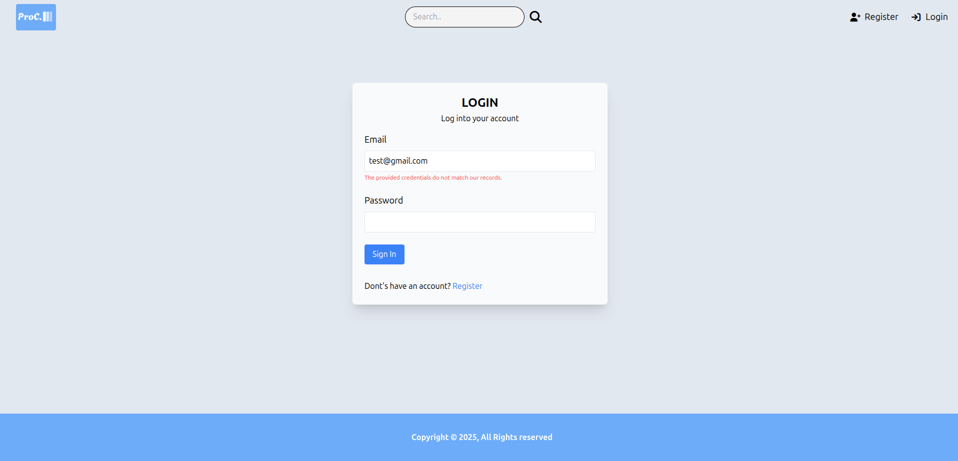

Figure 11: Test evidence 1.1

TEST EVIDENCE 2
Unit test: Login
Test: Used valid login credentials to check login functionality
Expected Result: User logged in

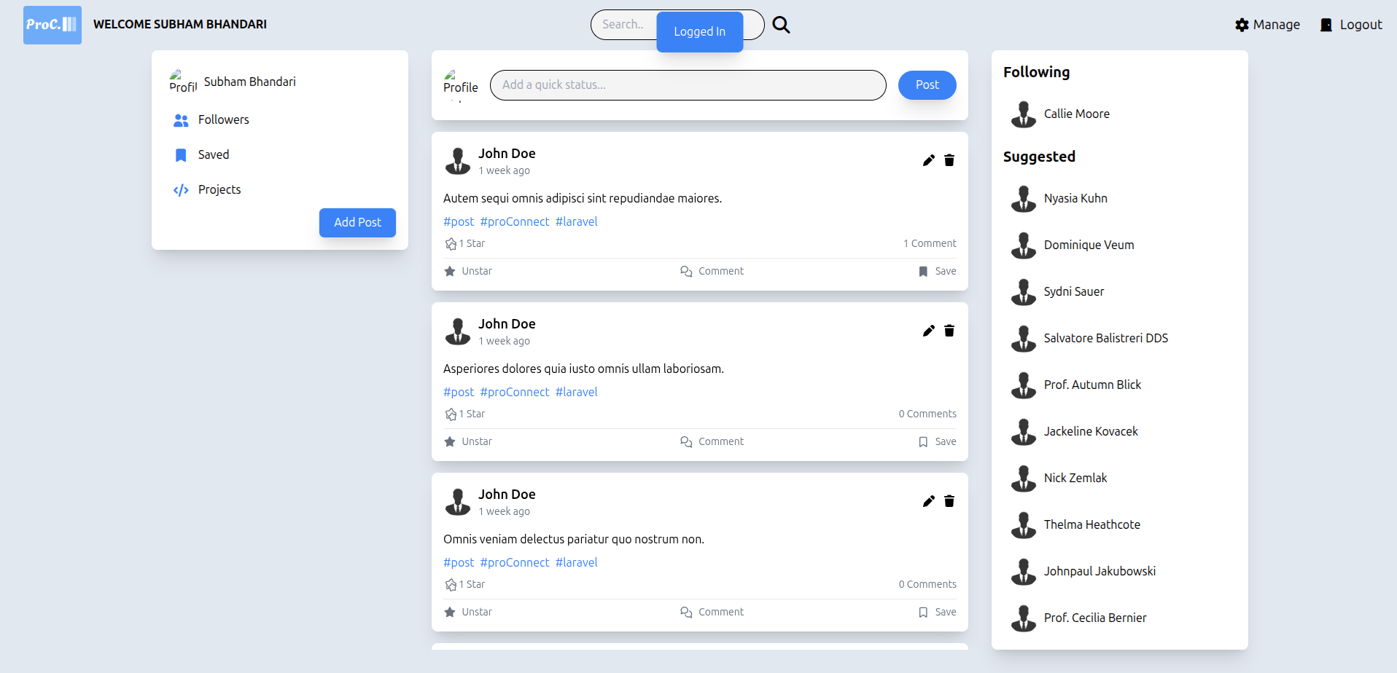

Figure 12: Test evidence 2.1

TEST EVIDENCE 3
Unit test: Register
Test: Registered to the application
Expected Result: User registered to the application

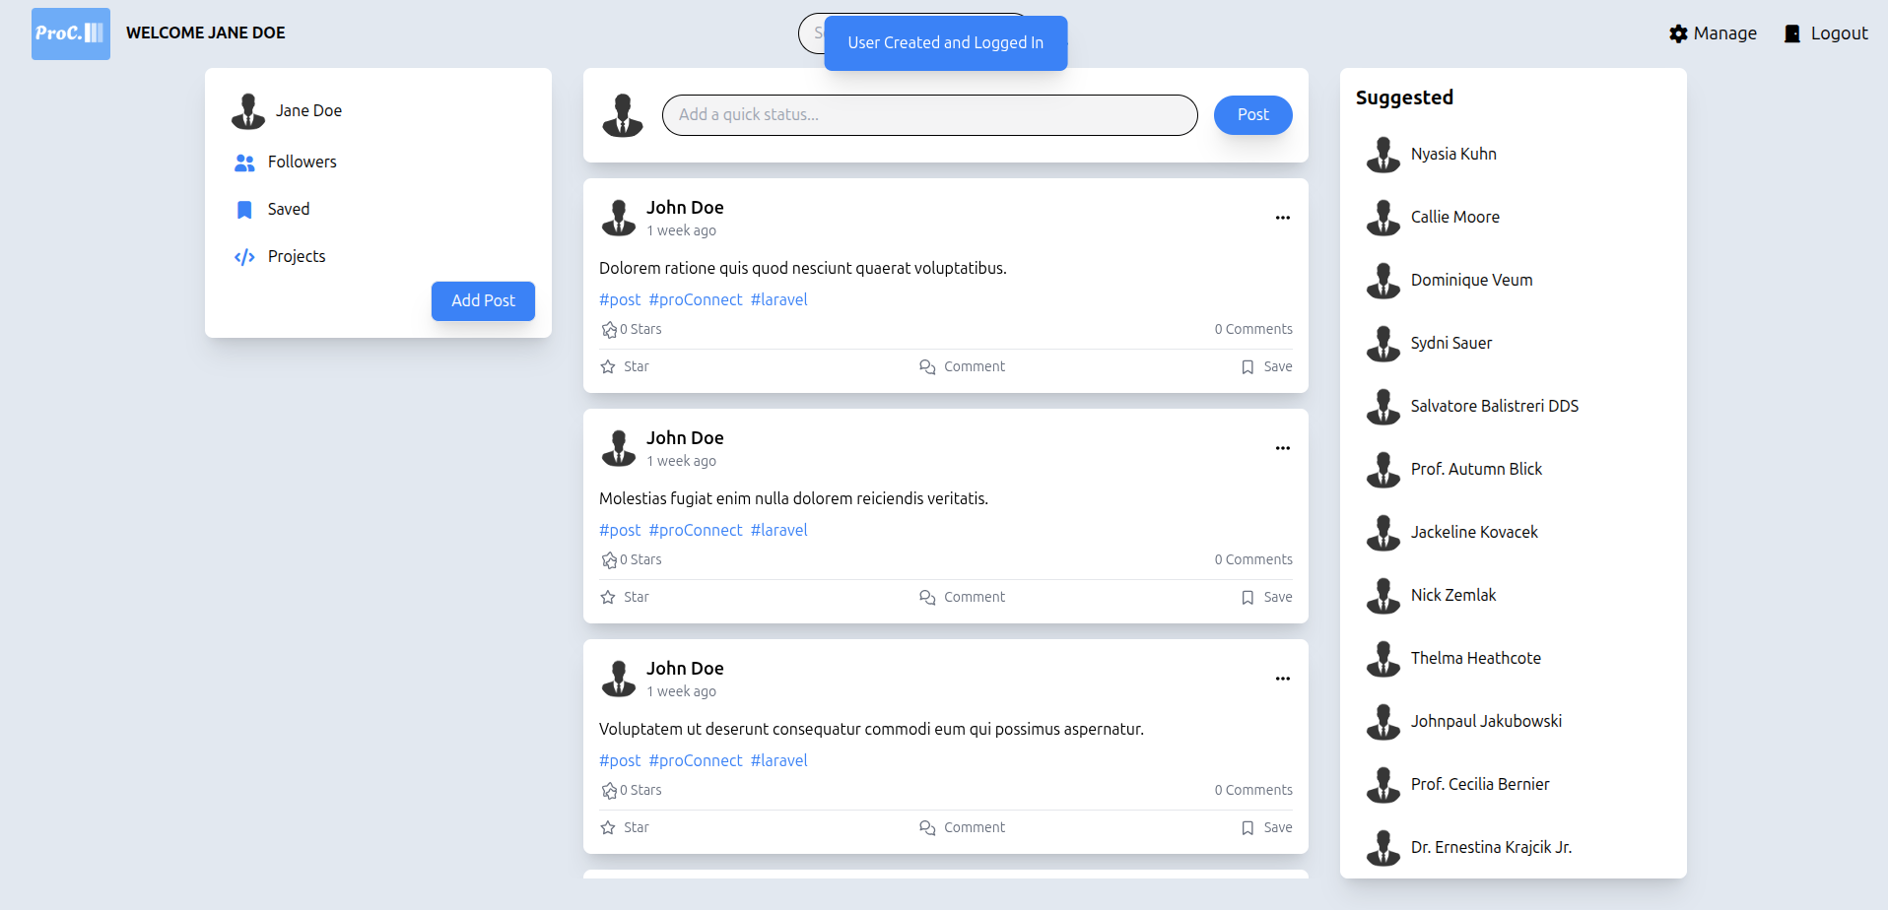

Figure 13: Test evidence 3.1

TEST EVIDENCE 4

Unit test: Manage Posts
Test: CRUD functionality on Posts
Expected Result: CRUD functionality performed
View Posts.
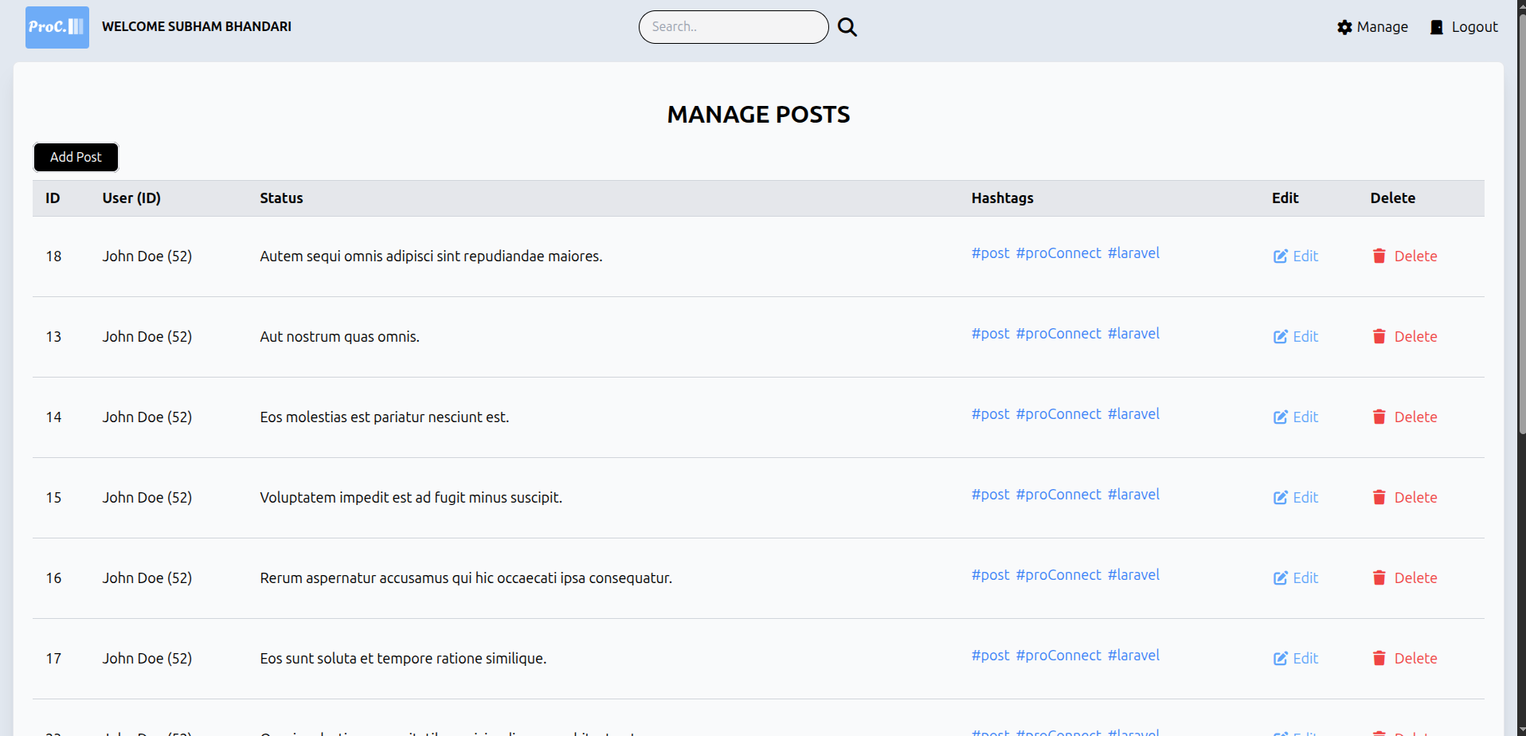

Figure 14: Test evidence 4.1

Add Post.
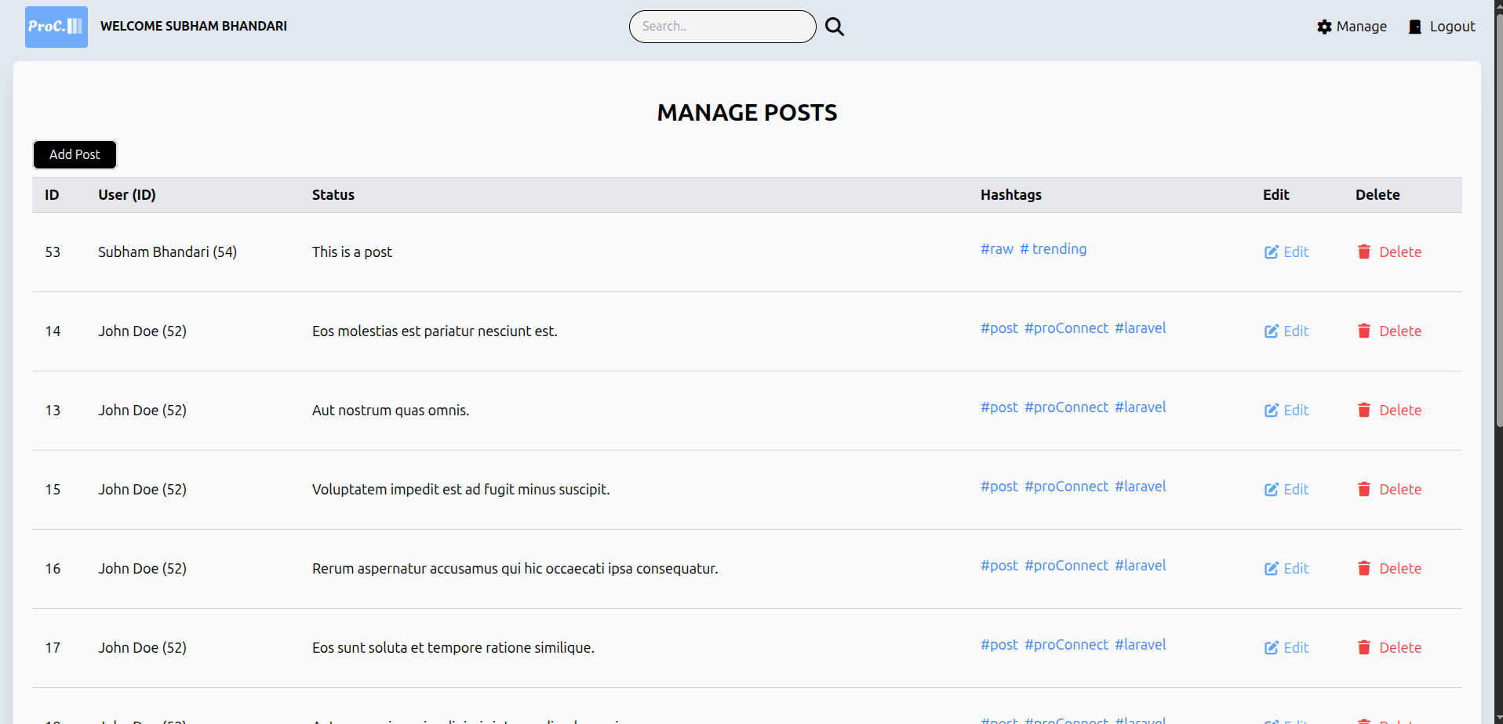

Figure 15: Test evidence 4.2

Update Post.

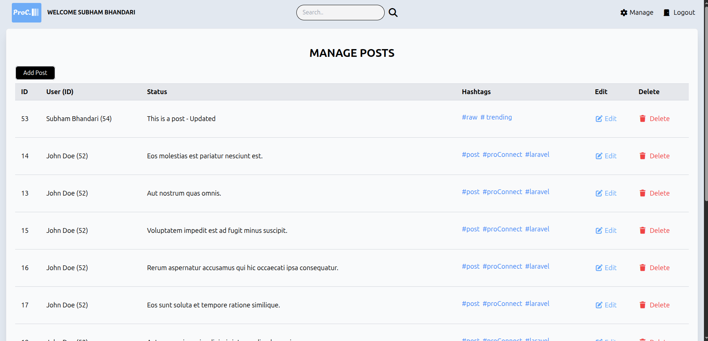

Figure 16: Test evidence 4.3

Delete Post.
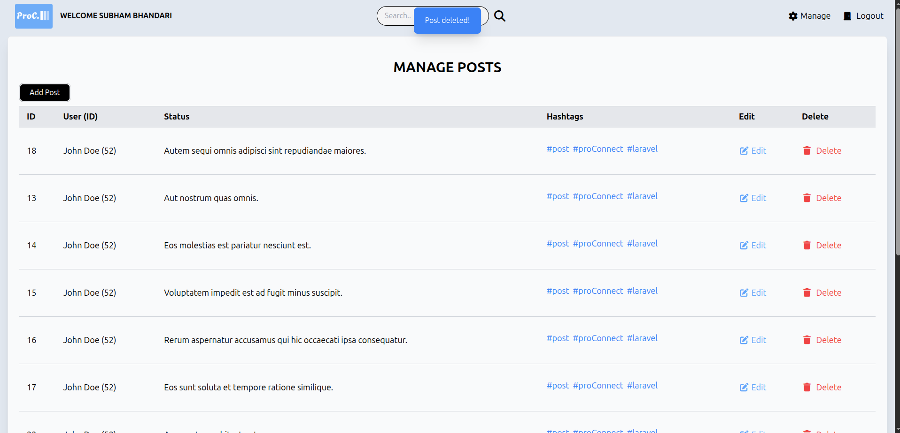

Figure 17: Test evidence 4.4

TEST EVIDENCE 5

Unit test: Manage Gigs
Test: CRUD functionality on Gigs

Expected Result: CRUD functionality performed

View Gigs:
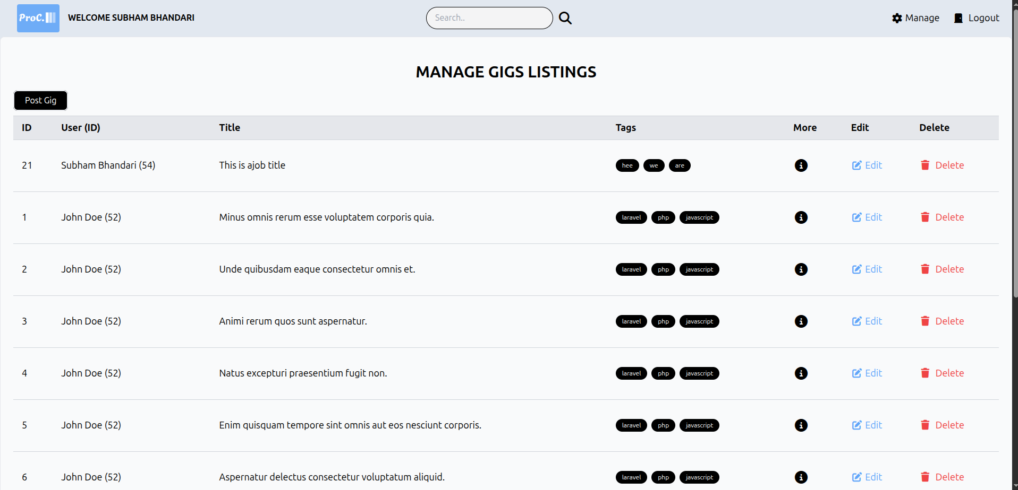

Figure 18: Test evidence 5.1

Delete Gig:
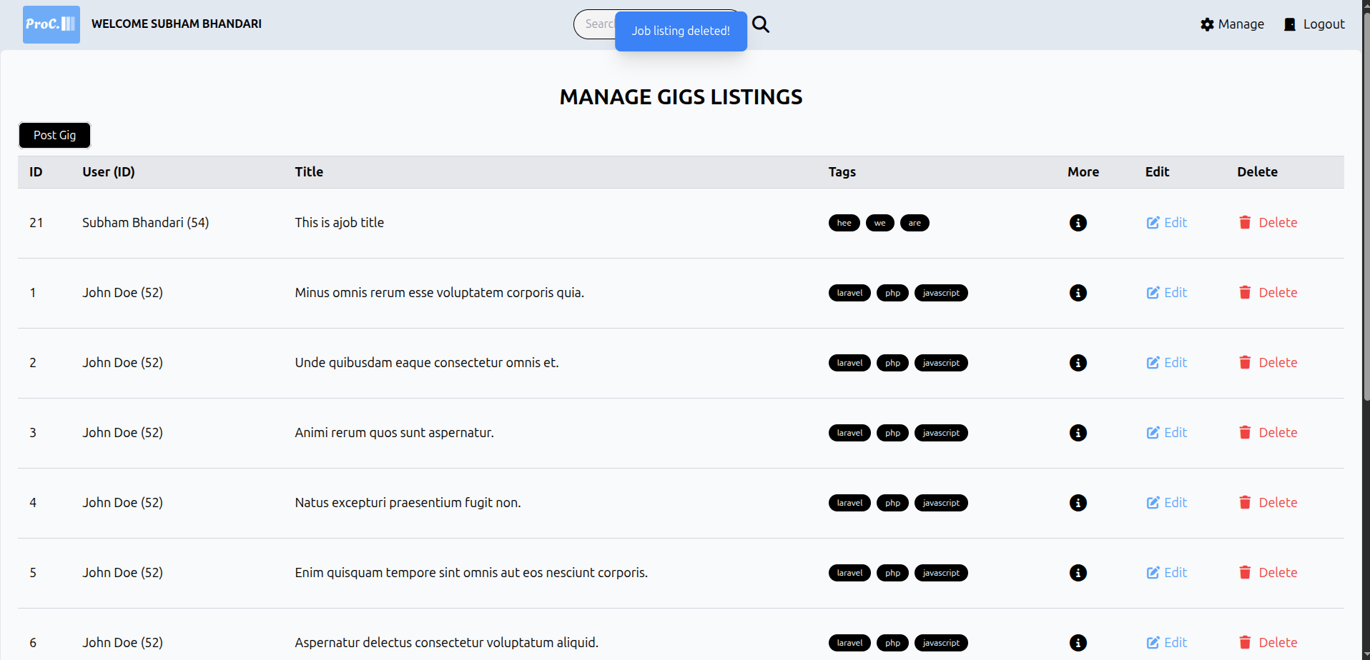

Figure 19: Test evidence 5.2

Add Gig
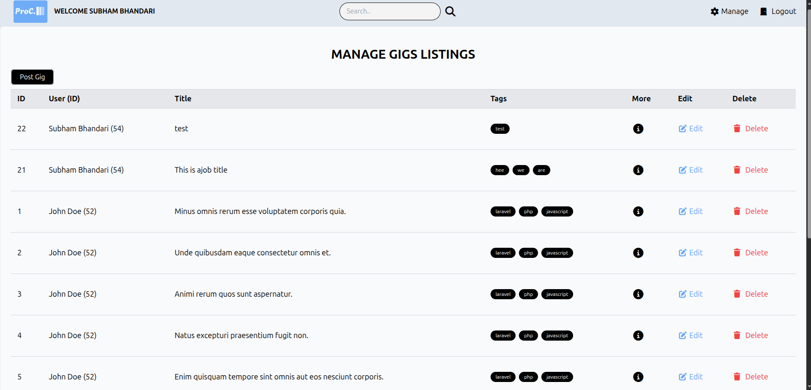

Figure 20: Test evidence 5.3

Update Gig:
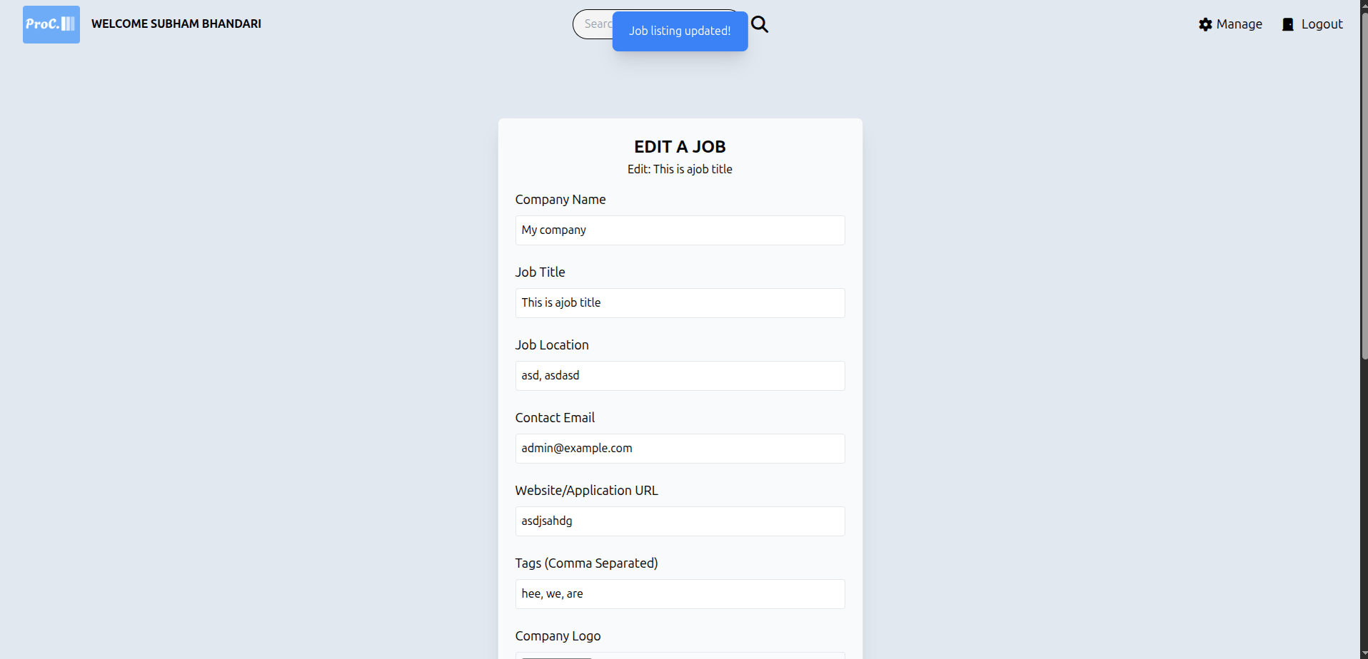

Figure 21: Test evidence 5.4

TEST EVIDENCE 6

Unit test: Manage Users
Test: CRUD functionality on Users
Expected Result: CRUD functionality performed

View Users.
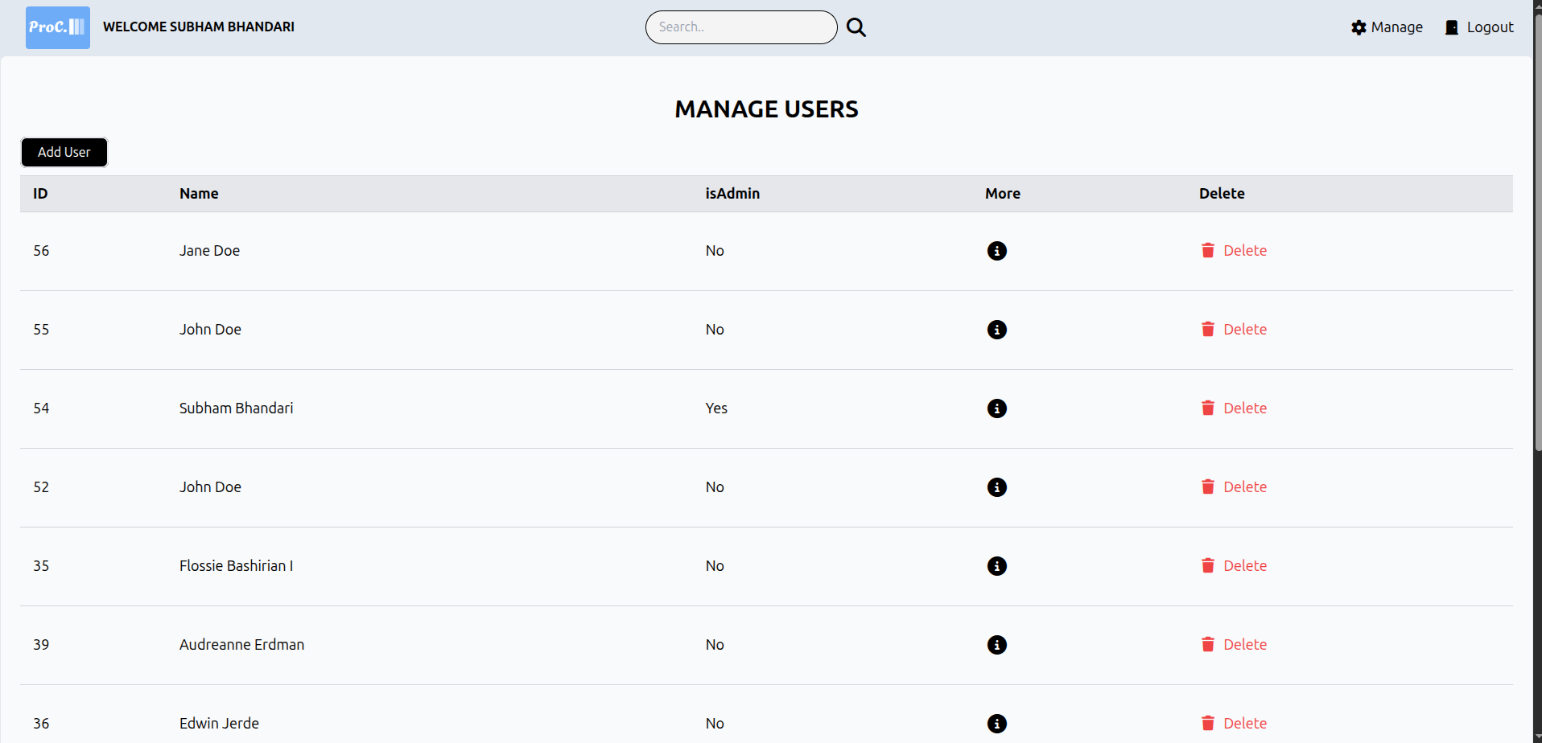

Figure 22: Test evidence 6.1

Add User.
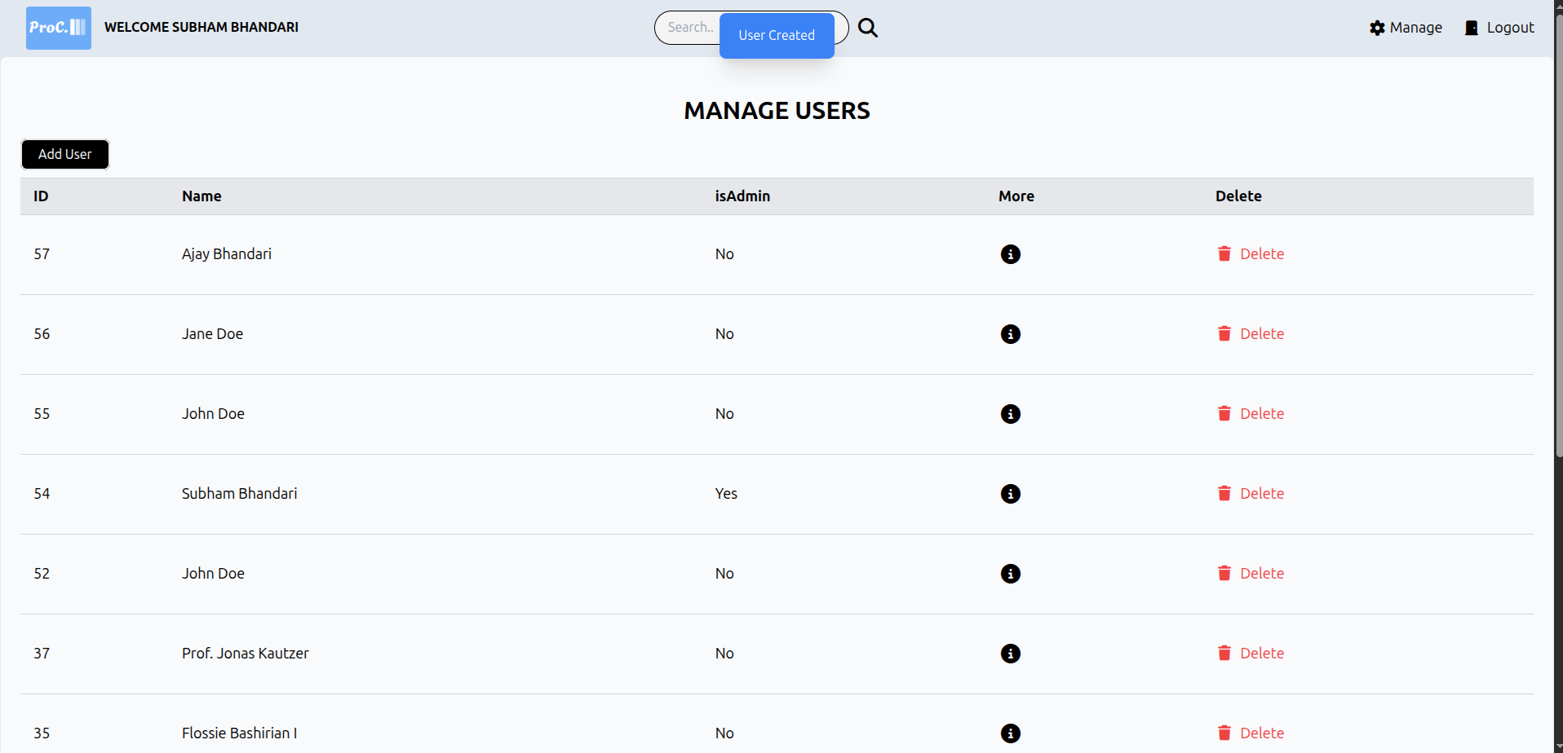

Figure 23: Test evidence 6.2

Delete User.

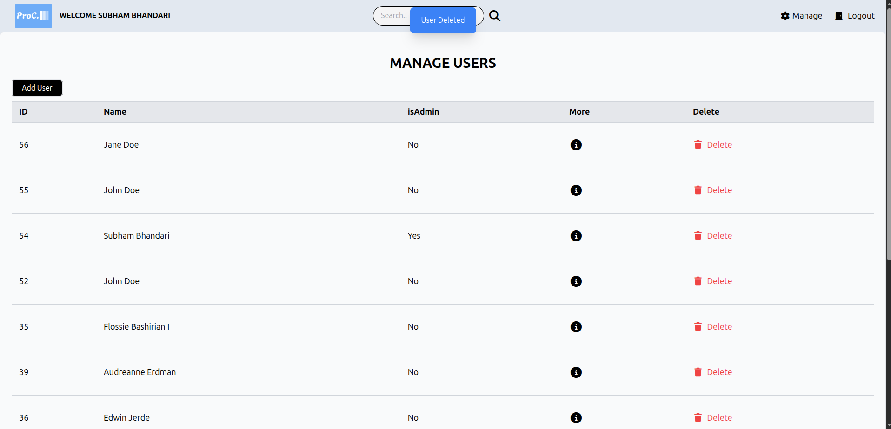

Figure 24: Test evidence 6.3

Test Cases for System Testing
System testing evaluates the entire system's functionality and performance as a whole. This phase tests the integrated components of the platform to ensure they work together as expected and meet the overall requirements.
After integrating all the modules into a workable system, the whole system was tested. Following tests were performed in the System Testing phase:
- Navigation between pages was tested
- Registration for user was tested
- Login for user was tested
- CRUD functionality on posts was tested
- CRUD functionality on users was tested
- CRUD functionality on gigs was tested
- Comment functionality on post was tested
- Star, Save and Comment functionality on post was tested
- Logout for user was tested

CHAPTER 5: CONCLUSION AND FUTURE

RECOMMENDATIONS

Lesson Learnt / Outcome
The development and deployment of the Social Networking and Gigs Platform, ProConnect have highlighted the transformative benefits of digital solutions in connecting individuals and organizations. The transition from traditional networking methods to a web-based platform offers unmatched convenience and operational efficiency, allowing users to connect, share, and collaborate anytime and anywhere. This stands in stark contrast to the limitations of offline networking, which often involves time-consuming physical meetings, geographical restrictions, and limited outreach. Digital platforms like ProConnect not only streamline professional interactions but also enhance security and data integrity, creating a reliable and trusted environment for members. The ease of accessing relevant connections, industry insights, and collaborative opportunities is critical for informed decision-making, empowering users to expand their professional reach and stay updated with the latest trends in their fields.
Additionally, integrating a business collaboration and service marketplace within ProConnect simplifies the process of finding and offering services, enabling members to browse, compare, and engage effortlessly. This integration supports better decision- making, fosters meaningful partnerships, and boosts professional growth. The platform’s interactive features, such as discussion forums, resource sharing, and event participation, cultivate a vibrant community and encourage knowledge exchange among professionals, promoting a collaborative and growth-driven ecosystem. The shift from traditional networking to a digital-first approach addresses numerous historical limitations, underscoring the importance of adopting modern technologies to meet the evolving needs of the professional community.

Conclusion
The transition to the Social Networking and Gigs Platform, ProConnect demonstrates significant advantages over traditional networking methods, providing an effective, efficient, and user friendly tool for building professional connections and accessing career opportunities. The platform’s ability to streamline interactions and enhance access to relevant industry insights supports better decision making and collaboration for professionals, businesses, and organizations. With its secure and reliable framework, ProConnect instills confidence among users, ensuring safe communication, trusted transactions, and verified opportunities which are vital for sustainable professional growth.
Modernizing professional networking through platforms like ProConnect is essential for creating responsive, secure, and dynamic systems capable of addressing contemporary challenges and opportunities in the global job and business market. The inclusion of a service marketplace and interactive community features enriches the platform’s offerings, enabling users to find and offer services, share expertise, and foster meaningful partnerships. These capabilities position ProConnect as a hub for knowledge exchange, opportunity discovery, and community engagement, ultimately empowering users to expand their networks and achieve their professional goals.

Future Recommendations
Looking ahead, there are several key areas where ProConnect can enhance its offerings and expand its impact. Introducing additional features such as AI powered job matching, skill assessment tools, and personalized career advisory services can provide more comprehensive support to professionals. Continuous monitoring and optimization of the platform’s performance are crucial for ensuring scalability and handling increased user activity effectively. Developing a dedicated mobile application will improve accessibility, particularly for users who rely on smartphones as their primary means of accessing professional platforms.
Fostering greater user engagement through interactive features like discussion forums, live chat support, and user generated content can strengthen the community aspect of the platform. Ensuring the highest security standards by regularly updating security protocols and conducting vulnerability assessments is essential for maintaining user trust. Finally, integrating project management and secure payment solutions could provide end to end services for the gig and freelance marketplace, offering a seamless experience from opportunity discovery to project completion. By focusing on these areas, ProConnect can continue to evolve, driving the adoption of digital solutions in professional networking and delivering even greater value to the global professional community.

APPENDICES

Project Screenshots
    - Home Page

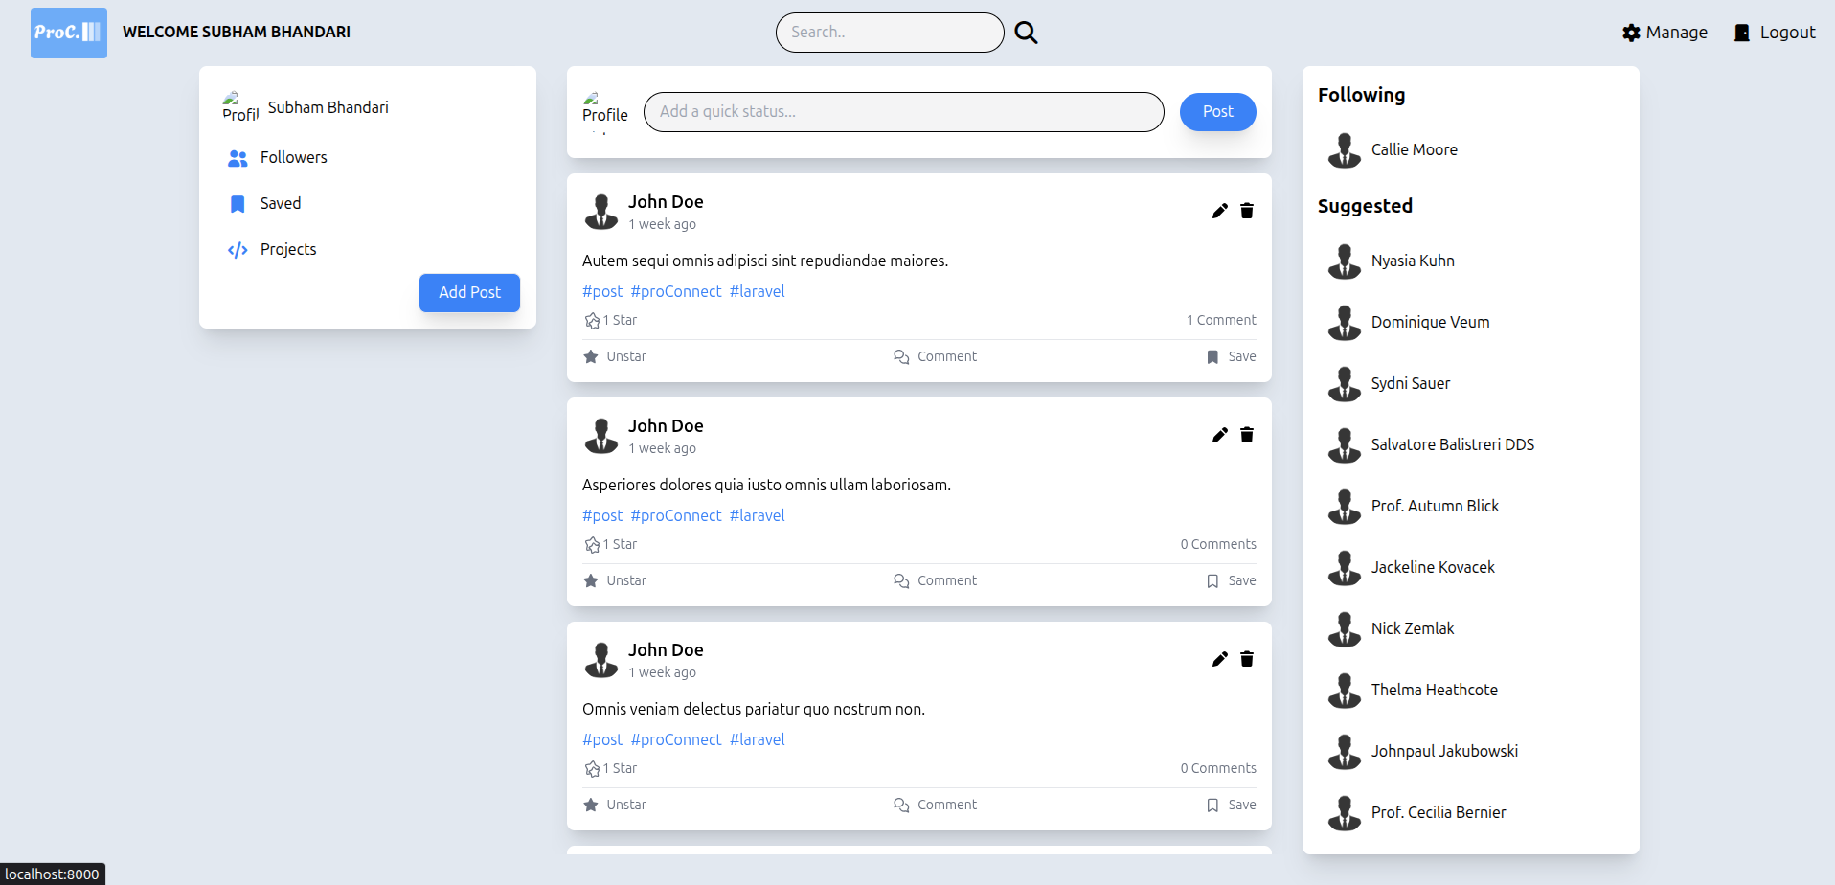

    - Login Page

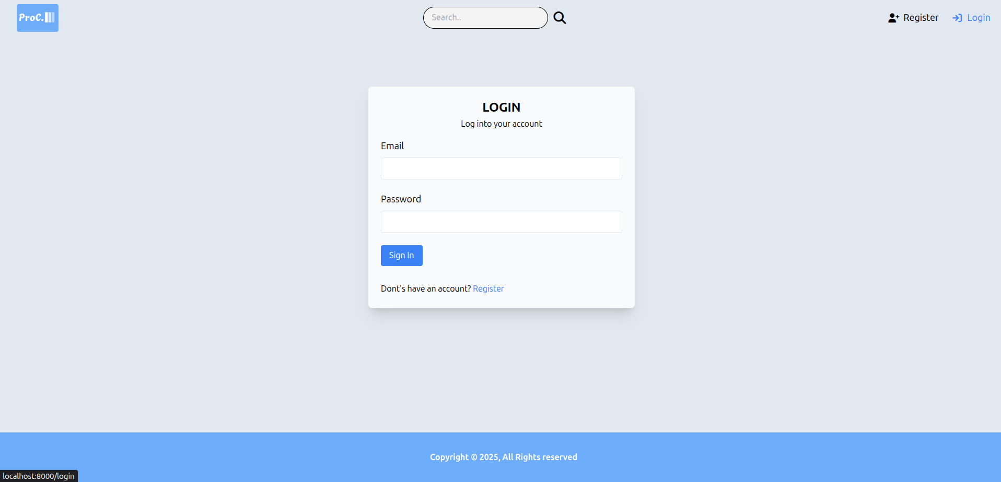
    - Register Page

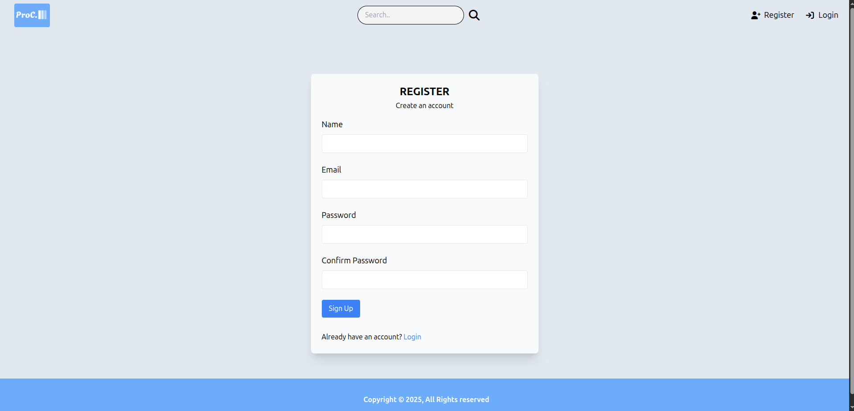

    - Profile Page

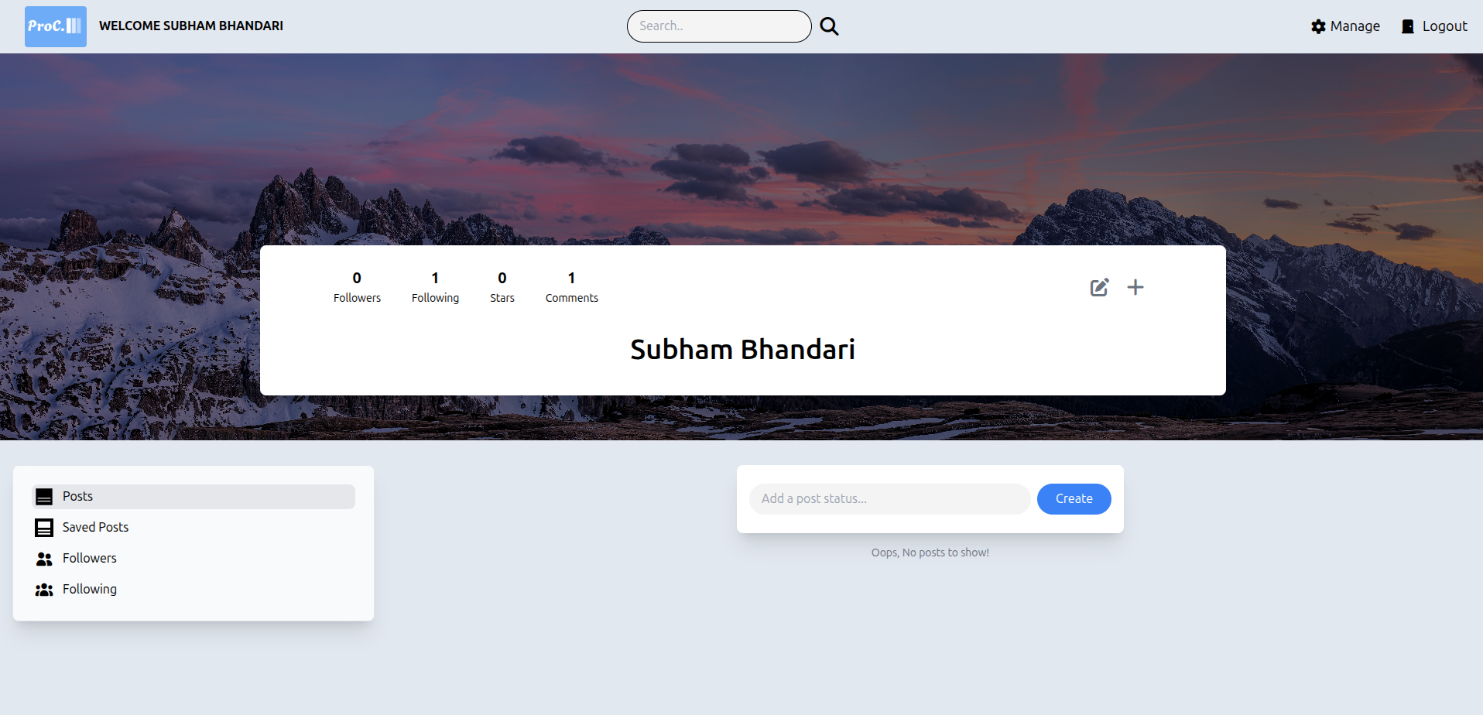

    - Profile Edit Page

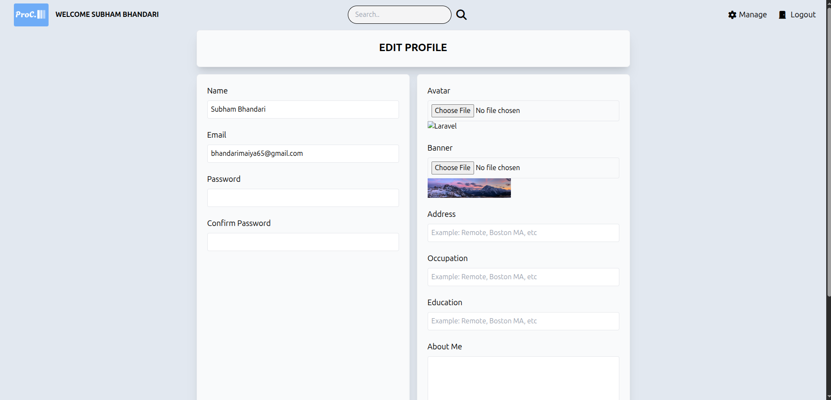

    - Search Page

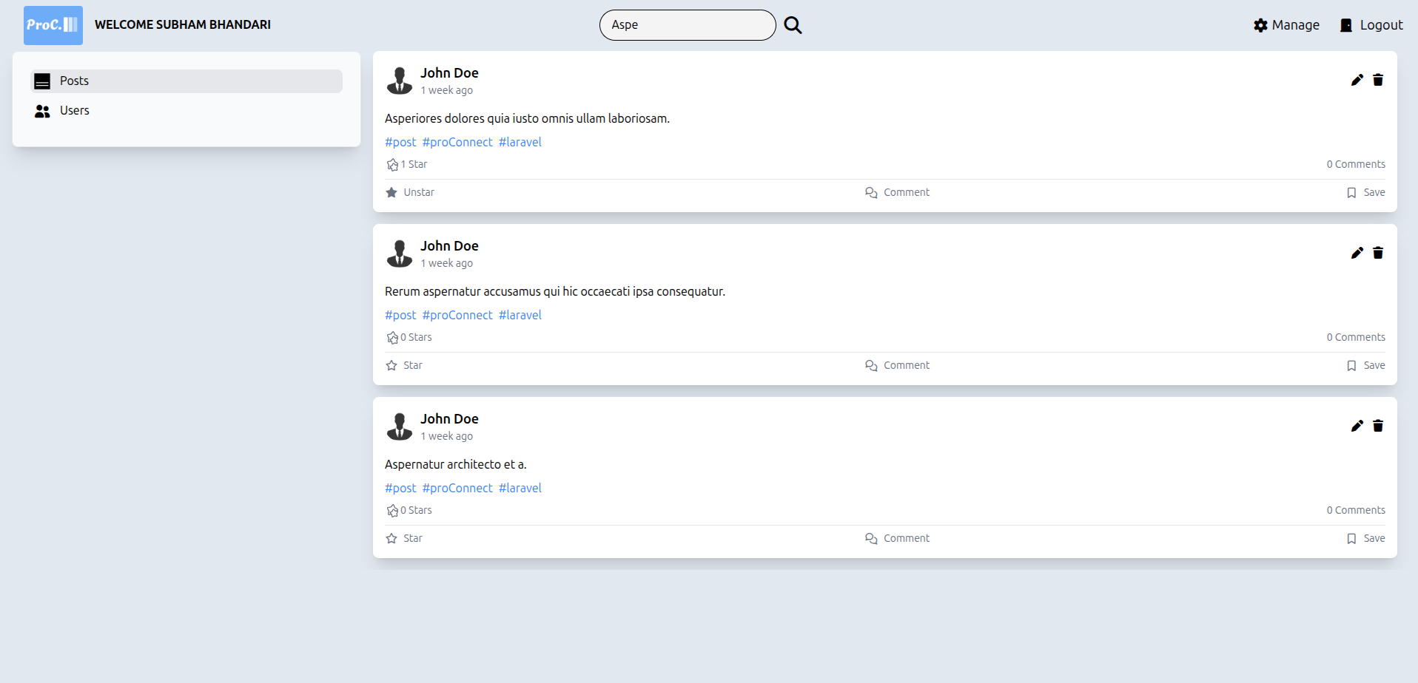

    - Gigs Page

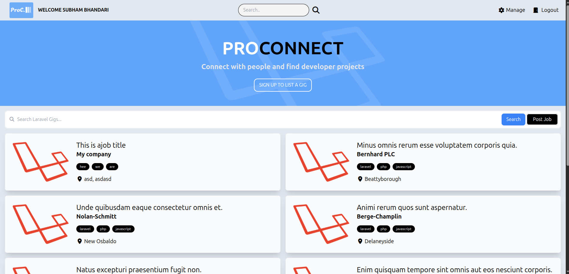

    - Gig Detail Page

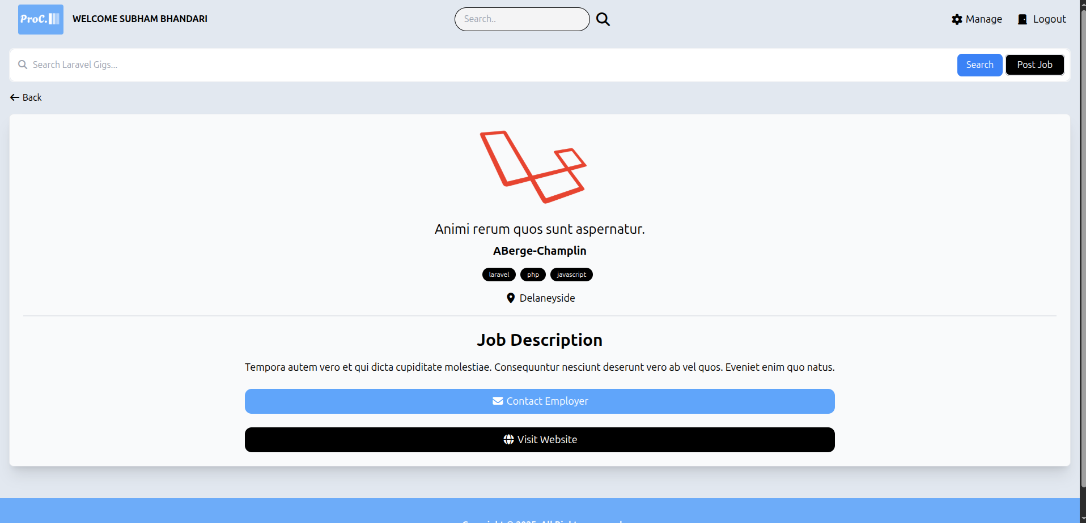

    - Gig Search Page

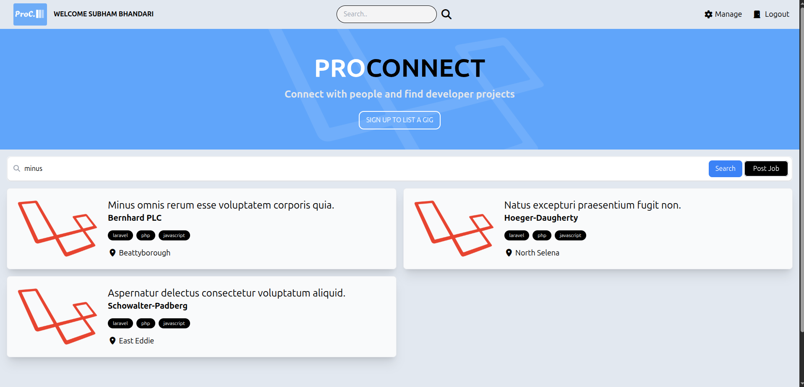

    - Manage Post Page

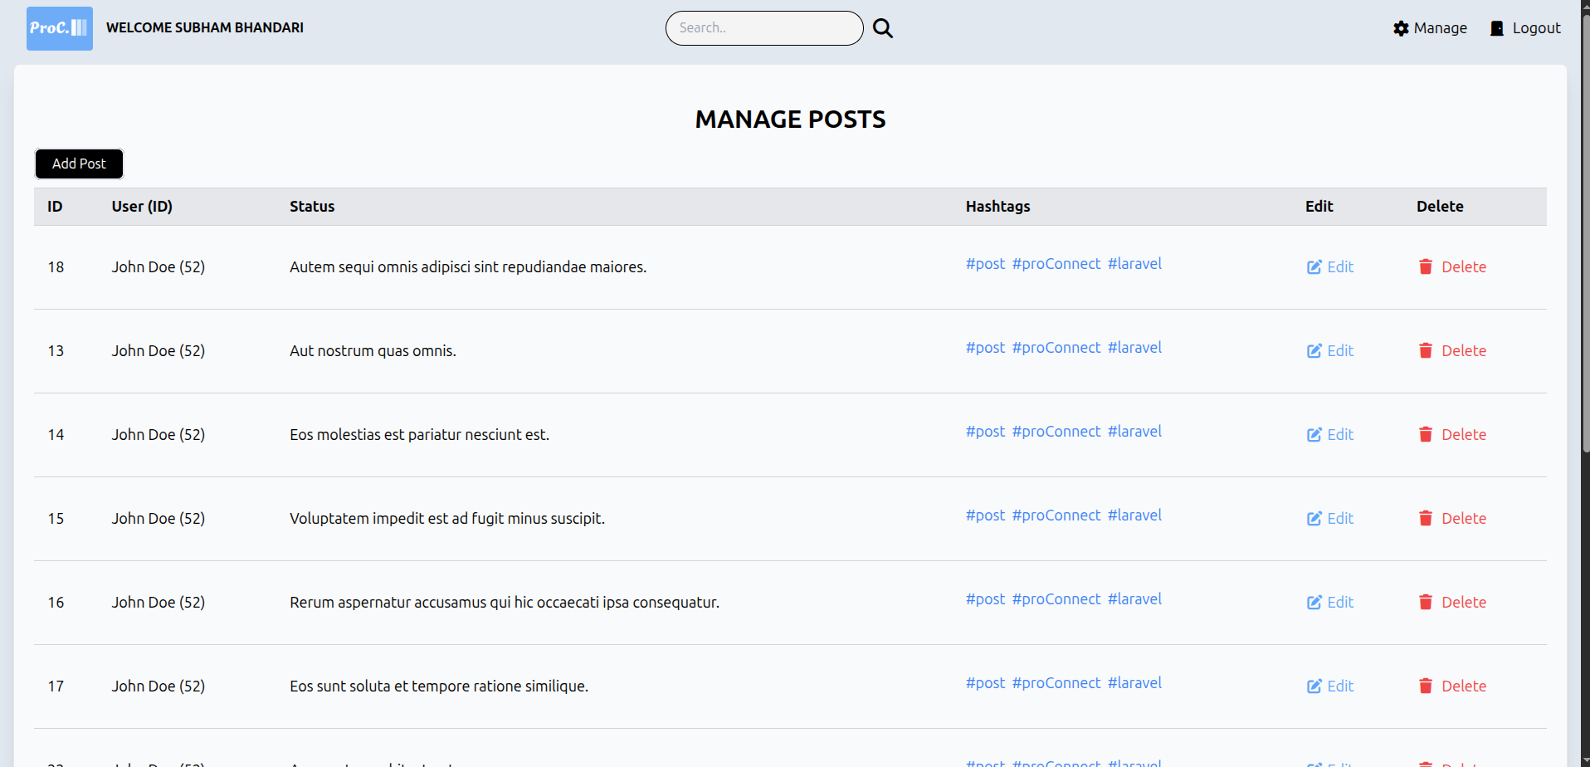

    - Create Post Page

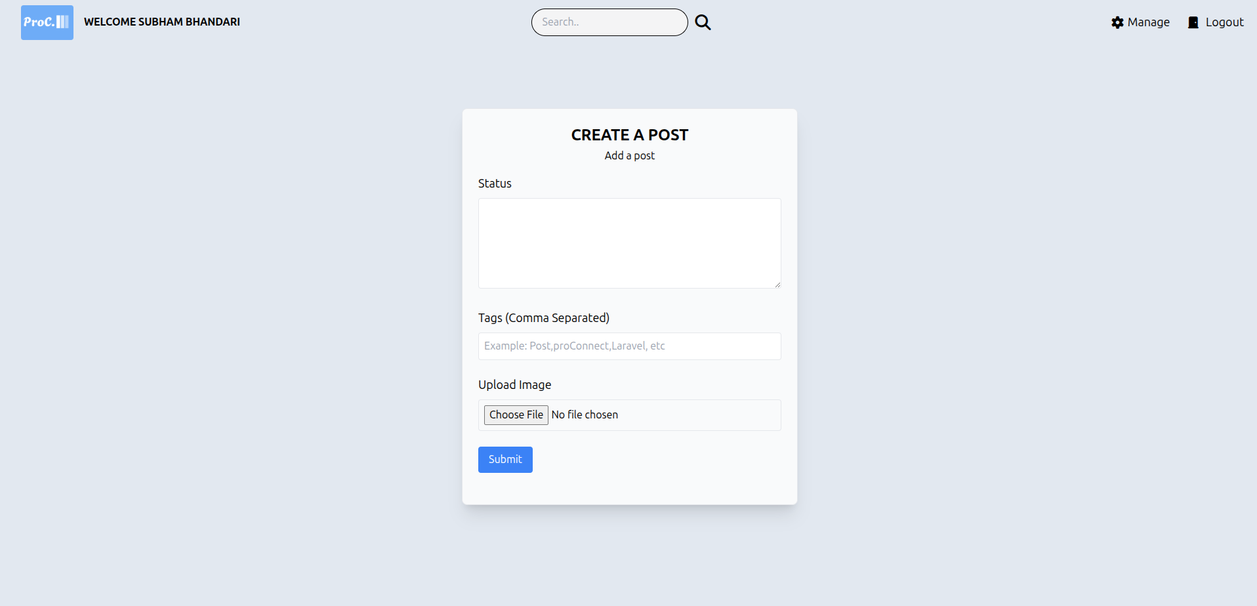

    - Edit Post Page

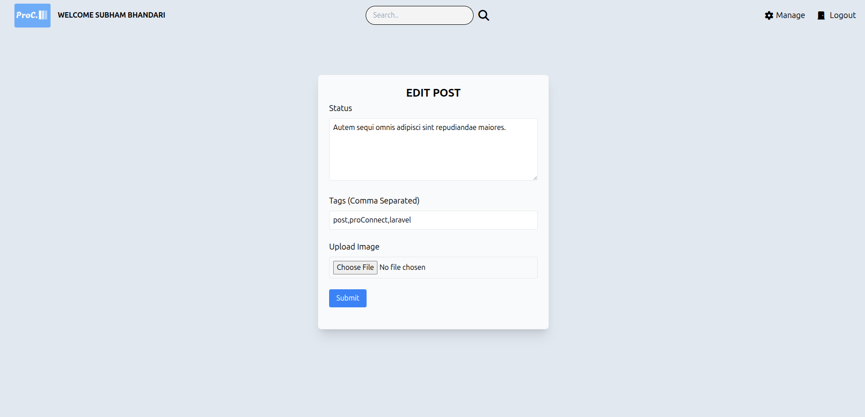

    - Manage User Page

    - Add User Page

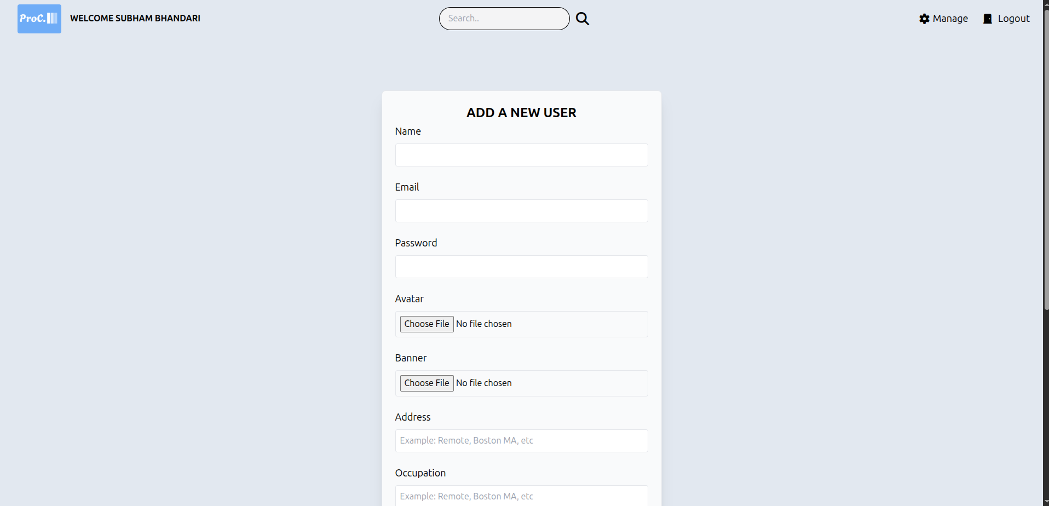

    - Manage Gigs Page

    - Edit Gig Page

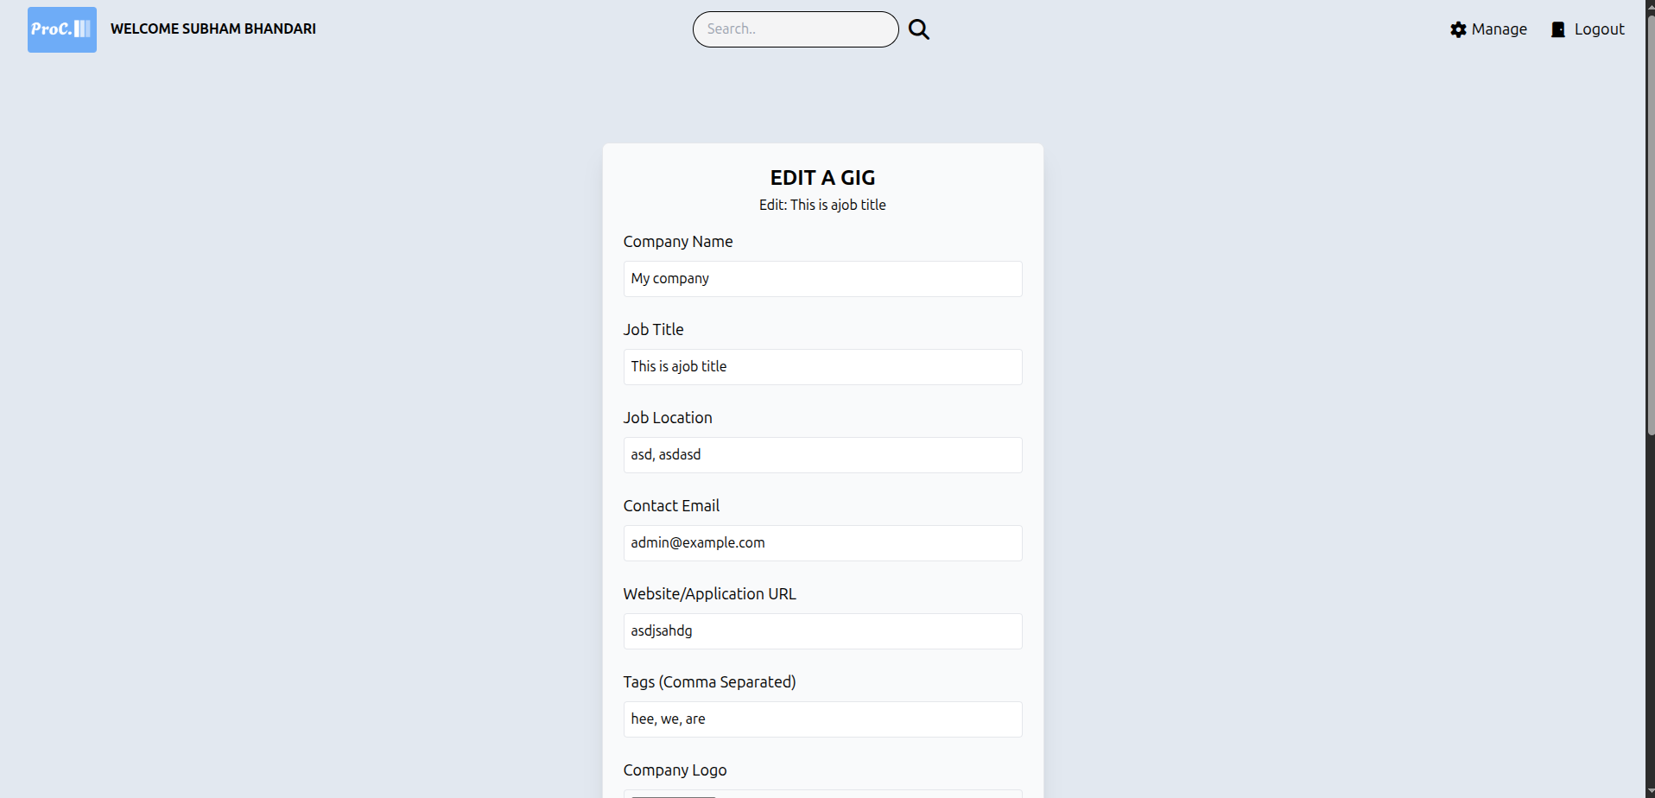

    - Add Gig Page

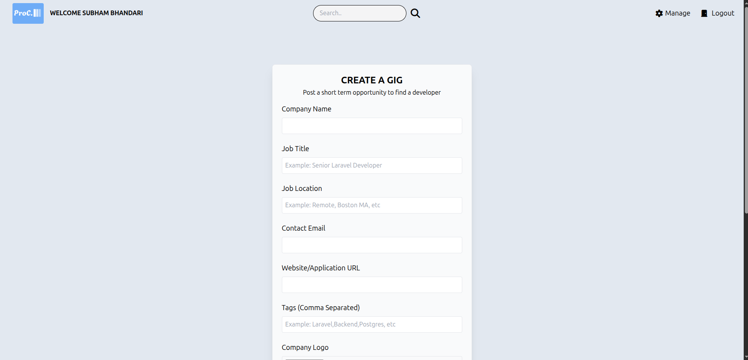

REFERENCES

[1] LinkedIn, "Professional networking platform," [Online]. Available: https://www.linkedin.com/ [Accessed: Jul. 11, 2025].
[2] Fiverr, "Freelance services marketplace," [Online]. Available: https://www.fiverr.com/ [Accessed: Jul. 11, 2025].
[3] ResearchGate, "The role of technology in enhancing professional networking and career development," [Online]. Available: https://www.researchgate.net/
[4] Tutorialspoint, "Waterfall Model," Accessed: Jun. 28, 2025. [Online]. Available: https://www.tutorialspoint.com/sdlc/sdlc_waterfall_model.htm [Accessed: Jul. 11, 2025].

