

Tribhuvan University
Faculty of Humanities and Social Sciences

A PROJECT REPORT
ON
Smart Helpdesk
A Multi-Tenant Support Ticket Management System

Submitted to
Department of BCA
Everest College
Thapathali, Kathmandu
In partial fulfillment of the requirements for the Bachelor in Computer Application (CACS452 Project III)

Submitted by
Subham Bhandari, 6-2-355-29-2021
Utsav Karki, 6-2-355-33-2021
BCA 8th Semester, IV Year

Under the Supervision of
Mr. Kamal Pathak

Tribhuvan University
Faculty of Humanities and Social Sciences
Everest College

Supervisor's Recommendation
I hereby recommend that this project prepared under my supervision by SUBHAM BHANDARI, 6-2-355-29-2021 and UTSAV KARKI, 6-2-355-33-2021 entitled "Smart Helpdesk: A Multi-Tenant Support Ticket Management System" in partial fulfillment of the requirements for the degree of Bachelor in Computer Application is recommended for the final evaluation.

.............................................
Mr. Kamal Pathak
Supervisor
Department of BCA
Everest College, Thapathali, Kathmandu

Tribhuvan University
Faculty of Humanities and Social Sciences
Everest College

Letter of Approval
This is to certify that this project prepared by SUBHAM BHANDARI, 6-2-355-29-2021 and UTSAV KARKI, 6-2-355-33-2021 entitled "Smart Helpdesk: A Multi-Tenant Support Ticket Management System" in partial fulfillment of the requirements for the degree of Bachelor in Computer Application has been evaluated. In our opinion it is satisfactory in the scope and quality as a project for the required degree.
.............................................  SUPERVISOR  Mr. Kamal Pathak  Department of BCA  Everest College | .............................................  HOD / CO-ORDINATOR  Mr. Kamal Pathak  Department of BCA  Everest College
.............................................  INTERNAL EXAMINER | .............................................  EXTERNAL EXAMINER

Acknowledgement
We are glad to present this report on "Smart Helpdesk", prepared as our CACS452 Project III in the eighth semester of the Bachelor in Computer Application. We express our sincere gratitude to everyone who guided and supported us throughout the project.
We extend our genuine thanks to our project supervisor, Mr. Kamal Pathak, for his continuous guidance, constructive feedback and encouragement from the proposal to the final defence. We are equally thankful to Mr. Kamal Pathak, Head of the Department of BCA, for his support and for the academic environment in which this work was possible.
We are indebted to the Department of BCA, Everest College, and to the faculty members whose courses in database management, software engineering, web technology, operating systems, data mining and research methodology laid the foundation of this project. We also thank our families and friends for their patience and support, and the open-source communities whose frameworks, databases and tools allowed us to focus our own work on the system's design, its algorithms and its verification.

Abstract
Small support teams often handle requests through shared mailboxes or basic ticketing tools in which priority is set by hand, work is assigned by habit, one outage produces many unrelated tickets and service-level breaches are noticed only after they happen. This project designs and implements Smart Helpdesk, a multi-tenant support ticket management system that one installation offers to many independent organisations, either as a hosted service or on an organisation's own server. It is built with a Laravel application programming interface, a React single-page application and PostgreSQL, packaged with Docker and deployed to a cloud virtual machine.
Four operational decisions are made by the system's own simple algorithms, and each decision is explained to the agent: a weighted priority score over impact, urgency, customer tier and waiting time; assignment to the eligible agent with the lowest load relative to capacity; duplicate detection by comparing the word sets of tickets; and a service-level agreement (SLA) timer that pauses, warns and records breaches on working hours. A reporting module records every change to the main records, shows any record as it was at a past moment and analyses backlog and workload over time. Each organisation's data is kept separate in the application and in the database. The system also provides a media library, email notifications, email-to-ticket, a REST API with signed webhooks and a management dashboard.
Manual testing of the main workflows and of each algorithm with worked examples confirmed that the system behaves as specified.

Keywords: helpdesk, multi-tenancy, ticket prioritisation, agent assignment, duplicate detection, service level agreement

Table of Contents
Acknowledgement iii
Abstract iv
List of Figures vii
List of Tables ix
List of Abbreviations x
Chapter 1: Introduction 1
1.1 Introduction 1
1.2 Problem Statement 1
1.3 Objectives 2
1.4 Scope and Limitation 2
1.5 Development Methodology 3
1.6 Report Organization 4
Chapter 2: Background Study and Literature Review 5
2.1 Background Study 5
2.1.1 Tickets, priority and service levels 5
2.1.2 Weighted scoring and load balancing 5
2.1.3 Text similarity 5
2.1.4 Multi-tenant software 6
2.2 Literature Review 6
2.2.1 Existing helpdesk systems 6
2.2.2 Related research 7
Chapter 3: System Analysis and Design 7
3.1 System Analysis 7
3.1.1 Requirement Analysis 7
3.1.2 Feasibility Analysis 11
3.1.3 Object Modelling using Class and Object Diagrams 12
3.1.4 Dynamic Modelling using State and Sequence Diagrams 14
3.1.5 Process Modelling using Activity Diagrams 18
3.2 System Design 22
3.2.1 Refinement of Class, Object, State, Sequence and Activity Diagrams 22
3.2.2 Component Diagrams 24
3.2.3 Deployment Diagrams 25
3.3 Algorithm Details 26
3.3.1 Priority scoring: basic weighted priority 26
3.3.2 Agent assignment: least-loaded eligible agent 27
3.3.3 Duplicate detection: Jaccard word overlap 28
3.3.4 SLA evaluation: simple SLA timer 28
3.3.5 History reconstruction and time analytics 29
Chapter 4: Implementation and Testing 30
4.1 Implementation 30
4.1.1 Tools Used 30
4.1.2 Implementation Details of Modules 30
4.2 Testing 34
4.2.1 Test Cases for Unit Testing 34
4.2.2 Test Cases for System Testing 35
4.3 Result Analysis 35
Chapter 5: Conclusion and Future Recommendations 36
5.1 Conclusion 36
5.2 Future Recommendations 36
References 38
Appendices 39
Appendix A: Screenshots 39

List of Figures
Figure 1.1: Waterfall model of the development 3
Figure 3.1: Use case diagram of ticket handling and automation 8
Figure 3.2: Use case diagram of administration, contacts and reporting 9
Figure 3.3: Gantt chart of the project schedule 12
Figure 3.4: Class diagram of the domain model 13
Figure 3.5: Object diagram of a seeded ticket 14
Figure 3.6: State diagram of the ticket lifecycle 15
Figure 3.7: State diagram of an SLA timer 16
Figure 3.8: Sequence diagram of ticket creation 17
Figure 3.9: Sequence diagram of the SLA check 17
Figure 3.10: Sequence diagram of inbound email processing 18
Figure 3.11: Activity diagram of agent assignment 19
Figure 3.12: Activity diagram of duplicate detection 20
Figure 3.13: Activity diagram of inbound email routing 21
Figure 3.14: Algorithm interfaces and their baseline implementations 23
Figure 3.15: Entity relationship diagram 24
Figure 3.16: Component diagram 25
Figure 3.17: Deployment diagram 26
Figure 4.1: Management dashboard 32
Figure 4.2: Ticket screen with conversation, SLA timers and details 33
Figure 4.3: Priority explanation shown on a ticket 33
Figure A.1: Landing page 39
Figure A.2: Sign-in page of a workspace 39
Figure A.3: Ticket list with filters 40
Figure A.4: New ticket with duplicate suggestions 40
Figure A.5: Assignment ranking with excluded agents 41
Figure A.6: Ticket close to its SLA deadline 41
Figure A.7: Ticket history with the point-in-time view 42
Figure A.8: Contact list 42
Figure A.9: Report catalogue 43
Figure A.10: Priority settings 43
Figure A.11: SLA policies 44
Figure A.12: Ticket list in the dark theme 44
Figure A.13: Platform console with the list of workspaces 45

List of Tables
Table 1.1: Phases of the waterfall model and their outputs 4
Table 2.1: Comparison of existing open-source helpdesk systems 6
Table 3.1: Functional requirements by module 9
Table 3.2: Description of use case "Create ticket" 10
Table 3.3: Description of use case "Assign ticket" 10
Table 3.4: Non-functional requirements 11
Table 3.5: Project schedule 11
Table 3.8: Inputs of the priority score 27
Table 4.1: Tools and technologies 30
Table 4.2: Unit test cases 34
Table 4.3: System test cases 35

List of Abbreviations
Abbreviation | Expansion
API | Application Programming Interface
BCA | Bachelor in Computer Application
CPU | Central Processing Unit
CSS | Cascading Style Sheets
CSV | Comma-Separated Values
GB | Gigabyte
HOD | Head of Department
HTTPS | Hypertext Transfer Protocol Secure
ID | Identifier
ITIL | Information Technology Infrastructure Library
MB | Megabyte
P1 to P4 | Priority levels 1 (critical) to 4 (low)
PHP | PHP: Hypertext Preprocessor
PNG | Portable Network Graphics
REST | Representational State Transfer
SLA | Service Level Agreement
ST, UT | System test, unit test (test case identifiers)
XLSX | Excel spreadsheet file format

Chapter 1: Introduction

1.1 Introduction
Every organisation that serves customers or employees receives requests: a login that fails, an invoice that is wrong, a server that is down. A helpdesk turns these requests into tickets that can be prioritised, assigned, tracked against a promised response time and closed with a record of what was done. Commercial platforms such as Zendesk, ServiceNow and Jira Service Management provide this for large enterprises, while small and medium teams often rely on shared mailboxes or open-source tools that store tickets well but leave most decisions to people.
Smart Helpdesk is a web-based support ticket management system built for such teams. One installation serves many independent organisations, called tenants, each with its own users, agents, customers, tickets and settings, and the same software can run as a hosted service or on an organisation's own server. Beyond storing tickets, the system makes four decisions automatically and explains each one: how urgent a ticket is, which agent should handle it, whether it repeats an existing ticket, and whether its service-level agreement (SLA) is at risk. It also records how every record changed over time, offers reports on tickets, customers, agents and service levels, sends notifications by email and in the application, turns customer emails into tickets, and lets other systems integrate through a documented API and webhooks.

1.2 Problem Statement
A review of how small support teams work and of existing open-source helpdesks (Section 2.2) shows the following problems:
- Inconsistent prioritisation. Priority is chosen by whoever creates the ticket, and a ticket's urgency does not grow while it waits.
- Unbalanced assignment. Tickets are assigned by hand or by simple rotation, so work piles up on experienced agents while skills and current workload are ignored.
- Duplicate tickets. One outage produces many tickets that describe the same problem in different words, and agents work on them in parallel.
- Late SLA awareness. Response and resolution targets are checked in reports after the fact instead of warning agents before a breach.
- Shallow reporting. Managers see current counts but not how the backlog or a customer's record looked on a past date.
- Isolation and deployment. A hosted helpdesk must guarantee that one organisation never sees another's data, while some organisations need the same software on their own servers.

1.3 Objectives
The objectives of the project are:
- To design and implement a multi-tenant helpdesk in which each organisation's data is strictly isolated, and which can run on any virtual machine or on an organisation's own server.
- To implement simple, explainable algorithms for priority scoring, agent assignment, duplicate ticket detection and SLA monitoring with working-hours calendars.
- To provide the supporting features needed for real use: the ticket lifecycle with public replies and internal notes, a media library, email notifications and email-to-ticket, a dashboard, an audit trail, a REST API and signed webhooks.
- To implement a reporting module that records every change to the main records and shows any record as it was at a past moment.
The algorithms are intentionally minimal and replaceable, so that they can be understood completely and later substituted with stronger techniques.

1.4 Scope and Limitation
Scope. The system covers workspace provisioning by a platform administrator; sign-in, invitations, roles and permissions within each workspace; contacts and organisations with customer tiers; teams, skills, categories, agent capacity, availability and shifts; the complete ticket lifecycle with comments, attachments and history; the four algorithms with explanations shown to agents; SLA policies with business calendars and warning and breach notifications; in-application and email notifications; email-to-ticket; a media library; a dashboard and a catalogue of reports with drill-down and point-in-time views; a REST API with client credentials and signed webhooks; light and dark themes; and deployment with Docker to any virtual machine, demonstrated on an Amazon Web Services instance.
Limitations.
- The algorithm weights and thresholds are set by administrators rather than learned from history.
- Duplicate detection compares words, so two tickets that describe the same problem in different vocabulary are not detected.
- Load testing was not carried out; the system runs on a single small virtual machine.
- A customer self-service portal, live chat, a knowledge base, custom fields and billing are outside the scope.
- The agent application is designed for desktop and laptop screens; layouts for phones are not provided.

1.5 Development Methodology
The project followed the waterfall model (Figure 1.1). The requirements of the system were known at the start from the problem statement and the course requirements, and the project had a fixed period of about three months, so the work was divided into phases that were completed one after another, each ending with a document or product that was reviewed before the next phase began.
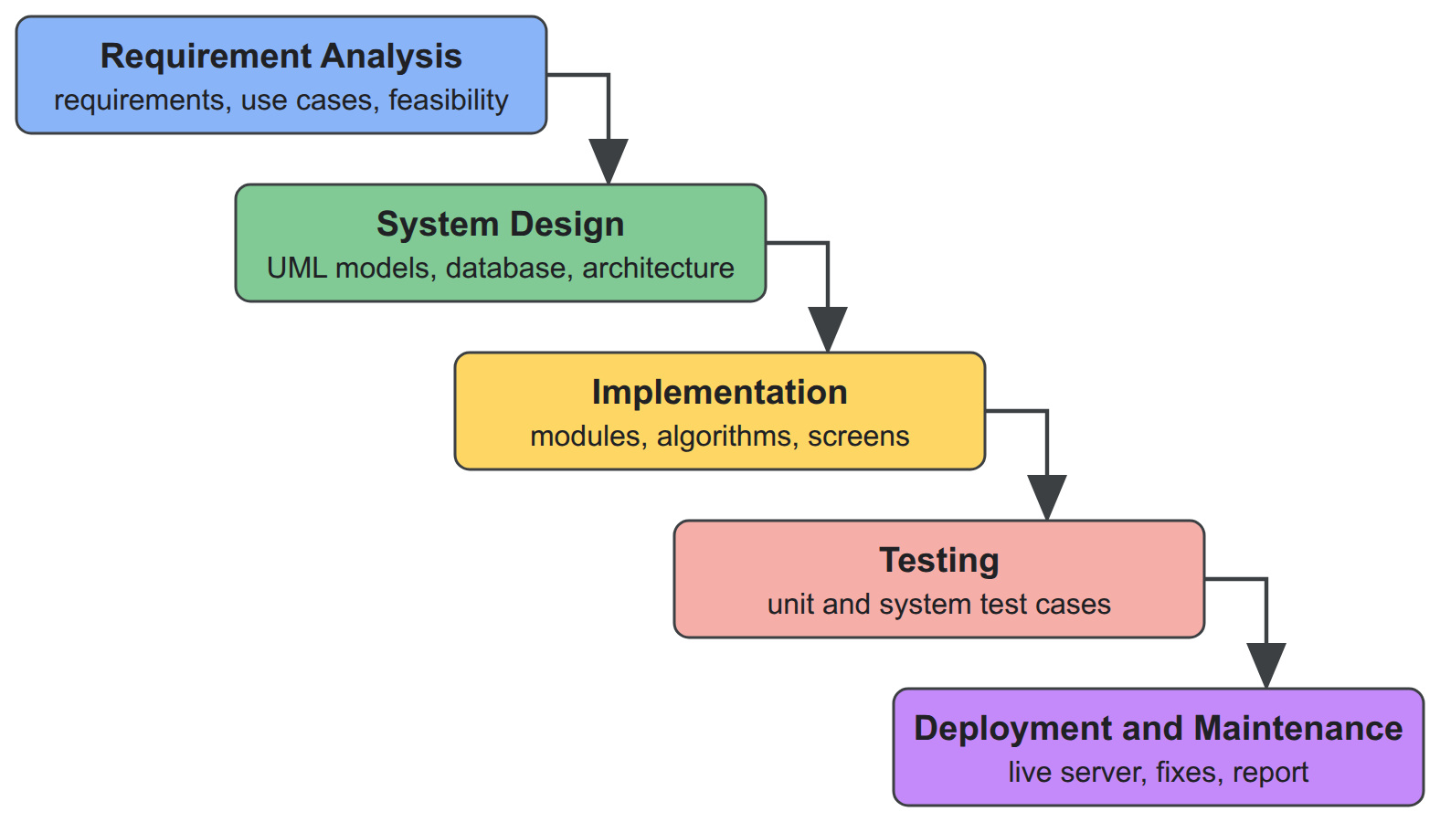
Figure 1.1: Waterfall model of the development
- Requirement analysis: study of existing helpdesk systems, collection of functional and non-functional requirements, use cases and feasibility study.
- System design: class, object, state, sequence and activity diagrams, database design, component and deployment design, and the design of the four algorithms.
- Implementation: development of the modules, from tenancy, sign-in and the ticket model to the algorithms, SLA timers, email, reports, integrations and the user interface.
- Testing: manual unit testing of each function and system testing of the complete workflows.
- Deployment and maintenance: installation on a cloud virtual machine, correction of the problems found, and completion of the documentation.
The two team members worked on separate features during implementation and reviewed each other's work before it was merged. Table 1.1 lists the output of each phase.
Table 1.1: Phases of the waterfall model and their outputs
Phase | Main activities | Output
Requirement analysis | study of existing systems, requirements, use cases, feasibility | requirement specification
System design | UML models, database and architecture design, algorithm design | design documents and diagrams
Implementation | backend modules, algorithms, web application screens | working system
Testing | unit and system test cases | tested system and test report
Deployment and maintenance | cloud deployment, fixes, documentation | live system and project report

1.6 Report Organization
Chapter 2 introduces the concepts the system is built on and reviews existing helpdesk systems and related research. Chapter 3 presents the requirement and feasibility analysis, the object, dynamic and process models, the system design and the details of the algorithms. Chapter 4 describes the tools, the implementation of each module, the test cases and the analysis of the results. Chapter 5 concludes the report and recommends future work.

Chapter 2: Background Study and Literature Review

2.1 Background Study

2.1.1 Tickets, priority and service levels
In service management a ticket is a unit of work with a lifecycle. Smart Helpdesk uses six statuses (open, assigned, in progress, pending, resolved and closed) because each one changes what the system does: an open ticket without an agent is a candidate for assignment, a pending ticket waits for the customer and pauses its SLA clock, and a resolved ticket can be reopened.
Priority is commonly derived from impact (how much of the organisation is affected) and urgency (how soon the effect becomes serious); Jira Service Management, for example, maps four impact and four urgency levels to five priorities with a lookup matrix [1]. The ITIL 4 guidance notes that prioritisation also depends on the backlog and on target resolution times [2], which motivated a score that also considers how long a ticket has waited.
A service level agreement defines targets such as first response time and resolution time. Products differ in the details, for example whether a timer pauses while the ticket waits for the customer and whether targets count calendar or business hours. Smart Helpdesk makes these behaviours explicit settings.

2.1.2 Weighted scoring and load balancing
Simple Additive Weighting scores an alternative as the weighted sum of its normalised criteria values [3]. Operating systems use ageing to stop low-priority work from waiting forever by raising its priority as it waits. For distributing work, load balancers and contact centres send each request to the least-loaded server or to the least-loaded agent who has the required skill [4]. The priority and assignment algorithms of this project are built on these ideas.

2.1.3 Text similarity
Information retrieval compares documents by the words they contain. Text is split into words, lower-cased and cleared of common stop words; the Jaccard similarity of two word sets is the number of shared words divided by the number of distinct words in both [5]. Richer methods weight words by how rare they are or use learned language models.

2.1.4 Multi-tenant software
A multi-tenant application serves several organisations from one deployment. Keeping all organisations in shared tables with a tenant identifier on every row is the simplest to operate but depends on every query being filtered correctly. PostgreSQL row-level security adds a filter enforced by the database itself, so a query that forgets the filter returns no rows instead of another organisation's data [6]. The system uses both layers.

2.2 Literature Review

2.2.1 Existing helpdesk systems
Four open-source helpdesks were studied for the capabilities this project targets (Table 2.1).
Table 2.1: Comparison of existing open-source helpdesk systems
System | Priority | Assignment | Duplicate detection | SLA
osTicket | manual levels per help topic | by department; manual claim | none | grace period after which a ticket is overdue
Zammad | three fixed levels | group rules; no workload awareness | manual merge | response and solution timers with calendars
GLPI | computed from an urgency and impact matrix | rules assign a technician or group | none | attached by rules
FreeScout | minimal | workflow rules | none | only through a paid module

Only GLPI computes priority, and it uses a fixed matrix without waiting time. None of the systems assigns tickets by measured workload and skills, and none detects duplicate tickets automatically. Smart Helpdesk combines a transparent priority score, workload-aware assignment, duplicate detection and calendar-aware SLA timers in one system that explains each decision.

2.2.2 Related research
Recent work treats ticket priority and routing as classification problems solved with machine learning on historical tickets. These models need labelled history and cannot easily explain their output, so a transparent weighted score is a reasonable starting point for a new installation. For duplicate reports, Runeson et al. compared the words of new bug reports with existing ones and found about 30 % of duplicates among the top five suggestions [7]; later work added weighted terms and learned models. For SLA timers, statecharts give a clear way to describe states that run alongside a ticket's workflow [8]. The algorithms of this project follow the simplest of these approaches and are built so that stronger methods can replace them later.

Chapter 3: System Analysis and Design

3.1 System Analysis

3.1.1 Requirement Analysis
i. Functional requirements
The actors of the system are the Platform Super Admin, who manages workspaces; the Tenant Admin, who configures a workspace; the Support Manager, who oversees queues and reports; the Support Agent, who works tickets; external systems, which use the API and receive webhooks; the Contact, who raises requests by email; and the scheduler, which drives time-based processing. Figures 3.1 and 3.2 show the use cases.
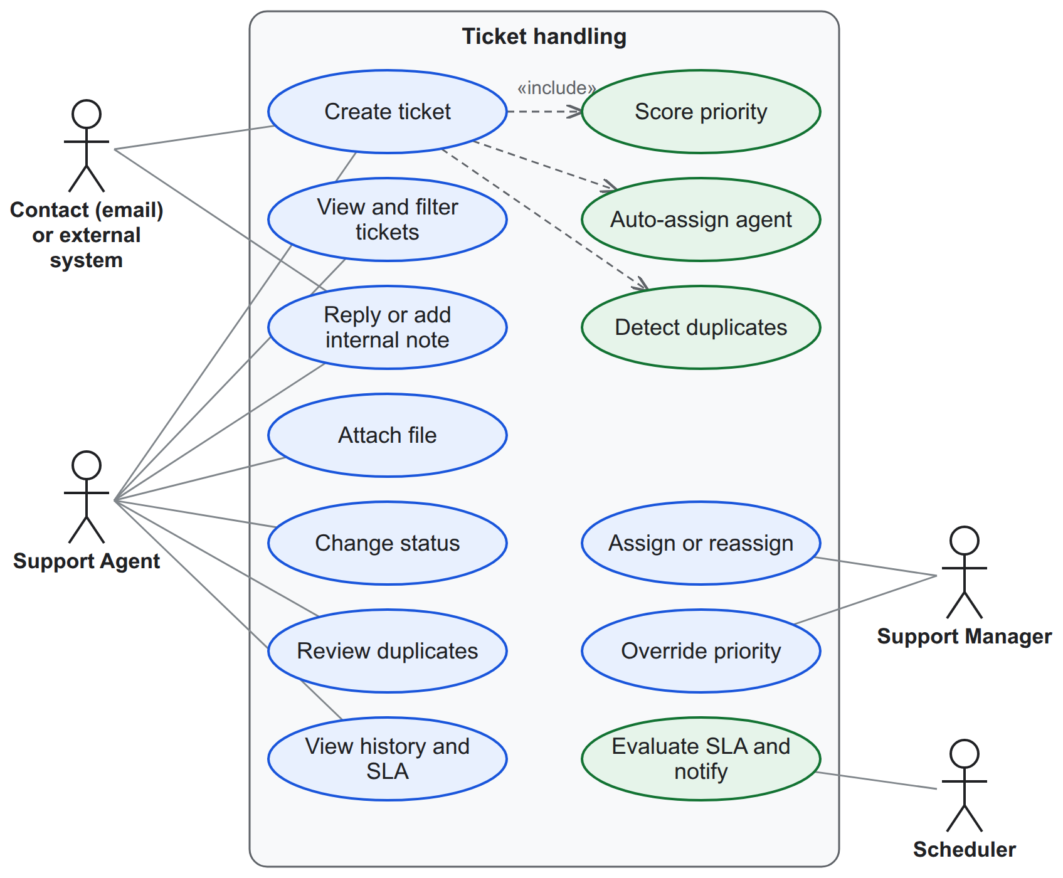
Figure 3.1: Use case diagram of ticket handling and automation
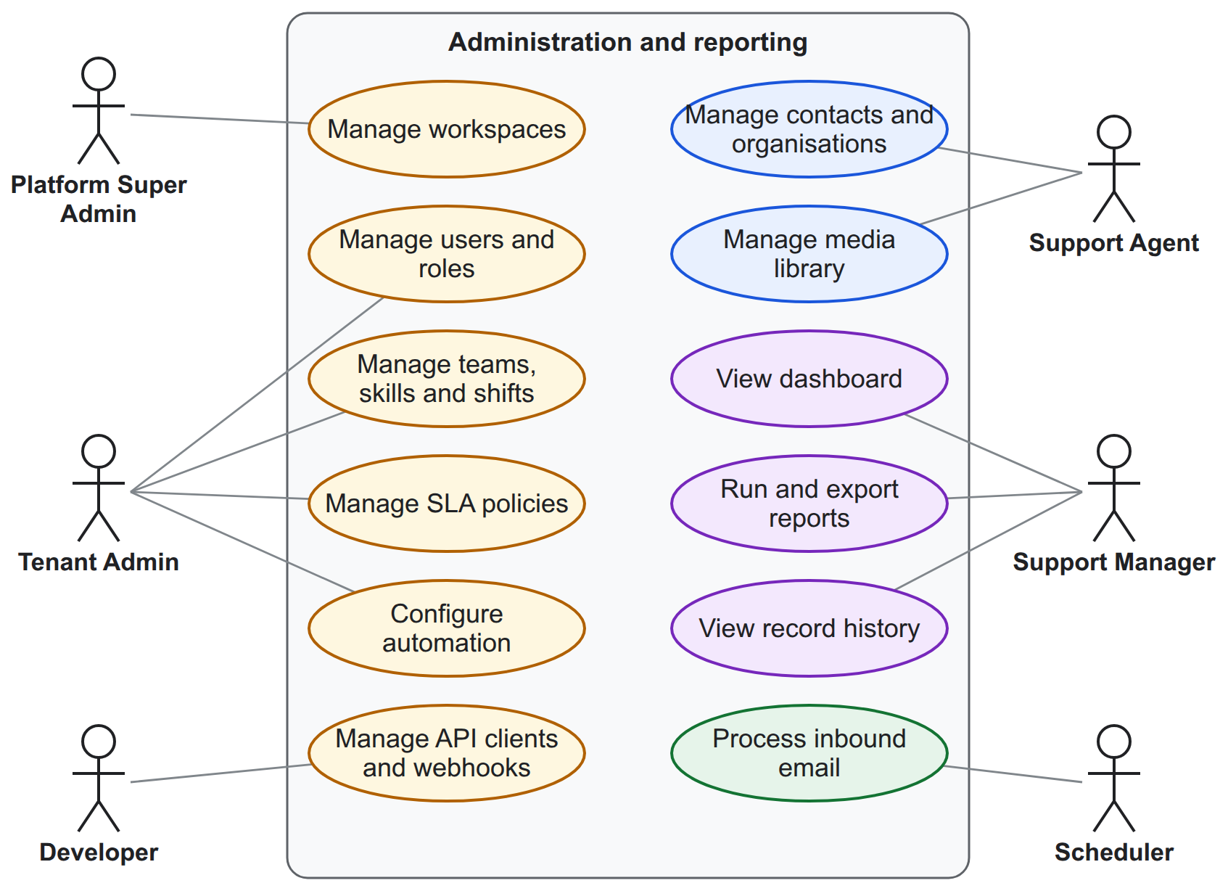
Figure 3.2: Use case diagram of administration, contacts and reporting
Table 3.1: Functional requirements by module
Module | Requirement
Tenancy | Create, suspend and reactivate workspaces; take the workspace of every request from the signed-in session or API client; seed default roles, categories, SLA policy and settings
Identity | Sign in with email and password; invite users; assign roles made of permissions; check a permission on every action
Contacts and agents | Manage contacts and organisations with customer tier; teams, skills, categories, agent capacity, availability and shifts
Tickets | Create tickets; move them through the lifecycle; add public replies and internal notes; attach files; keep history; list, filter and search
Automation | Score priority; assign agents; suggest duplicates; explain every automatic decision
SLA | Define policies and business calendars; run first-response and resolution timers; pause while pending; warn before and record breaches
Media and email | Store files in a workspace library; send notification emails; turn customer replies into comments and new emails into tickets
Integrations | REST API, client credentials, API documentation, signed webhooks with retries
Reporting | Record every change to the main records; report catalogue with filters and drill-down; record history and point-in-time view; CSV and XLSX export

Table 3.2: Description of use case "Create ticket"
Field | Description
Actors | Support Agent; external system through the API; Contact through email
Precondition | The actor is signed in to the workspace (or the email is routed to it)
Main flow | 1. Actor enters title, description, contact, category, impact, urgency and attachments. 2. System shows likely duplicates. 3. Actor confirms. 4. System numbers the ticket, computes its priority, starts SLA timers and assigns an agent. 5. System records history and sends notifications.
Alternative flows | 2a. Actor marks the ticket as a duplicate; it is closed and linked to the original. 4a. No agent is eligible; the ticket stays unassigned and managers are notified.
Postcondition | The ticket exists with number, priority, explanation, SLA timers and assignment

Table 3.3: Description of use case "Assign ticket"
Field | Description
Actors | System (automatic), Support Manager (manual)
Main flow | 1. System keeps the agents who are available, on shift, below capacity, in the team and hold the required skills. 2. System orders them by open tickets per unit of capacity. 3. System assigns the first agent and stores the ordered list. 4. Agent is notified.
Alternative flow | 1a. A manager reviews the ranking and chooses a different agent with a reason.

ii. Non-functional requirements
Table 3.4: Non-functional requirements
Quality | Requirement
Security | No access to another workspace through any screen or API; permission check on every action; sign-in throttling; signed webhooks and emails; private file storage
Performance | Ticket list and ticket creation respond within about one second for a workspace with many thousands of tickets
Reliability | Background work is queued and retried; daily backups with a tested restore
Usability | Light and dark themes; keyboard operation; readable contrast; loading, empty and error states on every screen
Portability | Runs on any Linux virtual machine with Docker

3.1.2 Feasibility Analysis
i. Technical feasibility. All components are mature open-source software: Laravel on PHP, React, PostgreSQL, Valkey, object storage and a mail server. They run together with Docker Compose on one virtual machine; the live deployment uses an Amazon Web Services instance with two virtual CPUs and 2 GB of memory.
ii. Operational feasibility. The system follows the workflow support teams already use and explains every automatic decision, so agents can trust or override it. Administrators adjust the algorithms through forms rather than code.
iii. Economic feasibility. No software licence is required. A virtual machine of the required size costs roughly US$8 to 35 per month, and an organisation's own server can be used instead. Development used free tools.
iv. Schedule feasibility. The project was planned over twelve weeks following the phases of the waterfall model (Section 1.5), each phase starting when the previous one was complete, with documentation written throughout (Table 3.5 and Figure 3.3).
Table 3.5: Project schedule
S.N. | Phase | Weeks | Duration
1 | Requirement analysis | 1 to 2 | 2 weeks
2 | System design | 3 to 4 | 2 weeks
3 | Implementation | 5 to 9 | 5 weeks
4 | Testing | 10 to 11 | 2 weeks
5 | Deployment and maintenance | 12 | 1 week
6 | Documentation and report | 1 to 12 | 12 weeks

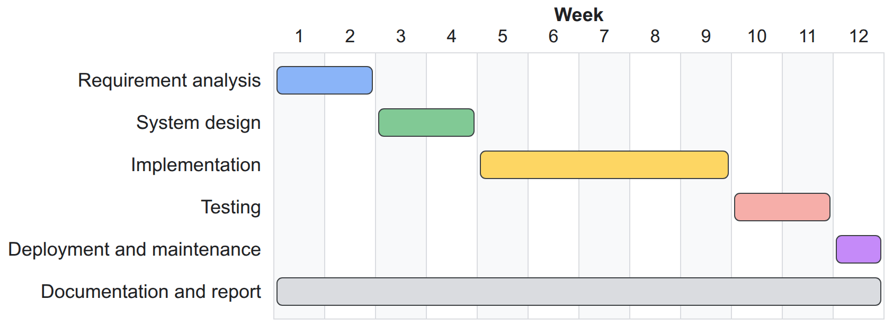
Figure 3.3: Gantt chart of the project schedule

3.1.3 Object Modelling using Class and Object Diagrams
The domain model (Figure 3.4) is centred on the Ticket. A ticket belongs to one workspace, is requested by one contact (who may belong to an organisation with a customer tier), has one category, and may be assigned to a team and an agent. A ticket has comments, history events, assignments, two SLA timers, duplicate suggestions and attached files. A category requires skills; an agent holds skills, belongs to teams and has shifts. An SLA policy has targets per priority level and uses a business calendar with holidays. For reporting, a change record stores every change of a main record.
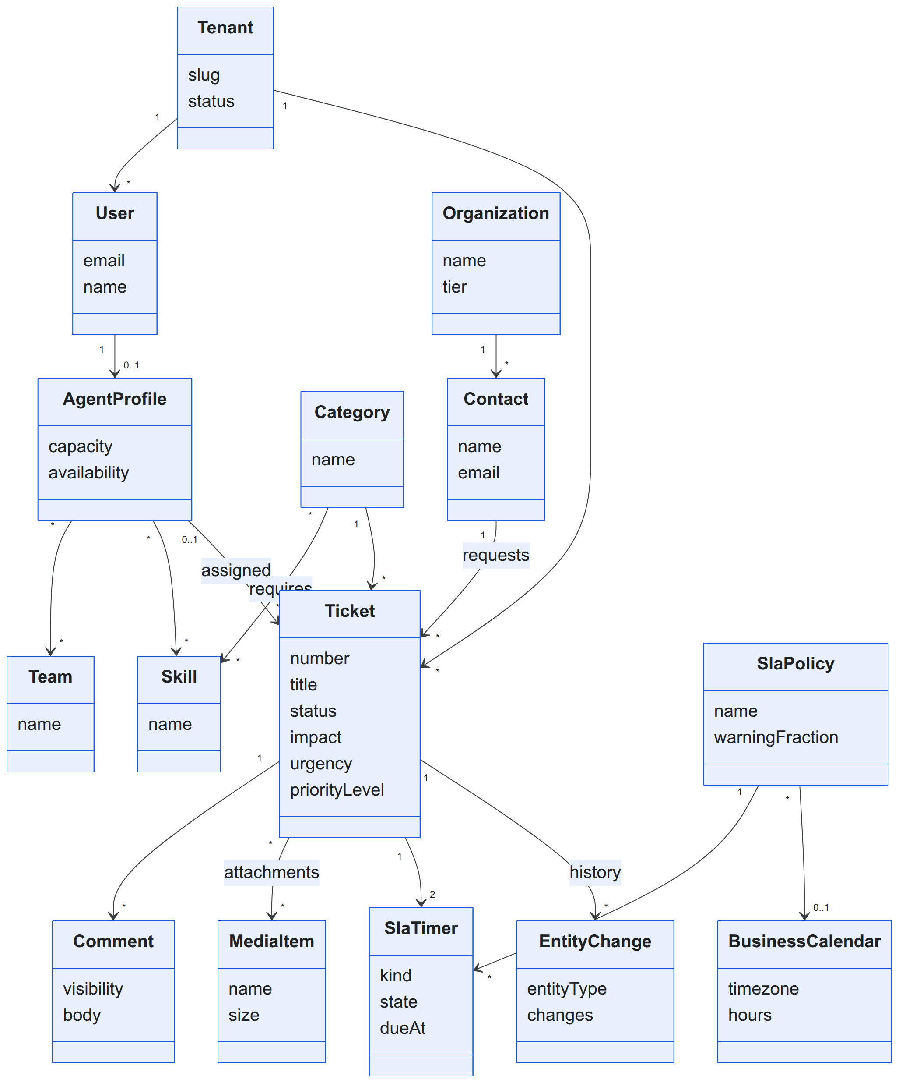
Figure 3.4: Class diagram of the domain model
Figure 3.5 shows an object diagram of a seeded ticket: ticket #1042 requested by a contact of a premium organisation, in the Billing category, assigned to agent Asha of the Finance Support team, with an eight-hour resolution timer.
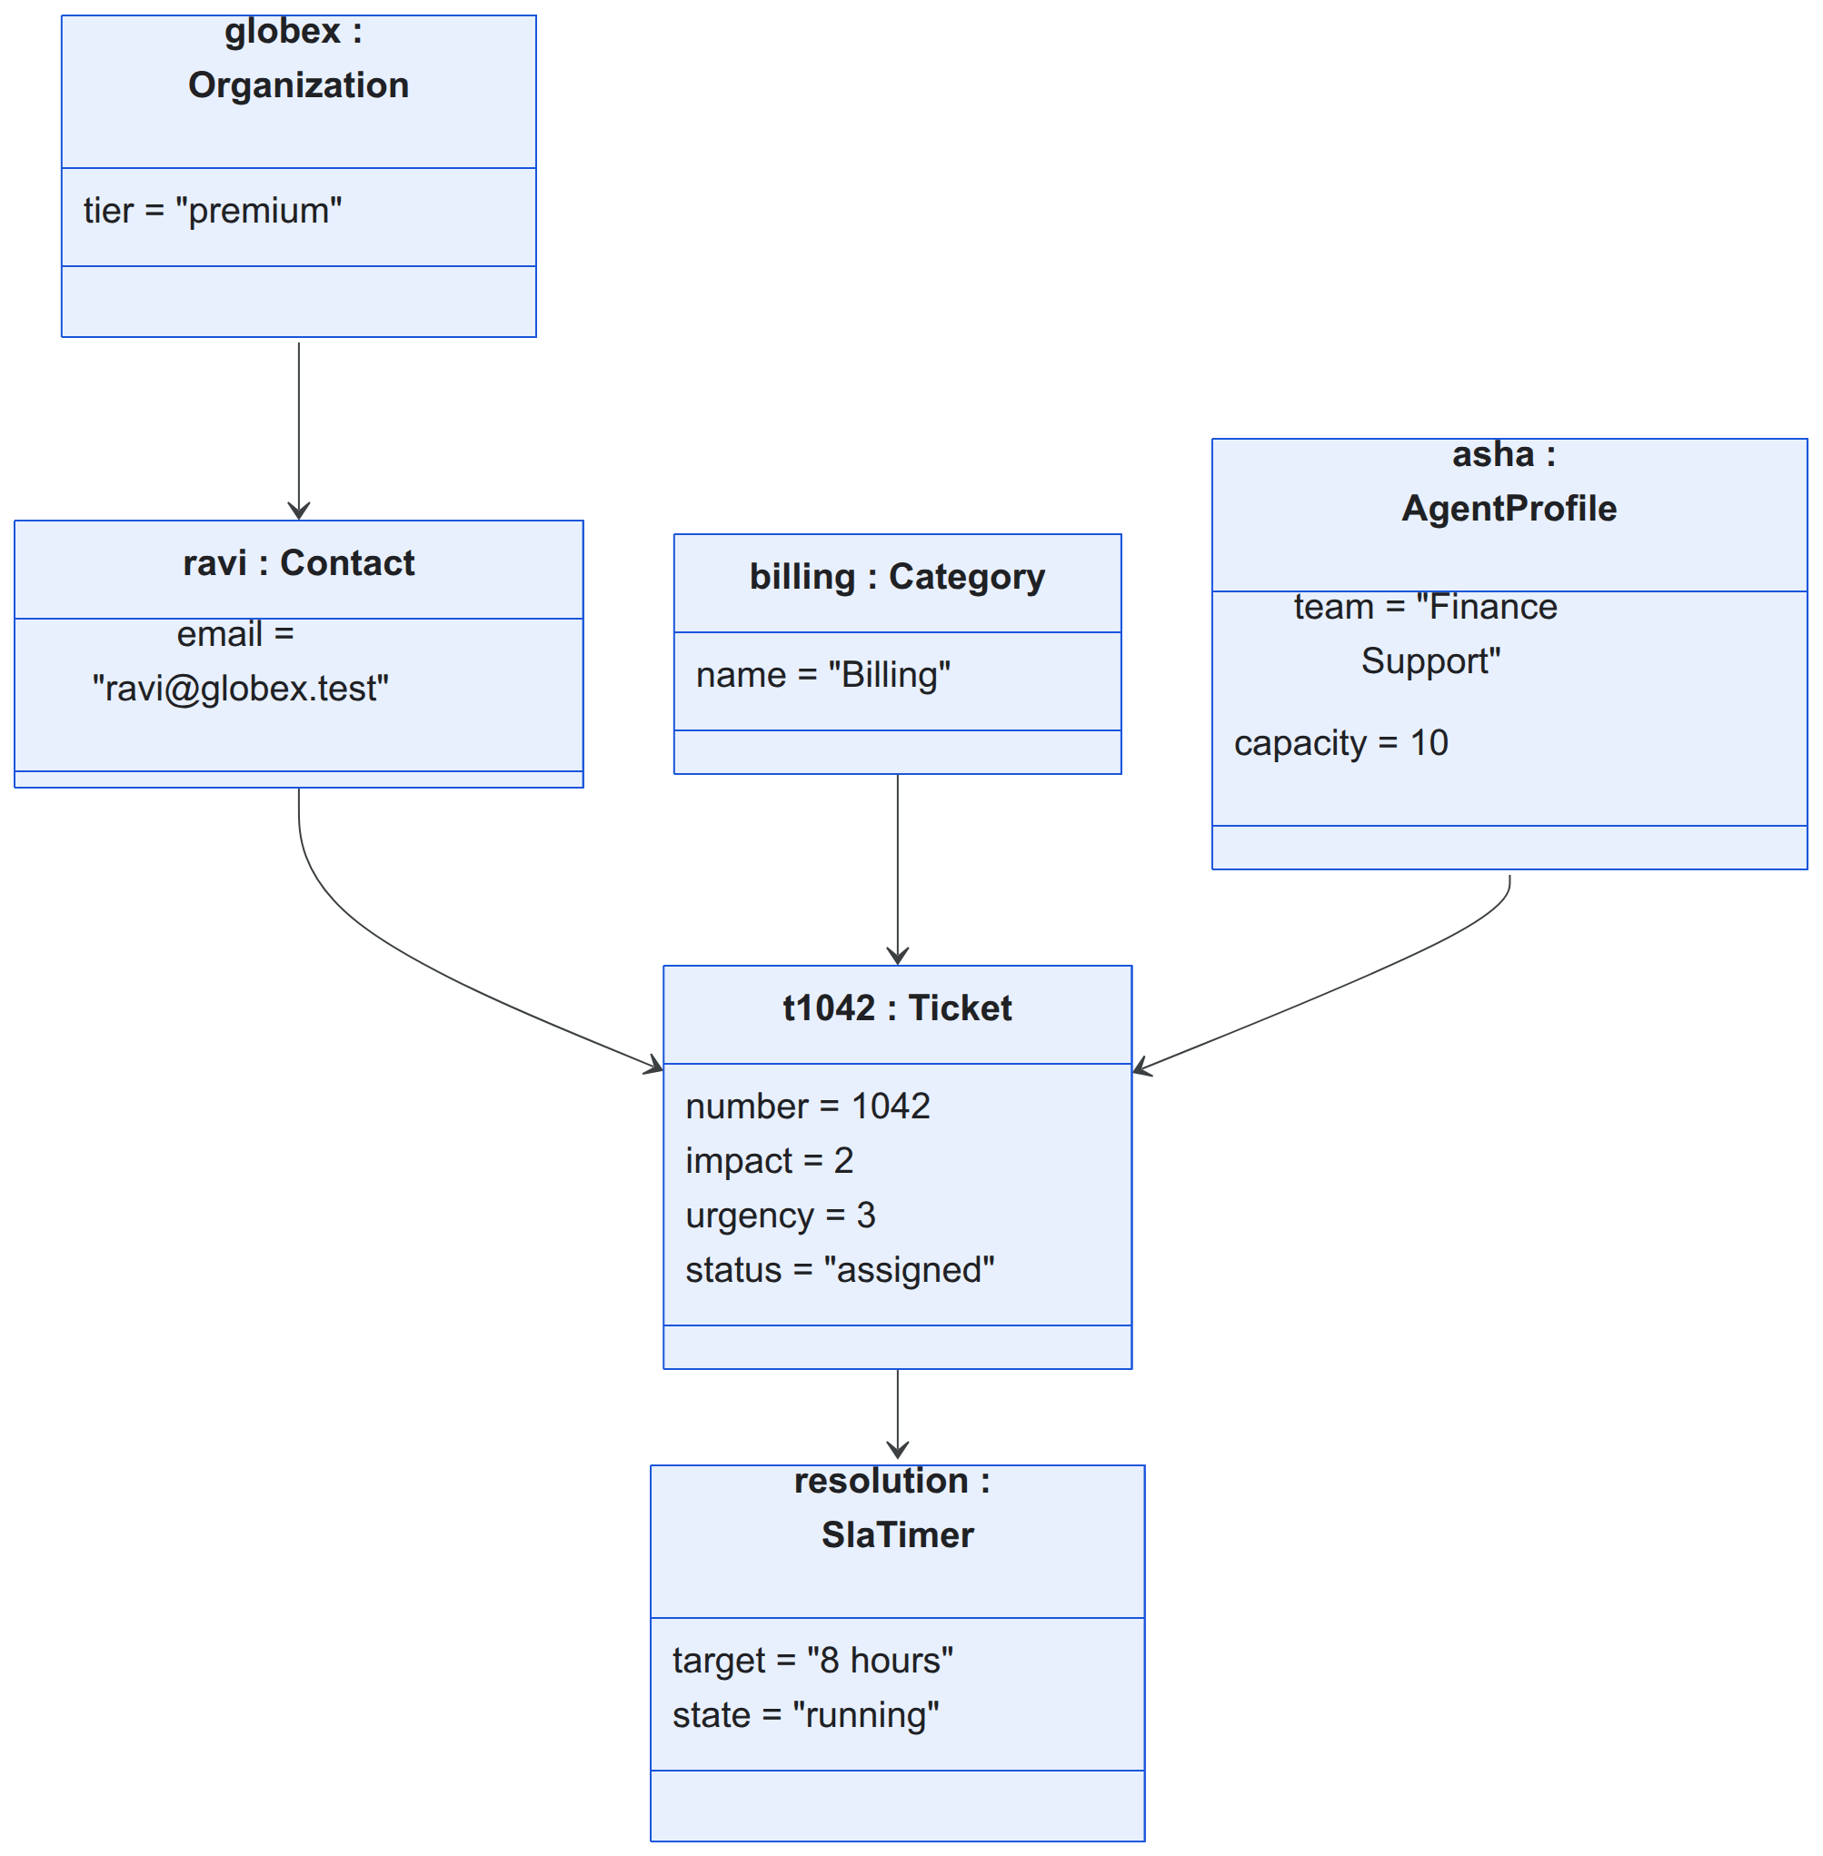
Figure 3.5: Object diagram of a seeded ticket

3.1.4 Dynamic Modelling using State and Sequence Diagrams
The ticket lifecycle (Figure 3.6) has six states. A new ticket is open; assignment moves it to assigned; work moves it to in progress; waiting for the customer moves it to pending; a resolved ticket is closed manually or automatically and can be reopened. Any other transition is rejected.
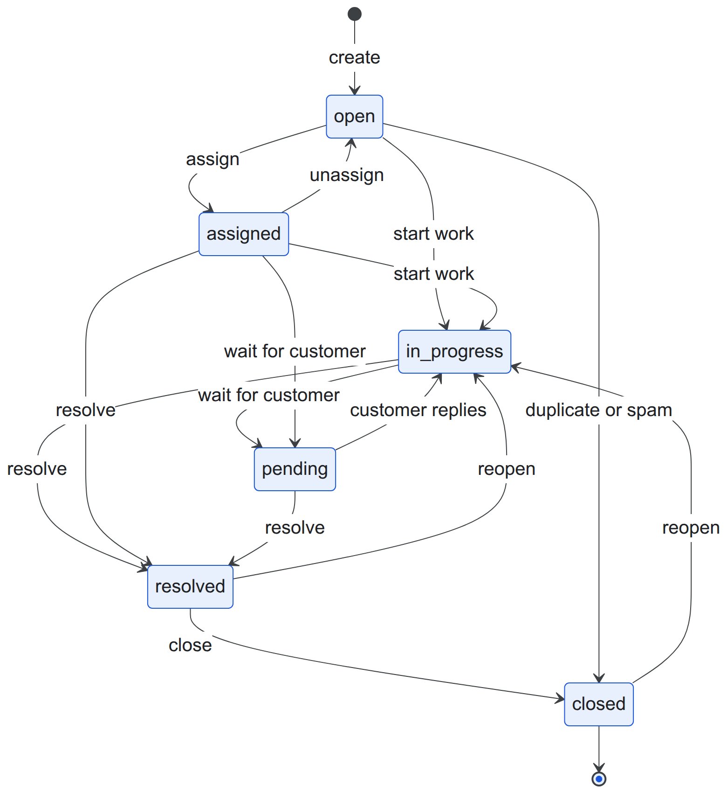
Figure 3.6: State diagram of the ticket lifecycle
Each ticket also has SLA timers that run alongside the lifecycle (Figure 3.7). A timer is running, paused, in warning, breached, met or cancelled.
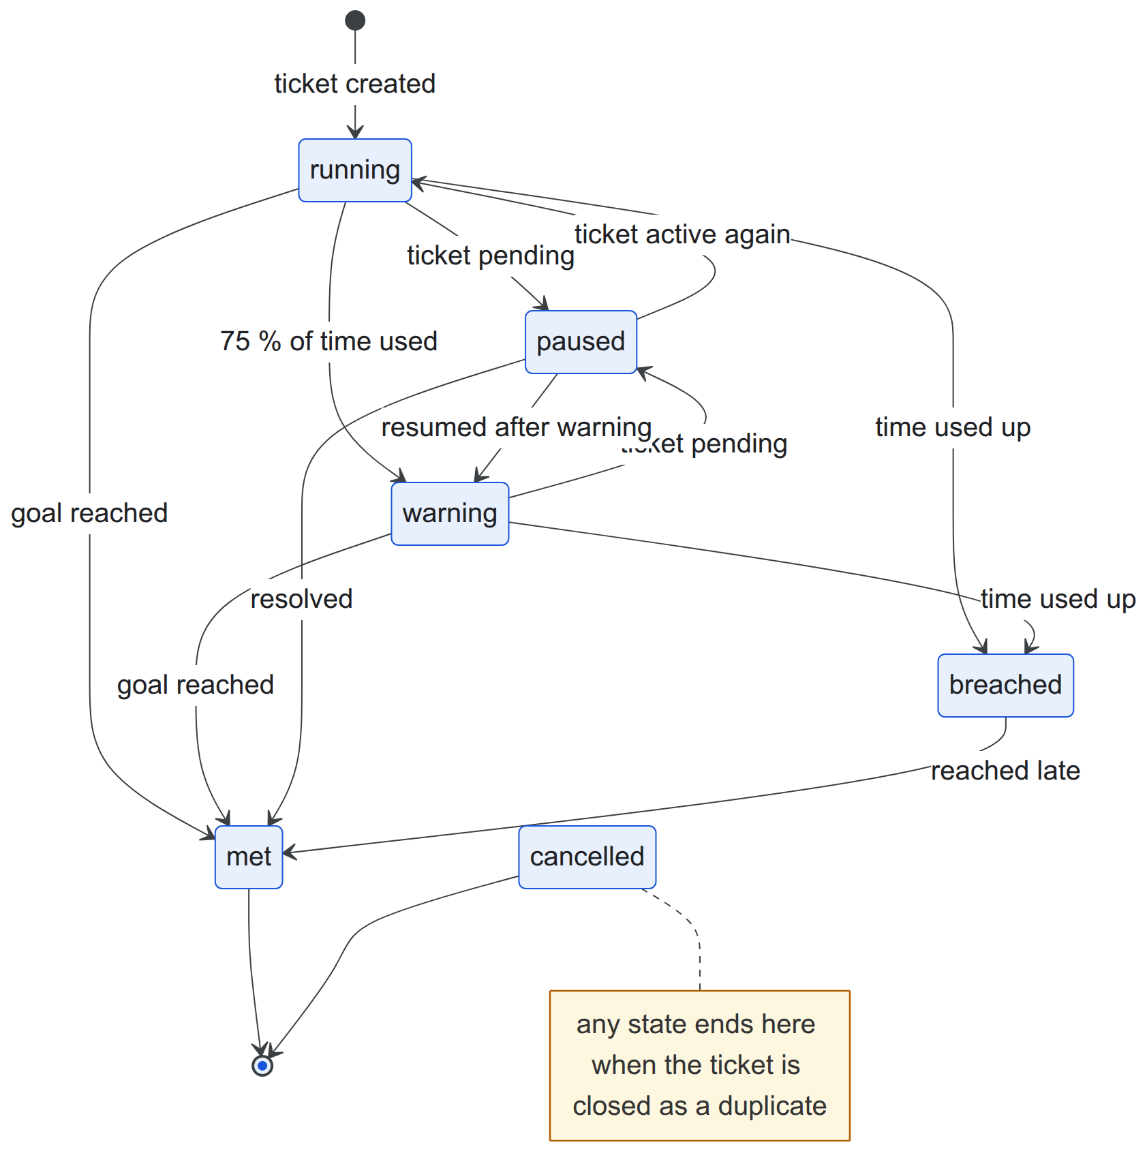
Figure 3.7: State diagram of an SLA timer
Figure 3.8 shows the creation of a ticket, in which priority, SLA, duplicate and assignment decisions are made in one database transaction. Figure 3.9 shows the SLA check that runs every minute, and Figure 3.10 the processing of an inbound email.
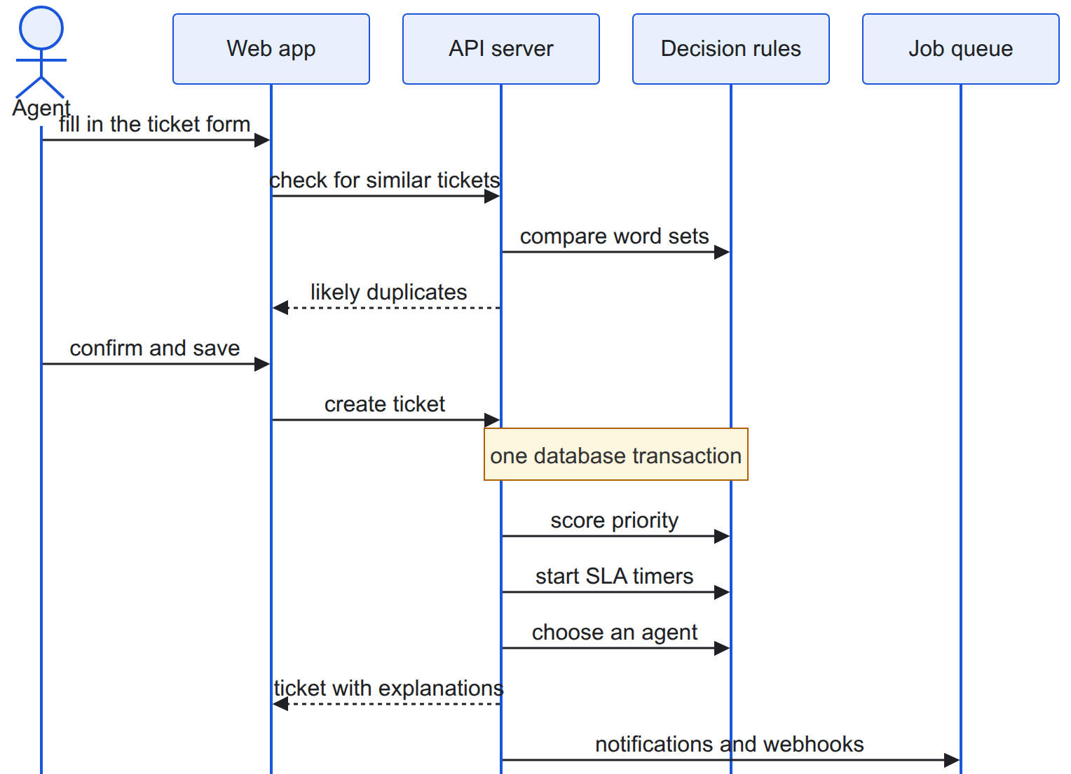
Figure 3.8: Sequence diagram of ticket creation
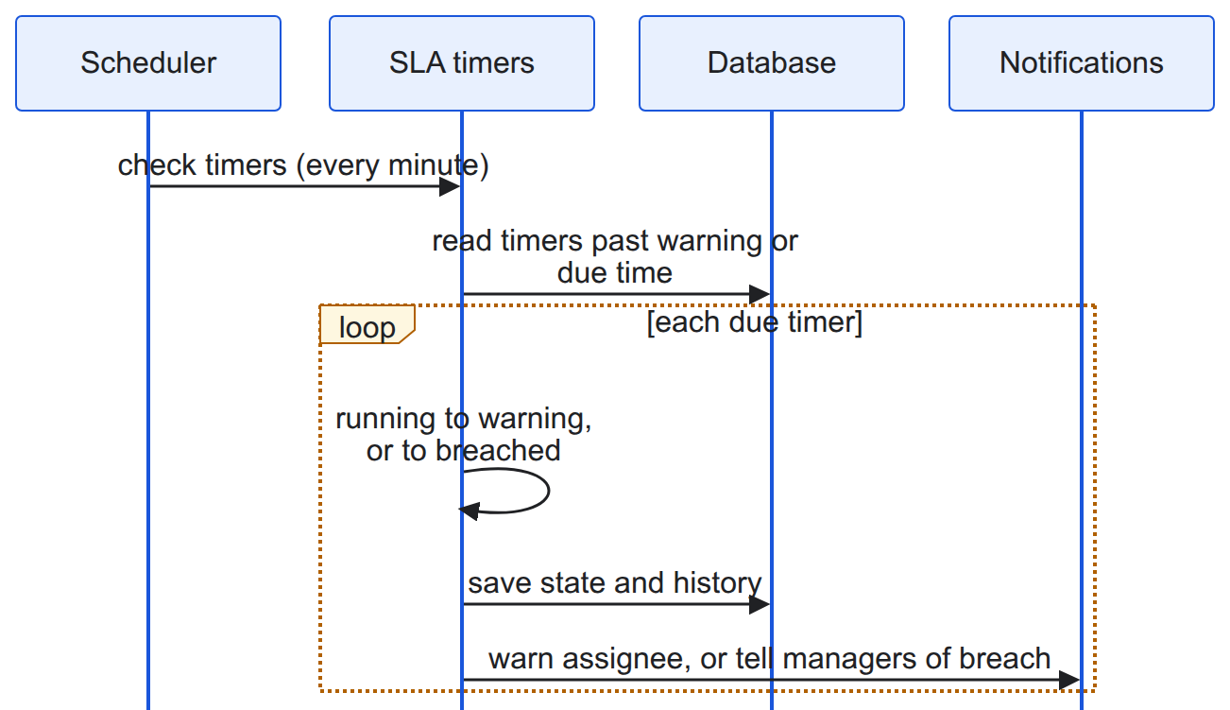
Figure 3.9: Sequence diagram of the SLA check
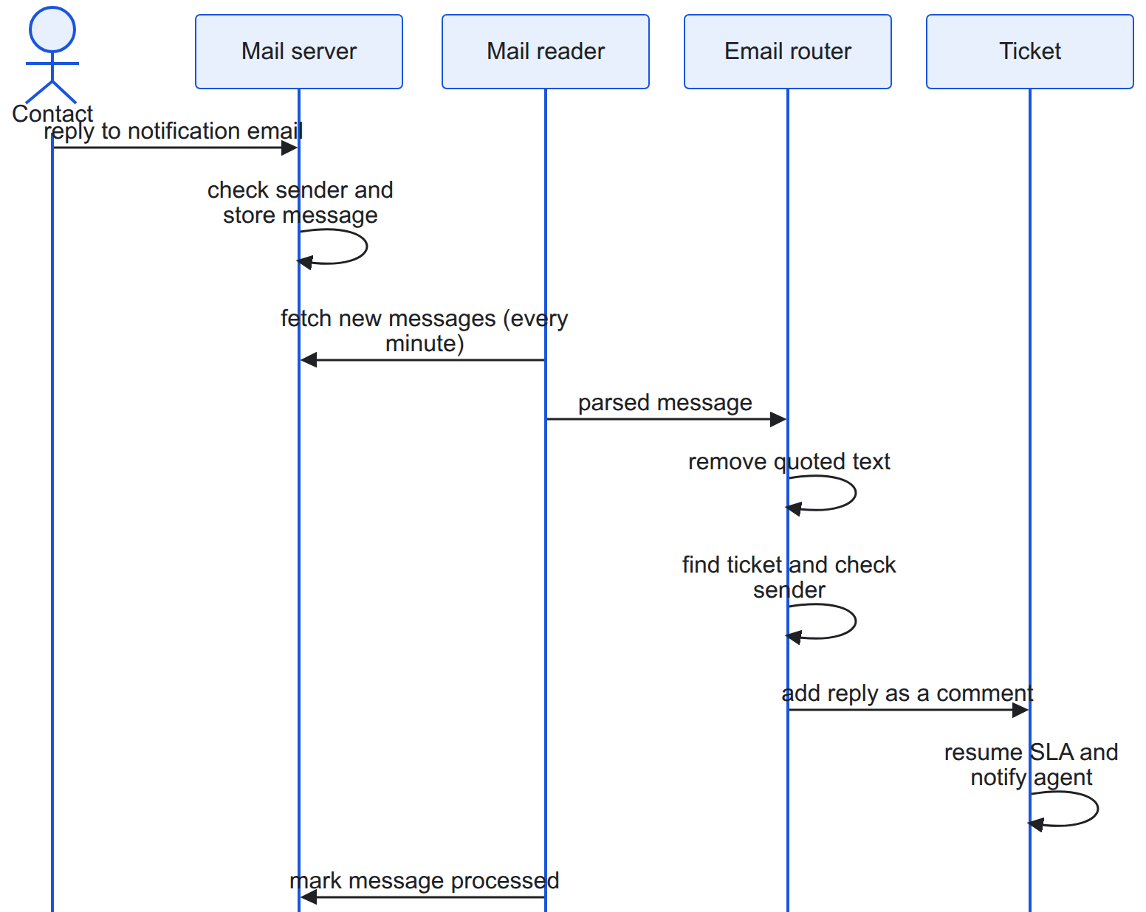
Figure 3.10: Sequence diagram of inbound email processing

3.1.5 Process Modelling using Activity Diagrams
Figure 3.11 shows agent assignment, including the case where no agent is eligible; Figure 3.12 shows duplicate detection; and Figure 3.13 shows how an inbound email becomes a comment, a new ticket or a rejection.
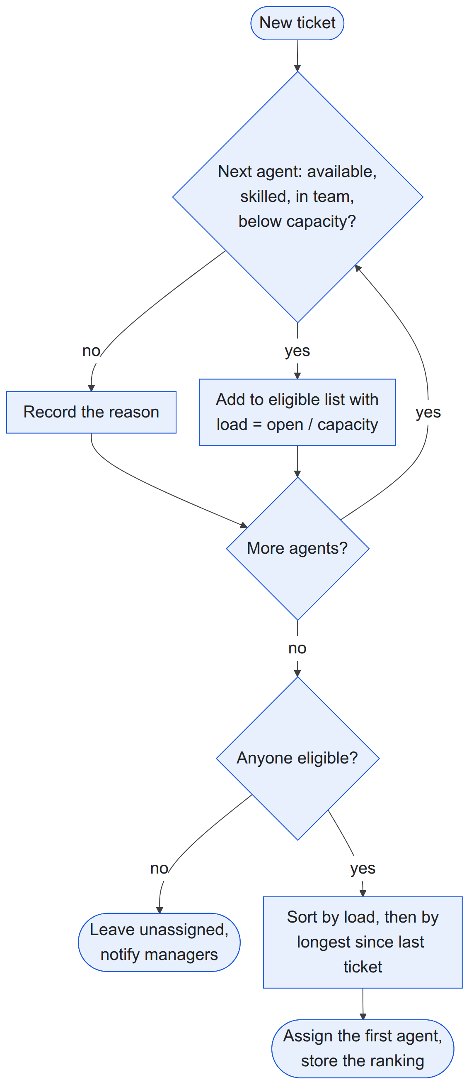
Figure 3.11: Activity diagram of agent assignment
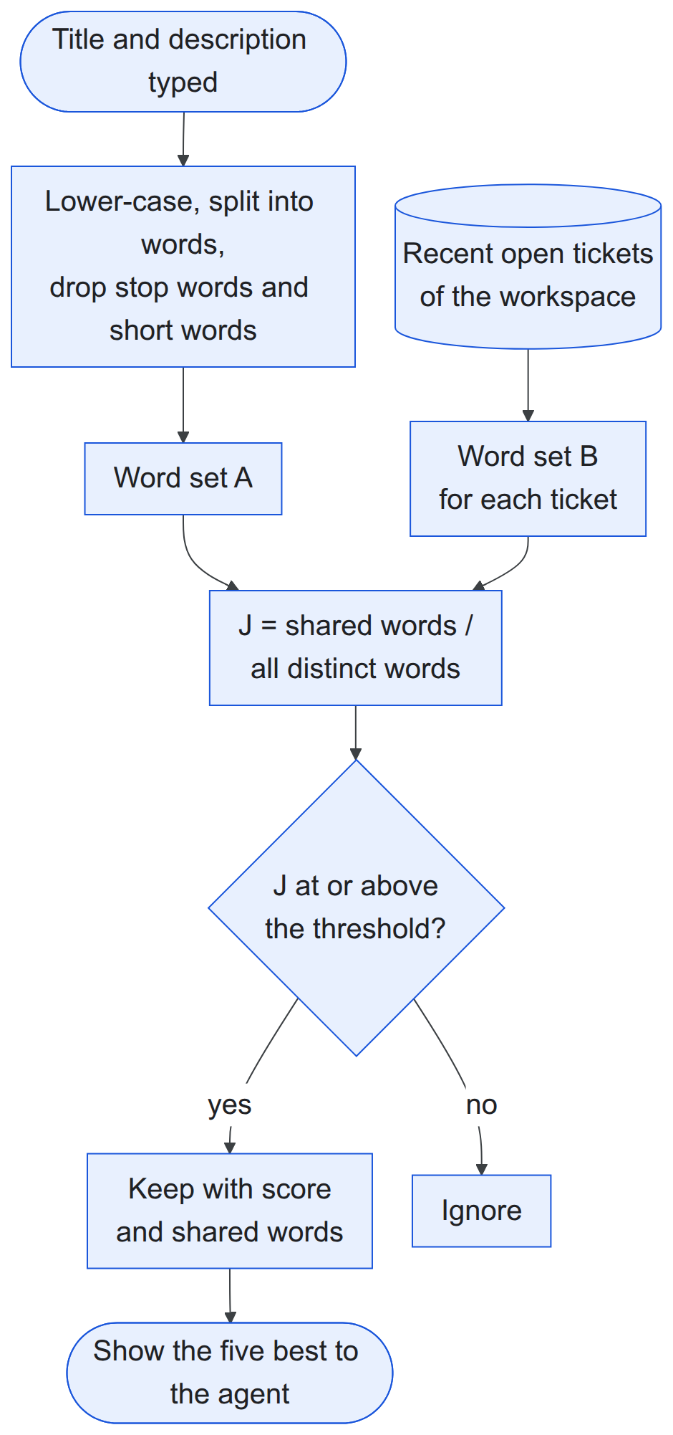
Figure 3.12: Activity diagram of duplicate detection
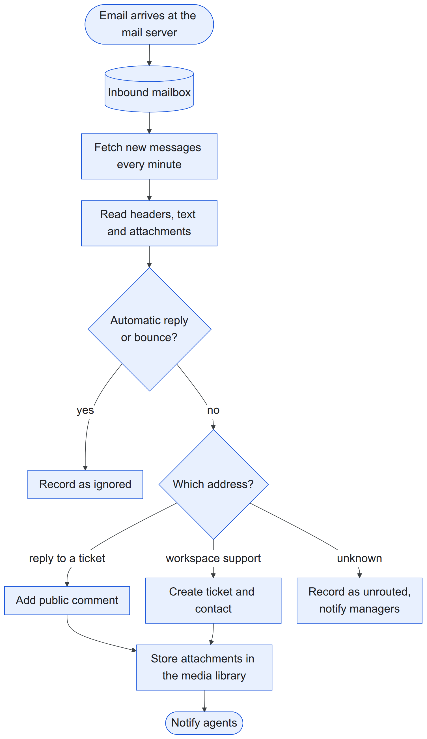
Figure 3.13: Activity diagram of inbound email routing

3.2 System Design

3.2.1 Refinement of Class, Object, State, Sequence and Activity Diagrams
The analysis classes were refined into modules. Each algorithm became an interface with a simple baseline implementation that receives plain input values and returns a result together with its explanation (Figure 3.14), so that a stronger algorithm can replace it without changing the rest of the system. Each write operation, such as creating, assigning or resolving a ticket, became a single step that runs inside one database transaction and announces what happened once it is saved. The ticket state diagram became a transition table, and the SLA state diagram a table of allowed timer transitions.
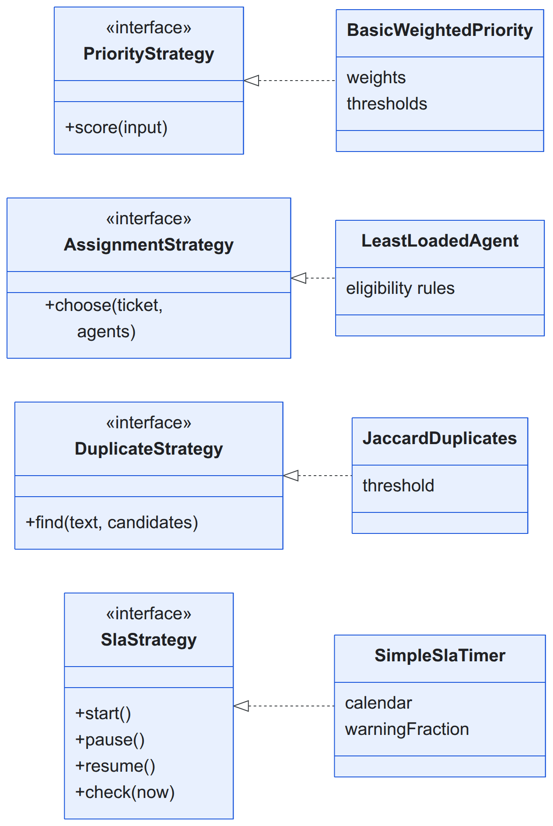
Figure 3.14: Algorithm interfaces and their baseline implementations
The database design (Figure 3.15) follows the refined classes. Every workspace-owned table carries the workspace identifier and a row-level security policy; ticket numbers are allocated per workspace; and text indexes support search and duplicate candidate retrieval.
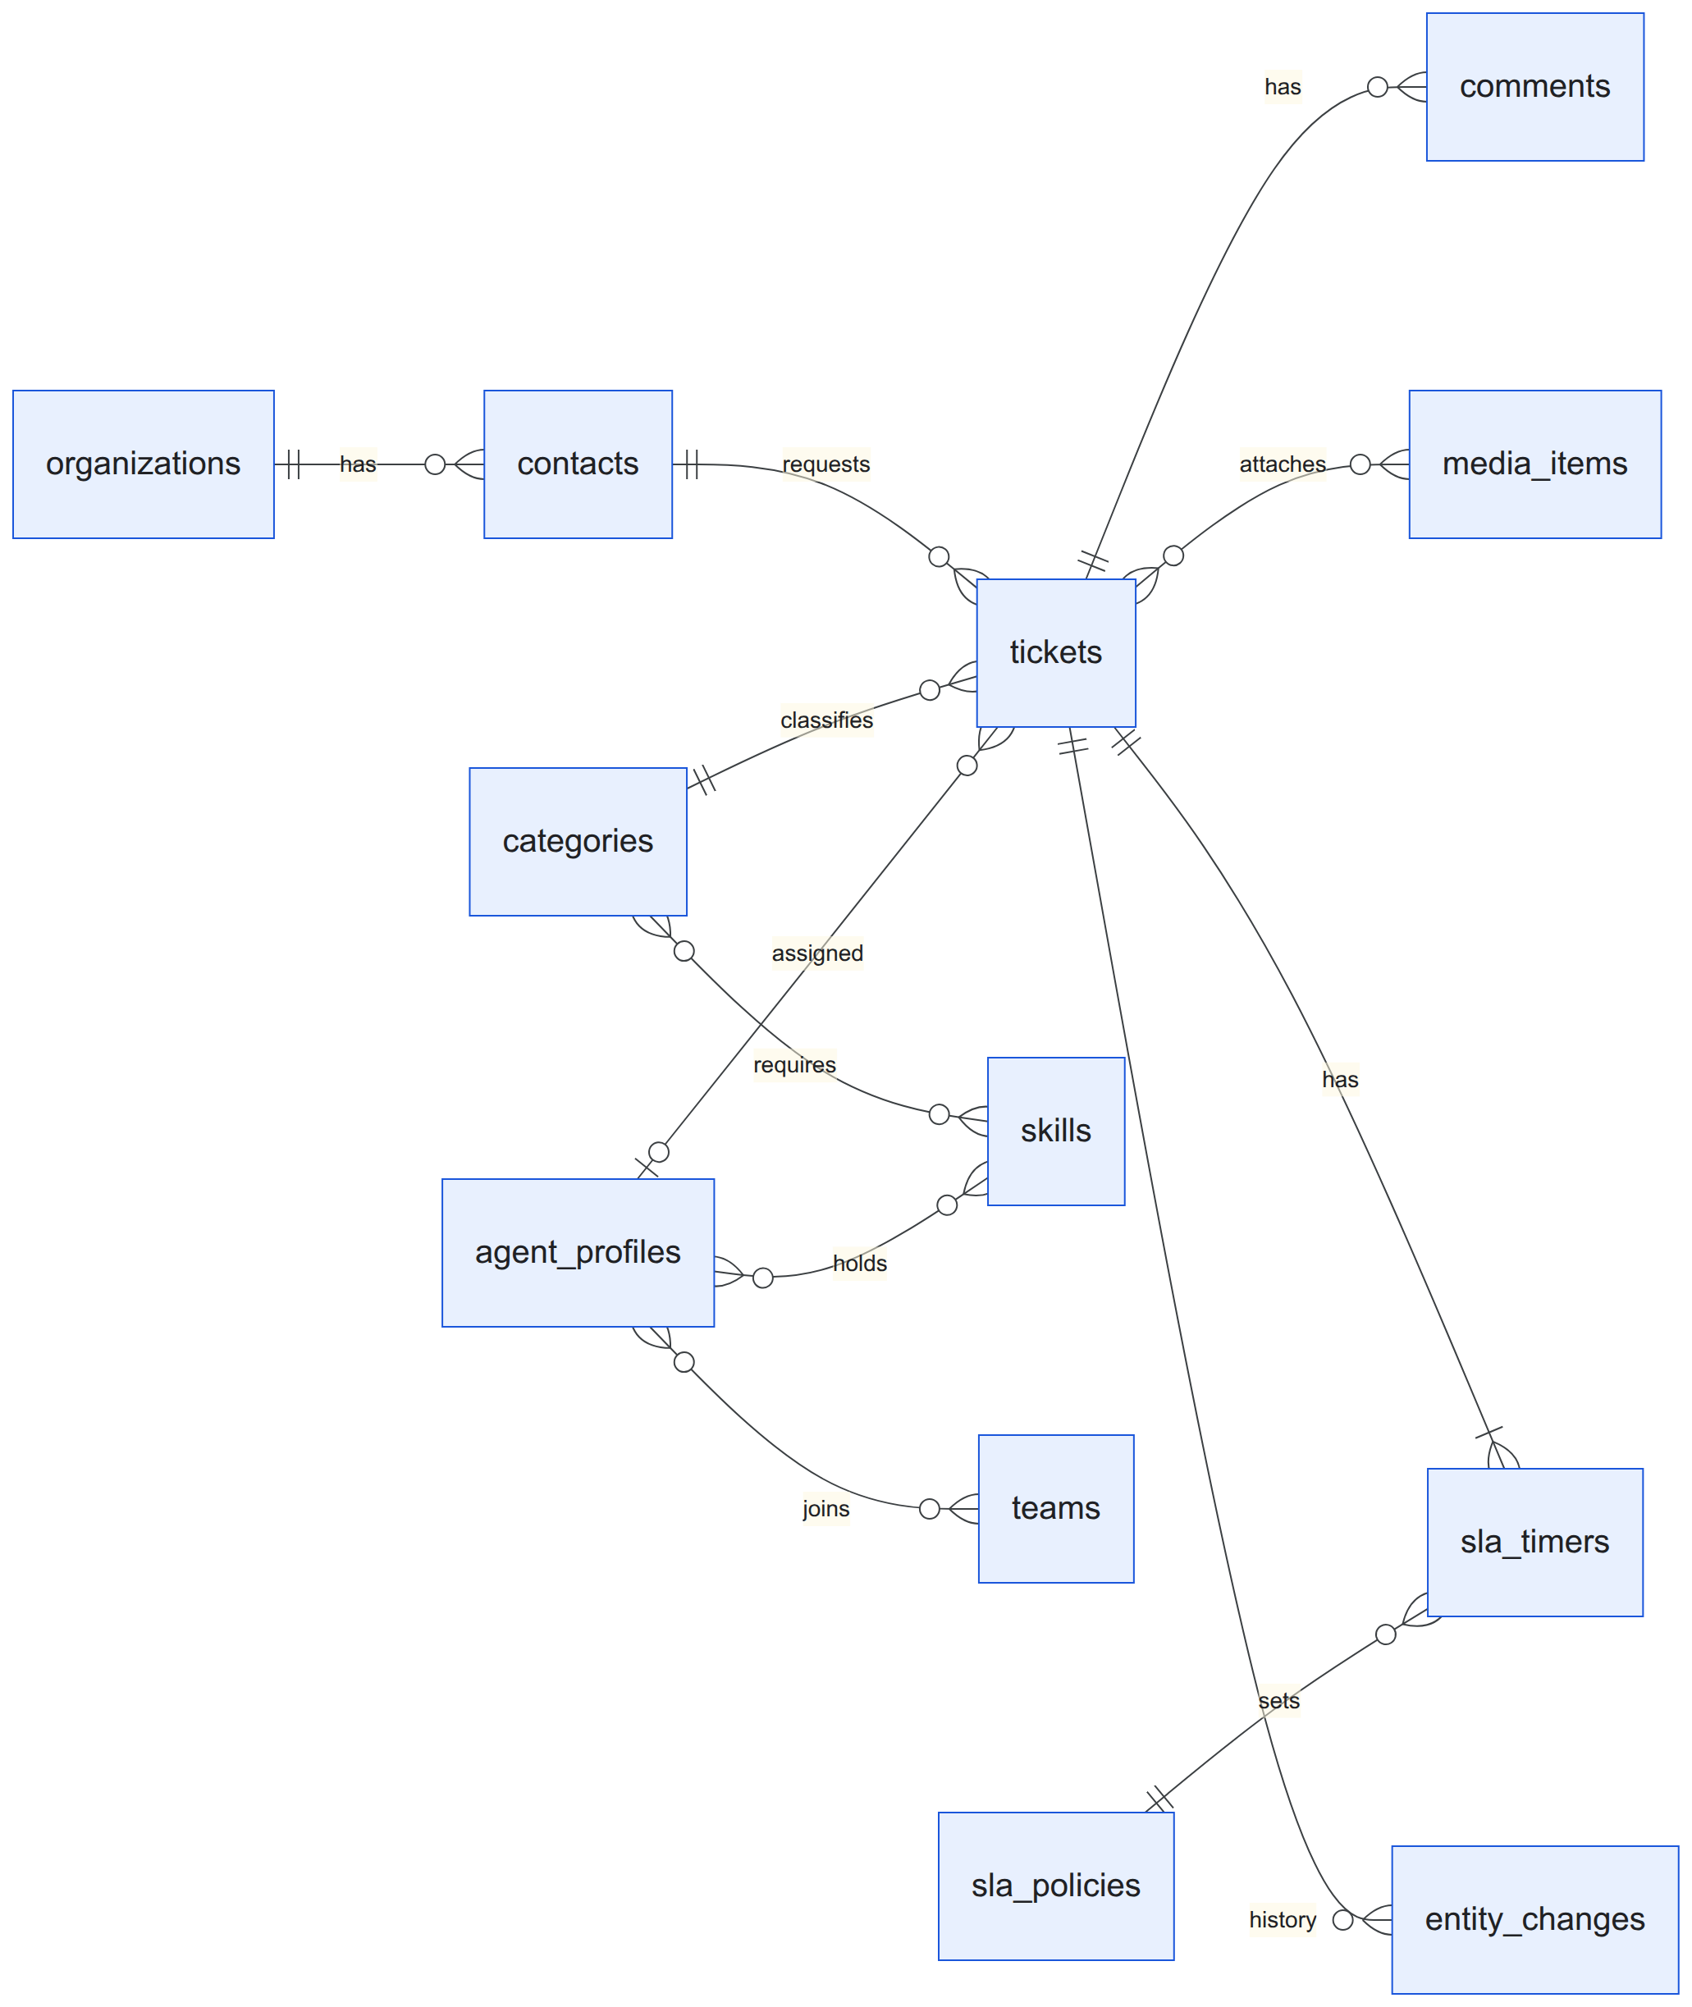
Figure 3.15: Entity relationship diagram

3.2.2 Component Diagrams
The backend is divided into modules (Figure 3.16): platform, tenancy, identity, contacts, agents, tickets, SLA, automation, media, mail, notifications, integrations, reporting and audit. Dependencies point in one direction, and notification, integration, reporting and audit components only react to events. The frontend is a single-page application divided into features on top of a shared design system.
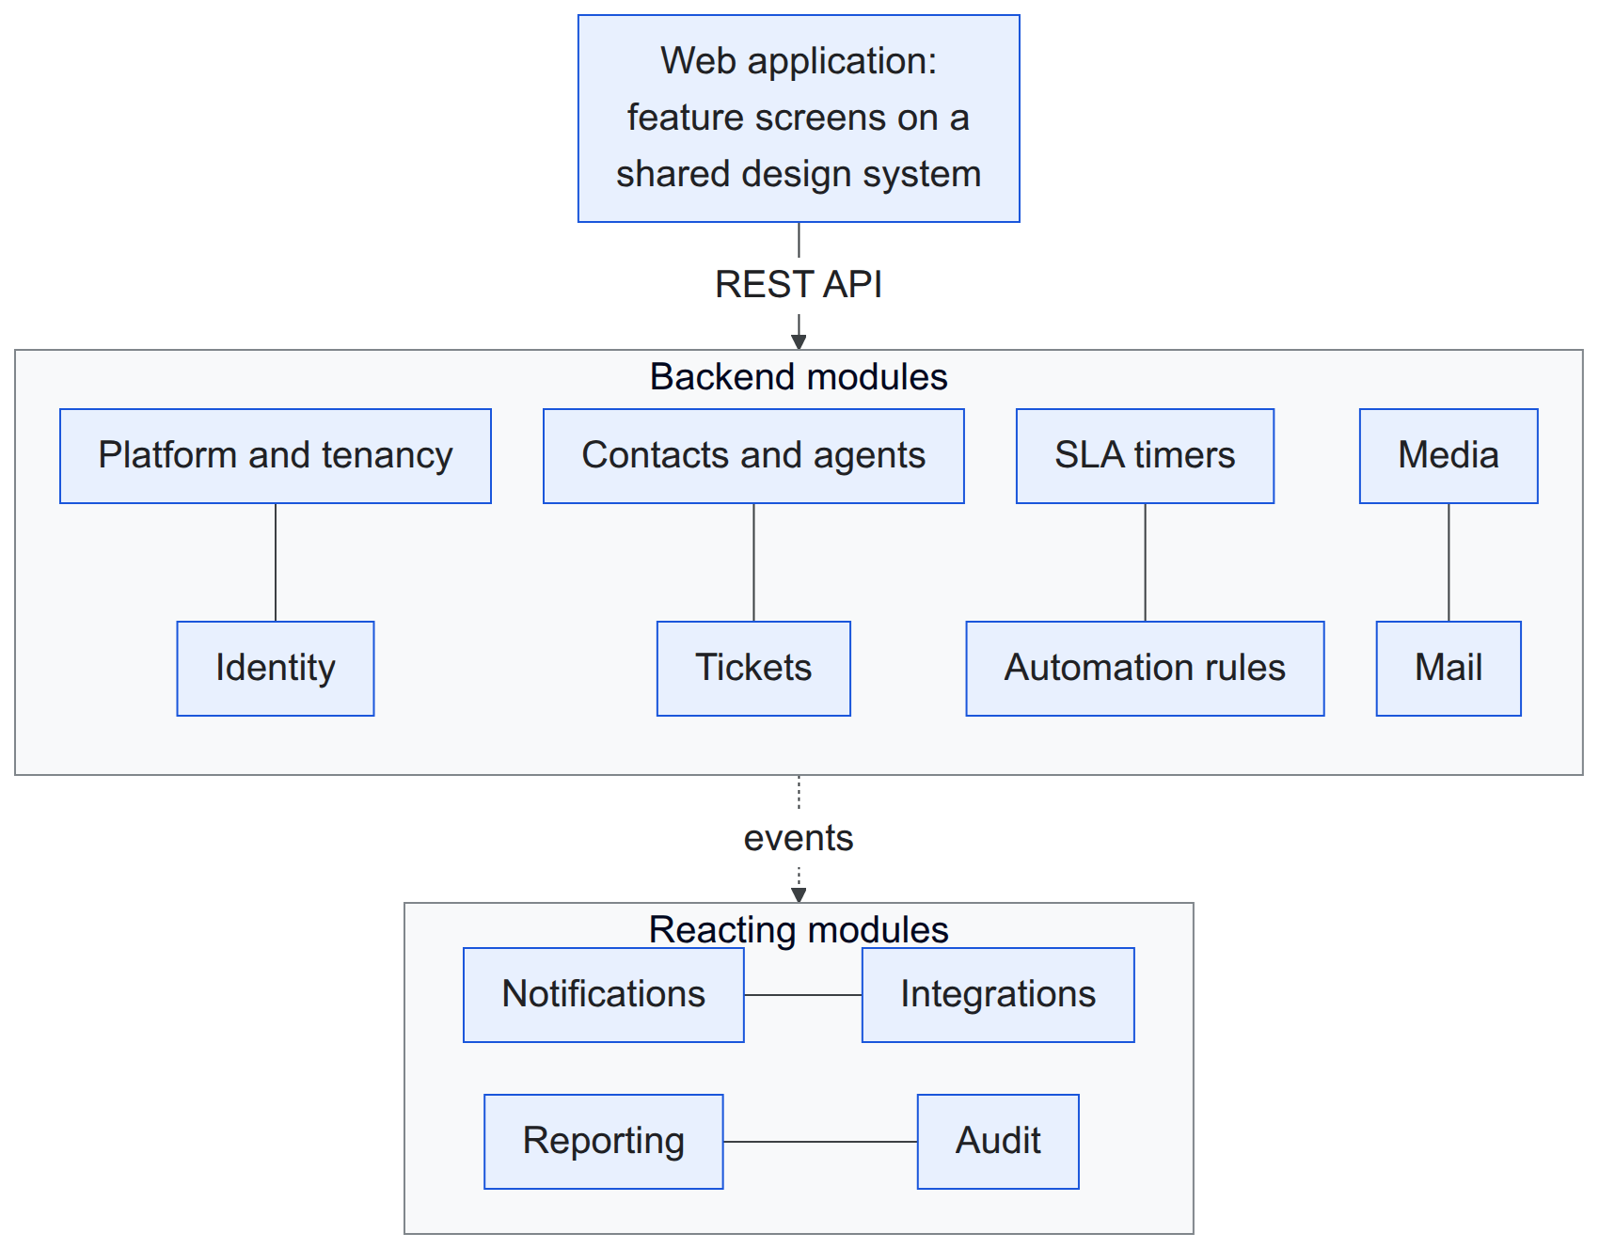
Figure 3.16: Component diagram

3.2.3 Deployment Diagrams
Figure 3.17 shows the deployment on one virtual machine. A reverse proxy terminates HTTPS for the application, API, administration, documentation, file and mail hosts and serves the web application; the PHP application, queue workers and scheduler run from one container image; PostgreSQL, Valkey, object storage and the mail server run as separate containers on an internal network. The same arrangement runs on a developer computer, an organisation's own server or any cloud virtual machine.
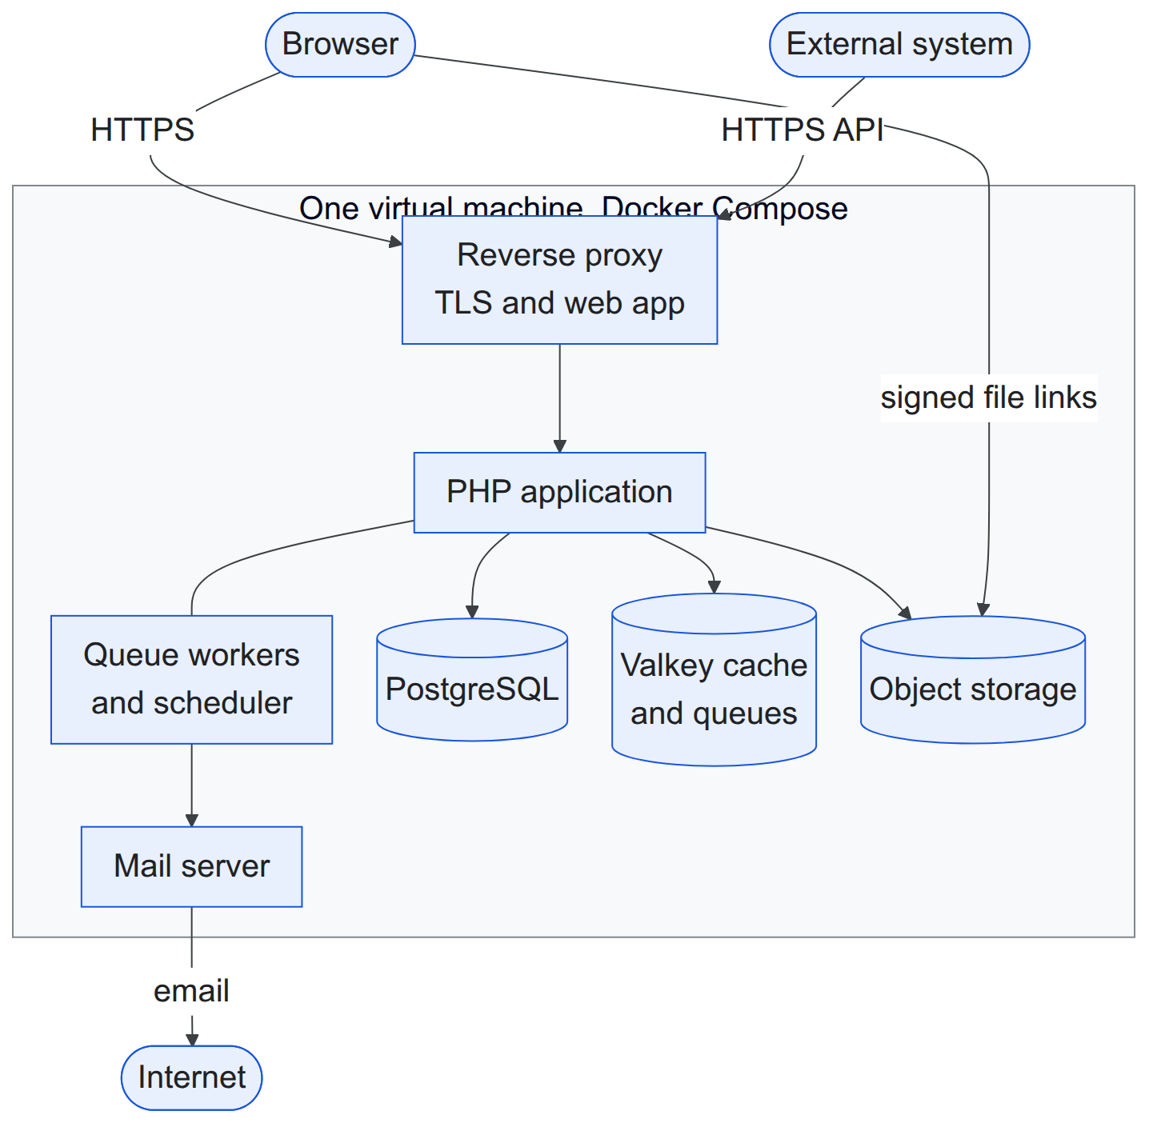
Figure 3.17: Deployment diagram

3.3 Algorithm Details
The four decision algorithms are deliberately simple baselines. Each is implemented behind an interface (strategy) so that it can be replaced by a stronger technique after this project without changing the rest of the system, and each decision stores the name and version of the strategy that made it.

3.3.1 Priority scoring: basic weighted priority
The priority score is a weighted sum of four values scaled to the range 0–1, a form of simple additive weighting [3]. Impact and urgency are the inputs commonly used by service-management tools [1]; customer tier reflects the importance of the requester; waiting time is an ageing term that raises tickets that have waited long.
Table 3.8: Inputs of the priority score
Input | Values | Scaled value | Weight
Impact | 1 (one user) to 4 (whole organisation) | (impact − 1) ÷ 3 | 0.40
Urgency | 1 (low) to 4 (immediate) | (urgency − 1) ÷ 3 | 0.35
Customer tier | standard, premium, enterprise | 0, 0.5, 1 | 0.15
Waiting time | hours since creation | min(1, hours ÷ 72) | 0.10

score = 100 × (0.40 × impact' + 0.35 × urgency' + 0.15 × tier' + 0.10 × age')
level = P1 if score ≥ 75, P2 if score ≥ 50, P3 if score ≥ 25, otherwise P4

function score(ticket, now):
total ← 0
for each (name, weight, scaled value) of the four inputs:
part ← 100 × weight × value
total ← total + part
record (name, value, weight, part) in the explanation
return total, level(total), explanation

The score is computed on creation, when an input changes and hourly for open tickets; a manager's manual priority always takes precedence. The cost is constant per ticket. For example, a ticket with impact 2, urgency 3 and a premium customer scores 13.3 + 23.3 + 7.5 + 3.3 = 47.5 (P3) after 24 hours and 54.2 (P2) after 72 hours, which shows the ageing effect.

3.3.2 Agent assignment: least-loaded eligible agent
The rule combines the least-loaded choice of load balancers with the skill filter used in contact centres [4]. An agent is eligible when available (and on shift if shifts are enforced), holding all skills the category requires, in the ticket's team if one is set, and below capacity. Among eligible agents the one with the smallest ratio of open tickets to capacity is chosen; ties go to the agent assigned least recently, which behaves like round robin.
function choose(ticket, agents):
eligible ← agents that pass every eligibility rule (others recorded with the failed rule)
if eligible is empty: leave the ticket unassigned and notify managers
sort eligible by (open ÷ capacity, last assignment time, id)
return the first agent and the sorted list as explanation

The cost is O(A log A) for A agents. For example, if Asha and Chen both have 3 of 10 tickets and Bikram has 2 of 5, Bikram's load (0.40) is higher than theirs (0.30); Chen, assigned earlier than Asha, receives the ticket.

3.3.3 Duplicate detection: Jaccard word overlap
Following the first duplicate-report detectors, which compared the words of a new report with existing reports [7], each ticket is reduced to a set of words: the title and description are lower-cased, split on characters other than letters, digits and hyphens, and stripped of a fixed list of 117 stop words and of words shorter than three characters; hyphens are kept so that error codes such as err-401 survive, and any Unicode letter counts, so Devanagari words stay whole. Two sets are compared with the Jaccard similarity [5]:
J(A, B) = |A ∩ B| ÷ |A ∪ B|

function find(ticket, candidates): // same tenant, last 30 days, not closed, at most 50
A ← words(ticket)
for c in candidates:
B ← words(c)
if |A ∩ B| ÷ |A ∪ B| ≥ 0.35: keep (c, score, A ∩ B)
return the five highest scores

For "Cannot login after password reset" against "Login fails after resetting password", the sets share five of ten distinct words (J = 0.50) and the older ticket is suggested; an unrelated invoice ticket scores 0.15 and is ignored. The comparison costs O(K × W) for K candidates of about W words. The method is transparent but misses paraphrases and word forms, which a stronger replacement would address.

3.3.4 SLA evaluation: simple SLA timer
Each ticket has a first-response timer and a resolution timer, each a small state machine [8] with the states running, paused, warning, breached, met and cancelled. Deadlines are computed through a calendar that counts either all hours or only the organisation's working hours.
start: due ← cal.add(now, target); warn ← cal.add(now, f × target) // f: the policy's warning fraction, default 0.75
enter pending: paused_at ← now
leave pending: d ← cal.elapsed(paused_at, now); due ← cal.add(due, d); warn ← cal.add(warn, d)
priority change: due ← cal.add(started_at, new target + paused time)
goal reached: state ← met (first public reply, or ticket resolved)
every minute: running and now ≥ warn → warning, notify assignee (once)
not met and now ≥ due → breached, notify assignee and managers (once)

For a P2 ticket with an eight-hour resolution target created at 09:00 and waiting for the customer from 10:00 to 12:00, the warning moves from 15:00 to 17:00 and the deadline from 17:00 to 19:00. With office hours of 10:00–17:00, an eight-hour target starting on Thursday at 15:00 ends on Friday at 16:00. The minute check reads only due timers through an index and records when each notification was sent, so running it twice has no additional effect.

3.3.5 History reconstruction and time analytics
A database trigger records each insert, update and delete on reportable tables as a change row containing only the attributes that changed, with their old and new values, the actor and the time. The state of a record at a past instant t is rebuilt by starting from the current row and undoing, newest first, every change made after t:
function asOf(entity, t):
changes ← changes of entity with occurred_at > t, newest first
state ← current row (or the last values stored in its delete change)
for c in changes:
if c is the creation: return "did not exist at t"
for (attribute, old, new) in c: state[attribute] ← old
return state

For analysis over time, each ticket's ordered events are swept into non-overlapping intervals of constant status, assignee, team and priority:
function intervals(events, calendar, now):
state ← initial state; start ← creation time; result ← []
for e in events ordered by time:
next ← apply(state, e)
if next ≠ state:
result.append(state, start, e.time, calendar.elapsed(start, e.time))
state, start ← next, e.time
result.append(state, start, open, calendar.elapsed(start, now))
return result

Time in a status is the sum of the matching intervals; the backlog at an instant is the number of unresolved intervals containing it; an agent's workload over time is the priority-weighted count of that agent's intervals. Reconstruction costs O(k) for k later changes and interval building O(e) for e events of a ticket. Daily snapshots are computed from the intervals after midnight in the organisation's time zone, and every derived table can be rebuilt from the recorded history and checked for drift.

Chapter 4: Implementation and Testing

4.1 Implementation

4.1.1 Tools Used
Table 4.1 lists the tools and technologies used to build and test the system.
Table 4.1: Tools and technologies
Category | Tool | Purpose
Backend | PHP 8.5, Laravel 13 | API, background jobs, scheduling, mail, validation
Frontend | React 19, TypeScript, Vite | single-page web application
Frontend libraries | TanStack Router, Query, Table and Form; Zod | routing, server data, tables, forms, validation
User interface | Tailwind CSS, shadcn/ui, Lucide icons, Recharts | design system, components, icons, charts
Database | PostgreSQL 18 | relational data, text search, row-level security
Cache and queues | Valkey, Laravel Horizon | cache, background job queues and their monitoring
Files and email | RustFS object storage, Stalwart mail server | file storage, sending and receiving email
API documentation | Scramble | interactive API reference
Infrastructure | Docker Compose, Caddy, Ansible, OpenTofu | containers, HTTPS proxy, server setup, cloud provisioning
Diagrams | Mermaid | use case, class, object, state, sequence, activity, component and deployment diagrams
Testing | Google Chrome, Mozilla Firefox | manual testing of every screen and workflow
Editor and version control | Visual Studio Code, Git, GitHub | development and source control

4.1.2 Implementation Details of Modules
The backend is divided into modules, each with its own routes, data models, business rules and database tables, and a module may depend only on the modules below it. Every change of data runs as one step inside a database transaction, so a failure leaves nothing half saved. The four algorithms are written as plain functions behind interfaces, so the rest of the system never depends on a particular algorithm.
Tenancy and platform. After sign-in, the workspace of every request is taken from the user's session or from the API client that made the request, never from the web address. Requests from users of another workspace and requests to a suspended workspace are refused. The database then limits every query to the current workspace through row-level security. A new workspace is created with default roles, categories, an SLA policy, a calendar and settings. The platform administrators have their own sign-in, separate from the workspaces.
Identity. Users sign in with email and password, accept invitations and reset forgotten passwords by email. Roles are sets of permissions within a workspace, such as "assign tickets" or "manage SLA policies", and every action checks the permission it needs.
Tickets. Creating a ticket gives it the next number of its workspace and, in the same transaction, computes its priority, starts its SLA timers, looks for duplicates and assigns an agent. Status changes are allowed only along the lifecycle of Figure 3.6. Replies, internal notes and attachments are stored with the ticket, and the ticket list supports filtering, sorting, text search and paging.
Automation. The priority, assignment and duplicate algorithms each return their decision together with an explanation, which is stored and shown to agents in words. A manager may override a priority or an assignment with a recorded reason.
SLA. Each ticket has a first-response timer and a resolution timer that start, pause, resume, finish and recompute as the ticket changes. Deadlines are counted on a business calendar with working hours and holidays, and a scheduled task checks due timers every minute and sends warning and breach notifications.
Media and mail. Files are uploaded directly to object storage through short-lived signed links, checked for size and type, and given thumbnails. Notification emails carry a reply address that identifies the ticket; incoming emails are read from the mail server every minute, cleaned of quoted text and added as a comment or turned into a new ticket.
Reporting. A database trigger records every change to the main tables with the old and new values. From these records the system can show any record as it was at a past moment, build the periods a ticket spent in each state, keep daily summaries, and run a catalogue of reports that can be filtered, drilled into and exported as CSV or XLSX files.
Integrations. External systems obtain an access token with their client identifier and secret and can use only the permissions granted to them. Webhook messages are signed with a shared secret so that receivers can verify them, and failed deliveries are retried.
Frontend. The web application is organised by feature on a shared design system with light and dark themes. Lists keep their filters in the address bar, forms warn about unsaved changes, and every automatic decision is shown in words with its explanation. Figures 4.1 to 4.3 show the main screens; more screens are in the appendix.
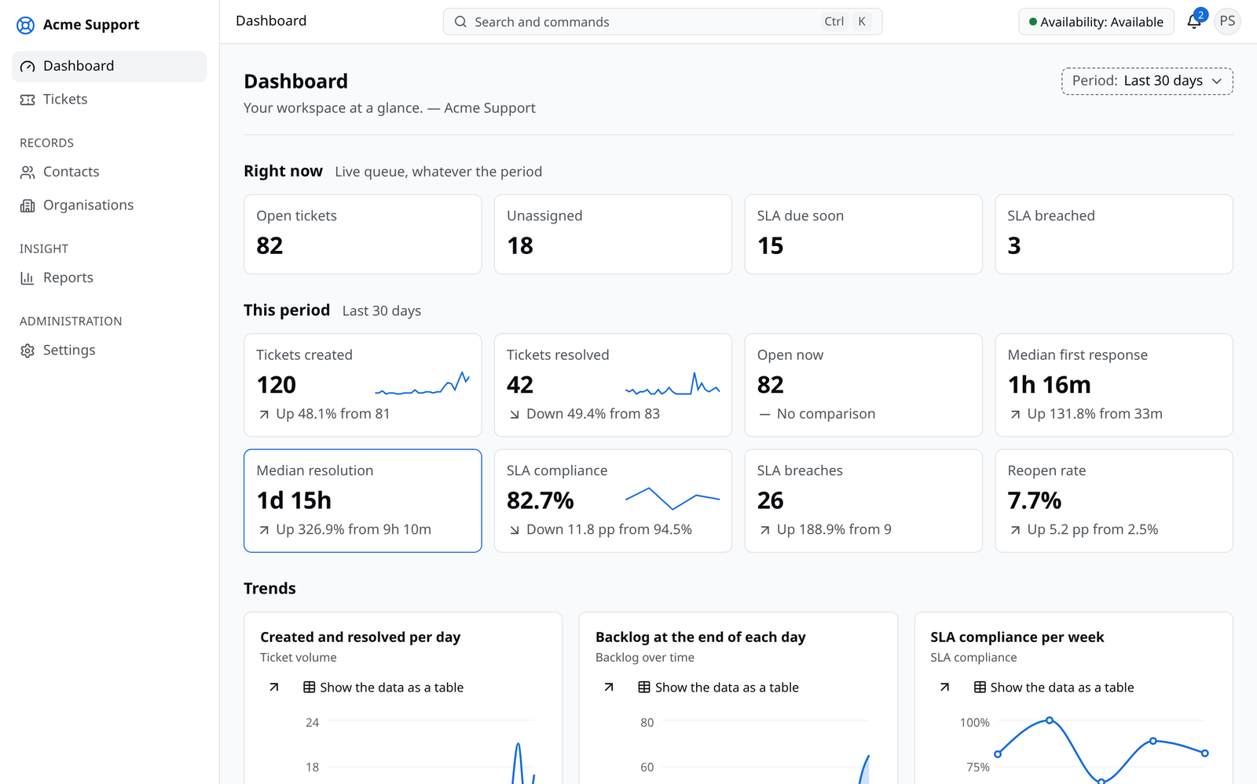
Figure 4.1: Management dashboard
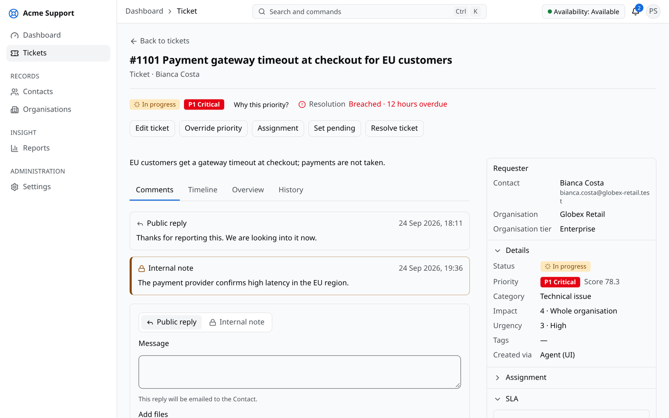
Figure 4.2: Ticket screen with conversation, SLA timers and details
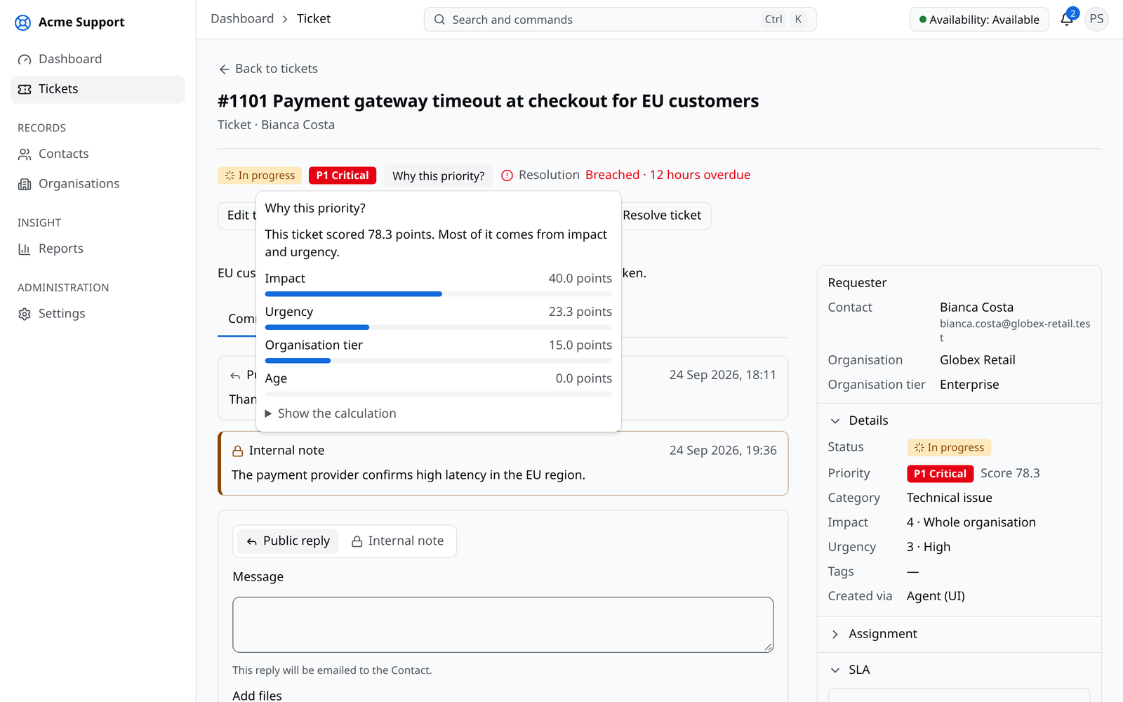
Figure 4.3: Priority explanation shown on a ticket

4.2 Testing
The system was tested manually in the testing phase. Each function was first tested on its own (unit testing), and complete workflows were then tested through the web application on the development machine and on the deployed server (system testing). Every test was run in both the light and the dark theme in Google Chrome, and tests were repeated after each correction.

4.2.1 Test Cases for Unit Testing
Table 4.2: Unit test cases
ID | Test case | Input | Expected output | Actual output | Result
UT-01 | Sign in with correct details | registered email and password | dashboard opens | dashboard opened | Pass
UT-02 | Sign in with a wrong password | registered email, wrong password | error message, no sign-in | "The workspace, email or password is incorrect." shown | Pass
UT-03 | Create a contact | name and email | contact saved and listed | contact listed | Pass
UT-04 | Create a contact without an email | name only | validation message | "Enter an email address." shown | Pass
UT-05 | Edit an organisation | new customer tier | tier updated | tier updated | Pass
UT-06 | Create a category | name and required skill | category saved | category listed | Pass
UT-07 | Delete a category in use | category with tickets | deletion refused | category kept, error shown | Pass
UT-08 | Create a ticket | title, description, contact, category | ticket saved with a number | ticket #1043 created | Pass
UT-09 | Create a ticket without a title | empty title | validation message | "Enter a title." shown | Pass
UT-10 | Add a public reply | reply text | reply shown in the conversation | reply shown | Pass
UT-11 | Add an internal note | note text | note shown only to agents | note marked internal | Pass
UT-12 | Attach a file | PNG image of 1 MB | file attached with a thumbnail | thumbnail shown | Pass
UT-13 | Invite a user | email and role | invitation email sent | invitation received | Pass
UT-14 | Create a team | name and members | team saved | team listed | Pass
UT-15 | Create an SLA policy | targets per priority | policy saved | policy listed | Pass

4.2.2 Test Cases for System Testing
Table 4.3: System test cases
ID | Scenario | Steps | Expected result | Result
ST-01 | New user | owner invites a user; user accepts and signs in | user works with the invited role | Pass
ST-02 | Ticket workflow | agent creates a ticket, replies, sets it pending, resolves and closes it | status changes shown; ticket closed | Pass
ST-03 | Automatic handling | create a ticket in a category with eligible agents | priority, SLA timers and an assigned agent shown with explanations | Pass
ST-04 | Duplicate suggestion | type a ticket similar to an existing one | existing ticket suggested before saving | Pass
ST-05 | Email reply | contact replies to a notification email | reply appears on the ticket | Pass
ST-06 | Workspace separation | user of workspace B opens a ticket link of workspace A | "not found" shown | Pass
ST-07 | Report export | open a report and export CSV | file downloaded with the listed rows | Pass
ST-08 | Deployment | open the live site and sign in | site served over HTTPS with the demonstration workspace | Pass

4.3 Result Analysis
All unit and system test cases passed. The main workflows worked end to end both on the development machine and on the deployed server, and the screens behaved the same in both themes.
The four algorithms were checked with worked examples calculated by hand. The priority level shown on each test ticket matched the hand calculation, and its explanation listed the share of each factor. New tickets went to the eligible agent with the fewest open tickets for their capacity, and agents without the required skill, off shift or at capacity were listed with the reason. Tickets typed with the same key words as an existing ticket were suggested as duplicates with the shared words shown, while unrelated tickets were not. SLA timers paused while a ticket waited for the customer, and the warning and breach notifications were sent at the expected times on working hours.
Reports showed the same numbers as the ticket list, and a ticket viewed at a past moment matched its earlier state. The limitations found were that duplicates written in completely different words are not detected, and that the behaviour under heavy load was not tested.

Chapter 5: Conclusion and Future Recommendations

5.1 Conclusion
This project built Smart Helpdesk, a multi-tenant support ticket management system in which one installation serves many organisations while keeping each organisation's data separate in the application and in the database. The system covers the full ticket workflow, a media library, email in both directions, a dashboard, reports with record history, a REST API and signed webhooks, and it runs on a cloud virtual machine or an organisation's own server.
All objectives of Section 1.3 were met. Four simple algorithms make the key decisions: a weighted priority score, least-loaded agent assignment, word-based duplicate detection and SLA timers on working hours, and each decision is explained to the agent. Manual unit and system testing confirmed that the features and the algorithms behave as specified. The main lessons were that explanations make automatic decisions easier to trust, that time handling is the hardest part of SLA management, and that data separation between organisations must be checked on every screen and API.

5.2 Future Recommendations
- Load testing and monitoring of the ticket list, ticket creation and dashboard under many users before wider use.
- Stronger algorithms, such as a priority score that considers the SLA deadline and duplicate detection that recognises different words with the same meaning.
- A customer portal where contacts follow their tickets, with live chat and messaging channels.
- Weights learned from history, fitting the priority and assignment settings from resolved tickets.
- Mobile layouts so that agents can work tickets from their phones.

References
[1] Atlassian, "How impact and urgency are used to calculate priority," Jira Service Management Cloud Documentation. [Online]. Available: https://support.atlassian.com/jira-service-management-cloud/docs/how-impact-and-urgency-are-used-to-calculate-priority/
[2] AXELOS, Incident Management: ITIL 4 Practice Guide. London, U.K.: AXELOS Limited, 2020.
[3] "Simple additive weighting: a metamodel for multiple criteria decision analysis methods," Expert Systems with Applications, 2016, doi: 10.1016/j.eswa.2016.01.042.
[4] N. Gans, G. Koole, and A. Mandelbaum, "Telephone call centers: Tutorial, review, and research prospects," Manufacturing & Service Operations Management, vol. 5, no. 2, pp. 79–141, 2003.
[5] C. D. Manning, P. Raghavan, and H. Schütze, Introduction to Information Retrieval. Cambridge, U.K.: Cambridge University Press, 2008.
[6] PostgreSQL Global Development Group, "Row security policies," PostgreSQL 18 Documentation. [Online]. Available: https://www.postgresql.org/docs/current/ddl-rowsecurity.html
[7] P. Runeson, M. Alexandersson, and O. Nyholm, "Detection of duplicate defect reports using natural language processing," in Proc. 29th Int. Conf. Software Engineering, 2007, pp. 499–510.
[8] D. Harel, "Statecharts: A visual formalism for complex systems," Science of Computer Programming, vol. 8, no. 3, pp. 231–274, 1987.

Appendices

Appendix A: Screenshots
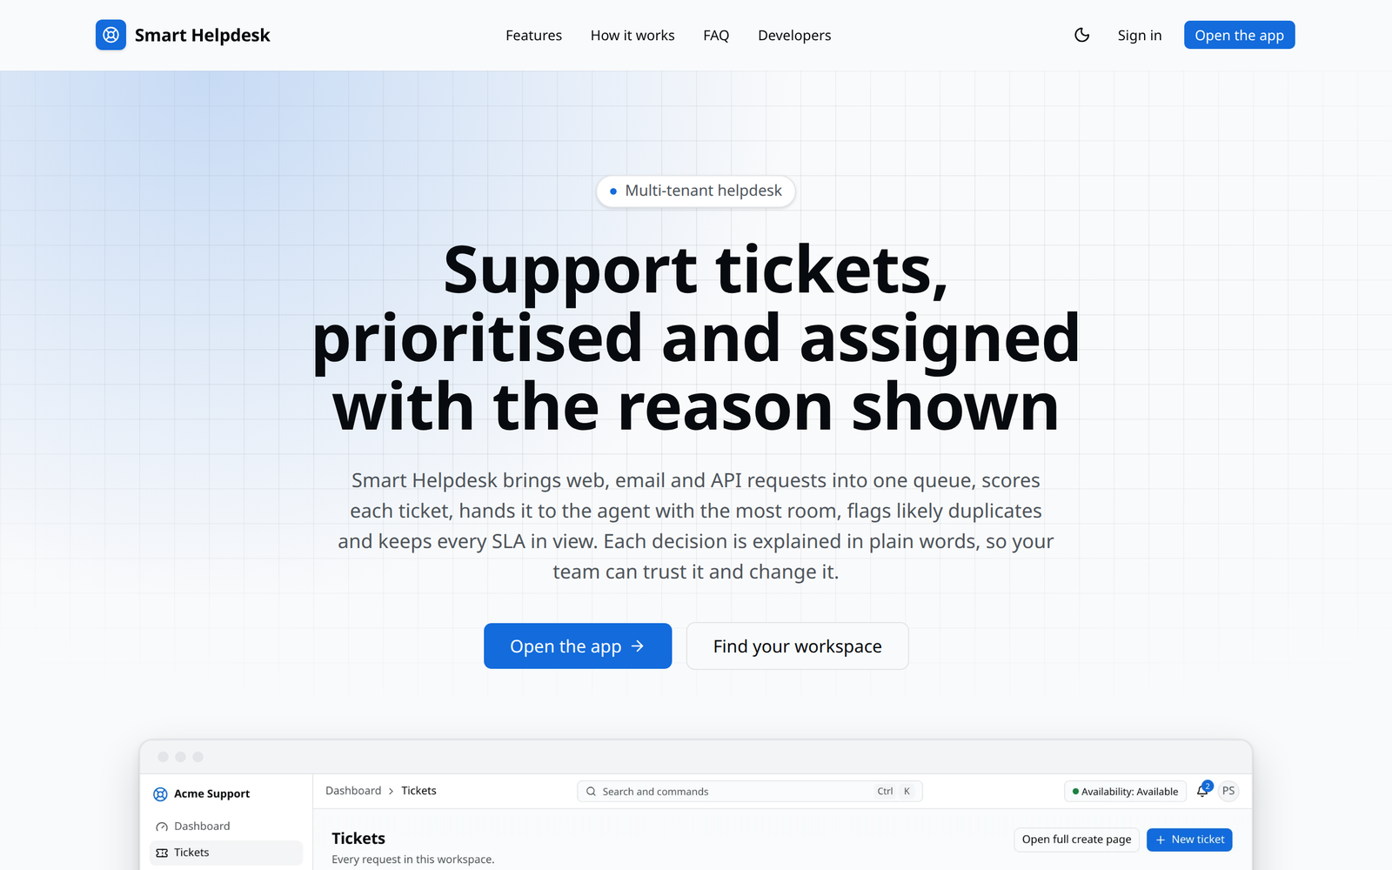
Figure A.1: Landing page
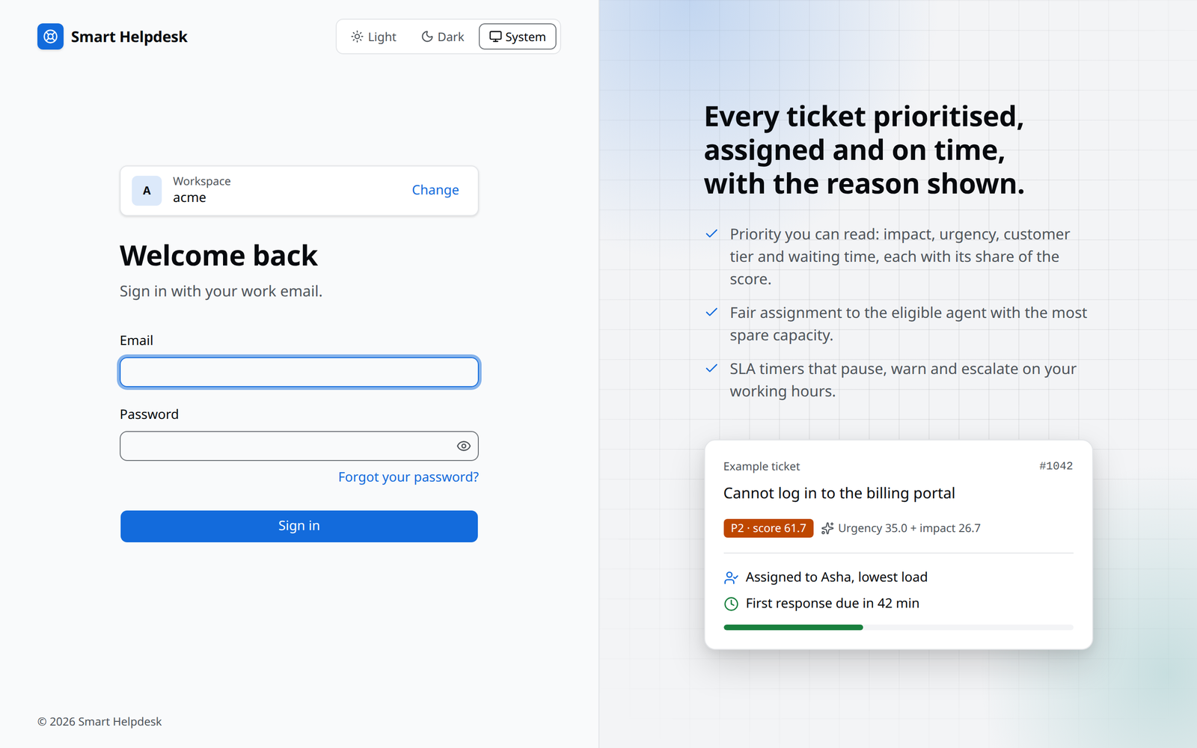
Figure A.2: Sign-in page of a workspace
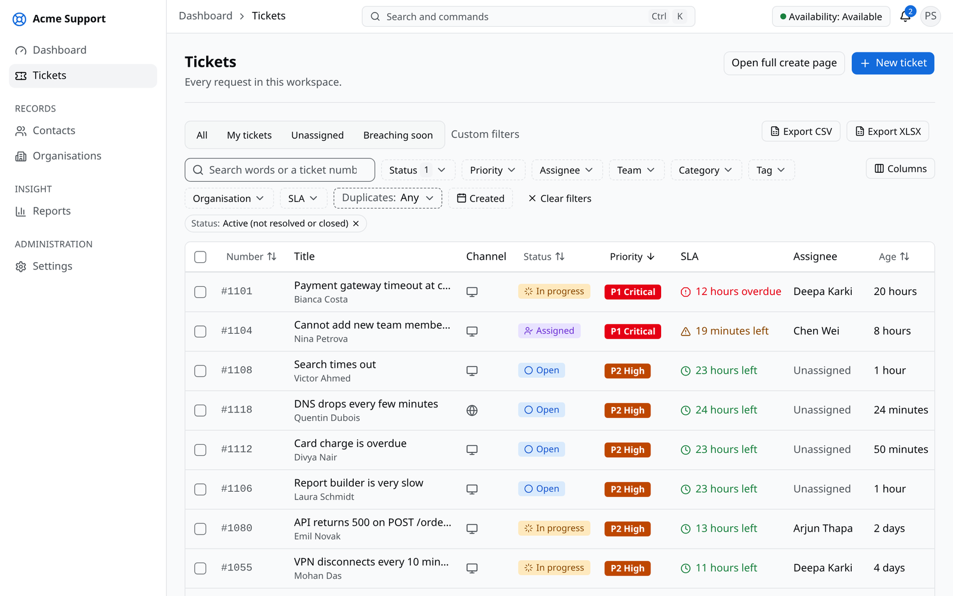
Figure A.3: Ticket list with filters
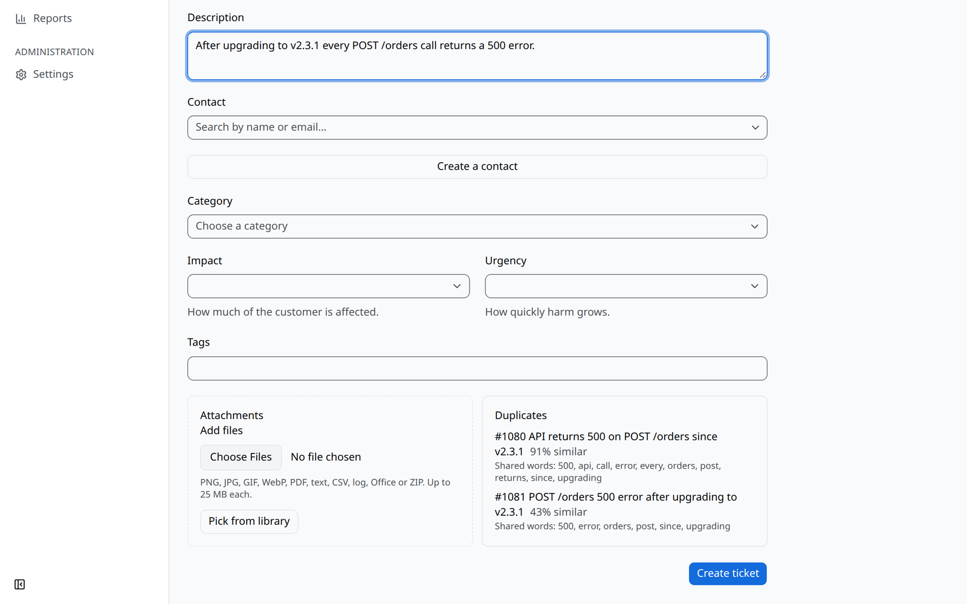
Figure A.4: New ticket with duplicate suggestions
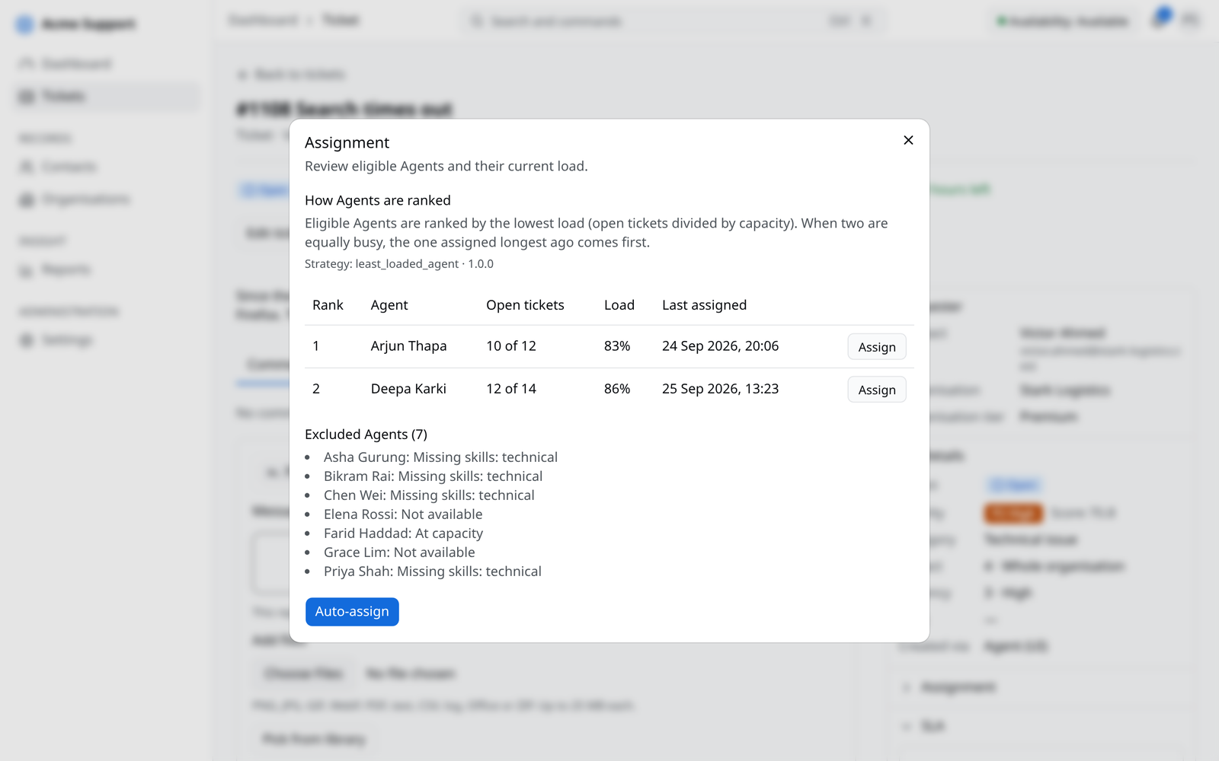
Figure A.5: Assignment ranking with excluded agents
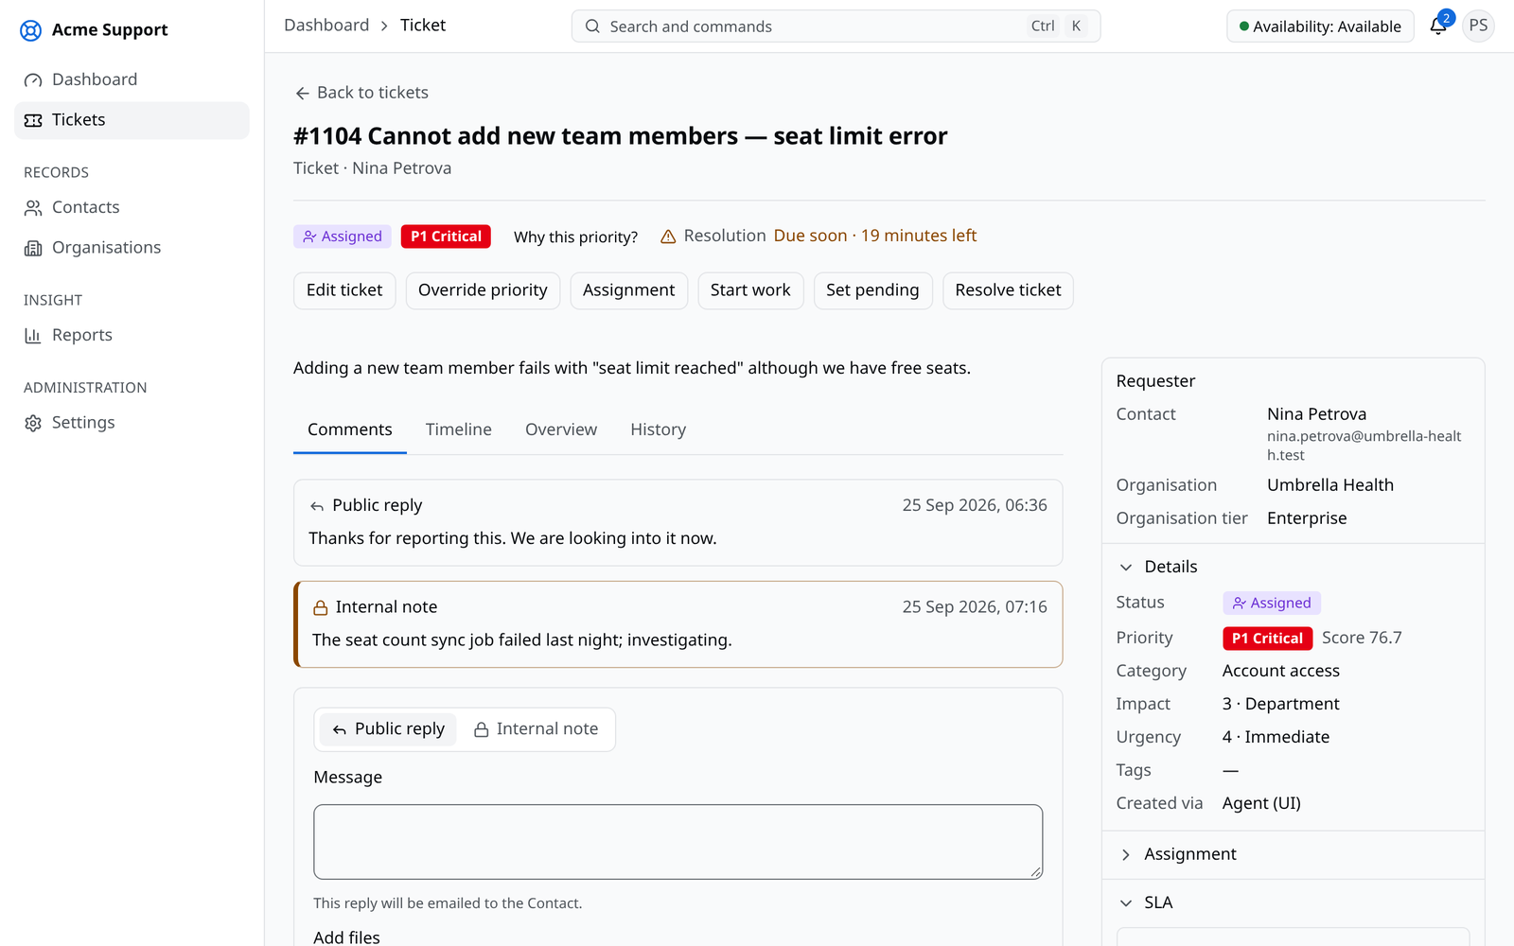
Figure A.6: Ticket close to its SLA deadline
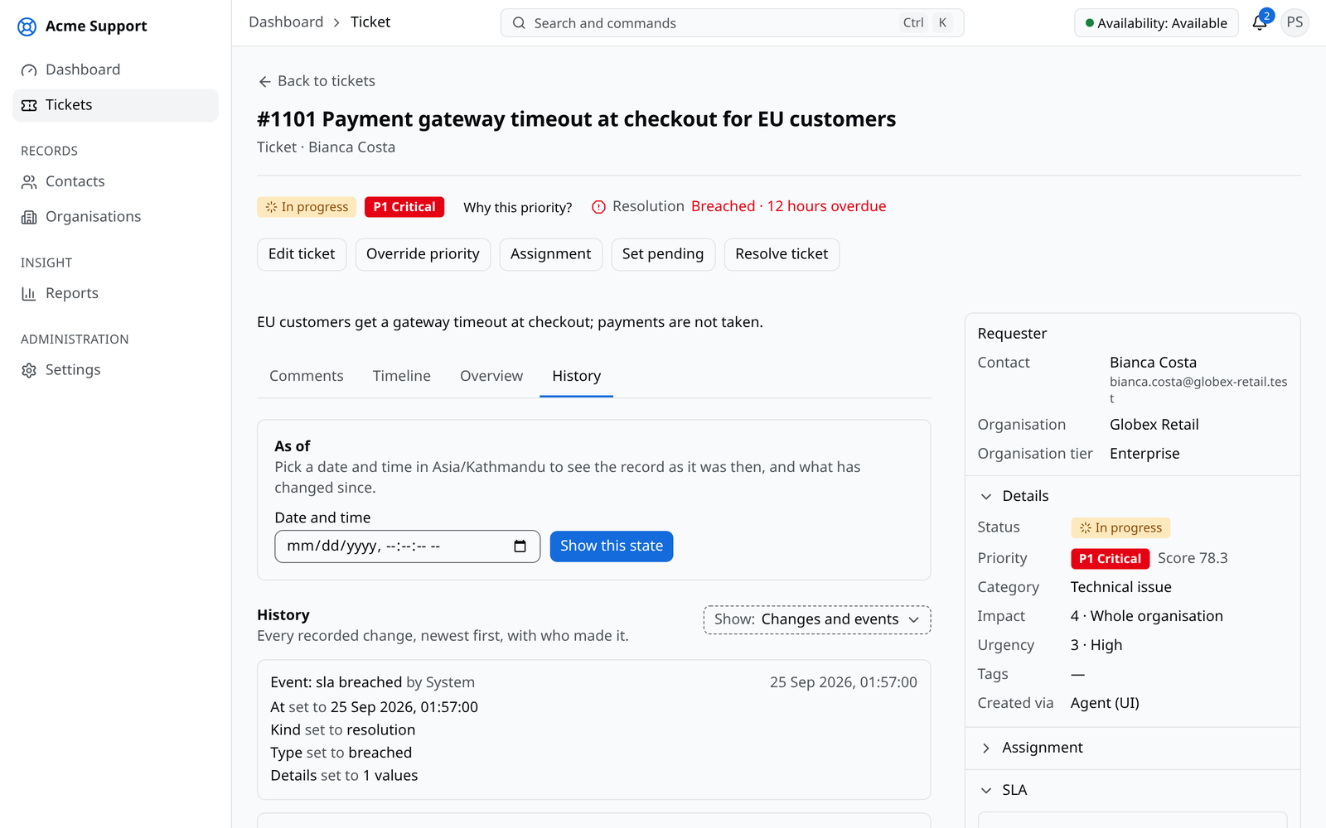
Figure A.7: Ticket history with the point-in-time view
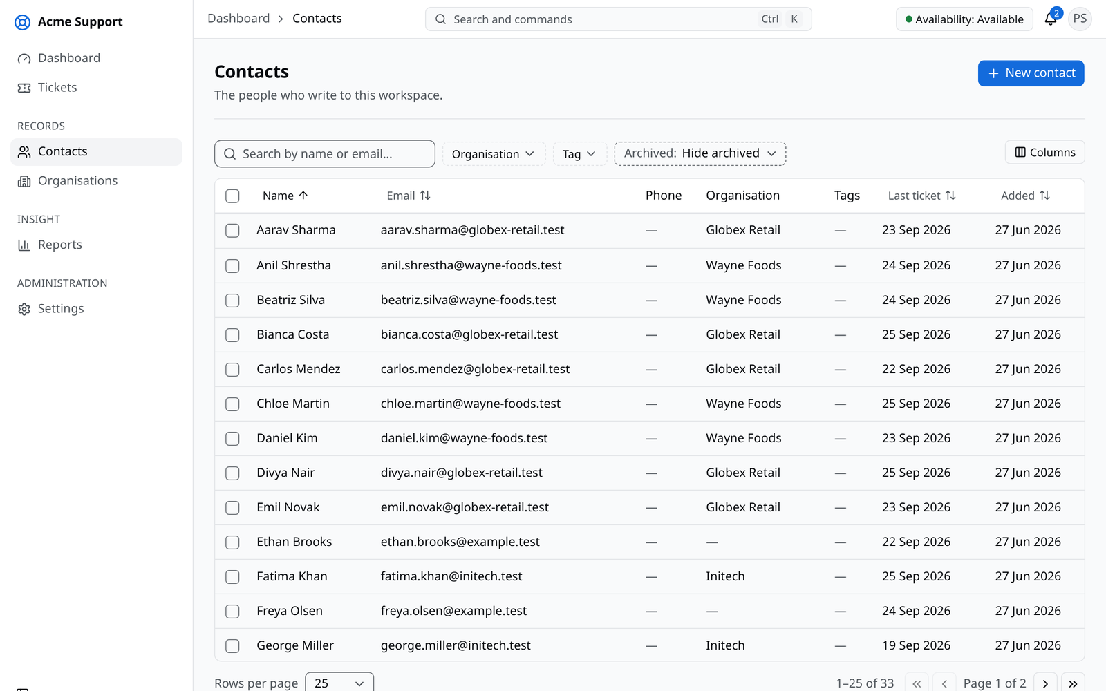
Figure A.8: Contact list
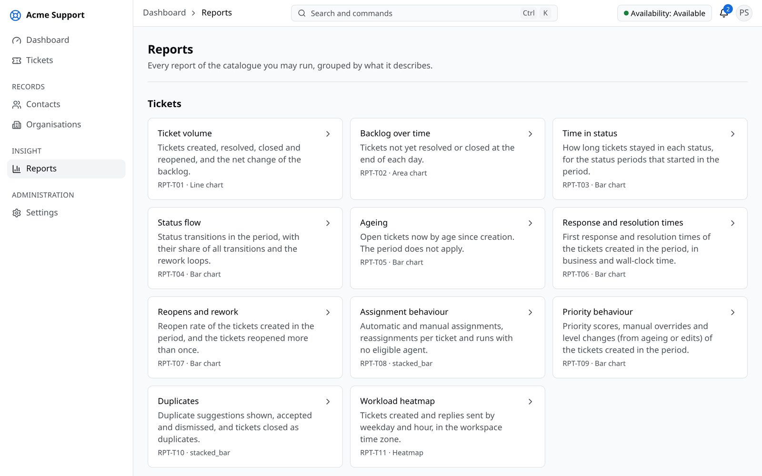
Figure A.9: Report catalogue
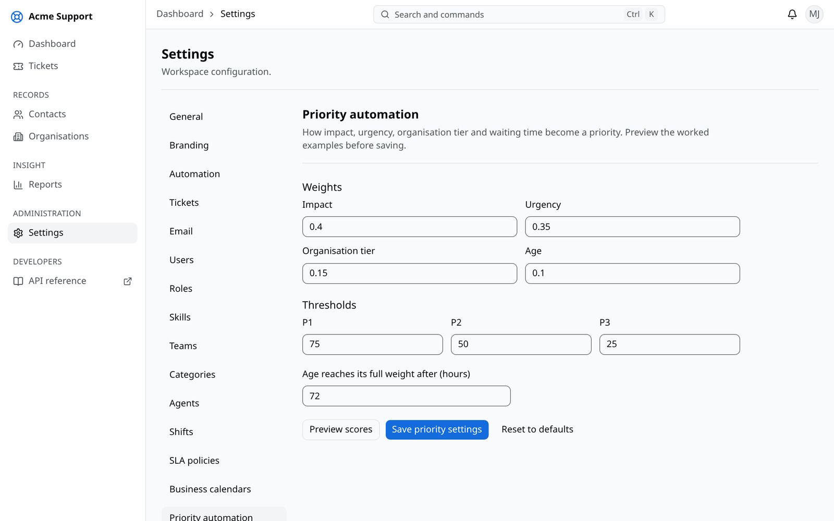
Figure A.10: Priority settings
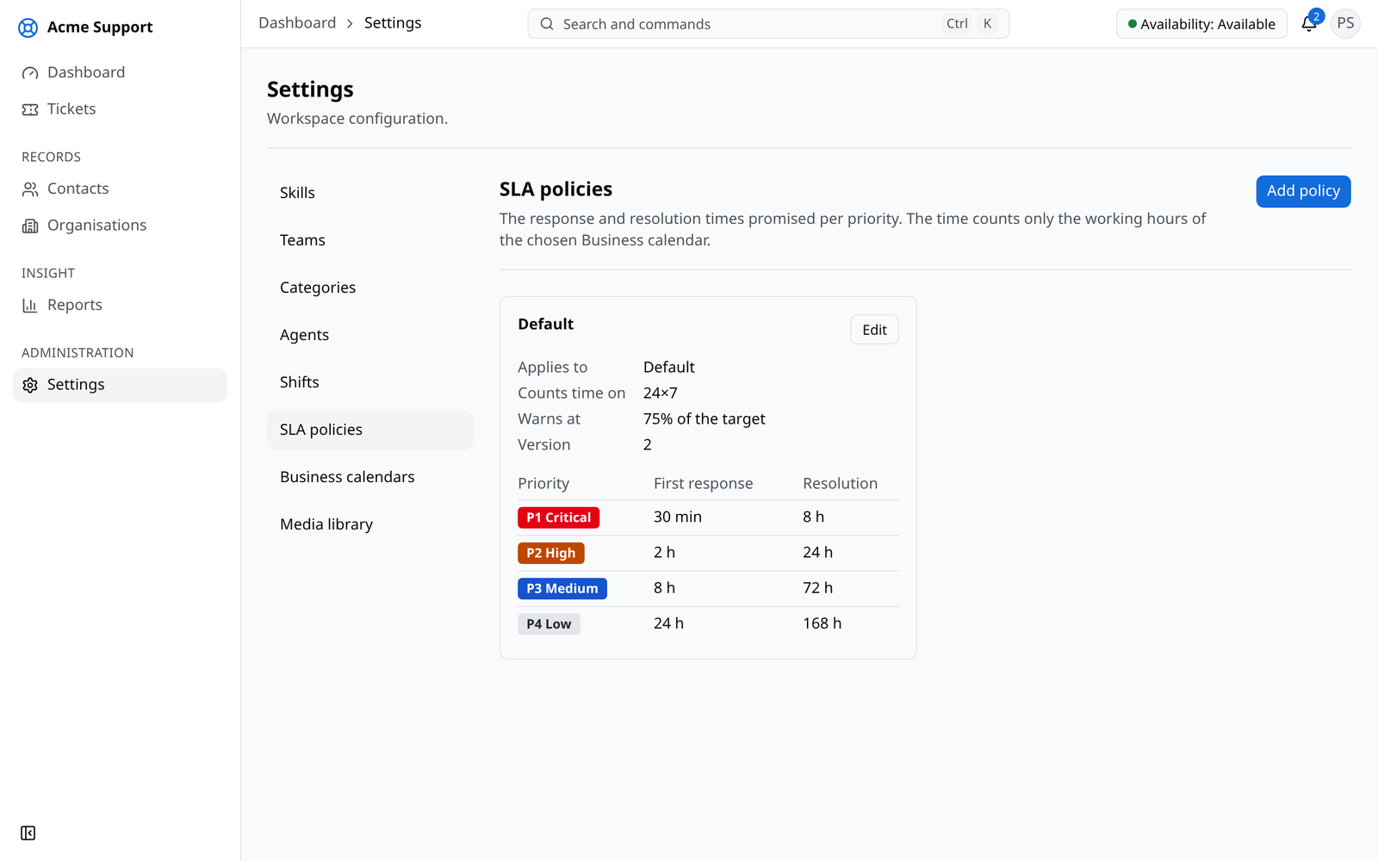
Figure A.11: SLA policies
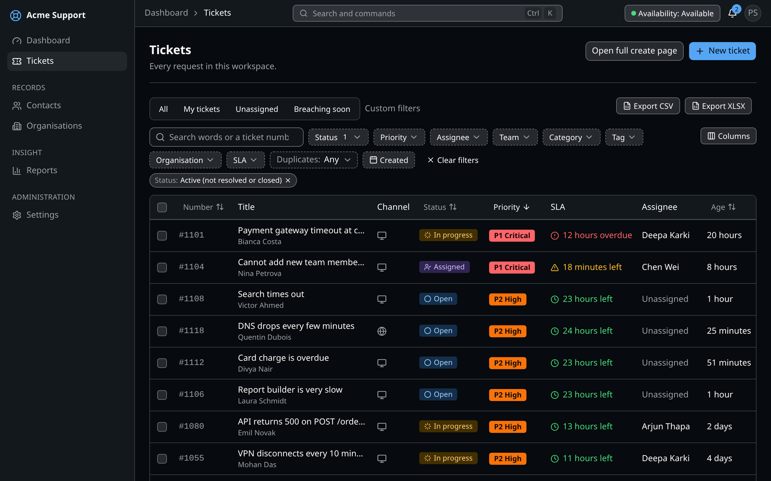
Figure A.12: Ticket list in the dark theme
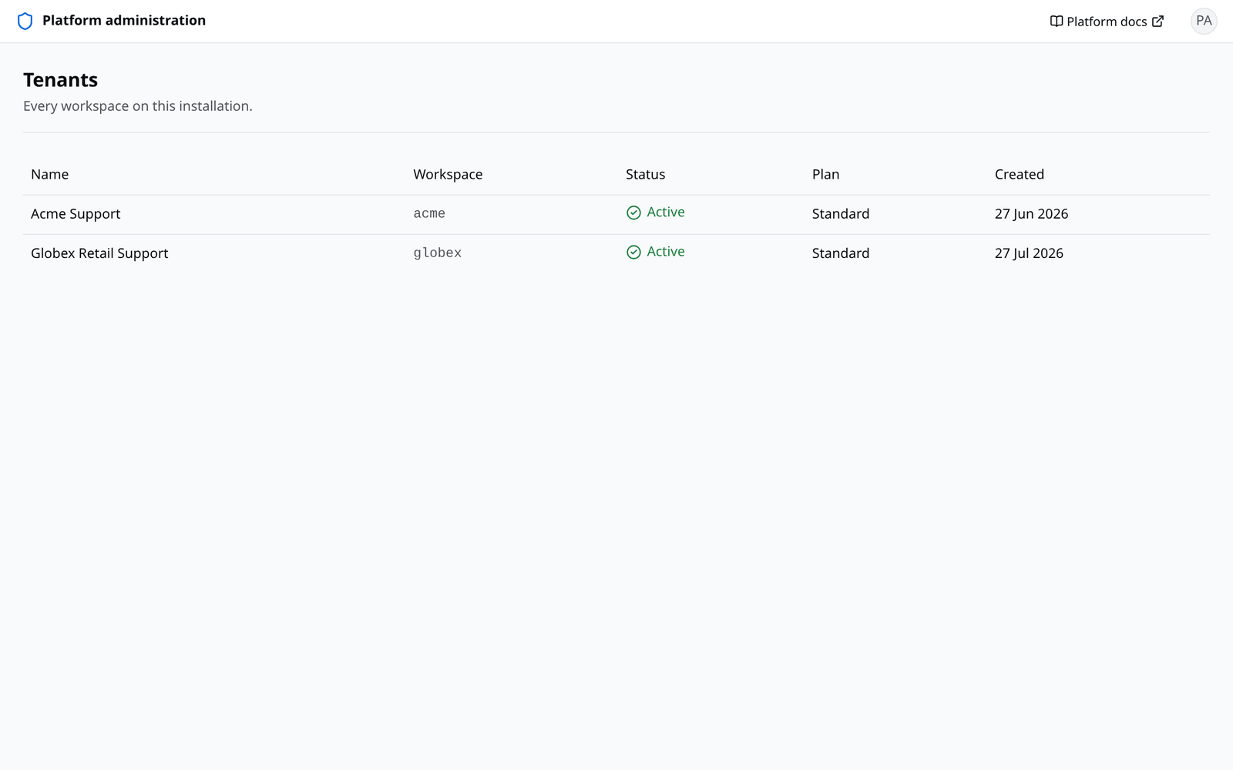
Figure A.13: Platform console with the list of workspaces

