

Tribhuvan University
Faculty of Humanities and Social Sciences
A PROJECT REPORT
ON
Smart Helpdesk
A Multi-Tenant Support Ticket Management System

Submitted to
Department of BCA
Everest College
Thapathali, Kathmandu
In partial fulfillment of the requirements for the Bachelor in Computer Application (CACS452 Project III)

Submitted by
Subham Bhandari, 6-2-355-29-2021
Utsav Karki, 6-2-355-33-2021
BCA 8th Semester, IV Year
Under the Supervision of
Mr. Kamal Pathak

Tribhuvan University
Faculty of Humanities and Social Sciences
Everest College

Supervisor's Recommendation
I hereby recommend that this project prepared under my supervision by SUBHAM BHANDARI, 6-2-355-29-2021 and UTSAV KARKI, 6-2-355-33-2021 entitled "Smart Helpdesk: A Multi-Tenant Support Ticket Management System" in partial fulfillment of the requirements for the degree of Bachelor in Computer Application is recommended for the final evaluation.

.............................................
Mr. Kamal Pathak
Supervisor
Department of BCA
Everest College, Thapathali, Kathmandu

Tribhuvan University
Faculty of Humanities and Social Sciences
Everest College

Letter of Approval
This is to certify that this project prepared by SUBHAM BHANDARI, 6-2-355-29-2021 and UTSAV KARKI, 6-2-355-33-2021 entitled "Smart Helpdesk: A Multi-Tenant Support Ticket Management System with Automated Prioritization, Agent Assignment, Duplicate Detection, SLA Monitoring, Integrations, and Analytics" in partial fulfillment of the requirements for the degree of Bachelor in Computer Application has been evaluated. In our opinion it is satisfactory in the scope and quality as a project for the required degree.
.............................................  SUPERVISOR  Mr. Kamal Pathak  Department of BCA  Everest College | .............................................  HOD / CO-ORDINATOR  Mr. Kamal Pathak  Department of BCA  Everest College
.............................................  INTERNAL EXAMINER | .............................................  EXTERNAL EXAMINER

Acknowledgement
We are glad to present this report on "Smart Helpdesk", prepared as our CACS452 Project III in the eighth semester of the Bachelor in Computer Application. We express our sincere gratitude to everyone who guided and supported us throughout the project.
We extend our genuine thanks to our project supervisor, Mr. Kamal Pathak, for his continuous guidance, constructive feedback and encouragement from the proposal to the final defence. We are equally thankful to Mr. Kamal Pathak, Head of the Department of BCA, for his support and for the academic environment in which this work was possible.
We are indebted to the Department of BCA, Everest College, and to the faculty members whose courses in database management, software engineering, web technology, operating systems, data mining and research methodology laid the foundation of this project. We also thank our families and friends for their patience and support, and the open-source communities whose frameworks, databases and tools allowed us to focus our own work on the system's design, its algorithms and its verification.
Subham Bhandari (6-2-355-29-2021)
Utsav Karki (6-2-355-33-2021)

Abstract
Small and medium support teams often handle customer and internal requests through shared mailboxes or basic ticketing tools in which priority is set by hand, work is assigned by habit, one outage produces many unrelated tickets, and service-level breaches are noticed only after they happen. This project designs, implements and evaluates Smart Helpdesk, a multi-tenant support ticket management system that one installation offers to many independent organisations, as a hosted service or on an organisation's own server. It is built as a modular monolith with a Laravel application programming interface, a React single-page application, PostgreSQL, Valkey and S3-compatible object storage, packaged with Docker Compose and deployed to a cloud virtual machine.
Four operational decisions are made by the system's own, deliberately simple and replaceable algorithms, and every decision is explained to the agent: a weighted priority score over impact, urgency, customer tier and waiting time; assignment to the eligible agent with the lowest load relative to capacity, ties going to the agent assigned longest ago; duplicate detection by the Jaccard similarity of normalised word sets; and a service-level agreement (SLA) timer state machine with pause, recomputation and working-hours calendars. A reporting module captures every change to the main records with a database trigger, reconstructs any record as it was at a past moment, and analyses backlog, workload and time in status. Tenant isolation is enforced by scoped data access and PostgreSQL row-level security and verified by an automated isolation suite. The platform also provides a media library, email notifications and email-to-ticket through a bundled mail server, a documented REST API with OAuth 2.0 client credentials, signed webhooks, a management dashboard and 28 catalogue reports.
The algorithms were evaluated on reproducible datasets. Least-loaded assignment reached a Jain's fairness index of 0.967 on 500 tickets, against 0.865 for round robin and 0.786 for random assignment, with no capacity overflow. Duplicate detection reached precision 0.95, recall 0.70 and F1 0.81 on held-out labelled pairs at the default threshold. All 12 priority scenarios and all 10 SLA timelines produced the expected results, and history reconstruction was correct for all 1 000 sampled records. The system passed 1 971 backend tests, 279 frontend unit tests, 319 browser component tests and 41 end-to-end tests.
Keywords: helpdesk, multi-tenancy, ticket prioritisation, load balancing, duplicate detection, Jaccard similarity, service level agreement, change data capture

Table of Contents

List of Figures

List of Tables

List of Abbreviations
Abbreviation | Expansion
AHP | Analytic Hierarchy Process
API | Application Programming Interface
CI | Continuous Integration
CSV | Comma-Separated Values
DFD | Data Flow Diagram
DKIM | DomainKeys Identified Mail
DMARC | Domain-based Message Authentication, Reporting and Conformance
DNS | Domain Name System
E2E | End-to-End (testing)
EDF | Earliest Deadline First
ER | Entity Relationship
FSM | Finite State Machine
FTS | Full-Text Search
HMAC | Hash-based Message Authentication Code
HTTP | Hypertext Transfer Protocol
IaC | Infrastructure as Code
IDF | Inverse Document Frequency
IMAP | Internet Message Access Protocol
IR | Information Retrieval
ITIL | Information Technology Infrastructure Library
ITSM | IT Service Management
JSON | JavaScript Object Notation
JSONB | Binary JSON (PostgreSQL data type)
KPI | Key Performance Indicator
MCDM | Multi-Criteria Decision Making
MIME | Multipurpose Internet Mail Extensions
MVP | Minimum Viable Product
OAuth | Open Authorization
OAT | One-At-a-Time (sensitivity analysis)
RBAC | Role-Based Access Control
REP | Retrieval function for duplicate bug reports (Sun et al.)
REST | Representational State Transfer
RLS | Row-Level Security
SaaS | Software as a Service
SAW | Simple Additive Weighting
SLA | Service Level Agreement
SMTP | Simple Mail Transfer Protocol
SPA | Single-Page Application
SPF | Sender Policy Framework
SQL | Structured Query Language
SSRF | Server-Side Request Forgery
TF-IDF | Term Frequency–Inverse Document Frequency
UI | User Interface
UML | Unified Modeling Language
URL | Uniform Resource Locator
UUID | Universally Unique Identifier
VM | Virtual Machine
VPS | Virtual Private Server
WCAG | Web Content Accessibility Guidelines

Chapter 1: Introduction

1.1 Introduction
Every organisation that serves customers or employees receives requests: a login that fails, an invoice that is wrong, a server that is down. A helpdesk turns these requests into tickets that can be prioritised, assigned, tracked against a promised response time and closed with a record of what was done. Commercial platforms such as Zendesk, ServiceNow and Jira Service Management provide this capability to large enterprises, while small and medium teams commonly rely on shared mailboxes or open-source tools that store tickets well but leave most decisions to people.
Smart Helpdesk is a web-based support ticket management system built for such teams. One installation serves many independent organisations, called tenants, each with its own users, agents, customers, tickets and settings, and the same software can run as a hosted service or on an organisation's own server. Beyond storing tickets, the system makes four operational decisions automatically and explains each one: how urgent a ticket is, which agent should handle it, whether it repeats an existing ticket, and whether its service-level agreement (SLA) is at risk. It also records how every record changed over time and offers detailed reports on tickets, contacts, organisations, agents, teams and service levels, including what any record looked like on a past date. It delivers notifications by email and in the application, turns customer emails into tickets, keeps every file in a tenant media library, and exposes a documented REST API and webhooks so that other systems can integrate with it.

1.2 Problem Statement
Observation of how small support teams work, and a review of existing open-source helpdesks (Section 2.2), show the following problems:
- Inconsistent prioritisation. Priority is chosen by whoever creates the ticket. Low-priority tickets can wait indefinitely, and a ticket's urgency does not grow as its deadline approaches.
- Unbalanced assignment. Managers assign tickets manually or by simple rotation, so work accumulates on experienced agents while skill requirements and current workload are ignored.
- Duplicate tickets. A single outage produces many tickets describing the same problem in different words; agents discover the duplication late and work on it in parallel.
- Late SLA awareness. Response and resolution targets are checked after the fact in reports instead of warning agents before a breach; waiting for the customer and non-working hours are rarely handled correctly.
- Shallow reporting. Existing tools report current counts, but managers cannot see how the backlog, an agent's workload or a customer's record looked on a past date, or how long tickets spent in each state.
- Isolation and deployment constraints. A hosted helpdesk must guarantee that one customer organisation can never see another's data, while some organisations require the same software on their own infrastructure with their own mail and storage.

1.3 Objectives
The objectives of the project are:
- To design and implement a multi-tenant helpdesk in which tenants are strictly isolated at the application, database and storage levels, and which can be hosted on any virtual machine or installed on-premise.
- To implement a simple, configurable priority scoring algorithm based on weighted multi-criteria evaluation with an ageing term.
- To implement an agent assignment algorithm that sends each ticket to the least-loaded qualified agent, and to measure its fairness.
- To implement a duplicate ticket detection algorithm using the project's own word extraction and Jaccard similarity, and to measure its precision, recall and F1 score.
- To implement an SLA evaluation state machine with warning, breach, pause, recomputation and working-hours calendars.
- To provide the supporting product capabilities required for real use: ticket lifecycle with public replies and internal notes, media library, email notifications and email-to-ticket, dashboard, audit trail, REST API with OAuth2 client credentials, and signed webhooks.
- To implement a detailed reporting module that captures every change to the main entities, reconstructs any record as it existed at a past moment, and analyses backlog, workload and time in each status over time.
- To verify the system with unit, integration, system and tenant-isolation tests and to analyse the algorithms' results with reproducible experiments.
The four algorithms are intentionally minimal and replaceable, so that they can be understood completely, evaluated honestly and later substituted with stronger techniques.

1.4 Scope and Limitation
Scope. The system covers tenant provisioning, suspension and reactivation by a platform administrator through the platform API, with a separate sign-in for the platform console; authentication, invitations, roles and granular permissions per tenant; contacts and organisations with customer tiers; teams, skills, categories, agent capacity, availability and shifts; the complete ticket lifecycle with comments, attachments and history; the four algorithms with explanations visible to agents; SLA policies with business calendars and warning and breach notifications; in-app and email notifications through a bundled mail server; inbound email processing; a tenant media library; a management dashboard and a catalogue of detailed reports with drill-down, record history and point-in-time views; a versioned REST API with interactive documentation; OAuth2 client credentials and signed webhooks; light, dark and system themes with a comfortable and a compact density; and deployment with Docker Compose, OpenTofu and Ansible to any virtual machine, demonstrated on an Amazon Web Services instance.
Limitations.
- The priority and assignment weights are configured by administrators rather than learned from historical data.
- Duplicate detection is lexical: two tickets that describe the same problem with no shared vocabulary are not detected.
- The four algorithms are deliberately simple baselines: assignment ignores skill strength and decides one ticket at a time, duplicate detection does not handle word forms or synonyms, and SLA escalation only notifies. Each is built behind an interface so that it can be replaced after the project.
- A customer self-service portal, live chat and social media channels, a knowledge base, custom fields, billing and artificial-intelligence features are outside the scope and are listed as future work.
- Load and performance testing was not carried out within the project period; the system runs on a single small virtual machine and does not demonstrate high availability or horizontal scaling.
- The platform console offers sign-in and a read-only list of workspaces; creating, suspending and reactivating workspaces is done through the platform API.
- The agent application is designed for desktop and laptop screens (from 1024 pixels wide); layouts for phones are not provided.

1.5 Development Methodology
The project followed an incremental development model organised into four milestones, each ending with a working and tested system:
- Foundation: repository, container environment, tenancy, authentication and permissions, design system, contacts and the ticket data model.
- Core product: ticket workflow and user interface, SLA engine with calendars, priority scoring, agent assignment, duplicate detection, media library, notifications and reporting read models.
- Hardening and evaluation: report catalogue and user interface, record history views, dashboard, API clients, webhooks, mail server and email-to-ticket, row-level security, deployment, experiments, end-to-end tests and demonstration preparation.
- User experience redesign: an audit of every screen against usability findings, followed by the redesign of the navigation, ticket queue and ticket workspace, explanations of automated decisions, SLA presentation, dashboard, reports and charts, record history, settings and responsive behaviour.
Before implementation, a research and design phase compared candidate technologies and recorded each significant choice as an architecture decision record. Tasks were planned from an explicit dependency graph and executed in continuous development sessions on four parallel tracks (backend platform, frontend, infrastructure and quality, algorithms and reporting), with AI coding assistants used for implementation under the team's review; the pure algorithm modules were developed first because they do not depend on the database. The two team members developed features on separate branches that were reviewed and merged into a shared development branch, for example the platform console sign-in. Every task was accepted only against a written definition of done covering permissions, tenant isolation, validation, tests, accessibility and documentation.
Table 1.1: Development milestones
Milestone | Main deliverables | Exit evidence
1 Foundation | tenancy, authentication, RBAC, design system, contacts, ticket model, CI | two tenants isolated; tickets listed with server-side paging
2 Core product | ticket workflow, SLA engine, priority, assignment, duplicates, media, notifications, reporting read models | automated decisions visible with explanations; history recorded
3 Hardening | reports and record history, dashboard, API, webhooks, mail, RLS, deployment, experiments, E2E | results tables, green test suites, rehearsed demonstration
4 UX redesign | navigation, ticket workspace, explanations, SLA, dashboard, reports, record history, settings, responsive layout | usability findings closed, accessibility scans green, demonstration screenshots regenerated

1.6 Report Organization
Chapter 2 introduces the concepts the system is built on and reviews existing helpdesk systems and research on ticket prioritisation, routing, duplicate detection and SLA management. Chapter 3 presents the requirement and feasibility analysis, the object, dynamic and process models, the system design and the details of the four algorithms. Chapter 4 describes the tools and the implementation of each module, the unit and system test cases, and the analysis of experimental results. Chapter 5 concludes the report and recommends future work.

Chapter 2: Background Study and Literature Review

2.1 Background Study

2.1.1 Tickets, priority and service levels
In IT service management a ticket represents a unit of work with a lifecycle. Smart Helpdesk uses six statuses — open, assigned, in progress, pending, resolved and closed — because each one changes what the system does: an open ticket without an agent is a candidate for assignment, a pending ticket is waiting for the customer and pauses its SLA clock, and a resolved ticket can be reopened within a configurable window.
Priority is commonly derived from impact (how much of the organisation is affected) and urgency (how soon the effect becomes serious). Vendors implement this as a lookup matrix: Jira Service Management maps four impact levels and four urgency levels to five priorities [1], ServiceNow uses data lookup rules [2] and GLPI lets each entity edit its own matrix [3]. The ITIL 4 incident management guidance, however, states that evaluating impact and urgency is not itself prioritisation; prioritisation depends on the whole backlog, resource availability and target resolution times [4]. This distinction motivated a continuous score that also considers waiting time and the approaching deadline.
A service level agreement defines targets such as first response time and resolution time. Real products differ in important details: Zendesk measures targets in calendar or business hours and does not pause reply timers while a ticket is pending [5]; Jira Service Management models each SLA as a stopwatch with start, pause and stop conditions [6]; ServiceNow can start a timer retroactively when priority changes [7]; Zammad measures first response from ticket creation and never resets it [8]; osTicket uses a single grace period [9]. Smart Helpdesk makes these behaviours explicit, configurable settings.

2.1.2 Multi-criteria decision making and scheduling
Simple Additive Weighting (SAW) scores an alternative as the weighted sum of its normalised criteria values [10]. It is compensatory: a weak value on one criterion can be offset by a strong value on another. The Analytic Hierarchy Process derives weights from pairwise comparisons and checks their consistency [11]. Operating systems use ageing to prevent starvation in priority scheduling by raising the priority of waiting processes [12], and Earliest Deadline First scheduling is optimal on a single processor when all tasks can meet their deadlines [13]. The baseline priority score in this project uses the simplest of these ideas, SAW with an ageing term; deadline-aware ordering is left for the replacement strategy.

2.1.3 Load balancing and skills-based routing
Network load balancers distribute requests by round robin, weighted round robin or least connections [14]. Choosing the less loaded of two random servers reduces the maximum load dramatically compared with purely random placement [15]. Contact centres route work by matching an agent's skills to the skill a request requires, and practical systems use greedy rules such as "least-loaded qualified agent" because optimal policies are intractable [16]. When a batch of tasks must be matched to workers optimally, the Hungarian method solves the assignment problem in polynomial time [17]. Fairness of a load distribution can be measured with Jain's fairness index, which equals one when all loads are equal [18].

2.1.4 Text similarity
Information retrieval represents documents as term vectors. Text is tokenised, case-folded, filtered for stop words and stemmed; the Porter algorithm removes suffixes in ordered steps conditioned on the measure of the remaining stem [19]. Terms are weighted by term frequency and inverse document frequency (TF-IDF), and two documents are compared by the cosine of the angle between their vectors [20]. Jaccard similarity compares sets of tokens, and n-gram overlap captures short phrases. BM25 is a probabilistic ranking function with term-frequency saturation and length normalisation [21]. MinHash [22] and SimHash [23] approximate similarity for very large collections. The baseline in this project uses only word sets and Jaccard similarity; TF-IDF, BM25 and embeddings are the planned improvements.

2.1.5 Multi-tenant software
A multi-tenant application serves several customer organisations from one deployment. Data can be isolated by a tenant identifier on shared tables, by a schema per tenant or by a database per tenant; the first option is simplest to operate but depends on every query being filtered correctly. PostgreSQL row-level security adds a database-enforced filter: a policy compares each row's tenant identifier with a per-session setting, so a query that forgets the filter returns no rows instead of another tenant's data [24]. The system uses shared tables with application-level scoping through the Tenancy for Laravel package [25] and row-level security as a second layer.

2.1.6 Temporal data and time analytics
Operational databases normally keep only the current state of each record. To answer questions about the past — the backlog at the end of a given day, or a customer's organisation before it changed — a system must keep either every version of each row (transaction-time or system-versioned tables, standardised in SQL:2011) or every change, from which versions can be rebuilt by replay. Recording changes inside the database with triggers captures every write path. Time-based measures such as "time spent in each status" are obtained by converting ordered state-change events into non-overlapping intervals, and the number of open tickets at an instant is the number of intervals that contain that instant. This project records changes with a trigger and derives intervals, per-ticket facts and daily snapshots from them.

2.1.7 Integration and messaging standards
The REST API reports errors as problem details [26], authenticates external systems with the OAuth 2.0 client credentials grant [27] and identifies records with time-ordered UUID version 7 values [28]. Outgoing webhooks are signed with HMAC [29] so that receivers can verify their origin. Outgoing email is signed with DKIM [30] so that receiving servers can verify that the platform is allowed to send it.

2.2 Literature Review

2.2.1 Existing helpdesk systems
Six open-source helpdesks were studied for the four capabilities this project targets.
Table 2.1: Comparison of existing open-source helpdesk systems
System | Priority | Assignment | Duplicate detection | SLA
osTicket [31] | manual levels per help topic | by department or help topic; manual claim | none | grace period after which a ticket is overdue
Zammad [32] | three fixed levels | group-based triggers; no load awareness | manual merge | first response, update and solution timers with calendars
GLPI [33] | computed from an editable urgency × impact matrix | rules engine assigns technician or group | none | SLA and OLA attached by rules
FreeScout [34] | minimal | workflow module rules | none | only through a paid module
UVdesk [35] | priority field | workflow rules | none | separate SLA module
Znuny [36] | priority field | queue-based | none | escalation times per queue or SLA

Only GLPI computes priority, and it does so with a static matrix without ageing or deadline awareness. None of the systems assigns tickets by measured, skill-aware workload, and none detects duplicate tickets automatically. SLA support ranges from a single overdue threshold to a well-specified timer model. Smart Helpdesk's contribution is to combine a transparent priority score, fairness-measured assignment, retrieval-based duplicate detection and a calendar-aware SLA state machine in one explainable system, and to evaluate each quantitatively.

2.2.2 Ticket prioritisation research
Recent work treats priority as a classification task. Lê and Ait-Bachir compared embedding-based approaches and fine-tuned transformers on IT tickets; the best transformer reached an average F1 of about 0.785, and generic embeddings with clustering did not generalise [37]. Ticket-BERT applies language models to labelling incident tickets [38]. These models require labelled history and cannot explain their output to an agent who disagrees. A deterministic weighted score is therefore a reasonable starting point for a new installation with no history, and it is designed to be replaced by a richer or learned model later.

2.2.3 Ticket routing research
Shao et al. mined the sequence of groups that resolved past tickets to predict where a ticket should be transferred, without using ticket text [39]. SmartDispatch recommended a short list of three to five resolver groups using text classifiers in large IBM service engagements [40]. Mandal et al. combined an ensemble classifier with a configurable rule engine for dispatching helpdesk emails, keeping deterministic rules in the loop [41]. These works focus on choosing the right group from history. The present project addresses the complementary problem of choosing an individual agent within the eligible set with a simple least-loaded rule, and shows the ranked candidates to the manager, as SmartDispatch does.

2.2.4 Duplicate report detection research
Duplicate bug reports are a well-studied problem. Runeson et al. applied tokenisation, stemming, stop-word removal and cosine similarity at Sony Ericsson, finding about 30 % of duplicates in the top five suggestions and 42 % in the top fifteen [42]. Wang et al. added a second similarity channel based on execution traces [43]. Jalbert and Weimer framed detection as a filter for incoming reports [44]. Sun et al. trained a discriminative model [45] and then proposed REP, which extends BM25F with similarity of non-textual fields such as product and component and improved recall by 10–27 % [46]. The baseline duplicate detector in this project is simpler than all of these: it compares word sets with the Jaccard coefficient. The later methods — weighted term vectors, BM25F with structured fields (REP) and learned models — show the path for its replacement, and Runeson's recall figures set realistic expectations for a lexical approach.

2.2.5 SLA and escalation practice
Vendor documentation differs on whether timers pause while a ticket waits for the customer and on how a priority change affects a running timer [5, 6, 7, 8]. PagerDuty models escalation as ordered levels with timeouts [47]. Harel's statecharts provide a formal way to describe concurrent states such as a ticket's workflow and its SLA timer [48]. The baseline timer adopts the common core of these products — two timers, pause while waiting for the customer, warning before breach — and leaves configurable pause and recomputation rules to a later version.

Chapter 3: System Analysis and Design

3.1 System Analysis

3.1.1 Requirement Analysis
i. Functional requirements
The actors of the system are the Platform Super Admin, who manages tenants; the Tenant Admin (and Tenant Owner), who configures a tenant; the Support Manager, who oversees queues and reports; the Support Agent, who works tickets; the Integration Developer and external systems, which use the API and receive webhooks; the Contact, who raises requests by email; and the scheduler, which drives time-based processing. Figures 3.1 and 3.2 show the use cases.
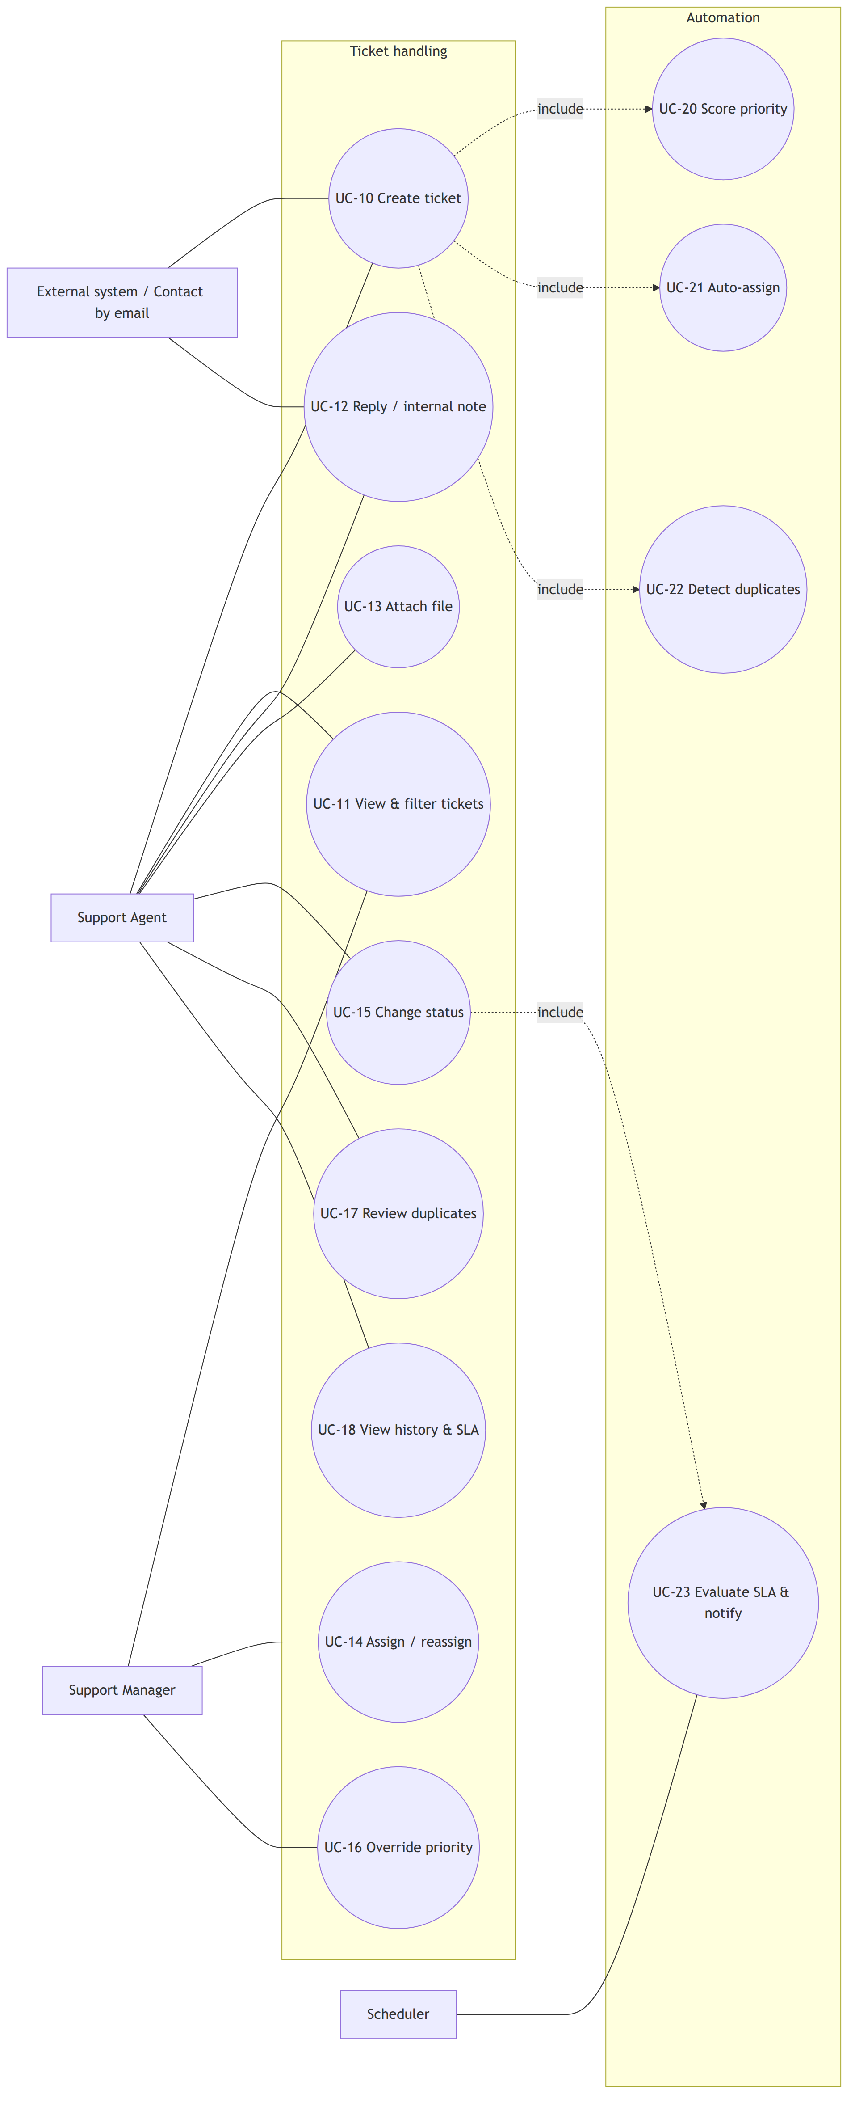
Figure 3.1: Use case diagram — ticket handling and automation
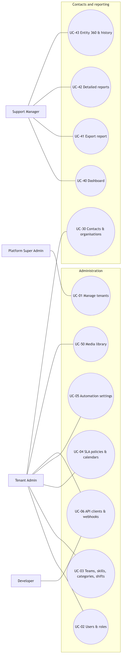
Figure 3.2: Use case diagram — administration, contacts and reporting
Table 3.1: Functional requirements by module
Module | Requirement
Tenancy | Create, suspend and reactivate tenants; take the tenant of every request from the signed-in session or API client, never from the host name or a header; seed default roles, categories, SLA policy, calendar and settings
Identity | Log in with email and password; invite users; assign tenant-scoped roles made of granular permissions; enforce a permission on every endpoint
Contacts | Manage contacts and organisations with customer tier, tags and external identifiers
Agents | Manage teams, skills with levels, categories with required skills, agent capacity, availability and shifts
Tickets | Create tickets; move them through the lifecycle; add public replies and internal notes; attach files; record history; list, filter, sort and search
Automation | Score priority; assign agents; suggest duplicates; show an explanation for every automatic decision
SLA | Define policies and business calendars; run first-response and resolution timers; pause while pending; warn before and detect breaches, notifying the assignee and managers
Media | Store every file in a tenant library with folders, tags, thumbnails and a storage quota
Email | Send DKIM-signed notification emails; convert customer replies into comments and new emails into tickets
Notifications | In-app and email notifications for assignment, replies, SLA warnings and breaches
Integrations | Versioned REST API, OAuth2 client credentials, interactive API documentation, signed webhooks with retries
Reporting | Record every change to the main entities; catalogue of reports for tickets, contacts, organisations, agents, teams, SLA, email, media and integrations with filters, grouping, period comparison and drill-down; record 360 pages with history and point-in-time view; CSV and XLSX export
Dashboard and audit | Dashboard indicators and charts; security audit log of administrative actions

Table 3.2: Description of use case "Create ticket"
Field | Description
Actors | Support Agent; external system through the API; Contact through email
Precondition | The actor is authenticated in the tenant (or the email is routed to the tenant)
Main flow | 1. Actor enters title, description, contact, category, impact, urgency and attachments. 2. System shows likely duplicates. 3. Actor confirms. 4. System allocates the ticket number, computes the priority score, starts SLA timers, stores duplicate suggestions and assigns an agent. 5. System records history and sends notifications and webhooks.
Alternative flows | 2a. Actor marks the ticket as a duplicate; it is closed and linked to the original. 4a. No eligible agent exists; the ticket stays unassigned and managers are notified.
Postcondition | The ticket exists with number, priority level, explanation, SLA timers and assignment

Table 3.3: Description of use case "Evaluate SLA and notify"
Field | Description
Actor | Scheduler (every minute)
Precondition | Running timers exist
Main flow | 1. Select timers whose warning or due time has passed. 2. Move each to warning or breached exactly once. 3. Record SLA events and ticket history. 4. Notify the assignee (warning) or the assignee and managers (breach).
Postcondition | Timer states reflect the current time; notifications and webhooks are queued

Table 3.4: Description of use case "Assign ticket"
Field | Description
Actors | System (automatic), Support Manager (manual)
Main flow | 1. System filters eligible agents by availability, shift, capacity, team and skills. 2. System orders them by open tickets per unit of capacity. 3. System assigns the first agent and stores the ordered list. 4. Agent is notified.
Alternative flow | 1a. A manager opens the assign dialog, reviews the ranking and selects a different agent.

Table 3.5: Description of use case "View entity history"
Field | Description
Actor | Support Manager, Tenant Admin
Precondition | The actor has the history permission
Main flow | 1. Actor opens a contact, ticket, organisation, agent or team. 2. System shows its current state, metrics and a timeline of changes with actor and old and new values. 3. Actor selects a past date and time. 4. System reconstructs the record's attributes at that moment and highlights the differences from today.
Postcondition | No data is modified

Use cases for tenant management, user and role management, SLA and calendar configuration, comments, media management, inbound email, dashboard and webhook management follow the same pattern and are listed in Appendix A.
ii. Non-functional requirements
Table 3.6: Non-functional requirements
Quality | Requirement
Security | No cross-tenant access through any interface; permission check on every endpoint; login throttling; signed webhooks and emails; private object storage with short-lived signed URLs
Performance | Ticket list responds within 300 ms at the 95th percentile with 100 000 tickets in one tenant; ticket creation with all automation within 800 ms; SLA evaluation of 10 000 timers within 5 s
Reliability | Background work is queued and retried; failed webhook deliveries are retried with back-off; daily backups with a tested restore
Usability and accessibility | Light, dark and system themes; keyboard operation; text contrast of at least 4.5:1 [49]; loading, empty and error states on every view
Portability | Runs on any Linux virtual machine with Docker; storage, mail and database endpoints are configuration
Maintainability | Modular structure with enforced dependencies; static analysis; automated tests with full coverage of the algorithms

3.1.2 Feasibility Analysis
i. Technical feasibility. All components are mature open-source software: Laravel 13 on PHP 8.5 [50], React 19 with the TanStack libraries [51, 52], PostgreSQL 18, Valkey, RustFS object storage and the Stalwart mail server. They run together in Docker Compose on one virtual machine; the live deployment uses an Amazon Web Services t3.small instance with two virtual CPUs, 2 GB of memory and 4 GB of swap, provisioned with OpenTofu and configured with Ansible.
ii. Operational feasibility. The system follows the workflow support teams already use and adds explanations to every automatic decision so that agents can trust or override it. Administrators configure the algorithms through forms with live previews rather than code.
iii. Economic feasibility. No software licence is required. A single virtual machine of the required size costs roughly US$8–35 per month depending on the provider, and on-premise installations use existing hardware. The demonstration deployment runs on cloud credits, outbound mail uses a free relay plan, and development used free tools.
iv. Schedule feasibility. The work was planned as tasks with an explicit dependency graph on four parallel tracks (backend platform, frontend, infrastructure and quality, algorithms and reporting), grouped into four milestones that each ended with a working, tested system; a documented cut list protected the deadline. Table 3.7 and Figure 3.3 show the schedule as it was executed, taken from the project's version-control history.
Table 3.7: Project schedule
S.N. | Phase | Start | End | Duration (days)
1 | Research, requirement analysis and feasibility | 17 Sep 2026 | 17 Sep 2026 | 1
2 | Architecture, system design and task planning | 17 Sep 2026 | 17 Sep 2026 | 1
3 | Milestone 1: foundation (tenancy, identity, design system) | 18 Sep 2026 | 18 Sep 2026 | 1
4 | Milestone 2: core product and the four algorithms | 18 Sep 2026 | 21 Sep 2026 | 4
5 | Milestone 3: hardening, integrations, mail and deployment | 21 Sep 2026 | 22 Sep 2026 | 2
6 | Milestone 4: user experience redesign | 23 Sep 2026 | 24 Sep 2026 | 2
7 | Algorithm experiments and result analysis | 21 Sep 2026 | 21 Sep 2026 | 1
8 | End-to-end testing and demonstration rehearsal | 22 Sep 2026 | 24 Sep 2026 | 3
9 | Report drafting and finalisation | 17 Sep 2026 | 25 Sep 2026 | 9

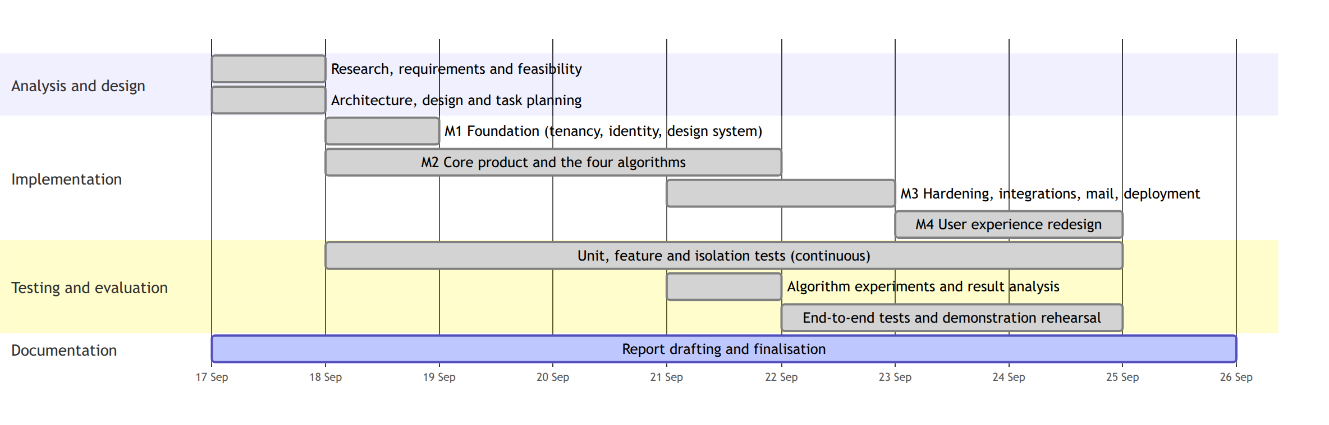
Figure 3.3: Gantt chart of the project schedule

3.1.3 Object Modelling using Class and Object Diagrams
The domain model (Figure 3.4) is centred on Ticket. A Ticket belongs to one Tenant, is requested by one Contact (which may belong to an Organisation with a customer tier), is classified by one Category, and may be assigned to one Team and one AgentProfile. A Ticket has many Comments, many ticket events (history), many Assignments, two SlaTimers, many DuplicateSuggestions and many linked MediaItems. A Category requires Skills; an AgentProfile belongs to a User, holds Skills with a level, belongs to Teams and has Shifts. An SlaPolicy has SlaTargets per priority level and may use a BusinessCalendar with Holidays. A MediaItem lives in a MediaFolder and can be linked to tickets, comments or branding. Integration classes are WebhookSubscription, WebhookDelivery and ApiClient; InboundEmail records received messages. For reporting, EntityChange records every change of a reportable entity, TicketInterval describes a continuous period of a ticket's state, TicketFact summarises a ticket's lifecycle, DailySnapshot stores end-of-day values, and ReportDefinition describes a catalogue report.
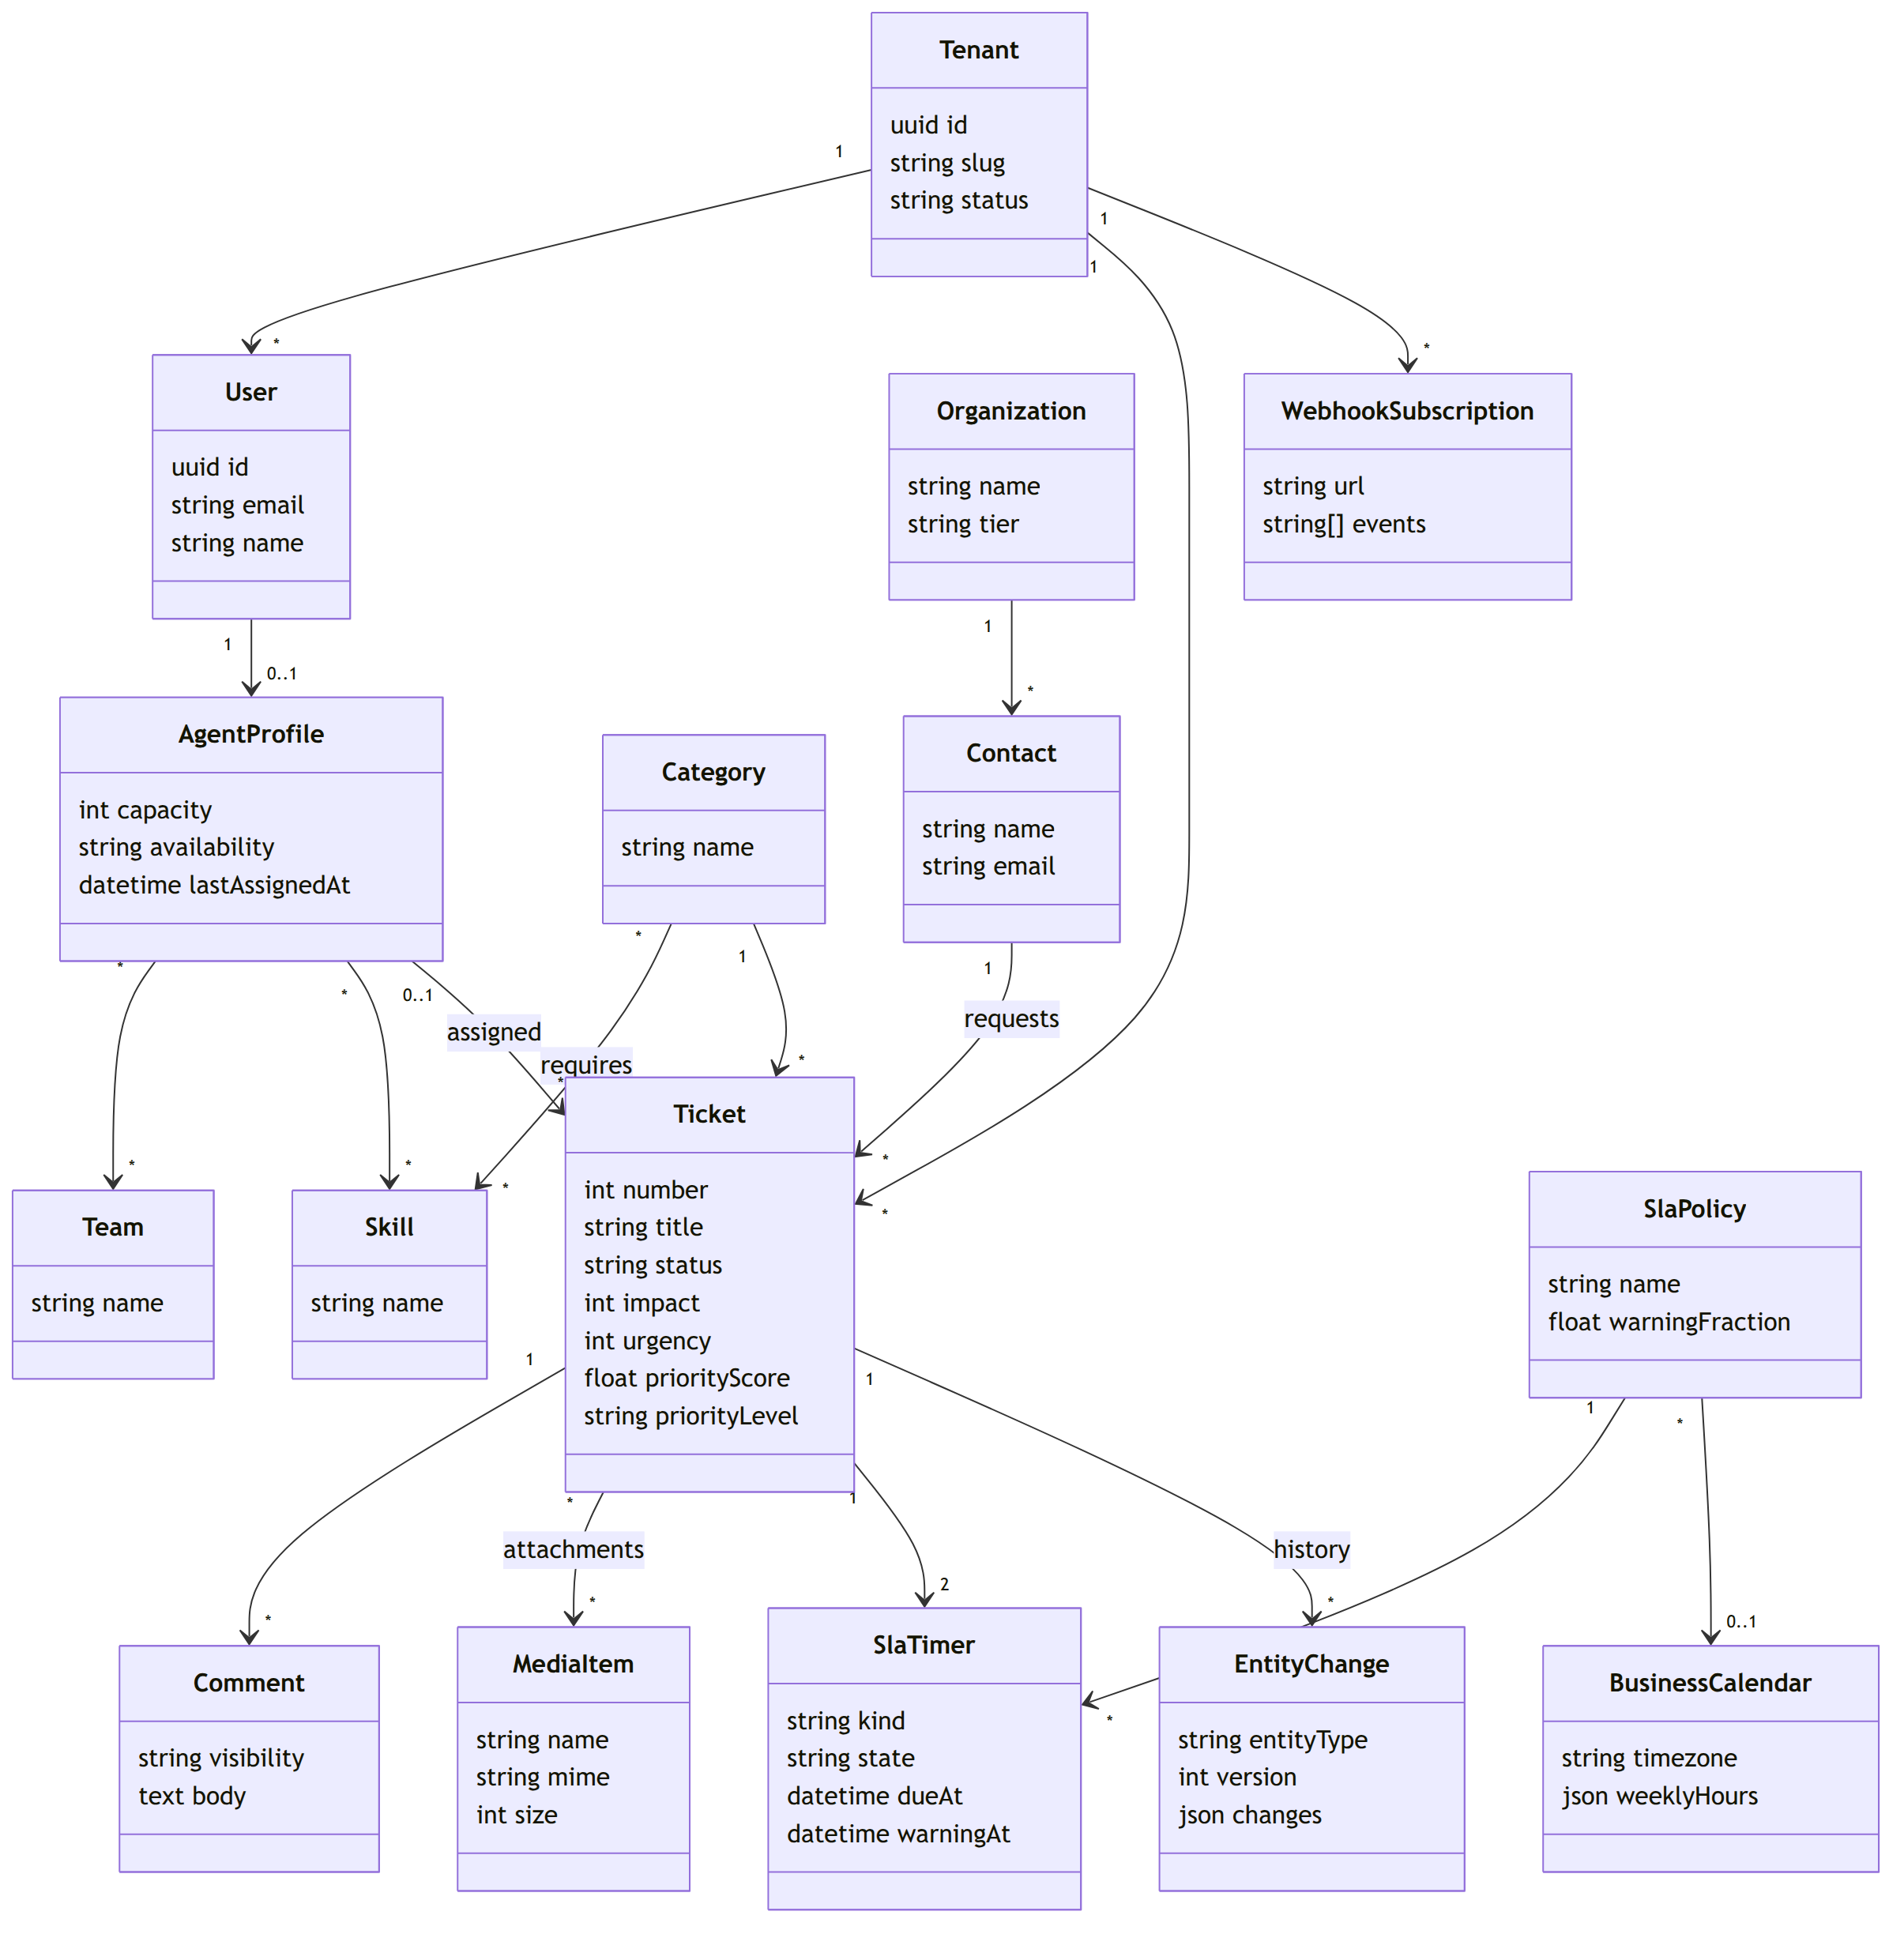
Figure 3.4: Class diagram of the domain model
Figure 3.5 shows an object diagram for a seeded tenant "Acme": ticket #1042 requested by contact Ravi of organisation Globex (tier premium), in category Billing requiring skills billing and refunds, assigned to agent Asha of team Finance Support, with a resolution timer of 8 hours under the policy "Default" using the calendar "Kathmandu office hours".
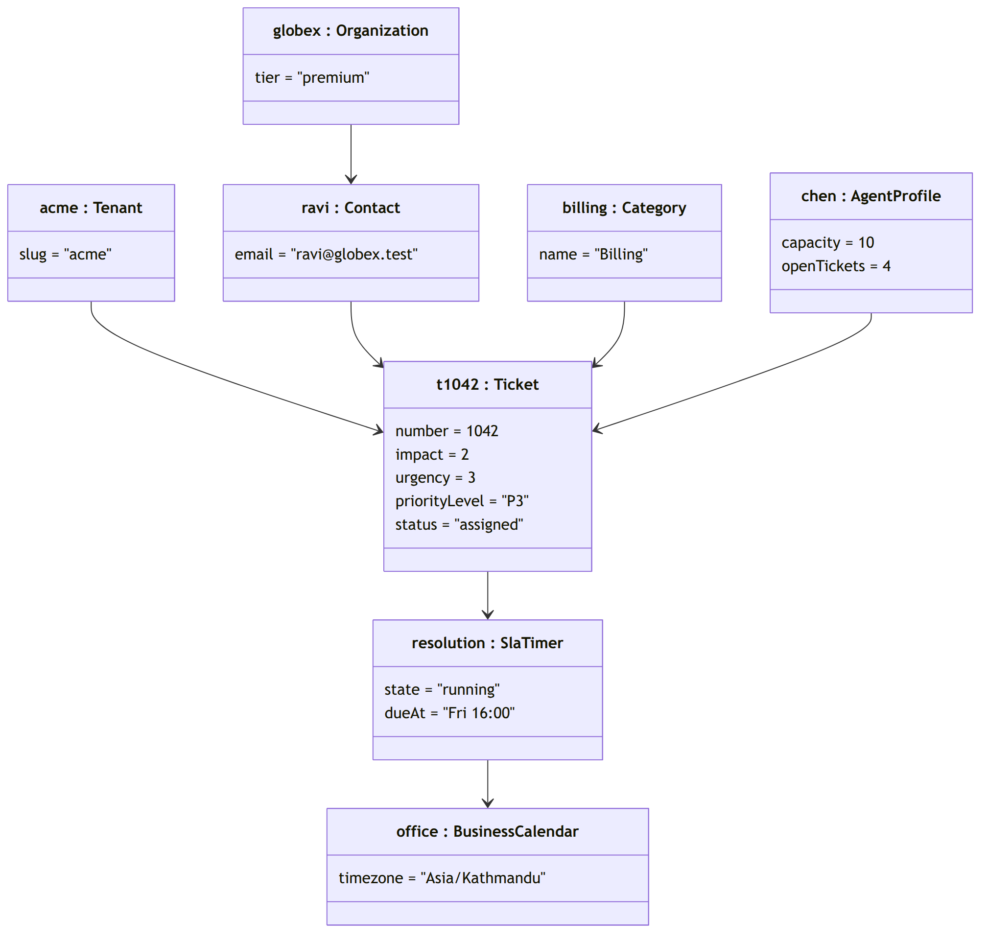
Figure 3.5: Object diagram of a seeded ticket

3.1.4 Dynamic Modelling using State and Sequence Diagrams
The ticket lifecycle (Figure 3.6) has six states. A new ticket is open; assignment moves it to assigned; work moves it to in progress; waiting for the customer moves it to pending; resolution requires a resolution comment; a resolved ticket is closed manually or automatically, and can be reopened within the reopen window. Any other transition is rejected by the server.
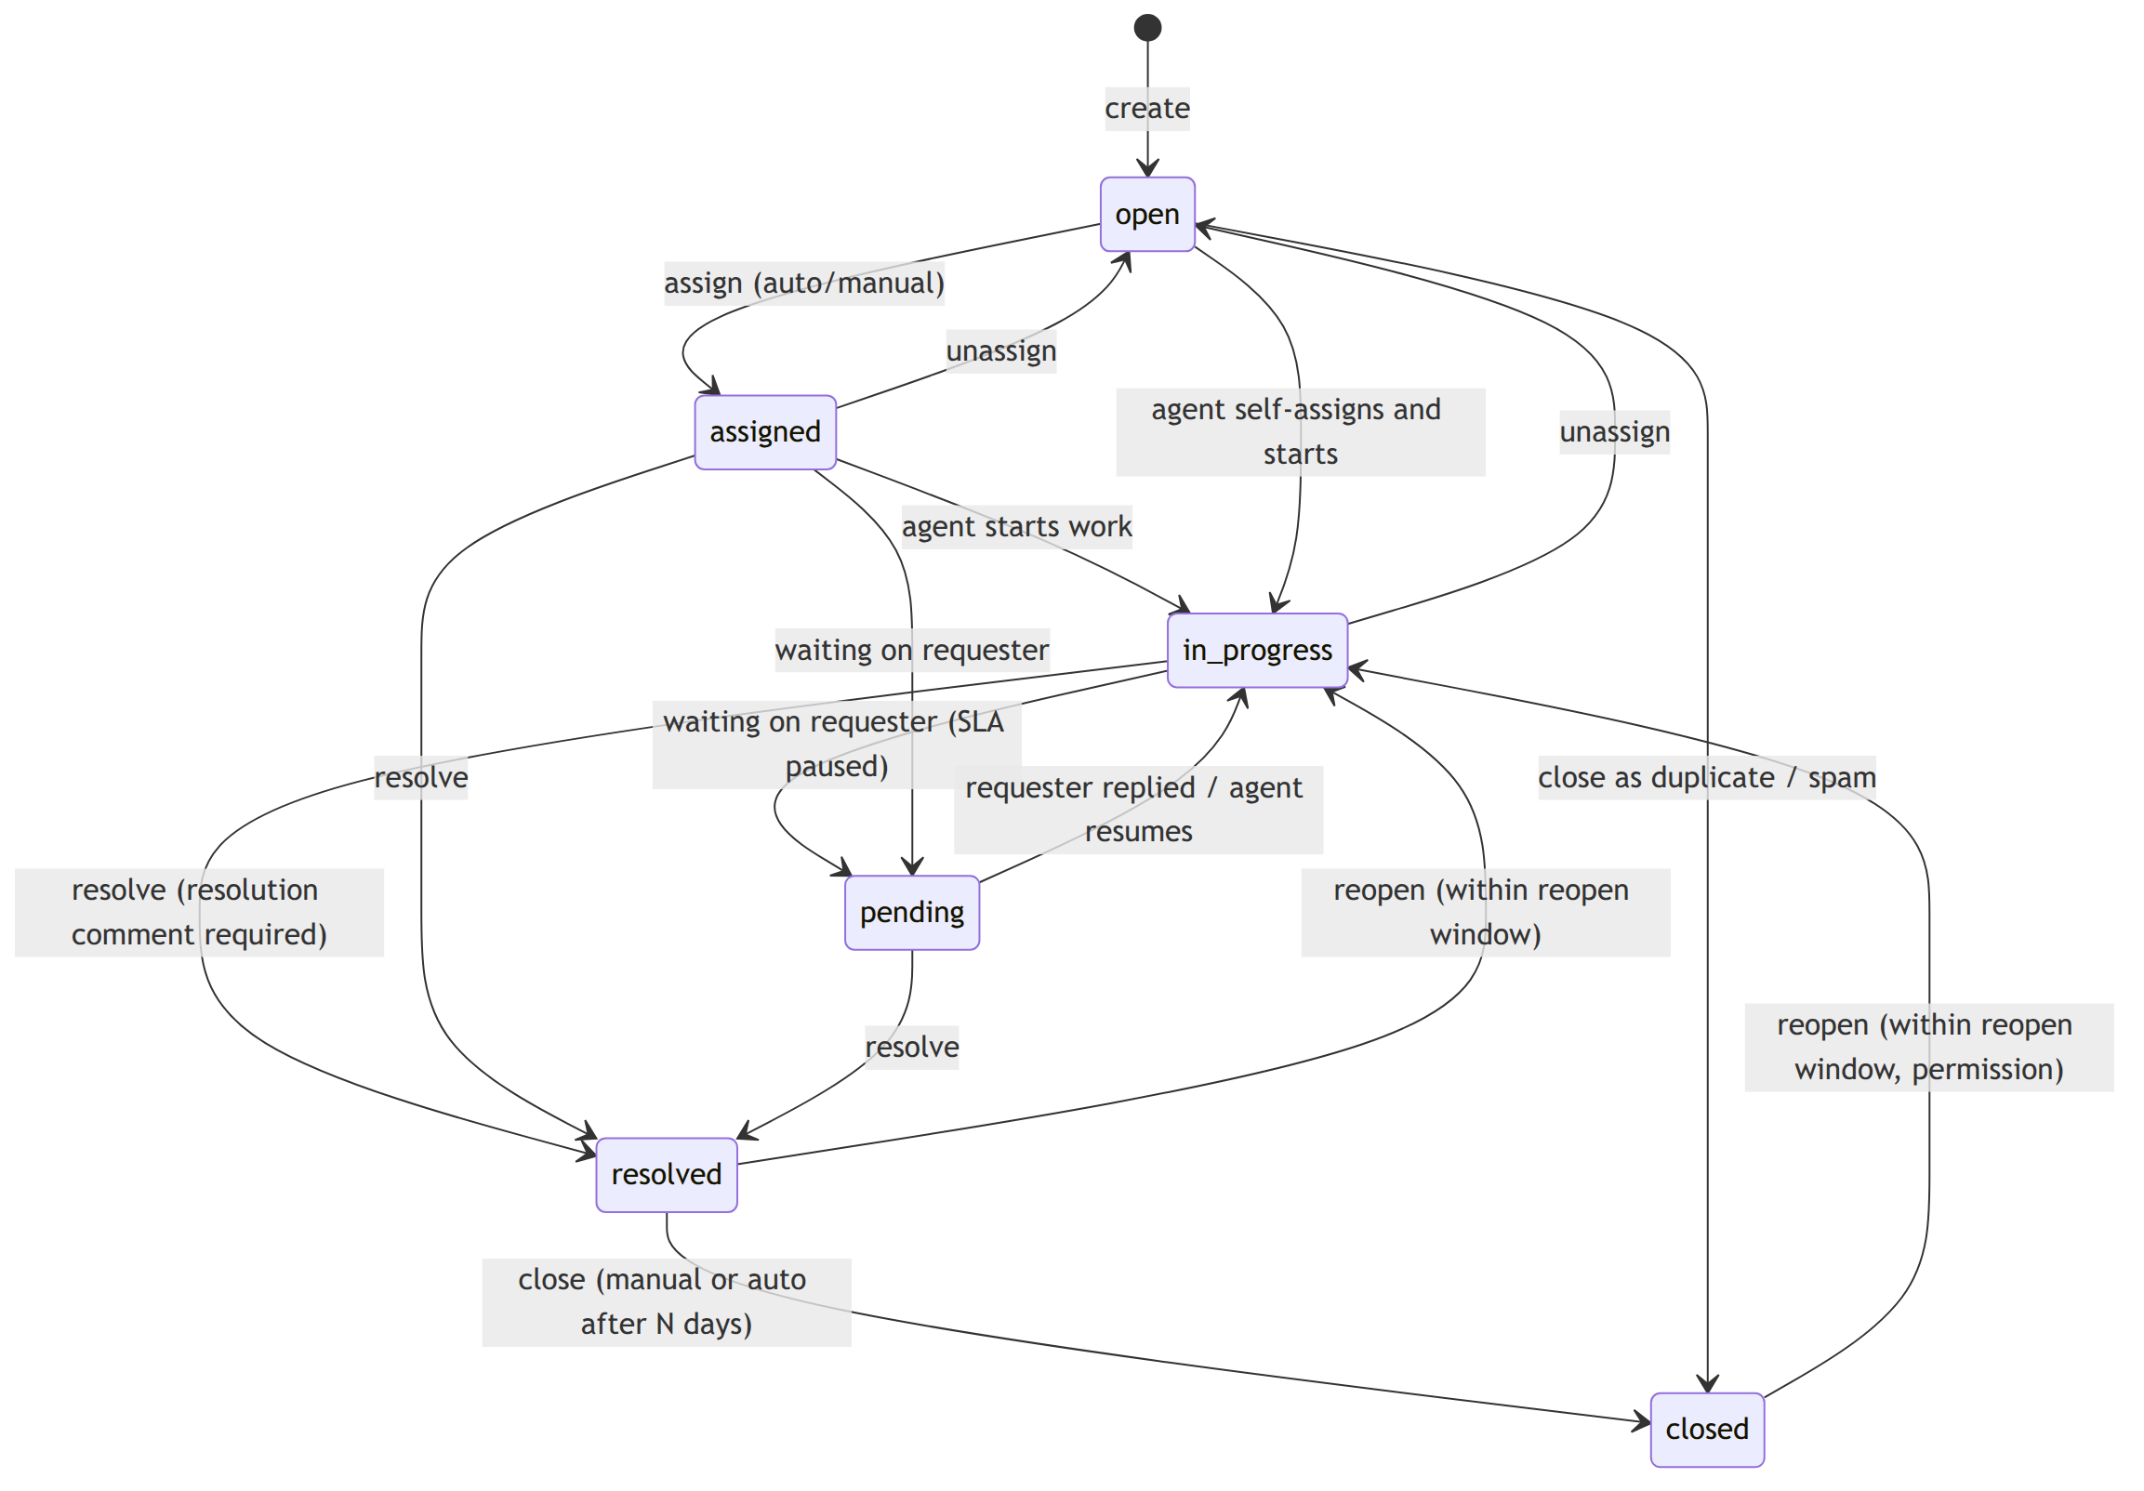
Figure 3.6: State diagram of the ticket lifecycle
Each ticket also has SLA timers that run concurrently with the lifecycle (Figure 3.7). A timer is running, paused, in warning, breached, met or cancelled; the two state machines interact only through events such as "ticket became pending" and "first public reply".
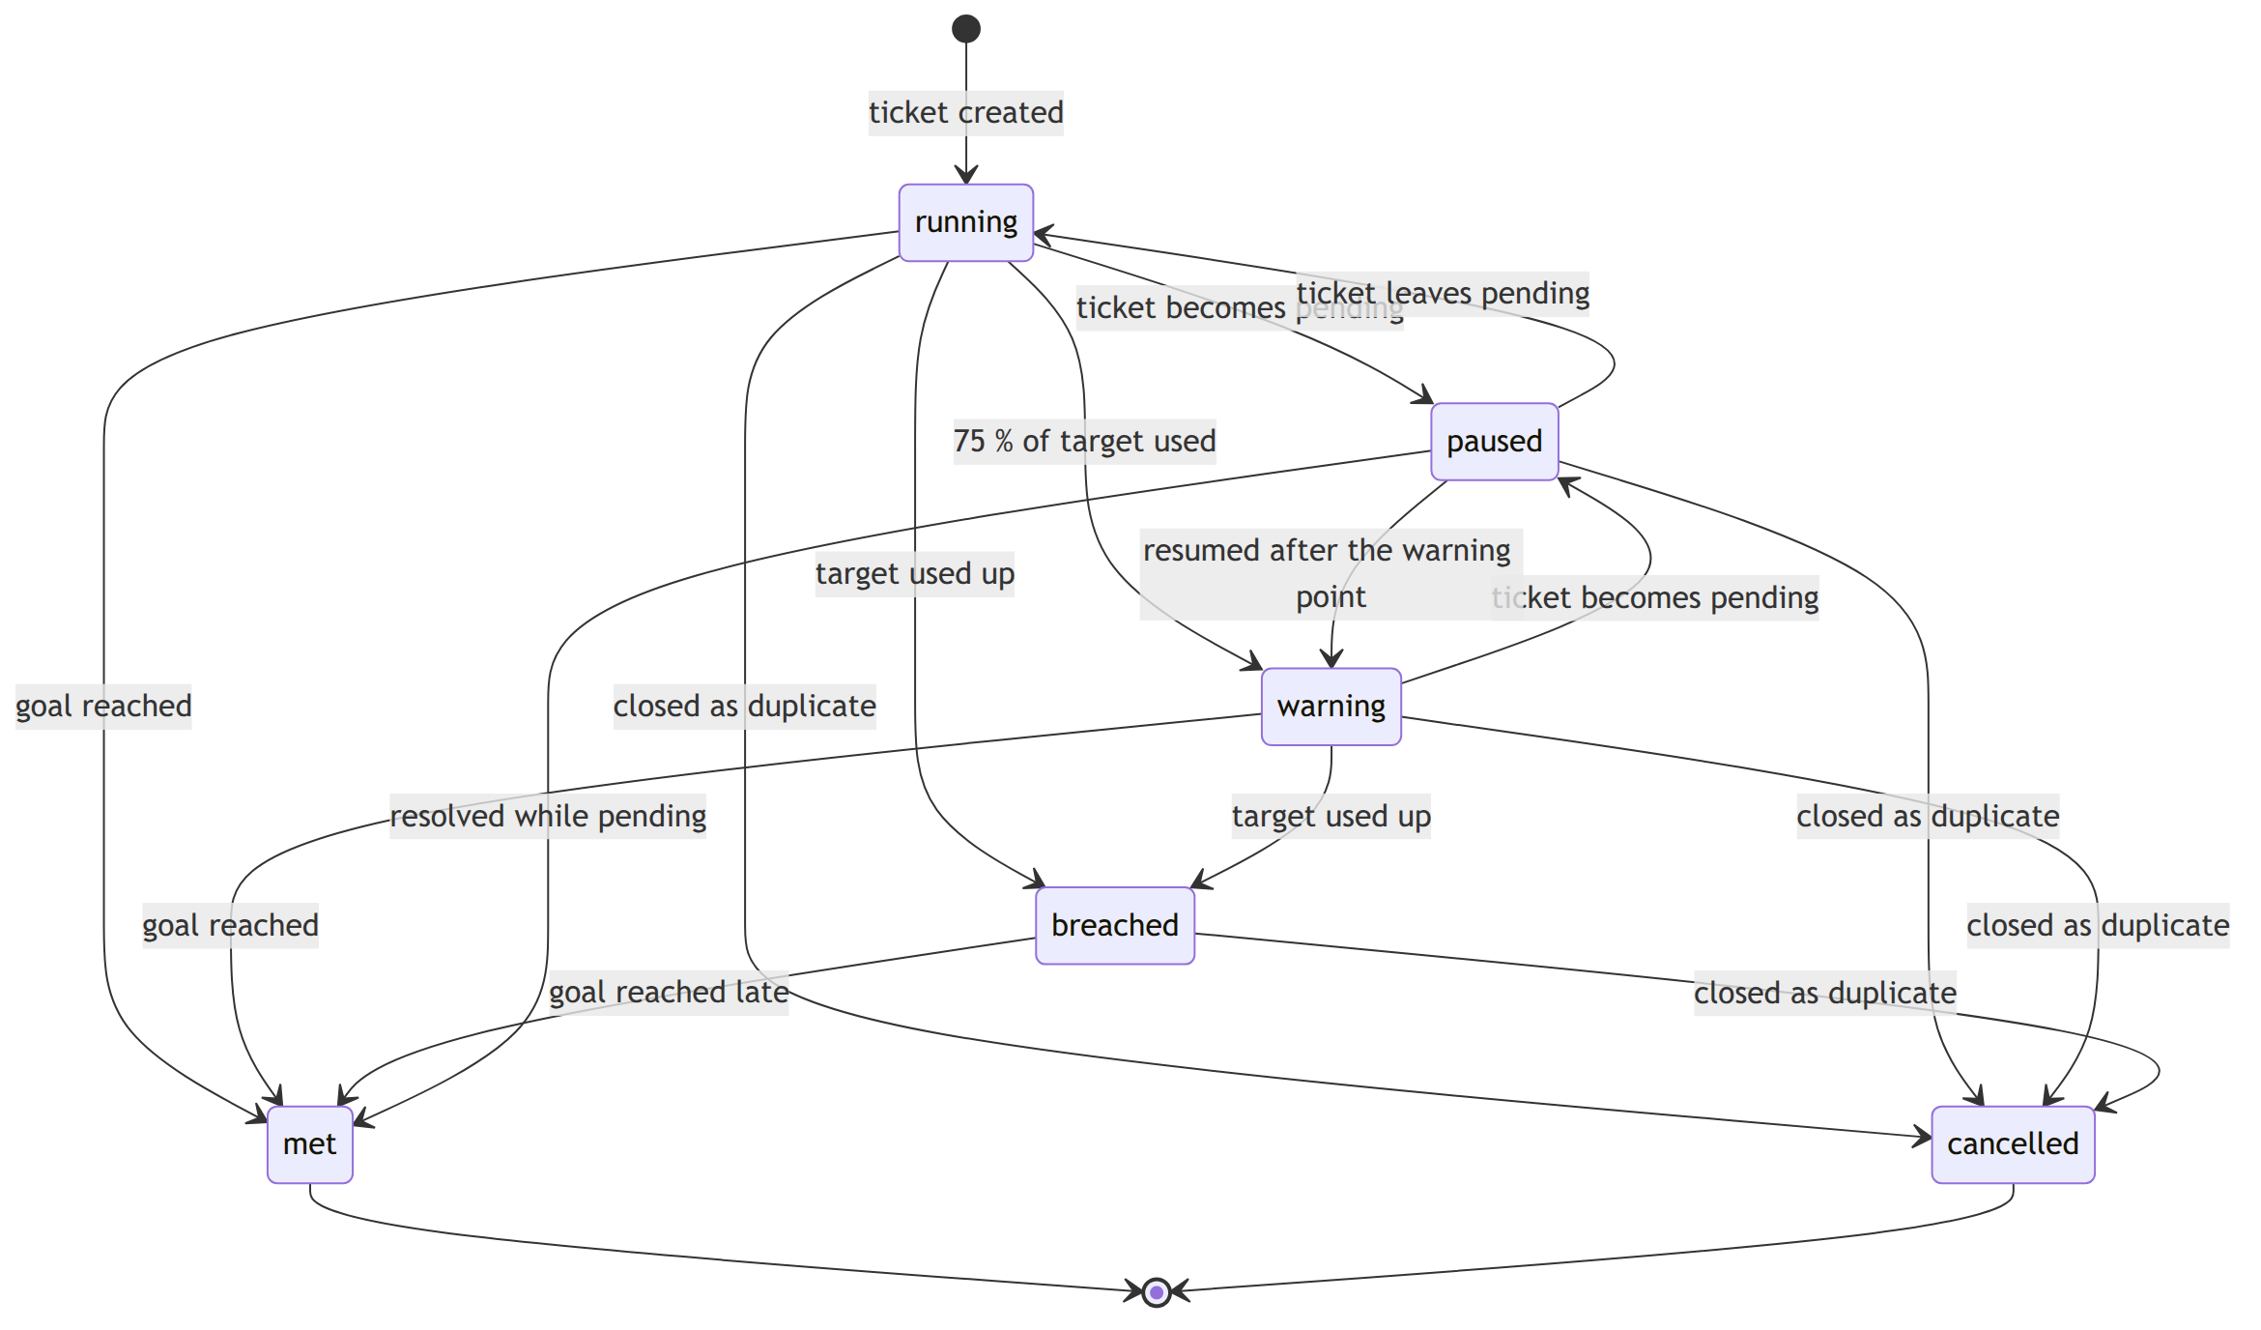
Figure 3.7: State diagram of an SLA timer
Figure 3.8 shows the sequence of creating a ticket, in which the create-ticket action calls the priority, SLA, duplicate and assignment strategies inside one database transaction and publishes events after commit. Figure 3.9 shows tenant resolution and login, Figure 3.10 the SLA sweep, Figure 3.11 webhook delivery with retries and Figure 3.12 processing of an inbound email.
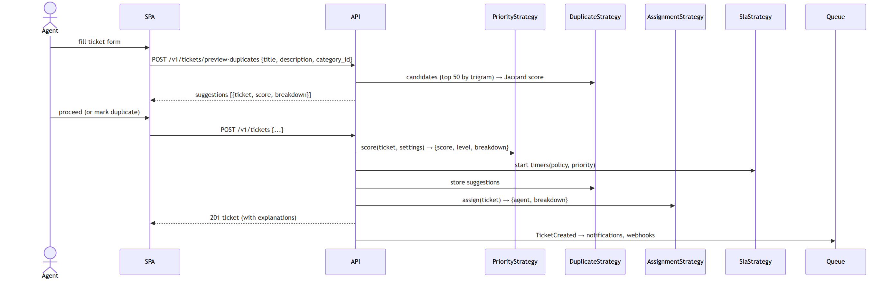
Figure 3.8: Sequence diagram of ticket creation with automation
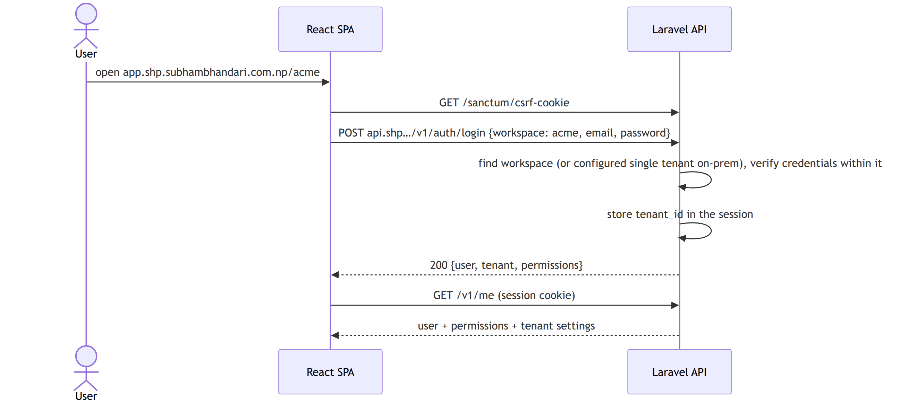
Figure 3.9: Sequence diagram of login and tenant resolution
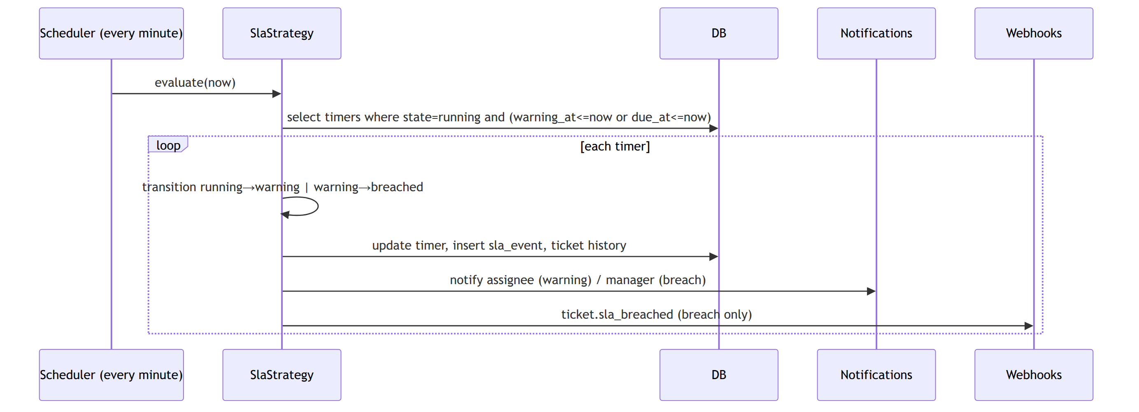
Figure 3.10: Sequence diagram of the SLA evaluation sweep
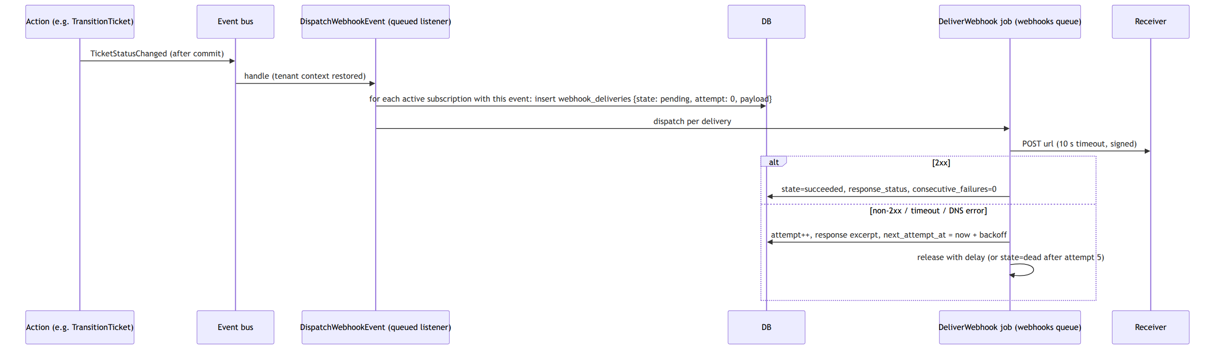
Figure 3.11: Sequence diagram of webhook delivery
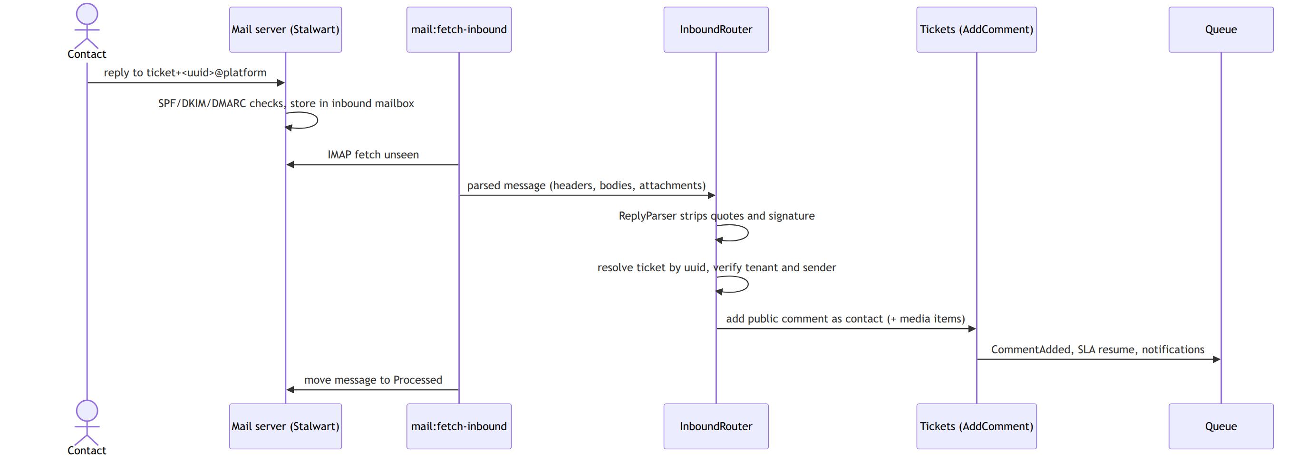
Figure 3.12: Sequence diagram of inbound email processing

3.1.5 Process Modelling using Activity Diagrams
Figure 3.13 shows the agent assignment activity, including the case where no agent is eligible. Figure 3.14 shows duplicate detection from word extraction to the threshold decision. Figure 3.15 shows the hourly re-evaluation of open tickets, and Figure 3.16 the routing of an inbound email to a comment, a new ticket or rejection.
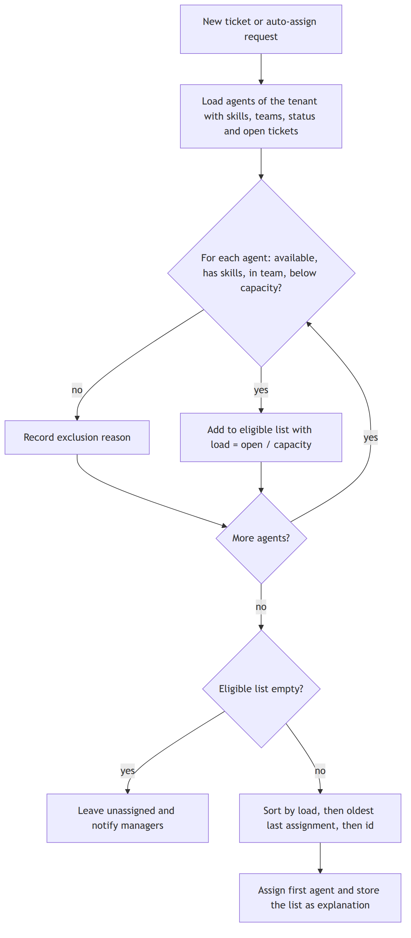
Figure 3.13: Activity diagram of agent assignment
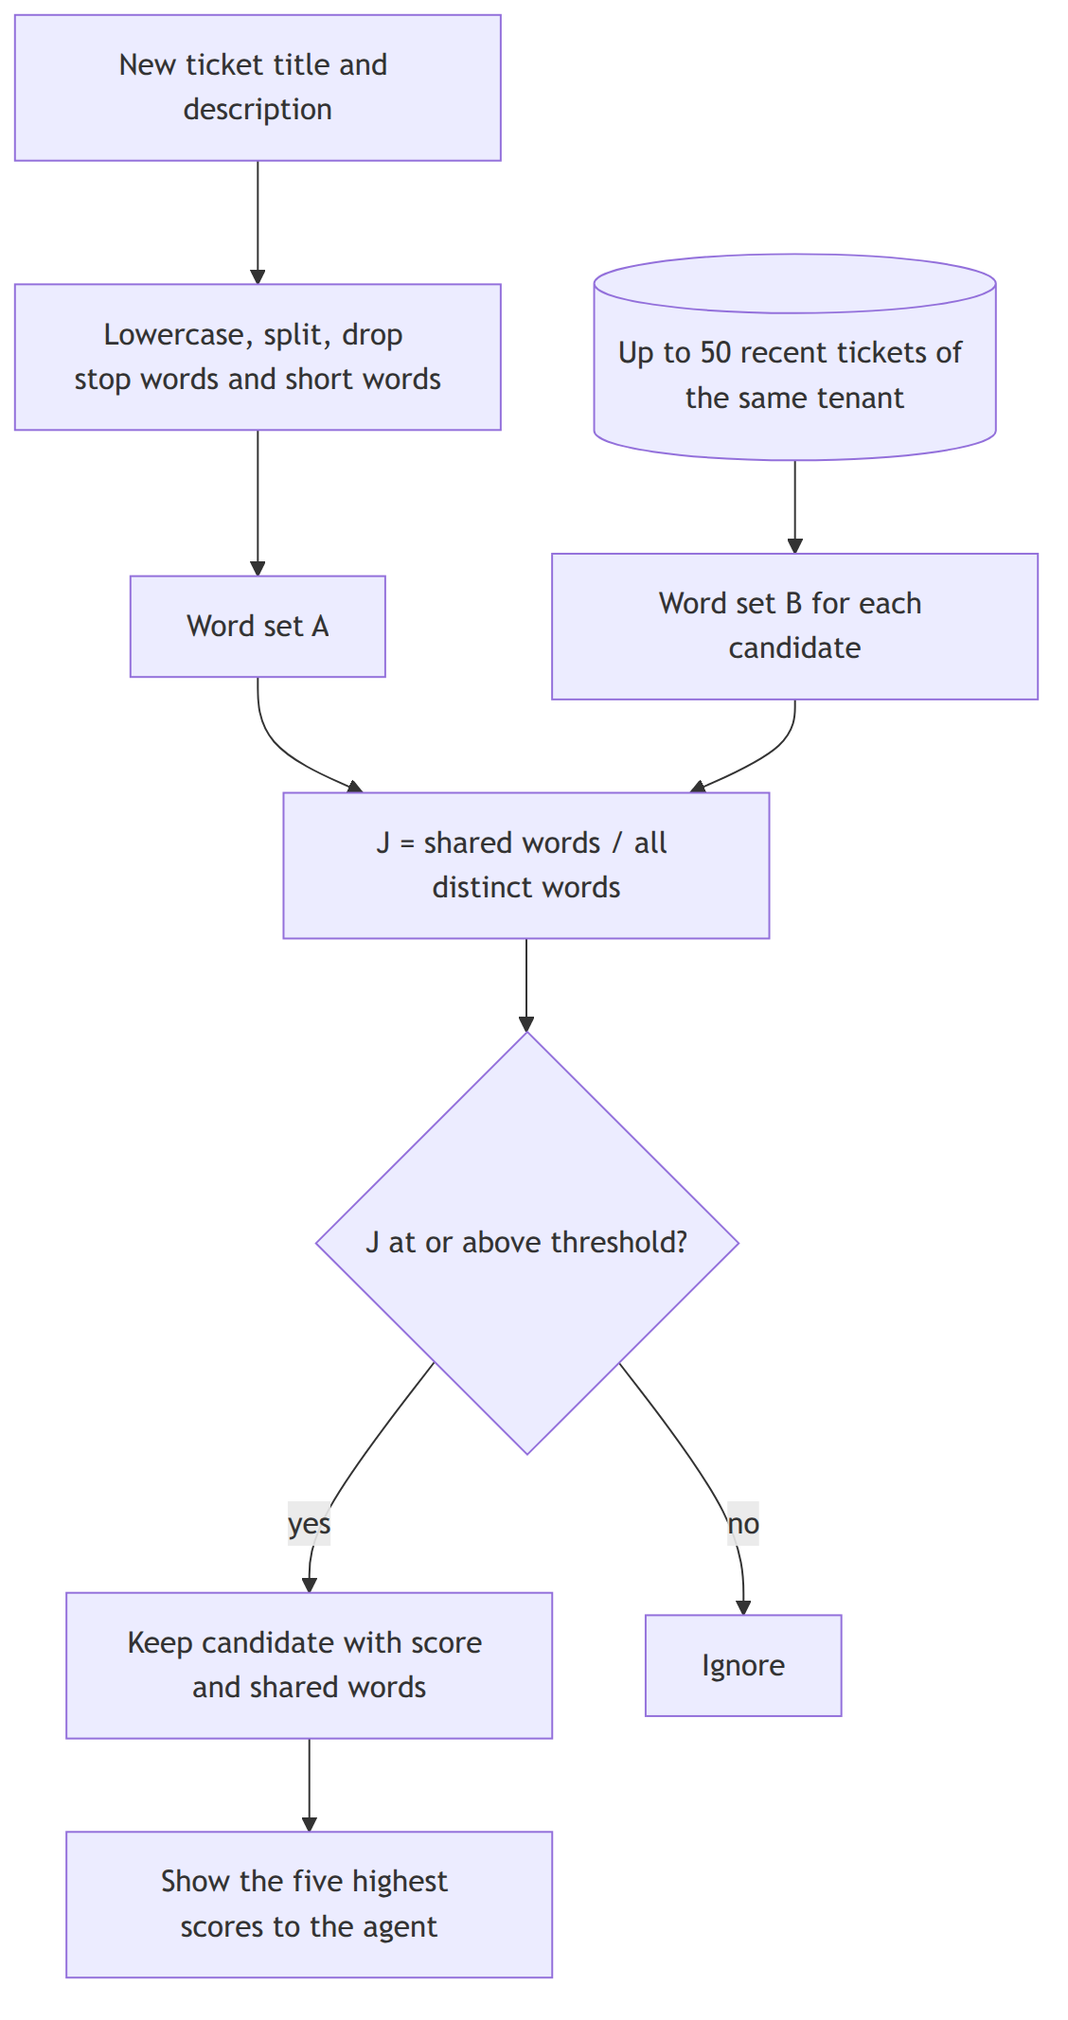
Figure 3.14: Activity diagram of duplicate detection
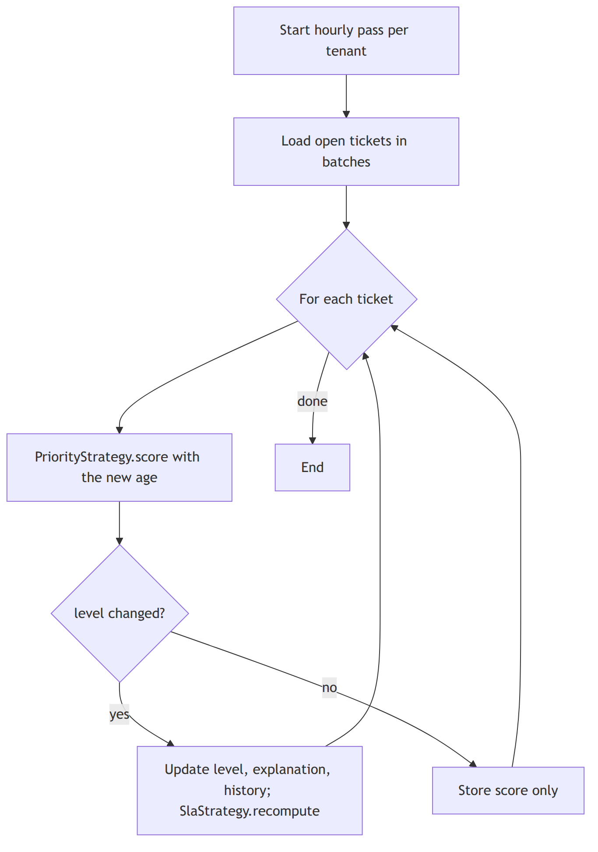
Figure 3.15: Activity diagram of hourly priority re-evaluation
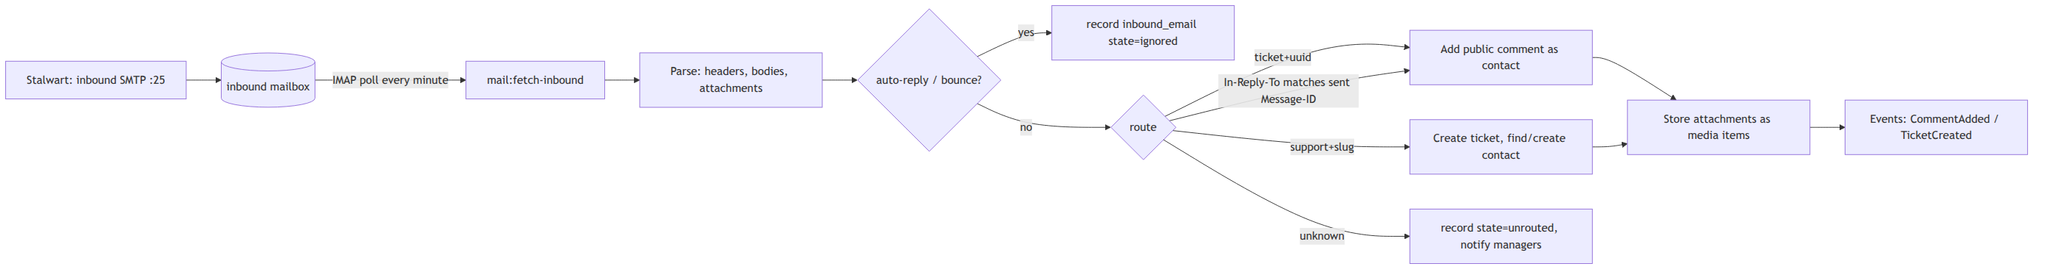
Figure 3.16: Activity diagram of inbound email routing

3.2 System Design

3.2.1 Refinement of Class, Object, State, Sequence and Activity Diagrams
The analysis classes were refined into implementation classes organised by module. Algorithms became strategy interfaces (PriorityStrategy, AssignmentStrategy, DuplicateStrategy, SlaStrategy) with baseline implementations (BasicWeightedPriority, LeastLoadedAgent, JaccardDuplicates, SimpleSlaTimer) and helper classes (WorkingHoursCalendar, ReplyParser) that receive plain input objects and return result objects containing an explanation. Write operations became single-purpose action classes (CreateTicket, AssignTicket, TransitionTicket, AddComment, RegisterUpload) that run inside transactions and publish events. The ticket state diagram became an enumeration with a transition table, and the SLA state diagram became a table-driven transition function. Figure 3.17 shows the refined class diagram of the automation module.
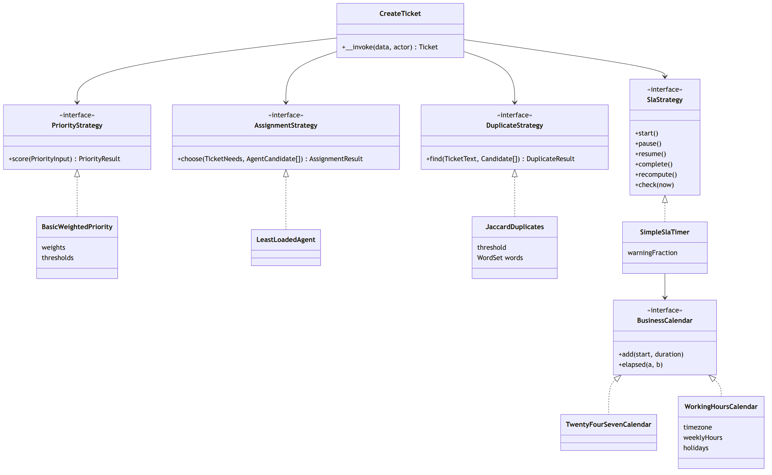
Figure 3.17: Replaceable algorithm strategies and their baseline implementations
The database design follows the refined classes (Figure 3.18). Every tenant-owned table has a tenant_id column and a row-level security policy; primary keys are UUID version 7; ticket numbers are allocated per tenant under a row lock; a generated full-text vector and trigram indexes support search and duplicate candidate retrieval.
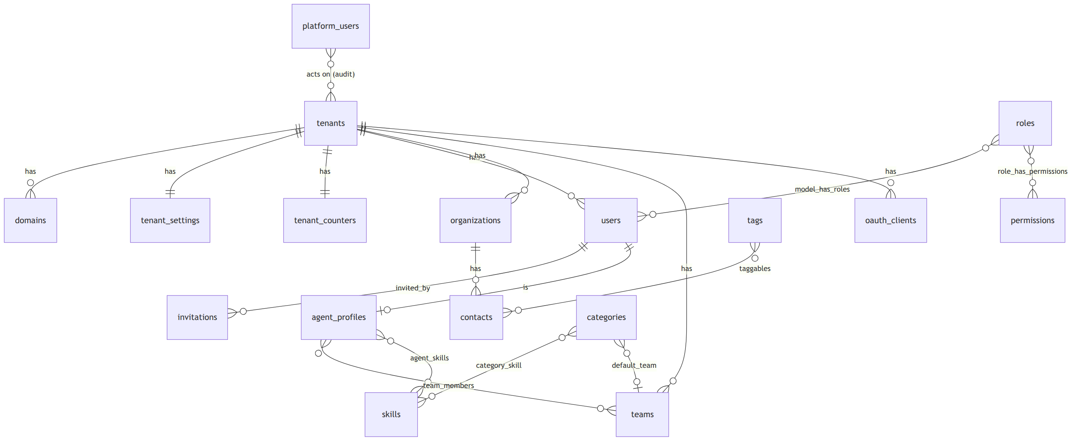
Figure 3.18: Entity relationship diagram

3.2.2 Component Diagrams
The backend is a modular monolith (Figure 3.19): Platform, Tenancy, Identity, Contacts, Agents, Tickets, SLA, Automation, Media, Mail, Notifications, Integrations, Reporting and Audit. Dependencies point in one direction; notification, integration, analytics and audit components only react to events or read data. The frontend is a single-page application divided into feature components (tickets, contacts, agents, SLA, automation settings, media, reports, dashboard, integrations) on top of a shared design system.
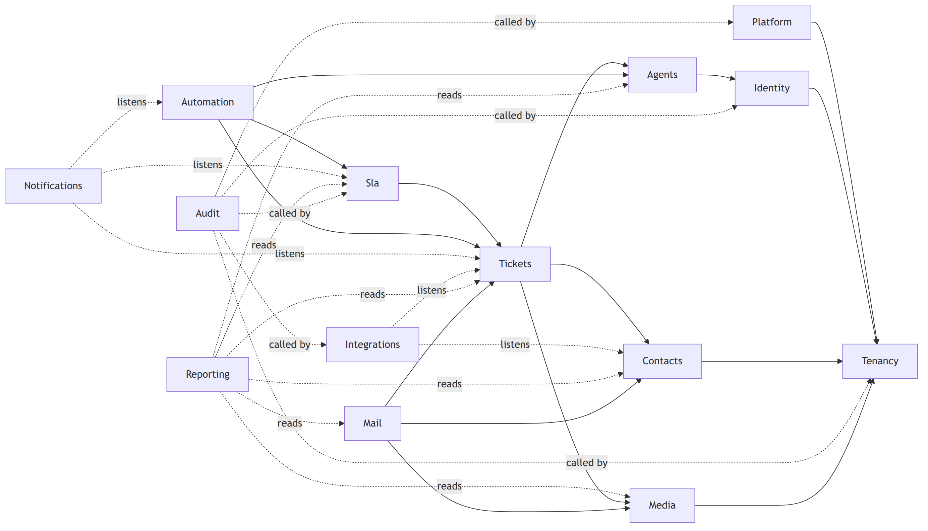
Figure 3.19: Component diagram

3.2.3 Deployment Diagrams
Figure 3.20 shows the deployment on one virtual machine. The platform is published under shp.subhambhandari.com.np with separate hosts for the application (app), API (api), platform administration (admin), monitoring (monitor), documentation (docs), file storage (files) and mail (mail); organisations are workspaces within the application's address, and the organisation of each request is taken from the user's session or the API client, never from the address. A Caddy reverse proxy terminates TLS for the fixed application hosts (application, API, administration, monitoring, documentation, files and mail under shp.subhambhandari.com.np) and serves the application; the PHP application, queue workers and scheduler run from one container image; PostgreSQL, Valkey, RustFS and the Stalwart mail server run as separate containers on an internal network. The same arrangement is used on a developer workstation, on an organisation's own server and on a virtual machine from any cloud provider; Ansible configures the host.
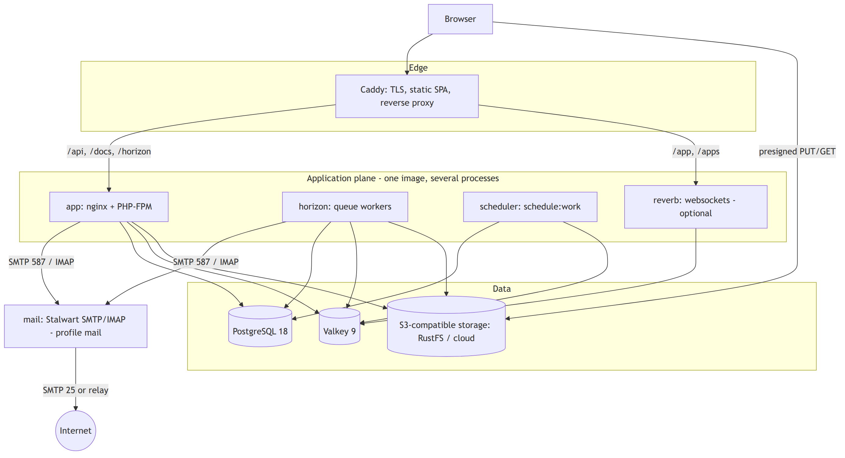
Figure 3.20: Deployment diagram

3.3 Algorithm Details
The four decision algorithms are deliberately simple baselines. Each is implemented behind an interface (strategy) so that it can be replaced by a stronger technique after this project without changing the rest of the system, and each decision stores the name and version of the strategy that made it.

3.3.1 Priority scoring: basic weighted priority
The priority score is a weighted sum of four values scaled to the range 0–1, a form of simple additive weighting [10]. Impact and urgency are the inputs commonly used by service-management tools [1]; customer tier reflects the importance of the requester; waiting time is an ageing term that raises tickets that have waited long [12].
Table 3.8: Inputs of the priority score
Input | Values | Scaled value | Weight
Impact | 1 (one user) to 4 (whole organisation) | (impact − 1) ÷ 3 | 0.40
Urgency | 1 (low) to 4 (immediate) | (urgency − 1) ÷ 3 | 0.35
Customer tier | standard, premium, enterprise | 0, 0.5, 1 | 0.15
Waiting time | hours since creation | min(1, hours ÷ 72) | 0.10

score = 100 × (0.40 × impact' + 0.35 × urgency' + 0.15 × tier' + 0.10 × age')
level = P1 if score ≥ 75, P2 if score ≥ 50, P3 if score ≥ 25, otherwise P4

function score(ticket, now):
total ← 0
for each (name, weight, scaled value) of the four inputs:
part ← 100 × weight × value
total ← total + part
record (name, value, weight, part) in the explanation
return total, level(total), explanation

The score is computed on creation, when an input changes and hourly for open tickets; a manager's manual priority always takes precedence. The cost is constant per ticket. For example, a ticket with impact 2, urgency 3 and a premium customer scores 13.3 + 23.3 + 7.5 + 3.3 = 47.5 (P3) after 24 hours and 54.2 (P2) after 72 hours, which shows the ageing effect.

3.3.2 Agent assignment: least-loaded eligible agent
The rule combines the least-connections method of load balancers [14] with the skill filter used in contact centres [16]. An agent is eligible when available (and on shift if shifts are enforced), holding all skills the category requires, in the ticket's team if one is set, and below capacity. Among eligible agents the one with the smallest ratio of open tickets to capacity is chosen; ties go to the agent assigned least recently, which behaves like round robin.
function choose(ticket, agents):
eligible ← agents that pass every eligibility rule (others recorded with the failed rule)
if eligible is empty: leave the ticket unassigned and notify managers
sort eligible by (open ÷ capacity, last assignment time, id)
return the first agent and the sorted list as explanation

The cost is O(A log A) for A agents. For example, if Asha and Chen both have 3 of 10 tickets and Bikram has 2 of 5, Bikram's load (0.40) is higher than theirs (0.30); Chen, assigned earlier than Asha, receives the ticket. Fairness is measured with Jain's index [18].

3.3.3 Duplicate detection: Jaccard word overlap
Following the first duplicate-report detectors, which compared the words of a new report with existing reports [42], each ticket is reduced to a set of words: the title and description are lower-cased, split on characters other than letters, digits and hyphens, and stripped of a fixed list of 117 stop words and of words shorter than three characters; hyphens are kept so that error codes such as err-401 survive, and any Unicode letter counts, so Devanagari words stay whole. Two sets are compared with the Jaccard similarity [20]:
J(A, B) = |A ∩ B| ÷ |A ∪ B|

function find(ticket, candidates): // same tenant, last 30 days, not closed, at most 50
A ← words(ticket)
for c in candidates:
B ← words(c)
if |A ∩ B| ÷ |A ∪ B| ≥ 0.35: keep (c, score, A ∩ B)
return the five highest scores

For "Cannot login after password reset" against "Login fails after resetting password", the sets share five of ten distinct words (J = 0.50) and the older ticket is suggested; an unrelated invoice ticket scores 0.15 and is ignored. The comparison costs O(K × W) for K candidates of about W words. The method is transparent but misses paraphrases and word forms, which the planned replacement addresses [21, 46].

3.3.4 SLA evaluation: simple SLA timer
Each ticket has a first-response timer and a resolution timer, each a small state machine [48] with the states running, paused, warning, breached, met and cancelled. Deadlines are computed through a calendar that counts either all hours or only the organisation's working hours.
start: due ← cal.add(now, target); warn ← cal.add(now, f × target) // f: the policy's warning fraction, default 0.75
enter pending: paused_at ← now
leave pending: d ← cal.elapsed(paused_at, now); due ← cal.add(due, d); warn ← cal.add(warn, d)
priority change: due ← cal.add(started_at, new target + paused time)
goal reached: state ← met (first public reply, or ticket resolved)
every minute: running and now ≥ warn → warning, notify assignee (once)
not met and now ≥ due → breached, notify assignee and managers (once)

For a P2 ticket with an eight-hour resolution target created at 09:00 and waiting for the customer from 10:00 to 12:00, the warning moves from 15:00 to 17:00 and the deadline from 17:00 to 19:00. With office hours of 10:00–17:00, an eight-hour target starting on Thursday at 15:00 ends on Friday at 16:00. The minute check reads only due timers through an index and records when each notification was sent, so running it twice has no additional effect.

3.3.5 History reconstruction and time analytics
A database trigger records each insert, update and delete on reportable tables as a change row containing only the attributes that changed, with their old and new values, the actor and the time. The state of a record at a past instant t is rebuilt by starting from the current row and undoing, newest first, every change made after t:
function asOf(entity, t):
changes ← changes of entity with occurred_at > t, newest first
state ← current row (or the last values stored in its delete change)
for c in changes:
if c is the creation: return "did not exist at t"
for (attribute, old, new) in c: state[attribute] ← old
return state

For analysis over time, each ticket's ordered events are swept into non-overlapping intervals of constant status, assignee, team and priority:
function intervals(events, calendar, now):
state ← initial state; start ← creation time; result ← []
for e in events ordered by time:
next ← apply(state, e)
if next ≠ state:
result.append(state, start, e.time, calendar.elapsed(start, e.time))
state, start ← next, e.time
result.append(state, start, open, calendar.elapsed(start, now))
return result

Time in a status is the sum of the matching intervals; the backlog at an instant is the number of unresolved intervals containing it; an agent's workload over time is the priority-weighted count of that agent's intervals. Reconstruction costs O(k) for k later changes and interval building O(e) for e events of a ticket. Daily snapshots are computed from the intervals after midnight in the organisation's time zone, and every derived table can be rebuilt from the recorded history and checked for drift.

Chapter 4: Implementation and Testing

4.1 Implementation

4.1.1 Tools Used
Table 4.1 lists the tools and the versions used in the final build, taken from the dependency lock files of the project.
Table 4.1: Tools and technologies
Category | Tool | Version | Purpose
Backend language and framework | PHP, Laravel | 8.5, 13.32 | API, queues, scheduling, mail, validation
Frontend | React, TypeScript, Vite | 19.3, 7.0, 8.3 | single-page application
Frontend libraries | TanStack Router, Query, Table, Form; Zod | 1.170, 5.103, 9.2, 1.33; 4.6 | routing, server state, tables, forms, validation
UI and styling | Tailwind CSS, shadcn/ui on Base UI, Lucide, Recharts | 4.3, 1.8 (Base UI), 1.47, 3.10 | design system, components, icons, charts
Database | PostgreSQL | 18.6 | relational data, full-text and trigram search, row-level security
Cache and queues | Valkey, Laravel Horizon | 9.1, 5.49 | cache, queues, locks, queue monitoring
Tenancy and access | Tenancy for Laravel, spatie/laravel-permission, Sanctum, Passport | 3.10, 8.3, 4.3, 13.8 | tenant context, permissions, sessions, OAuth 2.0
Real-time updates | Laravel Reverb | 1.11 | WebSocket broadcasting of ticket changes
Files and email | RustFS, intervention/image, Stalwart, webklex/laravel-imap | 1.0, 4.3, 0.16, 6.2 | object storage, thumbnails, mail server, inbound email
Reporting export | OpenSpout | 5.11 | XLSX export
API documentation | Scramble | 0.13 | OpenAPI 3.1 document and interactive reference
Testing | Pest, Vitest, Playwright, axe-core, MSW | 5.2, 5.0, 1.63, 4.13, 2.15 | unit, feature, component, end-to-end and accessibility tests
Code quality | Larastan, Pint, Biome | 3.12, 1.32, 2.5 | static analysis, formatting, linting
Infrastructure | Docker Compose, Caddy, Ansible, OpenTofu | 5.x, 2.11, 2.21, 1.12 | containers, reverse proxy and TLS, host configuration, cloud provisioning
CASE and diagramming | Mermaid | 11 | use case, class, object, state, sequence, activity, component and deployment diagrams
Editors and assistance | Visual Studio Code, Claude Code | — | development and AI-assisted coding under review
Version control and CI | Git, GitHub Actions | — | source control and automated checks on every push

4.1.2 Implementation Details of Modules
The backend is a modular monolith: each module is a namespace under app/Modules with its own routes, models, actions, domain classes, jobs, events, policies and migrations, and an architecture test rejects dependencies that point the wrong way. Write operations are single-purpose action classes that run inside one database transaction and publish events after commit. The four algorithms are pure PHP classes behind strategy interfaces; callers depend on the interface, never on the baseline class. The main classes of each module are described below.
Tenancy and platform. ResolveTenantFromPrincipal initialises the tenant of every authenticated request from the session set at login or from the API client's token, never from the host name; InitializeTenancyFromWorkspace handles the workspace named in the login request; EnsureTenantMembership rejects users and clients of other tenants and EnsureTenantActive blocks suspended tenants. RlsTenancyBootstrapper sets the PostgreSQL session variables used by row-level security and by the change-capture trigger, and the permission team of the current tenant. ProvisionTenant creates a tenant with its default roles, categories, SLA policy, calendar and settings. The platform console has its own guard and sign-in, separate from the tenants.
Identity. Session authentication (Sanctum) implements login, logout, invitation acceptance and password reset; roles are tenant-scoped sets of granular permissions (spatie/laravel-permission), and every endpoint declares the permission it needs, for example tickets.assign or sla.manage.
Tickets. TicketStatus is an enumeration holding the transition table of Figure 3.6. CreateTicket allocates the per-tenant ticket number under a row lock and calls the priority, SLA, duplicate and assignment strategies in one transaction; TransitionTicket, AddComment and MarkDuplicate implement the lifecycle; TicketListQuery applies filters, sorting and full-text search with server-side pagination.
Automation. The interfaces PriorityStrategy, AssignmentStrategy and DuplicateStrategy are bound in configuration to the baselines BasicWeightedPriority (returns a PriorityResult with its four parts), LeastLoadedAgent (returns an AssignmentResult with the ordered candidates and exclusion reasons) and JaccardDuplicates (uses WordSet and returns matches with their shared words). AssignTicket stores every assignment with its explanation, and a manager may override the choice with a recorded reason. Each baseline carries the AcademicBaseline attribute, which marks it for replacement after the defence.
SLA. SimpleSlaTimer, the baseline of SlaStrategy, implements start, pause, resume, complete, cancel, recompute and check as a table-driven state machine. WorkingHoursCalendar and TwentyFourSevenCalendar implement the BusinessCalendar interface, including holidays and daylight-saving changes; a scheduled command evaluates due timers every minute.
Media. RegisterUpload issues a short-lived presigned upload URL to object storage; CompleteUpload verifies size, type and checksum; the GenerateImageVariants job creates thumbnails; the tenant's storage quota is maintained under a row lock.
Mail. Outbound notifications carry threading headers and a reply address that identifies the ticket. The mail:fetch-inbound command reads the inbound mailbox through ImapInboundMailbox; ProcessInboundEmail parses the message, ReplyParser removes quoted text and signatures, and InboundRouter decides whether it becomes a comment, a new ticket or a recorded rejection.
Reporting. A migration installs the trigger function record_entity_change() on every reportable table. ChangeReplayer reconstructs a record as of any instant; IntervalBuilder and the RefreshTicketReport job maintain intervals and per-ticket facts; scheduled commands build daily snapshots and rebuild or verify the derived tables; ReportRunner executes the 28 catalogue ReportDefinition classes with allow-listed dimensions, measures and filters; the ExportReport job writes CSV and XLSX files to the media library.
Integrations. API clients obtain tokens with the OAuth 2.0 client credentials grant (Passport) and are bound to one tenant and a set of scopes. WebhookSigner signs each delivery with HMAC-SHA256 over a timestamp and the body; the DeliverWebhook job enforces timeouts and protection against requests to private addresses, and retries with exponential back-off.
Frontend. The single-page application is organised by feature (tickets, contacts, agents, SLA, automation, media, reports, integrations, settings) on a shared design system of semantic colour, typography, spacing and motion tokens with light, dark and system themes. DataTable binds TanStack Table to URL search parameters for server-side paging, sorting and filtering; forms use TanStack Form with Zod schemas and a save bar that warns about unsaved changes; every automated decision is shown in words with its stored explanation, and a record can be viewed as it was at a past moment. Figures 4.1 to 4.6 show the main screens.
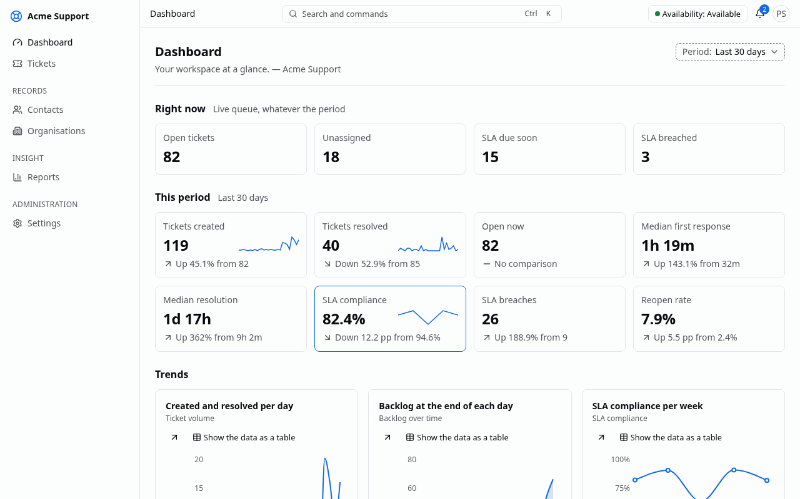
Figure 4.1: Management dashboard
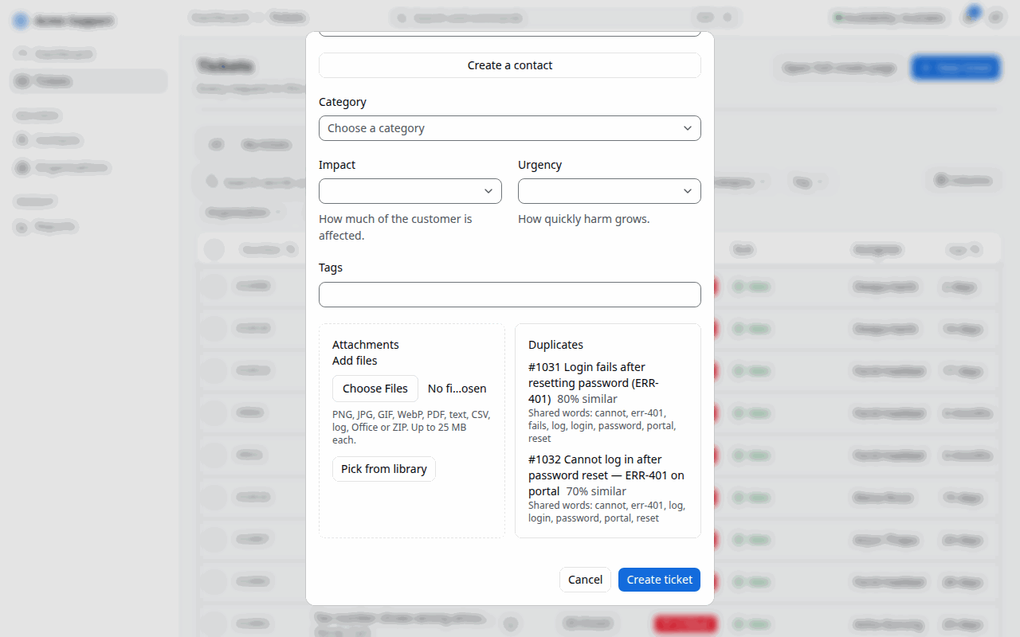
Figure 4.2: Duplicate suggestions while a ticket is created
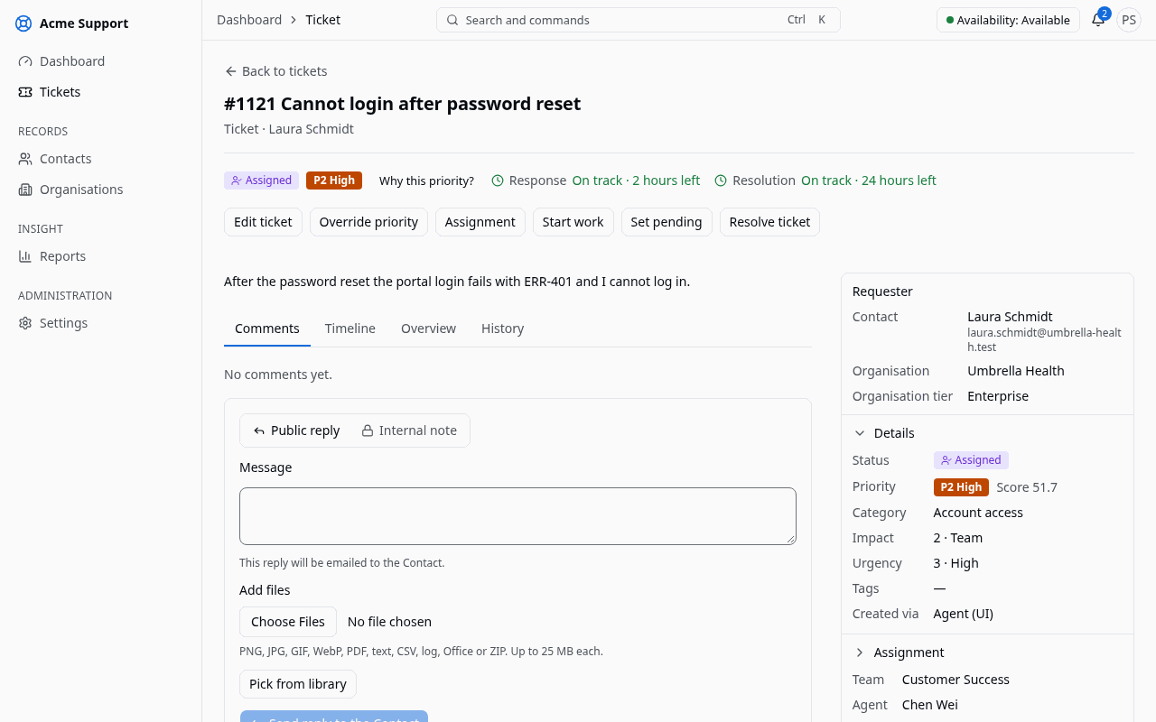
Figure 4.3: Ticket workspace with conversation, SLA timers and context panel
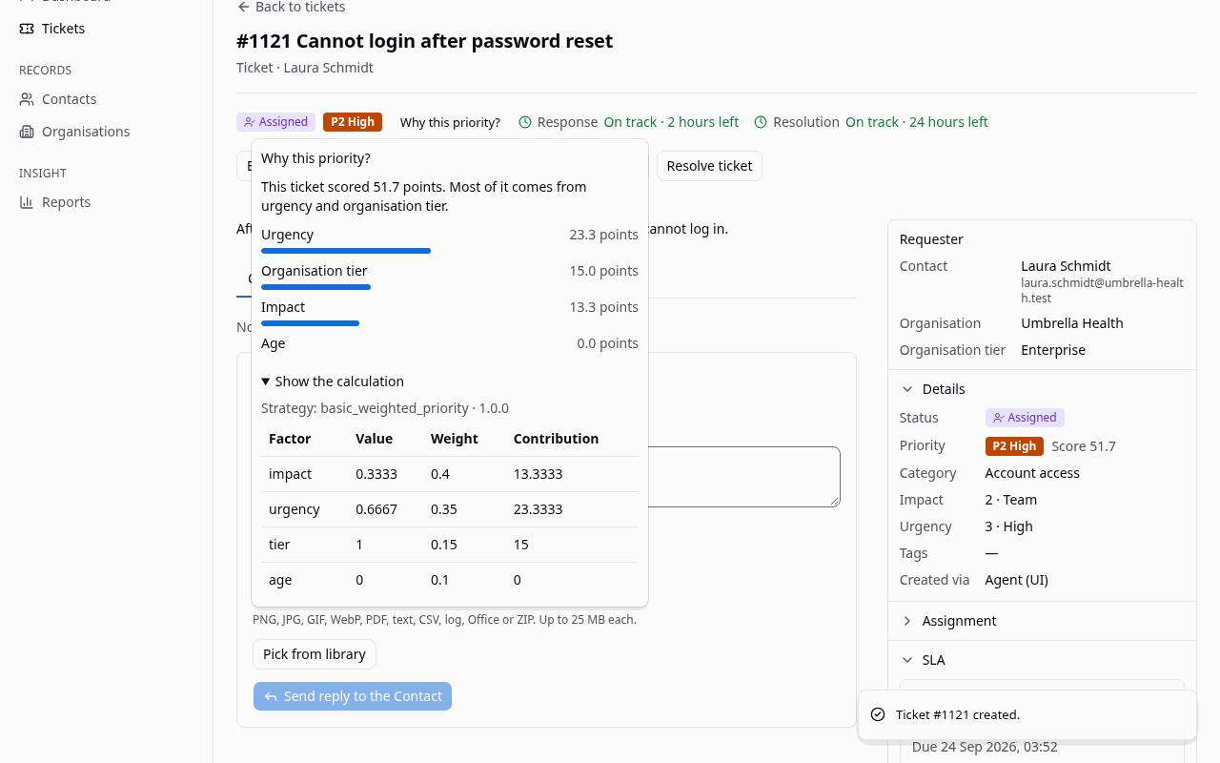
Figure 4.4: Priority explanation in words, with the calculation on request
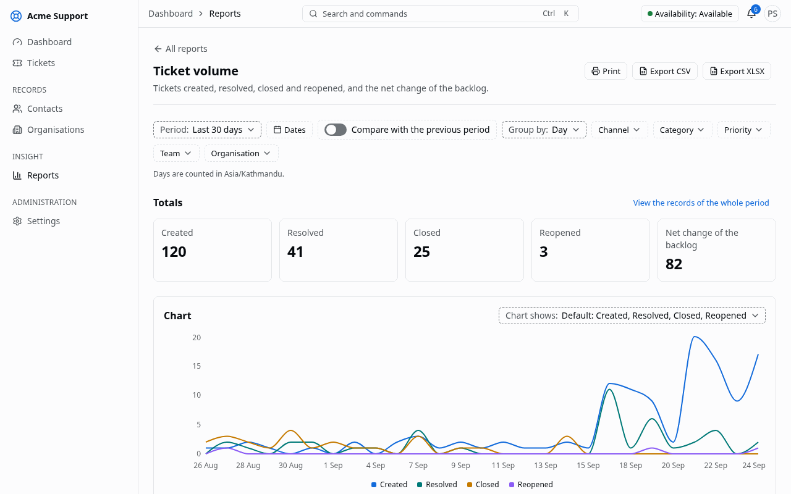
Figure 4.5: Report with parameters, chart and data table
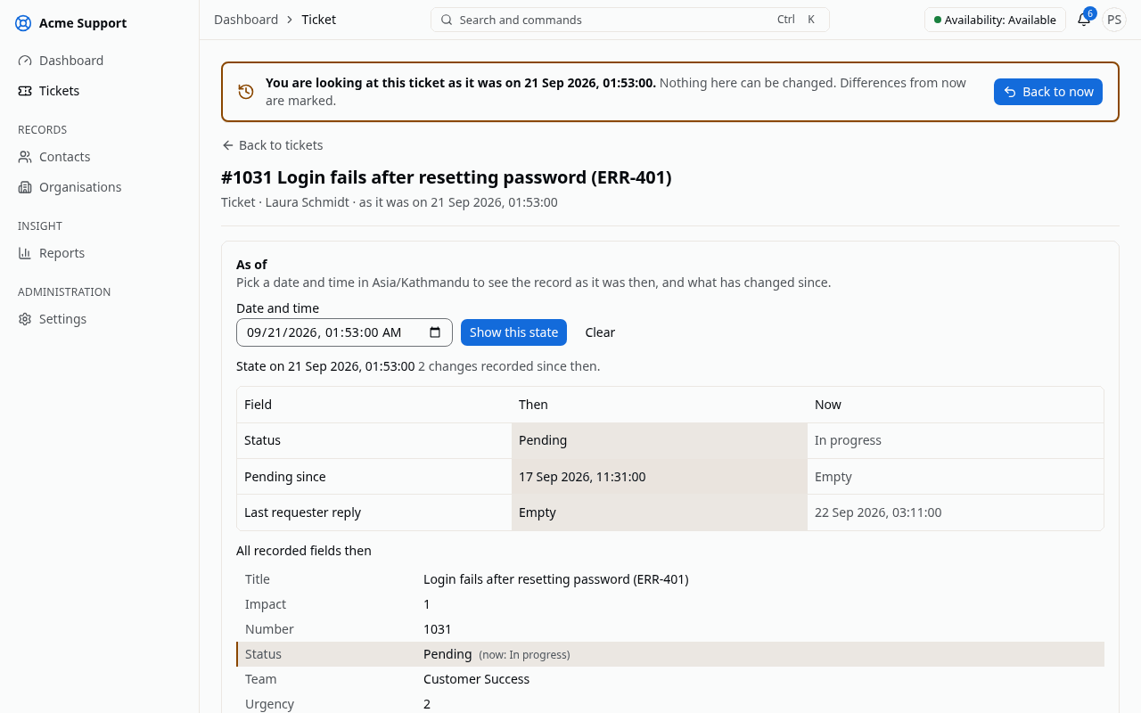
Figure 4.6: A ticket viewed as it was at a past moment

4.2 Testing
Testing followed a pyramid: fast unit tests for the algorithms and domain classes; feature tests for every API endpoint against PostgreSQL; a tenant isolation suite that tries to reach every tenant-owned model and endpoint from another tenant; a permission matrix for every role; contract tests that every strategy must pass; component tests of interactive screens in a real browser; and end-to-end tests of the main workflows against the running system, including automated accessibility scans. All suites ran in continuous integration on every push.
Table 4.2: Test summary
Level | Tool | Number of tests | Passed | Coverage
Backend unit (algorithms and domain) | Pest | 519 | 519 | algorithm baselines 100 %
Backend feature and API | Pest | 1 131 | 1 125 | backend overall 89.5 %
Tenant isolation | Pest | 226 | 225 | —
Permission matrix | Pest | 66 | 66 | —
Strategy contracts and architecture | Pest | 36 | 36 | —
Frontend unit | Vitest | 279 | 279 | —
Frontend component (real browser) | Vitest, MSW, axe-core | 319 | 319 | —
End-to-end and accessibility | Playwright, axe-core | 41 | 41 | —

No test failed. The seven backend tests not counted as passed were skipped, not failed: six reproducibility checks that regenerate the experiment tables need the experiments/ folder, which the application container does not mount, so the tables in Section 4.3 were reproduced separately with the experiment commands; one isolation check had no model of the kind it inspects. Coverage is line coverage measured with PCOV over the whole backend suite.

4.2.1 Test Cases for Unit Testing
Table 4.3 lists representative unit test cases. Each row is an automated test in the project; the last column names the test file under backend/tests.
Table 4.3: Unit test cases
ID | Module | Test case and input | Expected result | Result | Test file
UT-01 | Priority | Worked examples, e.g. impact 4, urgency 4, enterprise, 0 h | score 90.0, level P1; parts add up to the score | Pass | Unit/Automation/BasicWeightedPriorityTest
UT-02 | Priority | Ageing: impact 2, urgency 3, premium at 24 h and 72 h | 47.5 (P3), then 54.2 (P2) | Pass | Unit/Automation/BasicWeightedPriorityTest
UT-03 | Priority | Scores exactly 75, 50 and 25 | levels P1, P2 and P3 at the boundary | Pass | Unit/Automation/BasicWeightedPriorityTest
UT-04 | Priority | Manual override of a computed P3 to P1 | effective level P1, computed score kept | Pass | Unit/Automation/BasicWeightedPriorityTest
UT-05 | Priority | Weights not adding up to 1; impact 5 | rejected with a settings or input error | Pass | Unit/Automation/BasicWeightedPriorityTest
UT-06 | Assignment | Agent without a required skill, at capacity, off shift, away | excluded, each with its reason | Pass | Unit/Automation/LeastLoadedAgentTest
UT-07 | Assignment | Loads 3/10, 2/5, 3/10 | an agent with load 0.30 wins, not the one with fewest tickets | Pass | Unit/Automation/LeastLoadedAgentTest
UT-08 | Assignment | Equal loads, different last assignments | the agent assigned longest ago wins (worked example: Chen) | Pass | Unit/Automation/LeastLoadedAgentTest
UT-09 | Assignment | No eligible agent | nobody assigned, every candidate explained | Pass | Contracts/BaselineStrategiesTest
UT-10 | Assignment | Jain's index for equal loads and for one agent holding everything | 1 and 1/n | Pass | Unit/Automation/FairnessIndexTest
UT-11 | Duplicates | Word extraction of a ticket with the code "ERR-401" | lower-case words, err-401 kept, stop words and short words dropped | Pass | Unit/Automation/WordSetTest
UT-12 | Duplicates | Identical and disjoint word sets | Jaccard 1 and 0 | Pass | Unit/Automation/JaccardDuplicatesTest
UT-13 | Duplicates | Worked example: login-after-reset pair and an invoice ticket | 0.50 suggested, 0.15 ignored | Pass | Unit/Automation/JaccardDuplicatesTest
UT-14 | Duplicates | Eight candidates above the threshold | the five best, ordered by score, then newest, then id | Pass | Unit/Automation/JaccardDuplicatesTest
UT-15 | SLA | No reply, checked every minute | warning at 09:45 and breach at 10:00, once each | Pass | Unit/Sla/SimpleSlaTimerTest
UT-16 | SLA | Pending from 10:00 to 12:00 | warning moves to 17:00 and due time to 19:00 | Pass | Unit/Sla/SimpleSlaTimerTest
UT-17 | SLA | 8 h target from Thursday 15:00, office 10:00–17:00 | due Friday 16:00 | Pass | Unit/Sla/WorkingHoursCalendarTest
UT-18 | SLA | Holiday inside the timer | holiday skipped | Pass | Unit/Sla/WorkingHoursCalendarTest
UT-19 | SLA | Priority raised to P1 at 13:00 after a pause | due 15:00, warning 14:00, recomputed from the start | Pass | Unit/Sla/SimpleSlaTimerTest
UT-20 | Tickets | Every pair of the six statuses | exactly the documented transitions allowed | Pass | Unit/Tickets/TicketStatusTest
UT-21 | Mail | Replies from Gmail, Outlook and Apple Mail | only the new text kept | Pass | Unit/Automation/ReplyParserTest
UT-22 | Strategies | Each baseline through its contract | deterministic, bounded, order-independent, explained with strategy name and version | Pass | Contracts/BaselineStrategiesTest
UT-23 | History | 500 random seeded histories | as-of result equals every saved version and forward replay | Pass | Unit/Reporting/ChangeReplayerTest
UT-24 | History | Created, assigned, pending, resolved and reopened events | intervals with correct wall-clock and business durations | Pass | Unit/Reporting/IntervalBuilderTest
UT-25 | History | Update that changes nothing reportable | no change row written | Pass | Feature/Reporting/ChangeCaptureTest
UT-26 | Webhooks | Known payload, secret and timestamp; tampered body; old timestamp | matches the test vector; tampered and replayed deliveries rejected | Pass | Unit/Integrations/WebhookSignerTest

4.2.2 Test Cases for System Testing
System tests exercise the complete system: browser, API, queues, database, object storage and mail. Rows marked E2E are automated Playwright tests run against the running stack; rows marked rehearsal were verified by the scripted demonstration rehearsal (tools/demo-rehearsal), which passed all 25 of its steps on the final build; the deployment row was verified on the live cloud instance.
Table 4.4: System test cases
ID | Scenario | Steps | Expected result | Evidence | Status
ST-01 | User onboarding | owner invites a user; user accepts; user signs in | user pending until acceptance, then works with the invited role | E2E users.spec | Pass
ST-02 | Golden path | agent creates a ticket; system prioritises, suggests duplicates, assigns and starts SLA; agent replies, sets pending, resolves and closes | each step visible with its explanation; first response met; SLA paused while pending | E2E golden-path.spec | Pass
ST-03 | Duplicate handling | create a ticket similar to an existing one | suggestion with score and shared words before saving | E2E golden-path.spec; rehearsal | Pass
ST-04 | SLA warning and breach | advance the clock past the warning and due times | timer shows due soon, then breached; assignee and managers notified; webhook sent | rehearsal (demo-tick) | Pass
ST-05 | Tenant isolation | a user of tenant B opens tenant A's ticket URL and API resource | not found in the interface and 404 from the API; list holds only B's tickets | E2E isolation.spec | Pass
ST-06 | Email reply | contact replies to a notification email | reply appears as a public comment on the ticket | rehearsal; live mail round trip | Pass
ST-07 | Integration | API client gets a token and creates a ticket; client revoked; webhook receiver verifies a delivery; a refused delivery is retried | ticket created; revoked token refused; signed delivery verified; retry succeeds | E2E api-clients.spec, webhooks.spec | Pass
ST-08 | Reporting and history | open a report, export CSV; drill into a day's number; open a ticket's history as of three days earlier | numbers match the records; earlier state shown; file downloaded | E2E reports.spec | Pass
ST-09 | Theme and accessibility | switch themes; reload; scan the main screens and dialogs in light and dark | preference kept; no serious or critical accessibility violations | E2E theme.spec, accessibility.spec | Pass
ST-10 | Deployment | provision a cloud virtual machine with OpenTofu and configure it with Ansible | HTTPS instance with the demonstration workspace and working mail | live instance | Pass

4.3 Result Analysis
All experiments were run with fixed random seeds on versioned datasets, and every number below is taken from the experiment output files (experiments/results/v1). Two runs with the same seed produce identical results, which an automated test checks.

4.3.1 Agent assignment fairness
The synthetic workload contained eight agents with different skills and capacities and 500 tickets with seeded arrival times and handling times [53]. Three policies were compared on the same workload: random choice among qualified agents, round robin among qualified agents, and the least-loaded baseline.
Table 4.5: Assignment fairness by policy (final state after 500 tickets)
Policy | Jain's index | Std. deviation | Max open | Min open | Capacity overflows
Random (skills respected) | 0.786 | 3.59 | 14 | 3 | 74
Round robin (skills respected) | 0.865 | 2.71 | 13 | 4 | 36
Least-loaded eligible agent (baseline) | 0.967 | 1.27 | 9 | 5 | 0

The least-loaded rule distributed work most evenly: its Jain's index was 0.967 against 0.865 for round robin, and the spread between the busiest and the least busy agent fell from 11 tickets (random) to 4. It is also the only policy that never placed an agent above capacity, because capacity is part of its eligibility rule; round robin overloaded agents 36 times and random choice 74 times. Averaged over the whole run, its index stayed at 0.955, so the fairness is not an artefact of the final moment (Figures 4.7 and 4.8).
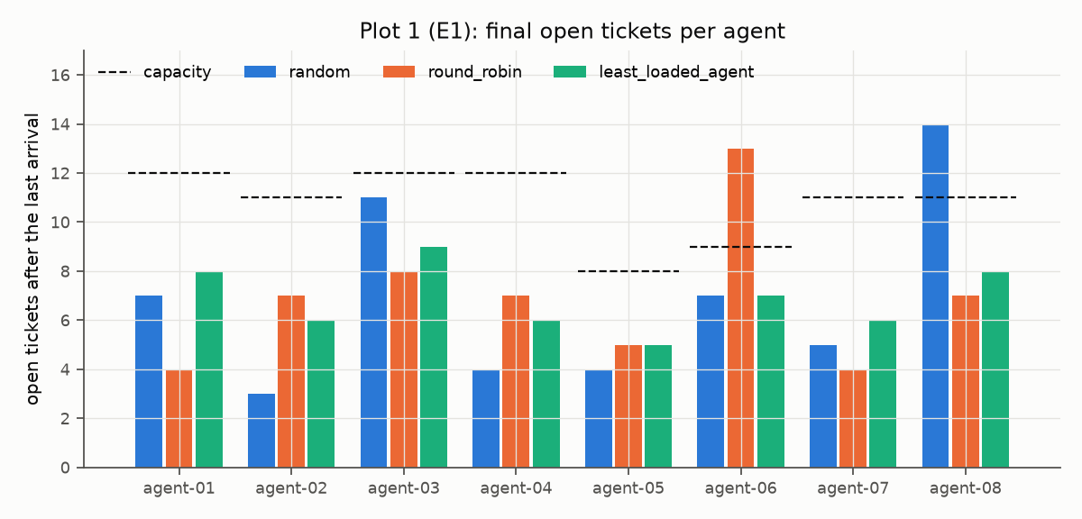
Figure 4.7: Final open tickets per agent under each policy
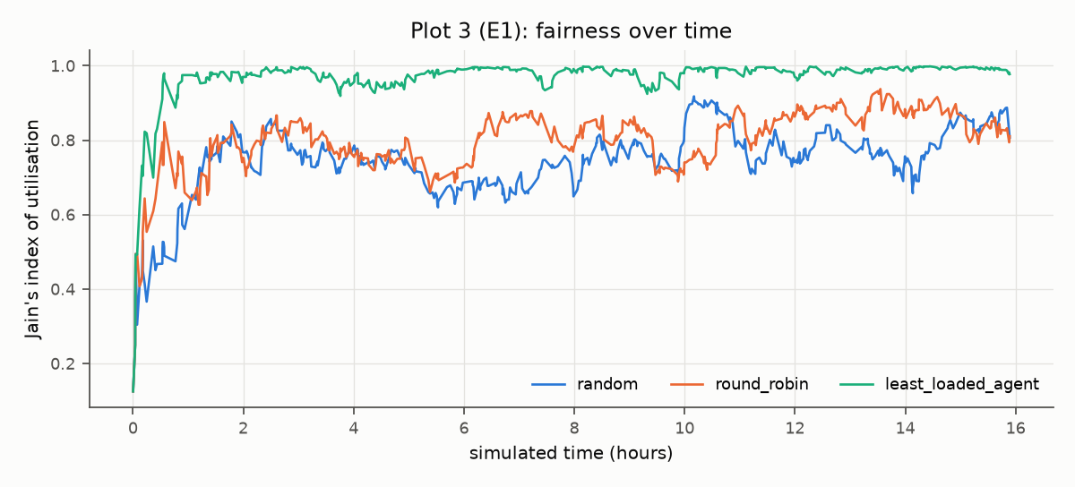
Figure 4.8: Jain's fairness index over time under each policy

4.3.2 Duplicate detection accuracy
The labelled dataset contained 300 ticket pairs: 100 duplicates (60 generated by dropping and swapping words, 40 written by hand) and 200 non-duplicates, 50 of which came from the same category to make them hard. Table 4.6 shows the Jaccard check on all pairs at several thresholds. The threshold was then chosen on 70 % of the pairs and the result reported on the remaining 30 %. Accuracy is not reported because non-duplicates dominate [20].
Table 4.6: Jaccard duplicate check at selected thresholds (all 300 pairs, title and description)
Threshold | TP | FP | FN | Precision | Recall | F1
0.25 | 84 | 12 | 16 | 0.875 | 0.84 | 0.857
0.35 (default) | 76 | 3 | 24 | 0.962 | 0.76 | 0.849
0.45 | 66 | 0 | 34 | 1.000 | 0.66 | 0.795
0.55 | 62 | 0 | 38 | 1.000 | 0.62 | 0.765

On the held-out 30 %, the default threshold of 0.35 gave precision 0.95, recall 0.70 and F1 0.81; the threshold chosen on the training pairs (0.30) gave F1 0.84. Raising the threshold removes false suggestions but loses duplicates quickly, and the default keeps false suggestions rare, which matters because every wrong suggestion costs an agent's attention.
Table 4.7: Word sets compared (held-out F1 and Recall@5 among 5 100 tickets)
Configuration | Best threshold | F1 at best threshold | F1 at 0.35 | Recall@5 (ranking)
Title only | 0.15 | 0.952 | 0.667 | 0.03
Title and description (baseline) | 0.30 | 0.836 | 0.808 | 0.92
Runeson et al., top five (reported) [42] | — | — | — | 0.30

Titles alone separate the labelled pairs well only at a very low threshold, and they fail when the duplicate must be found among 5 100 tickets: Recall@5 drops to 0.03 because short titles share few words with each other and many with unrelated tickets. With the description included, the true duplicate was among the top five suggestions for 92 % of the queries, well above the 30 % that Runeson et al. reported for a comparable lexical method on real bug reports. The synthetic data is cleaner than real tickets, so this comparison indicates the method's potential rather than its field performance.
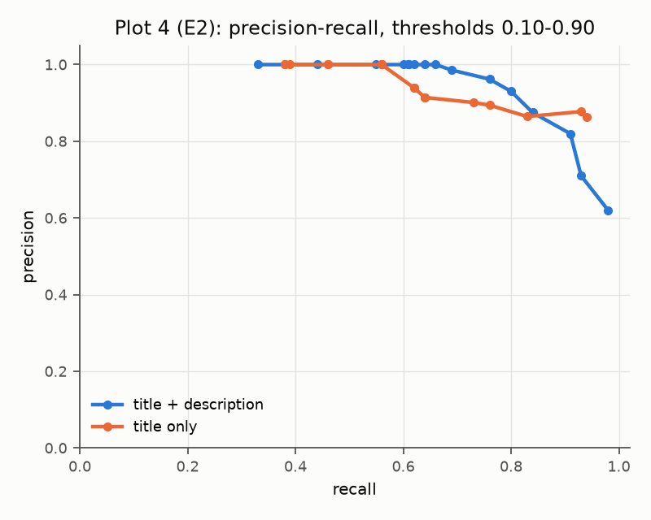
Figure 4.9: Precision and recall of the Jaccard check by threshold

4.3.3 Priority scoring behaviour
All 12 designed scenarios produced the expected score and level. For sensitivity, each weight was changed by ±0.1 while the others were rescaled so that the weights still sum to one, and the table counts how many of 200 generated tickets changed level [54].
Table 4.8: Effect of weight changes on priority levels (200 tickets)
Weight changed | −0.1: tickets changing level (%) | +0.1: tickets changing level (%)
Impact (0.40) | 29 (14.5) | 33 (16.5)
Urgency (0.35) | 32 (16.0) | 28 (14.0)
Customer tier (0.15) | 43 (21.5) | 22 (11.0)
Waiting time (0.10) | 21 (10.5) | 35 (17.5)

No single change moved more than about a fifth of the tickets, so the levels are stable against small configuration mistakes. The customer tier is the most influential weight despite its small default: lowering it moved 43 tickets, 32 of them upwards, because the weight it releases is redistributed to impact and urgency. The ageing term works as intended: a ticket with impact 2, urgency 3 and a premium customer starts at P3 and becomes P2 after 42 hours of waiting (Figure 4.10).
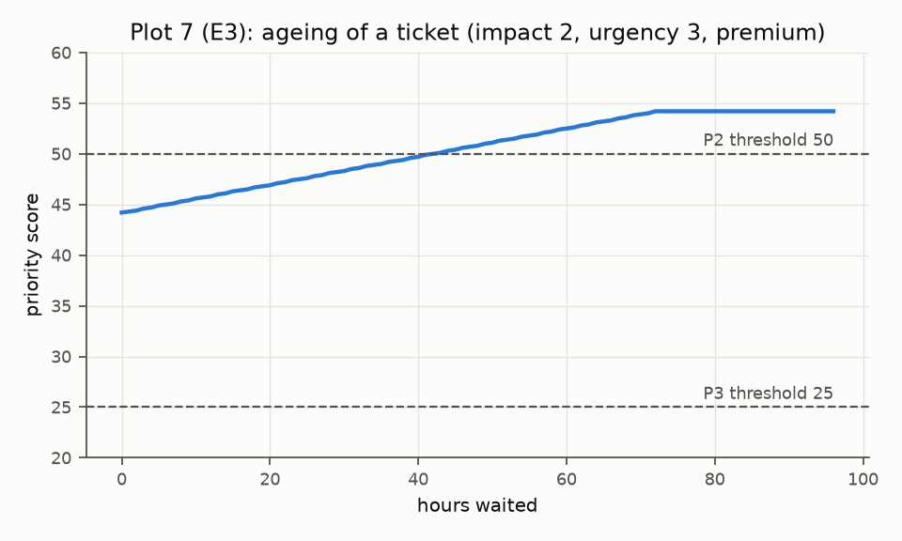
Figure 4.10: Priority score of one ticket while it waits

4.3.4 SLA scenario verification
Ten timelines were replayed with a frozen clock against the SLA strategy, five on a 24×7 calendar and five on working hours. All ten produced the expected state, warning time, due time and notification counts (Table 4.9).
Table 4.9: SLA scenarios
ID | Scenario | Expected outcome | Status
L01 | Agent replies within the first-response target | met; warning 09:45, due 10:00 | Pass
L02 | Resolution timer paused while pending 10:00–12:00 | running; warning 17:00, due 19:00 | Pass
L03 | No reply, checked every minute | warning and breach, once each | Pass
L04 | As L02, then priority raised to P1 at 13:00 | due recomputed from the start to 15:00 | Pass
L05 | Resolved at 16:00, reopened at 16:30 | new resolution timer | Pass
L06 | Working hours: created Thursday 15:00, 8 h | due Friday 16:00 | Pass
L07 | Working hours: created Friday 16:00, Saturday closed | Saturday skipped | Pass
L08 | Working hours: Friday is a holiday | holiday skipped | Pass
L09 | Working hours: pending Thursday 16:00 to Sunday 11:00 | nine working hours added | Pass
L10 | As L09, then the target changes to 4 h | recomputed including the paused time | Pass

4.3.5 History, reporting and performance
The history experiment replayed 90 days of activity on 300 tickets (2 664 recorded changes). Reconstruction was correct for all 1 000 sampled record versions, both backward from the current row and forward from the creation, and the incremental read models matched a full rebuild for every ticket and every day (Table 4.10).
Table 4.10: History and reporting results
Measure | Result
As-of reconstruction, backward replay (1 000 samples) | 100 % correct
As-of reconstruction, forward replay (1 000 samples) | 100 % correct
Intervals, facts and daily snapshots: incremental vs rebuilt | 100 % agree (300 tickets, 90 days)
Backlog by team per day for 90 days, from snapshots (95th percentile) | 0.28 ms
Backlog per day for 90 days, from intervals (95th percentile) | 21.4 ms
Ticket as-of view (95th percentile) | 0.98 ms
Ticket update with / without change capture (median) | 0.40 ms / 0.20 ms

Daily snapshots make the heaviest trend report more than seventy times faster than computing it from intervals, and change capture adds about 0.2 ms to a ticket update, an acceptable price for a complete history. Load testing of the whole application (response times of the ticket list, ticket creation and the dashboard under many concurrent users) was planned but not carried out within the project period; the performance targets of Table 3.6 are therefore not yet verified and are listed as future work.
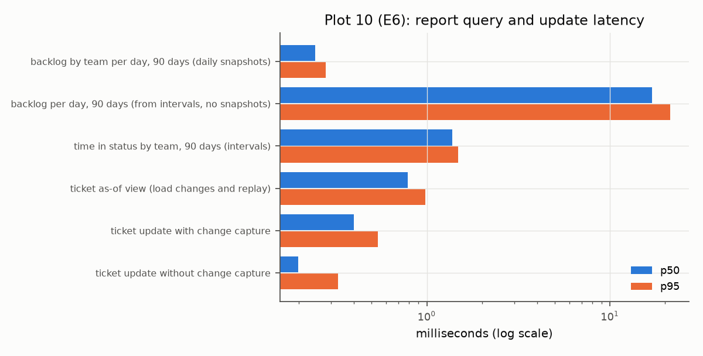
Figure 4.11: Latency of report queries and history operations

4.3.6 Discussion and threats to validity
The results support the design choice of simple, explainable baselines. Least-loaded assignment is clearly fairer than the rotation most small teams use and never exceeds an agent's capacity. The Jaccard check finds most duplicates with very few false suggestions when titles and descriptions are compared, and its errors are explainable from the shared words it displays. The priority score behaves predictably under small weight changes, and the SLA timers and history reconstruction were correct in every tested case.
Several threats limit these conclusions. The algorithms are intentionally minimal and would be outperformed by stronger techniques on real data. The workload and most duplicate pairs were generated from a small phrase bank per category, and generated text is cleaner than real tickets; the 40 hand-written pairs were written and labelled by one person rather than by independent annotators. Thresholds were tuned on 70 % of the pairs and reported on the remaining 30 %, which is a small test set. The SLA and priority scenarios verify the specification rather than measure effectiveness in a real support team. Finally, the application was not load-tested, so its behaviour under heavy concurrent use is unknown.

Chapter 5: Conclusion and Future Recommendations

5.1 Conclusion
This project set out to build a complete, multi-tenant helpdesk whose central decisions are made by the project's own explainable algorithms rather than by manual habit or opaque models. The delivered system provides the full ticket workflow for many isolated organisations, runs on any virtual machine or on an organisation's own server, and integrates with other systems through a documented API, OAuth 2.0 clients, signed webhooks and email. It is deployed on a cloud virtual machine with working inbound and outbound mail, and its interface was redesigned in a final milestone around the findings of a screen-by-screen usability audit.
Against the objectives in Section 1.3: tenant isolation was enforced at three layers and verified by an automated suite (objective 1); the priority score, the assignment rule, the duplicate check and the SLA state machine were implemented as simple, tested and replaceable modules with explanations shown to agents (objectives 2–5); the reporting module recorded every change and reconstructed past states (objective 7); the supporting capabilities — media library, email in both directions, dashboard, audit, API and webhooks — were delivered (objective 6); and the testing and experiments in Chapter 4 quantified the behaviour of each algorithm (objective 8). The measured results support the design: least-loaded assignment raised Jain's fairness index from 0.865 (round robin) to 0.967 and never exceeded an agent's capacity; the duplicate check reached precision 0.95, recall 0.70 and F1 0.81 on held-out pairs and placed the true duplicate among its top five suggestions for 92 % of the queries; all 12 priority scenarios, all 10 SLA timelines and all 1 000 sampled history reconstructions were correct; and the system passed its unit, feature, isolation, component and end-to-end test suites. Load testing of the complete application remains to be done.
The main lessons were that explicit explanations make automatic decisions acceptable to users, that time handling (pauses, calendars, priority changes) is the hardest part of SLA management, and that tenant isolation must be tested systematically rather than assumed. The redesign milestone showed that a feature-complete system is not yet a usable one: showing decisions in words, keeping the conversation first on the ticket page and marking a historical view unmistakably mattered as much to the demonstration as the algorithms themselves. Working as a team on separate branches that were reviewed and merged kept the shared code consistent while features were developed in parallel.

5.2 Future Recommendations
- Load testing and monitoring. Measuring response times of the ticket list, ticket creation and the dashboard under many concurrent users on a realistic data volume, and adding application monitoring, before the system serves real teams.
- Complete platform console. Creating, editing, suspending and reactivating workspaces from the console, which today offers sign-in and a read-only list while those actions go through the platform API.
- Mobile layouts. Layouts for phones, which the agent application does not yet provide below 768 pixels.
- Customer portal and more channels. A portal where contacts log in to follow their tickets, followed by live chat, WhatsApp, Telegram, Viber and SMS channels feeding the same ticket model.
- Replacing the baseline algorithms. Each algorithm sits behind an interface and its evaluation is repeatable, so better strategies can be introduced and compared on the same data: a priority score that also considers the SLA deadline, assignment that weighs skill strength and optimises batches, duplicate detection with weighted terms (TF-IDF or BM25) and stemming, and SLA rules with per-metric pauses and escalation chains.
- Semantic duplicate detection and AI assistance. Adding sentence embeddings stored in PostgreSQL (pgvector) as a further similarity channel, learning the channel weights from agents' confirmations, and offering ticket summaries, suggested replies and automatic categorisation as reviewable suggestions.
- Learning weights from history. Using resolved tickets to fit priority and assignment weights, and comparing the learned models with the configured ones.
- Optimal batch assignment. Applying the Hungarian method to rebalance unassigned tickets at shift boundaries, and adding shift rosters, leave management and on-call escalation chains.
- Automation rules, custom fields and a knowledge base. Letting tenants define their own rules and ticket fields, and linking articles to tickets to deflect repeated questions.
- Scalability and availability. Dedicated databases for large tenants, multiple application servers with shared realtime messaging, managed database services and monitoring with OpenTelemetry.
- Richer analytics. A user-defined report builder, scheduled report delivery, partitioned history tables and an external analytics store for very large tenants.
- Custom domains and multi-workspace accounts. Letting organisations use their own support domain and letting one person belong to several workspaces.
- Commercial readiness. Subscription billing, white-label branding with verified sending domains, single sign-on and multi-factor authentication.

References
[1] Atlassian, "How impact and urgency are used to calculate priority," Jira Service Management Cloud Documentation. [Online]. Available: https://support.atlassian.com/jira-service-management-cloud/docs/how-impact-and-urgency-are-used-to-calculate-priority/
[2] ServiceNow, "Priority lookup rules," IT Service Management Documentation. [Online]. Available: https://www.servicenow.com/docs/r/it-service-management/incident-management/def-prio-lookup-rules.html
[3] GLPI Project, "Priority matrix," GLPI User Documentation. [Online]. Available: https://help.glpi-project.org/documentation/modules/assistance/prioritymatrix
[4] AXELOS, Incident Management: ITIL 4 Practice Guide. London, U.K.: AXELOS Limited, 2020.
[5] Zendesk, "About SLA policies and how they work," Zendesk Help. [Online]. Available: https://support.zendesk.com/hc/en-us/articles/5600997516058
[6] Atlassian, "SLAs," Jira Service Management Cloud Documentation. [Online]. Available: https://confluence.atlassian.com/servicedeskcloud/slas-732528967.html
[7] ServiceNow, "Use SLA retroactive start and pause," Service Level Management Documentation. [Online]. Available: https://www.servicenow.com/docs/r/it-service-management/service-level-management/t_UseSLARetroactiveStartAndPause.html
[8] Zammad, "Service level agreements," Zammad Admin Documentation. [Online]. Available: https://admin-docs.zammad.org/en/latest/manage/slas.html
[9] osTicket, "SLA plans," osTicket Documentation. [Online]. Available: https://docs.osticket.com/en/latest/Admin/Manage/SLA%20Plans.html
[10] "Simple additive weighting—A metamodel for multiple criteria decision analysis methods," Expert Systems with Applications, 2016, doi: 10.1016/j.eswa.2016.01.042.
[11] T. L. Saaty, "A scaling method for priorities in hierarchical structures," Journal of Mathematical Psychology, vol. 15, no. 3, pp. 234–281, 1977.
[12] A. Silberschatz, P. B. Galvin, and G. Gagne, Operating System Concepts, 10th ed. Hoboken, NJ, USA: Wiley, 2018.
[13] C. L. Liu and J. W. Layland, "Scheduling algorithms for multiprogramming in a hard-real-time environment," Journal of the ACM, vol. 20, no. 1, pp. 46–61, 1973.
[14] F5 NGINX, "HTTP load balancing," NGINX Documentation. [Online]. Available: https://docs.nginx.com/nginx/admin-guide/load-balancer/http-load-balancer/
[15] M. Mitzenmacher, "The power of two choices in randomized load balancing," IEEE Transactions on Parallel and Distributed Systems, vol. 12, no. 10, pp. 1094–1104, 2001.
[16] N. Gans, G. Koole, and A. Mandelbaum, "Telephone call centers: Tutorial, review, and research prospects," Manufacturing & Service Operations Management, vol. 5, no. 2, pp. 79–141, 2003.
[17] H. W. Kuhn, "The Hungarian method for the assignment problem," Naval Research Logistics Quarterly, vol. 2, no. 1–2, pp. 83–97, 1955.
[18] R. Jain, D.-M. Chiu, and W. Hawe, "A quantitative measure of fairness and discrimination for resource allocation in shared computer systems," Digital Equipment Corporation, Tech. Rep. DEC-TR-301, 1984.
[19] M. F. Porter, "An algorithm for suffix stripping," Program, vol. 14, no. 3, pp. 130–137, 1980.
[20] C. D. Manning, P. Raghavan, and H. Schütze, Introduction to Information Retrieval. Cambridge, U.K.: Cambridge University Press, 2008.
[21] S. Robertson and H. Zaragoza, "The probabilistic relevance framework: BM25 and beyond," Foundations and Trends in Information Retrieval, vol. 3, no. 4, pp. 333–389, 2009.
[22] A. Z. Broder, "On the resemblance and containment of documents," in Proc. Compression and Complexity of Sequences, 1997, pp. 21–29.
[23] M. S. Charikar, "Similarity estimation techniques from rounding algorithms," in Proc. 34th Annu. ACM Symp. Theory of Computing, 2002, pp. 380–388.
[24] PostgreSQL Global Development Group, "Row security policies," PostgreSQL 18 Documentation. [Online]. Available: https://www.postgresql.org/docs/current/ddl-rowsecurity.html
[25] ArchTech, "Tenancy for Laravel v3 documentation." [Online]. Available: https://tenancyforlaravel.com/docs/v3/
[26] M. Nottingham, E. Wilde, and S. Dalal, "Problem details for HTTP APIs," RFC 9457, IETF, 2023.
[27] D. Hardt, Ed., "The OAuth 2.0 authorization framework," RFC 6749, IETF, 2012.
[28] K. Davis, B. Peabody, and P. Leach, "Universally unique identifiers (UUIDs)," RFC 9562, IETF, 2024.
[29] H. Krawczyk, M. Bellare, and R. Canetti, "HMAC: Keyed-hashing for message authentication," RFC 2104, IETF, 1997.
[30] D. Crocker, T. Hansen, and M. Kucherawy, "DomainKeys Identified Mail (DKIM) signatures," RFC 6376, IETF, 2011.
[31] Enhancesoft, "osTicket open source support ticket system." [Online]. Available: https://osticket.com
[32] Zammad GmbH, "Zammad open source helpdesk." [Online]. Available: https://zammad.org
[33] Teclib', "GLPI IT service management software." [Online]. Available: https://glpi-project.org
[34] FreeScout, "FreeScout free help desk and shared mailbox." [Online]. Available: https://freescout.net
[35] Webkul, "UVdesk open source helpdesk." [Online]. Available: https://www.uvdesk.com
[36] Znuny GmbH, "Znuny service management." [Online]. Available: https://www.znuny.org
[37] M. T. Lê and A. Ait-Bachir, "Learning to prioritize IT tickets: A comparative evaluation of embedding-based approaches and fine-tuned transformer models," arXiv preprint arXiv:2512.17916, 2025.
[38] "Ticket-BERT: Labeling incident management tickets with language models," arXiv preprint arXiv:2307.00108, 2023.
[39] Q. Shao, Y. Chen, S. Tao, X. Yan, and N. Anerousis, "Efficient ticket routing by resolution sequence mining," in Proc. 14th ACM SIGKDD Int. Conf. Knowledge Discovery and Data Mining, 2008, pp. 605–613.
[40] S. Agarwal, R. Sindhgatta, and B. Sengupta, "SmartDispatch: Enabling efficient ticket dispatch in an IT service environment," in Proc. 18th ACM SIGKDD Int. Conf. Knowledge Discovery and Data Mining, 2012, doi: 10.1145/2339530.2339744.
[41] A. Mandal, N. Malhotra, S. Agarwal, A. Ray, and G. Sridhara, "Automated dispatch of helpdesk email tickets: Pushing the limits with AI," in Proc. AAAI Conf. Artificial Intelligence, vol. 33, 2019, pp. 9381–9388.
[42] P. Runeson, M. Alexandersson, and O. Nyholm, "Detection of duplicate defect reports using natural language processing," in Proc. 29th Int. Conf. Software Engineering, 2007, pp. 499–510.
[43] X. Wang, L. Zhang, T. Xie, J. Anvik, and J. Sun, "An approach to detecting duplicate bug reports using natural language and execution information," in Proc. 30th Int. Conf. Software Engineering, 2008, pp. 461–470.
[44] N. Jalbert and W. Weimer, "Automated duplicate detection for bug tracking systems," in Proc. IEEE/IFIP Int. Conf. Dependable Systems and Networks, 2008, pp. 52–61.
[45] C. Sun, D. Lo, X. Wang, J. Jiang, and S.-C. Khoo, "A discriminative model approach for accurate duplicate bug report retrieval," in Proc. 32nd Int. Conf. Software Engineering, 2010, pp. 45–56.
[46] C. Sun, D. Lo, S.-C. Khoo, and J. Jiang, "Towards more accurate retrieval of duplicate bug reports," in Proc. 26th IEEE/ACM Int. Conf. Automated Software Engineering, 2011, pp. 253–262.
[47] PagerDuty, "Escalation policies," PagerDuty Knowledge Base. [Online]. Available: https://support.pagerduty.com/main/docs/escalation-policies
[48] D. Harel, "Statecharts: A visual formalism for complex systems," Science of Computer Programming, vol. 8, no. 3, pp. 231–274, 1987.
[49] W3C, "Web Content Accessibility Guidelines (WCAG) 2.2," W3C Recommendation, 2023.
[50] Laravel, "Laravel 13.x documentation." [Online]. Available: https://laravel.com/docs/13.x
[51] Meta Open Source, "React documentation." [Online]. Available: https://react.dev
[52] TanStack, "TanStack Router, Query, Table and Form documentation." [Online]. Available: https://tanstack.com
[53] M. Harchol-Balter, Performance Modeling and Design of Computer Systems: Queueing Theory in Action. Cambridge, U.K.: Cambridge University Press, 2013.
[54] A. Saltelli et al., Global Sensitivity Analysis: The Primer. Chichester, U.K.: Wiley, 2008.

Bibliography
PostgreSQL Global Development Group, "Full text search" and "pg_trgm," PostgreSQL 18 Documentation. [Online]. Available: https://www.postgresql.org/docs/current/textsearch.html
OWASP Foundation, "OWASP Top 10." [Online]. Available: https://owasp.org/www-project-top-ten/

Appendices

Appendix A: Use case list
Table A.1: Use cases of the system
ID | Use case | Primary actor
UC-01 | Manage tenants | Platform Super Admin
UC-02 | Manage users and roles | Tenant Admin
UC-03 | Manage teams, skills, categories and shifts | Tenant Admin
UC-04 | Manage SLA policies and business calendars | Tenant Admin
UC-05 | Manage priority, assignment and duplicate settings | Tenant Admin
UC-06 | Manage API clients and webhooks | Tenant Admin, Developer
UC-10 | Create ticket | Agent, external system, contact by email
UC-11 | View and filter tickets | Agent, Manager
UC-12 | Add public reply or internal note | Agent, contact by email
UC-13 | Attach file | Agent
UC-14 | Assign or reassign ticket | Manager, system
UC-15 | Change ticket status | Agent
UC-16 | Override priority | Manager
UC-17 | Review duplicate suggestions | Agent
UC-18 | View ticket history and SLA | Agent
UC-20 | Score priority | System
UC-21 | Auto-assign | System
UC-22 | Detect duplicates | System
UC-23 | Evaluate SLA and notify | Scheduler
UC-30 | Manage contacts and organisations | Agent, Admin
UC-40 | View dashboard | Manager
UC-41 | Export report | Manager
UC-42 | Run detailed report | Manager, Admin
UC-43 | View entity 360 and history | Manager, Admin
UC-50 | Manage media library | Agent, Admin
UC-60 | Process inbound email | Scheduler

Appendix B: Source code excerpts
The excerpts below are copied from the project's source code with comments shortened. Each algorithm class implements its strategy interface and is called only through that interface.

B.1 Priority score (`BasicWeightedPriority::score`)
public function score(PriorityInput $input): PriorityResult
{
$values = [
'impact' => ($input->impact - 1) / 3,
'urgency' => ($input->urgency - 1) / 3,
'tier' => $input->tier->scaled(),
'age' => min(1.0, $input->hoursWaited / $this->settings->ageFullHours),
];
$parts = [];
$total = 0.0;
foreach ($values as $name => $value) {
$weight = $this->settings->weights[$name];
$contribution = 100 * $weight * $value;
$total += $contribution;
$parts[] = new PriorityPart($name, $value, $weight, $contribution);
}
// Rounding to 6 places first removes float noise before the one-decimal value.
$score = round(round($total, 6), 1);

return new PriorityResult(score: $score, level: $this->settings->levelFor($score),
parts: $parts, strategy: self::NAME, strategyVersion: self::VERSION,
settings: $this->settings->toArray());
}

B.2 Least-loaded assignment (`LeastLoadedAgent`)
public function choose(TicketNeeds $ticket, array $candidates): AssignmentResult
{
$eligible = [];
$exclusions = [];
foreach ($candidates as $agent) {
$exclusion = $this->whyNotEligible($agent, $ticket);
if ($exclusion === null) {
$eligible[] = $agent;
} else {
$exclusions[] = $exclusion;
}
}
usort($eligible, $this->compare(...));

return new AssignmentResult(
agentId: $eligible === [] ? null : $eligible[0]->id,
ranking: $eligible, exclusions: $exclusions,
strategy: self::NAME, strategyVersion: self::VERSION);
}

// Lowest load relative to capacity first, then the agent assigned longest ago,
// then the smallest id, so the result never depends on input order.
private function compare(AgentCandidate $a, AgentCandidate $b): int
{
return $a->compareLoad($b)
?: $this->compareLastAssigned($a, $b)
?: strcmp($a->id, $b->id);
}

B.3 Duplicate detection (`WordSet::words` and `JaccardDuplicates`)
public function words(string ...$texts): array
{
$text = mb_strtolower(implode(' ', $texts));
// Letters include combining marks so that Devanagari words are not split apart.
$text = (string) preg_replace('/[^\p{L}\p{M}\p{N}-]+/u', ' ', $text);
$words = [];
foreach (explode(' ', $text) as $token) {
if (mb_strlen($token) < self::MIN_LENGTH
|| isset($this->stopWords[$token])
|| trim($token, '-') === '') {
continue;
}
$words[$token] = true;
}

return array_map(strval(...), array_keys($words));
}

// JaccardDuplicates: |A ∩ B| / |A ∪ B| for each candidate ticket
private function compare(array $words, TicketText $candidate): DuplicateMatch
{
$other = $this->wordSet->words($candidate->title, $candidate->description);
$shared = array_values(array_intersect($words, $other));
sort($shared);
$union = count($words) + count($other) - count($shared);

return new DuplicateMatch($candidate->id, $shared, $union, $candidate->createdAt);
}

B.4 SLA warning and breach check (`SimpleSlaTimer::check`)
public function check(TimerData $timer, ?CarbonImmutable $now = null): TimerOutcome
{
$now ??= $this->now();
$events = [];
if (! $timer->state->isCounting()) {
return $this->outcome($timer);
}
if ($timer->state === TimerState::Running && $timer->warnedAt === null
&& $now->greaterThanOrEqualTo($timer->warningAt) && $now->lessThan($timer->dueAt)) {
$timer = $timer->with(['state' => TimerState::Warning, 'warnedAt' => $now]);
$events[] = $this->event(SlaEventType::Warning, $timer, $now,
['due_at' => TimerData::format($timer->dueAt)]);
}
if ($timer->breachedAt === null && $now->greaterThanOrEqualTo($timer->dueAt)) {
$timer = $timer->with(['state' => TimerState::Breached, 'breachedAt' => $now]);
$events[] = $this->event(SlaEventType::Breached, $timer, $now,
['due_at' => TimerData::format($timer->dueAt)]);
}

return $this->outcome($timer, ...$events);
}

B.5 Ticket status transitions (`TicketStatus`)
public function allowedTargets(): array
{
return match ($this) {
self::Open => [self::Assigned, self::InProgress, self::Closed],
self::Assigned => [self::InProgress, self::Pending, self::Resolved, self::Open],
self::InProgress => [self::Pending, self::Resolved, self::Open],
self::Pending => [self::InProgress, self::Resolved],
self::Resolved => [self::Closed, self::InProgress],
self::Closed => [self::InProgress],
};
}

public function transitionTo(self $target): self
{
if (! $this->canTransitionTo($target)) {
throw InvalidTransition::between($this, $target);
}

return $target;
}

B.6 Row-level security policy (`TenantTables`)
public const CURRENT_TENANT_SQL =
"NULLIF(current_setting('app.current_tenant', true), '')::uuid";

// Called by the migration of every tenant table. FORCE applies the policy
// to the table owner too, so no connection reads across tenants.
DB::statement("ALTER TABLE {$table} ENABLE ROW LEVEL SECURITY");
DB::statement("ALTER TABLE {$table} FORCE ROW LEVEL SECURITY");
DB::statement(sprintf('DROP POLICY IF EXISTS %s ON %s', self::POLICY, $table));
DB::statement(sprintf('CREATE POLICY %s ON %s USING (%s) WITH CHECK (%s)',
self::POLICY, $table, $predicate, $predicate));

B.7 Webhook signature (`WebhookSigner`)
public static function signature(string $secret, int $timestamp, string $body): string
{
return hash_hmac('sha256', $timestamp.'.'.$body, $secret);
}

// Receiver-side verification: any v1= entry matches and the timestamp
// is within the five-minute tolerance.
public static function verify(string $body, string $signatureHeader, int $timestamp,
string $secret, int $now, int $tolerance = self::TOLERANCE_SECONDS): bool
{
if ($timestamp === 0 || abs($now - $timestamp) > $tolerance) {
return false;
}
$expected = self::signature($secret, $timestamp, $body);
foreach (explode(',', $signatureHeader) as $part) {
$part = trim($part);
if (str_starts_with($part, self::SCHEME.'=') && hash_equals($expected, substr($part, 3))) {
return true;
}
}

return false;
}

Appendix C: Screenshots
The screenshots were captured from the demonstration workspace in the order of the final demonstration, in addition to Figures 4.1 to 4.6.
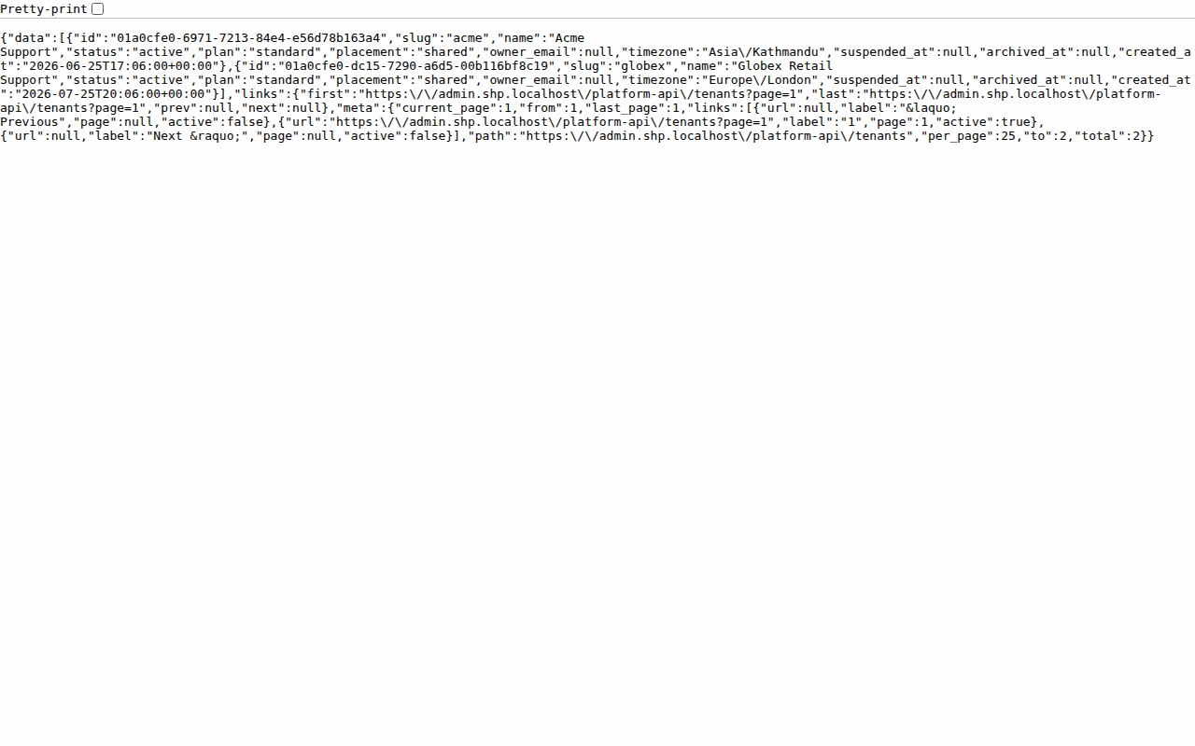
Figure C.1: Platform console with the list of workspaces
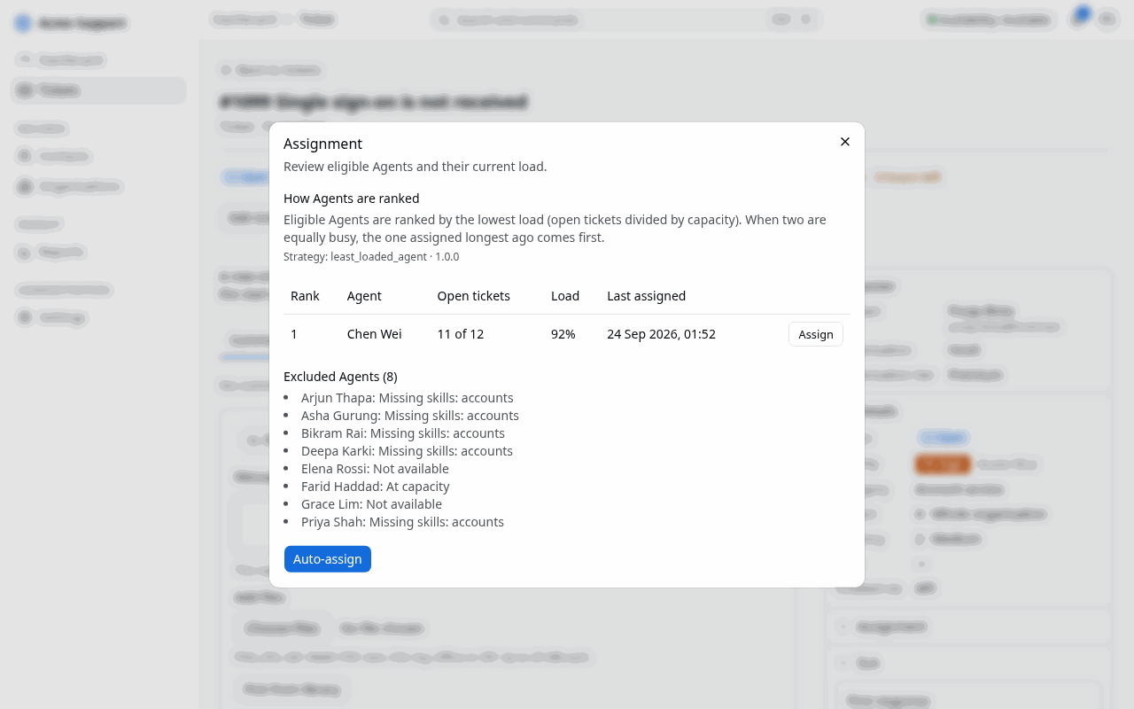
Figure C.2: Assignment ranking with the reason each agent was chosen or excluded
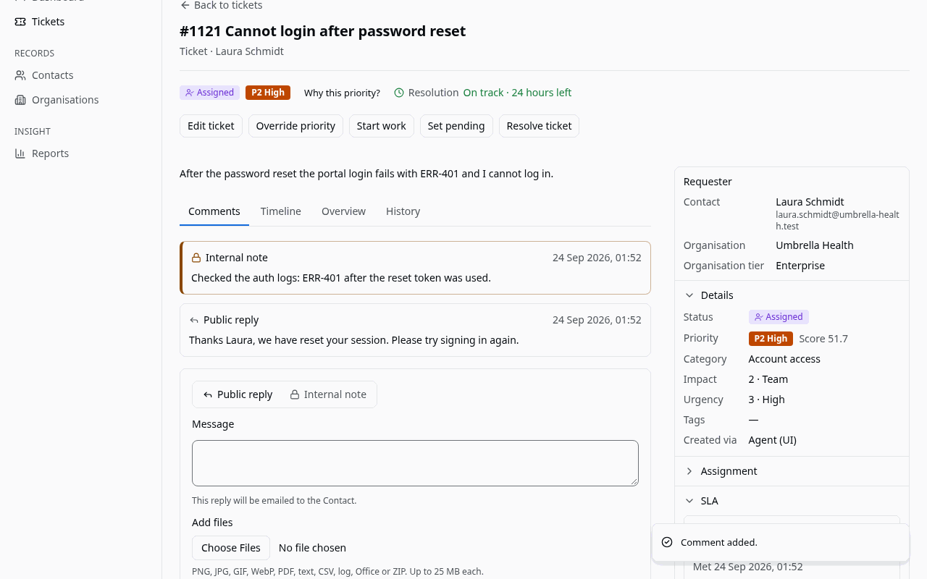
Figure C.3: Public reply sent to the contact by email
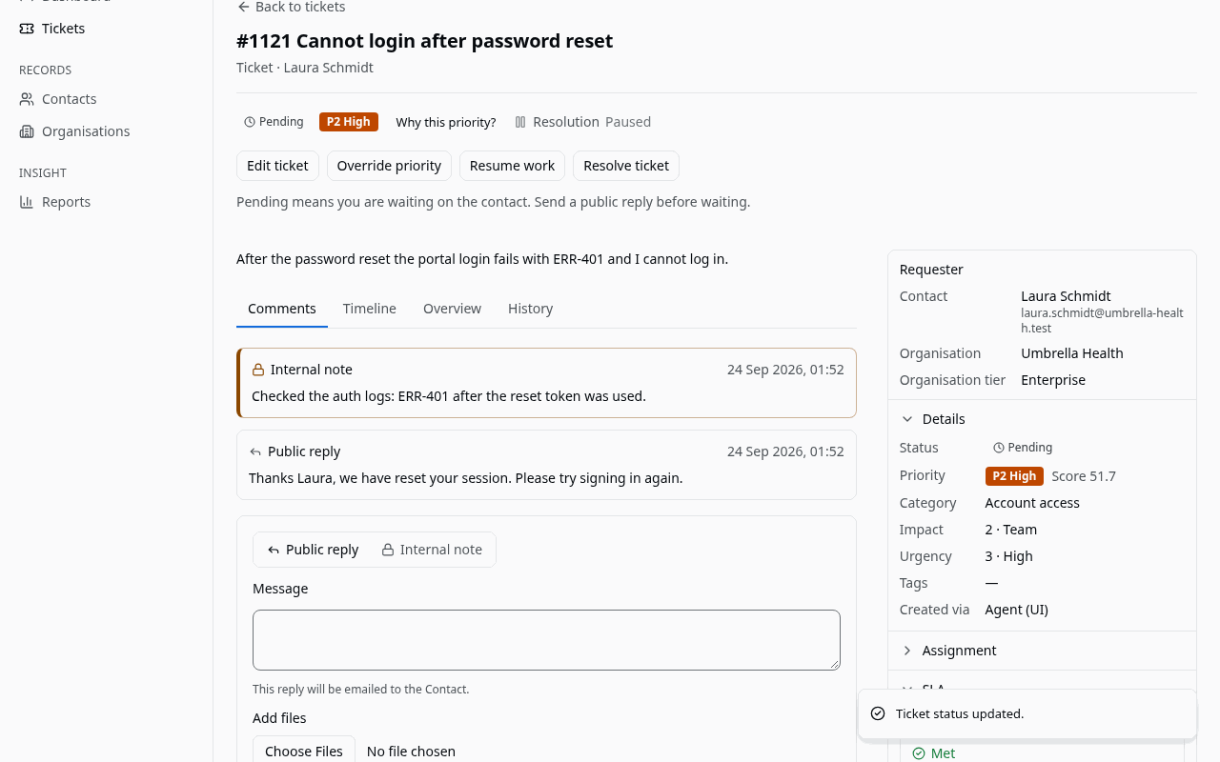
Figure C.4: SLA timer paused while the ticket is pending
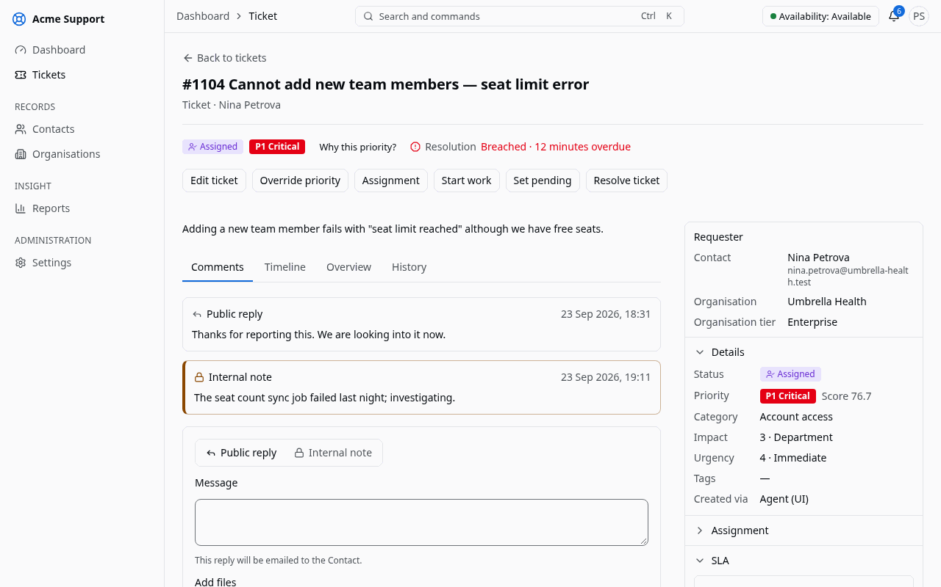
Figure C.5: SLA timer after the scheduler detected a warning
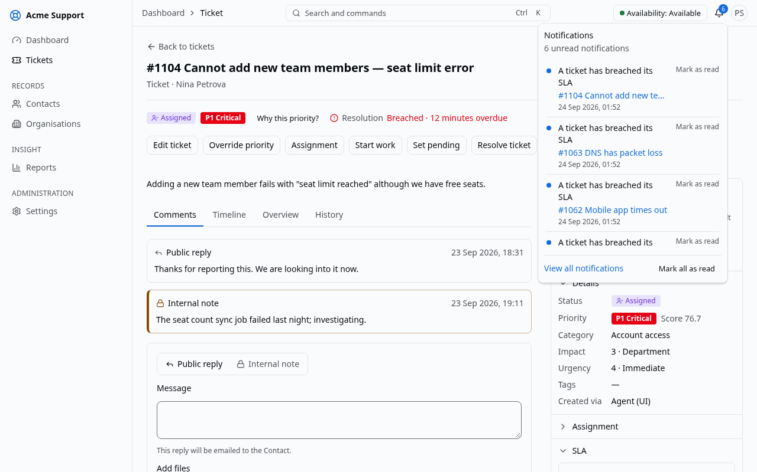
Figure C.6: In-application notifications
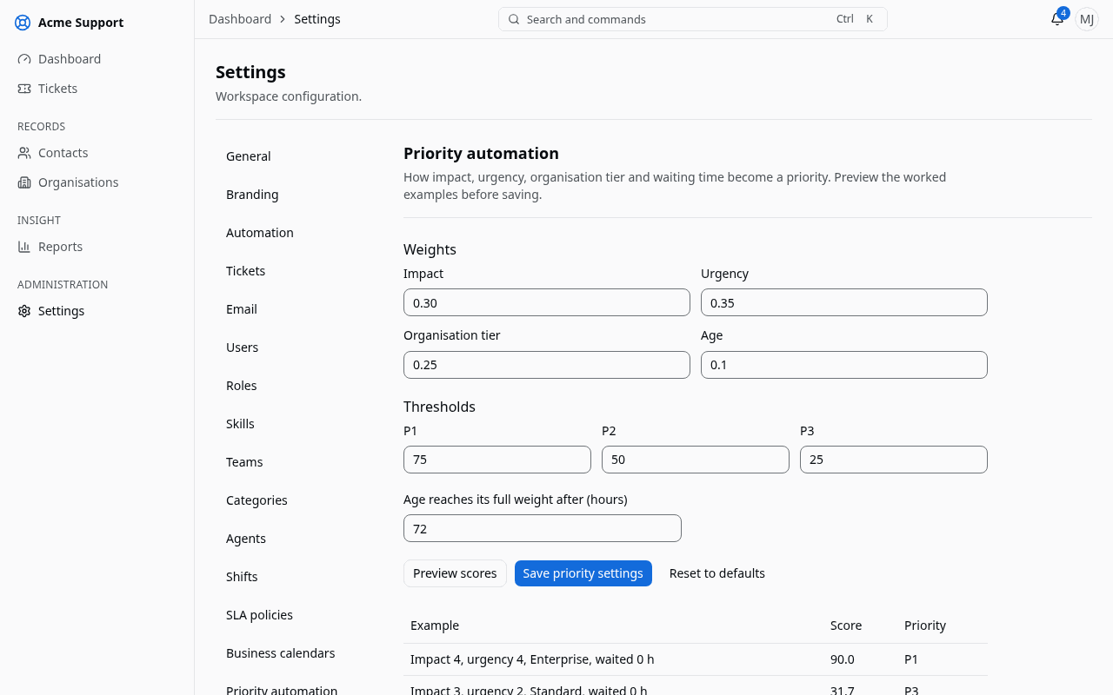
Figure C.7: Automation settings with a preview of the priority weights
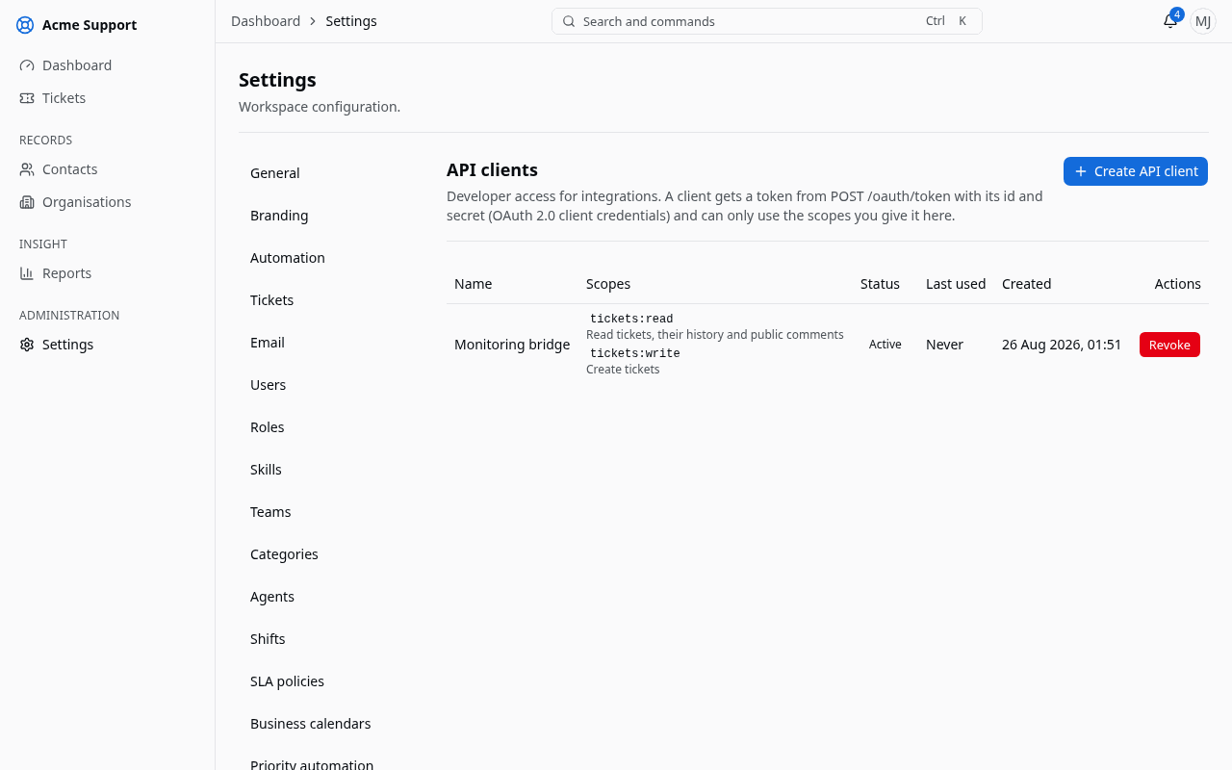
Figure C.8: API clients with scopes
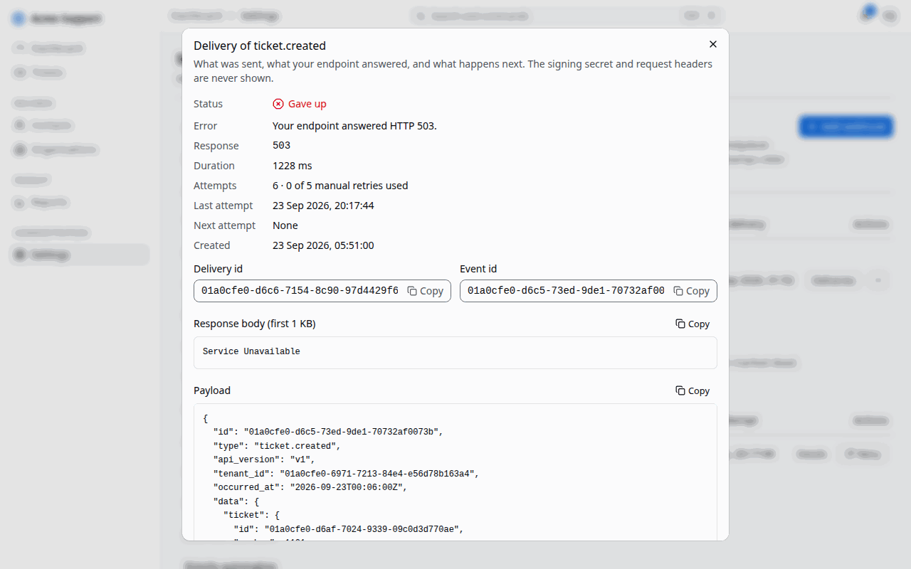
Figure C.9: Webhook subscription with its delivery log
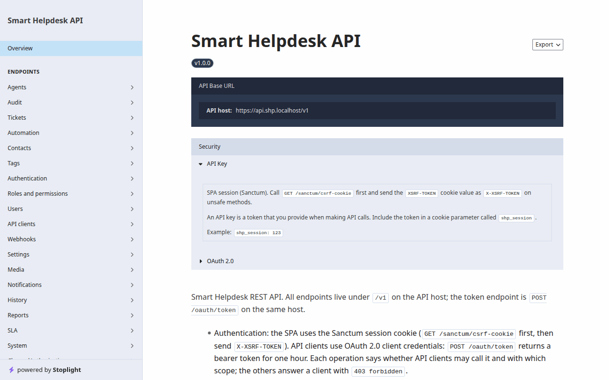
Figure C.10: Generated API documentation
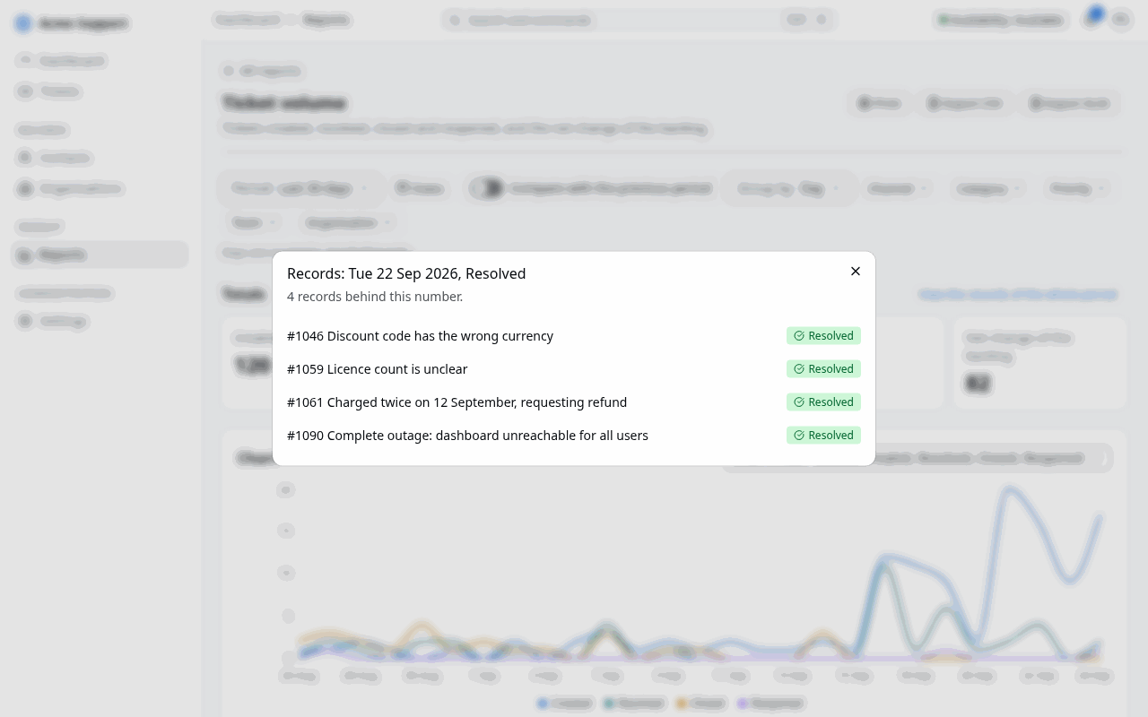
Figure C.11: Report drill-down to the tickets behind a number
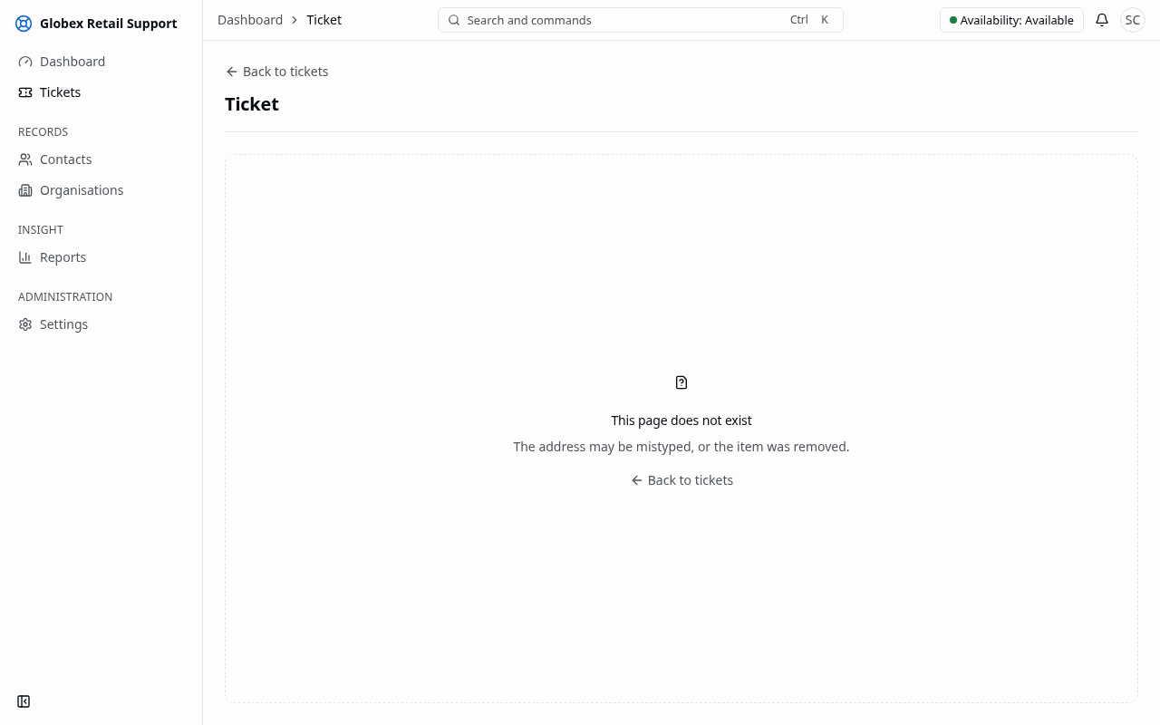
Figure C.12: A ticket of another workspace answered with "not found"
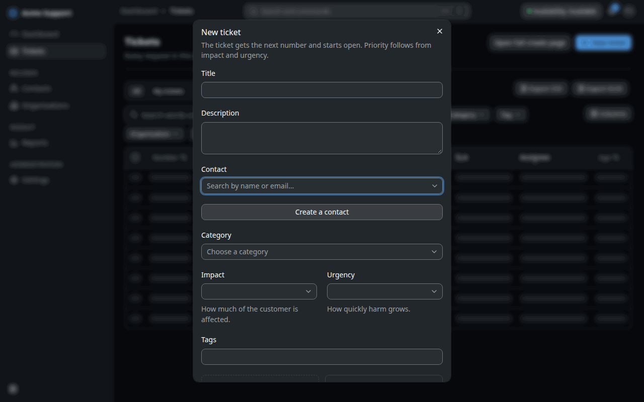
Figure C.13: Dark theme with keyboard focus

Appendix D: API excerpt

D.1 Creating a ticket
An API client with the tickets:write scope creates a ticket with a bearer token obtained through the OAuth 2.0 client credentials grant. The Idempotency-Key header makes a retried request safe.
POST /v1/tickets HTTP/1.1
Host: api.shp.subhambhandari.com.np
Authorization: Bearer <access token>
Idempotency-Key: 5f7d2c1e-order-1042
Content-Type: application/json

{
"title": "Cannot log in to the billing portal",
"description": "Since this morning the login page shows an error after the password.",
"contact_id": "019a1e10-…",
"category_id": "019a1e11-…",
"impact": 3,
"urgency": 4,
"tags": ["billing", "login"]
}

The answer is 201 Created with the ticket. Priority scoring and automatic assignment run in the same transaction as the creation, so the answer already carries the priority, its explanation and the assigned agent (fields shortened). With the default weights, impact 3, urgency 4, a standard-tier contact and no waiting time give 26.7 + 35.0 = 61.7, which is level P2:
{
"data": {
"id": "019a1f2f-…",
"number": 1042,
"status": "assigned",
"priority_score": 61.7,
"priority_level": "P2",
"priority_explanation": {
"strategy": "basic_weighted_priority",
"strategy_version": "1.0.0",
"score": 61.7,
"level": "P2",
"parts": ["…"]
},
"assigned_agent_id": "019a1e20-…",
"created_via": "api",
"created_at": "2026-09-21T10:15:32Z"
}
}

An invalid request returns an RFC 9457 problem document with a stable code, for example 422 with "code": "validation_failed" and the field errors.

D.2 Webhook payload envelope
Every webhook delivery has the same envelope. The body is signed with HMAC-SHA256 over timestamp.body (Appendix B.7), and the signature is sent in a request header.
{
"id": "019a1f2f-5b7c-7e1d-8c3a-1a2b3c4d5e6f",
"type": "ticket.status_changed",
"api_version": "v1",
"tenant_id": "019a1e00-…",
"occurred_at": "2026-09-17T10:15:32Z",
"data": {
"ticket": { "id": "019a…", "number": 1042, "status": "resolved", "…": "…" },
"from": "in_progress",
"to": "resolved"
}
}

Appendix E: Experiment datasets
The experiments in Section 4.3 use version 1 of the datasets, created on 21 September 2026. A dataset is never edited in place; a change creates a new version. Every table and figure in Section 4.3 is regenerated from these files by the experiment commands.
Table E.1: Experiment datasets
File | Content | Made by | Seed
workload/ | 8 agents (capacities 5–12, 2–3 skills), 6 categories, 500 tickets with exponential inter-arrival (mean 120 s) and handling times (mean 90 min) | experiment:generate-workload | 42
duplicates.json | 300 labelled pairs: 100 duplicates (60 generated, 40 hand-written) and 200 non-duplicates (50 same category, 150 different categories) | experiment:generate-duplicates | 42
duplicates-haystack.json | 5 000 generated tickets for the top-five search | same command | 43
priority-scenarios.json | 12 tickets with the expected score and level | hand-written | —
sla-scenarios.json | 10 timelines (5 on 24×7, 5 on working hours Sunday–Friday 10:00–17:00 Asia/Kathmandu, one with a holiday) with expected states, times and notification counts | hand-written | —

Generated ticket texts come from a small phrase bank per category, so tickets of one category share words, and the hand-written pairs were written and labelled by one person. Both are discussed as threats to validity in Section 4.3.6.

