**Team members:**

1. Bhavya Sri Sirasanagandla

Contribution: 50%

1. Manideep Nadimpelli

Contribution: 50%

**Objective:**

The main objective of this application is to create a login page using PUG and using cookies to store data in node. Using express static method load the css files.

**Pre requisites:**

1.WebStorm IDE

2.Node

3.Expressjs

4.Angular

5.PUG

**Implementation:**

1. Created login pug file in views folder.

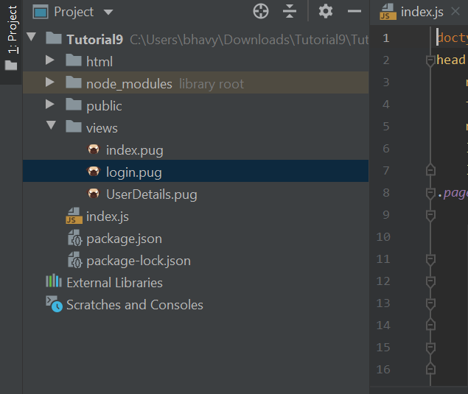

1. Created index.js file and added the code to connect to port 3000.set pug as view engine

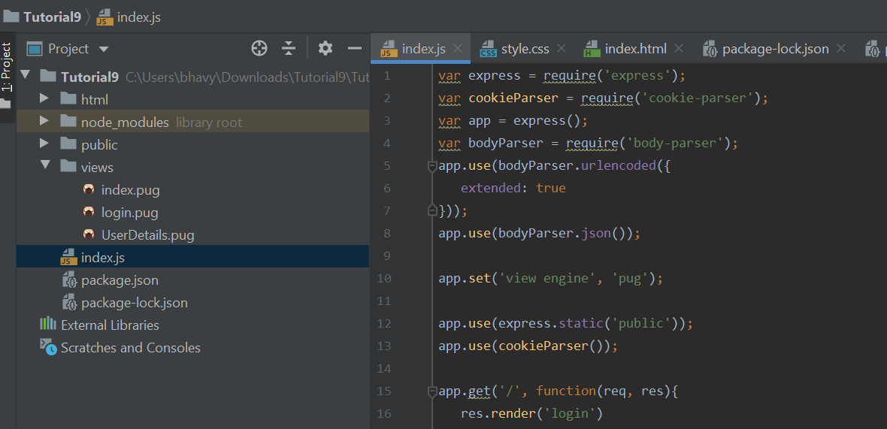

1. Using pug syntax, created login page.

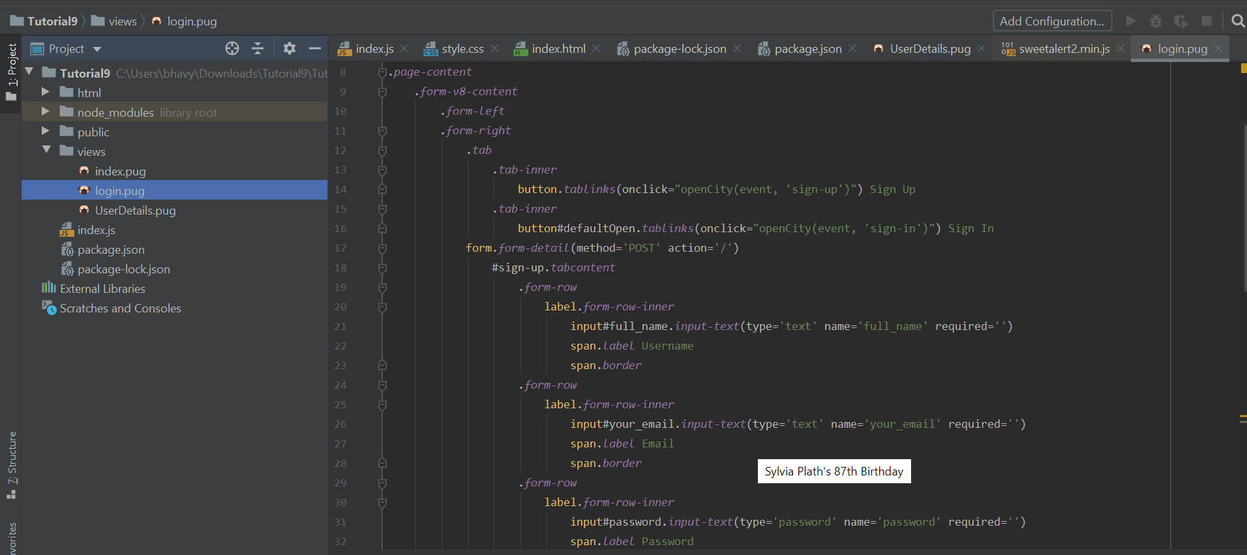

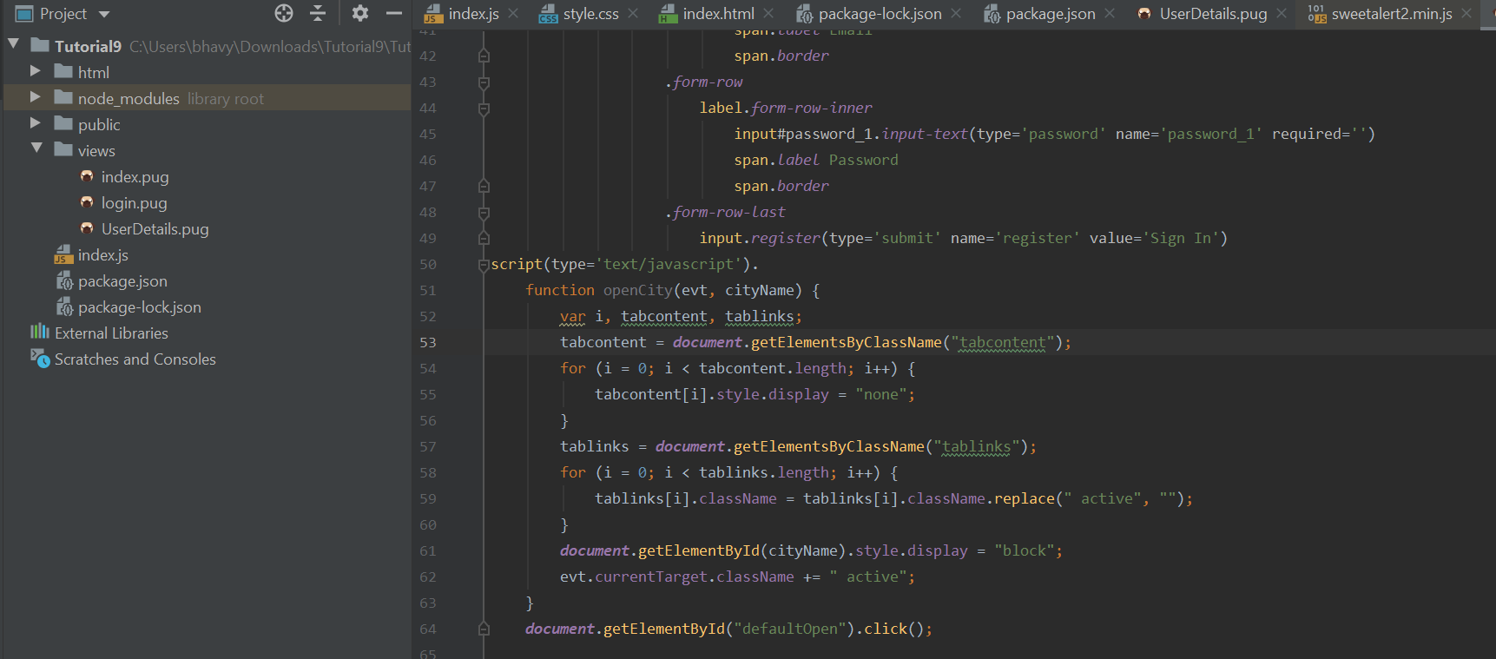

1. Created userdetails pug file and written code using pug syntax.

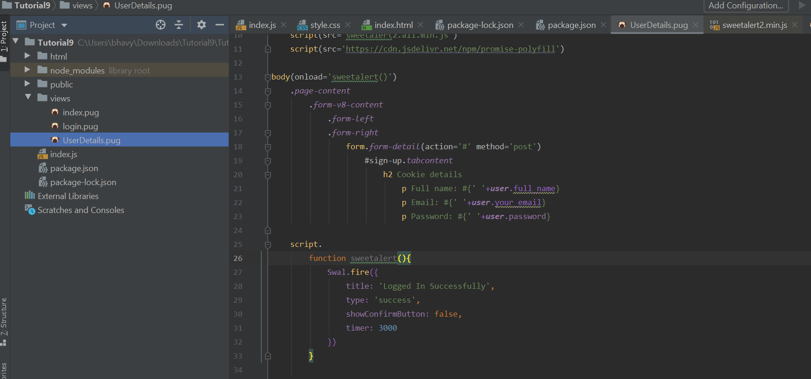

1. Loaded external css files using express static method.

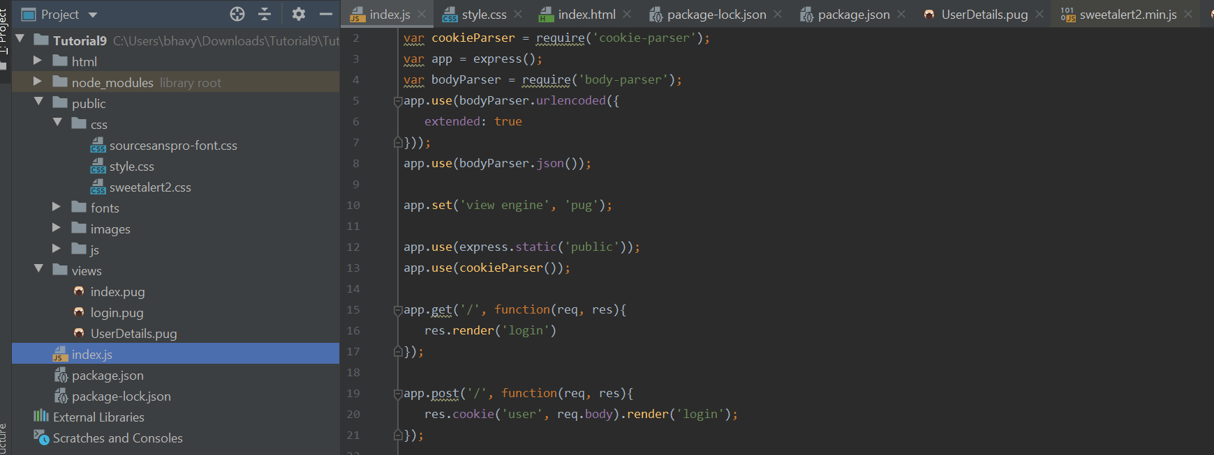

1. Storing user details using cookie parser. Installed cookie parser using npm install cookie -parser.

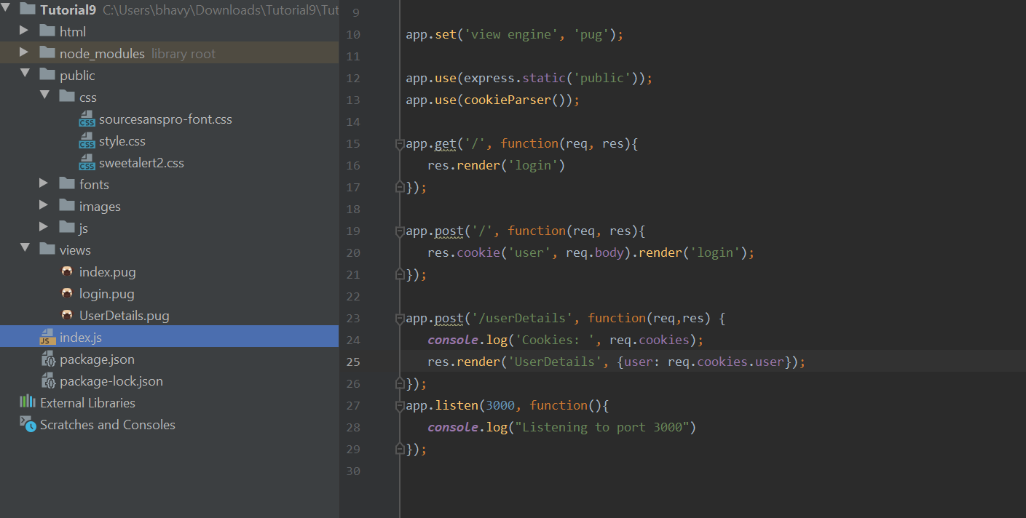

**Sample Output:**

1. By default, Login page will be shown. In that page user can register or login

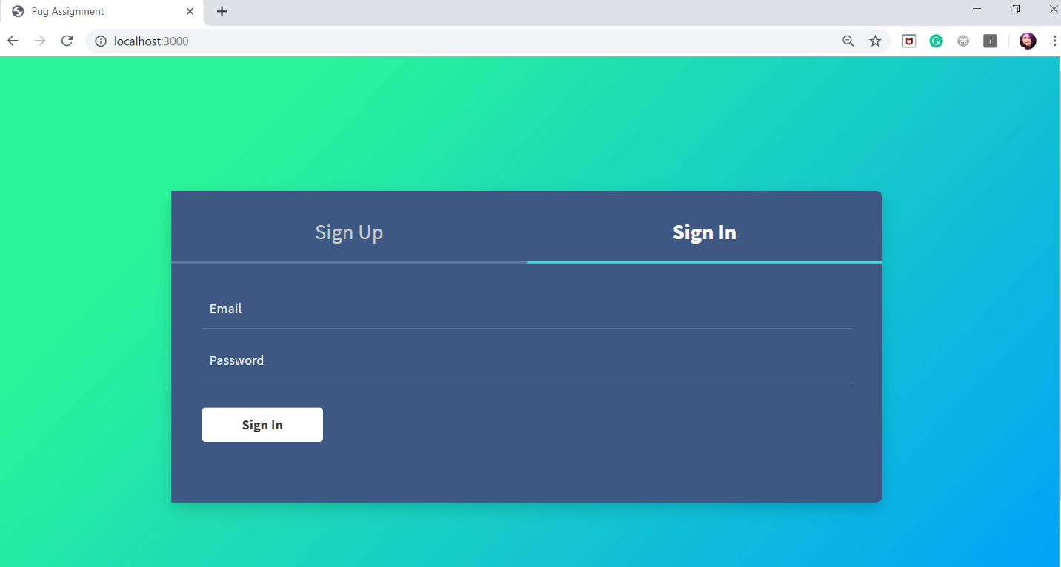

1. Added validations for register and login pages.

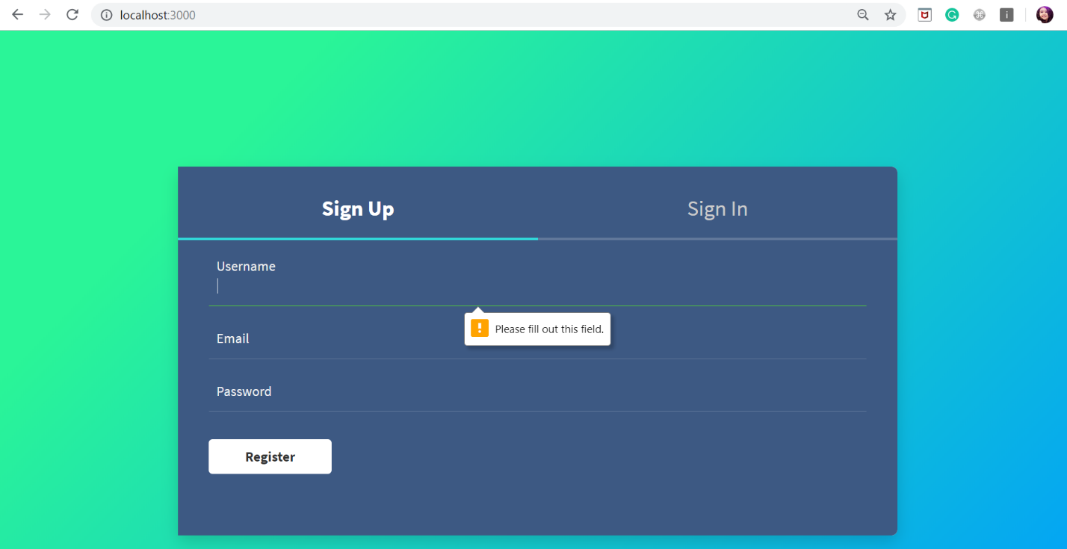

1. After registration ,it will open the sign in tab.

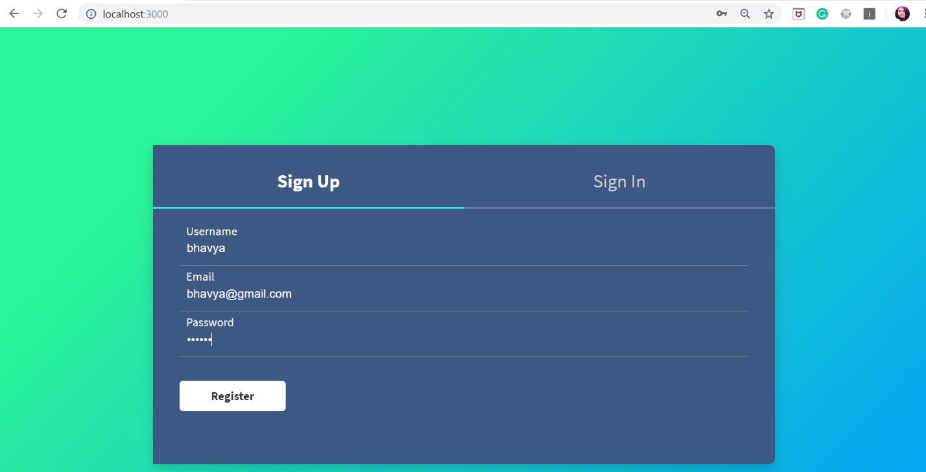

1. Alert message will be displayed after sign in method. User details which are stored in cookie will be displayed.

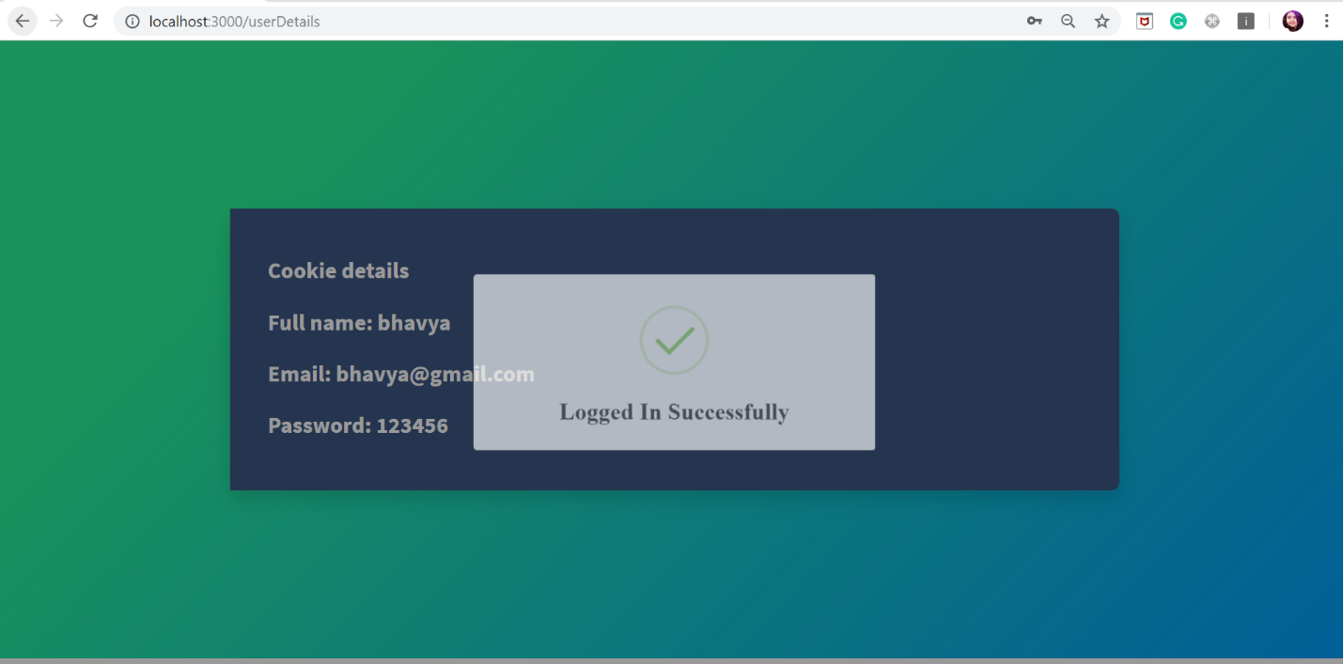



**Conclusion:**

* We analyzed the given source code and created templates using pug. Used cookies to store user data. and also used express static method to load css and js files.