**Introduction:**

Created an Ionic application which displays Movie data based on the searched movie and sentiment analysis .Used firebase authentication “email/password” , “facebook” and also firebase real time data base.

**Team members:**

1. Bhavya Sri Sirasanagandla

Contribution: 50%

1. Manideep Nadimpelli

Contribution: 50%

**Objective:**

Create an Ionic application using firebase , one cordova plugin , Ionic.

1.Used firebase authentication Email/password and Facebook.

2.Used firebase real time data base stored searched movie data of the user.

3.Added text to speech ionic native cordova plugin to speak out the searched movie name.

4. Deployed the application.

**Features:**

* In register page user can register. Registered data will be stored in firebase.
* In Login page user can login.It will pick the login details from firebase.User can login once he/she enters the valid details. If not alert message was shown.
* Added cordova text-to-speech plugin.

**Implementation:**

1. Created an ionic project using tabs menu template. 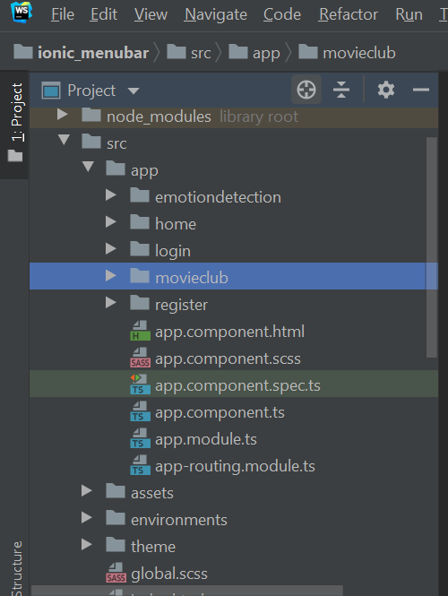
2. Created firebase account. Added firebase web app scripts to project.

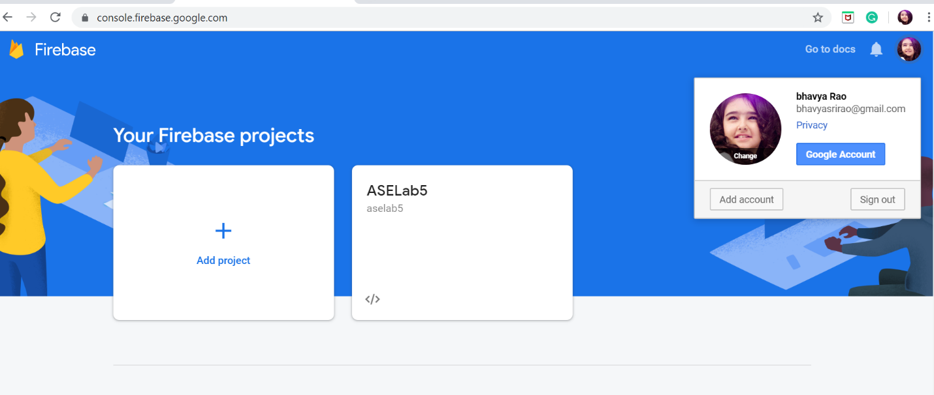

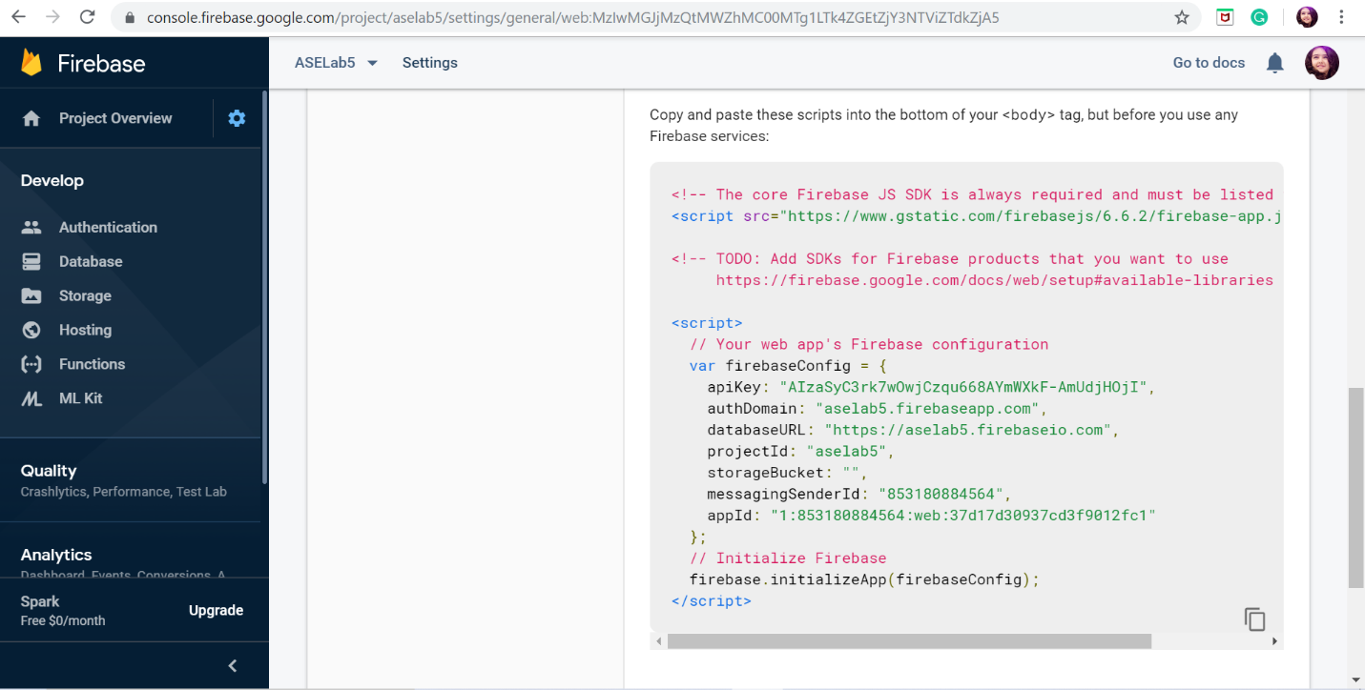

1. Enabled sign-in methods. For sign in we need to import @angular/fire module.

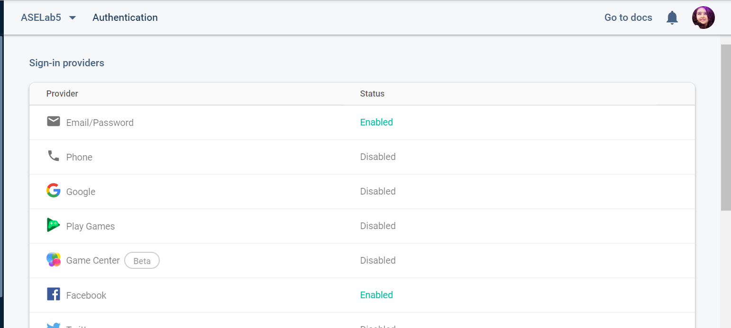

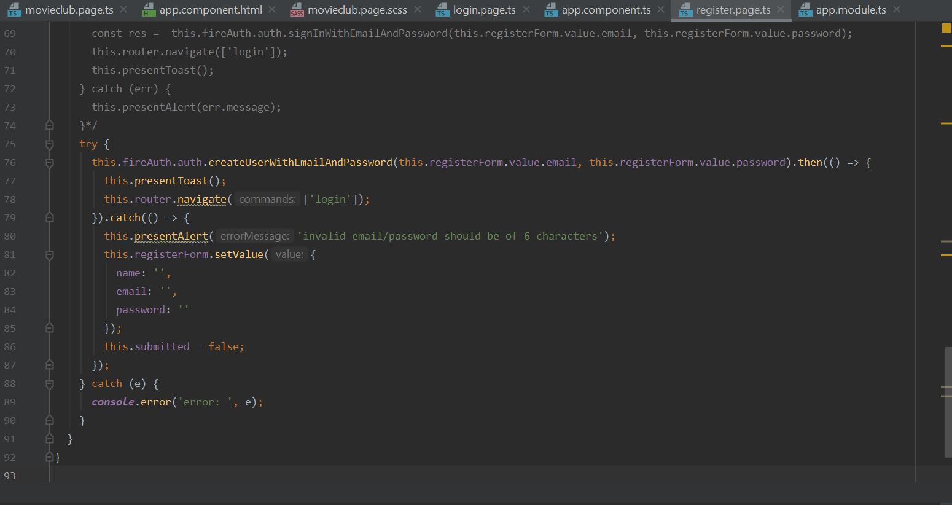

e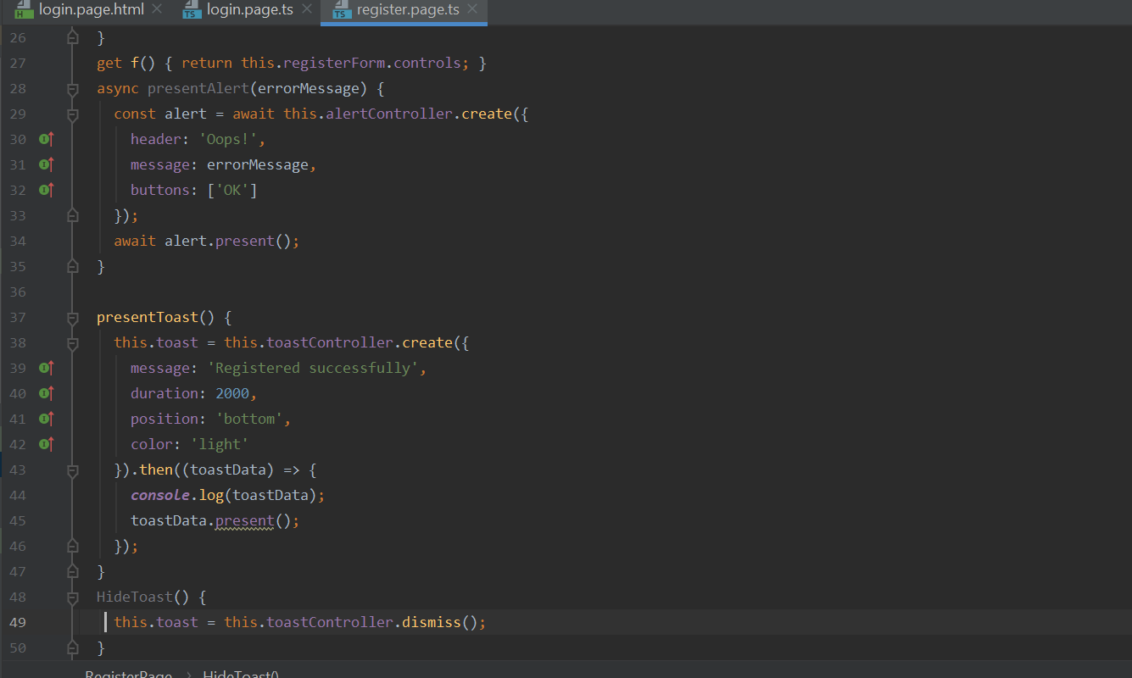

1. We have used ionic native cordova “TexttoSpeech” plugin to speak out the searched movie.We have installed **ionic cordova plugin add cordova-plugin-tts** and **npm install @ionic-native/text-to-speech**

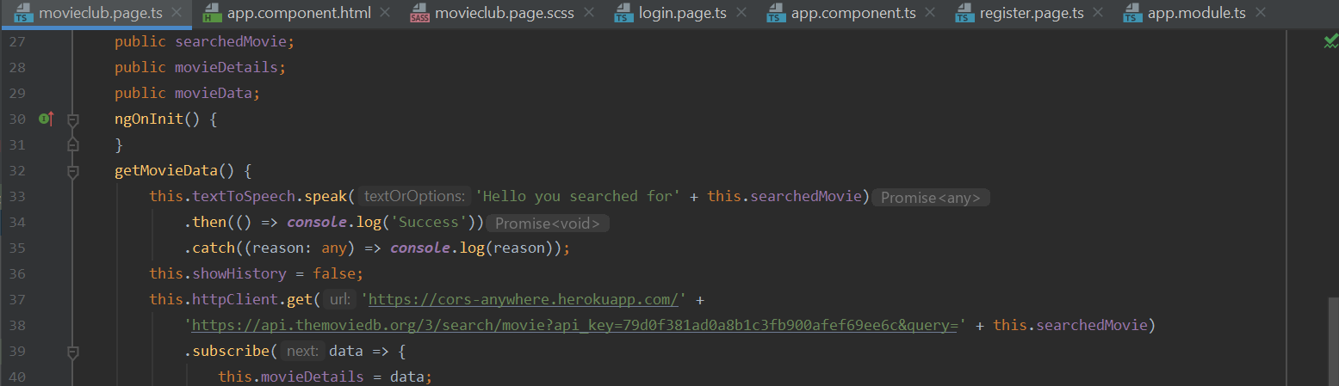

1. We are storing the data in firebase real time database.

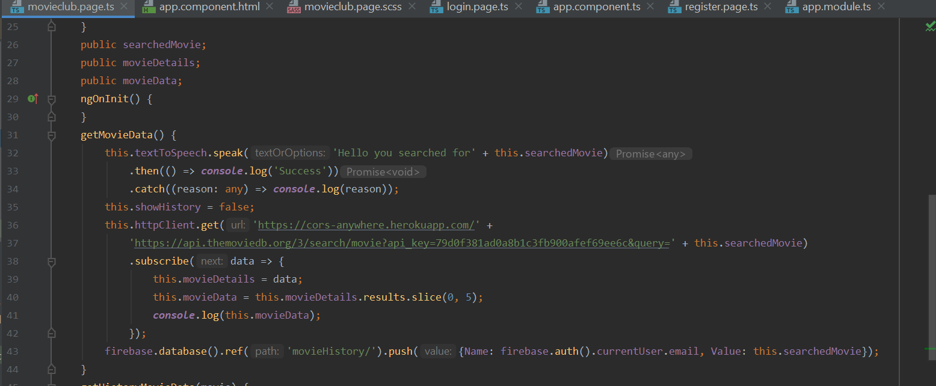

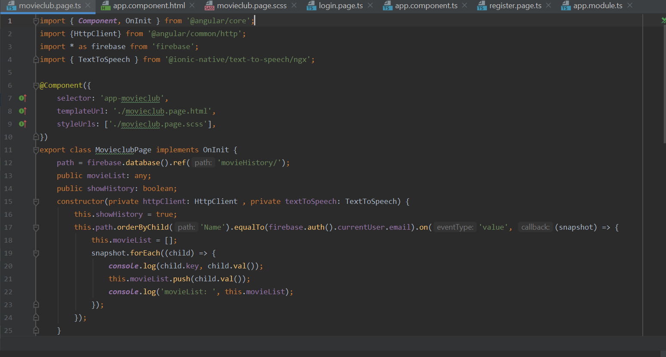

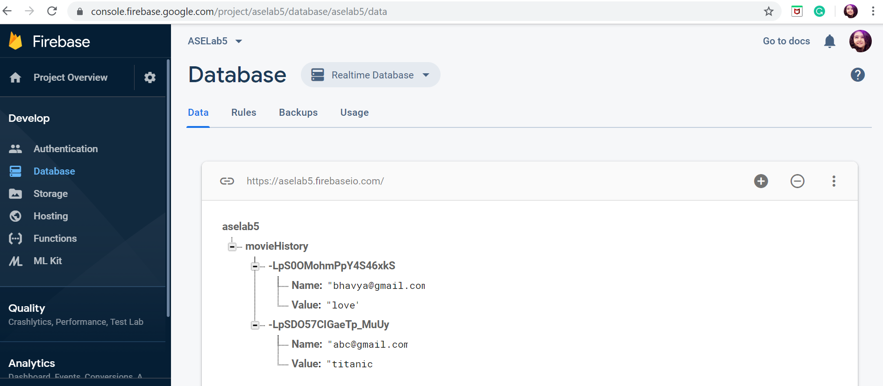

1. Finally we ran our app in emulator.Used Ionic cordova run android command.

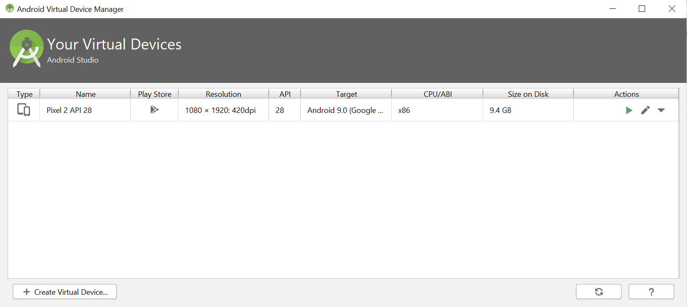

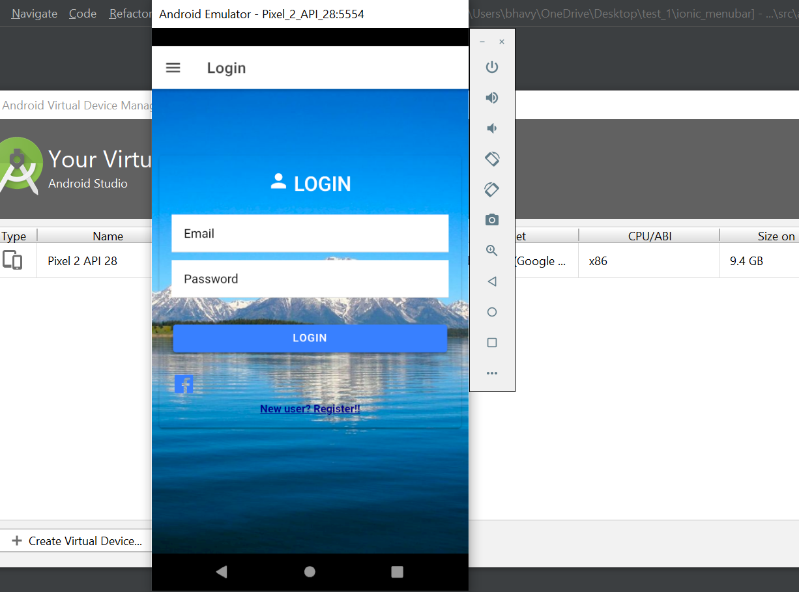

**Design:**

1. Created ionic menu bar using ionic tabs menu templates.



1. Once the user logins he can go to movieclub page where the previously searched data for that particular user will be shown.

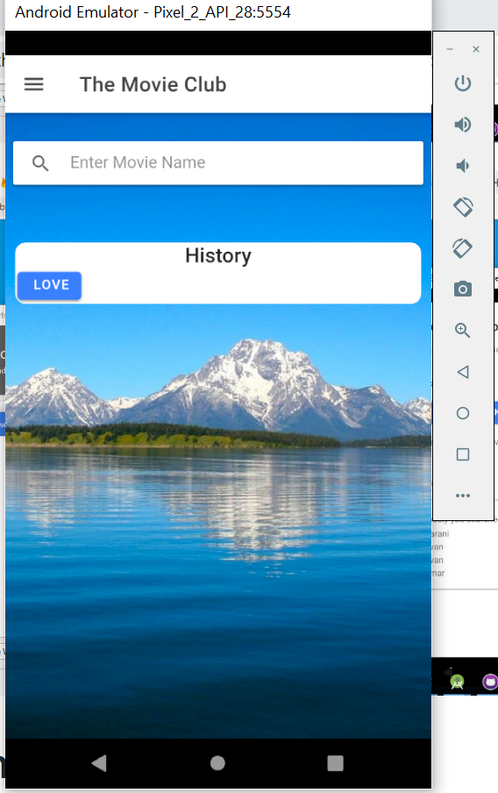

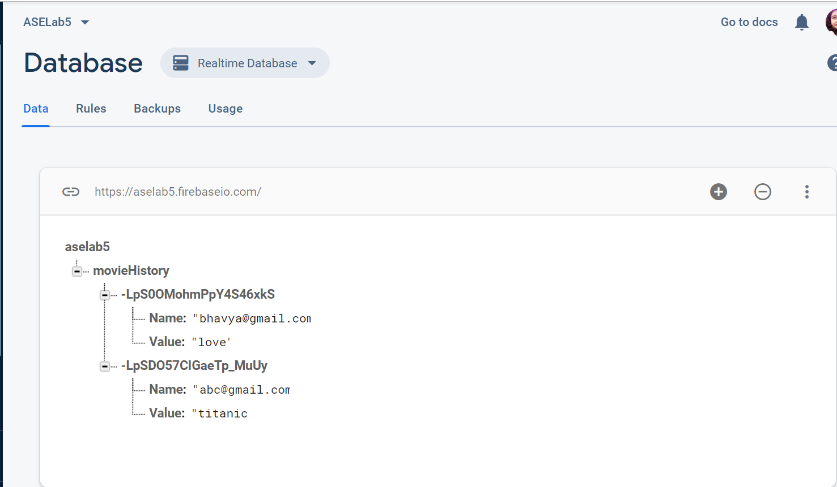

1. When the user search for any movie that data will be shown and using text to speech tha searched movie name will spoken out.

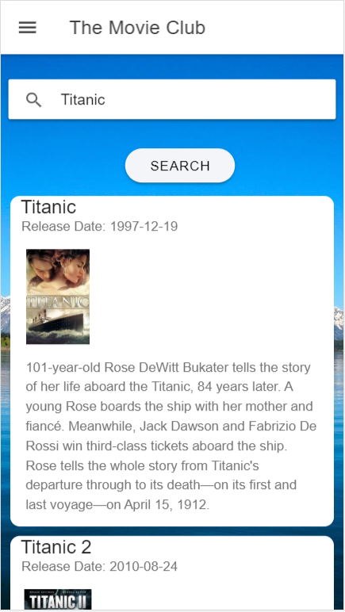

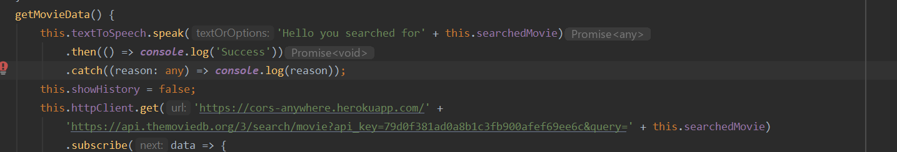

**References:**

* <https://www.w3schools.com/>
* <https://www.themoviedb.org/documentation/api/>
* <https://www.uclassify.com/browse/uclassify/sentiment>
* <https://angular.io/guide/form-validation>
* <https://firebase.google.com/docs>
* <https://ionicframework.com/docs/native/text-to-speech>

**Conclusion:**

* We got an idea about Firebase authentication and data storage and ionic cordova plugins