**Team members:**

1. Bhavya Sri Sirasanagandla

Contribution: 50%

1. Manideep Nadimpelli

Contribution: 50%

**Objective:**

Using nodejs and expressjs to implement CRUD functionalities on customer JSON file.

**Implementation:**

1. Installed expressjs using command “npm install express –save”.

Installed yarg, loadash, fs using the below commands.

“npm install yarg –save”

“npm install loadash –save”

“npm install fs –save”

1. Created customerData.json , cutomer.js and app.js. Imported customer.js into app.js.
2. Added command line options to access the customer data in “customerData” JSON file.

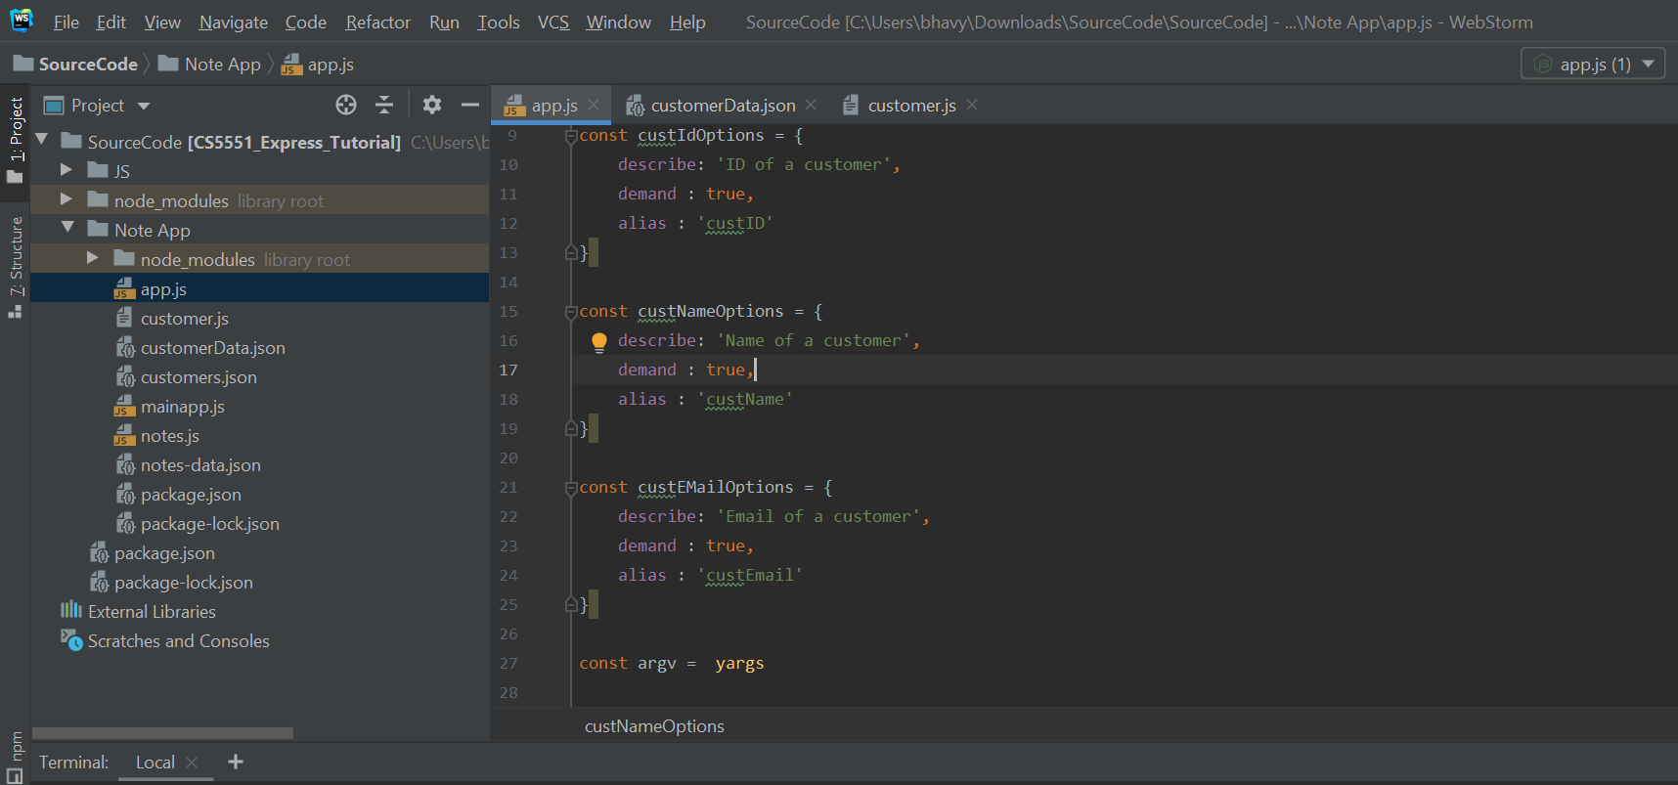

1. Created yargs commands for CRUD operations

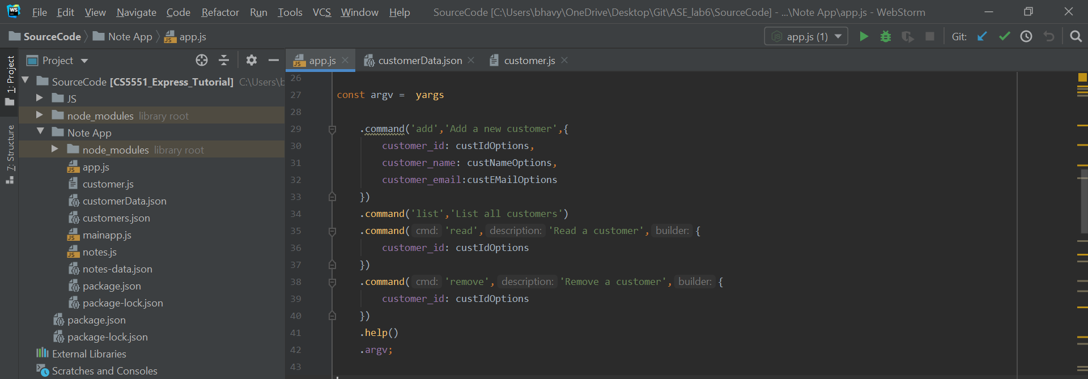

1. Created “featchCustomers” and “saveCustomers” to read and write the data from/to customerData.json file.

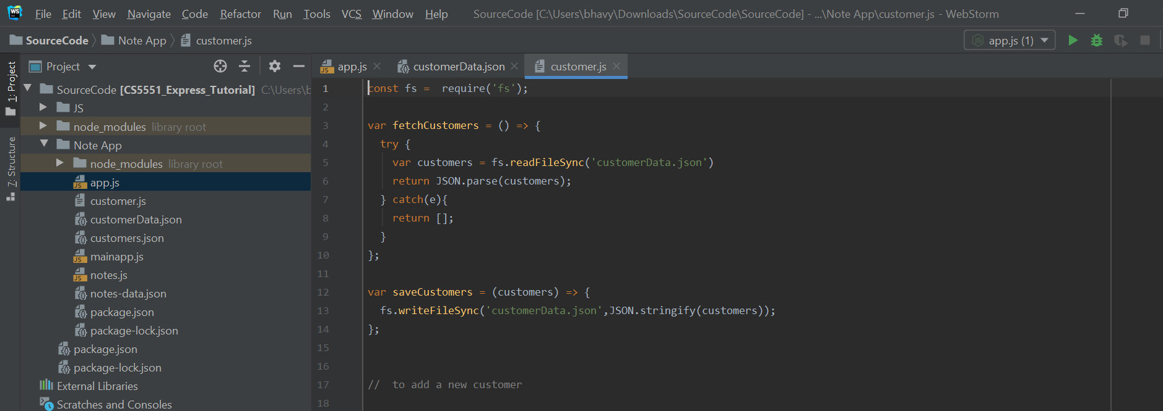

1. Perfomed add operation by creating “add” command in app.js and “addcustomer()” in customer.js file with command properties custID, custName, custEmail.

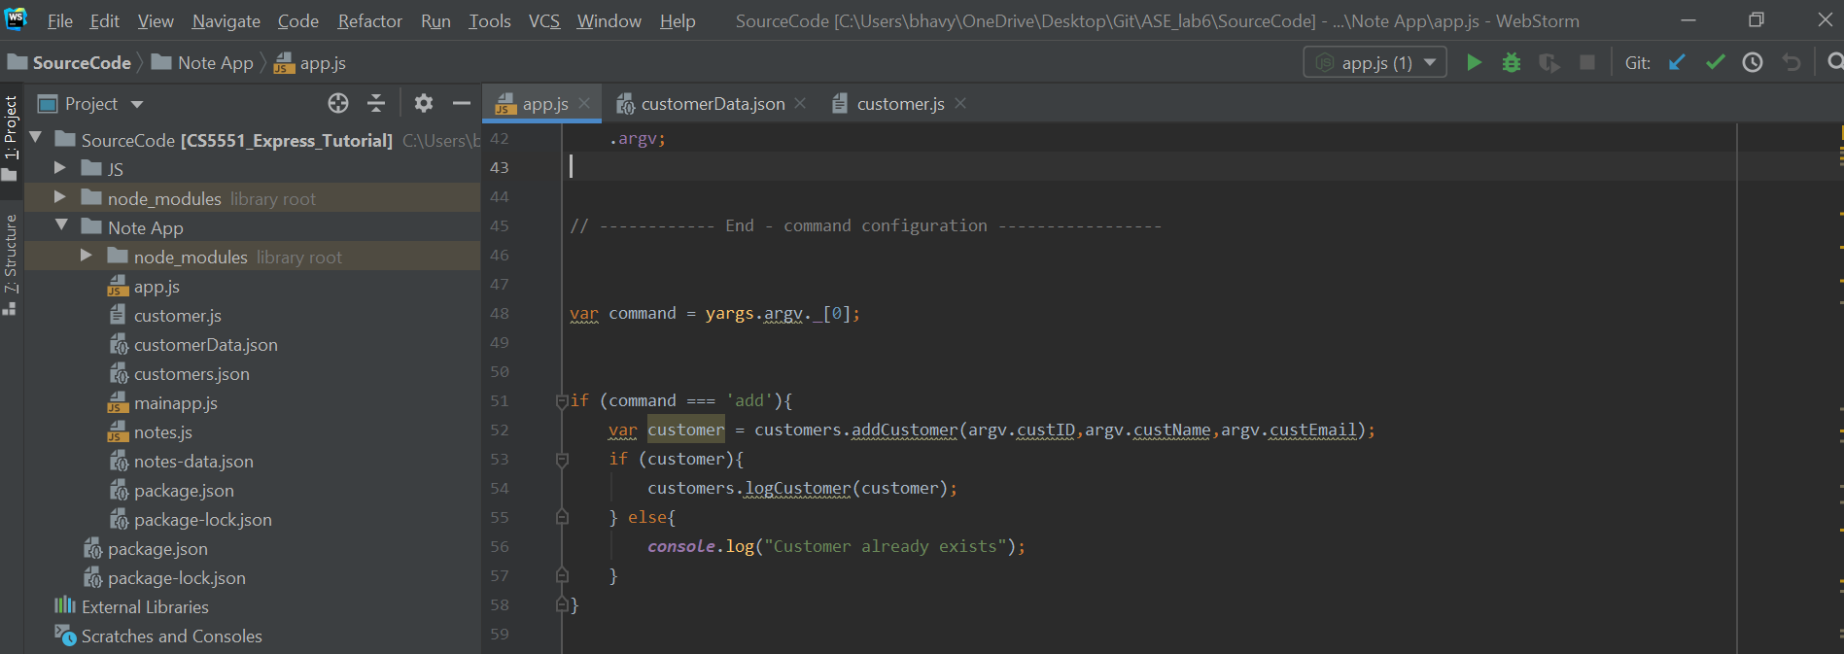

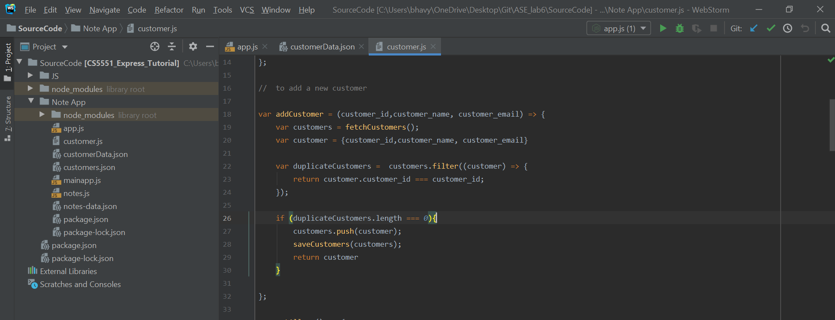

1. In a similar displayed customerdat by configuring “list” command and also created featchCustomer method in customer.js file

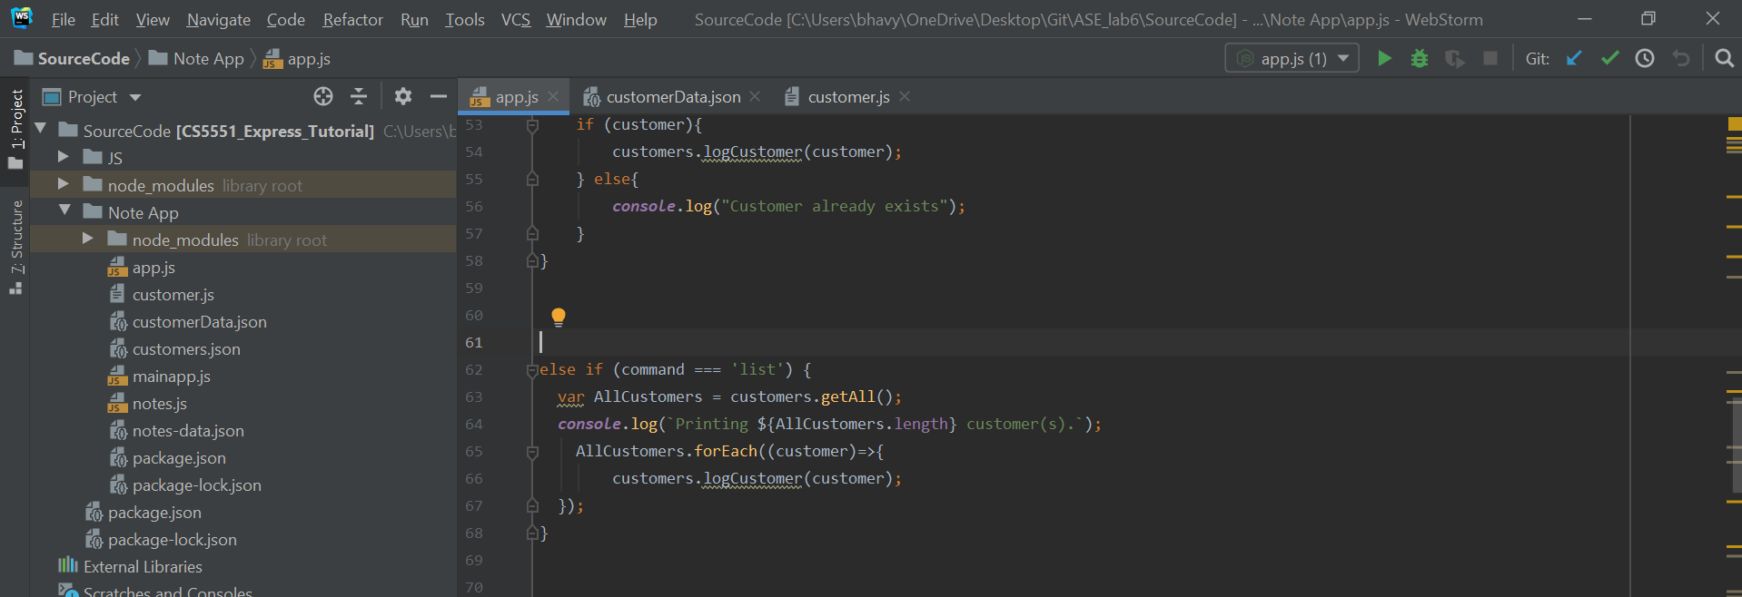

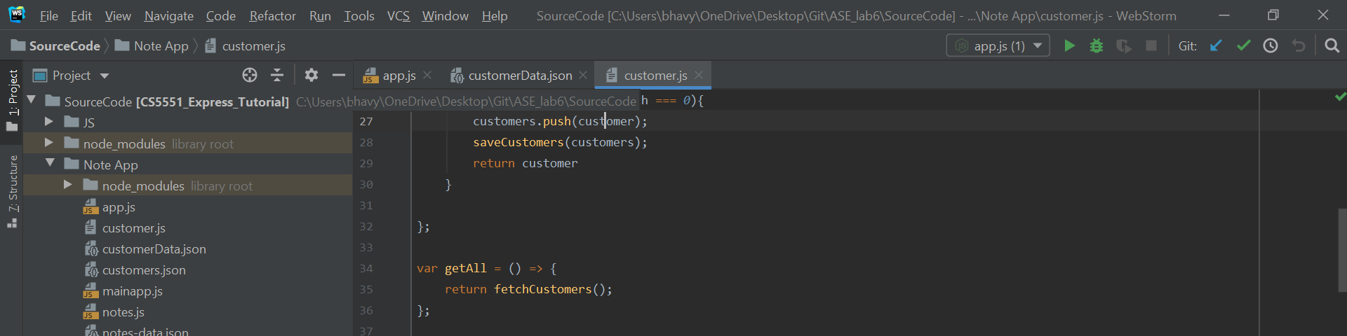

1. Performed update operation by configuring “update” command in app.js and updateCustomer method in customer.js file.Update operation will update the data for any existing customer.

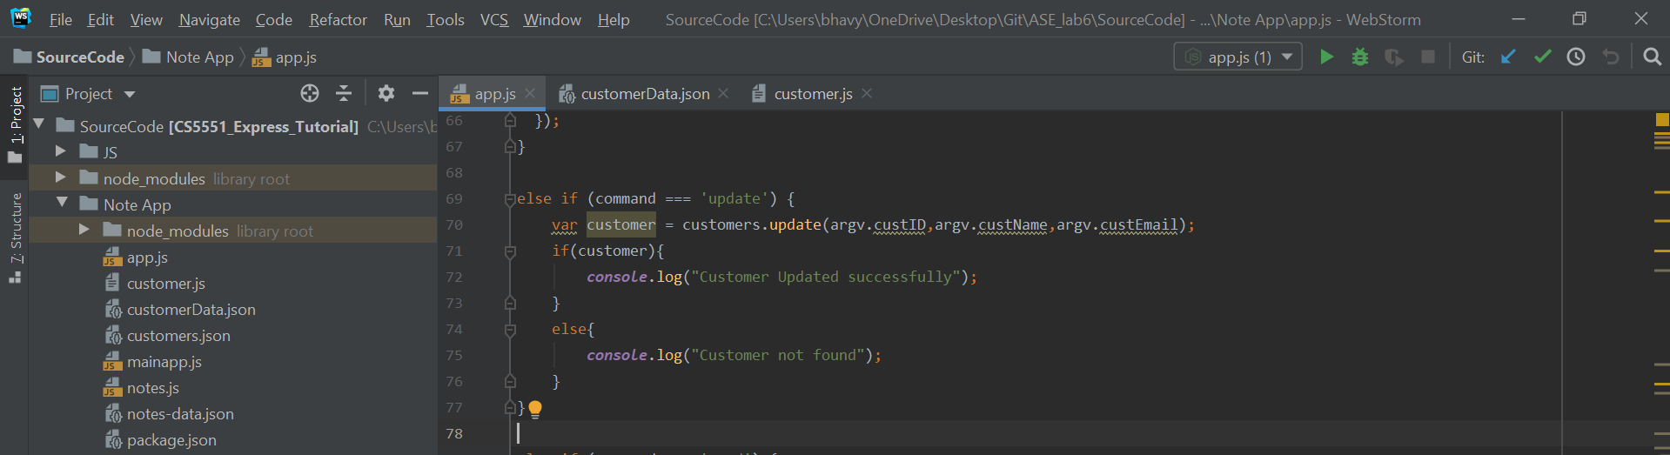

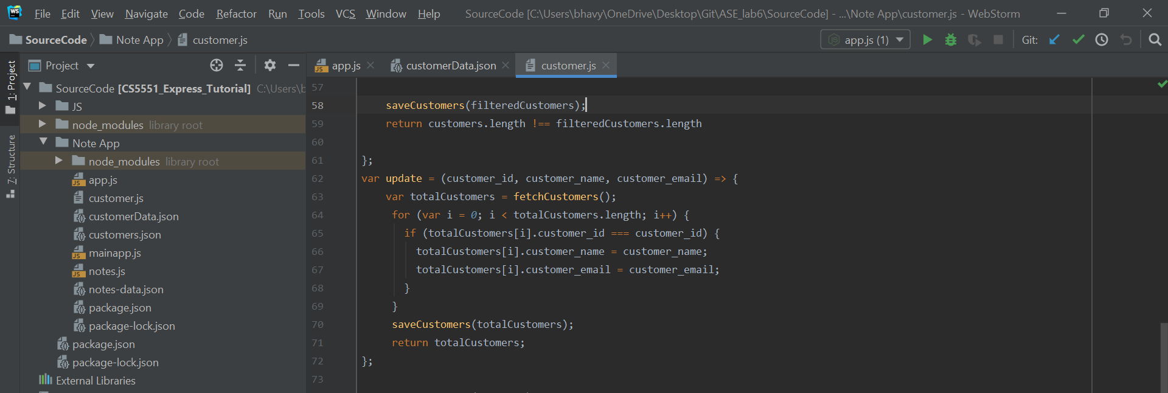

1. Performed “read” operation by configuring “read” command in app.js and getCustomer method in customer.js file.

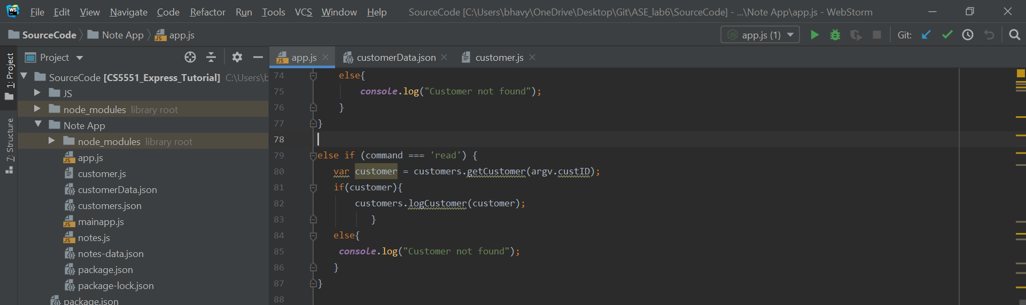

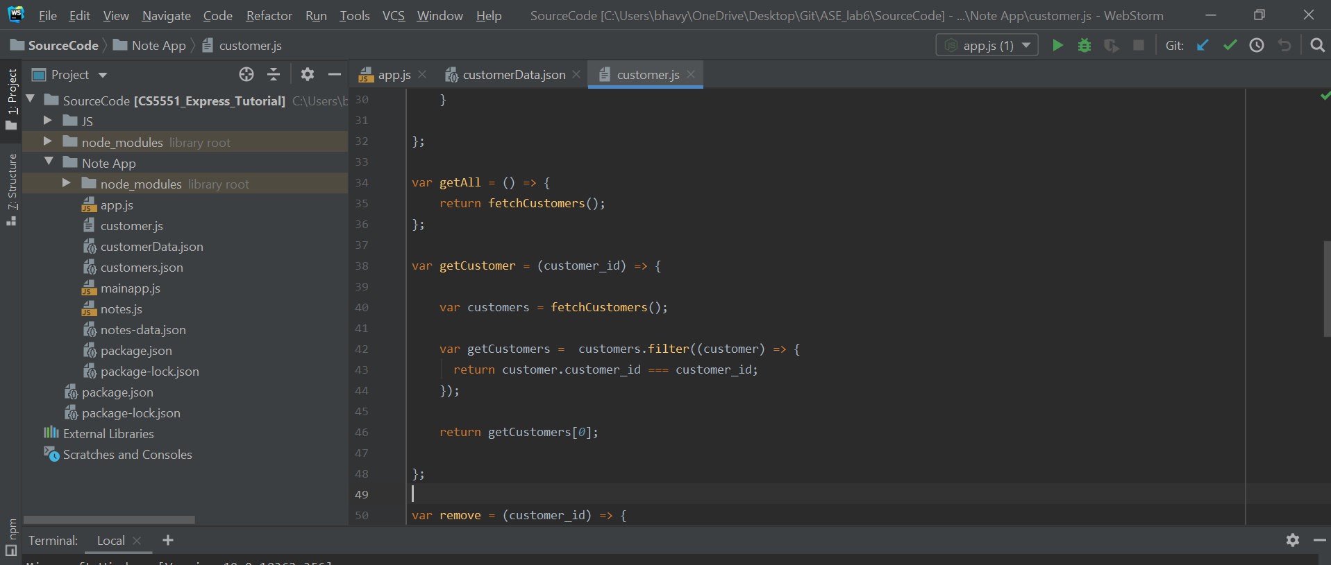

1. Performed “delete” operation by configuring “remove” command in app.js and “remove” method in customer.js file.

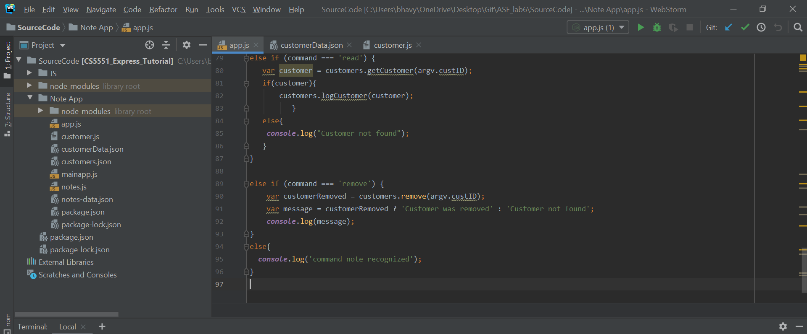

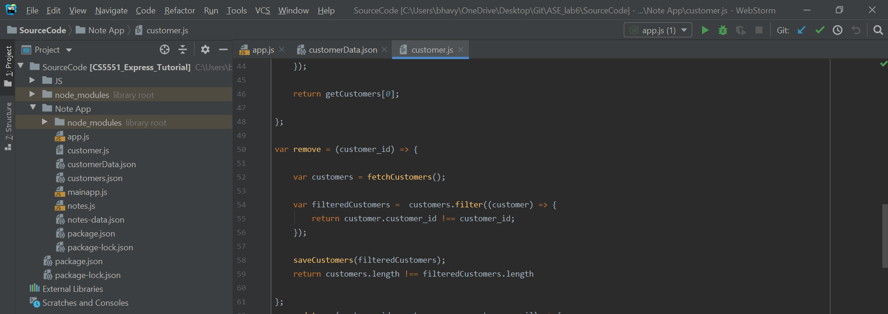

**Sample Output:**

1. For adding and removing a customer.

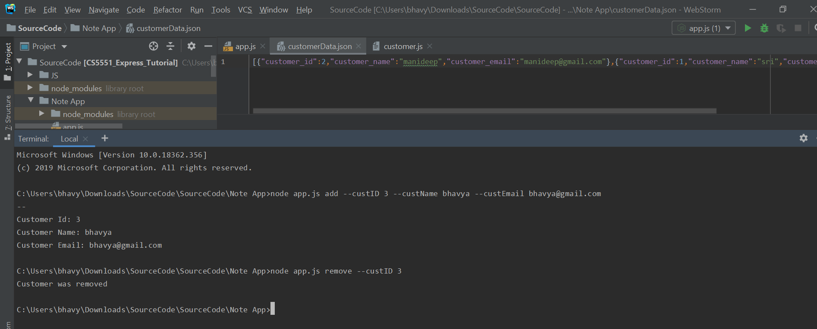

1. For listing and updating a customer.

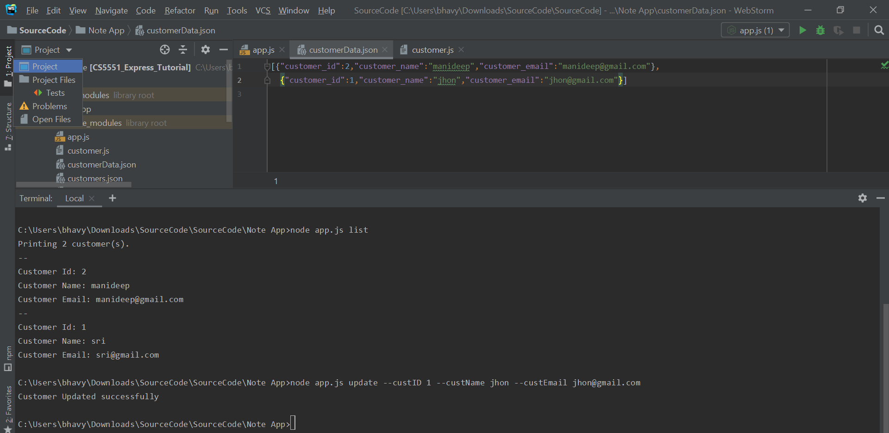

**Conclusion:**

* After completing this assignment we got an idea about how CRUD operations can be performed using nodejs and expressjs.