**Installing GIthub on fedora**

Type on terminal (location is wherever you want)

*Sudo apt -get install git (for Ubuntu)*

*Sudo yum install git for (fedora)*

Press enter, root password will be requested. Type password and enter again.

If git is already on you OS it will be displayed this message:

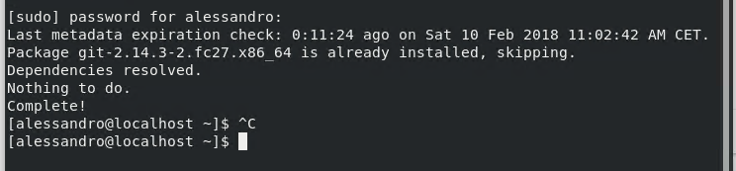

Then you have to create a git account and to configure and set up git on your linux you have to use the following commands:

*git config --global user.name "Your Name"*

*git config --global user.email* [*youremail@domain.com*](mailto:youremail@domain.com)

Use the following procedure to create a folder and to synchronize it with GitHub

Create a repository on github

Choose the directory or the position in your OS where you what to create the new directory

*mkdir foldername*

*create a folder in your git after you logged in*

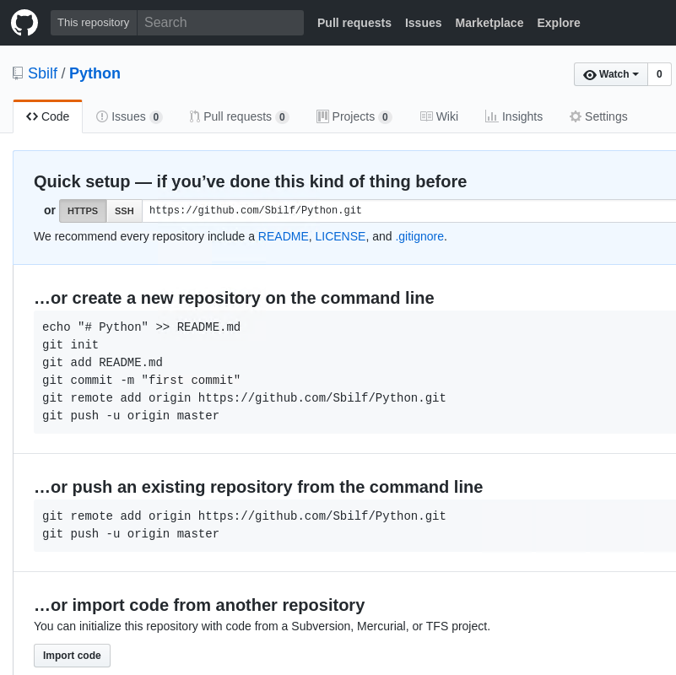

*I want to add a new file to my directory*

*Open terminal in the just created directory and from the terminal make sure that you are in the directory path and type*

*Nano abx.txt*

*To create a text file by opening the text editor. Write something inside and ctrl+O Enter to save and ctrl+X Enter to exit*

*Check for the file on the terminal by typing ls*

*Now commit the file to the git by type the following command*

*git add abc.txt*

*If you want to add some description type again*

*Commit -m “I added abc.txt”*

*Then type on the command line: git remote add origin https:/github.com/Sbilf/Python.git*

*To check that the directory exists and it should return an error saying that remote origin already exist*

*Then finally to add your file type git push -u origin master*

*Give your username*

*Give your password*

*Refresh your github webpage to see the updated file on the web.*

*Resources:*

[*https://www.youtube.com/watch?v=J_Clau1bYco*](https://www.youtube.com/watch?v=J_Clau1bYco)

*Basic Git command List - http://www.codebind.com/linux-tutoria...*

*Set Up Git:*

*git config --global user.name "Your Name"*

*git config --global user.email "youremail@domain.com"*

*other commands*

*git clone (url)*

*git add (file names)*

*git commit -m "(committed message)*

*git push -u origin master*

*git remote add origin master (url)*

**Anaconda installation and env setup**

Download your installer from anaconda.org [https://www.continuum.io/downloads](https://www.youtube.com/redirect?q=https%3A%2F%2Fwww.continuum.io%2Fdownloads&v=UbzZtzLxxo0&event=video_description&redir_token=3cZ0TgR-KVf-0HeKNi6w3MnMqAF8MTUxOTEzNjAxNUAxNTE5MDQ5NjE1)

2) Install Anaconda $ bash Anaconda3-4.3.1-Linux-x86_64.sh

3) Create a conda environment $ conda create -n mycondaenv

4) Activate the conda environment $ source activate mycondaenv

5)$python

How to upload env on anaconda cloud

conda env upload

**Jupyter lab installation**

https://www.youtube.com/watch?v=-SdN590WNZY