**Installing GIthub on fedora**

Type on terminal (location is wherever you want)

*Sudo apt -get install git (for Ubuntu)*

*Sudo yum install git for (fedora)*

Press enter, root password will be requested. Type password and enter again.

If git is already on you OS it will be displayed this message:

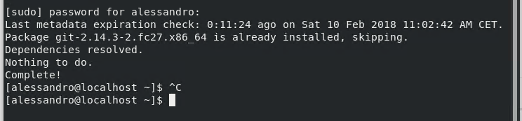

Then you have to create a git account and to configure and set up git on your linux you have to use the following commands:

*git config --global user.name "Your Name"*

*git config --global user.email* [*youremail@domain.com*](mailto:youremail@domain.com)

Use the following procedure to create a folder and to synchronize it with GitHub

Create a repository on github

Choose the directory or the position in your OS where you what to create the new directory

*mkdir foldername*

*create a folder in your git after you logged in*



*I want to add a new file to my directory*

*Open terminal in the just created directory and from the terminal make sure that you are in the directory path and type*

*Nano abx.txt*

*To create a text file by opening the text editor. Write something inside and ctrl+O Enter to save and ctrl+X Enter to exit*

*Check for the file on the terminal by typing ls*

*Now commit the file to the git by type the following command*

*git add abc.txt*

*If you want to add some description type again*

*Commit -m “I added abc.txt”*

*Then type on the command line: git remote add origin https:/github.com/Sbilf/Python.git*

*To check that the directory exists and it should return an error saying that remote origin already exist*

*Then finally to add your file type git push -u origin master*

*Give your username*

*Give your password*

*Refresh your github webpage to see the updated file on the web.*