**Login Page:**

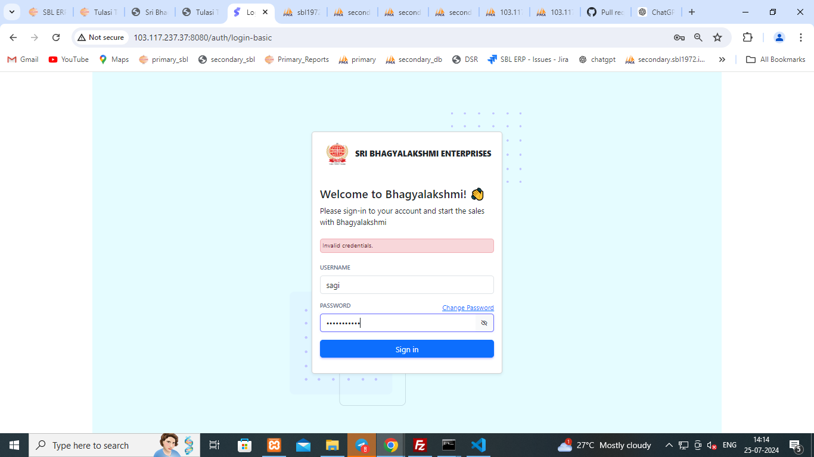

**Sagi Interface:**

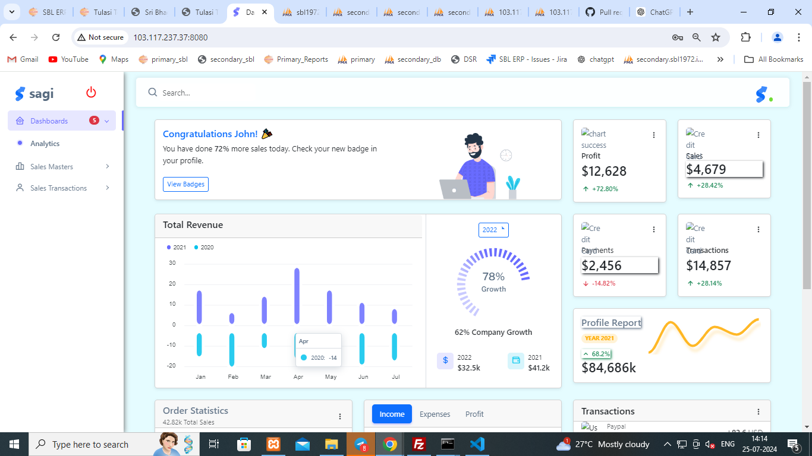

**Profile Master:**

**ADD Page:**

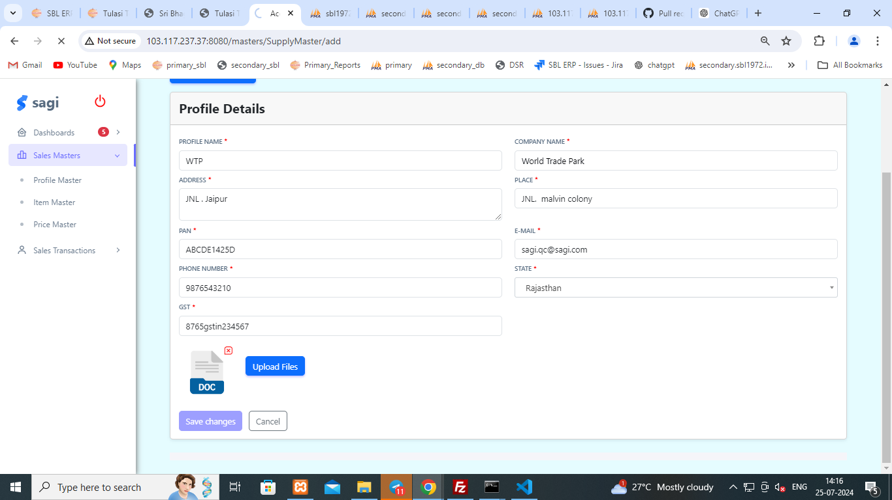

**Profile Display:  
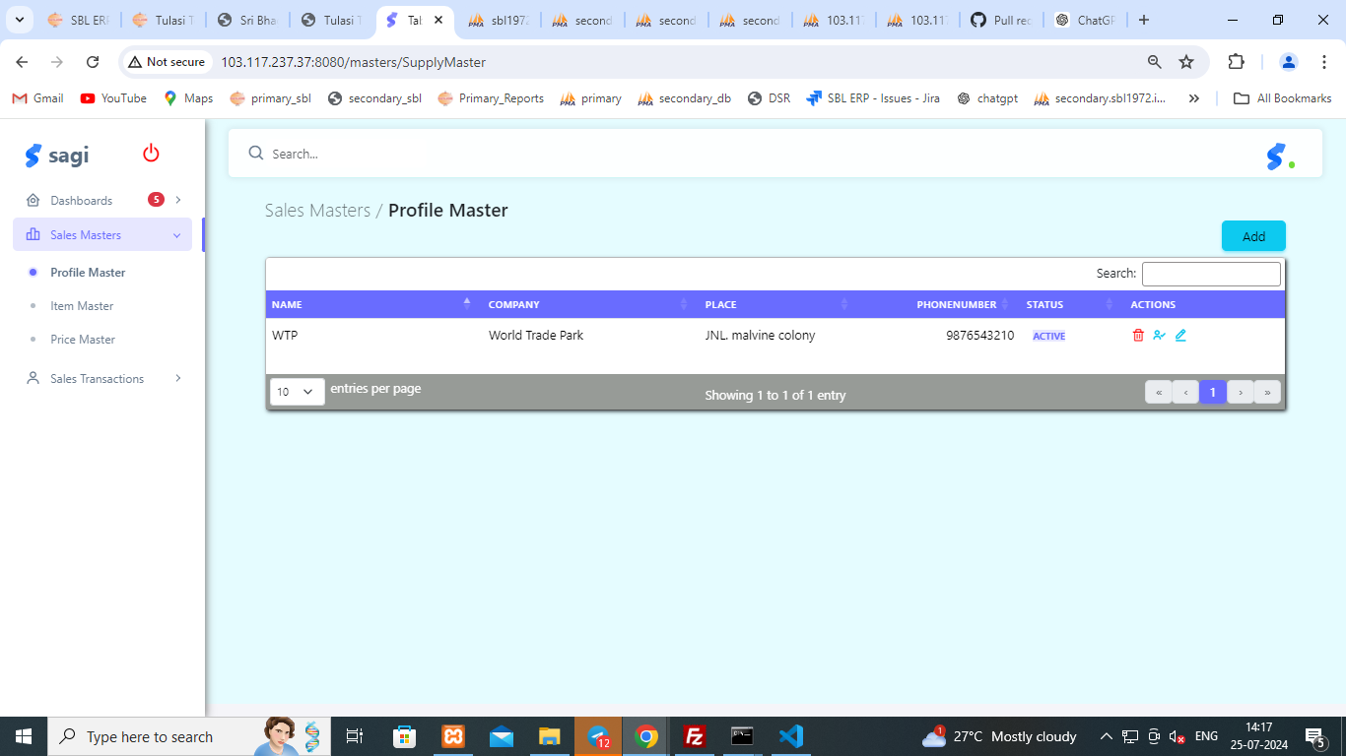**

**Item Master:**

**ADD Page:  
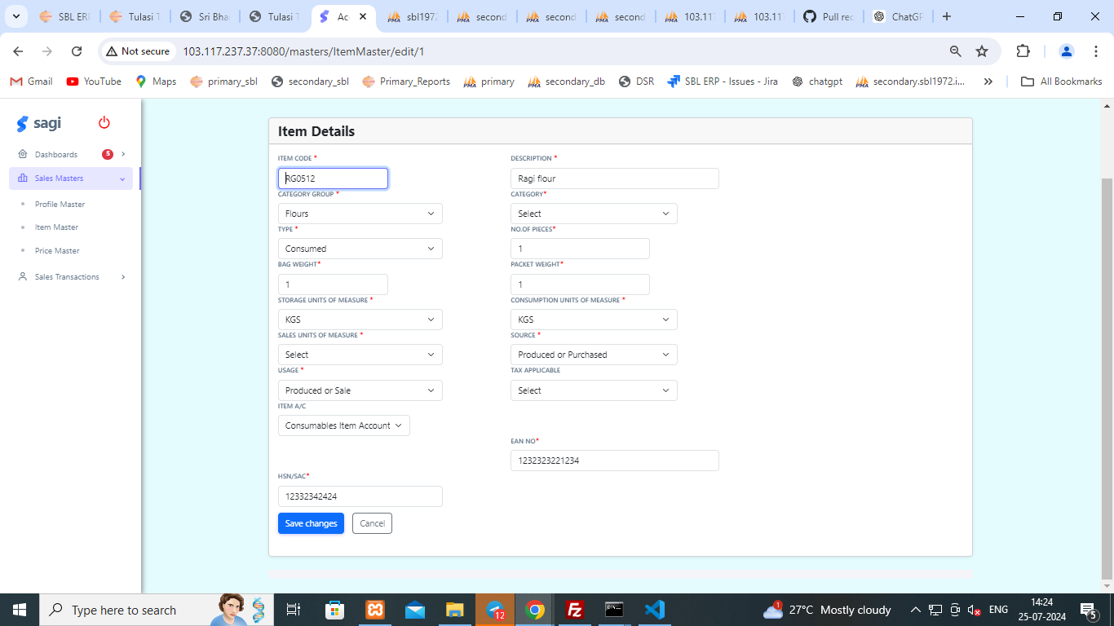**

**Item Master Display:**

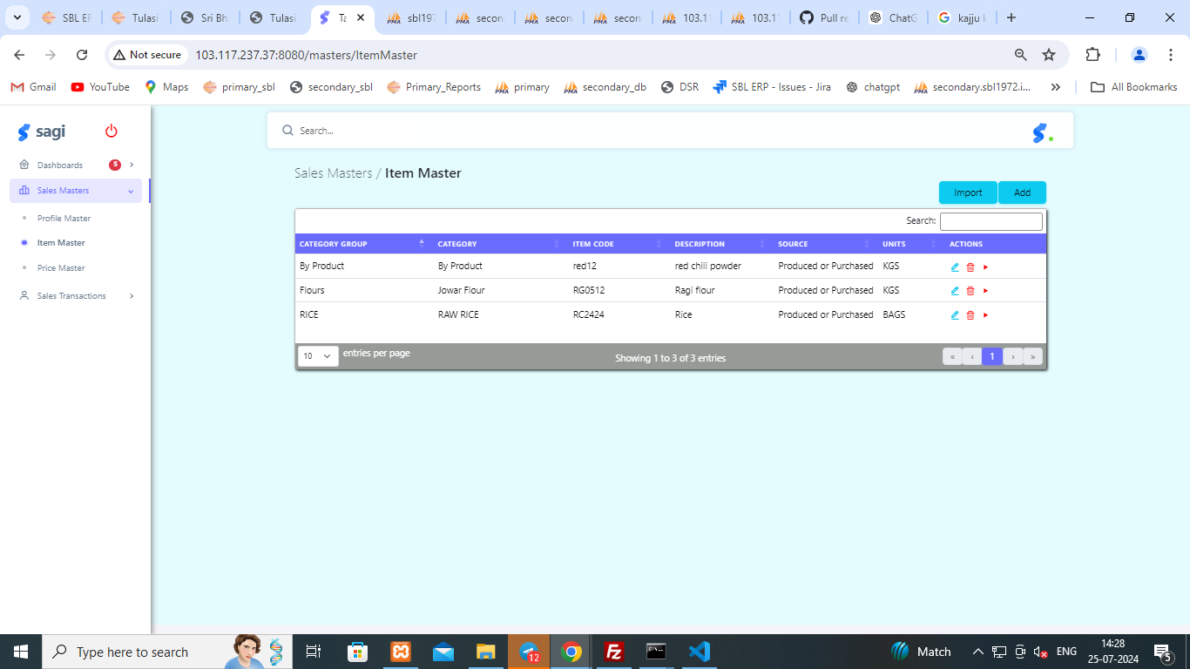

**Sagi Authorization(Primary):**

**Level 1:  
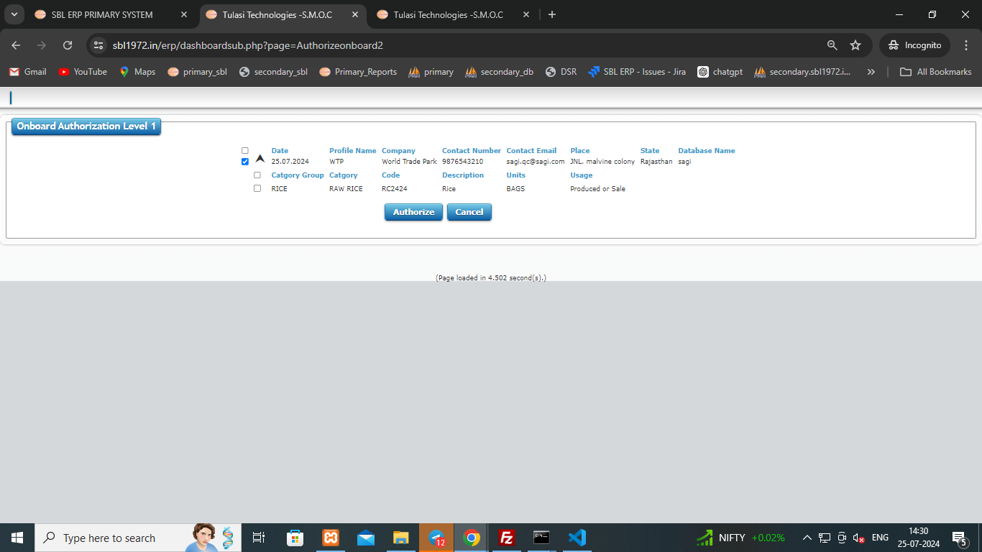**

**Level 2:**

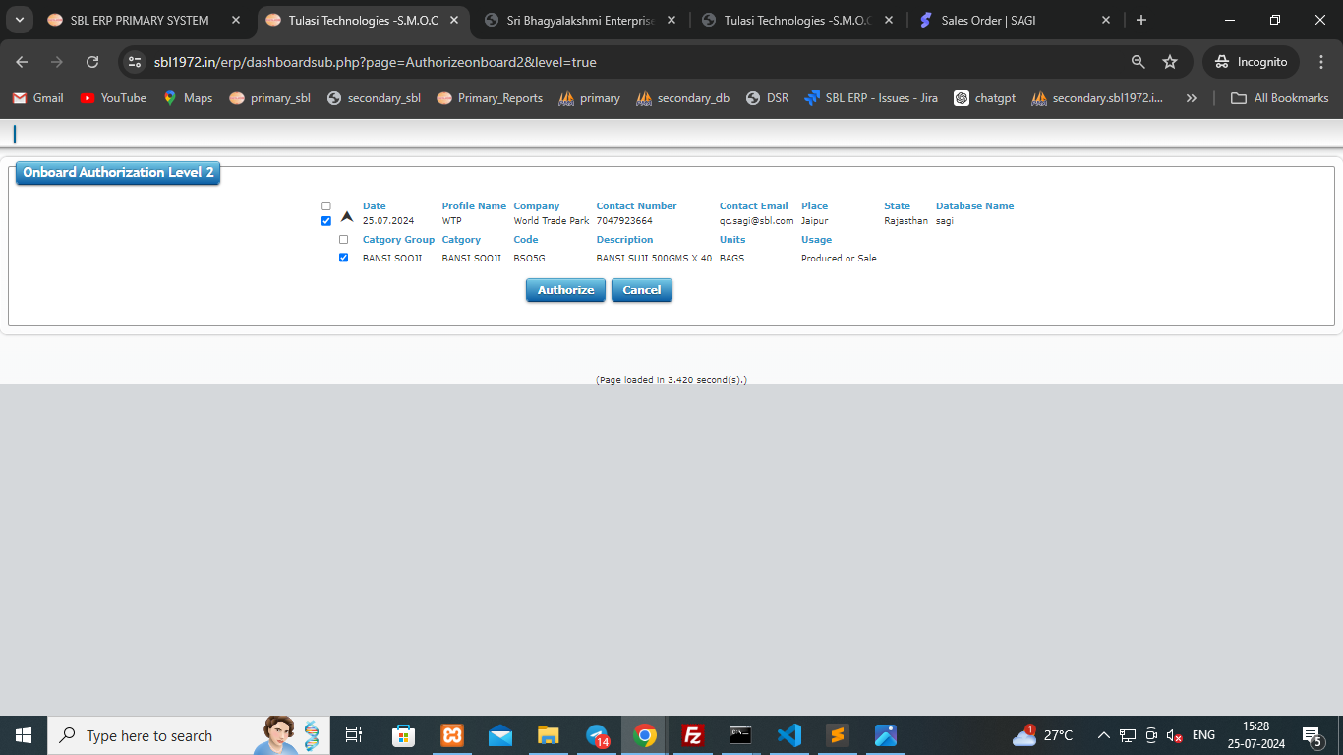

**Price Master:**

**ADD Page:**

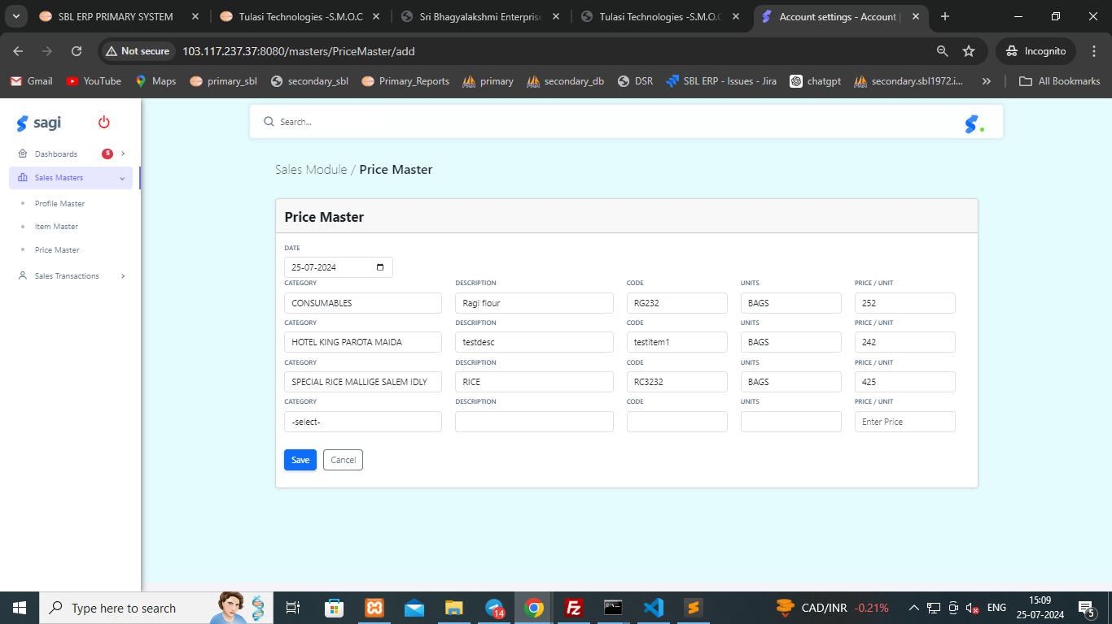

**PriceMaster Display:**

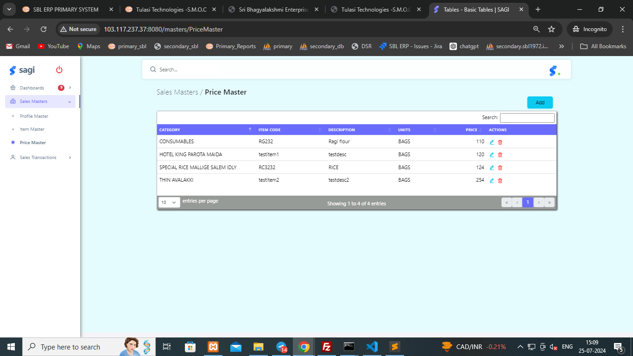

**Purchase Order(Secondary):**

**ADD Page:**

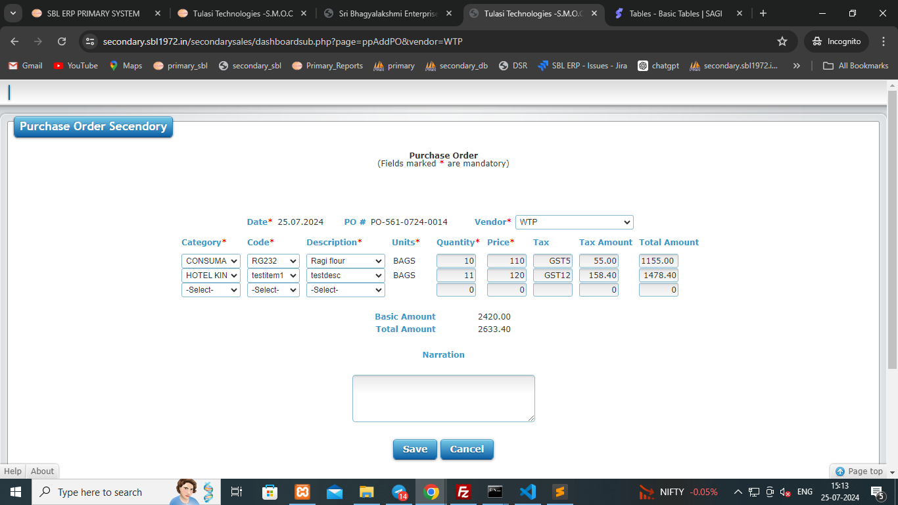

**Purchase Order Display:**

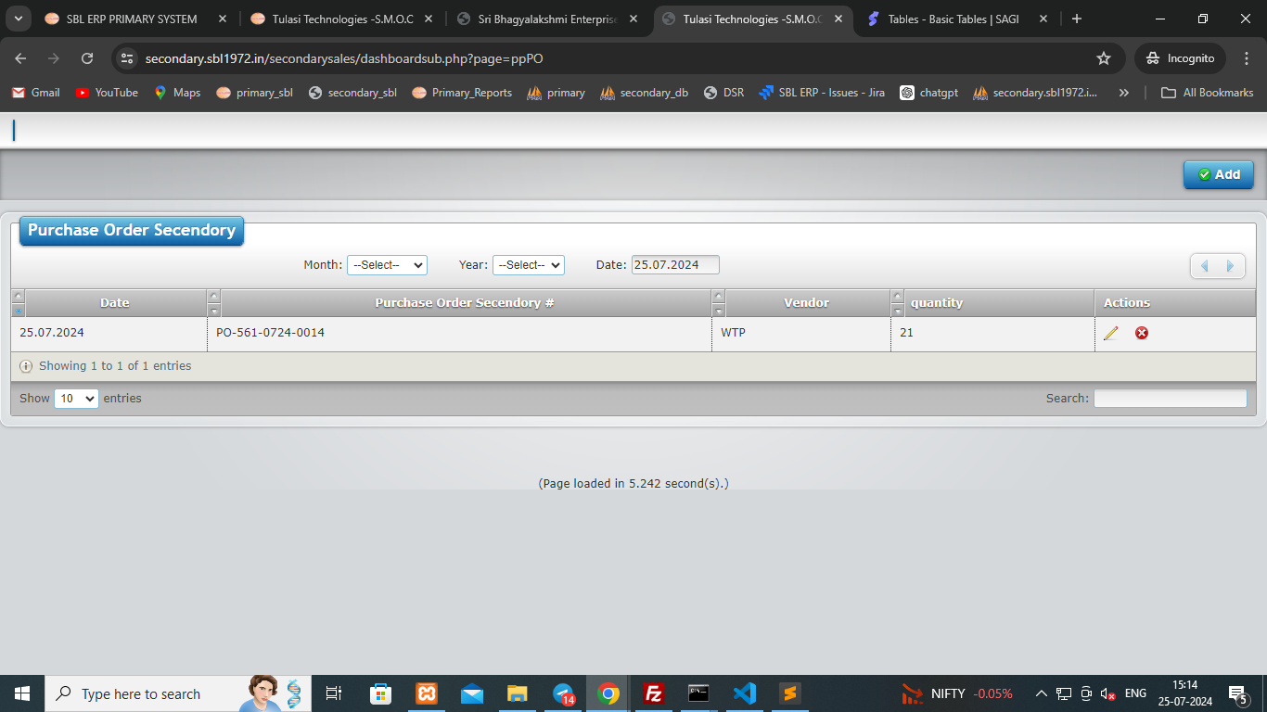

**Sales Order :**

**ADD Page:**

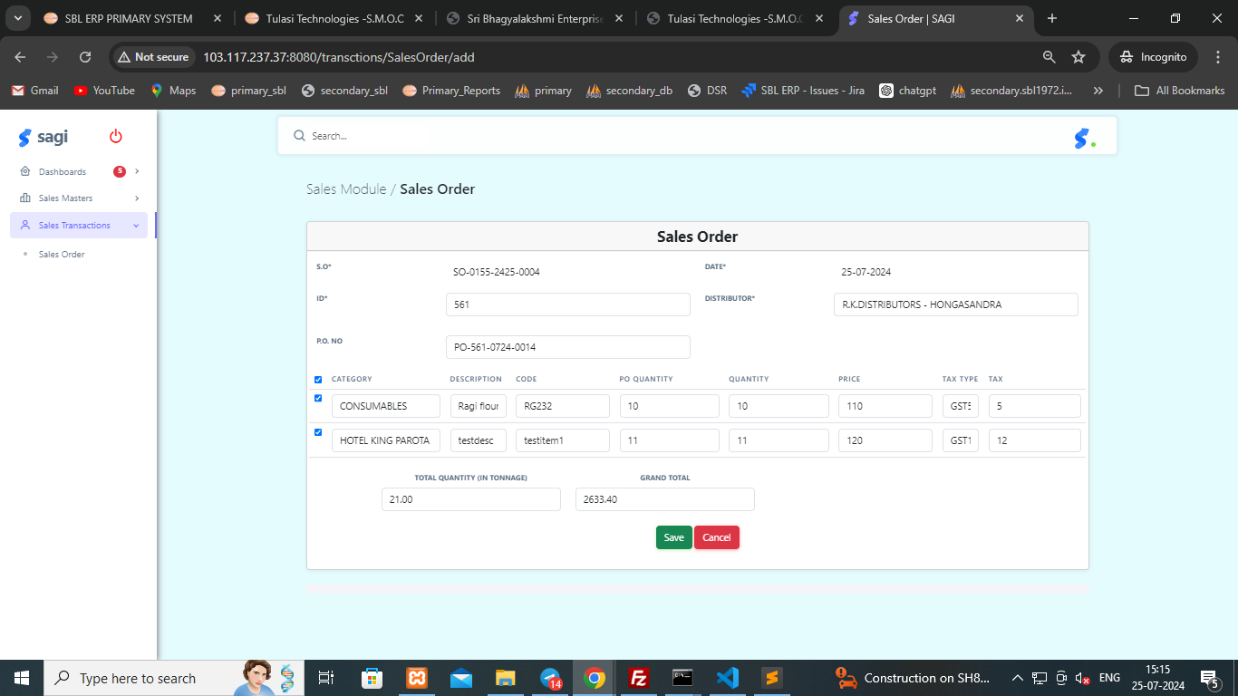

**Sales Order Display:**

