# Cover page

**Student Name+Surname:** Sbongile Chauke

**Student Number:** ST10365563

**Module Name:** Human Computer Interaction

**Module Code:** HCIN6222

**Assessment Type:** Portfolio of Evidence (Part 2)

**Due Date:** 21 October 2024

# Table of Content

Cover page 1

Table of Content 1

Part 2 – Interaction Design 2

1.1. The functionality that the website will offer. 2

1.2. A description of how you plan to implement the following in the design of the website: 2

1.2.1 Usability goals. 3

1.2.2 Desirable aspects of user experience. 3

1.2.3 Design principles. 3

1.2.4 Interaction types. 4

1.2.5 Social interactions. 5

1.2.6 Emotional interaction. 5

1.2.7 Web Content Accessibility and Guidelines (WCAG) 2.0. 5

Perceivable 6

Operable 6

Understandable 6

Robust 6

Conformance 6

Prototype 6

Reference list: 13

# Part 2 – Interaction Design

1. The website will be designed as an online tutoring service to assist my peers overcome academic challenges and excel in their studies where they can find content for a specific subject or module (Lal, 2023).

# 1.1. The functionality that the website will offer.

The website will be developed with pre-existing content for students with no direct interaction with tutors and it will offer a user-friendly interface with a minimalist atmosphere that will fit the student's aesthetics by implementing a list of available courses and subjects with detailed descriptions (Lal, 2023). It will allow students to go through study materials at their own pace accommodating their different learning styles (Lal, 2023). Pre-recorded tutoring videos for different topics as well as study materials such as articles, eBooks and study guides will be provided (Lal, 2023). It will provide self-evaluation quizzes to enhance learning and assist students evaluate their understanding of the material (Lal, 2023). The website will have a responsive design to facilitate learning on various devices such as smartphones, tablets and desktop computers (Lal, 2023). It will enable students to leave reviews and testimonials on the content to assist in improving future offerings (Lal, 2023). A search button will be included for easy navigation for students to find specific topics, courses or study materials based on their interests (Lal, 2023). Consistent updates will be made to keep the latest content relevant (Lal, 2023). Lastly the website will enable students to sign up or log in for registration (Lal, 2023).

1.2. A description of how you plan to implement the following in the design of the website:

# 1.2.1 Usability goals.

The website will have a clear navigation bar with web pages such as the homepage, to help students find content easily (Ramotion, 2024). A search button will be implemented to allow students to locate specific courses or topics quickly to reduce the number of steps to access study materials (Ramotion, 2024). A consistent design and layout across pages will be maintained to assist students familiarize themselves with the website with ease of use as well as enable students to provide feedback based on their experiences (Ramotion, 2024). There will be a use of familiar user interface elements that students can recognize such as search buttons and icons (Ramotion, 2024). Informative error messages that guide students on how to correct mistakes especially when they are filling in the registration form will be implemented (Ramotion, 2024). The website will have an appealing aesthetic and clean layout to create a positive first impression and reinforce user satisfaction using neutral colors or dark mode to prevent eye strain (Ramotion, 2024). The website will be fully responsive across all types of devices (Ramotion, 2024). The incorporation of features like keyboard navigation and alternative text for images to accommodate users with disabilities (Ramotion, 2024). Help centers will be created to assist students with common questions (Ramotion, 2024).

# 1.2.2 Desirable aspects of user experience.

The website will contain the use of visually pleasing colors and images that will align with the educational aesthetic as well as consistent logos, fonts and overall style to create familiarity (Ramotion, 2024). The website will have a clean design and coordinated layout that will guide students naturally through the content such as hover effects and animations that will make the website more engaging (Ramotion, 2024). Testimonials and reviews from past students will be highlighted to inspire new students and create a sense of community (Ramotion, 2024). There will be incorporation of quizzes or challenges that reward students for participation making learning fun (Ramotion, 2024). Opportunities for students to give feedback on courses and features ensuring they feel heard and valued (Ramotion, 2024). The website will be accessible for students with disabilities by implementing alternative text for images and keyboard navigation (Ramotion, 2024). There will be use of clear language in all content avoiding complex terminology so that students can understand better (Ramotion, 2024). Students will be offered support if ever they need assistance through help centers (Ramotion, 2024). The course material will be kept up to date to ensure relevance, which can reinforce students’ trust and satisfaction (Ramotion, 2024). The website will be optimized to ensure quick loading times, reinforcing students’ satisfaction and reducing exit rates.

# 1.2.3 Design principles.

The website will use consistent colors, fonts and button styles to create a consistent atmosphere for students (Ramotion, 2024). Content will be structured using headings and subheadings to guide students through the course material and make it clear (Ramotion, 2024). Grid systems will be employed to align text and images to create a coordinated appearance (Ramotion, 2024). Dark text on a light background will be used (Ramotion, 2024). Design elements such as buttons, icons and colors will be repeated throughout the website to create familiarity and aid navigation by categorizing content (Ramotion, 2024). Alternative text for images will be provided for visually impaired students as well as making interactive elements accessible via keyboard shortcuts for students who cannot use a mouse (Ramotion, 2024). Immediate feedback will be provided for student's actions such as form submissions or button clicks through messages or visual clues such as color changes (Ramotion, 2024). The website will adapt to different screen sizes and devices, and it will minimize the number of steps needed to complete tasks such as accessing course materials (Ramotion, 2024). A search button will be added to enable students to find relevant content easily (Ramotion, 2024).

# 1.2.4 Interaction types.

The website will have the use of clickable items such as buttons and icons that provide immediate visual feedback such as the change in color (Ramotion, 2024). Concurrent validation for form inputs will be provided to assist students correct mistakes before submission, reinforcing usability (Ramotion, 2024). For registration forms, there will be the inclusion of auto-complete features that suggest options based on students’ input to simplify the process (Ramotion, 2024). The website will have a sticky header that remains visible even when students scroll, allowing easy access to the navigation bar without having to scroll back up (Ramotion, 2024). Complex processes will be broken down into manageable steps such as accessing course materials (Ramotion, 2024).

**Drag-and-Drop Functionality:** Students can easily upload files such as assignments and projects that they need assistance with by dragging and dropping them into a designated area, simplifying the file upload process (Ramotion, 2024).

**Hover Effects:** Icons and buttons will have hover effects that provide additional information or change appearance such as color giving students immediate feedback and guiding them through different actions (Ramotion, 2024).

**Accordion Menus:** Collapsible menus will be used to organize long lists of content, such as frequently asked questions or course modules (Ramotion, 2024). This interaction will reduce clutter and allow students to focus on specific areas of interest (Ramotion, 2024).

**Interactive Modals:** Pop-up modals will be used to display important messages, notifications, or forms without navigating away from the current page, keeping students engaged with the task at hand (Ramotion, 2024).

**Swipe Gestures for Mobile Users:** The mobile version of the website will allow students to use swipe gestures to navigate between sections or pages, improving usability for those accessing the platform on touch devices (Ramotion, 2024).

# 1.2.5 Social interactions.

The website will enable students to comment on course material that will be posted creating organized interaction (Ramotion, 2024). A private messaging system will be incorporated to enable students to communicate directly. It will enable students to view testimonials of past students and add their own to be visible to other students using the website (Ramotion, 2024). A platform will be created for students who seek assistance and to share their knowledge such as study resources (Ramotion, 2024). Notifications will be implemented to alert students when they receive messages (Ramotion, 2024). It will enable students to create study groups and invite others to join using a link (Ramotion, 2024). A reliable help center will be created where students can find assistance (Ramotion, 2024).

# 1.2.6 Emotional interaction.

The website will send personalized welcome messages making students feel recognized and valued (Ramotion, 2024). Neutral colors will be utilized to evoke warmth and positivity to create a welcoming atmosphere (Ramotion, 2024). There will be a use of clear fonts that will resonate with students making the content accessible (Ramotion, 2024). The incorporation of storytelling into course content to enable students to connect emotionally with the material (Ramotion, 2024). Peer support will be facilitated through study groups where students can share experiences and encourage one another (Ramotion, 2024). There will be use of empathetic language in notifications and feedback messages to motivate students (Ramotion, 2024).

# 1.2.7 Web Content Accessibility and Guidelines (WCAG) 2.0.

# Perceivable

The text will contrast well with the background, images will have alternative text, and videos will have captions which will assist users who are visually impaired to understand and interact with content easily (w3.org, n.d.). Text alternatives will be provided for audio content so that users who are deaf or have hearing issues can access the information easily (w3.org, n.d.). Adaptable layouts that work well across different devices and screen sizes will be included (w3.org, n.d.).

Operable

The website will ensure that all interactive elements such as links, forms and buttons are accessible via keyboard (w3.org, n.d.). This will assist students who cannot use a mouse due to physical disabilities (w3.org, n.d.).

# Understandable

The website will provide clear and simple instructions, labels, and error messages (w3.org, n.d.). This will assist all students, especially those with psychological disabilities, to understand how to interact with content (w3.org, n.d.). It will maintain a consistent navigation structure and layout to avoid confusion (w3.org, n.d.). There will be a use of plain language and avoiding terminology (w3.org, n.d.).

# Robust

The website will ensure that it works across different browsers, devices, and assistive technologies (w3.org, n.d.).

# Conformance

The website will ensure that students with disabilities can interact with the content more effectively using the WCAG guidelines (w3.org, n.d.). Tests will regularly be made for the website against WCAG guidelines and use tools or involve users with disabilities in testing to ensure compliance and address any issues (w3.org, n.d.).

# Prototype

<https://www.figma.com/design/s1GfpJ5W2p42nCSLvCl4fj/FIGMA?node-id=42-3&t=jdTwymySyZqZe0kq-1>

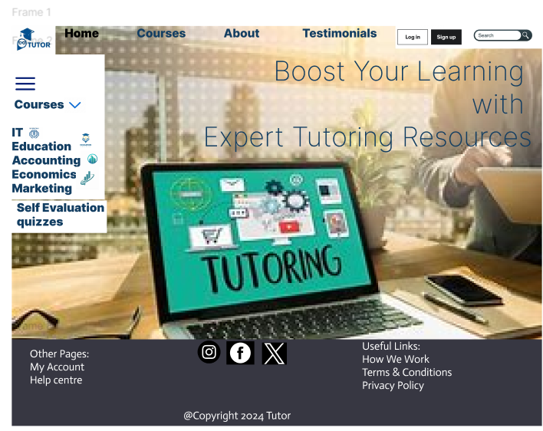

Figure 1: Home page

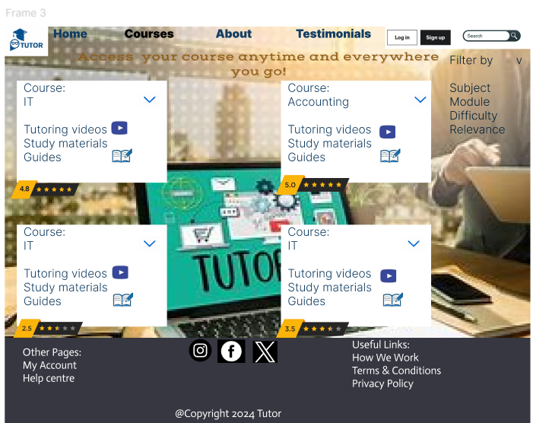

Figure 2: Courses Page

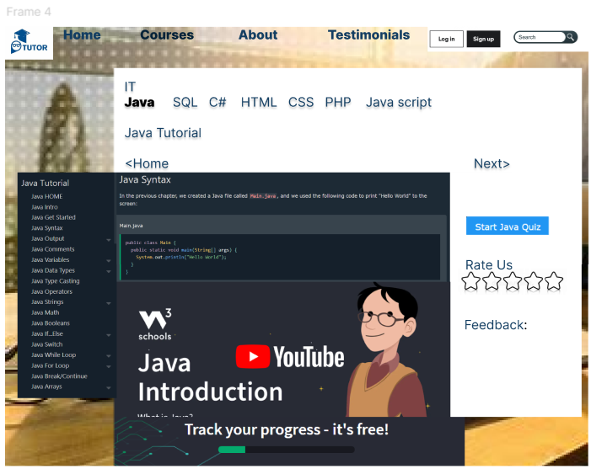

Figure 3: Detailed courses page

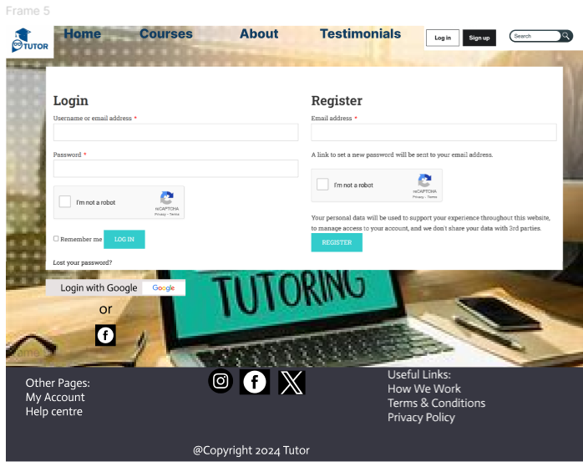

Figure 4: Login/Register form

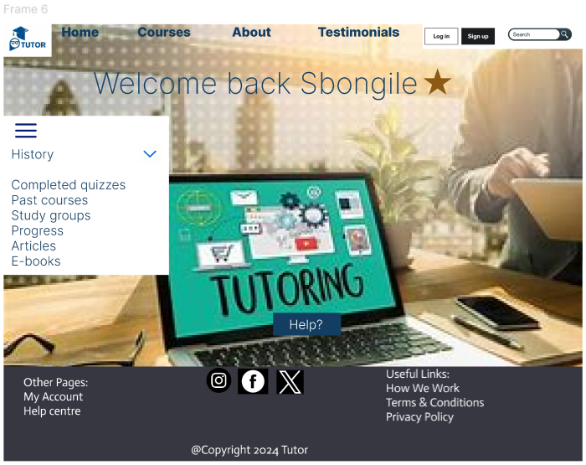

Figure 5: User dashboard

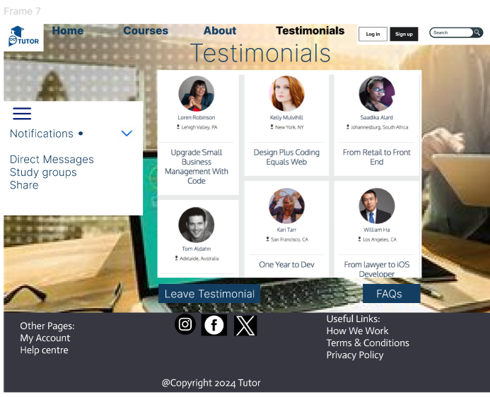

Figure 6: Testimonials page

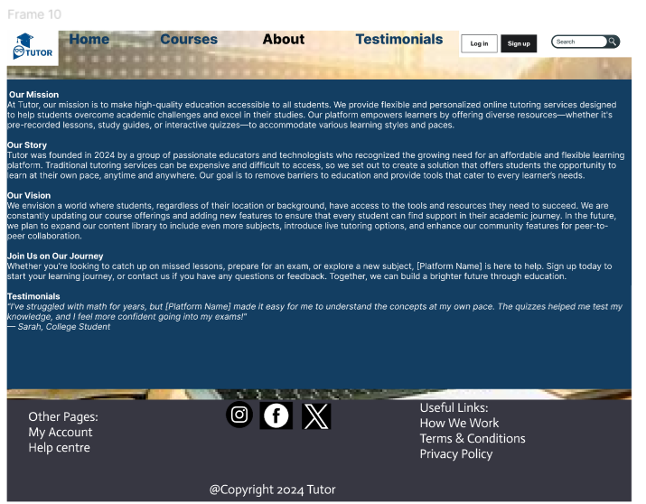

Figure 7: About page

# Reference list:

Lal, R. 2023. 10 Must-Have Features Of Online Tutoring Platforms, 25 August 2023. [Online]. Available at: <https://elearningindustry.com/must-have-features-of-online-tutoring-platforms#:~:text=By%20offering%20a%20user-friendly%20interface%2C%20robust%20search%20and,platform%20will%20stand%20out%20in%20the%20competitive%20market>.

[Accessed 20 September 2024]

Ramotion. 2024. Website Usability 101: Definition, Principles and Methods, 04 September 2024. [Online]. Available at: <https://www.ramotion.com/blog/website-usability/.>

[Accessed 20 September 2024]

W3.org. 2024. How to Meet WCAG (Quick Reference) A customizable quick reference to Web Content Accessibility Guidelines (WCAG) 2 requirements (success criteria) and techniques, 23 August 2024. [Online]. Available at: <https://www.w3.org/WAI/WCAG22/quickref/?versions=2.0>

[Accessed 20 September 2024]