Stack summary
Laptop specs
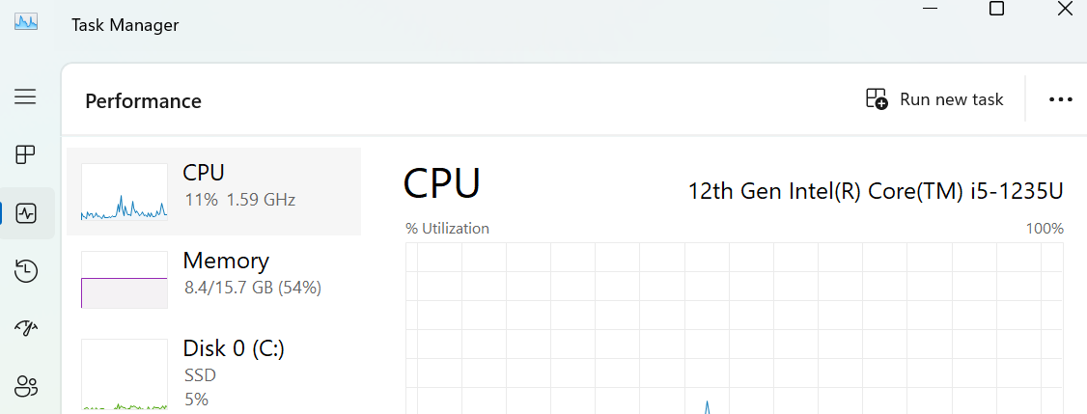
16 gb ram plus 1tb ssd is good enough
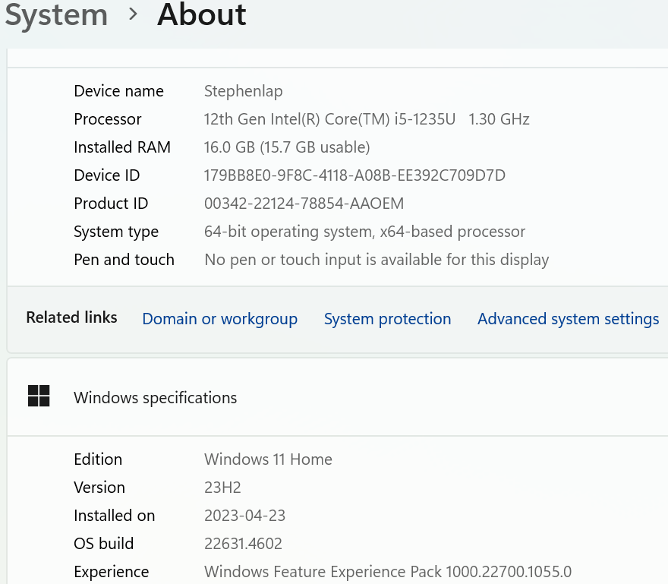
Its windows 11 os

Stack intro
Frontend:
- next.js for seo needed ssr-pages (containerized); it *also* does the react csr
- ant-design for the ui;
- ui bakery with exported react code into vs studio
  - react query: a library that helps create the intra-browser-react-engine code. Is used for the api calls to app-tier (albeit through a rps of the webserver);
  - react: for the 1-time creation of the csr static code files (the js bundle)– which then allows the browser-react-engine to call the rps-api (and I assume feed the results back into the browser gui)
- nginx (the webserver): hosts 3 things:
  - 1) the rps for the app-tiers apis which is called by the browser-react;
  - 2) the seo-needed ssr pages that are containerized;
  - 3) the static files esp the csr react js bundle
App-tier: nest.js (over node.js); will use raw sql *containerized
Db: vm based mysql db; the ddl is in github managed separately

Frontend
- Next.js:
  - Used for SEO-critical pages rendered with SSR.
  - Supports hybrid rendering for pages that require a mix of SSR and CSR.
- Ant Design:
  - Provides a polished, enterprise-grade UI with pre-built components for forms, tables, modals, etc.
  - Perfect for CRUD-heavy interfaces.
- React Query:
  - Handles API calls, caching, background updates, and state synchronization.
  - Ideal for managing dynamic CRUD operations in the frontend.
- React:
  - Powers the CSR for pages that handle dynamic interactions and CRUD operations.
  - Next.js uses React under the hood for all client-side rendering.
- NPM:
  - Yes, it’s part of Node.js and is the package manager used to manage dependencies.
- Nginx:
  - Used as the web server to serve static files (e.g., Next.js builds) and as a reverse proxy for API requests to the backend (NestJS).

Backend
- NestJS:
  - A robust, modular framework built on Node.js.
  - Handles all business logic and serves as the API layer for CRUD operations.
  - Designed for scalability and enterprise use.
- Raw SQL:
  - Provides complete control over queries for optimized performance.
  - Avoids the overhead of ORMs like TypeORM.

Database
- MySQL:
  - A reliable, widely used relational database suitable for enterprise CRUD-heavy apps.
- DDL Scripts:
  - Managed separately in GitHub for version control and collaboration.
  - Aligns with best practices for schema management, ensuring the database is the single source of truth.

Theory of operation summary:
App-Tier Architecture
- Microservices: Each microservice is 1-to-1 with a container, following best practices.
  - A microservice contains a single domain (approximately 10 tables for maintainability).
- Development: A lightweight HTTP listener runs on port 3000 to simulate a container environment during development.
- Production: The app-tier consists of:
  - Docker Environment: Contains three ephemeral containers (e.g., core, fork, shock) that scale independently. Each container includes:
    - The Node.js runtime.
    - A custom library with controllers, services, and repositories.
    - Additional libraries (e.g., TypeScript and MySQL client libraries).
  - PAAS for Containers: The Docker environment is deployed to a platform-as-a-service (PAAS), enabling orchestration and scaling of the app-tier microservices.

Database Tier
- MySQL Database: Runs on a dedicated VM.
  - Best practices avoid containerizing MySQL for enterprise-grade reliability and performance.
  - The database serves all microservices but remains isolated for security and stability.

Presentation-Tier Architecture
- Next.js Framework: Acts as a layer on top of Node.js and integrates with the Ant Design library to create the React app.
- Development: The React app is dynamically created and served by the Next.js development server for local testing.
- Production: The React app’s build files are deployed to the Nginx VM, placed in a staticfiles folder. Nginx directly serves these files to users with low latency.

Nginx Web Server
Nginx serves multiple purposes:
- Reverse Proxy (RPS) to App-Tier Microservices:
  - Routes client requests to microservices (e.g., core, fork, shock) running in Docker containers.
- Static File Server:
  - Hosts Static Site Generation (SSG) files, React app build files, and assets like JPEGs, CSS, and JavaScript.

Notes
- The app-tier is strictly for business logic and API processing.
- A reverse proxy to an SSR microservice is unnecessary, as the architecture is a Single Page Application (SPA).
- The presentation-tier and app-tier communicate independently, with Nginx acting as the entry point for both.

Visual studio

Download and install
Visual Studio: IDE and Code Editor for Software Developers and Teams
In the installer, you’ll see a list of workloads. For your stack, select:
  - Node.js Development (for backend and Next.js).
  - Data Storage and Processing (optional but useful for database-related tools).
If you left the open-vs after install with its check you will next got the login to vs screen. Enter your ms account. It’s a 1time thingee, cause vs is local but it does a weird checkin.

Mysql setup

install
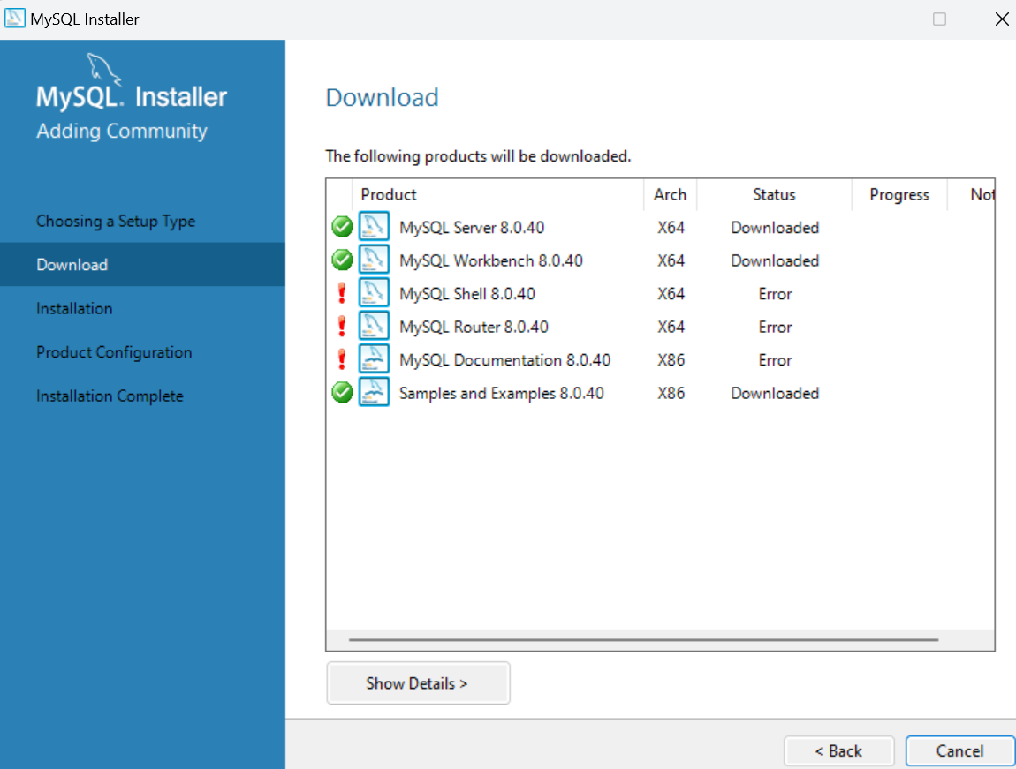
Make sure you are downloading the latest official version and not the v9 version.
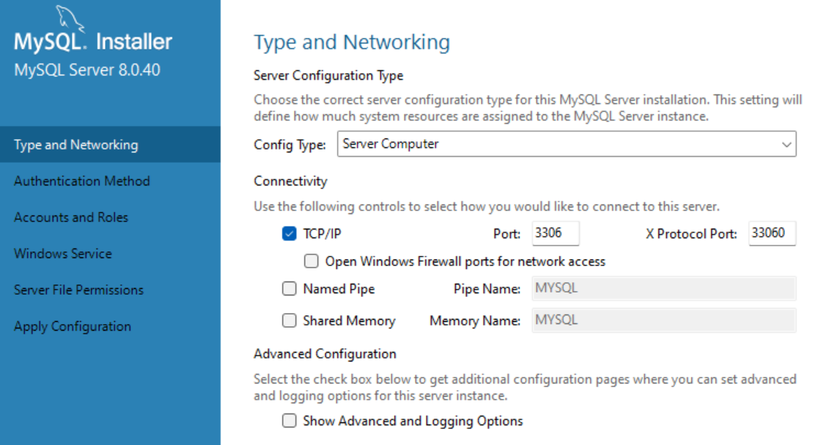

Creating the ddl for the tables
Run the ddl and remember this is not oracle. There is a single install with schemas as a construct, and users as a construct. They are not combined like in oracle.
- root: Superuser with full global privileges (server-wide).
- valve_app_user: App-tier user with CRUD privileges limited to the valve database/schema.
- valve_admin_user: Admin user with ALL PRIVILEGES on the valve database—ideal for schema changes and maintenance.
The use command at the start of ddl is a beset practice esp since I will run everything as root
Also not that the workbench has a default set now for the valve schema.

Next create the biggee of the 9 tables:
C:\valve
├── ddl-scripts # Database schema and SQL scripts
│ ├── 001_create_database_valve.sql
│ ├── 002_create_core_tables.sql
│ ├── 003_create_app_user.sql
│ ├── 004_create_admin_user.sql
│ └── seed-data.sql # Optional: initial data population
├── design-docs # Design documents and diagrams
│ ├── er_model_core_suite.jpeg
│ ├── er_model_crows_foot.jpeg
│ ├── core.mwb # MySQL Workbench file
│ └── buildbook.docx # Documentation for the system
├── valve-app-tier # App-tier project (NestJS)
│ ├── src/ # Source code
│ │ ├── app.module.ts
│ │ ├── main.ts # Entry point
│ │ ├── modules/
│ │ │ ├── customers/ # Exposed-API microservices
│ │ │ └── profiles/
│ │ ├── services/ # Intra-app-tier microservices
│ │ │ └── database.service.ts
│ ├── package.json # Dependencies and scripts
│ ├── tsconfig.json # TypeScript configuration
│ ├── .env # Environment variables
│ └── README.md
├── valve-frontend # Future frontend-tier (React)
│ ├── src/ # Source code
│ │ ├── components/ # React components
│ │ └── pages/
│ ├── public/ # Static assets
│ ├── package.json
│ ├── .env # Environment variables
│ └── README.md
├── archive # Old or deprecated versions of files
│ ├── old-er-diagrams/
│ └── legacy-scripts/
└── .gitignore # Git ignore rules for version control
nest new valve-app-tier
• cd valve-app-tier
• Start the Development Server: Run the following command to verify the setup:
npm run start
• Open Your Browser:
- Navigate to http://localhost:3000.
- You should see the "Hello World!" message.
Ctrl-c the npm start thread… then do :
npm install @nestjs/typeorm typeorm mysql2

Next Step: Configure the Database Connection
- Open src/app.module.ts:
  - This is the main module of your NestJS application where we’ll configure the database connection.
- Add Database Configuration: Replace the content of src/app.module.ts with the following:
typescript
Copy code
import { Module } from '@nestjs/common';
import { TypeOrmModule } from '@nestjs/typeorm';

@Module({
imports: [
TypeOrmModule.forRoot({
type: 'mysql', // Database type
host: 'localhost', // Database host
port: 3306, // MySQL default port
username: 'valve_app_user', // Replace with your MySQL app user
password: 'lol', // Replace with your actual password
database: 'valve', // Name of your database
autoLoadEntities: true, // Automatically load entities
synchronize: true, // Automatically sync schema (use only in dev!)
}),
],
})
export class AppModule {}
- Save the File:
  - Make sure to save your changes.

What This Does
- TypeOrmModule.forRoot:
  - Configures the connection to your MySQL database.
  - Reads the connection details like host, port, username, password, and database.
- autoLoadEntities:
  - Automatically loads all your entity classes for database interaction.
- synchronize:
  - Automatically creates and updates tables in the database to match your entity definitions. Use only for development—disable in production.

  - Use different methods and paths for other operations:
    - Retrieve a customer: GET /customers/:id
    - Update a customer: PUT /customers/:id
    - Delete a customer: DELETE /customers/:id

Example: Why This Approach Works
Using POST for creating resources mirrors how APIs are expected to work. Developers consuming your API will intuitively understand:
- A POST to /customers creates a customer.
- A GET to /customers/1 retrieves a specific customer.
- A PUT to /customers/1 updates a customer.

- For customer-profile relationships, keep it hierarchical:
  - /customers/:customerId/profiles
  - /customers/:customerId/profiles/by-skill-type/:skillType
- For non-customer-specific queries, consider flat routes:
  - /profiles/by-skill-type
  - /profiles

GET /customers # Fetch all customers
GET /customers/:customerId # Fetch details for a specific customer
GET /customers/:customerId/profiles # Fetch profiles for a specific customer
POST /customers/:customerId/profiles # Add a new profile for a customer
Flat Example (Profiles)
plaintext
Copy code
GET /profiles # Fetch all profiles
GET /profiles?customerId=123 # Fetch profiles for a specific customer
POST /profiles # Add a new profile (requires customerId in the body)

Summary of Key Points:
Layer | Function Name | Reason
Exposed API Controller | getCustomerProfiles() | Matches HTTP action and endpoint for simplicity. Name: Matches the HTTP action (GET) and the endpoint (/customers/:customerId/profiles).
Exposed API Service | fetchProfilesByCustomerId() | Indicates delegation to another service, clarifying the flow. Name: Emphasizes that it’s fetching data from another service, aligning with its job as a middleman.
Internal CRUD Controller | getProfiles() | General-purpose name reflecting the entity being handled.
Internal CRUD Repository | dbCallFindProfilesByCustomerId() | Specific to the DB operation and includes technical detail about the query's intent.

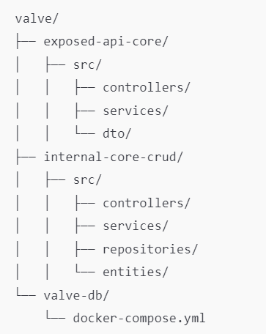

Hardcore Layers of Microservices
- Exposed-API Layer:
  - Handles external requests (from the React browser or other external consumers).
  - Translates HTTP requests into service calls.
- Internal-DB Layer:
  - Contains CRUD logic that interacts directly with the database.
  - Ensures raw SQL or ORM logic (like TypeORM) is encapsulated here.
- Internal-Business Layer:
  - Handles business logic that combines multiple internal-DB calls or applies complex calculations.
  - Often implemented later as the application grows.

best practice is:
we have 2 layers of microservices in the apptier:
exposed-api;
internal (which has both business logic and crud calls)
in addition, for each layer, we have:
1 project = 1 container = 1 microservice = 1 datadomain of appx 10 tables thus = appx 10 functions
Given that we have 3 datadomains each with tables (core, fork and shock), we thus have 6 projects of 6 :
- Exposed API Services:
- core-exposed-api
- fork-exposed-api
- shock-exposed-api
- Each handles incoming requests, validates them, and routes them to the internal service.
- Combined Internal Services:
- core-internal
- fork-internal
- shock-internal
- Each handles both CRUD operations and business logic.
Total Microservices:
- 6 microservices:
- 3 exposed APIs.
- 3 combined internal services.
The exposed has a combination function of controller plus service (ie caller)
The internal has 2 functions: controller and combo-repository (combines class repositoty + business logic service)

Exposed API Services
- Projects:
  - core-exposed-api
  - fork-exposed-api
  - shock-exposed-api
- Responsibilities:
  - Accept incoming HTTP requests (from browser, Postman, etc.).
  - Perform input validation (e.g., DTOs or middleware).
  - Act as a combination of controller + service (handles routing and minimal business logic).
Combined Internal Services
- Projects:
  - core-internal
  - fork-internal
  - shock-internal
- Responsibilities:
  - Controller:
    - Accept incoming requests from the exposed API.
    - Perform simple validations and pass the request to the repository.
  - Combo-Repository:
    - Combines:
      - Repository: Handles raw SQL and database interaction.
      - Business Logic Service: Adds business logic (e.g., combining data, applying transformations).

valve/\\\\
├── core-exposed-api/ # Exposed API service for Core domain
├── fork-exposed-api/ # Exposed API service for Fork domain
├── shock-exposed-api/ # Exposed API service for Shock domain
├── core-internal/ # Internal CRUD + business logic for Core domain
├── fork-internal/ # Internal CRUD + business logic for Fork domain
├── shock-internal/ # Internal CRUD + business logic for Shock domain
├── ddl-scripts/ # DDL scripts for database schema
├── design-docs/ # ER diagrams and other design documentation
└── ...

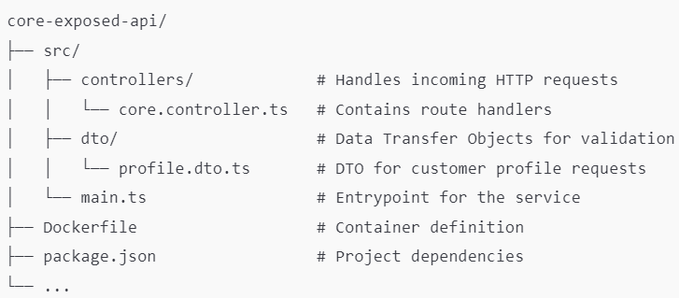
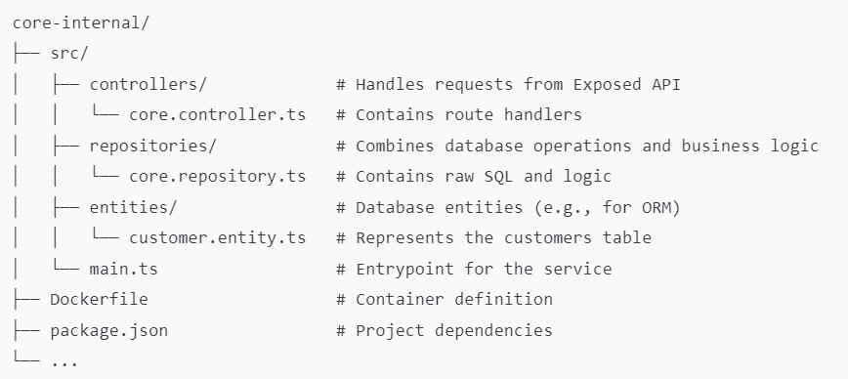
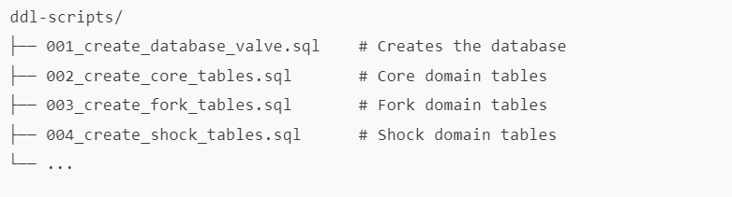
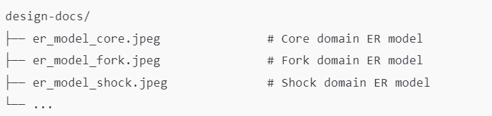
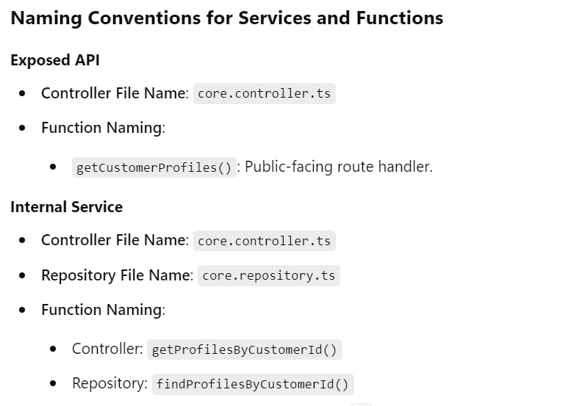

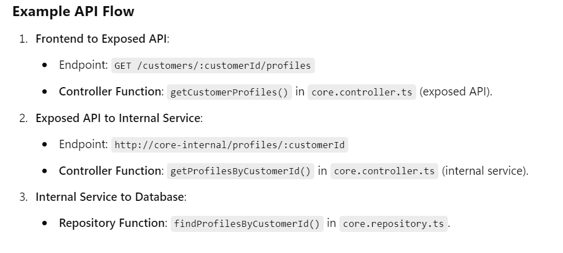

Core Nodejs and npm setup

Download and install
Node.js — Run JavaScript Everywhere
- Download the LTS version (recommended for most users).
- Run the installer and follow the prompts.
For most users, it’s best to leave everything at the default settings during the Node.js installation.
One change I did:
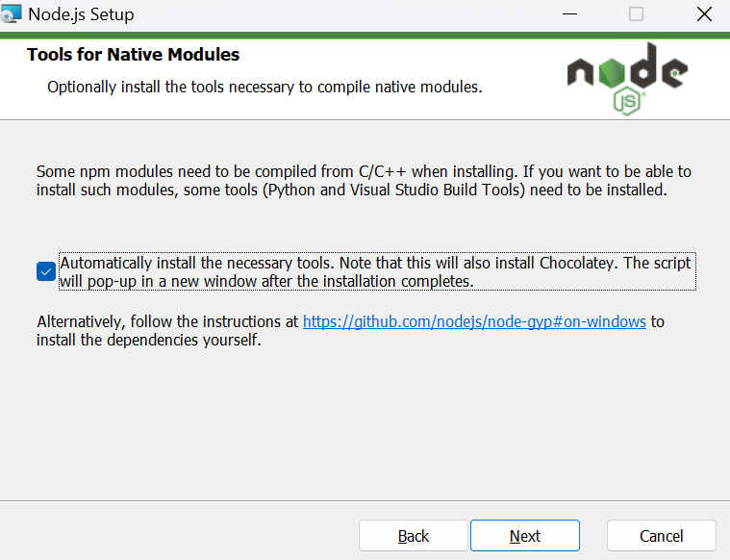

Verify installation
The first time run of npm -v got a weird error… so did the fix below

Fixing the Script Execution Policy
- Open PowerShell as Administrator:
  - Press Windows + R, type powershell, and press Ctrl + Shift + Enter to run it as an administrator.
- Check the Current Execution Policy:
  - Type the following and press Enter:
Get-ExecutionPolicy
  - This will likely return Restricted, which is why npm isn’t working.
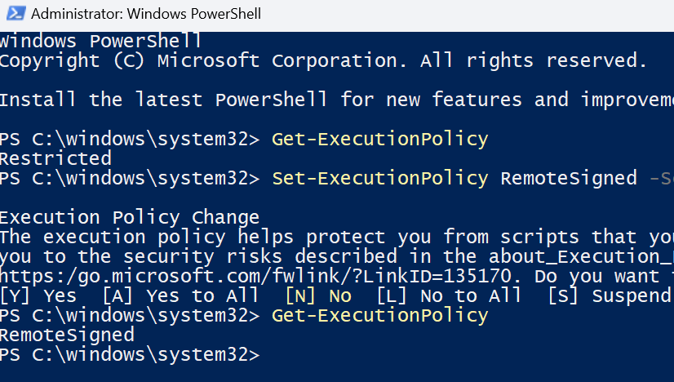
- Set the Execution Policy to Allow Scripts:
  - Type the following and press Enter:
Set-ExecutionPolicy RemoteSigned -Scope CurrentUser
  - This allows locally created scripts to run but still requires remote scripts to be signed for security.
- Confirm the Change:
  - When prompted, type Y and press Enter to confirm.
The execution policy is now set to RemoteSigned, which means PowerShell will allow scripts (like npm) to run as long as they are local or signed remotely. You’re all set to retry the npm command.

verify installation 2
Now go into powershell as regular user
node -v
npm -v
This should display the Node.js and npm versions.
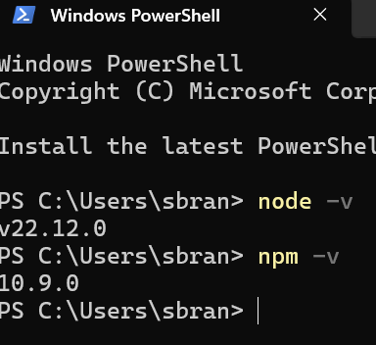

Node.js test: "Hello, World”
PS C:\> cd '.\00 thom-docs\'
PS C:\00 thom-docs> node hello.js
Hello, World!
Node.js code can run outside of a project btw. Just type: node blah.js <enter> that’s it!!!
The downside of not having the js within a project is that there is no libraries possible (I assume there is more to it as well)

npm test: npm init -initing a new project
npm node package manager, is a project creator
Here’s how you can test ‘npm init’ by initializing a new Node.js project:
Essentially you first mkdir the folder then go in it, and run the npm init <enter> that’s it!!!!!!!
Step 1: Create a Project Directory
- Open PowerShell.
- Navigate to a folder where you want to create your project. For example:
cd C:\Users\sbran\Documents
- Create a new folder for your project:
mkdir my-first-project
- Navigate into the new folder:
cd my-first-project

Step 2: Initialize a New Node.js Project
- Run the npm init command:
npm init
- You’ll be prompted to fill in some details about your project. For now, you can press Enter to accept the defaults for each prompt:
  - Package name: The name of your project.
  - Version: The version number (default is 1.0.0).
  - Description: Optional, leave it blank or add a description.
  - Entry point: The starting file for your app (default is index.js).
  - Test command: Leave blank.
  - Git repository: Leave blank for now.
  - Keywords: Leave blank or add a few words that describe the project.
  - Author: Enter your name or leave blank.
  - License: Default is ISC, but you can leave it as-is.
- When it asks "Is this OK?", type yes and press Enter.

Step 3: Verify the package.json File
- After running npm init, a file named package.json will be created in your project folder.
- To confirm, run:
dir
You should see package.json listed in the output.

npm test2:npm install express - into the new package
So irl we will not use express, its lightweight web server is all. Gonna use it merely to test npm install blahblah…
When you type: npm install blahblah <enter> you are downloading all the additional libraries for blahblah into this specific project directory (ie where you are now). You then also have to put the include in the .js file and use a command within the library.

***
PS C:\00 thom-docs\my-first-project> npm install express
added 66 packages, and audited 67 packages in 3s

13 packages are looking for funding
run `npm fund` for details

found 0 vulnerabilities
PS C:\00 thom-docs\my-first-project> dir

Directory: C:\00 thom-docs\my-first-project

Mode LastWriteTime Length Name
---- ------------- ------ ----
d----- 2024-12-10 1:42 PM node_modules
-a---- 2024-12-10 1:42 PM 28166 package-lock.json
-a---- 2024-12-10 1:42 PM 262 package.json

PS C:\00 thom-docs\my-first-project>
What is package.json?
- It’s a file that contains metadata about your project, such as:
  - Project name, version, and description.
  - Dependencies (libraries you install).
  - Scripts for running or building your project.

What’s in Your Directory Now
- node_modules/:
  - This folder contains all the installed libraries (in this case, Express.js and its dependencies).
  - It’s automatically created by npm and should not be manually modified.
- package-lock.json:
  - This file ensures consistent versions of dependencies across environments.
  - It’s important for maintaining stability in your project.
- package.json:
  - This file was updated to include Express.js as a dependency.
Finally, Created index.js file in the new project that used express libraries (we already added express to the package def). the code is a simple start session.
The js launches a session that listens on 3000. Can be tested via browser:
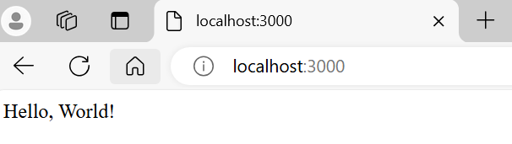

Core nodejs setup
1:
So, first you create the nest-project folder eg core-service
Then cd into it and nest new . # for the scaffolding!!
C:\valve\core-service>nest new .
This I assume is similar to the react app installation, but it’s a nest version of nodejs!! Im guessing behind the scenes it is running the ‘npm init -y’ just like the reactapp step1
- Next make the controller and repo subfolders for a fatter than nest-default installbase
C:\valve\core-service> cd src
C:\valve\core-service\src>mkdir controllers repositories //oob these wont exist
C:\valve\core-service\src>move app.controller.ts controllers/core.controller.ts //move & rename
C:\valve\core-service\src>move app.service.ts repositories/core.repository.ts
Move the test script over or delete yourcall.

2:
Next install into the project the project-specific libraries of typeorm
C:\valve\core-service>npm install typeorm
C:\valve\core-service>npm ls typeorm
core-service@0.0.1 C:\valve\core-service
`-- typeorm@0.3.20
npm install @nestjs/typeorm typeorm
rebuild with C:\valve\core-service>npm run build
> core-service@0.0.1 build
> nest build

3: Add the mysql libraries
npm install mysql2
4 after you have the repo and controller code all written then spark it up
npm run start:dev *or don’t have the :dev for less debug info live
cd c:\valve\core-service\
npm run start
go to browser and unittest as per query.txt file in the repo folder
eg
http://localhost:3000/customers/1/profiles

next and react setup

1: install next
C:\>cd valve
C:\valve>npx create-next-app@latest valve-ui
Need to install the following packages:
create-next-app@15.1.2
Ok to proceed? (y) y
√ Would you like to use TypeScript? ... No / **Yes
√ Would you like to use ESLint? ... No / **Yes
√ Would you like to use Tailwind CSS? ... **No / Yes
√ Would you like your code inside a `src/` directory? ... No / **Yes
√ Would you like to use App Router? (recommended) ... No / **Yes
√ Would you like to use Turbopack for `next dev`? ... **No / Yes
√ Would you like to customize the import alias (`@/*` by default)? ... **No / Yes
Creating a new Next.js app in C:\valve\valve-ui.
Recap of Choices
- TypeScript: ✅ Yes
  - Type-safe development, helps catch errors early, and is ideal for scaling projects.
- ESLint: ✅ Yes
  - Ensures consistent code formatting and best practices.
- Tailwind CSS: ❌ No
  - Using Ant Design for styling instead of Tailwind CSS.
- Code Inside src/: ✅ Yes
  - Organizes your code better and keeps the root directory clean.
- App Router: ✅ Yes
  - Next.js’s modern routing system, great for layouts and server components.
- Turbopack: ❌ No
  - Sticking with Webpack for stability and better library support.
- Custom Import Alias: ❌ No
  - Using the default alias (@/*), which maps to the src/ directory.

2: run the dev server
set PORT=3001 && npm run dev
C:\valve\valve-ui>set PORT=3001 && npm run dev

> valve-ui@0.1.0 dev
> next dev

▲ Next.js 15.1.2
- Local: http://localhost:3001
- Network: http://192.168.1.71:3001

✓ Starting...
✓ Ready in 1711ms

3: Install antD
C:\valve\valve-ui>npm install antd @ant-design/icons

added 68 packages, and audited 364 packages in 12s

121 packages are looking for funding
run `npm fund` for details

found 0 vulnerabilities
(restart the dev server after the install btw)
C:\valve\valve-ui>npm run dev

> valve-ui@0.1.0 dev
> next dev

▲ Next.js 15.1.2
- Local: http://localhost:3001
- Network: http://192.168.1.71:3001

✓ Starting...
✓ Ready in 2.8s

4 replace the guts of the layout.tsx:

import type { Metadata } from "next";
import { Geist, Geist_Mono } from "next/font/google";
import "antd/dist/reset.css"; // Import Ant Design styles
import "./globals.css"; // Keep your global CSS

const geistSans = Geist({
variable: "--font-geist-sans",
subsets: ["latin"],
});

const geistMono = Geist_Mono({
variable: "--font-geist-mono",
subsets: ["latin"],
});

export const metadata: Metadata = {
title: "Valve UI",
description: "POC for Valve SaaS",
};

export default function RootLayout({
children,
}: Readonly<{
children: React.ReactNode;
}>) {
return (
<html lang="en">
<body className={`${geistSans.variable} ${geistMono.variable}`}>
{children}
</body>
</html>
);
}

5 replace the guts of page.tsx
"use client"; // Required for Ant Design components to work

import { Button } from "antd";

export default function Home() {
return (
<div style={{ textAlign: "center", marginTop: "50px" }}>
<h1>Welcome to Valve UI</h1>
<p>This is a POC using Ant Design and Next.js.</p>
<Button type="primary" style={{ marginTop: "20px" }}>
Test Ant Design Button
</Button>
</div>
);
}

Install cross-env
Make it so port is 3001 for valve_ui
Go valve-ui folder then:
npm install cross-env --save-dev

kill problems?
netstat -ano | findstr :3001
taskkill /PID 50824 /F

6: do the helloworld test
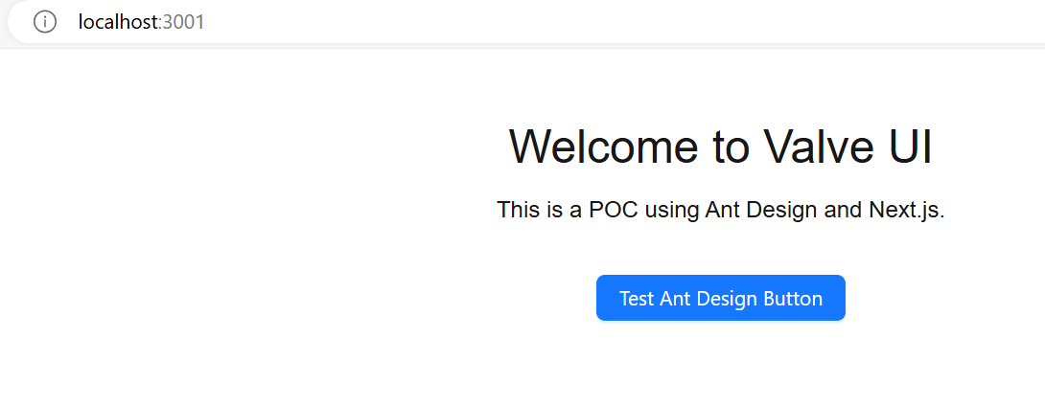

setup visualstudio environment

1: two instance best practice
open 2 instances and use the ‘open folder’ choice from the main screen. Browse to value-ui for one, and core-service for the other.
Note that under view is output and terminal both. Use them!

2: start the 2 services (core-service and valve-ui)
core-service on 3000
Then start using core-service in vs via:
npm run start
and.. for valve-ui do this in terminal (because its powershell):
$env:PORT=3001; npm run dev
Or in cmd do:

netstat -ano | findstr :3001
to verify 3001 is available…

3: test
Great! Now that the core-service (app-tier) is running in its terminal, let's proceed with the presentation tier (valve-ui).

- Check that the app-tier API works by visiting an endpoint in your browser:
  - Example: http://localhost:3000/customers/1/profiles
- Check that the Next.js app is accessible at:
  - http://localhost:3001

4 install bcrypt for password in core-service
cd C:\valve\core-service
npm install bcrypt
npm install --save-dev @types/bcrypt

final test of everything
go to browser
rightclick anywhere
in the console tab on the browser you can see output from the valveui pages codebase
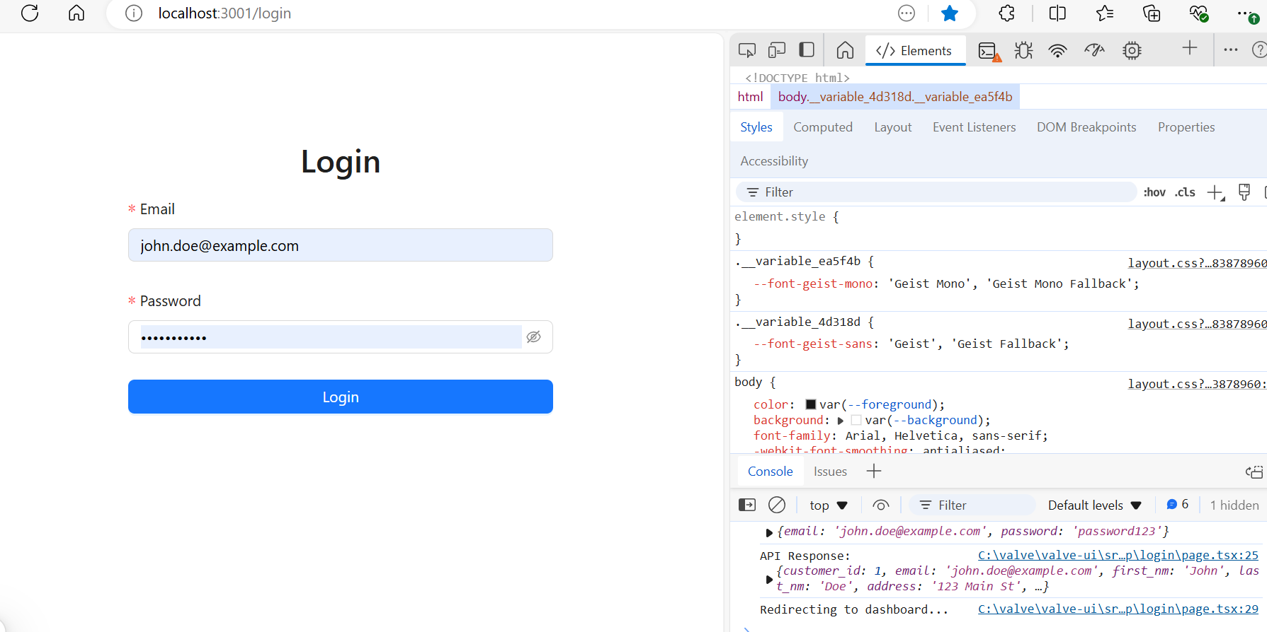

auth-service (faster as more expert)
1: create the scaffolding and draft gen-edit the 3 ts files
mkdir auth-service
cd auth-service
npx @nestjs/cli new .
npm install @nestjs/jwt @nestjs/passport bcrypt
npm install --save-dev @types/bcrypt
npm install mysql2@3.11.5
npm install @nestjs/typeorm typeorm mysql2
npm install cross-env --save-dev
cd src
mkdir controllers
mkdir repositories
mkdir services
gen-edit the 3 ts files
gen-edit the port def in \auth-service\package.json to have:
"start:dev": "cross-env PORT=3002 nest start --watch",
gen-edit the \auth-service\src\app.module.ts:
import { AuthController } from './controllers/auth.controller';
import { AuthService } from './services/auth.service';
and also the arrays at the bottom.
Copy and tweak the \src\main.ts

2: install the openssl for private key
Win32/Win64 OpenSSL Installer for Windows - Shining Light Productions
Download from url above: the light 64 msi and install it.

3: gen the 2 keys
Cd valve\auth-service\
Mkdir prvtkey
Mkdir pubkey

cd "C:\Program Files\OpenSSL-Win64\bin"
openssl genrsa -out "C:\valve\auth-service\prvtkey\private.key" 2048
openssl rsa -in C:\valve\auth-service\prvtkey\private.key -pubout -out C:\valve\auth-service\pubkey\public.key

4: set the env var for privatekey
Create the .env file
Add the JWT_PRIVATE_KEY=
npm install dotenv
add to auth.service.ts (since this is the code that uses this constantlike env var):
import * as dotenv from 'dotenv';
dotenv.config();
then down below add in: console.log('JWT Private Key:', process.env.JWT_PRIVATE_KEY);

5: test the auth-service directly
in order to get the right port:
npm run start:dev
curl -X POST http://localhost:3001/auth/login -H "Content-Type: application/json" -d "{\"email\":\"john.doe@example.com\",\"password\":\"password123\"}"

6: test auth-service end-to-end from ui /login
Start up the nginx emulator..
npm run start:dev
right click anywhere in browser and choose ‘inspect’
browse to http://localhost:3000/login
then type in the userpass as per the test-secripts folder…
mysql -u valve_app_user -p
or
mysql -u valve_admin_user -p

C:\Program Files\MySQL\MySQL Server 8.0\bin>mysql -u valve_app_user -p
Enter password: ***
Welcome to the MySQL monitor. Commands end with ; or \g.
Your MySQL connection id is 178
Server version: 8.0.40 MySQL Community Server - GPL

Copyright (c) 2000, 2024, Oracle and/or its affiliates.

Oracle is a registered trademark of Oracle Corporation and/or its
affiliates. Other names may be trademarks of their respective
owners.

Type 'help;' or '\h' for help. Type '\c' to clear the current input statement.

mysql>
source C:\valve\ddl-scripts\002_create_core_tables.sql

Revised State Types
- Application-Level State (Global + Persistent):
  - Scope: App-wide, affects multiple screens, and persists across sessions.
  - Examples:
    - Active customer, active bike.
  - Storage: React Context + LocalStorage.
  - Why: These need to persist and be accessible throughout the app lifecycle.
- Session-Level State (Cross-Screen + Temporary):
  - Scope: Shared across multiple screens within the same session but reset on refresh.
  - Examples:
    - Filter settings on the customer grid.
    - Sorting preferences that persist when navigating to and from detail pages.
  - Storage: React Context or another global state management tool (like Redux).
  - Why: This state must persist as long as the app is open but doesn’t need to survive a browser reload.
- Navigation-Level State (Screen-Specific + Ephemeral):
  - Scope: Limited to a single screen or component.
  - Examples:
    - Open/closed state of a dropdown.
    - Visibility toggle for a sidebar or modal.
  - Storage: useState within the specific component.
  - Why: These states are purely tied to local interactions and don’t need to be shared or remembered.
• Application-Level State:
- Use React Context + LocalStorage.
- Examples: Active customer, active bike.
• Session-Level State:
- Use React Context (without LocalStorage).
- Examples: Filters, sorting, or other cross-screen session-specific states.
• Navigation-Level State:
- Use useState for single-component or single-screen state.
- Examples: Modal visibility, dropdowns.

Fork domain:
- • manufacturers_fork
- • manufacturer_bikes
- • manufacturer_fork_specification
- • manufacturer_fork_recomsettings
- • cust_bikefork
- • cust_bikefork_h
- • cust_bikefork_setting
- • cust_bikefork_setting_h
- • cust_bikefork_service

