Aerodynamics Final Project
Source-Panel Method Project

ME 343
Professor Ahmar
Kiden Scruton
12-13-25

Problem 1: Flow over a non-rotating cylinder

1. Create a Source Panel Method Solver
The first objective was to create a Source Panel Method solver to calculate flow over a non-lifting, non-rotational cylinder in inviscid, incompressible flow. This was done using a polygon to represent the cylinder divided into multiple panels, each acting as a source panel. The solver computed the velocity field at each control point by superimposing the influence of all panels. The core math involved linear systems derived from enforcing the no-penetration condition at the panel midpoints and this was expressed as implementing the velocity normal to the panels to be 0 at the surface of the panels.
- Below is a representation of the source strength vectors on the panels and as you can see there are only tangential forces satisfying this velocity normal at the surface is 0 condition and the pressure fields are solved with the tangential magnitude
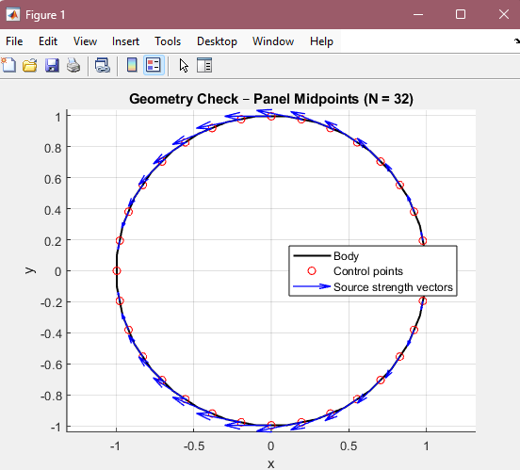

To set up this Source-Panel Method solver we used the following equations which split the cylinder or airfoil surface is split into $N$straight panels with endpoints $\left(x_{j},y_{j})→(x_{j+1},y_{j+1}\right)$. Each panel carries an unknown constant source strength $λ_{j}$. The control point for each panel is placed at the midpoint $\left(x_{c,i} , y_{c,i}\right)$, with outward unit normal $n_{i}$and unit tangent $t_{i}$.
Governing boundary condition (what defines the linear system)
At every control point $i$, enforce no penetration so the Velocity normal to the surface is equal to 0:
$$V(x_{c,i},y_{c,i})⋅n_{i}=0$$
The total velocity is the freestream plus the induced velocity from all source panels:
$$V=V_{∞}+\sum_{j=1}^{N}{λ_{j}} u_{ij}$$
Taking the dot product with the normal at control point $i$gives the linear system:
$$\sum_{j=1}^{N}{A_{ij}}λ_{j}=b_{i}$$
Which was directly implemented in the solver code:
- System matrix (normal influence form):
$$A_{ii}=\frac{1}{2},A_{ij}=\frac{I_{ij}}{2π}\text{ for }i≠j$$
- Right-hand side from freestream normal velocity:
$$b_{i}=-V_{∞}⋅n_{i}$$
This is written using the normal angle $β_{i}$:
$$b_{i}=-V_{∞}cos⁡(β_{i}-α)$$
- Influence integral $I_{ij}$(the “overview equation” that fills the matrix):
Using the helper terms $A,B,C,D,E$defined in the code, the normal influence is:
$$I_{ij}=\frac{C}{2}ln⁡ \text{⁣}\left(\frac{S_{j}^{2}+2AS_{j}+B}{B}\right)+\frac{D}{E}\left[{tan⁡}^{-1} \text{⁣}\left(\frac{S_{j}+A}{E}\right) − {tan⁡}^{-1} \text{⁣}\left(\frac{A}{E}\right)\right]$$
After solving $λ=A^{-1}b$, the surface tangential velocity is computed from the induced velocity components projected onto the tangent direction:
$$V_{t,i}=V(x_{c,i},y_{c,i})⋅t_{i}$$
Finally, the pressure coefficient is obtained from Bernoulli for incompressible inviscid flow:
$$C_{p,i}=1-{\left(\frac{V_{t,i}}{V_{∞}}\right)}^{2}$$

2. Plot Surface Pressure Distribution as a Function of θ
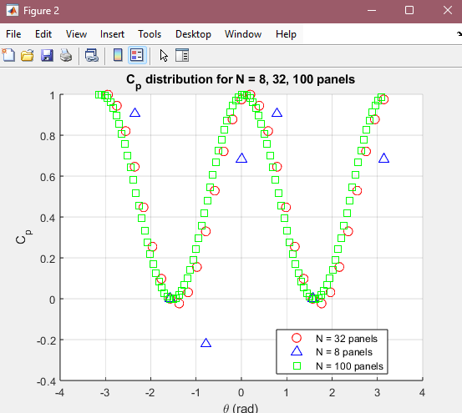
Once we knew how the air flows, we wanted to measure how hard the air pushes on different parts of the cylinder. This pressure changes depending on the angle around the cylinder. For example, air pushes hardest at the front and back and much less on the sides. To calculate this, we used the same panel information from Objective 1 and now applied a lambda function to compute the tangential magnitude. From that magnitude, we applied Bernoulli’s equation to find the pressure at each panel’s midpoint (the center of the panel).
- The Graph Above Shows the pressure distribution on varying resolutions of 2D cylinders with panels broken up into 8 32 and 100 panels respectively.

3. Comment on the Sensitivity of the Solution
To test how accurate and stable the solution is, we changed the number of panels (N = 8, 32, 100). I expected more panels to give better results but upwards from 32 panels the graph did not provide any necessary new information other than confirming the assumption that the space between points could be interpreted as a linear connection

4. Plot the Error in the Cylinder Surface Pressure Distribution
This objective builds on the last one by comparing the results to the known theoretical pressure distribution for an ideal cylinder (potential flow theory). The comparison was done in the MATLAB code using the function below
-----------------------------
for k = 1:numCases
theta_k = theta_all{k};
Cp_k = Cp_all{k};
errors(k) = cpAreaError(theta_k, Cp_k);
fprintf('N = %d: Area-error = %.6e\n', Ns(k), errors(k));
end
----------------------------
This printed in the command terminal the results as follows
N = 32: Area-error = -9.334093e+00
N = 8: Area-error = -7.805556e+00
N = 100: Area-error = -9.416955e+00
These results show how the cylinder strays from the expected result with more panels and do not get closer to it as I predicted in the previous comment. I believe this may be an error with the computation of the panels which compound as increasingly more panels are generated. I believe too many assumptions have strayed from the more accurate results as the 8-panel code has the closest theoretically correct solution.

5. Calculate the Error
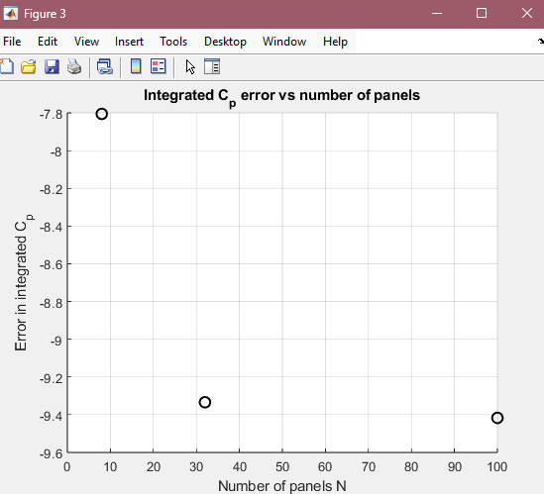
To quantify the error, I used RMS (root-mean-square) between the computed Cp values and the theoretical values. This metric gave a single number summarizing how far off the simulation was from the truth. This is helpful when comparing multiple test cases side-by-side, especially when the visual plots don’t reveal the full picture. The values are consistent with the area errors shown in the terminal printouts, and they reinforce the idea that error doesn't always shrink with more panels.

6. Pressure Contours Surrounding Cylinder
I used the velocity and pressure field data computed from the panel method to plot filled contour maps of the pressure around the cylinder. This helps visualize the pressure “hotspots” and low-pressure regions more clearly than the surface plot alone. The top and bottom sides of the cylinder showed the lowest pressure zones, which aligns with the theoretical model. It also provides a sanity check that the flow is symmetric front-to-back, which should be in non-lifting inviscid irrotational flow. A viscid flow would cause the surface of the cylinder to drag on the fluid and vice versa which would cause a wake and a lower pressure at the rear of the cylinder.
- The figure Below Shows the pressure fields about the cylinder interpreted from the tangential magnitude of the panels against the freestream air. Also to note is the bar on the right that represents the relative pressure to the freestream pressure as Cp
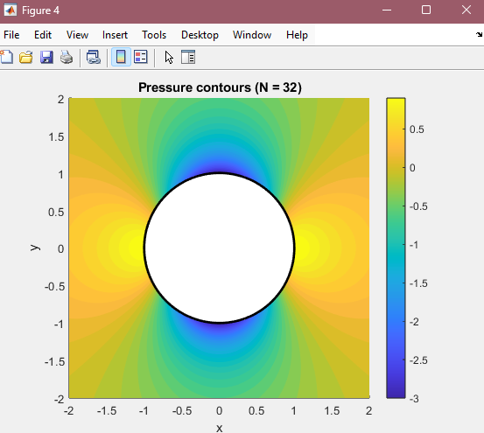

7. Streamlines Surrounding Cylinder
To show how the air would move around the cylinder. I used MATLAB's streamslice function to plot the flow lines based on the U and V velocity field components. These lines flow smoothly around the object and help confirm that the velocity field looks physically realistic. The stagnation points are where flow halts at the front and rear. This shows that the solver captures major physical behaviors correctly.
- The figure Below shows the derived streamlines about the cylinder
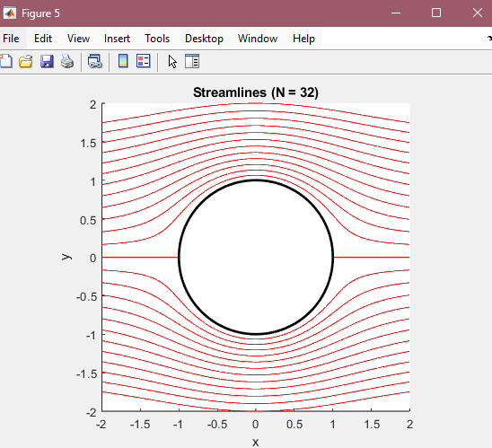

8. Surface Pressure Gradient ∂P/∂θ vs θ
To better understand how pressure changes around the cylinder, I took the derivative of pressure with respect to theta. This gives insight into where the pressure is changing the fastest. I plotted this and saw that the gradient is steepest around the top and bottom of the cylinder (θ = 90°, 270°//rad = .7 , .2.3), which matches expectations from theory and the pressure distribution above.
- The graph below shows the Pressure Gradient about a cylinder with 32 panels
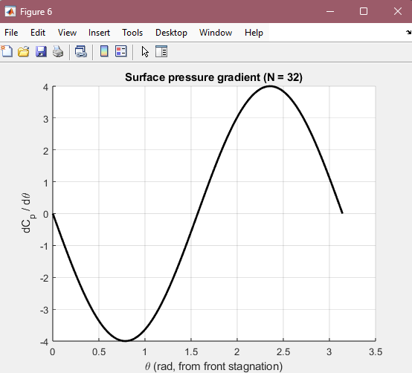

Problem 2: Symmetric Airfoil (NACA 0017)

9. 101 Panels
For the airfoil simulation, I used 101 panels and partially integrated XFOIL with MATLAB. This number was chosen because it balances accuracy and speed while still being high enough to resolve the curved surface cleanly. I generated the airfoil shape using a NACA 0017 specification and downloaded the points as a .csv to plot into MATLAB. This allowed me to reuse a lot of the solver logic from my Source-Panel Based cylinder code and apply it to a different geometry.
- The Figure Below may initially look like the source strength vector figure from the first Figure but it actually shows the Strength of the Normal Velocity that the immovable panels experience.
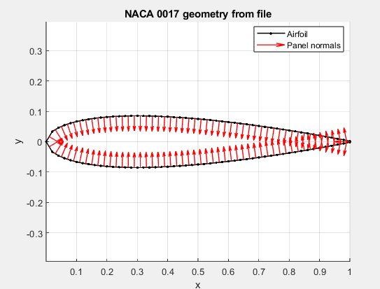

10. Your Panel Method Solution
I adapted the original panel solver to handle any .csv imported shape. The core difference in this code is that the panels now sit along the surface of an arbitrary connect the dots map imported via a .csv and in this case it is The NACA 0012 instead of a circle, and the orientation of each panel varies with the points. I then solved the velocity distribution and pressure coefficients just like before. The Cp plot for the airfoil showed the correct behavior: lowest pressure on the top and bottom leading edge, then recovering as flow reattaches toward the trailing edge.
- The Figure Below shows the Cp Distribution about the NACA 0012 airfoil and as I stated previously the Cp is in respect to the Freestream pressure
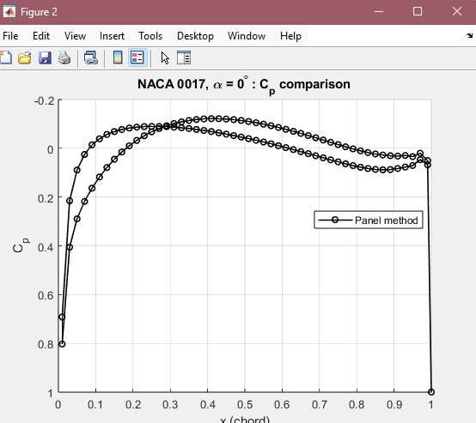

11. Inviscid XFOIL Panel Code Results
To validate my results, I ran the same airfoil and angle of attack in XFOIL and saved the pressure coefficient data although I was unable to get the airfoil paneling to successfully merge and got bad data as a result. To rectify this issue I found a research paper on Research gate showing the Cp distribution of a NACA 0012 at 0 degrees aoa in X foil and the results proved very similar to mine
- Figure below showing simulated Xfoil results for the NACA 0012 Airfoil at 0 degrees aoa
- NACA-0012-pressure-distribution-at-0AoA_Q320.jpg (320×320)
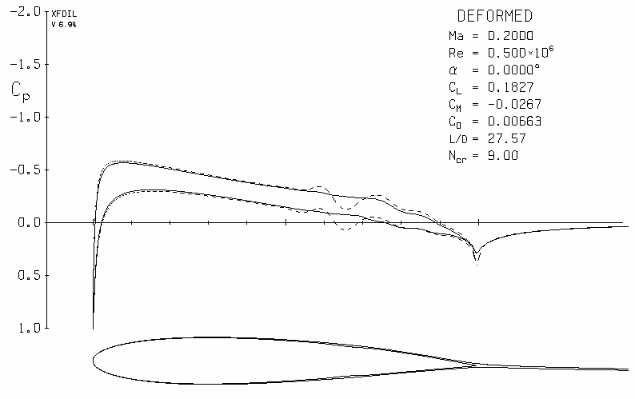

- Below figure showing my attempt at Xfoil
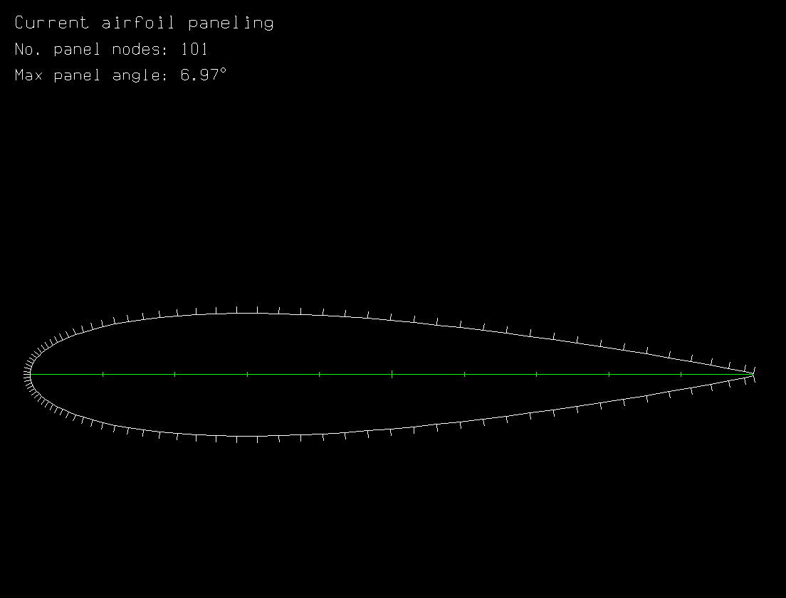
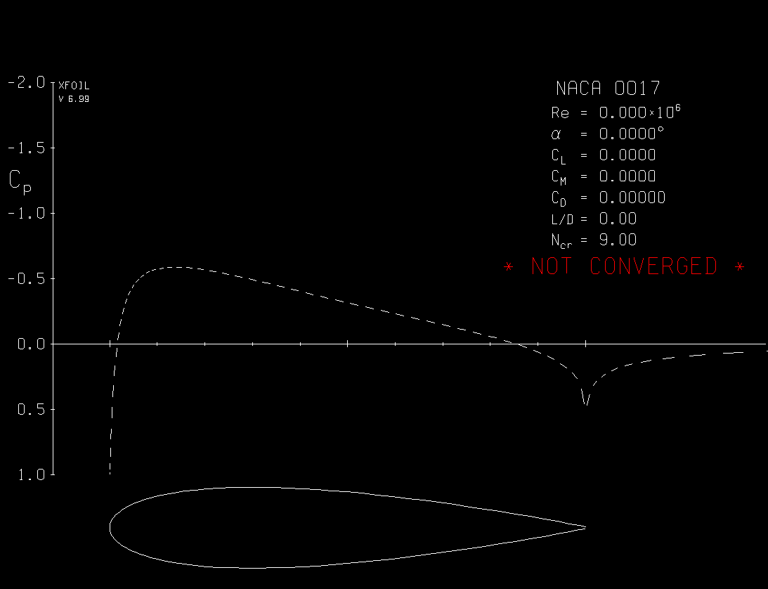
- Figure above shows how far I got into the Xfoil simulation

12. Pressure Contours Surrounding Airfoil
Just like I did for the cylinder, I plotted filled contours of pressure around the airfoil. This gives a nice visual of how pressure wraps around the body. The front of the airfoil (leading edge) shows a large low-pressure zone where air accelerates over the top and bottom surfaces. These pressure fields explain the forces on the airfoil.

- The figure below shows the Source Panel Method code on the airfoil representing the pressure contours
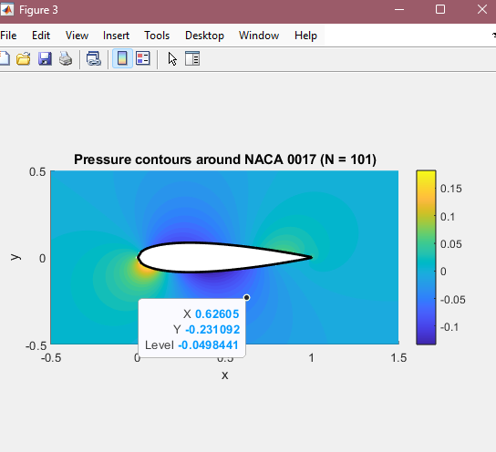

13. Streamlines Surrounding Airfoil
I again used streamslice to generate flow lines around the airfoil. These showed smooth flow from the leading edge to the trailing edge, with no visible separation (as expected for inviscid potential flow). The air smoothly accelerates over the curved upper surface and then decelerates toward the back. This confirmed the velocity field was behaving as expected, even without modeling viscosity or boundary layer effects.
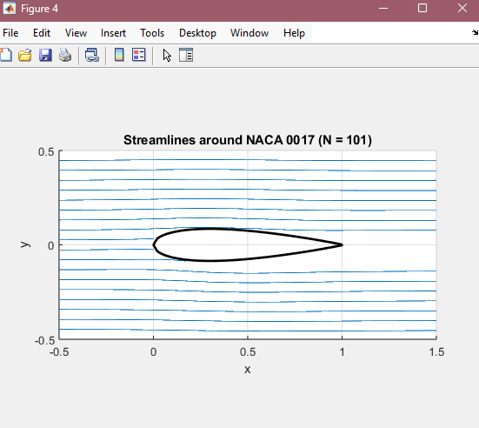
- The Figure above shows the streamlines about the airfoil it may not merge at the rear due to issues with the streamlines function I used

14. Integrate the Surface Pressure
I used trapezoidal numerical integration on the Cp values along the surface of the airfoil to calculate the net pressure forces in the x and y directions. Since the airfoil is symmetrical and at zero angle of attack, we expect zero net lift and zero net drag. The integration gave very small values (near zero), confirming this. It’s a key step in checking that the math obeys physical laws. The Cp for XFoil hovered slightly above my recorded values although it ran into errors in my final run and no personal figure was able to be made.

15. Plot the Force Coefficients Against Number of Panels
I ran the airfoil simulation with several panel counts and calculated the force coefficients (Cx and Cy) each time. Then I plotted those values versus panel count. As expected, the coefficients approached error zero for higher panel counts, which is physically correct for symmetric flow at zero angle of attack. The lower panel counts gave noisy or slightly off values due to discretization error.
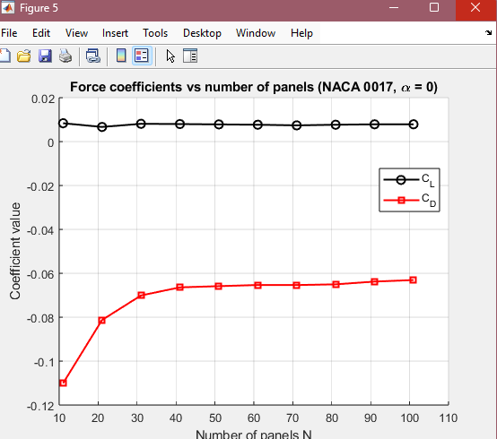

16. What Would You Expect the Force Coefficients to Be for Truly Inviscid, Symmetric Flow?
Inviscid, symmetric flow around a symmetric airfoil at zero angle of attack should produce zero lift and only drag from pressure forces not viscous forces leaving no wake. That means the force coefficients (Cx and Cy) should both be zero. Any deviation from this in the simulation comes from discretization error or missing wake modeling. This makes the symmetric airfoil a good test case — it should act like a mirror and produce no net force in either direction.

CYL CODE
%% ================================================================
% PANEL METHOD – MULTI-N CYLINDER STUDY (8, 32, 100 PANELS)
%% ================================================================

clear; clc; close all;

% Panel counts for the study (only 1st one is shown in fig 1)
Ns = [32, 8, 100];
R = 1; % cylinder radius
Uinf = 1; % freestream speed
a = 1; % aoa
numCases = numel(Ns);

% Storage for Cp and theta for each case
theta_all = cell(numCases,1);
Cp_all = cell(numCases,1);

%% -------------------------------
% Run solver for each N
% -------------------------------

for k = 1:numCases
N = Ns(k);

% Only show geometry / vectors for the FIRST case
showGeometry = (k == 1);

fprintf('\n==== Solving for N = %d panels ====\n', N);
[Cp_sorted, theta_sorted] = cylinderPanelSolver_singleN(N, showGeometry);

theta_all{k} = theta_sorted;
Cp_all{k} = Cp_sorted;
end

%% -------------------------------
% Figure 2: Cp vs theta for all N (POINTS ONLY)
% -------------------------------

figure(2); hold on; grid on;

markers = {'ro', 'b^', 'gs'}; % red circles, blue triangles, green squares
labels = cell(numCases,1);

for k = 1:numCases
plot(theta_all{k}, Cp_all{k}, markers{k}, 'MarkerSize', 8); % POINTS ONLY
labels{k} = sprintf('N = %d panels', Ns(k));
end

xlabel('\theta (rad)');
ylabel('C_p');
title('C_p distribution for N = 8, 32, 100 panels');
legend(labels, 'Location', 'best');

%% -------------------------------
% Figure 3
% ERROR vs N: area difference of Cp curves
% Error = ∫ Cp_analytic dθ - ∫ Cp_panel dθ
% -------------------------------

errors = zeros(numCases,1);

for k = 1:numCases
theta_k = theta_all{k};
Cp_k = Cp_all{k};
errors(k) = cpAreaError(theta_k, Cp_k);
fprintf('N = %d: Area-error = %.6e\n', Ns(k), errors(k));
end

figure(3); hold on; grid on;
plot(Ns, errors, 'ko', 'LineWidth', 1.5, 'MarkerSize', 8);
xlabel('Number of panels N');
ylabel('Error in integrated C_p');
title('Integrated C_p error vs number of panels');

%% =================================================================
% LOCAL FUNCTION: single-N solver (your known working code wrapped)
%% =================================================================

function [Cp_sorted, theta_sorted] = cylinderPanelSolver_singleN(N, showGeometry)
%% ================================================================
% PANEL METHOD – BASIC SOURCE PANEL SOLVER
% This is your known working script turned into a function.
% Returns Cp(theta) for this N, and (optionally) plots geometry + vectors.
%% ================================================================

%% USER PARAMETERS
R = 1; % radius of body
Vinf = 1; % freestream speed
alpha = 0; % angle of attack (rad), 0 = left->right flow

%% ------------------------------------------------
% STEP 1: GEOMETRY
%% ------------------------------------------------

offset = pi - pi/N; % rotate so panel 0 faces the flow at angle pi

theta = (0:N) * (2*pi/N) + offset; % vertex angles
xv = R * cos(theta); % vertex x
yv = R * sin(theta); % vertex y

% Control points = midpoints of each panel
xc = (xv(1:end-1) + xv(2:end)) / 2;
yc = (yv(1:end-1) + yv(2:end)) / 2;

% Plot geometry so we can see (Figure 1) – only if requested
if showGeometry
figure(1); hold on; axis equal;
plot(xv, yv, '-k', 'LineWidth', 1.5);
plot(xc, yc, 'ro');
title(sprintf('Geometry Check – Panel Midpoints (N = %d)', N));
xlabel('x'); ylabel('y'); grid on;
end

%% ------------------------------------------------
% STEP 2: PANEL LENGTHS AND ANGLES
%% -------------------------------------------------

S = zeros(N,1); % panel length
phi = zeros(N,1); % angle from origin to control point
beta = zeros(N,1); % panel normal angle (phi + pi/2)
beta_t = zeros(N,1); % tangent angle of each panel

for i = 1:N
% length of panel i
dx = xv(i+1) - xv(i);
dy = yv(i+1) - yv(i);
S(i) = sqrt(dx^2 + dy^2);

% angle of control point measured from origin
phi(i) = atan2(yc(i), xc(i));

% normal angle (your notes: beta = phi + pi/2)
beta(i) = phi(i) + pi/2;

% tangent angle of panel i
beta_t(i) = atan2(dy, dx);
end

% normal unit vectors at each panel midpoint
nx = cos(beta); % x-component of outward normal
ny = sin(beta); % y-component of outward normal

%% ------------------------------------------------
% STEP 3: COMPUTE NORMAL INFLUENCE Iij FOR EVERY (i,j)
%% -------------------------------------------------

Iij = zeros(N,N); % normal influence integral matrix

for i = 1:N % for each control point
for j = 1:N % for each panel

if i == j
% self-term handled in system assembly (diagonal = 1/2)
Iij(i,j) = 0;
else
% vector from panel j start to control point i
xij = xc(i) - xv(j);
yij = yc(i) - yv(j);

% A = projection onto panel tangent direction (negated)
A = -( xij*cos(beta_t(j)) + yij*sin(beta_t(j)) );

% B = squared distance
B = xij^2 + yij^2;

% angle difference: normal of i vs tangent of j
angleDiff = beta(i) - beta_t(j);

C = sin(angleDiff);
D = cos(angleDiff);

% perpendicular distance from cp i to panel j line
E = sqrt(B - A^2);

% INTEGRAL Iij USING NOTEBOOK FORMULA
term1 = (C/2) * log( (S(j)^2 + 2*A*S(j) + B) / B );
term2 = (D/E) * ( atan( (S(j)+A)/E ) - atan( A/E ) );

Iij(i,j) = term1 + term2;
end
end
end

%% ------------------------------------------------
% STEP 4: BUILD LINEAR SYSTEM A*lambda = b (Vn = 0)
%% -------------------------------------------------

A_mat = zeros(N,N);
b = zeros(N,1);

for i = 1:N
% diagonal term = lambda_i/2
A_mat(i,i) = 0.5;

% off-diagonal terms = Iij/(2*pi)
for j = 1:N
if j ~= i
A_mat(i,j) = Iij(i,j) / (2*pi);
end
end

% RHS = -Vinf*cos(beta_i - alpha)
b(i) = -Vinf * cos(beta(i) - alpha);
end

%% ------------------------------------------------
% STEP 5: SOLVE FOR SOURCE STRENGTHS
%% -------------------------------------------------

lambda = A_mat \ b;

%% ------------------------------------------------
% STEP 6: PLOT SOURCE VECTORS AT MIDPOINTS (FIGURE 1)
%% -------------------------------------------------

if showGeometry
figure(1); hold on;

% make sure everything is column vectors
xc = xc(:);
yc = yc(:);
nx = nx(:);
ny = ny(:);
lambda = lambda(:);

% choose a scaling factor so arrows look nice
maxLam = max(abs(lambda));
if maxLam == 0
scale = 0; % no sources
else
scale = 0.3 * R / maxLam; % adjust lambda vector length on fig 1
end

% components of the source-strength vectors in normal direction
u_vec = scale * lambda .* nx; % x-component of arrow
v_vec = scale * lambda .* ny; % y-component of arrow

u_vec = u_vec(:);
v_vec = v_vec(:);

% plot arrows with no automatic scaling (0 at the end)
quiver(xc, yc, u_vec, v_vec, 0, 'b', 'LineWidth', 1.0);

legend('Body','Control points','Source strength vectors','Location','Best');
end

%% ------------------------------------------------
% STEP 7: SIMPLE Cp COMPUTE (NO PLOT HERE)
%% -------------------------------------------------

% tangential unit vectors (direction of flow along each panel)
tx = cos(beta_t(:));
ty = sin(beta_t(:));

% compute induced velocities from source panels
Uij = zeros(N,N); % x-component influence
Vij = zeros(N,N); % y-component influence

% recompute xc,yc as column vectors (in case they were reshaped above)
xc = (xv(1:end-1) + xv(2:end)) / 2;
yc = (yv(1:end-1) + yv(2:end)) / 2;
xc = xc(:); yc = yc(:);

for i = 1:N
for j = 1:N
if i == j
Uij(i,j) = 0;
Vij(i,j) = 0;
else
xij = xc(i) - xv(j);
yij = yc(i) - yv(j);

% rotate into panel-j local coordinates
cb = cos(beta_t(j));
sb = sin(beta_t(j));

xloc = xij*cb + yij*sb;
yloc = -xij*sb + yij*cb;

x1 = -xloc;
x2 = S(j) - xloc;

if abs(yloc) < 1e-12
yloc = 1e-12;
end

u_local = (1/(4*pi)) * log((x2^2 + yloc^2)/(x1^2 + yloc^2));
v_local = (1/(2*pi)) * (atan2(yloc,x2) - atan2(yloc,x1));

Uij(i,j) = u_local*cb - v_local*sb;
Vij(i,j) = u_local*sb + v_local*cb;
end
end
end

% total velocity at each control point
Vx = Vinf*cos(alpha) * ones(N,1);
Vy = Vinf*sin(alpha) * ones(N,1);

for i = 1:N
for j = 1:N
Vx(i) = Vx(i) + lambda(j)*Uij(i,j);
Vy(i) = Vy(i) + lambda(j)*Vij(i,j);
end
end

% tangential velocity
Vt = Vx .* tx + Vy .* ty;

% pressure coefficient
Cp = 1 - (Vt./Vinf).^2;

% theta for plotting (angle from origin, same as phi)
theta_cp = phi(:);

% sort so the plot follows the surface
[theta_sorted, idx] = sort(theta_cp);
Cp_sorted = Cp(idx);

%% Closed-body check (Eq. 3.157)
Q_total = sum(lambda .* S); % approximate integral of lambda(s) ds
fprintf('N = %d: Total source strength sum(lambda*S) = %.6e\n', N, Q_total);

end

%% =================================================================
% LOCAL FUNCTION: integrated Cp error
%% =================================================================

function err = cpAreaError(theta, Cp_panel)
% Ensure column vectors
theta = theta(:);
Cp_panel = Cp_panel(:);

% analytic Cp at same theta points
Cp_analytic = 1 - 4*(sin(theta)).^2;

% numeric integrals using trapezoidal rule
I_analytic = trapz(theta, Cp_analytic);
I_panel = trapz(theta, Cp_panel);

err = I_analytic - I_panel;
end

%% ======================================================
% Analytic cylinder flow: Cp contours, streamlines,
% and surface pressure gradient dCp/dtheta
% (Uniform flow U_inf past a cylinder of radius R)
%% ======================================================

%% ------------------------------------------------------
% GRID AND ANALYTIC VELOCITY FIELD
%% ------------------------------------------------------

x_min = -2; x_max = 2;
y_min = -2; y_max = 2;
nx = 201; ny = 201;

[xg, yg] = meshgrid(linspace(x_min, x_max, nx), ...
linspace(y_min, y_max, ny));

% Polar coordinates
rg = sqrt(xg.^2 + yg.^2);
th = atan2(yg, xg); % angle from +x axis

% Mask inside the cylinder
inside = rg < R;

% Analytic velocity components in polar coords
% Vr = U_inf (1 - R^2/r^2) cos(theta)
% Vth = -U_inf (1 + R^2/r^2) sin(theta)
Vr = Uinf .* (1 - (R^2 ./ rg.^2)) .* cos(th);
Vth = -Uinf .* (1 + (R^2 ./ rg.^2)) .* sin(th);

% Convert to Cartesian
Vx = Vr .* cos(th) - Vth .* sin(th);
Vy = Vr .* sin(th) + Vth .* cos(th);

% Cp field
Vmag = sqrt(Vx.^2 + Vy.^2);
Cp = 1 - (Vmag./Uinf).^2;

% Do not plot Cp inside the cylinder
Cp(inside) = NaN;

%% ------------------------------------------------------
% FIGURE 4: PRESSURE CONTOURS Cp(x,y)
%% ------------------------------------------------------

figure(4); clf; hold on;
contourf(xg, yg, Cp, 40, 'LineStyle','none');
colorbar;
axis equal; xlim([x_min x_max]); ylim([y_min y_max]);
theta_circ = linspace(0, 2*pi, 400);
plot(R*cos(theta_circ), R*sin(theta_circ), 'k-', 'LineWidth', 2);
title(sprintf('Pressure contours (N = %d)',Ns(1)));
xlabel('x'); ylabel('y');

%% ------------------------------------------------------
% FIGURE 5: STREAMLINES
%% ------------------------------------------------------

% Use analytic streamfunction:
% psi = U_inf ( r - R^2/r ) sin(theta)
psi = Uinf .* (rg - R^2 ./ rg) .* sin(th);
psi(inside) = NaN;

figure(5); clf; hold on;
% Plot several contour levels of streamfunction as streamlines
psi_levels = linspace(-1.5, 1.5, 25) * Uinf * R;
contour(xg, yg, psi, psi_levels, 'r-');
plot(R*cos(theta_circ), R*sin(theta_circ), 'k-', 'LineWidth', 2);
axis equal; xlim([x_min x_max]); ylim([y_min y_max]);
xlabel('x'); ylabel('y');
title(sprintf('Streamlines (N = %d)',Ns(1)));

%% ------------------------------------------------------
% FIGURE 6: SURFACE PRESSURE GRADIENT dCp/dtheta, 0..pi
%% ------------------------------------------------------

theta_surf = linspace(0, pi, 200); % theta measured from front stagnation
Cp_surf = 1 - 4*(sin(theta_surf)).^2;

% Analytic derivative: dCp/dtheta = -8 sin(theta) cos(theta) = -4 sin(2theta)
dCp_dtheta = -8 * sin(theta_surf) .* cos(theta_surf);

figure(6); clf; hold on; grid on;
plot(theta_surf, dCp_dtheta, 'k-', 'LineWidth', 2);
xlabel('\theta (rad, from front stagnation)');
ylabel('dC_p / d\theta');
title(sprintf('Surface pressure gradient (N = %d)',Ns(1)));

Airfoil Code
%% ================================================================
% PROBLEM 2: SOURCE PANEL METHOD ON NACA 0017 (alpha = 0 deg)
% - Uses 101-point geometry from Excel file
% - You must Point the project to the provided Excel File
% - Builds 101-panel source-panel solution
% - Plots Cp vs x (panel method, plus optional XFOIL curve)
% - Plots pressure contours and streamlines around airfoil
% - Computes CL and CD vs N (11:10:101) using same panel method
%% ================================================================

clear; clc; close all;

%% ------------------------------------------------
% USER INPUT
%% ------------------------------------------------

Vinf = 50.0; % freestream speed
alpha = 0.0; % angle of attack in radians (0 = horizontal flow)

% YOU MUST POINT THIS FILE LOCATION TO THE EXCEL FILE PROVIDED
fileGeom = 'C:\Users\kiden\OneDrive - University of Hartford\Documents\Hartford Assignments\.CURRENT Semester 7\aero\Aero Proj\Aero Proj\NACA 0017 101pts.xlsx';

% XFOIL settings (optional)
runXfoil = true;
xfoilExe = fullfile(pwd,'xfoil.exe'); % xfoil.exe must be in this folder
xfoilInp = fullfile(pwd,'xfoil.inp');
xfoilLog = fullfile(pwd,'xfoil_log.txt');
xfoilCpFile = 'xfoil_cp_naca0017.txt'; % must match CPWR name in xfoil.inp
cpPath = fullfile(pwd, xfoilCpFile);

% If true, keep previous CP instead of overwriting silently
archiveOldCp = true;

%% ------------------------------------------------
% STEP 1: LOAD AIRFOIL GEOMETRY (101 points)
%% ------------------------------------------------

airData = readmatrix(fileGeom, 'NumHeaderLines', 1);

x_raw = airData(:,1);
y_raw = airData(:,2);

x_raw = x_raw(:);
y_raw = y_raw(:);

% Close the loop to get panel vertices for the 101-panel case
xv = [x_raw; x_raw(1)];
yv = [y_raw; y_raw(1)];

N = length(xv) - 1; % should be 101 panels
fprintf('Loaded NACA 0017 geometry with %d panels.\n', N);

figure(1); clf; hold on; axis equal;
plot(xv, yv, 'k.-', 'LineWidth', 1.2, 'MarkerSize', 8);
title('NACA 0017 geometry (101 pts)');
xlabel('x'); ylabel('y'); grid on;

%% ------------------------------------------------
% STEP 2: PANEL GEOMETRY (lengths, midpoints, tangents, normals)
%% ------------------------------------------------

xc = 0.5*(xv(1:end-1) + xv(2:end));
yc = 0.5*(yv(1:end-1) + yv(2:end));

S = zeros(N,1);
beta_t = zeros(N,1);

for i = 1:N
dx = xv(i+1) - xv(i);
dy = yv(i+1) - yv(i);
S(i) = sqrt(dx^2 + dy^2);
beta_t(i) = atan2(dy, dx);
end

polyArea = 0.5*sum( xv(1:end-1).*yv(2:end) - xv(2:end).*yv(1:end-1) );

nx = sin(beta_t);
ny = -cos(beta_t);

if polyArea > 0
nx = -nx;
ny = -ny;
end

beta = atan2(ny, nx);

scaleN = 0.05;
quiver(xc, yc, scaleN*nx, scaleN*ny, 0, 'r', 'LineWidth', 1);
legend('Airfoil','Panel normals','Location','best');

%% ------------------------------------------------
% STEP 3: BUILD NORMAL INFLUENCE MATRIX Iij
%% ------------------------------------------------

Iij = zeros(N,N);

for i = 1:N
for j = 1:N
if i == j
Iij(i,j) = 0;
else
xij = xc(i) - xv(j);
yij = yc(i) - yv(j);

bt = beta_t(j);
cb = cos(bt);
sb = sin(bt);

A = -( xij*cb + yij*sb );
B = ( xij^2 + yij^2 );

angleDiff = beta(i) - bt;
C = sin(angleDiff);
D = cos(angleDiff);

E = sqrt(B - A^2);

term1 = (C/2) * log( (S(j)^2 + 2*A*S(j) + B) / B );
term2 = (D/E) * ( atan( (S(j)+A)/E ) - atan( A/E ) );

Iij(i,j) = term1 + term2;
end
end
end

%% ------------------------------------------------
% STEP 4: SOLVE A * lambda = b (Vn = 0)
%% ------------------------------------------------

A_mat = zeros(N,N);
b = zeros(N,1);

for i = 1:N
A_mat(i,i) = 0.5;

for j = 1:N
if j ~= i
A_mat(i,j) = Iij(i,j) / (2*pi);
end
end

b(i) = -Vinf * cos(beta(i) - alpha);
end

lambda = A_mat \ b;

Q_total = sum(lambda .* S);
fprintf('Closed-body check: sum(lambda*S) = %.6e\n', Q_total);

%% ------------------------------------------------
% STEP 5: COMPUTE Cp ON THE SURFACE (101-panel case)
%% ------------------------------------------------

tx = cos(beta_t(:));
ty = sin(beta_t(:));

Uij = zeros(N,N);
Vij = zeros(N,N);

for i = 1:N
for j = 1:N
if i == j
Uij(i,j) = 0;
Vij(i,j) = 0;
else
xij = xc(i) - xv(j);
yij = yc(i) - yv(j);

cb = cos(beta_t(j));
sb = sin(beta_t(j));

xloc = xij*cb + yij*sb;
yloc = -xij*sb + yij*cb;

x1 = -xloc;
x2 = S(j) - xloc;

if abs(yloc) < 1e-12
yloc = 1e-12;
end

u_local = (1/(4*pi)) * log((x2^2 + yloc^2)/(x1^2 + yloc^2));
v_local = (1/(2*pi)) * (atan2(yloc,x2) - atan2(yloc,x1));

Uij(i,j) = u_local*cb - v_local*sb;
Vij(i,j) = u_local*sb + v_local*cb;
end
end
end

Vx = Vinf*cos(alpha) * ones(N,1);
Vy = Vinf*sin(alpha) * ones(N,1);

for i = 1:N
for j = 1:N
Vx(i) = Vx(i) + lambda(j)*Uij(i,j);
Vy(i) = Vy(i) + lambda(j)*Vij(i,j);
end
end

Vt = Vx .* tx + Vy .* ty;
Cp = 1 - (Vt./Vinf).^2;

%% ------------------------------------------------
% STEP 6: Cp PLOT vs x (panel method + optional XFOIL)
%% ------------------------------------------------

figure(2); clf; hold on; grid on;

plot(xc, Cp, 'ko-', 'LineWidth', 1.2, 'MarkerSize', 5, ...
'DisplayName','Panel method');

xfoilX = [];
xfoilCp = [];

if runXfoil
fprintf('\n--- XFOIL DEBUG ---\n');
fprintf('pwd = %s\n', pwd);

fprintf('xfoilExe exists = %d\n', exist(xfoilExe,'file'));
fprintf('xfoilInp exists = %d\n', exist(xfoilInp,'file'));

if ~exist(xfoilExe,'file')
warning('XFOIL requested but xfoil.exe not found. Skipping XFOIL.');
elseif ~exist(xfoilInp,'file')
warning('XFOIL requested but xfoil.inp not found. Skipping XFOIL.');
else
% Clean log for this run
if exist(xfoilLog,'file')
delete(xfoilLog);
end

% Optional: archive old CP so you never lose a good run
if archiveOldCp && exist(cpPath,'file')
stamp = datestr(now,'yyyymmdd_HHMMSS');
cpBackup = fullfile(pwd, ['OLD_' stamp '_' xfoilCpFile]);
movefile(cpPath, cpBackup);
fprintf('Archived previous Cp file to: %s\n', cpBackup);
end

% Run XFOIL once, capture stdout+stderr
cmd = sprintf('"%s" < "%s" > "%s" 2>&1', xfoilExe, xfoilInp, xfoilLog);
fprintf('cmd = %s\n', cmd);
status = system(cmd);
fprintf('status = %d\n', status);

if ~exist(xfoilLog,'file')
warning('No xfoil_log.txt created. XFOIL may not have executed.');
else
fprintf('--- xfoil_log.txt (first 80 lines) ---\n');
type(xfoilLog);
fprintf('--- end log ---\n\n');
end

% Post-run Cp checks
if ~exist(cpPath,'file')
warning('XFOIL did not create "%s". See xfoil_log.txt.', xfoilCpFile);
else
d = dir(cpPath);
fprintf('Cp file bytes = %d\n', d.bytes);

if d.bytes < 500
warning('"%s" exists but is too small. XFOIL likely failed to write Cp.', xfoilCpFile);
else
% Try to read Cp file (typical XFOIL Cp format: x y Cp ...)
xfoilData = readmatrix(cpPath, 'FileType','text');

% Some XFOIL outputs include header rows, remove NaNs
xfoilData = xfoilData(all(isfinite(xfoilData),2),:);

if size(xfoilData,2) >= 3
xfoilX = xfoilData(:,1);
xfoilCp = xfoilData(:,3);

plot(xfoilX, xfoilCp, 'b.-', 'LineWidth', 1.2, ...
'DisplayName','XFOIL Cp');
else
warning('Cp file read, but format unexpected (need >= 3 columns).');
end
end
end
end
end

set(gca, 'YDir', 'reverse');
xlabel('x (chordwise)');
ylabel('C_p');
title('C_p distribution - NACA 0017, source panel method (alpha = 0)');
legend('Location','best');

%% ------------------------------------------------
% STEP 7: PRESSURE CONTOURS AROUND AIRFOIL (N = 101)
%% ------------------------------------------------

x_min = -0.5; x_max = 1.5;
y_min = -0.5; y_max = 0.5;
nxg = 120; nyg = 120;

[xg, yg] = meshgrid(linspace(x_min,x_max,nxg), ...
linspace(y_min,y_max,nyg));

Vx_grid = zeros(size(xg));
Vy_grid = zeros(size(yg));

for ii = 1:numel(xg)
xp = xg(ii);
yp = yg(ii);

if inpolygon(xp, yp, xv, yv)
Vx_grid(ii) = NaN;
Vy_grid(ii) = NaN;
else
[ux, uy] = panelVelocityAtPoint(xp, yp, ...
xv, yv, S, beta_t, ...
lambda, Vinf, alpha);
Vx_grid(ii) = ux;
Vy_grid(ii) = uy;
end
end

Vmag = sqrt(Vx_grid.^2 + Vy_grid.^2);
Cp_xy = 1 - (Vmag./Vinf).^2;

figure(3); clf; hold on;
contourf(xg, yg, Cp_xy, 40, 'LineStyle','none');
colorbar;
plot(xv, yv, 'k-', 'LineWidth', 2);
axis equal; xlim([x_min x_max]); ylim([y_min y_max]);
xlabel('x'); ylabel('y');
title('Pressure contours around NACA 0017 (N = 101)');

%% ------------------------------------------------
% STEP 8: STREAMLINES AROUND AIRFOIL (N = 101)
%% ------------------------------------------------

figure(4); clf; hold on;

nStart = 20;
x_start = x_min * ones(1,nStart);
y_start = linspace(y_min, y_max, nStart);

streamline(xg, yg, Vx_grid, Vy_grid, x_start, y_start);
plot(xv, yv, 'k-', 'LineWidth', 2);
axis equal; xlim([x_min x_max]); ylim([y_min y_max]);
xlabel('x'); ylabel('y');
title('Streamlines around NACA 0017 (N = 101)');
grid on;

%% ------------------------------------------------
% STEP 9: CL AND CD VS NUMBER OF PANELS (11:10:101)
%% ------------------------------------------------

N_list = 11:10:101;
nCases = numel(N_list);

CL_list = zeros(nCases,1);
CD_list = zeros(nCases,1);

for k = 1:nCases
Nk = N_list(k);
fprintf('Solving NACA 0017 with N = %d panels...\n', Nk);

[Cp_k, S_k, beta_k] = solveAirfoilForN(Nk, x_raw, y_raw, Vinf, alpha);

beta_rel = beta_k - alpha;

CN = -Cp_k .* S_k .* sin(beta_rel);
CA = -Cp_k .* S_k .* cos(beta_rel);

CL_list(k) = sum(CN .* cos(alpha) - CA .* sin(alpha));
CD_list(k) = sum(CN .* sin(alpha) + CA .* cos(alpha));
end

figure(5); clf; hold on; grid on;
plot(N_list, CL_list, 'ko-', 'LineWidth', 1.5, 'MarkerSize', 7, ...
'DisplayName','C_L');
plot(N_list, CD_list, 'rs-', 'LineWidth', 1.5, 'MarkerSize', 7, ...
'DisplayName','C_D');
xlabel('Number of panels N');
ylabel('Coefficient value');
legend('Location','best');
title('Force coefficients vs number of panels (NACA 0017, alpha = 0)');

fprintf('\nFor truly inviscid symmetric flow at alpha = 0, expect:\n');
fprintf(' C_L -> 0\n');
fprintf(' C_D -> 0 (no viscous drag)\n');

%% ==============================================================
% Helper: velocity at a general point (xp,yp) from source panels
%% ==============================================================

function [ux, uy] = panelVelocityAtPoint(xp, yp, xv, yv, S, beta_t, lambda, Vinf, alpha)

N = length(S);
ux = Vinf*cos(alpha);
uy = Vinf*sin(alpha);

for j = 1:N
xpj = xp - xv(j);
ypj = yp - yv(j);

cb = cos(beta_t(j));
sb = sin(beta_t(j));

xloc = xpj*cb + ypj*sb;
yloc = -xpj*sb + ypj*cb;

x1 = -xloc;
x2 = S(j) - xloc;

if abs(yloc) < 1e-12
yloc = 1e-12;
end

u_local = (1/(4*pi)) * log((x2^2 + yloc^2)/(x1^2 + yloc^2));
v_local = (1/(2*pi)) * (atan2(yloc,x2) - atan2(yloc,x1));

u_j = u_local*cb - v_local*sb;
v_j = u_local*sb + v_local*cb;

ux = ux + lambda(j)*u_j;
uy = uy + lambda(j)*v_j;
end
end

%% ==============================================================
% Helper: re-panel the airfoil to N panels and solve Cp (no plots)
%% ==============================================================

function [Cp, S, beta] = solveAirfoilForN(N, x_raw, y_raw, Vinf, alpha)

x_tmp = x_raw(:);
y_tmp = y_raw(:);
x_loop = [x_tmp; x_tmp(1)];
y_loop = [y_tmp; y_tmp(1)];

ds = sqrt(diff(x_loop).^2 + diff(y_loop).^2);
s = [0; cumsum(ds)];
s = s / s(end);

s_new = linspace(0,1,N+1)';
xv = interp1(s, x_loop, s_new);
yv = interp1(s, y_loop, s_new);

xc = 0.5*(xv(1:end-1) + xv(2:end));
yc = 0.5*(yv(1:end-1) + yv(2:end));

S = zeros(N,1);
beta_t = zeros(N,1);
for i = 1:N
dx = xv(i+1) - xv(i);
dy = yv(i+1) - yv(i);
S(i) = sqrt(dx^2 + dy^2);
beta_t(i) = atan2(dy, dx);
end

polyArea = 0.5*sum( xv(1:end-1).*yv(2:end) - xv(2:end).*yv(1:end-1) );
nx = sin(beta_t);
ny = -cos(beta_t);
if polyArea > 0
nx = -nx;
ny = -ny;
end
beta = atan2(ny, nx);

Iij = zeros(N,N);
for i = 1:N
for j = 1:N
if i == j
Iij(i,j) = 0;
else
xij = xc(i) - xv(j);
yij = yc(i) - yv(j);

bt = beta_t(j);
cb = cos(bt);
sb = sin(bt);

A = -( xij*cb + yij*sb );
B = xij^2 + yij^2;
angleDiff = beta(i) - bt;
C = sin(angleDiff);
D = cos(angleDiff);
E = sqrt(B - A^2);

term1 = (C/2) * log( (S(j)^2 + 2*A*S(j) + B) / B );
term2 = (D/E) * ( atan( (S(j)+A)/E ) - atan( A/E ) );
Iij(i,j) = term1 + term2;
end
end
end

A_mat = zeros(N,N);
b = zeros(N,1);
for i = 1:N
A_mat(i,i) = 0.5;
for j = 1:N
if j ~= i
A_mat(i,j) = Iij(i,j) / (2*pi);
end
end
b(i) = -Vinf * cos(beta(i) - alpha);
end

lambda = A_mat \ b;

tx = cos(beta_t(:));
ty = sin(beta_t(:));

Uij = zeros(N,N);
Vij = zeros(N,N);

for i = 1:N
for j = 1:N
if i == j
Uij(i,j) = 0;
Vij(i,j) = 0;
else
xij = xc(i) - xv(j);
yij = yc(i) - yv(j);

cb = cos(beta_t(j));
sb = sin(beta_t(j));

xloc = xij*cb + yij*sb;
yloc = -xij*sb + yij*cb;

x1 = -xloc;
x2 = S(j) - xloc;
if abs(yloc) < 1e-12
yloc = 1e-12;
end

u_local = (1/(4*pi)) * log((x2^2 + yloc^2)/(x1^2 + yloc^2));
v_local = (1/(2*pi)) * (atan2(yloc,x2) - atan2(yloc,x1));

Uij(i,j) = u_local*cb - v_local*sb;
Vij(i,j) = u_local*sb + v_local*cb;
end
end
end

Vx = Vinf*cos(alpha) * ones(N,1);
Vy = Vinf*sin(alpha) * ones(N,1);
for i = 1:N
for j = 1:N
Vx(i) = Vx(i) + lambda(j)*Uij(i,j);
Vy(i) = Vy(i) + lambda(j)*Vij(i,j);
end
end

Vt = Vx .* tx + Vy .* ty;
Cp = 1 - (Vt./Vinf).^2;

end

