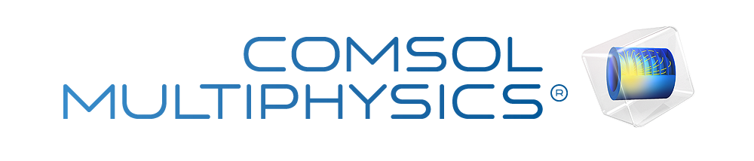

Kiden's Fluid Mechancs Report 1
Report date
Sep 2, 2026, 10:58:07 PM
Contents
1. Global Definitions
1.1. Parameters
2. Component 1
2.1. Definitions
2.2. Geometry 1
2.3. Materials
2.4. Laminar Flow
2.5. Mesh 1
3. Study 1
3.1. Stationary
4. Results
4.1. Datasets
4.2. Tables
4.3. Plot Groups

Global Definitions
Date | Aug 27, 2026, 7:18:28 PM

Global settings
Name | Kiden's Fluid Mechancs Report 1.mph
Path | C:\Users\kiden\OneDrive - University of Hartford\Documents\Hartford Assignments\.Current_Semester 9\Kiden's Fluid Mechancs Report 1.mph
Version | COMSOL Multiphysics 6.4 (Build: 429)

Used products
CAD Import Module
COMSOL Multiphysics

Computer information
CPU | AMD64 Family 23 Model 104 Stepping 1, 6 cores, 5.85 GB RAM
Operating system | Windows 11

Parameters
Parameters 1
Name | Expression | Value | Description
v0 | 1 [cm/s] | 0.01 m/s | Inlet Velocity
l_in | 1.5[cm] | 0.015 m | Inlet length
l_out | 3[cm] | 0.03 m | Outlet length
r_in | 0.25[cm] | 0.0025 m | Inlet radius
w_out | 1[cm] | 0.01 m | Outlet width

Component 1

Definitions

Coordinate Systems

Boundary System 1
Coordinate system type | Boundary system
Tag | sys1

Coordinate names
First | Second | Third
t1 | t2 | n

Geometry 1
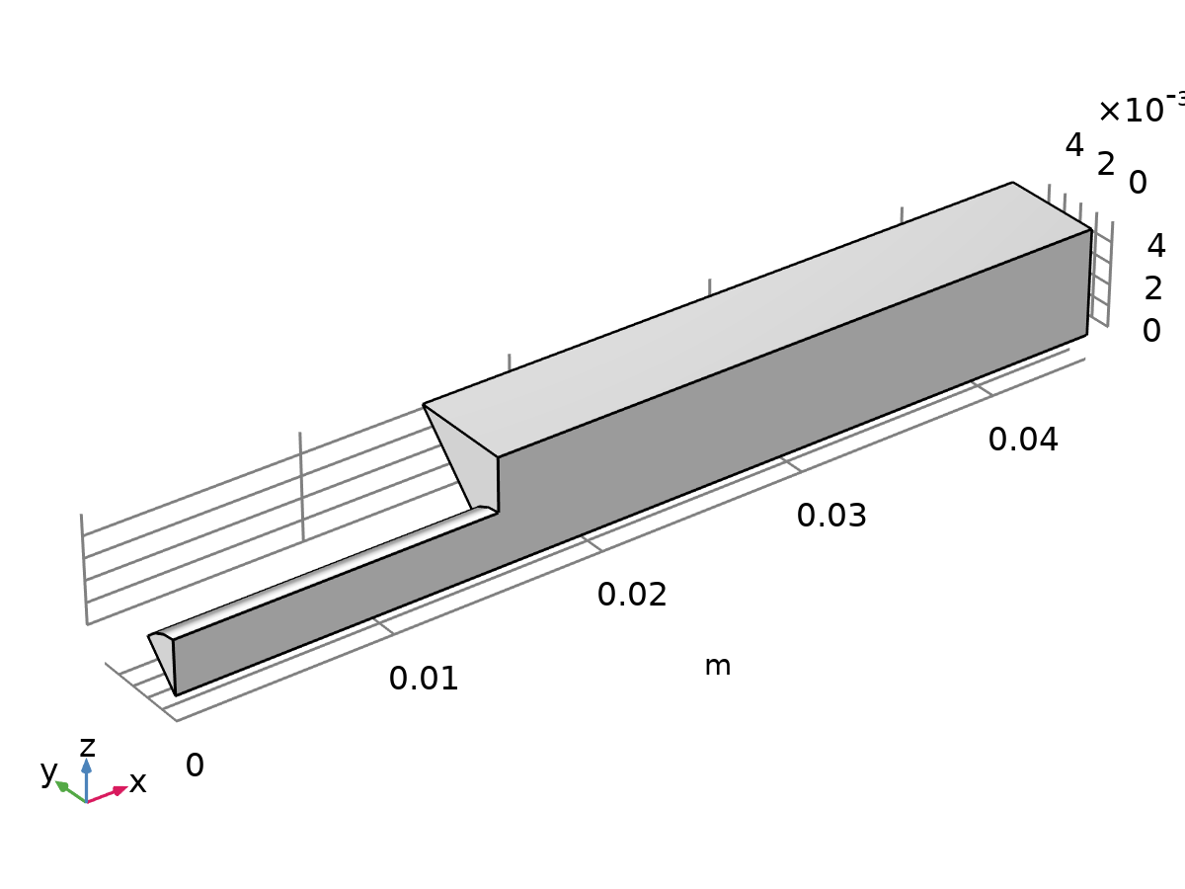
Geometry 1
Units
Length unit | m
Angular unit | deg

Materials

Water, liquid
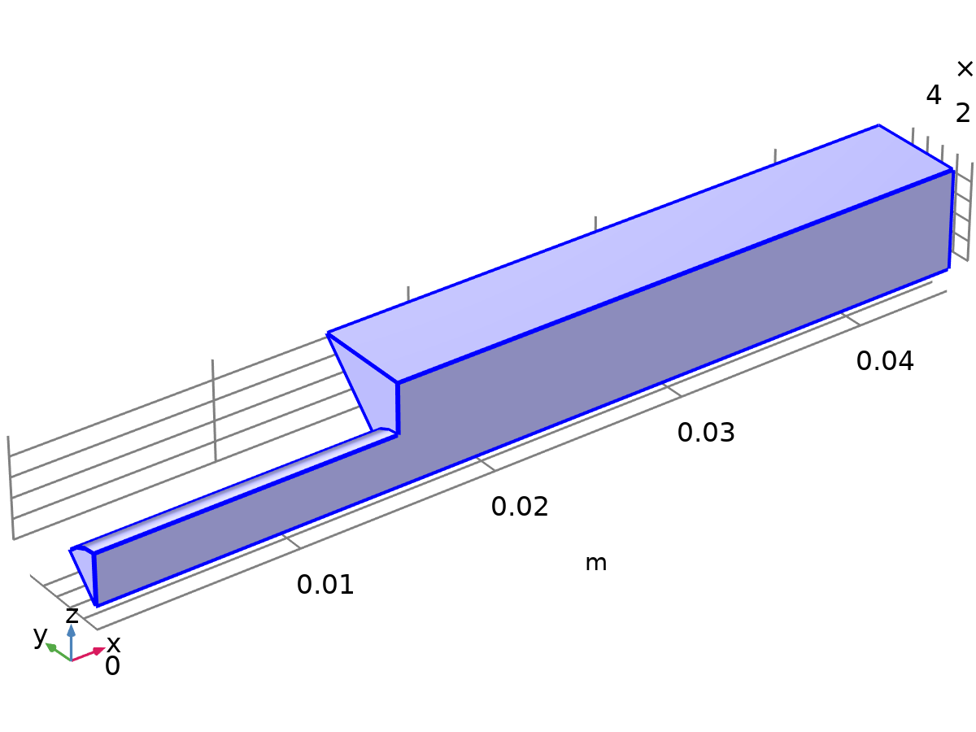
Water, liquid
Selection
Geometric entity level | Domain
Selection | Geometry geom1: Dimension 3: All domains

Laminar Flow
Laminar Flow
Equations
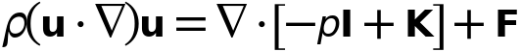
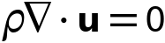
Features
Name | Level
Fluid Properties 1 | Domain
Initial Values 1 | Domain
Wall 1 | Boundary
Inlet 1 | Boundary
Symmetry 1 | Boundary
Symmetry 2 | Boundary
Outlet 1 | Boundary

Mesh 1
Settings
Description | Value
Type | Physics - controlled mesh
Element size | Coarse

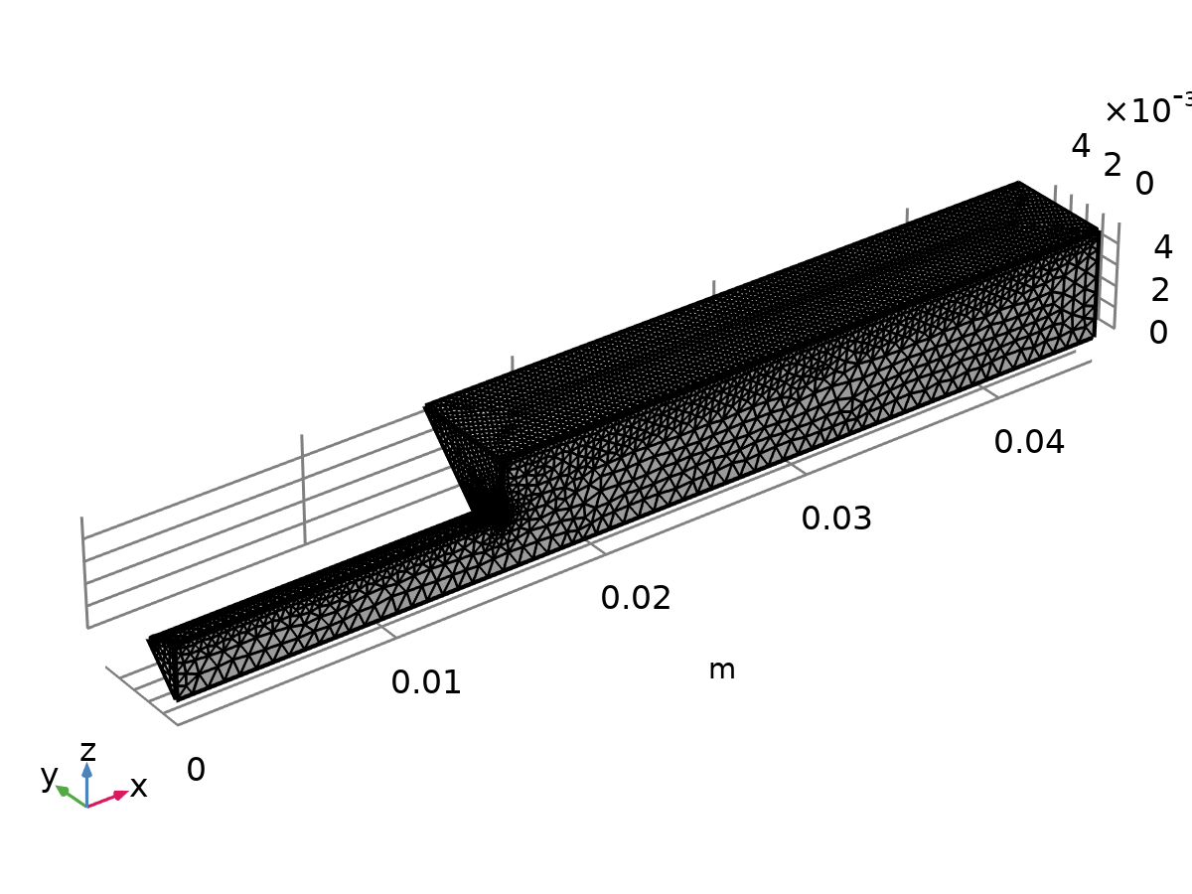
Mesh 1

Size (size)
Settings
Description | Value
Calibrate for | Fluid dynamics
Maximum element size | 7.18E-4
Minimum element size | 1.107E-4
Curvature factor | 0.8
Resolution of narrow regions | 0.5
Maximum element growth rate | 1.25

Size 1 (size1)
Selection
Geometric entity level | Boundary
Selection | Geometry geom1: Dimension 2: Boundaries 1–3, 7

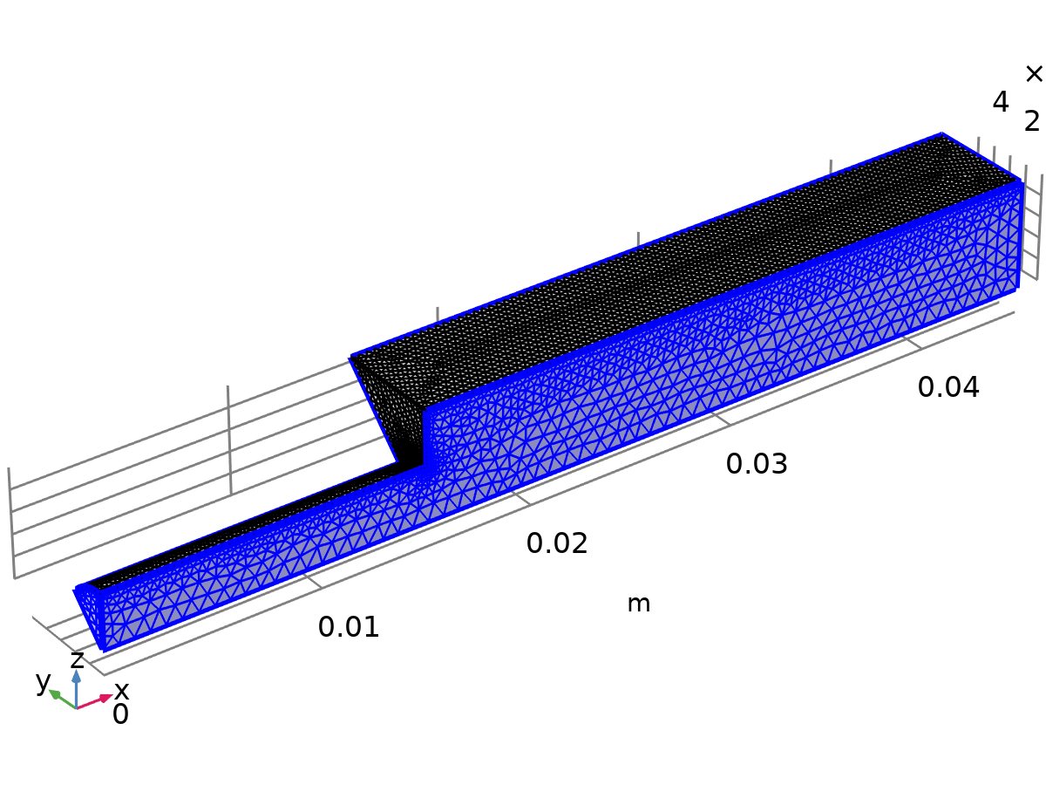
Size 1
Settings
Description | Value
Calibrate for | Fluid dynamics
Minimum element size | 5.937E-5

Size 2 (size2)
Selection
Geometric entity level | Boundary
Selection | Geometry geom1: Dimension 2: Boundaries 4–6

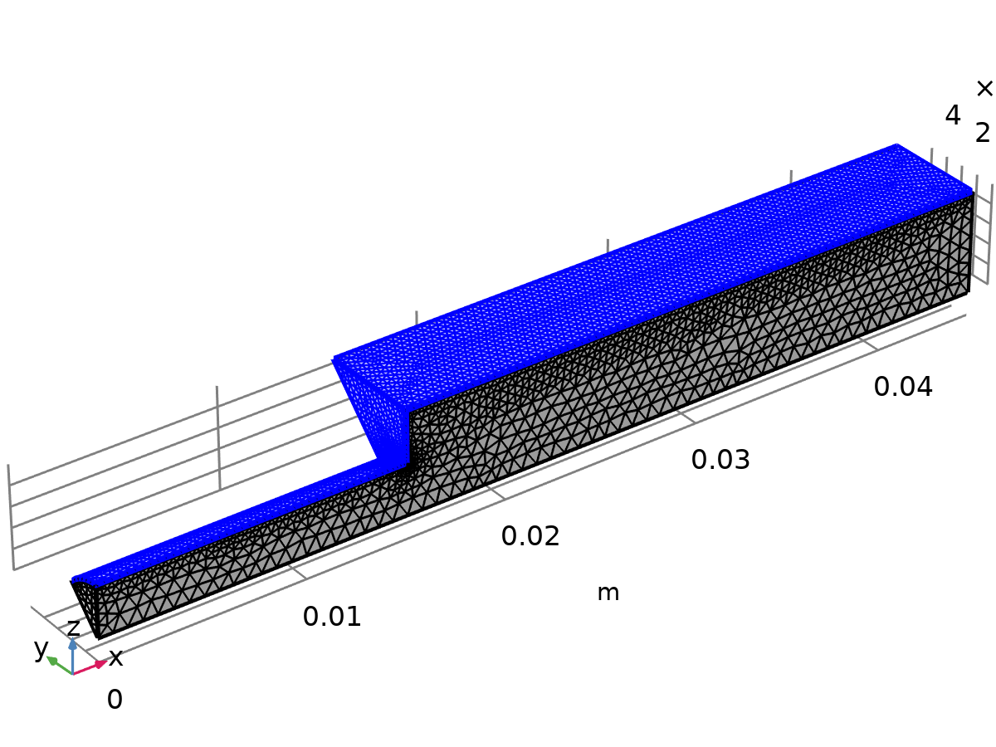
Size 2
Settings
Description | Value
Calibrate for | Fluid dynamics
Maximum element size | 3.7E-4
Minimum element size | 5.937E-5
Curvature factor | 0.6
Resolution of narrow regions | 0.7
Maximum element growth rate | 1.15

Corner Refinement 1 (cr1)
Selection
Geometric entity level | Domain
Selection | Geometry geom1: Dimension 3: Domain 1

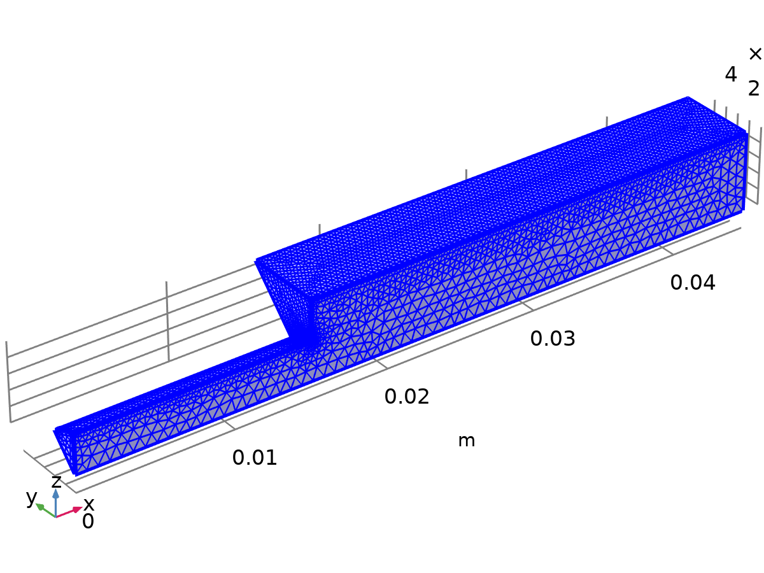
Corner Refinement 1
Settings
Description | Value
Boundary selection | geom1, Geometry geom1: Dimension 2: Boundaries 4–6
Corner selection | geom1, Geometry geom1: Dimension 1: No edges

Free Tetrahedral 1 (ftet1)
Selection
Geometric entity level | Domain
Selection | Remaining

Free Tetrahedral 1
Settings
Description | Value
Avoid inverted curved elements | On

Boundary Layers 1 (bl1)
Selection
Geometric entity level | Domain
Selection | Geometry geom1: Dimension 3: Domain 1

Boundary Layers 1
Information
Description | Value
Handling of sharp edges | Trimming

Boundary Layer Properties 1 (blp1)
Selection
Geometric entity level | Boundary
Selection | Geometry geom1: Dimension 2: Boundaries 4–6

Boundary Layer Properties 1
Settings
Description | Value
Number of layers | 2
Thickness adjustment factor | 5

Study 1
Computation information
Computation time | 23 s

Stationary
Study settings
Description | Value
Include geometric nonlinearity | Off

Store in output
Interface | Output | Selection
Laminar Flow (spf) | Physics controlled

Mesh selection
Component | Mesh
Component 1 | Mesh 1

Results

Datasets

Group 1

Cut Plane xz (y=0)
Data
Description | Value
Dataset | Study 1/Solution 1 (sol1)

Plane data
Description | Value
Plane type | Quick
Plane | XZ - planes
Y-coordinate | 0

Advanced
Description | Value
Space variables | {cpl1x, cpl1y}
Normal variables | {cpl1nx, cpl1ny, cpl1nz}

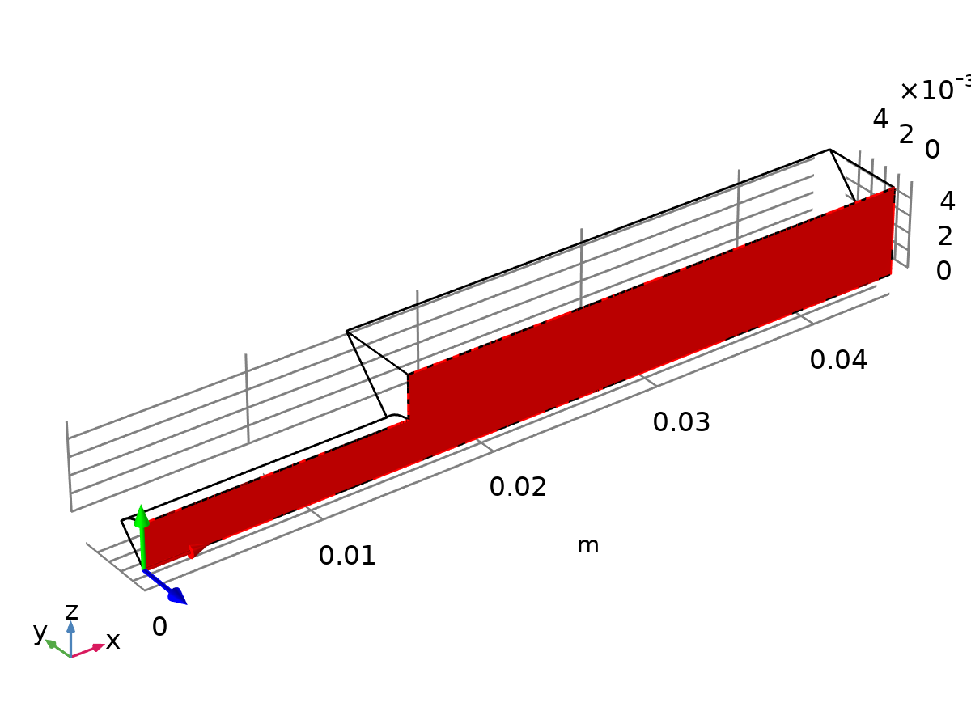
Dataset: Cut Plane xz (y=0)

Study 1/Solution 1
Solution
Description | Value
Solution | Solution 1 (sol1)
Component | Component 1 (comp1)
Frame | Material (X, Y, Z)

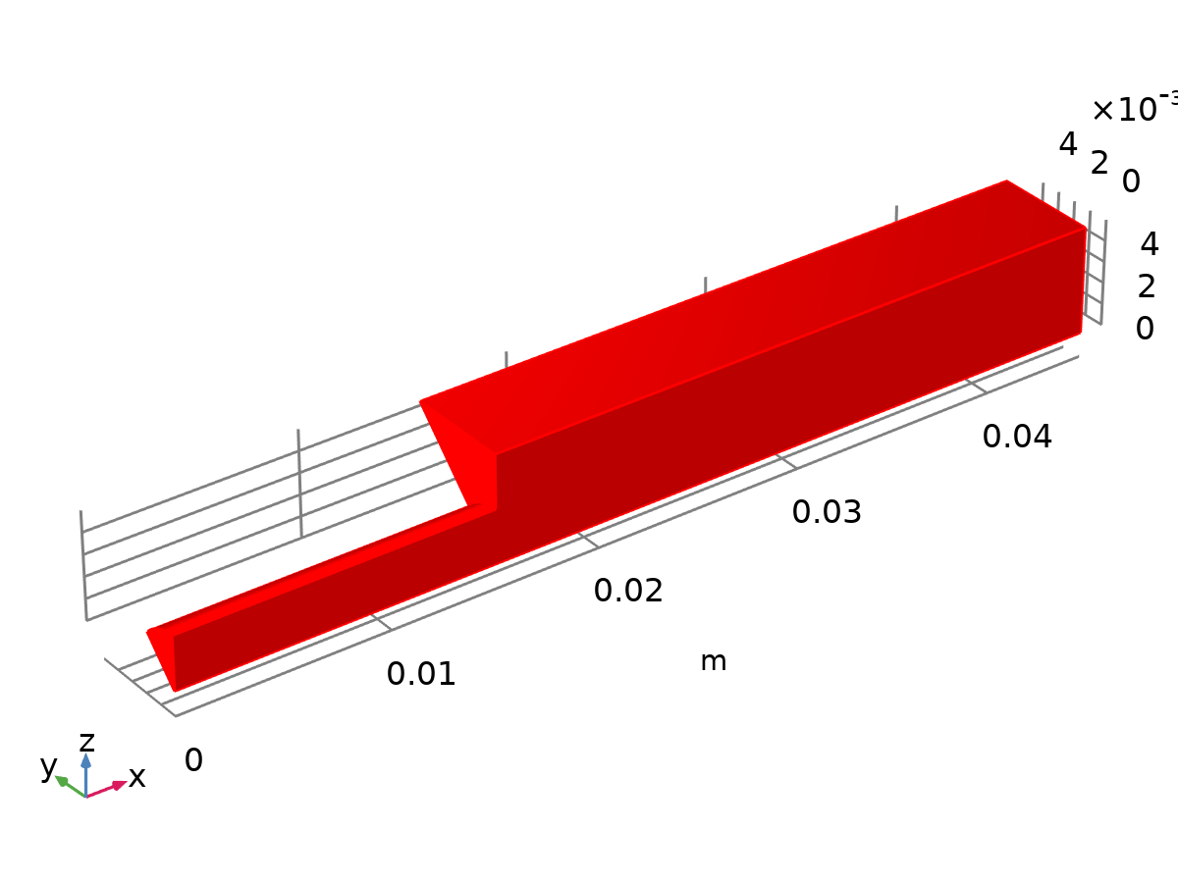
Dataset: Study 1/Solution 1

Cut Line x=0
Data
Description | Value
Dataset | Cut Plane xz (y=0)

Line data
Description | Value
Line entry method | Point and direction
Point | {0, 0}
Direction | {0, 1}

Advanced
Description | Value
Space variable | cln1x
Normal variables | {cln1nx, cln1ny}
Tangent variables | {cln1tx, cln1ty}

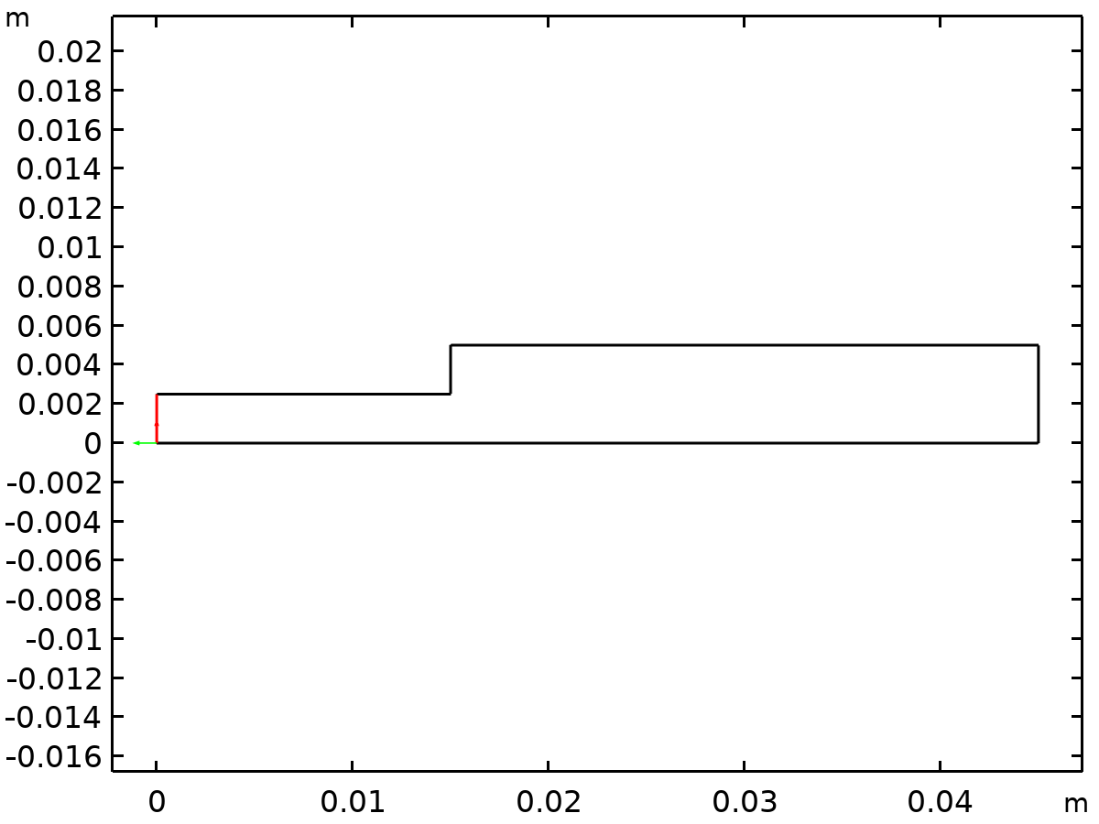
Dataset: Cut Line x=0

Cut Line x=0.01
Data
Description | Value
Dataset | Cut Plane xz (y=0)

Line data
Description | Value
Line entry method | Point and direction
Point | {0.01, 0}
Direction | {0, 1}

Advanced
Description | Value
Line number | cln1number
Space variable | cln1x
Normal variables | {cln1nx, cln1ny}
Tangent variables | {cln1tx, cln1ty}

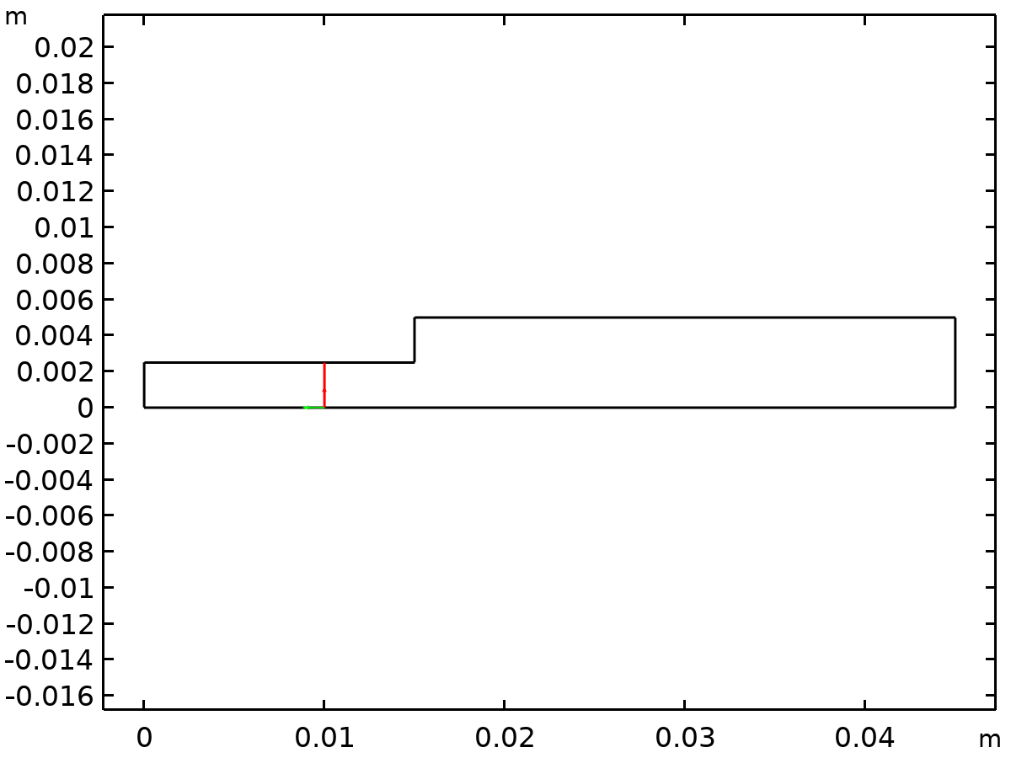
Dataset: Cut Line x=0.01

Cut Line x=0.015
Data
Description | Value
Dataset | Cut Plane xz (y=0)

Line data
Description | Value
Line entry method | Point and direction
Point | {0.015, 0}
Direction | {0, 1}

Advanced
Description | Value
Line number | cln1number
Space variable | cln1x
Normal variables | {cln1nx, cln1ny}
Tangent variables | {cln1tx, cln1ty}

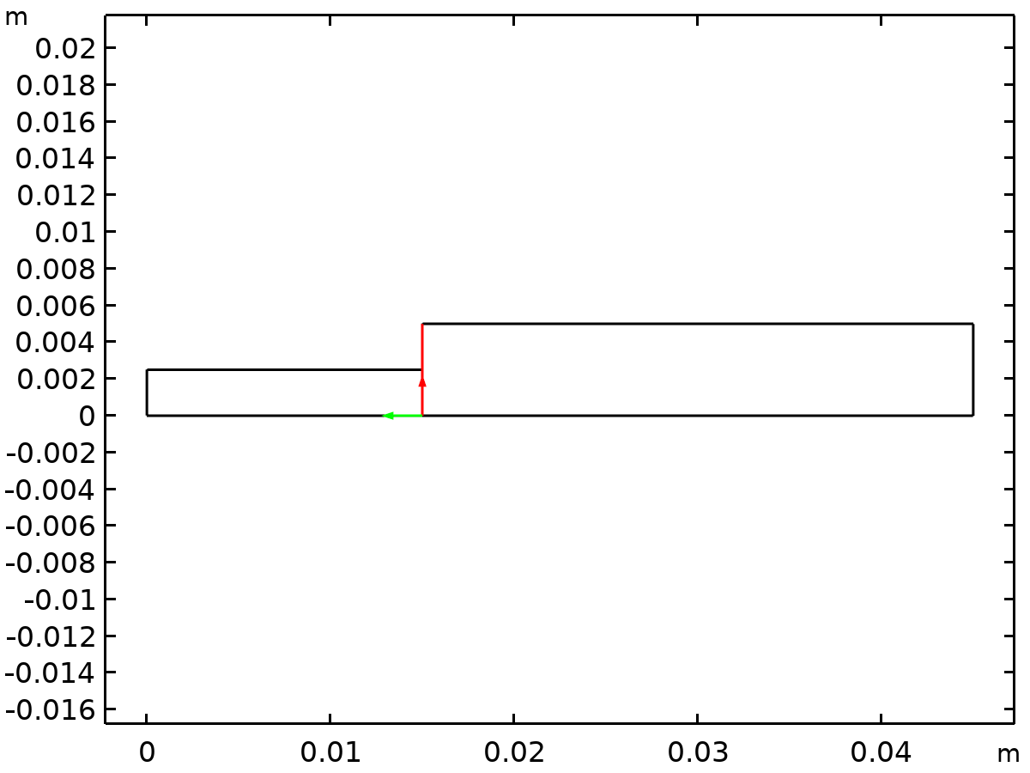
Dataset: Cut Line x=0.015

Cut Line x=0.0175
Data
Description | Value
Dataset | Cut Plane xz (y=0)

Line data
Description | Value
Line entry method | Point and direction
Point | {0.0175, 0}
Direction | {0, 1}

Advanced
Description | Value
Line number | cln1number
Space variable | cln1x
Normal variables | {cln1nx, cln1ny}
Tangent variables | {cln1tx, cln1ty}

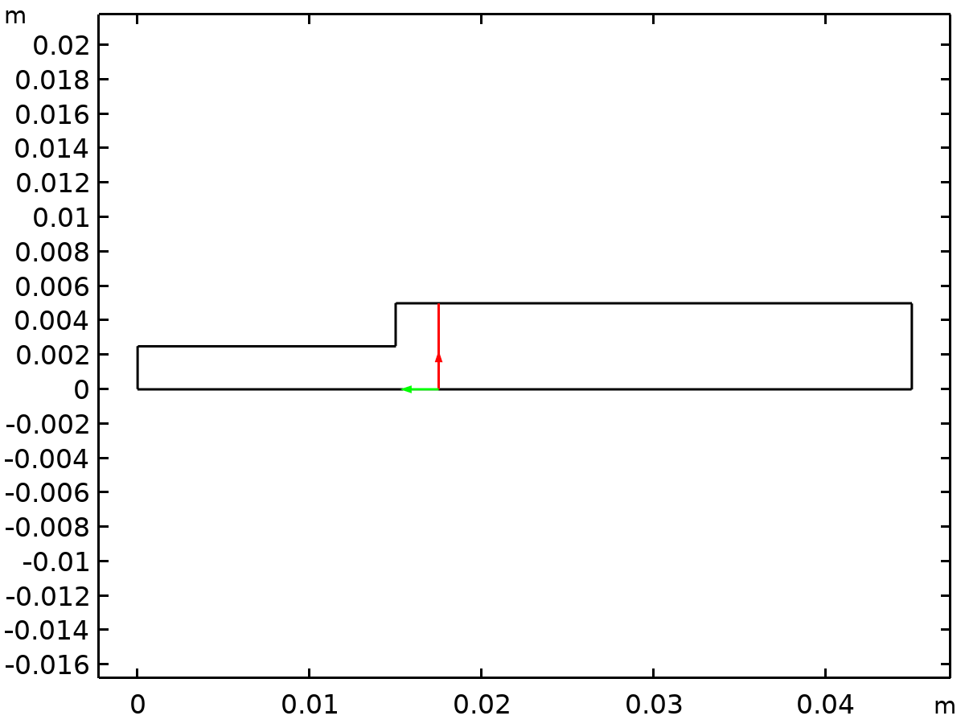
Dataset: Cut Line x=0.0175

Cut Line x=0.02
Data
Description | Value
Dataset | Cut Plane xz (y=0)

Line data
Description | Value
Line entry method | Point and direction
Point | {0.02, 0}
Direction | {0, 1}

Advanced
Description | Value
Line number | cln1number
Space variable | cln1x
Normal variables | {cln1nx, cln1ny}
Tangent variables | {cln1tx, cln1ty}

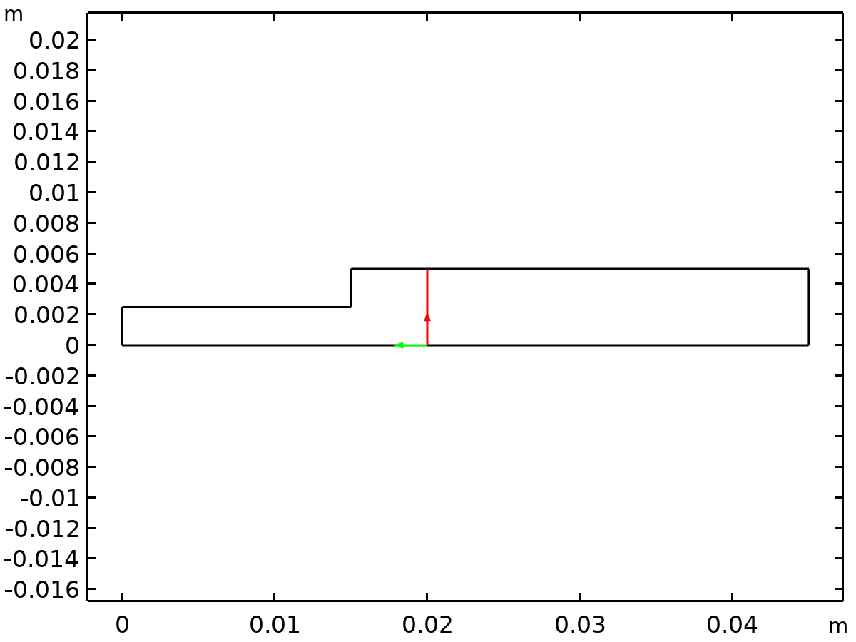
Dataset: Cut Line x=0.02

Tables

Evaluation 2D
Interactive 2D values
x | y | Value
0.024454 | 0 | 0.011876

Plot Groups

FIG. 3 Velocity Magnitude
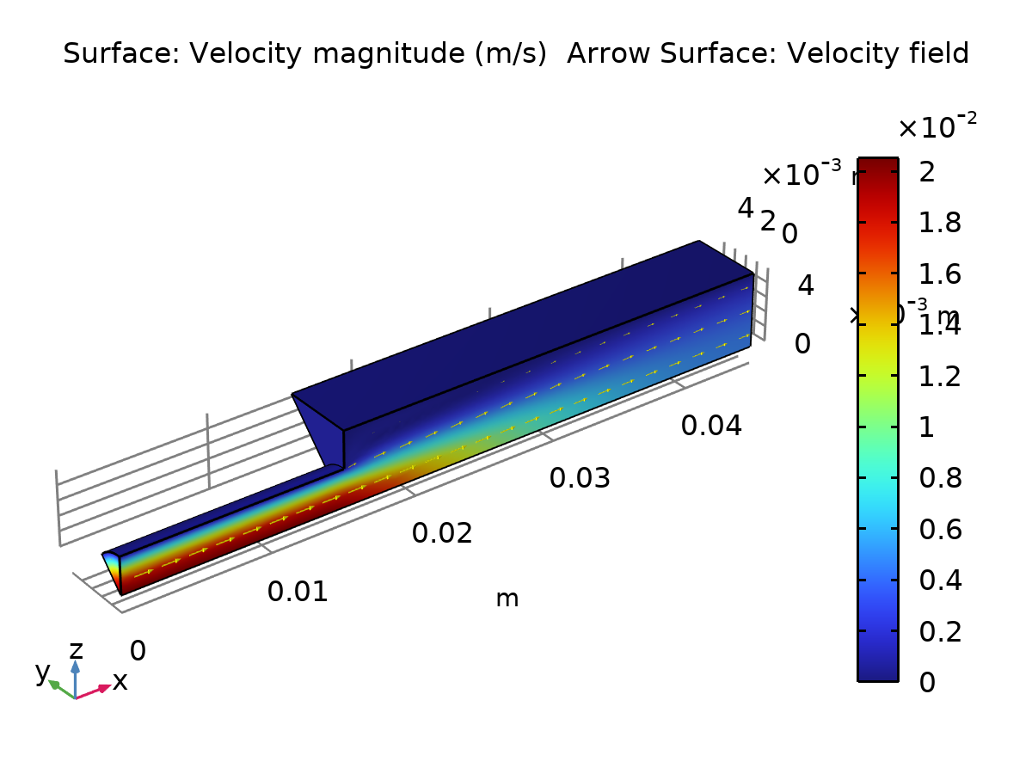
Surface: Velocity magnitude (m/s) Arrow Surface: Velocity field

Pressure (spf)
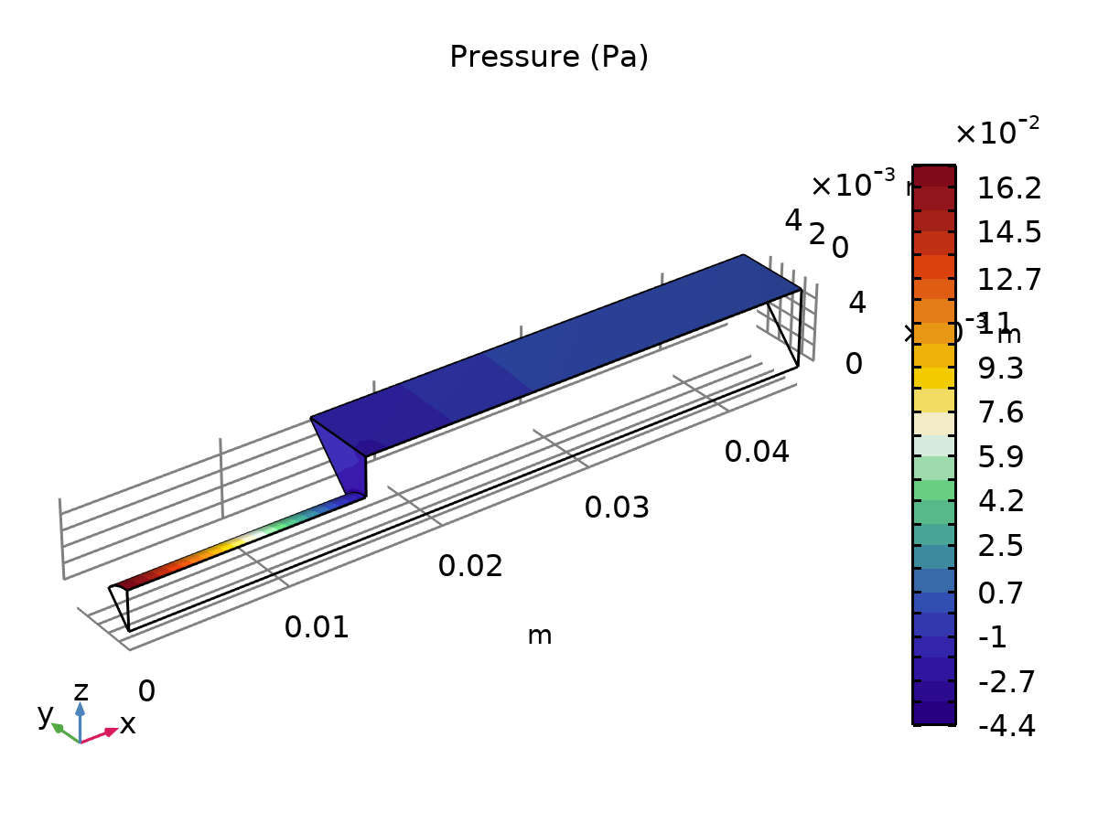
Pressure (Pa)

Velocity, Streamlines
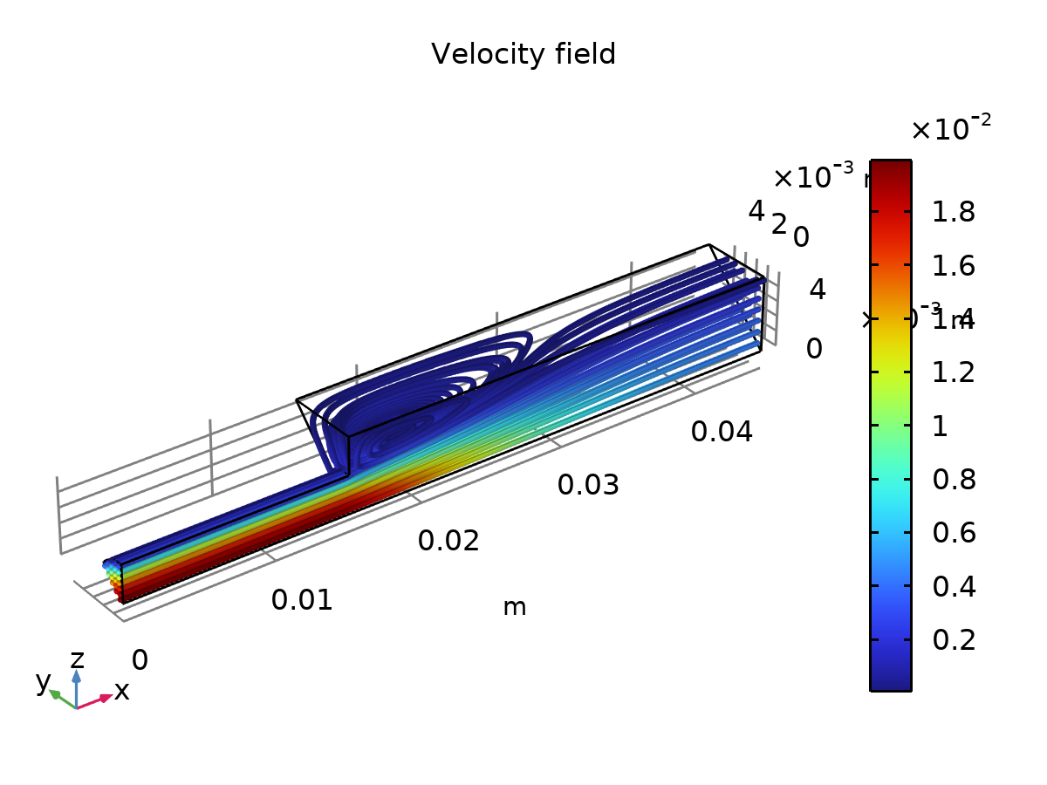
Velocity field

FIG. 7A Velocity Magnitudes Along Cut Lines
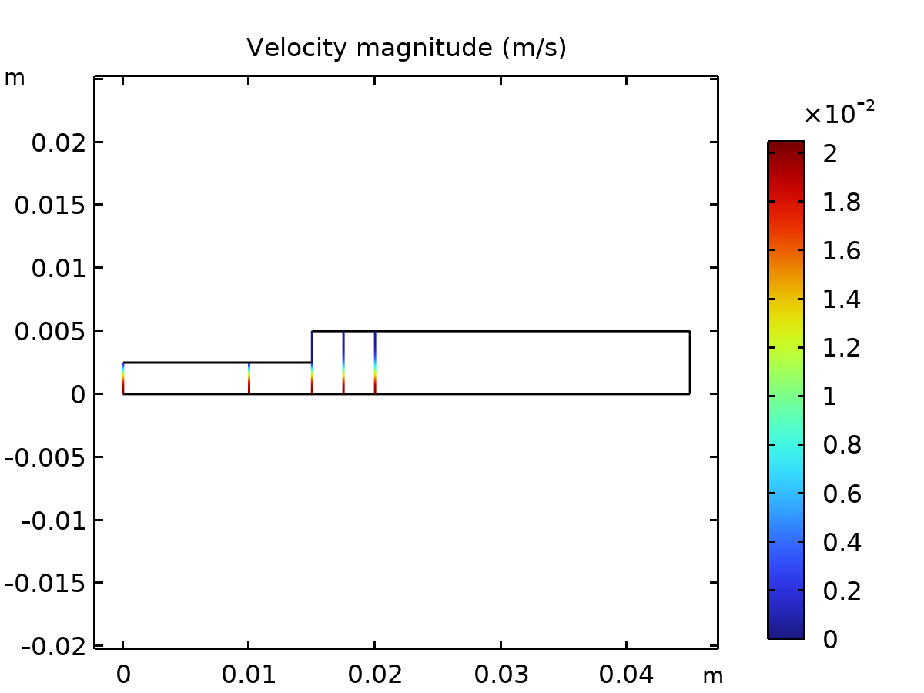
Velocity magnitude (m/s)

FIG. 5 Velocity Profiles at Several Axial Locations
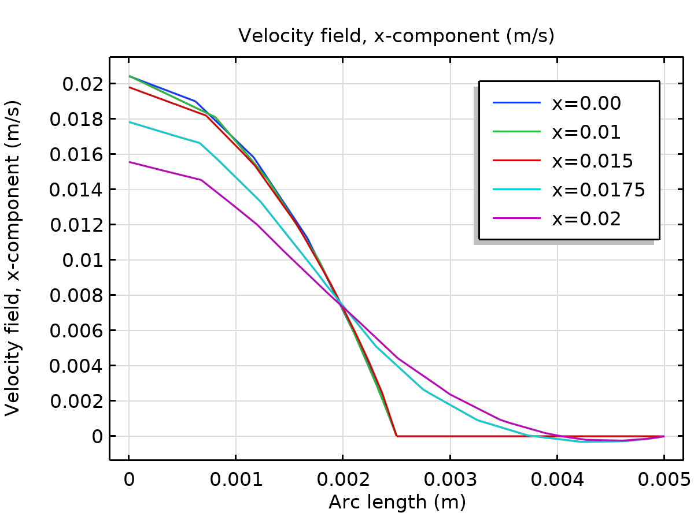
Velocity field, x-component (m/s)
This shows the spped of the fluid at cartain points and here we can see how the fluid boundary condition applies with the boundary condition represented on the right side of the graph.

