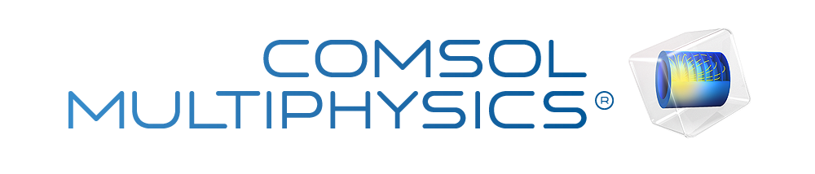

Kiden's Fluid Mechancs Report 2
Report date
Sep 10, 2026, 11:15:29 AM
Contents
1. Global Definitions
1.1. Parameters
2. Component 1
2.1. Definitions
2.2. Geometry 1
2.3. Laminar Flow
2.4. Mesh 1
3. Study 1
3.1. Parametric Sweep
3.2. Stationary
4. Results
4.1. Datasets
4.2. Plot Groups

Global Definitions
Date | Sep 10, 2026, 2:55:47 AM

Global settings
Name | Kiden's Fluid Mechancs Report 2.mph
Path | C:\Users\kiden\OneDrive - University of Hartford\Documents\Hartford Assignments\.Current_Semester 9\Kiden's Fluid Mechancs Report 2.mph
Version | COMSOL Multiphysics 6.4 (Build: 429)

Used products
CFD Module
COMSOL Multiphysics

Computer information
CPU | AMD64 Family 23 Model 104 Stepping 1, 6 cores, 5.85 GB RAM
Operating system | Windows 11

Parameters
Parameters 1
Name | Expression | Value | Description
p_in | 10 [kPa] | 10000 Pa | Inlet pressure

Component 1

Definitions

Coordinate Systems

Boundary System 1
Coordinate system type | Boundary system
Tag | sys1

Coordinate names
First | Second | Third
t1 | to | n

Settings
Description | Value
Axis | phi

Geometry 1
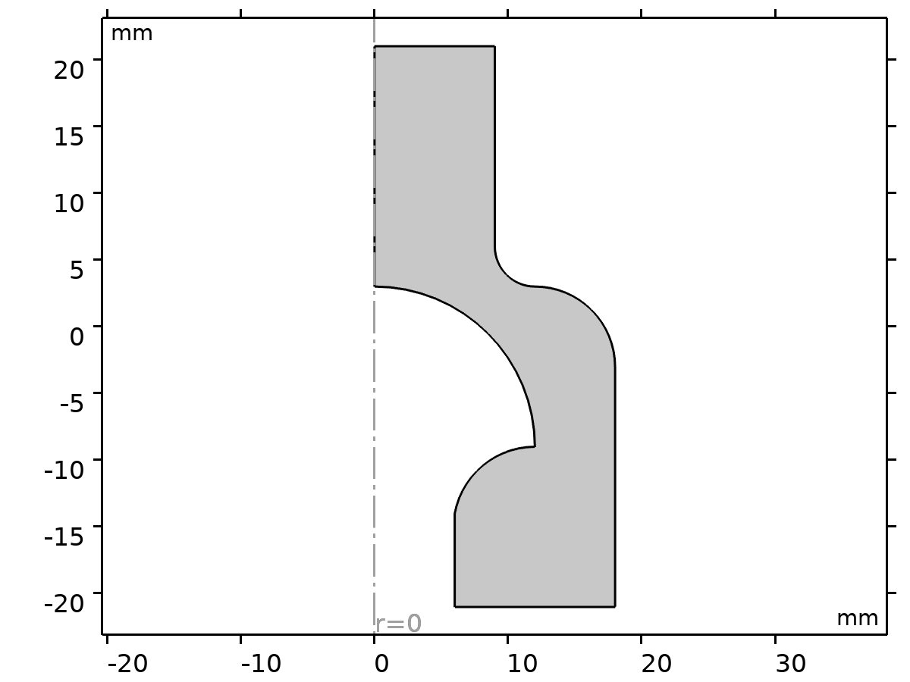
Geometry 1
Units
Length unit | mm
Angular unit | deg

Laminar Flow
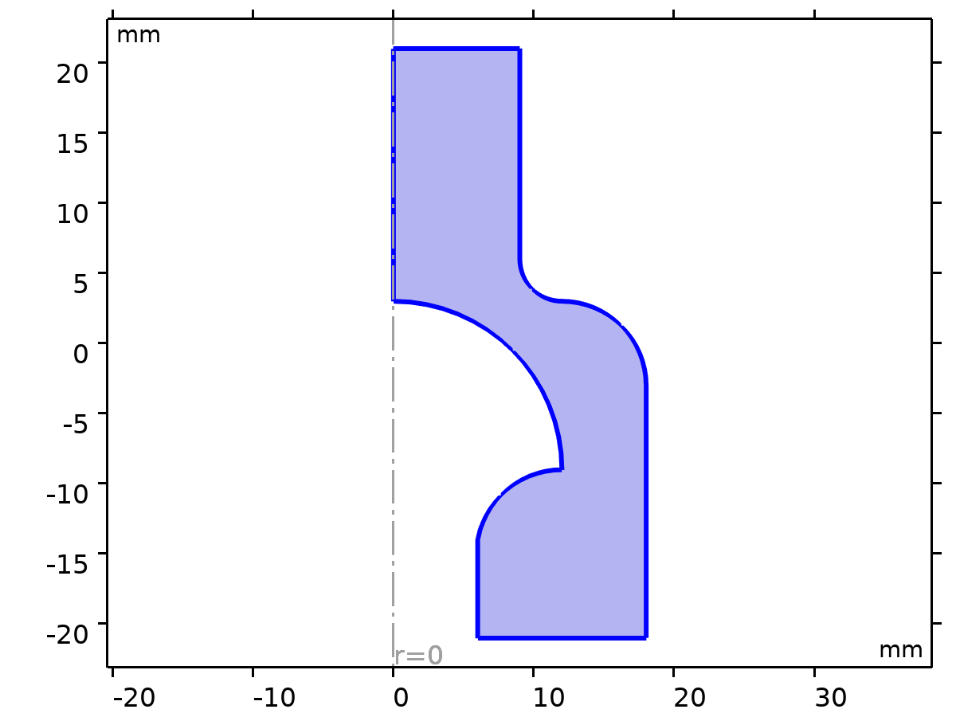
Laminar Flow
Equations
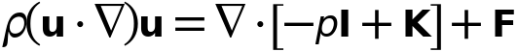
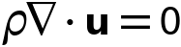
Features
Name | Level
Fluid Properties 1 | Domain
Initial Values 1 | Domain
Axial Symmetry 1 | Boundary
Wall 1 | Boundary
Inlet 1 | Boundary
Outlet 1 | Boundary

Mesh 1
Settings
Description | Value
Type | Physics - controlled mesh
Element size | Extra fine

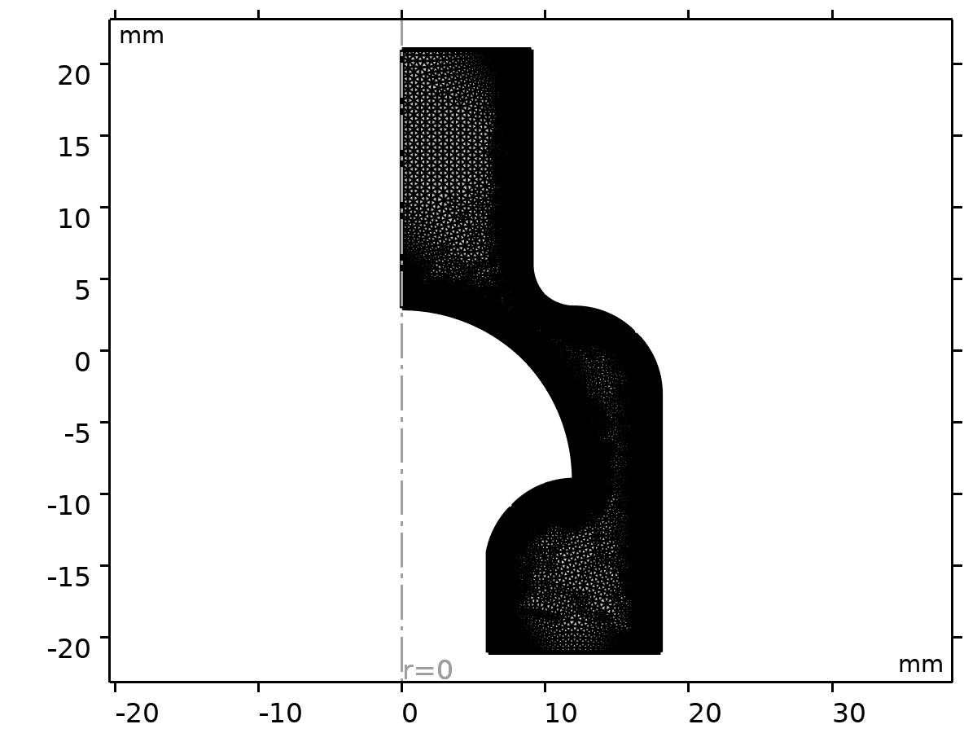
Mesh 1

Size (size)
Settings
Description | Value
Calibrate for | Fluid dynamics
Maximum element size | 0.504
Minimum element size | 0.0072
Curvature factor | 0.25
Predefined size | Finer

Size 1 (size1)
Selection
Geometric entity level | Boundary
Selection | Geometry geom1: Dimension 1: Boundaries 3, 5–10

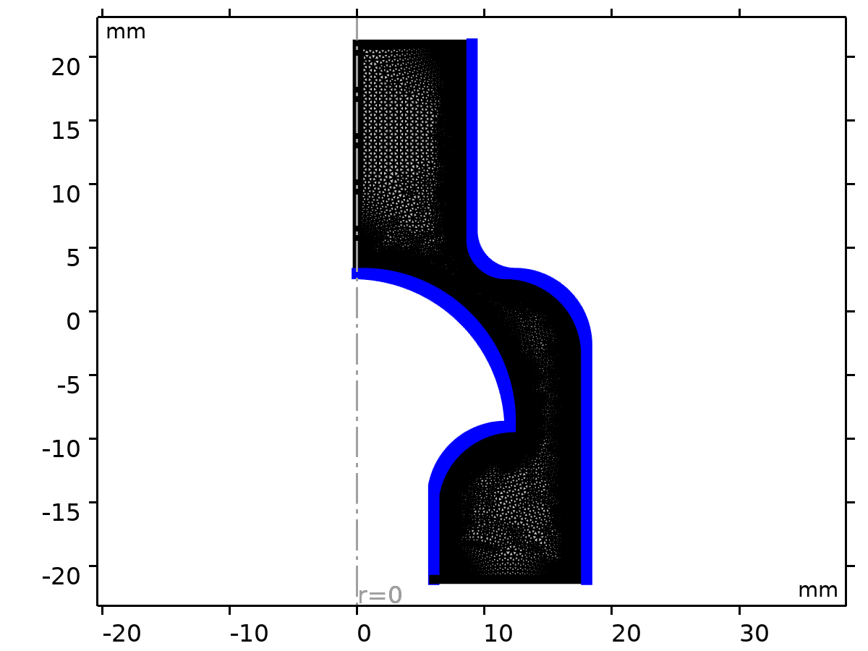
Size 1
Settings
Description | Value
Calibrate for | Fluid dynamics
Maximum element size | 0.121
Minimum element size | 3.6E-4
Curvature factor | 0.2
Maximum element growth rate | 1.05
Predefined size | Extremely fine

Corner Refinement 1 (cr1)
Selection
Geometric entity level | Domain
Selection | Geometry geom1: Dimension 2: Domain 1

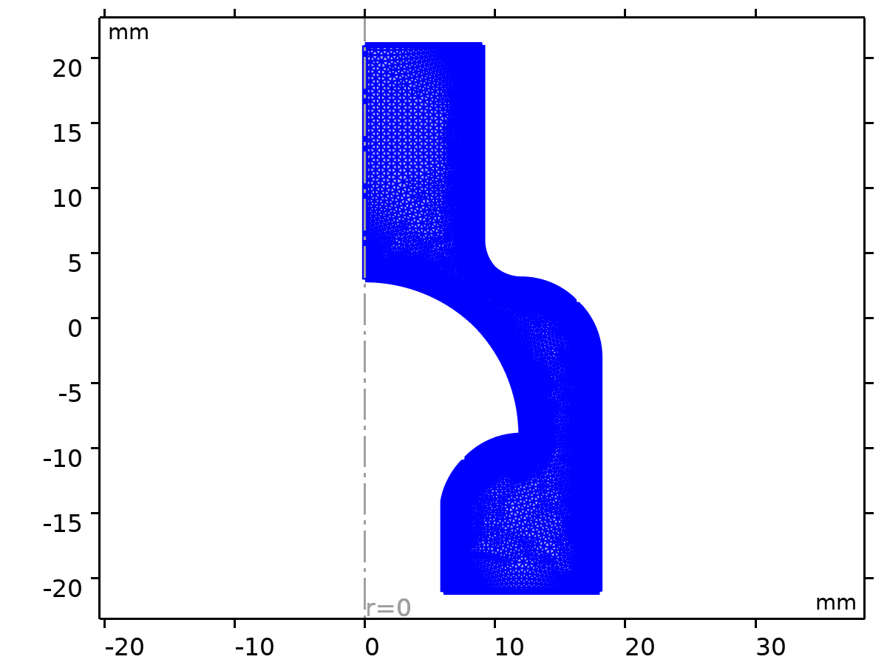
Corner Refinement 1
Settings
Description | Value
Boundary selection | geom1, Geometry geom1: Dimension 1: Boundaries 3, 5–10
Corner selection | geom1, Geometry geom1: Dimension 0: No points

Free Triangular 1 (ftri1)
Selection
Geometric entity level | Domain
Selection | Remaining

Free Triangular 1

Boundary Layers 1 (bl1)
Selection
Geometric entity level | Domain
Selection | Geometry geom1: Dimension 2: Domain 1

Boundary Layers 1
Information
Description | Value
Handling of sharp corners | Trimming

Settings
Description | Value
Number of iterations | 4
Maximum element depth to process | 6

Boundary Layer Properties 1 (blp1)
Selection
Geometric entity level | Boundary
Selection | Geometry geom1: Dimension 1: Boundaries 3, 5–10

Boundary Layer Properties 1
Settings
Description | Value
Number of layers | 2
Thickness adjustment factor | 5

Study 1
Computation information
Computation time | 35 s

Parametric Sweep
Parameter name | Parameter value list | Parameter unit
p_in | range(10000,40000,210000) | Pa

Study settings
Description | Value
Sweep type | All combinations
Parameter name | p_in
Unit | Pa

Parameters
Parameter name | Parameter value list | Parameter unit
#p_in (Inlet pressure) | range(10000,40000,210000) | Pa

Stationary
Study settings
Description | Value
Include geometric nonlinearity | Off

Store in output
Interface | Output | Selection
Laminar Flow (spf) | Physics controlled

Mesh selection
Component | Mesh
Component 1 | Mesh 1

Results

Datasets

Study 1/Solution 1
Solution
Description | Value
Solution | Solution 1 (sol1)
Component | Component 1 (comp1)

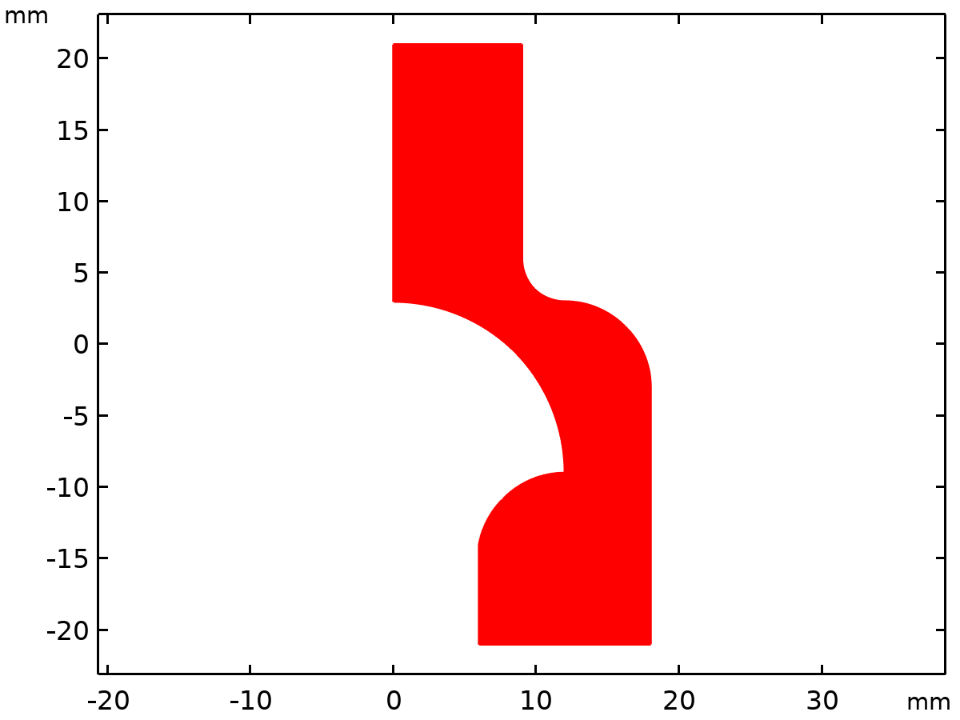
Dataset: Study 1/Solution 1

Revolution 2D
Data
Description | Value
Dataset | Study 1/Solution 1 (sol1)

Axis data
Description | Value
Axis entry method | Two points
Points | {{0, 0}, {0, 1}}

Revolution layers
Description | Value
Start angle | -90
Revolution angle | 225

Advanced
Description | Value
Space variables | {rev1x, rev1y, rev1z}

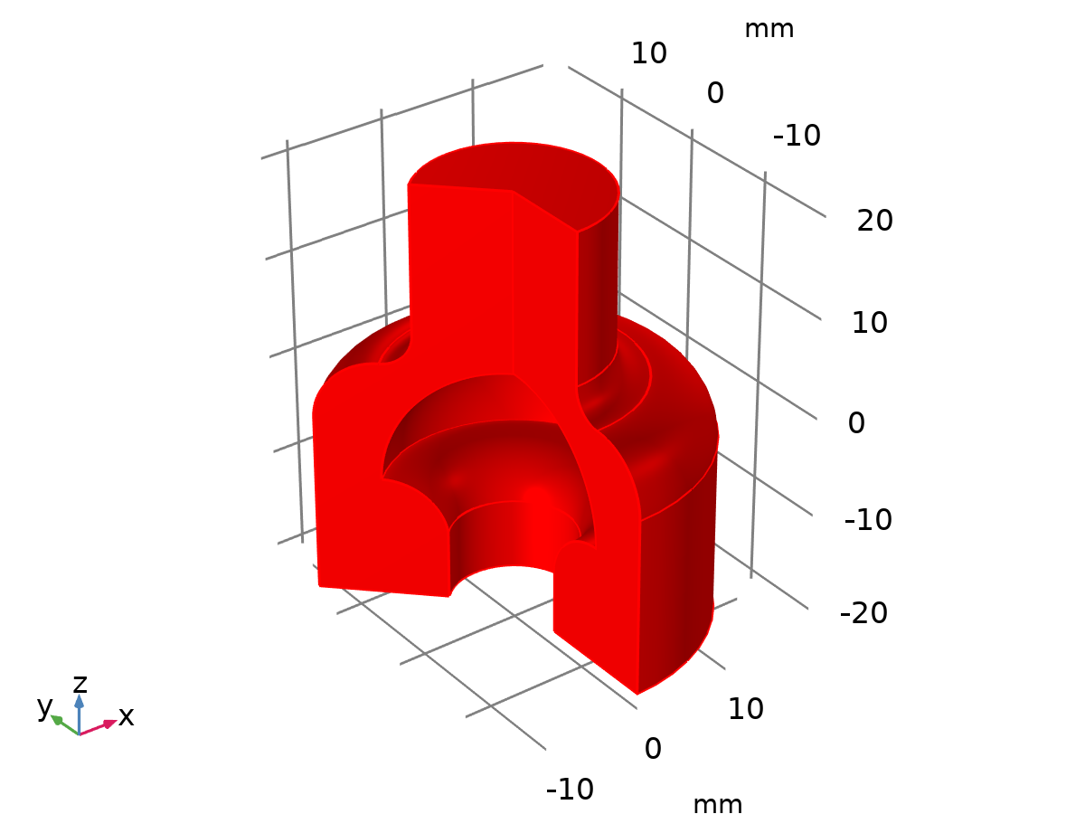
Dataset: Revolution 2D

Cut Line 2D 1
Data
Description | Value
Dataset | Study 1/Solution 1 (sol1)

Line data
Description | Value
Line entry method | Two points
Points | {{7.55, 0.32}, {9.97, 3.79}}

Advanced
Description | Value
Space variable | cln1x
Normal variables | {cln1nx, cln1ny}
Tangent variables | {cln1tx, cln1ty}

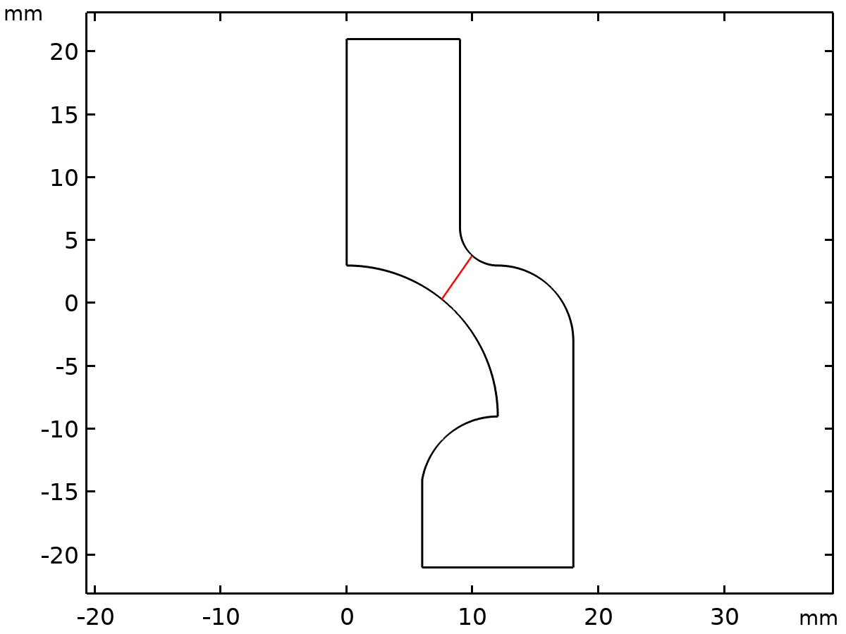
Dataset: Cut Line 2D 1

Plot Groups

FIG. 3A Velocity, p_in = 10 kPa
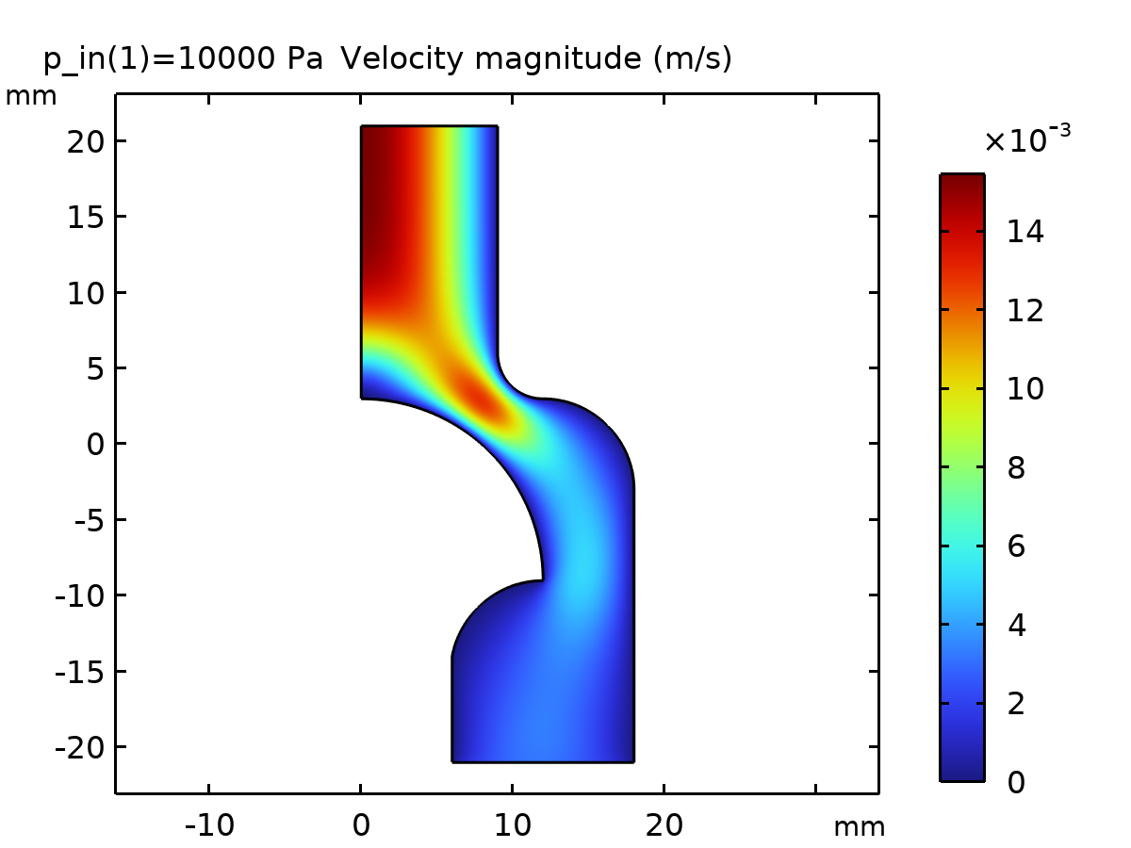
Velocity magnitude (m/s)

Pressure (spf)
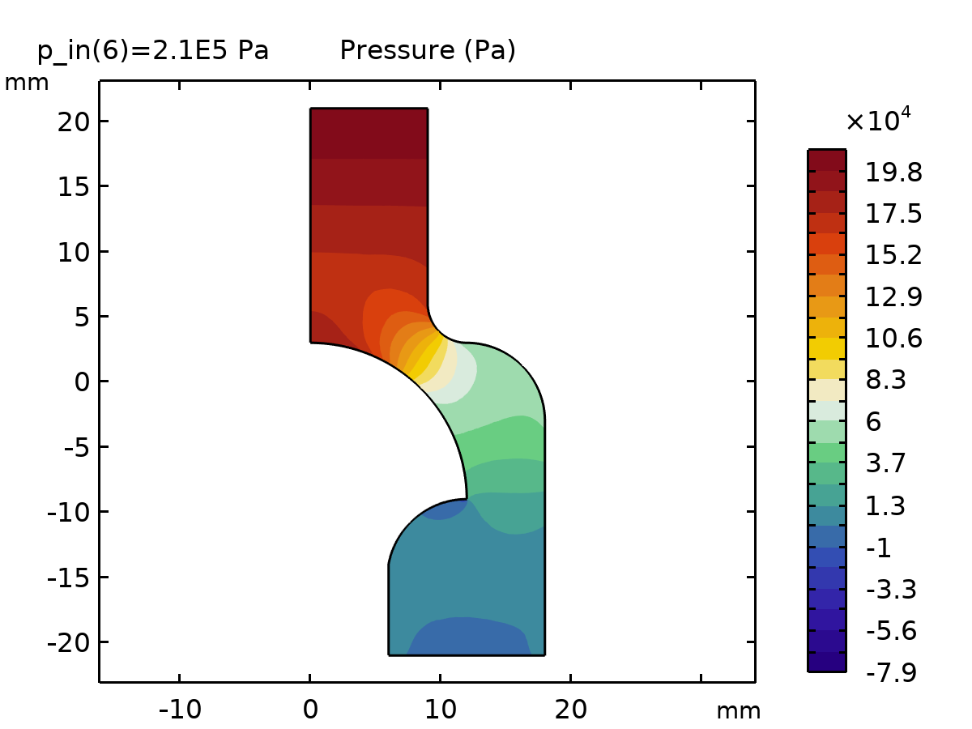
Pressure (Pa)

Velocity, 3D (spf)
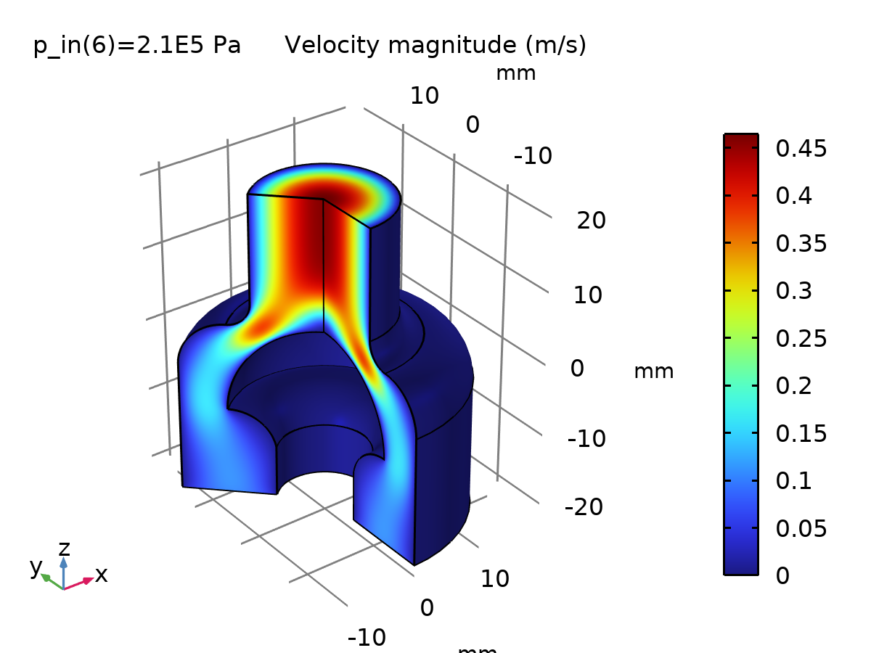
Velocity magnitude (m/s)

Viscosity
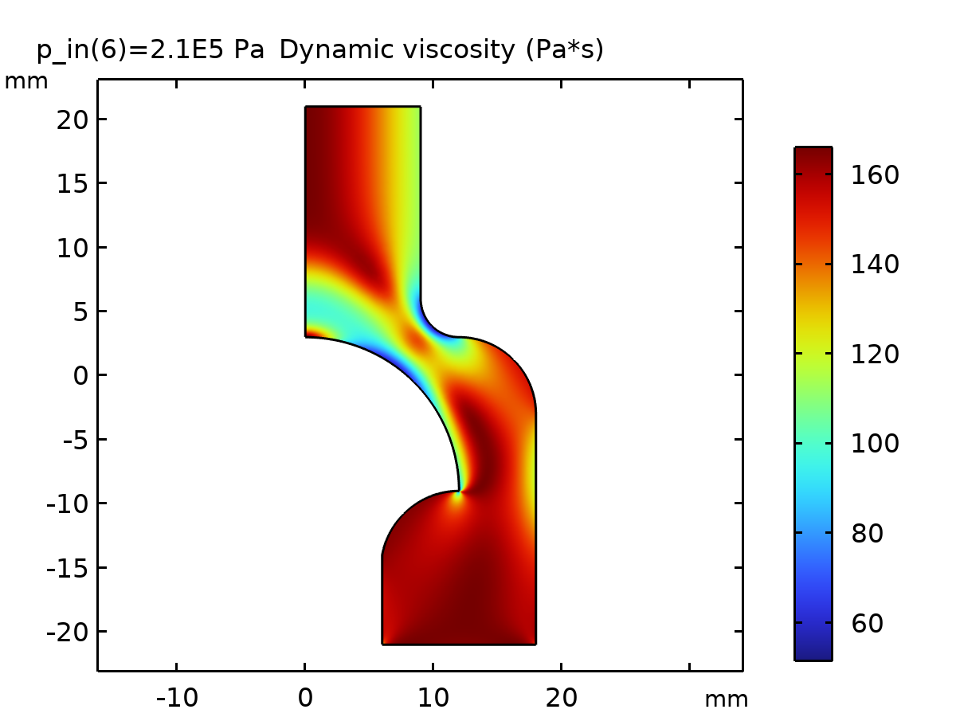
Dynamic viscosity (Pa*s)

1D Plot Group 5
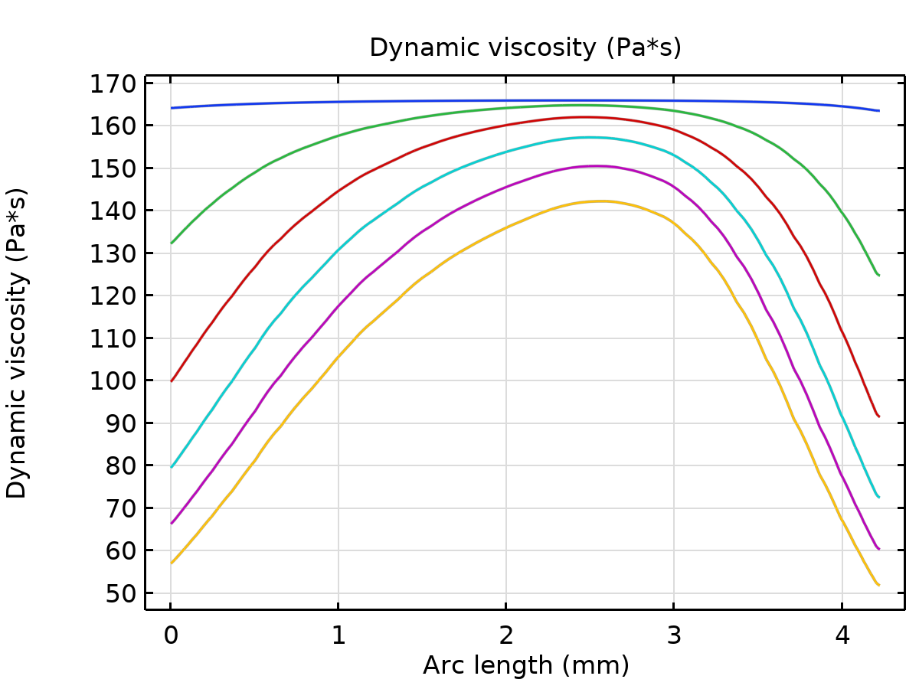
Dynamic viscosity (Pa*s)

FIG. 3B Velocity, p_in = 210 kPa
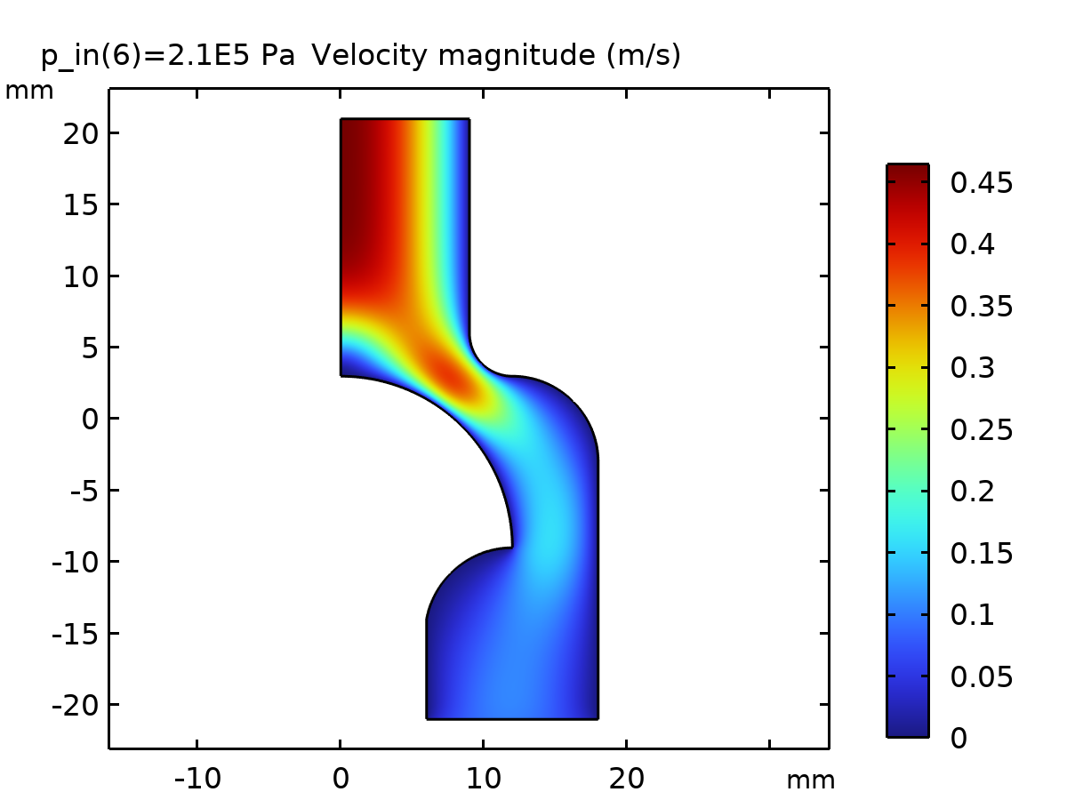
Velocity magnitude (m/s)

