CAD Final Project
Retro-Industrial Fan

ME 376
Professor Obst
Kiden Scruton
12-12-25

Abstract
This study investigates the structural feasibility of a novel fan design with retro-industrial styling made to be cheap to manufacture, easy to assemble and fully self-contained. The fan was designed in SolidWorks, and the Moment-based structural Analysis was performed in Ansys.

Table of Contents
Abstract 2
List of Figures 4
List of Tables 5
1.0 Introduction (Heading 1) 6
2.0 Background Information (Heading 1) 7
2.1 Topic #1 background (Heading 2) 7
2.1.1 Sub-topic (Heading 3) 7
3.0 Results and Discussion (Heading 1) 8
3.1 Topic #1 Results (Heading 2) 8
3.1.1 Sub-topic (Heading 3) 8
4.0 Summary and Recommendations (Heading 1) 10
4.1 Topic #1 Summary (Heading 2) 10
4.1.1 Sub-topic (Heading 3) 10
References 11
Appendix 12

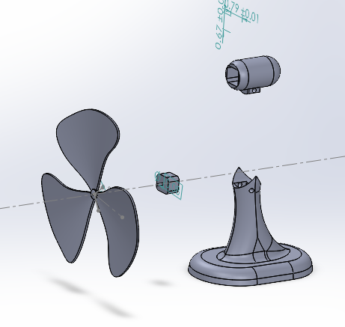
List of Figures

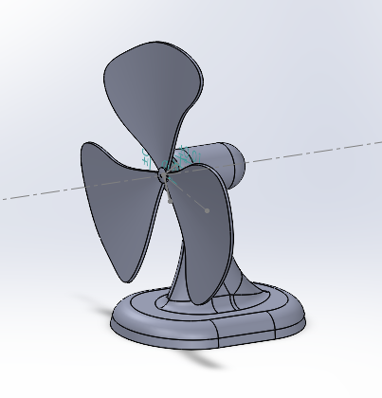
Figure 1: Exploded view of the retro-industrial fan assembly (SolidWorks). 6

Figure 2: Final retro-industrial fan assembly (SolidWorks) 7
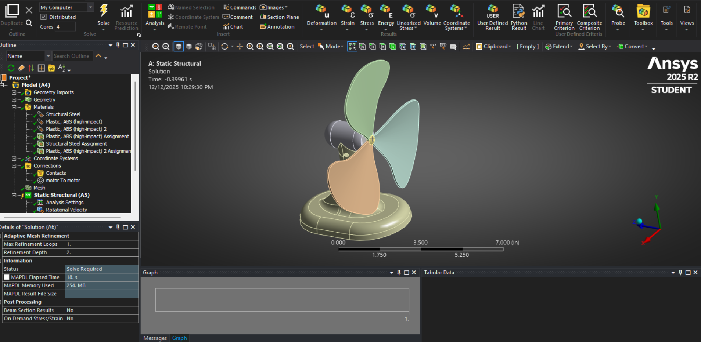
Figure 3: Fan assembly imported into ANSYS with boundary conditions applied. 8

List of Tables (Heading 1)
Table 1: Bill of Materials (major components). 8

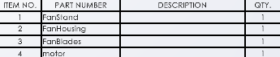

1.0 Introduction (Heading 1)
This paper investigates the structural properties of a novel Retro-Industrial desk fan design with a rugged, Fallout-inspired aesthetic while keeping the geometry practical to manufacture and assemble. The design objective is to confirm that the rotating assembly can withstand operating loads without excessive deformation or local overstress, and to use FEA results to guide final geometry decisions

2.0 Background Information

A desk fan converts motor torque into airflow by rotating blades about a shaft. Structurally, the critical features are the shaft-to-hub connection and the blade root region, where stress concentrations can form due to geometry transitions and component contacts. For this study the fan was designed around three constraints: (1) low manufacturing complexity, (2) straightforward assembly, and (3) safe operation with a conservative structural margin. The loading case used in ANSYS applies a moment through the shaft to represent motor drive loading, and the resulting stresses and deflections are evaluated against typical allowable limits for the selected material model the materials used are ABS for the fan blades and Structural Steel for the motor and shaft.

2.1 Design Objectives and Constraints
Objectives:
- Provide consistent airflow for desktop use.
- Maintain a rigid shaft-to-hub connection.
- Limit blade deflection to avoid contact with surrounding geometry.
- Keep blade root stresses below material yield with margin.
- Preserve a retro-industrial aesthetic while avoiding unnecessary features that complicate
Manufacturing.

2.1.1 Ansys Introduction
The fan is analyzed using a linear static structural model with an applied shaft moment and a fixed motor-side shaft support. Blade-to-hub interfaces are bonded. Aerodynamic and transient effects are neglected to focus on worst-case structural stresses.

Figure 1: Exploded view of the retro-industrial fan assembly (SolidWorks).

3.0 Results and Discussion
Here we provide data and other results from the investigations outlined in the previous section and discuss what the results mean in the context of the study.
Figure 2: Final retro-industrial fan assembly (SolidWorks)

3.1 CAD Model and Assembly
The fan was modeled as a parametric assembly with separate parts for the shaft, hub, and blades. Geometry choices were guided by manufacturability, with simple surfaces, consistent thickness where possible, and filleted transitions at stress-critical regions such as the blade root. An exploded configuration was created to support assembly documentation and Bill of Materials generation.
Create subheadings for the paper before writing much text. This will serve as an outline for the paper that will help keep writing focused. Don’t be afraid to change or rearrange the subheadings as you write and edit, if it will improve flow.

3.2 ANSYS Structural Simulation Setup
The SolidWorks assembly was imported into ANSYS Mechanical.. Bonded contacts were used between blades and hub to represent a rigid connection. A fixed support was applied at the Base of the Fan. A moment about the shaft axis was applied to represent motor drive loading.
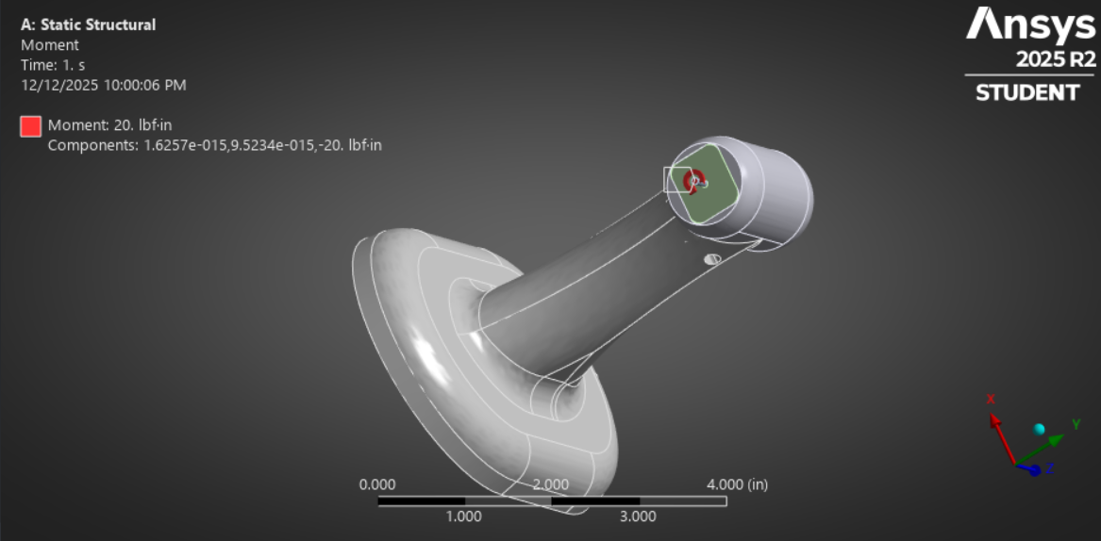
Figure 4: Showing the moment shaft force ANSYS

3.3 Simulation Results
The stress field concentrates at the mounting shaft and the top of the motor, with the peak values occurring near the blade root and at hub features where load transfers into the shaft. Deformation is dominated by blade bending, and the relative deflection shape is consistent with the applied shaft moment. Key outputs reported for the final run include equivalent (von Mises) stress and total deformation.
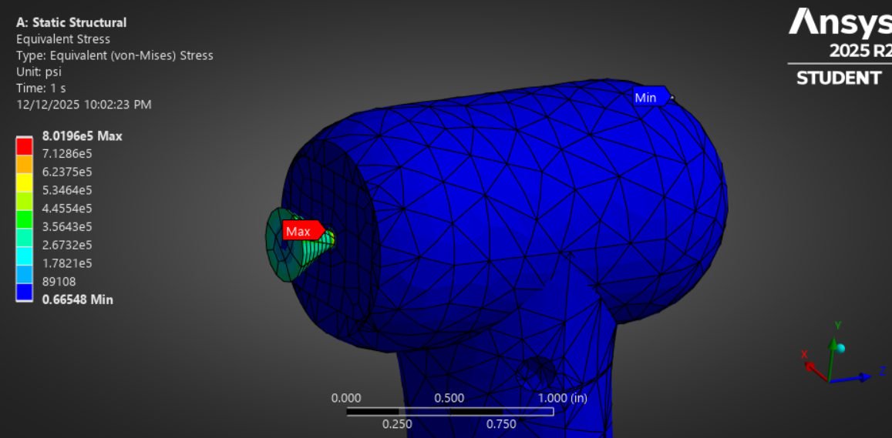Fig 5 Stress shown on shaft
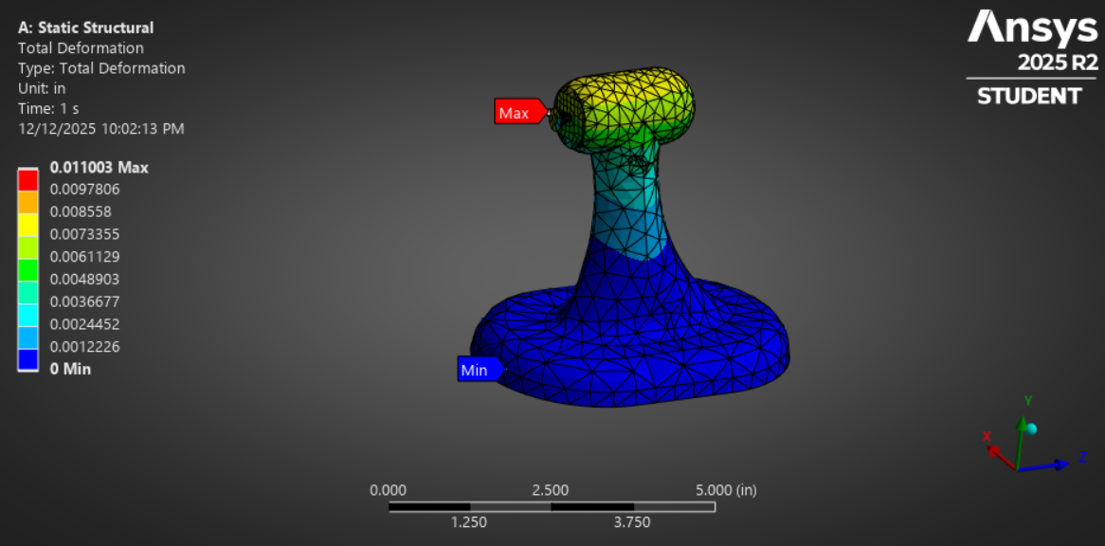
Fig 6 Static structural Total deformation

4.0 Summary and Recommendations
A retro-industrial desk fan was successfully designed as a manufacturable SolidWorks assembly and evaluated using ANSYS structural simulation. The structural load path through the shaft and hub was verified, and the highest stress regions were identified at the blade root and hub transitions. Based on the reported stress and deformation trends, the final configuration focuses on maintaining smooth transitions at the blade root, avoiding sharp corners, and preserving adequate stiffness at the hub interface. Further improvement will go towards a higher airflow design

4.1 Conclusions

- The rotating assembly design is structurally feasible under the selected moment-based loading case.- Maximum stress occurs at blade root and hub transition regions, consistent with expected geometry

- Blade deflection is primarily bending, and should be checked against clearance to surrounding parts.- Simplifying cosmetic features improves mesh stability without changing the primary structural

References
NSYS, Inc. ANSYS Mechanical User Guide, accessed 2025.
Dassault Systemes. SolidWorks Documentation, accessed 2025.

Appendix
