ME 505 Modeling Report
Gyro-Scopic Balanced Inline Skateboard Project
Authors: Kiden Scruton, Wilonia Jerome
Course & Section: ME 505, Section 6:30–8:00 MW
Date: May 13 2025

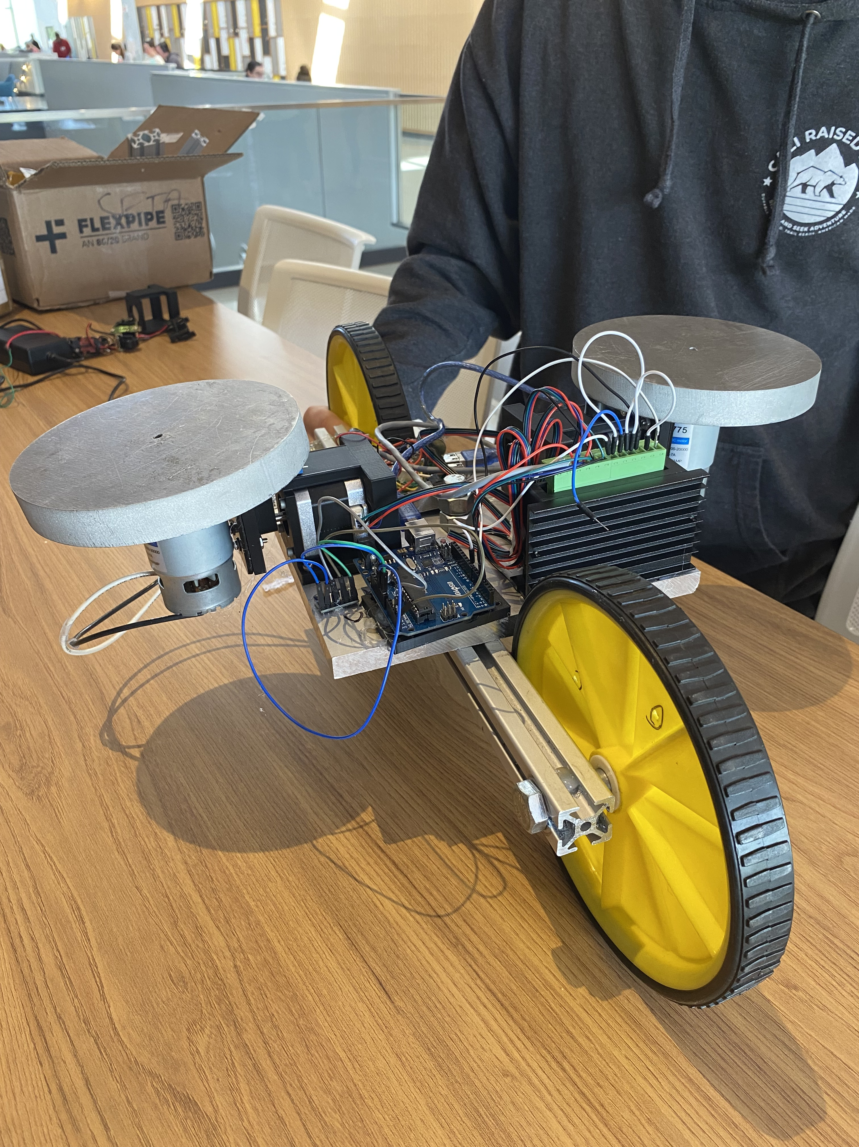

2. Theory and Modeling
2.1 System Overview
Full System Description: Our mechatronic skateboard project uses an MPU-6050 IMU for roll/tilt sensing, an Arduino Uno for real-time control, a TB6600 stepper driver to command two contra-rotating flywheels, and manual potentiometer regulation for constant spin speed.
Electrical Interfaces & Wiring:

  - MPU-6050 → Arduino (I²C): SDA→A4, SCL→A5, VCC→5 V, GND→GND
  - TB6600 Logic Inputs: PUL+/DIR+/ENA+ tied to Arduino D8 (5 V), PUL–/DIR–/ENA– to GND
  - Power: 12 V battery → TB6600 VMOT and Arduino VIN; common ground
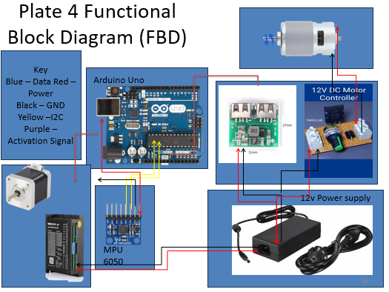
- Component Block Diagram: Sensor → Controller → Actuator → Mechanical Gyro → Feedback.
2.2 Component Theory
2.2.1 Sensing
- MPU-6050 Operation: 3-axis accelerometer + 3-axis gyro. We use a complementary filter:
- Baseline & Drift: ±3° deadzone, 0.2° drift over 5 min.
- We included a deadzone of +- 3 degrees for Prototype testing

2.2.2 Actuation
- Stepper Fundamentals: NEMA-17 with 60 oz-in holding torque, full-step resolution.
- TB6600 Interface: Pulse/direction/enable signals, microstep settings.
- Torque Test: Holding torque ~0.5 N·m at configured current.
- Final prototype required more holding torque than that decive was able to output – this prevented final testes of the prototype
2.2.3 Mechanical
- Gyroscopic Principle: Contra-rotating flywheels cancel net spin torque, leaving pure precession torque
- Mounting: 3D-printed gimbal adapters + radial bearings.
- MOI Calculations:
2.3 Overall System Model
Governing ODE:
(I_b)*​ϕ¨​+(2(I_s)​ω(K_d)​)ϕ˙​+(mgh+2(I_s)​ω(K_p)​)ϕ=0
(Townsend & Shenoi, “Gyrostabilizer Vehicular Technology”)
Parameter Definitions:
  - I_b: roll inertia of board
  - I_s: single flywheel inertia
  - ω: spin rate (rad/s)
  - K_p, K_d: P/D gains
  - mgh: gravitational restoring torque
Term Interpretation:
- I_b​ = MOI of the vehicle about the roll axis
- ϕ = Roll angle
- ϕ˙​ ,ϕ¨​ = Roll rate and roll acceleration
- I_s​ = Moment of inertia of one flywheel
- ω = Flywheel spin rate (rad/s)
- K_p​ , K_d​ = Control gains for position and velocity (PID-like gains)
- mgh = Gravitational restoring torque (mass × gravity × height of CG)

(I_b)*​ϕ¨ -> This represents the internal resistance to change calculated by the roll acceleration and the MOI about the roll axis ie roll inertia

(2(I_s)​ω(K_d)​)ϕ˙​ -> This represents the damping and prevents overshooting and oscillation. To increase or decrease the damping you change the var K_d

(mgh+2(I_s)​ω(K_p)​)ϕ -> This Represents the centering force AKA now hard the device attempts to right itself upwards. To change the strength, change the value of the var K_p. This eq also shows the deviation from the desired roll angle.

3. Simulation
3.1 Software Platform
- LabVIEW 2022 RT with Control Design & Simulation Module.
3.2 Block Diagram

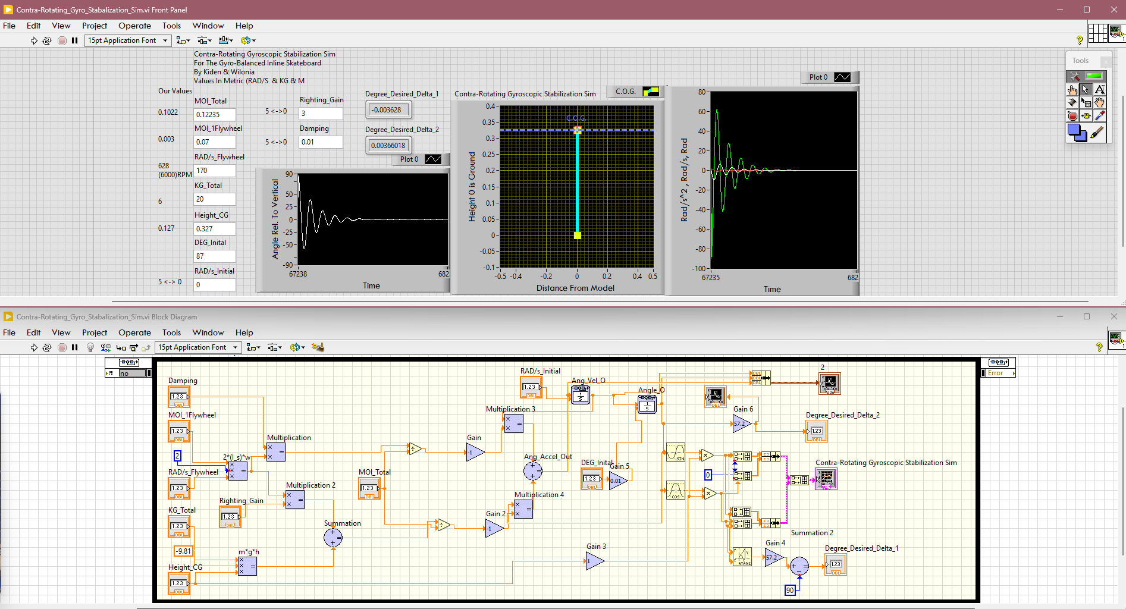
3.3 Simulation Setup
- Initial Conditions:
- ϕ(0)=20°, ϕ˙(0)=0
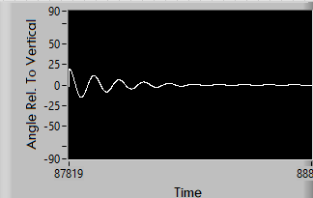
Above shows an example of the underdamped inverted pendulum starting at 20 degrees
- Parameters: I_b=0.1022, I_s=0.003, ω=628,K_p=3,K_d=0.01,mgh=6.
- Solver: fixed-step Euler 4th-order Runge-Kutta , dt=0.01 s, total time=10 s.
3.4 Simulation Results
- Time-Series: ϕ(t) shows underdamped oscillation settling ~4 s.
- COG XY Plot: the underdamped pendulum is shown at angle ~-20 degrees after 10 seconds
- Phase-Plane: stable spiral toward origin.

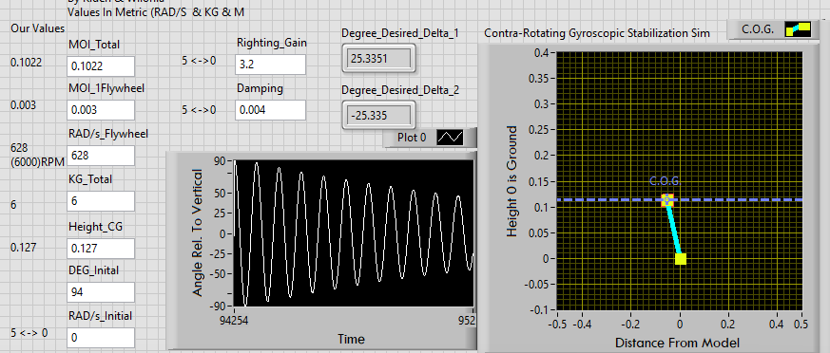
4. Analysis
4.1 Simulation vs. Hardware
No hardware Test completed due to over torque issue although simulation tests have been done.
4.2 Discrepancies & Causes
When the simulation cannon maintain gyroscopic stability the simulation values increase to negative infinity – this is likely caused by a panic by the computer to compute what can be done to reorient the pendulum although given the constraints it is not possible and this simulation breaks; this is useful as it makes it clear which configurations are outside of the scope of practicality ex low rpm and high weight.
4.3 Recommendations for future improvement
- Model motor dynamics
- Introduce sensor latency/noise
- Add friction model
- Increase torque in stepper motors
- Increase stepper motor controller amperage
- Increase flywheel size
- PWM flywheel speed controller

5. Conclusion
- Objectives: Derived model, built sim & hardware, validated dynamics.
- Findings: Gains (Kp,Kd)~(3,0.01) yield stable underdamping and would be values to prove the usefulness through real-world tests
- Future Work: nonlinear model, full prototype test.

6. References
- Townsend, N., & Shenoi, R. (2011). Gyrostabilizer Vehicular Technology. ASME Applied Mechanics Reviews.

7. Appendix
- Full Arduino code
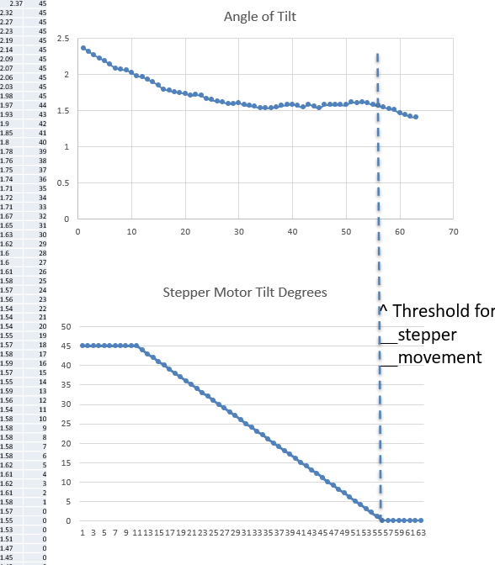
[Below] Arduino Code which results in the above CSV, Graph and was used to demonstraight our device -
#include <Wire.h>

#define MPU_ADDR 0x68
#define STEP_PIN 2
#define DIR_PIN 3
#define CTRL_PIN 7
#define VLOGIC_PIN 8 // 5V source for TB6600 logic+

// Constants
const float TILT_RANGE = 80.0;
const float START_MOVE = 5.0;
const float STOP_MOVE = 2.0;
const int MAX_STEPS = 45;
const int PULSE_WIDTH = 100;
const int MIN_DELAY = 200;
const int MAX_DELAY = 3000;
const int RETURN_DELAY = 1000;
const float ALPHA = 0.95;

long currentStep = 0;
float zeroTilt = 0;
float filtTilt = 0;
float prevTilt = 0;
float angularAccel = 0;
unsigned long lastTime = 0;
bool moving = false;

void setup() {
pinMode(STEP_PIN, OUTPUT);
pinMode(DIR_PIN, OUTPUT);
pinMode(CTRL_PIN, OUTPUT);
pinMode(VLOGIC_PIN, OUTPUT);

digitalWrite(STEP_PIN, LOW);
digitalWrite(CTRL_PIN, HIGH); // ENA− active
digitalWrite(VLOGIC_PIN, HIGH); // PUL+/DIR+/ENA+ logic HIGH

Serial.begin(115200);
Wire.begin();

// Wake MPU6050
Wire.beginTransmission(MPU_ADDR);
Wire.write(0x6B);
Wire.write(0x00);
Wire.endTransmission();
delay(200);

// Initial averaging
for (int i = 0; i < 10; i++) {
readRawAY();
delay(5);
}

zeroTilt = getTilt();
prevTilt = 0;
filtTilt = 0;
currentStep = 0;
moving = false;
lastTime = millis();

// CSV Header
Serial.println("Tilt,Steps");
}

void loop() {
float rawTilt = getTilt() - zeroTilt;
filtTilt = ALPHA * filtTilt + (1 - ALPHA) * rawTilt;
filtTilt = constrain(filtTilt, -TILT_RANGE, TILT_RANGE);

// Calculate angular acceleration
unsigned long now = millis();
float dt = (now - lastTime) / 1000.0;
float tiltVelocity = (filtTilt - prevTilt) / dt;
angularAccel = (tiltVelocity - (prevTilt - zeroTilt) / dt) / dt;
prevTilt = filtTilt;
lastTime = now;

// 📟 CSV Output Only
Serial.print(filtTilt, 2);
Serial.print(",");
Serial.println(currentStep);

// Hysteresis for motion logic
if (!moving && fabs(filtTilt) > START_MOVE) moving = true;
else if (moving && fabs(filtTilt) < STOP_MOVE) moving = false;

// Movement execution
if (moving) {
bool forward = (filtTilt > 0);

if ((forward && currentStep < MAX_STEPS) ||
(!forward && currentStep > -MAX_STEPS)) {

digitalWrite(DIR_PIN, forward ? HIGH : LOW);

float accelFactor = constrain(fabs(angularAccel) / 50.0, 0.0, 1.0);
float scaled = accelFactor * accelFactor;
int delayTime = map(int(scaled * 1000), 0, 1000, MAX_DELAY, MIN_DELAY);

stepPulse(delayTime);
currentStep += forward ? 1 : -1;
}
return;
}

// Return to center logic
if (abs(currentStep) > 0 && fabs(filtTilt) < STOP_MOVE) {
digitalWrite(DIR_PIN, currentStep < 0 ? HIGH : LOW);
stepPulse(RETURN_DELAY);
currentStep += (currentStep < 0) ? 1 : -1;
}
}

void stepPulse(int delayTime) {
digitalWrite(STEP_PIN, HIGH);
delayMicroseconds(PULSE_WIDTH);
digitalWrite(STEP_PIN, LOW);
delayMicroseconds(delayTime);
}

float getTilt() {
int16_t ay = readRawAY();
return map(ay, -16000, 16000, -90, 90);
}

int16_t readRawAY() {
Wire.beginTransmission(MPU_ADDR);
Wire.write(0x3D); // ACCEL_YOUT_H
Wire.endTransmission(false);
Wire.requestFrom(MPU_ADDR, 2, true);
if (Wire.available() < 2) return 0;
return (Wire.read() << 8) | Wire.read();
}

LabVIEW VI block diagram
