AC Sweep Analysis
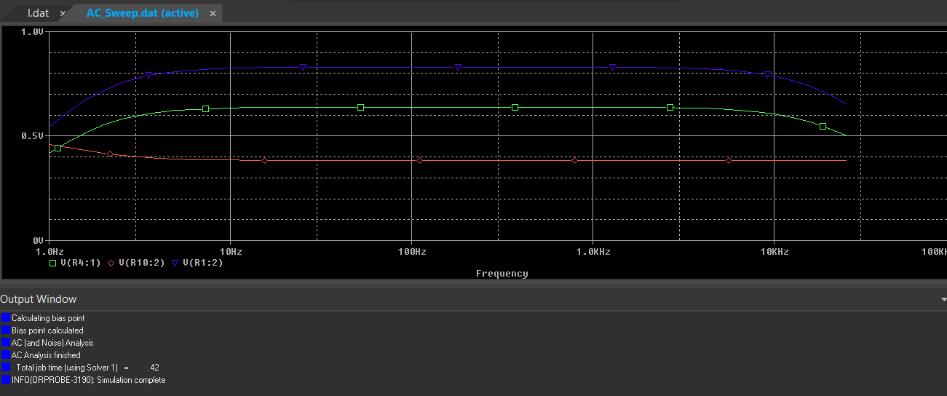
This analysis evaluates the amplification and frequency response of the circuit using an AC sweep. The red trace represents the input, the blue trace is the output, and the green trace is a point of interest. and both signals were observed through test points marked in the schematic.
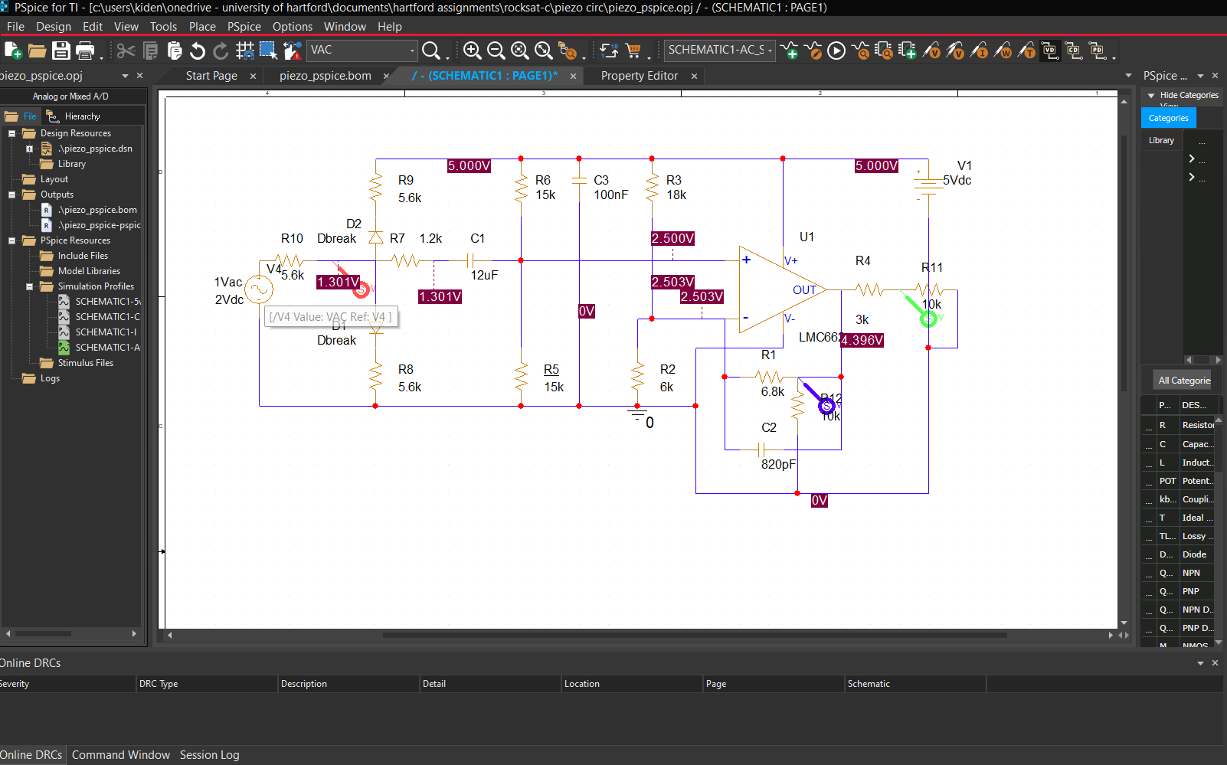
The circuit provides both high-pass and low-pass filtering behavior. The high-pass stage removes DC drift and very low-frequency noise, while the low-pass filter effectively attenuates signals above the Nyquist frequency of the ADC1208. The amplification of low-amplitude signals ensures more accurate and resolvable measurements within the ADC's dynamic range. In addition, the circuit camps the voltage, adds a DC bias and, increases signal strength with an operational amplifier the LMC662

Extended Frequency Sweep
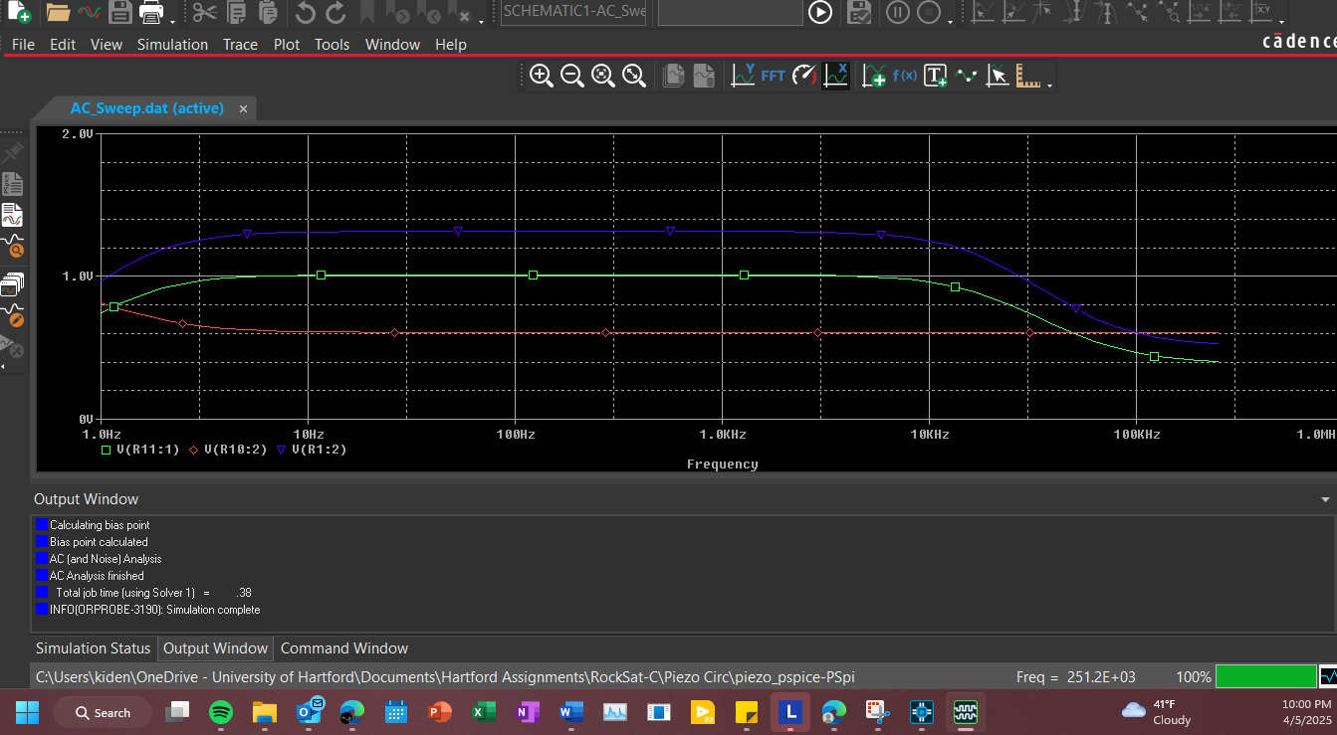
A sweep up to 200 kHz demonstrates the low-pass filter’s effectiveness, with output attenuation increasing beyond the desired 15 kHz cutoff. This confirms the filter performs as expected, limiting input bandwidth to the ADC.

No-Load vs. Loaded Analysis
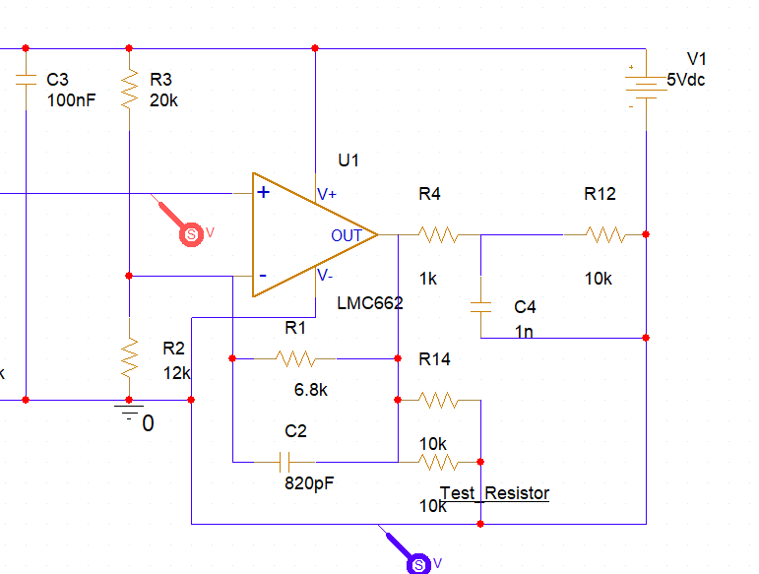
A test resistor (Test_Resistor) simulates the ADS1256’s 10 kΩ input impedance. Simulation results show no difference in circuit behavior whether this resistor is present or not. This confirms: The op-amp is stable with or without load and The ADC’s input impedance does not distort the signal path

Transient Sim below 200Hz 3v
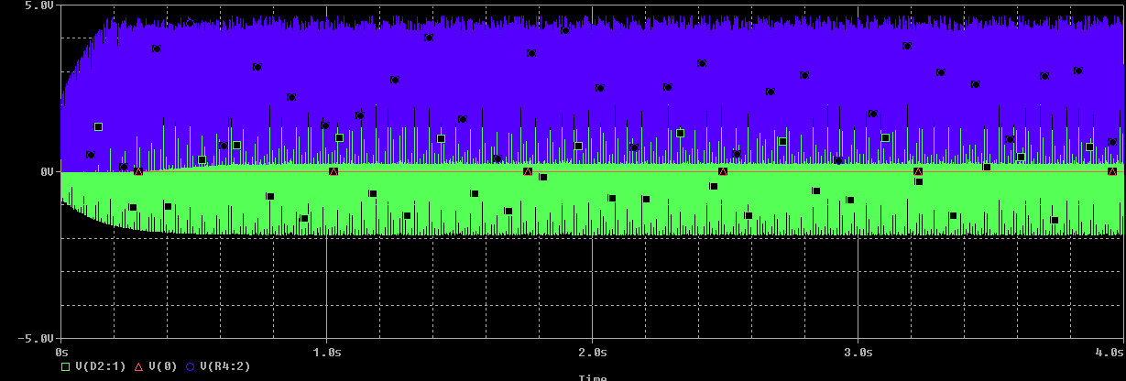
Above - With Placeholder ADC load (10 kΩ)
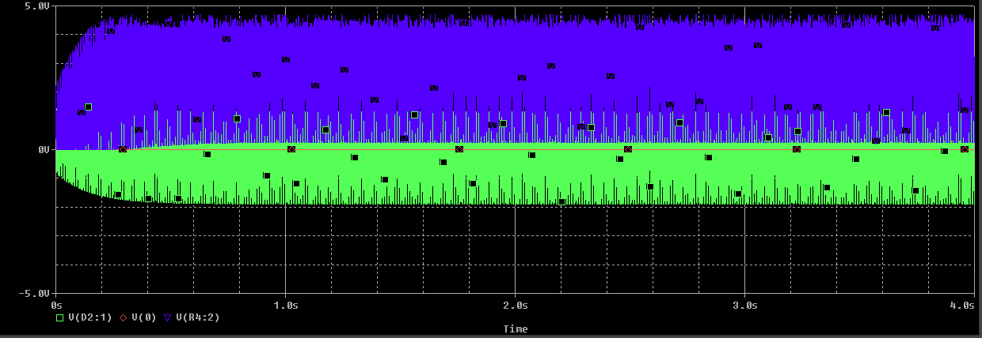
Above - Without ADC Load

FFT and Transient Analysis with Varying Input Amplitudes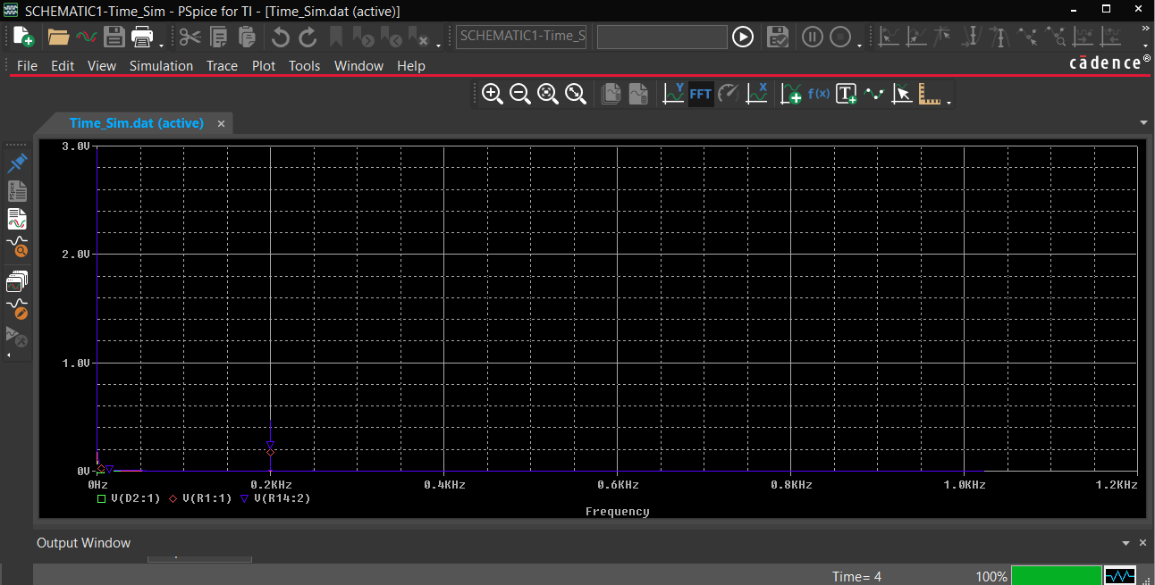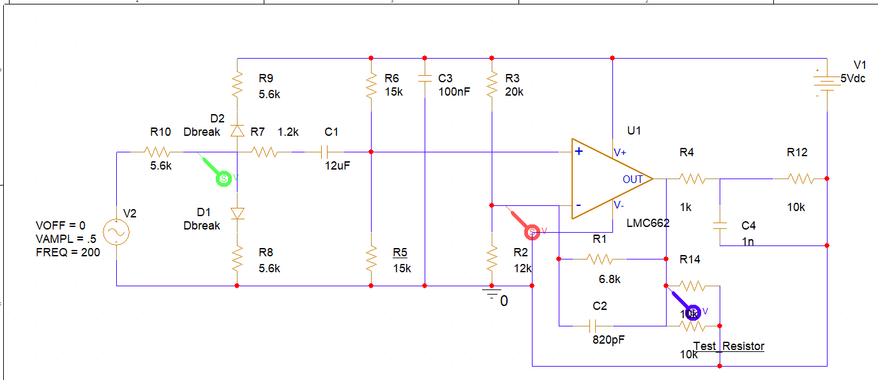
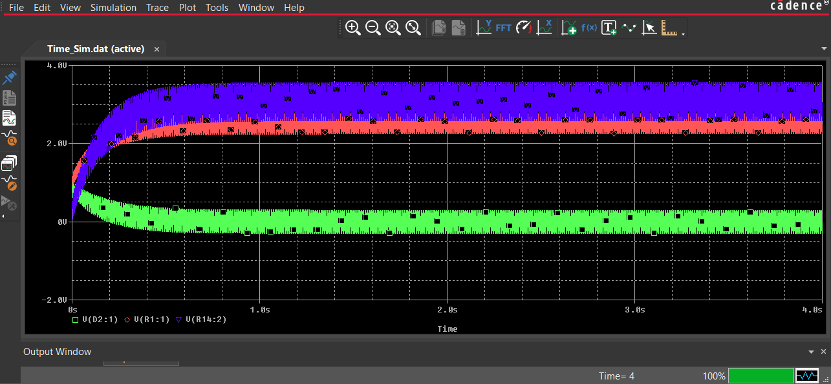
The above page shows the FFT of a ideal 0.5v 200Hz signal over 4 seconds initially you see the startup then the correct signal amplification is applied the blue wave is the output to the ADC with the simulated ADC load and the Green wave is the input the resulting FFT shows the “Vibrational” signal centered about 0v while the output is centered about 3v well within the ADC and op amp range
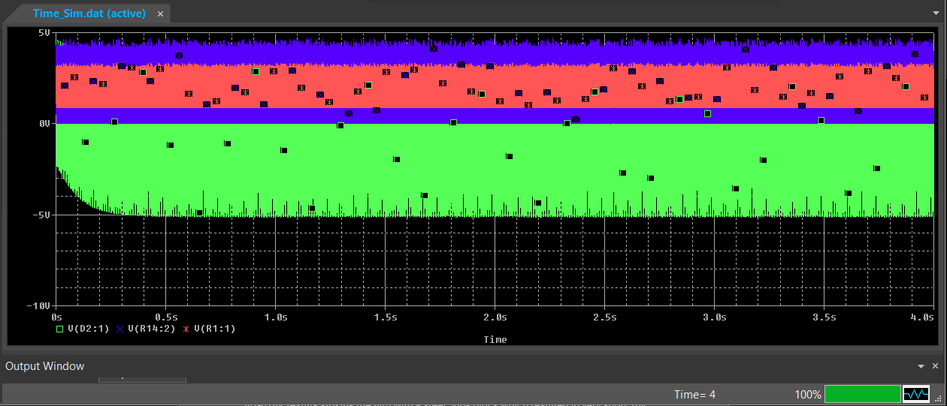
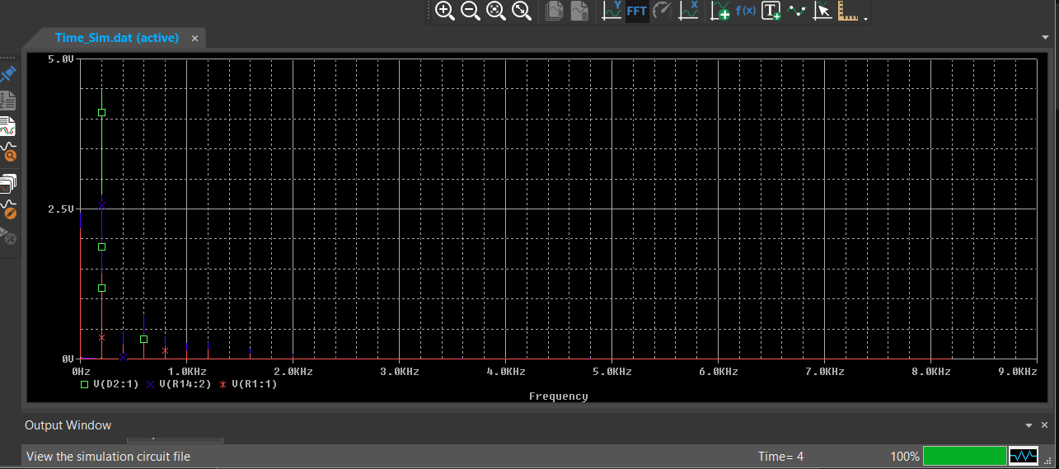
The above test shows a very extreme high magnitude which we discovered in destructive MT-028K testing striking the film with a steel 500g block which resulted in very short 10v strikes, otherwise the same conditions as the previous test are in place we see that harmonics are introduced notably at 400 600 800 1000HZ due to the peaking of the amplifier and we need to be weary of overload but due to the clear correct operation of the voltage clam preventing excessive voltage and the rare occurrence only occurring in very extreme test and with the high impedance piezo output we will continue with the current design though make note for potential improvements
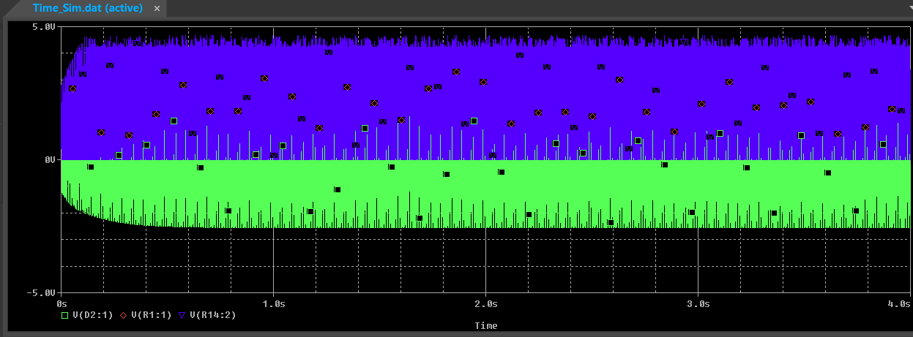
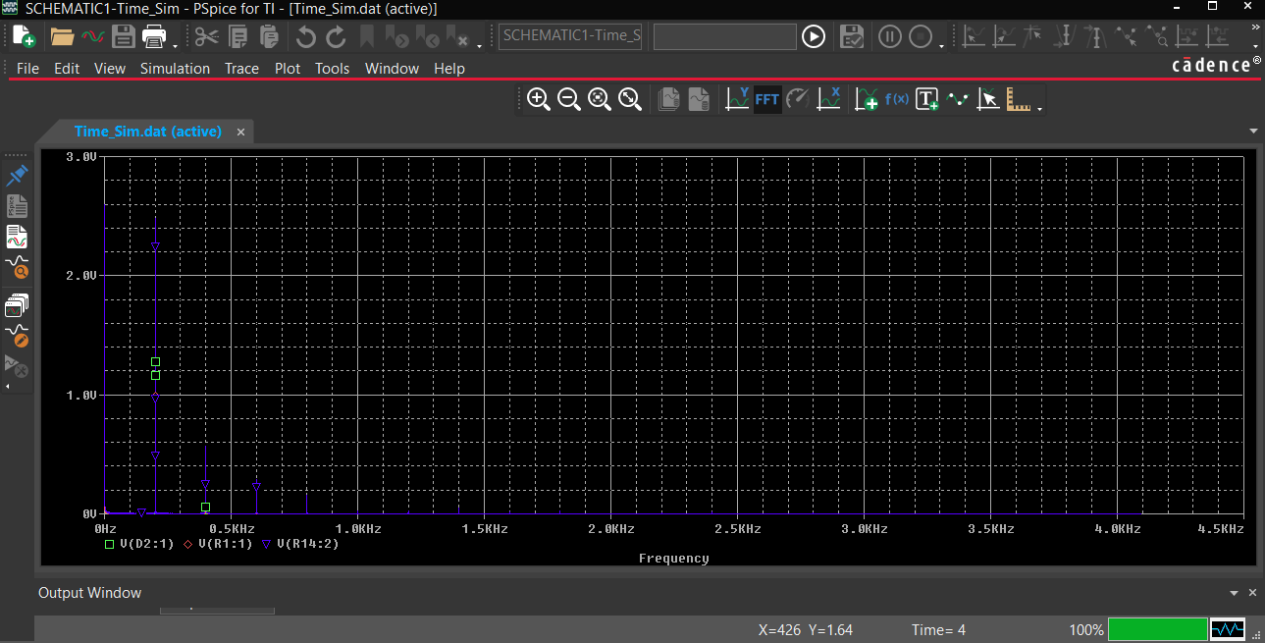
The above test shows a 4v signal, which is the maximum expected output for the flight. The op amp gain slightly peaks on the 0 rail of the op amp. This also introduces slight harmonics but the desired frequency shines through
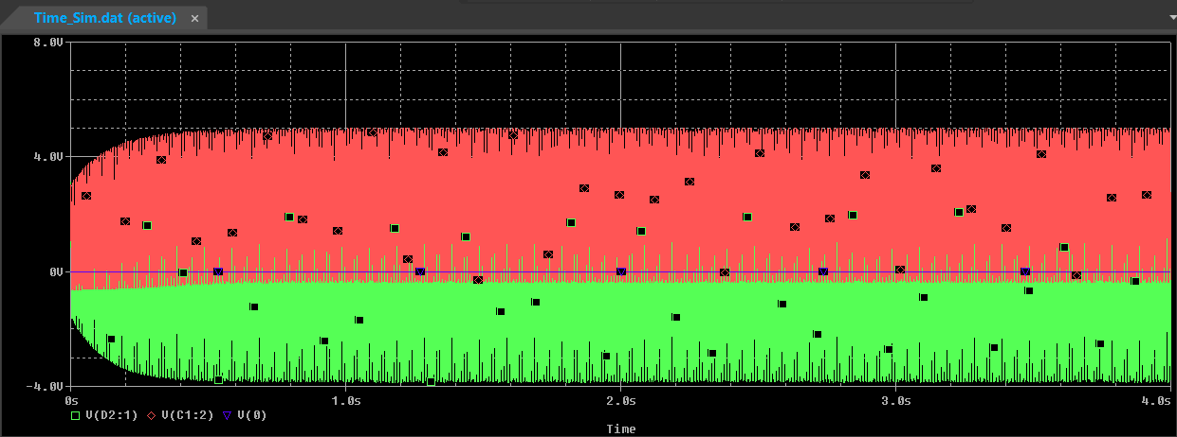
To note: the input voltage of 6v is the maximum input voltage for out op amp design. The transient analysis above has the red marker placed at the op amp input and green at circuit input simulating piezo-electric input with clipping the wave + Voltage bias it sweeps 0-5v

Combination circuit Transient Analysis
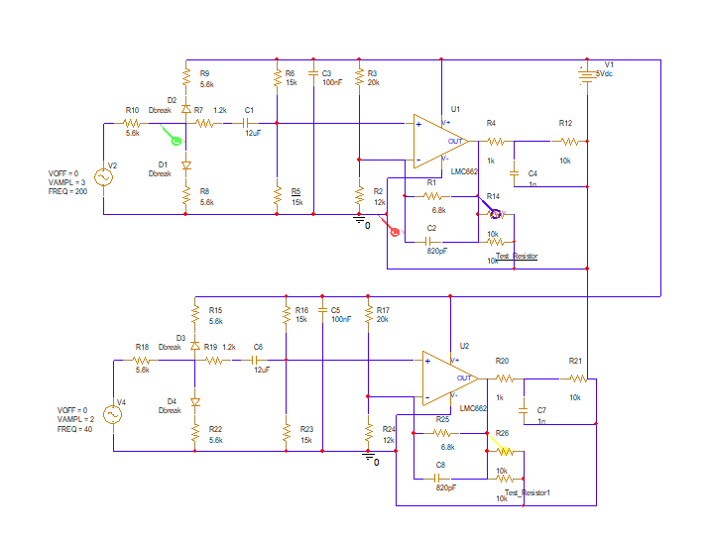
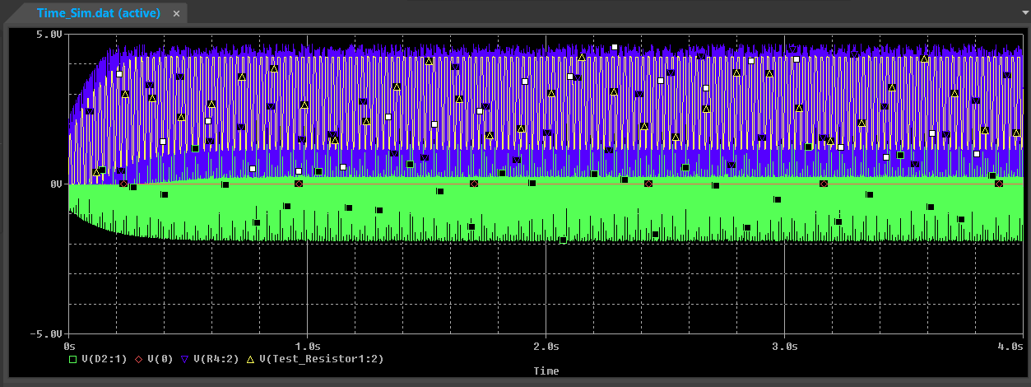
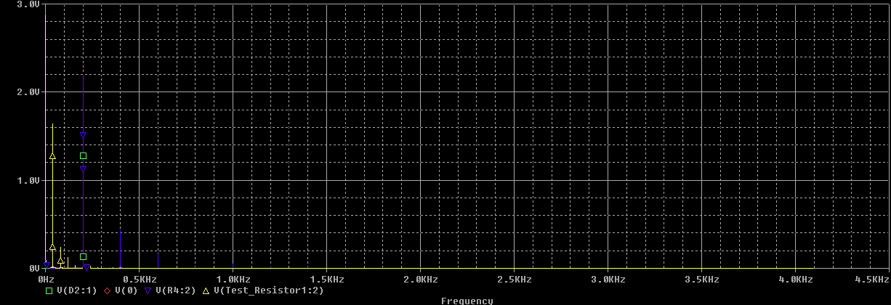
This shows a dual op amp and dual ac input with dual outputs Blue and Yellow Respectively. Blue is and amplitude 3 200Hz signal while Yellow is amplitude 2v and 20Hz which are clearly identifiable on the FFT and the share voltage a ground does not affect the output through the transient analysys

Combination Circuit AC Sweep
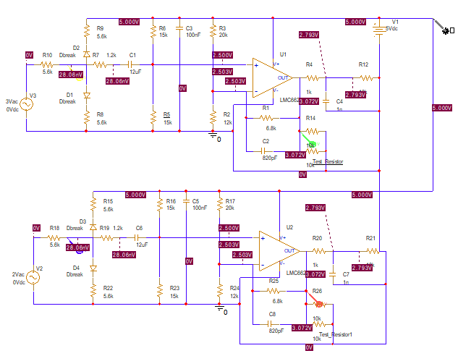
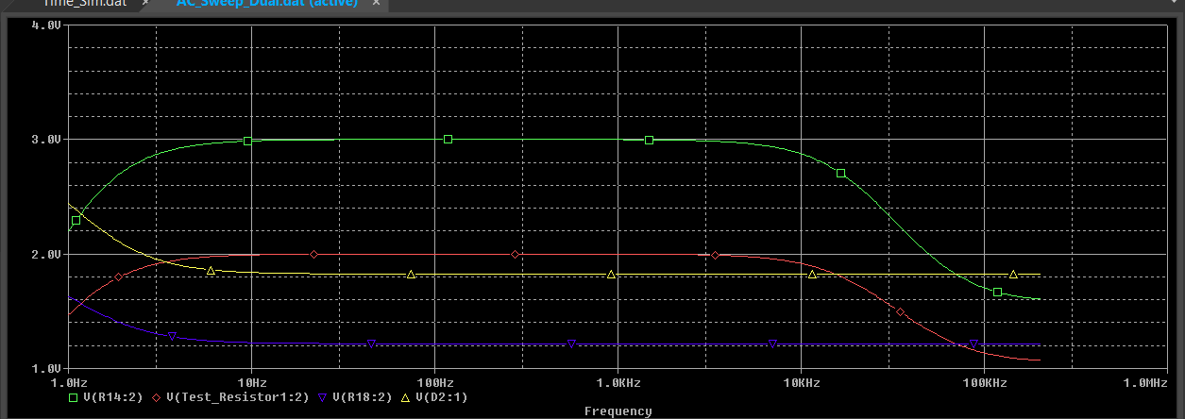

This shows desired filter frequency is maintained in the dual op amp configuration as well as amplification
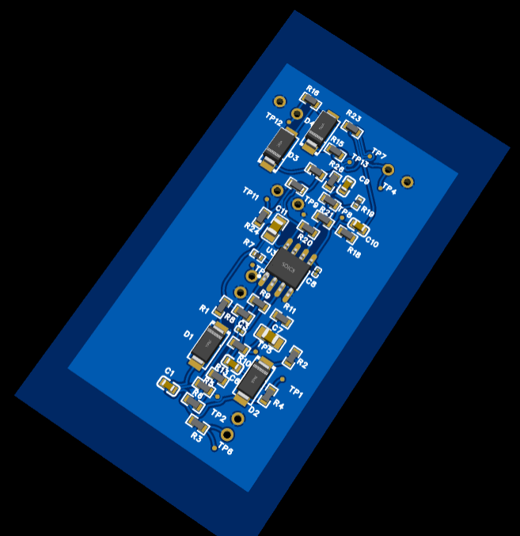
Finally completed PCB based on the dual circuit design complete and single layer

