

**University of Bahrain**

**College of Information Technology**

**Department of Computer Science**

**Airline System “AirCloud”-Phase 1**

**Prepared by**

**Anwaar Mohamed Alsayoof 20175652**

**Alnowier Khalid Abdulla 20177132**

**Sara Khalid Buchery 20182566**

**Jinnat Akter 20188776**

**Abdullah Mohammed Mosaibah 20189150**

**For**

**ITCS 497- sec 01**

**Academic Year 2021-2022-Semester 2**

# **But First, Look Around: List all project and their links**

There exist many systems on the internet that share the same functionalities and tasks as our system and we can compare them to our project AirCloud, the problem is they are not free and open source, therefore we cannot join them. Nonetheless, to give people who are interested in joining our project in the future some insight and a proper background on the project, we listed the following similar projects:

* **Rehlat:**

*Website:* <https://www.rehlat.com/>

*Android:*<https://play.google.com/store/apps/details?id=com.app.rehlat&hl=en>

*IOS:*<https://apps.apple.com/us/app/rehlat/id1141857583?ls=1>

Rehlat is an online booking ticket system that manages the booking process in an effortless and hassle-free way, it has both a website and an application. Rehlat offers a service that will be added to our system which is Visa requirement and travel restrictions which checks eligibility for e-visa requirements and also provide instructions and health guidelines, so customers will be knowledgeable about each country’s guidelines during covid-19.

* **Wego:**

<https://bh.wego.com/en>

Wego offers numerous services that will be included to AirCloud such as booking flights, searching among many websites to choose the best deals, book a room in a hotel, as well as adding vaccination status (for covid-19) option to inform the customer if the country requires vaccination or not.

* **Booking:**

<https://www.booking.com/cars/index.html?label=gen173nr-1FCAEoggI46AdIM1gEaBiIAQGYATG4ARfIAQzYAQHoAQH4AQKIAgGoAgO4AqPK05EGwAIB0gIkZmE2Yzk3OWEtMDA2Yy00YjM3LWE2YTYtYTFhNDIzMmQzMjY22AIF4AIB;sid=cfa74f64399bb493bbf137136a292f20;adplat=cross_product_bar&>

The following website has a service “car rentals” that will be added to our system. This service allows the users to choose from many car renting agencies to book drives beforehand, so that customers doesn’t not need to go and search for other websites and waste time.

* **Travelocity:**

<https://www.travelocity.com/>

Travelocity has a “filter by” function, which is included in our system, it allows the customers to filter the searching for flights and hotels according to their budget, guest rating, payment type, meal plans etc.

# **Starting from What You Have: start from your 305 project**

The purpose of this system is to provide airline tickets, which helps the customers to search the availability and prices of various airline tickets, along with the different packages available with the reservations. The system will mostly work as the other airline system with additional functions. The system is aiming to enhance the airline during covid-19. Due to the changes that happened during covid-19 that affected the whole world, for several of time a lot of the airlines were shut down from working, and during the time they started to open again people were afraid to go to the airport to finish their documents and their booking. so, we resolved for a better way to continue this system by creating a system for customers that can do everything they want from their home and only appear when it is the flight time. Our system is going to be helpful and will save a lot of effort and time, it is going to enhance the ways that customers want to arrange their flight, their booking and other. People from various parts of the world can register very easily. The new system is more personalized. It is made in such a manner that all the inexperienced users can understand all the options in it very easily. It is made in a quick and easy referential manner. This system helps the user to go through the rates quoted by different travel agencies and select the convenient rate that is suitable for him. In addition, access to all important matters is not always locked and can be opened easily at the time of urgency. The advantages of the proposed system are that security is maintained in the new system. Securities for all important data are maintained confidentially. As it is easily understandable and user friendly, quick entries can be made in this system.

Mission statement: By integrating various systems into a single system, individuals will be able to use a single powerful system with a wide range of capabilities.

# **Choose a Good Name: write how you did that**

The project name is (AirCloud), which is a combination of Air and Cloud, and both of those words indicate what the project is going to be about.

* Air: indicates that we are in the air travel industry, so the customer should know from the first glance what we do and take a good idea about our project.
* Cloud: indicates that our product is cloud based and hosted there.

We made sure that the name stays as short as possible, this is especially important for branding. We believe that having a short and easy-to-remember name will help our project to get discovered by search engines, and humans.

# **State That the Project is Free**

AirCloud system is an open-source system that is developed under the GPL-3.0 license, we have initiated the project repository on the most popular git community and service GITHUB, and you can find the project to either participate/use in the followed link  
<https://github.com/abdullahMosibah/airCloud>

# **Features and Requirements List**

* One of the system's components is an online airline services platform, which will function by setting high security standards to manage all the services provided.
* Since the system interacts with the user's personal information in registration, log in and travel history records, the platform will also maintain a high level of privacy and security.
* The system's interface is intended to be straightforward, clear, and easy, and to be utilized by a broad variety of users.
* The system will be available 24/7. Any maintenance would be scheduled, and users would be notified.
* The system would allow modifications and adjustments to numerous entities in its databases, such as updating flight databases, users altering their personal information, etc.
* The system will accommodate a maximum of 100,000 concurrent users.
* The system will display global statistics showing the extent of the spread of Covid-19 in all countries around the world.
* The user or administrator enters the application using the username and password stored in the system.
* The user can book airline tickets to any destination of his or her choice.
* The user will be able to pay for his tickets or hotel booking using a debit/credit card, Apple Pay, or PayPal.
* The system responds to an action in less than 2 seconds and automatically saves all actions of the user in the system, to minimize the number of loadings and enabling the system to operate faster.
* The user and the customer service representative can communicate via live chat, voice record, and phone call.

# **Development Status**

Despite the fact that the project is still ongoing, the first system design has been completed. Developers will try their utmost to complete the project as quickly as possible, and once the function is completed, the whole project will be uploaded to the repository.

# **Downloads**

The source code of the software should be visible to the contributors in standard formats. We agreed that we must follow the standard build and installation methods. Also, there is a specific procedure we should follow when we are packaging and releasing packages. First, each executable package should have a unique version number. Second, the website of the project should have two download links: one to download the application, and one for development purposes only.

# **Version Control and Bug Tracker Access**

We believe that if we want to have a successful open-source project, we need to maintain the quality of our code, in order to that we need to have

* code collaboration tools/services.
* ability to track the state of each file in our project.

In addition, we need to track who made what change in a specific code or file in our project, so we have an ever-growing need for a version control system.

We did quick research to see what the most successful open-source projects use for a version control system, we found out that almost all of them use GIT. git is on its own an open source/free project !.  
In short git is a distributed version control system that is easy to use and has a tiny footprint with lightning-fast performance. We found out that git outclasses most version control solutions. Git is a good solution for text-based docs (.py, .java, .class, .cpp etc.) to make the best use of it we decided to also make all of our design documents text based, that can be compiled to HTML. so that we can track it’s changes more efficiently,  
In addition to that, we need even more collaboration features, like tracking bugs and open issues, a way to comment on code changes (plain git does not support that) and a channel that allows us to communicate with our project users/contributors. In case our project goes to one hundred million users, how can we handle that many clone requests? or we have 1000 developers that want to contribute to our project. How can we handle that also?

We went out to look for solutions/services. And found out that there are so many services that offer what we want:

1. Bitbucket.
2. GitLab
3. GitHub.

After discussing with team members. We found out that GitHub is the best solution for our use case. For multiple reasons,

1. we want to make our project available to all people around the world, and GitHub serves that very well.
2. GitHub offers plans for small development teams for free and even sponsorships.
3. GitHub offers the best experience and integrates well with local git cli.

* From this tab developers can view the available branch to work on.

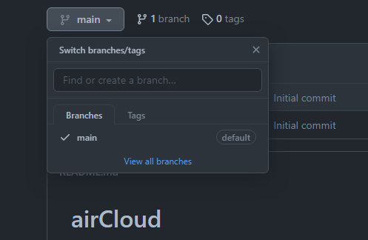

* In addition, GitHub offers easy UI/UX to create a new pull request. From here we can track all code changes.

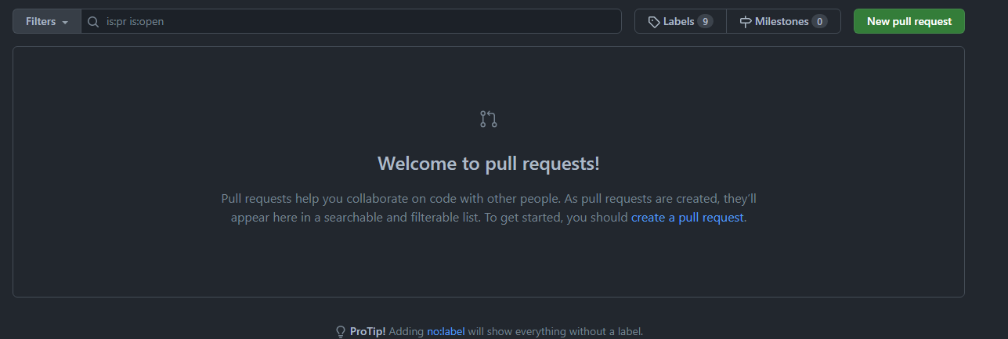

* And from here we can track all issues created and filter (open, closed, solved)

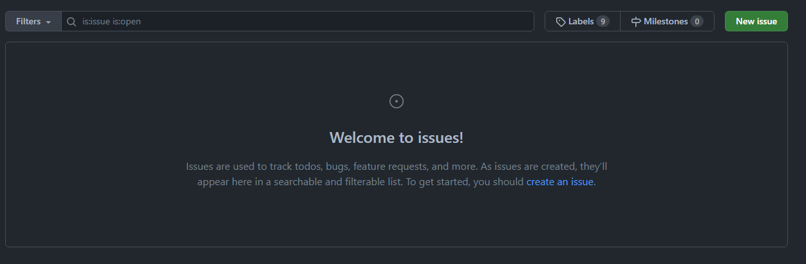

# **Communications Channels**

* Contact Information:
* Anwaar Mohamed Alsayoof 20175652@stu.uob.edu.bh
* Alnowier Khalid Abdulla 20177132@stu.uob.edu.bh
* Sara Khalid Buchery 20182566@stu.uob.edu.bh
* Jinnat Akter 20188776@stu.uob.edu.bh
* Abdullah Mohammed Mosaibah 20189150@stu.uob.edu.bh

In the software development process, communication is crucial. Communication has to be facilitated via channels such as mailing lists, forums, problem trackers, and chat systems, especially in dispersed open-source teams. we used three ways to communicate first is the WhatsApp application which is the easiest to communicate with and to send out short alerts and reminders, second which is MS Teams to do the meeting and discussing, and last is google document which is hold our thought and documents <https://docs.google.com/document/d/1Qv2zYocPROuMG6KHkbUY0d_6KNQ3GqJB_zm_w-xOVk0>. To join our group, send an email to one of the Project Administrators with your name, phone number, and the improvement you will make.

# **Developer Guidelines**

Since we are an open-source project, we are expecting to have a lot of developers trying to contribute to our code base, so it is important to have clear and focused developer guideline.

* **Code sample:**
* Code should be optimized always for readability.
* Code should be low coupled using defined frameworks.
* Code should always be >= 80%-unit test covered, upon pull request.

* **Code format:**
* All developers who want to contribute should use
  + Prettier linter and formatter
  + Ec6 linter.
* **Code Scope:**
* Code should not include bad time/space complexity algorithms e.g. (! n)
  + Three level Nested loop.
* **Developers’ interaction:**
* All developers who want to contribute should use Slack to communicate problems and concerns, and use zoom to host meetings.

* **Internal bug report:**
* If a developer encounters a bug during development these steps should be followed: -
  + Take a screenshot of the behavior and the related code base.
  + Provide these data: -
    - Name: the name of the bug and it should be meaningful.
    - Time: the time when the bug happened
    - Used hardware: which hardware used when the bug happened, is it phone or laptop etc.
  + Compile all that in a message and send it in the #bug-report channel in slack and create an issue in GitHub with that information.

# **Documentation**

The purpose of this system is to provide airline tickets, which helps customers to search the availability and prices of various airline tickets, along with different packages and reservations that are available. The system has many additional functionalities to satisfy the customers. There are many advantages of the proposed system, and one of them is, the security for all important data is maintained confidentially. The system is easily understandable, and user friendly, therefore quick entries can be made in the system. One should be familiar with modern mobile applications and object-oriented development to use this open-source project, as it is written in Java.

**Set-up steps:** To set up the software, download it and open it in any Java supporting IDE such as IntelliJ. Run the software and a message will show up at the command prompt, welcoming you to the application. Examples of using the system are attached in the demonstration section, and a tutorial of how to set it up is attached as well.

# **Maintaining a FAQ**

1. I am unable to sign in. What should I do?

* Please be certain that you logged in with your registered email address and password. It should be noted that the password is case sensitive.
* If you are registering for the first time, you must first activate your account. An email will be sent to the email address you registered with containing a link that you must click on for the sake to activate your account. Please check your spam or junk mail folders if you have not received an email.
* If you do not remember your password, please click on Forgot your password? To reset it. An email will be sent with a link to reset.

1. What features are supported?

* Users can modify their search criteria and retry prior searches.
* Locate the user's booking history in one spot.
* Payment methods accepted involve Credit/Debit Card and PayPal.
* Auto apply best possible offers.
* Provide easy cancellation & swift refund.

1. How do I find out fares and departure times?

* select your preferred route and dates of travel, enter the number of adults, children, and infants, then click on “find flights”. You will be presented with the fare options available and departure/arrival times for your trip, if these are not suitable you can search for previous/next days by clicking on the date tabs at the top of the screen. Alternatively contact our contact center or start a live chat with our agents.

1. I have a promotion code; how can I use it?

* If you have a promotion code simply enter the code into the “promo code” box when searching for your flights, your discount will be automatically calculated and included in the fares displayed.

1. Can I choose my seat when I book my flight?

* Yes, you can choose your seat when you make your booking anytime up to two hours before your departure time for international flights and one hour for domestic flights.

1. How can I edit my account information?

* Login to your account, click on “My Profile”, modify your information and click “Update”.

1. I would like to make changes to my booking. How do I do this?

* Login to your account, click on ‘Manage my Booking’. After retrieving your booking, select from the shown options. The changes you make are subject to the fare rules and time restrictions of the fare you have booked, as well as the terms and conditions of any additional services you have booked.

1. I would like to cancel my booking; how do I do this?

* To cancel your booking click on ‘Manage my Booking’ and after retrieving your booking, click on ‘cancel flight’. Please note a fee will be charged for cancellation and any remaining balance held in a credit shell for your future use.

1. Can I carry and use medical items on board?

* You may carry essential medications in your cabin baggage, please ensure you have a letter from your doctor or hospital as airport security may require confirmation that you are permitted to carry said items. airCloud cannot be held responsible for any items removed from baggage by security personnel or any official authority.

1. Where can I find information on baggage limits?

* All information regarding baggage allowance is available on our Baggage allowance page.

1. My child is traveling alone. What do I need to do to book?

* All information regarding the travel of unaccompanied minors is available on our Unaccompanied Children page. In addition, an Unaccompanied Minors Declaration form must be filled out.

1. Will I be contacted in advance if my flight is delayed or canceled?

* Yes, where possible we will contact you to advise of any delays or cancellations in advance of travel. Please ensure you provide your full contact details (including a mobile which will be available during your trip).

# **Developer Documentation**

Developer documentation describes how we interact with code and work with it, and some projects utilize tools such as Wiki to publish their original documentation. Developers document how they interact with all aspects of the given software, beginning with their initial ideas, then writing the necessary code to implement the software that they envision, then disseminating the additional features that must be included in the software and identifying bugs, and finally adding all aspects of the software such as audio, images, effects, and more.

# **Demos, Screenshots, Videos, and Example Output**

* Application prototype:

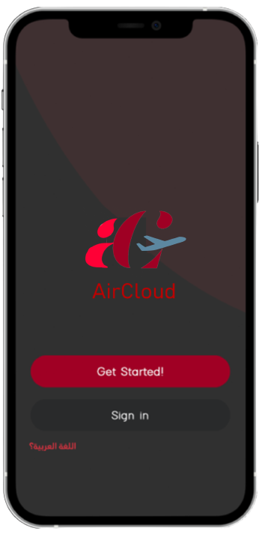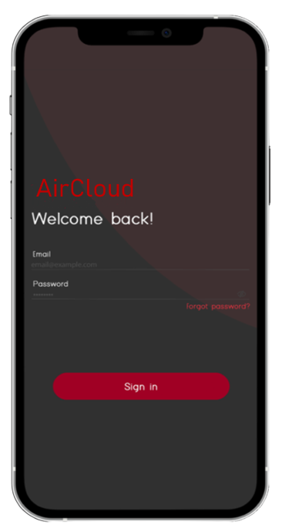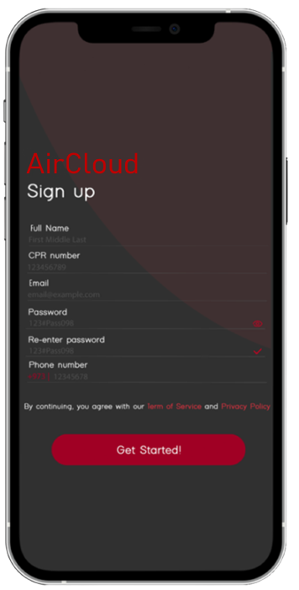

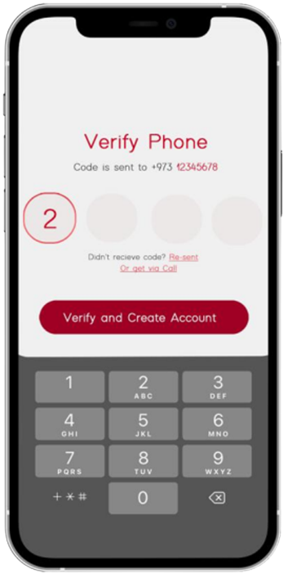

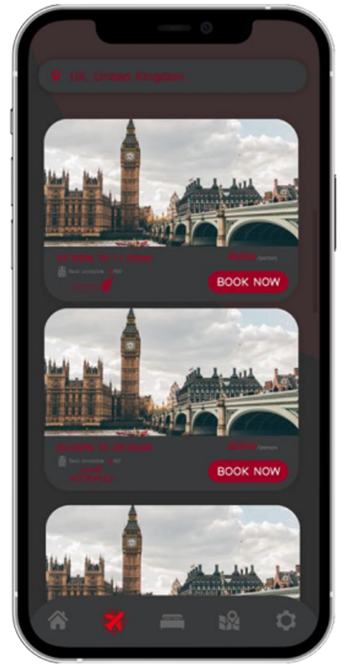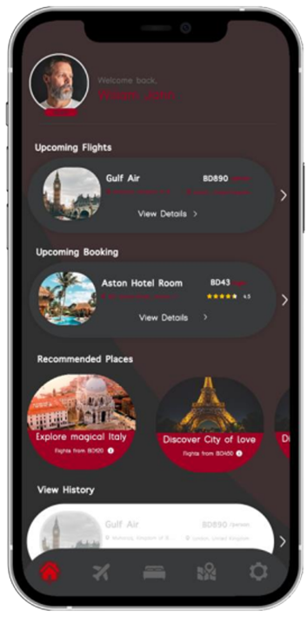

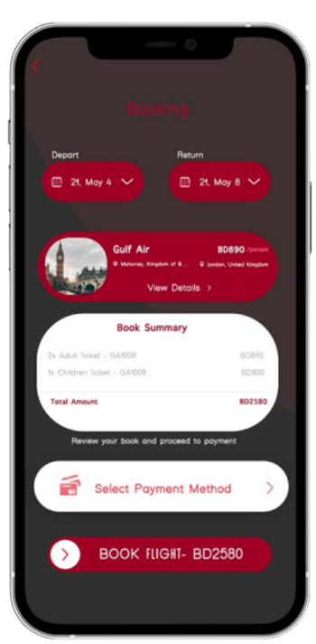

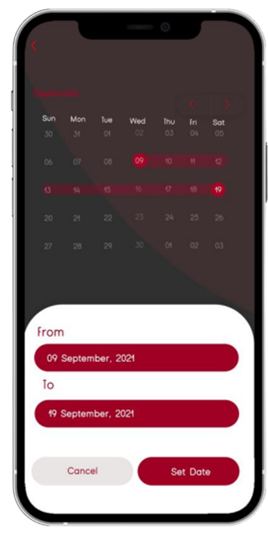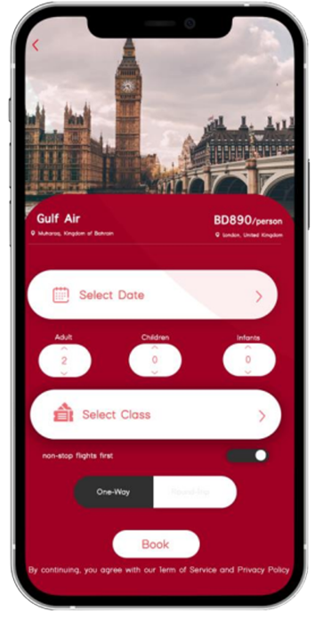

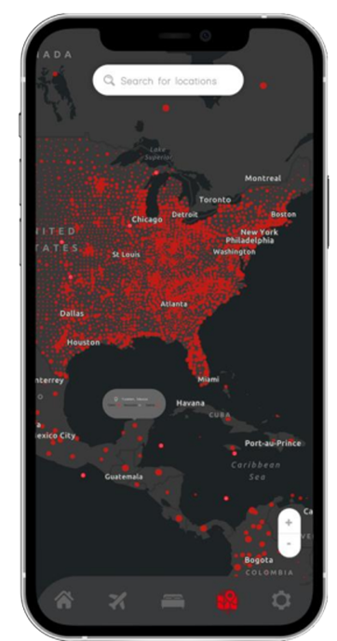

# **Hosting**

We choose to host our project and make it available on GitHub. The major site we choose as part of its hosting services is GitHub AS GH because of what it gives and the management system it provides, whether revision or version. It is a bug/issue tracker that also serves as a wiki, and it's free, which will help with the budget.

We can save and edit project sources on GitHub, and the person who made the changes will be visible, making it simple to see where the changes were made. We can also provide comments for improved software.

**Codes of Conduct**

We have mentioned earlier that we have chosen GPL3 as our open source license, Based on our discussion for our community rules, we have chosen to use the common code convention (Contributor covenant: <https://www.contributorcovenant.org/>) which is utilized by well-known ventures like the GNU/Linux kernel and above all, we use the GNU Kind Communications Guidelines (<https://www.gnu.org/phiosystemhy/kindcommunication.en.html>) to ensure that our environment is welcoming to new programmers entering our project and to ensure that the values of our free software movement program development values expressed legitimately and the message of our venture reach more extensive group of onlookers in administered way not in random voluntary way so we got to control the method of communications so that everyone is satisfied.

# **Announcing**

We decided to announce our project in different popular social media, as well as free software websites so we can reach as many audiences as possible from different sectors all around the world. The social media includes (<https://www.reddit.com/r/opensource/>) which is a famous open source page on Reddit that discuss everything related to open source projects, hacker news (news.ycombinator.com) site which is general light forum for hackers and startups, free software foundation(FSF) (<https://www.fsf.org/>) that is a nonprofit free software foundation that prompts computer user freedom. We also wanted to share our project in some Arab communities for free software such as Linux Arab community forum (<https://www.linuxac.org/>), and asous (<https://aosus.org/>).

## 