USER MANUAL

Project ATLANTE
A practical guide to 3D reconstruction from video and COLMAP datasets
Version 2.0 • Web app and reconstruction workflow
User guide • updated 11 November 2026

How to use this guide
This manual guides you from preparing the capture to viewing, comparing, and downloading the mesh. Screenshots are grouped into separate chapters so that controls and results are easy to match.
Before you begin Mesh quality depends above all on capture quality, stability, and coverage. A good capture reduces time spent on failed attempts and post-processing.

1. Start a reconstruction
Choose the input mode, quality preset, and file in the left panel. The viewer appears in the right panel when you open a mesh from history.
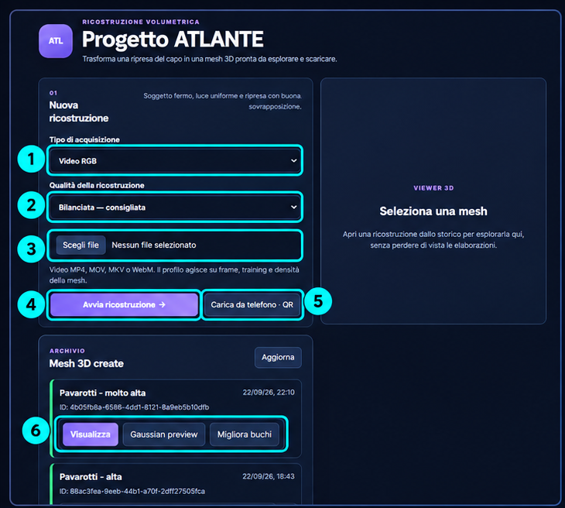
Figure 1 — Reconstruction setup, quality selection, and mesh history.
- Select “Video RGB” to upload an MP4, MOV, MKV, or WebM file.
- Alternatively, select “Prepared COLMAP dataset” (prepared COLMAP dataset) and upload a ZIP containing `images/` and `sparse/0/{cameras.bin, images.bin, points3D.bin}`.
- Choose a preset: “Fast” (Fast) for tests, “Balanced” (Balanced) for normal use, “High” (High) for more detail, and “Very High” (Very High) only for clean footage and sufficient GPU memory.
- Click “Start reconstruction” (Start reconstruction). The page shows a separate card for each job, including its ID, input, preset, phase, and progress.

2. Mesh viewer and history
Completed reconstructions remain in history. The 3D viewer opens on the right and lets you rotate, zoom, and pan the model.
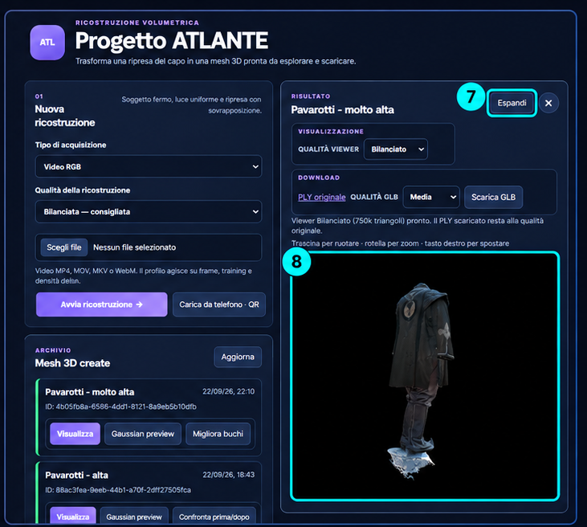
Figure 2 — Mesh viewer, download controls, and a history card.
- “View” (View) opens the mesh. Drag to orbit, use the scroll wheel to zoom, and right-click-drag to pan.
- “Viewer quality” (Viewer quality) selects a lighter version for browsing; the original PLY is not changed.
- “Download PLY” downloads the original mesh. The “GLB quality” (GLB quality) menu applies only to the exported GLB.
- “Rename” (Rename) changes the name shown in history. “Delete” (Delete) permanently removes the job, including its inputs, outputs, and logs.
- “Improve holes” (Improve holes) creates a conservative variant that only closes small topological boundaries without reshaping the whole surface. Use the repair comparison to inspect it against the original.

3. Gaussian preview
Gaussian preview opens a dedicated viewer for a sampled and compressed Gaussian Splat. When the RGB source video is available, it is shown alongside the splat in a continuous muted loop. This helps compare coverage, silhouette, and artifacts before inspecting the final mesh.
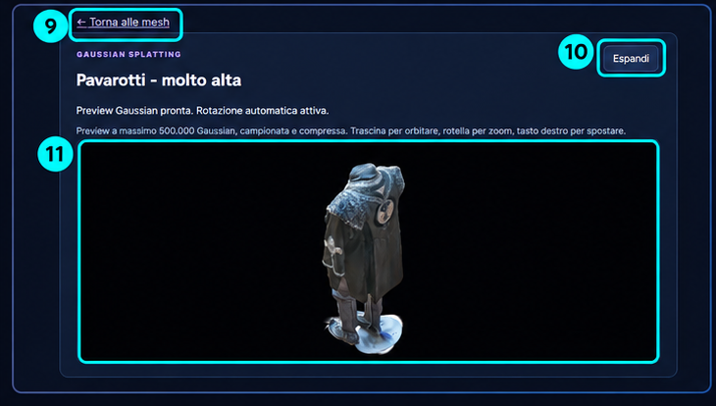
Figure 3 — Dedicated Gaussian preview with automatic rotation and navigation controls.
- Automatic rotation is enabled on opening; interact with the viewer to inspect details.
- “Expand” (Expand) switches to a page-sized viewer focused on the scene.
- The preview is optimized for the browser; it does not replace the original PLY or modify the reconstruction.

4. Upload from a phone
The “Upload from phone · QR” (Upload from phone · QR) button opens a dialog with a QR code. The phone must be on the same network as the server, or the service must be reachable over HTTPS.
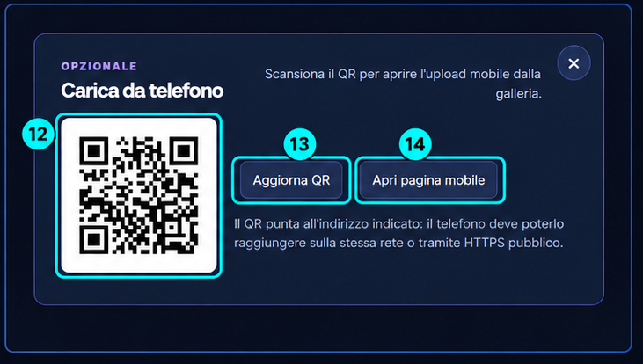
Figure 4 — QR dialog for opening the mobile uploader and phone gallery.
- Click “Upload from phone · QR” in the “New reconstruction” (New reconstruction) panel.
- Scan the QR code with your phone and choose a video from the gallery.
- If the server address changes, use “Refresh QR” (Refresh QR). Do not use `localhost` in the QR URL; it would point to the phone itself.
- After upload completes, return to the main web app to follow the job progress.

5. How to record an effective video
The reconstruction cannot invent surfaces it never saw. The video must provide sharp, overlapping views of the same subject. As a rule, move the camera—not the subject.

Recommended movement
- Keep the object completely still. Even small movements between views can create duplicates or holes.
- Move slowly around the subject at a nearly constant distance. Capture at least a semicircle; a full 360° orbit is preferable when possible.
- Make a second pass slightly higher or lower to capture oblique views and visible top/bottom areas.
- Move smoothly. Avoid jerky motion, digital zoom, fast pans, and abrupt exposure changes.
- Maintain strong visual overlap between consecutive frames so that each area appears in several nearby views, not just one.

Settings and environment
- Use 1080p or higher, lock focus on the subject, and enable optical stabilization if available. Avoid heavily compressed or low-bitrate footage.
- Prefer even, diffuse light. Avoid backlighting, harsh spotlights, specular reflections, and shadows that change as you move around the subject.
- Choose a plain, non-reflective background separated from the subject. A uniform backdrop helps automatic masking.
- Transparent, glossy, monochrome, or textureless surfaces are difficult for photogrammetry and Gaussian Splatting to reconstruct.
- Make sure all important sides are visible. A covered surface or one missing from the video will remain incomplete in the mesh.
Warning signs If frames are blurry, the subject is too small in the image, or the room is as prominent as the subject, record again before starting a long training run.

6. Results and common issues
Symptom | Recommended action
The mesh includes parts of the room | Record with a simpler background and more separation between subject and background; keep the subject still.
The mesh has large holes | Check whether the video actually covers that side. Hole repair targets only small topological openings, not surfaces that were never captured.
The viewer is slow | Choose a low or balanced viewer quality. The original PLY can be much larger than the preview.
The job is waiting for a GPU | The job is queued: each worker runs one GPU job at a time. Wait until a worker is available.
The phone cannot open the QR page | Check that the phone and server can reach each other on the same LAN. Use the server address in the QR URL, not `localhost`.

7. Pre-run checklist
- The subject is still and fully visible.
- Slow orbit with many angles, preferably 360° plus a second camera height.
- Sharp frames, even lighting, and a plain background.
- Preset matches the available runtime and GPU memory.
- Enough free server storage for outputs, checkpoints, and meshes.

