Sales Data Analysis Report
Step 1: Data Collection
In this step, a sample of Superstore, a sales data set, was edited after which it was loaded using the Pandas library. The data that is found in the data set is founded on the customer orders, product and sales, discounts and profits in different regions and departments. After the dataset was imported into a Pandas DataFrame the first five rows of the data were displayed using the.head() function to make sure the data had been loaded. This was to ensure that the form of the data, the names of columns and the sample numbers were well comprehended prior to proceeding with the data analysis.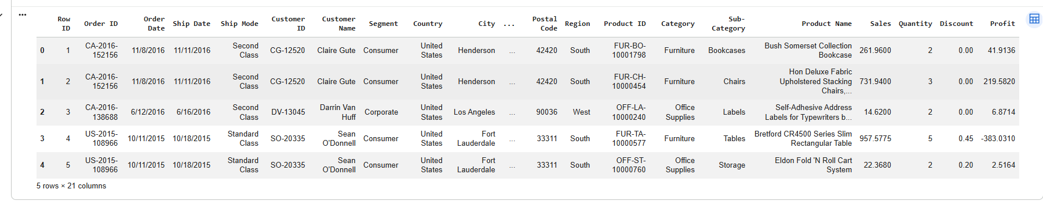
Step 2: Data Visualization
The data patterns and relationships were explored through the use of the visualization of data. The correlation which existed between Sales and Profit was plotted in a scatter diagram where it was observed that the increase in Sales did not always translate into an increase in Profit due to other forces such as discounts. The total comparison of total sales as caused by product category was carried out by the use of a bar chart, which revealed that the Technology category has made the highest total sales made. Such visualizations were useful in setting trends, comparison and potential business conclusions intuitively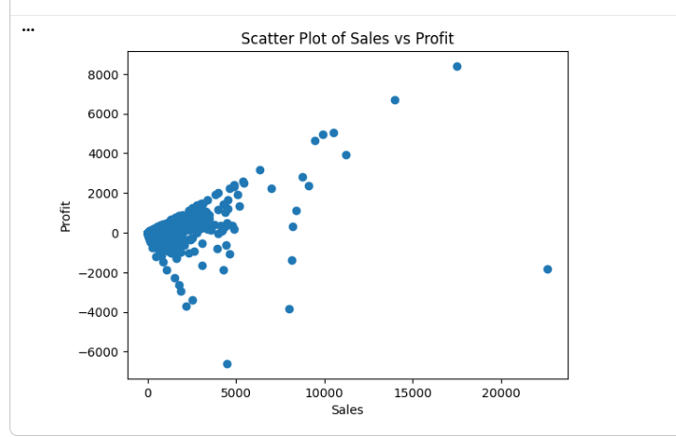
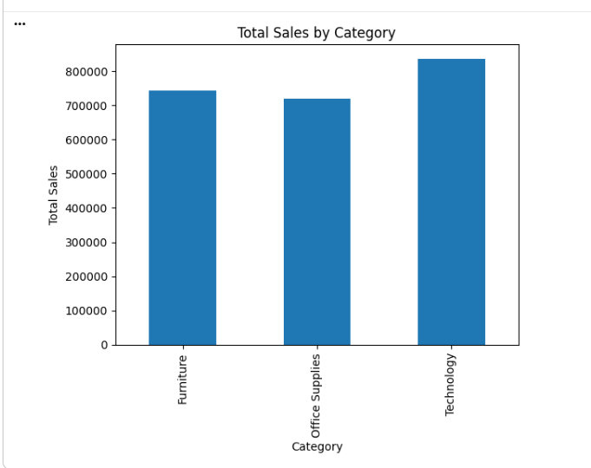

Step 3: Data Preprocessing
Data was pre-processed to improve their quality and reliability of data. The first step to determine values that were not there involved sum isnull () where the numerical columns were then filled with means. The second step was to identify outliers using Interquartile Range (IQR) method on Sales column and omit drastic figures in order to reduce skewness. Data reduction methodologies were sampling half of the data and removing the unimportant identifier columns such as Order ID and Customer ID. Finally, Sales, which was rescaled by Min-Max scaling on, was made discrete into groups of Low, Medium, High and Very High Sales.
Screenshots
Missing values before and after handling
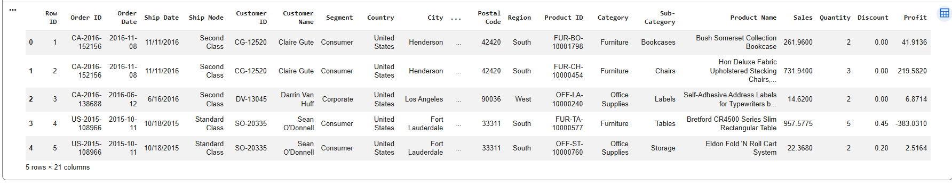
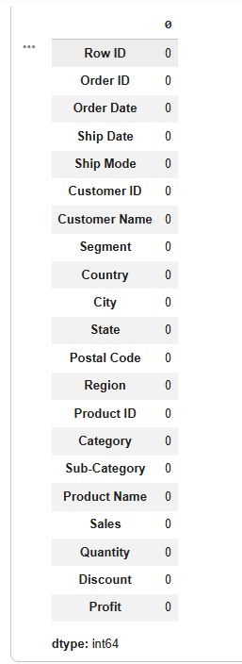
IQR calculation and identified outliers
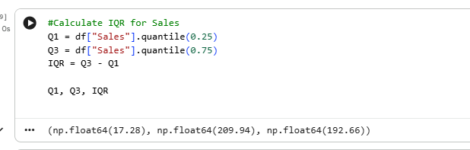
Dataset shape before and after sampling and column reduction
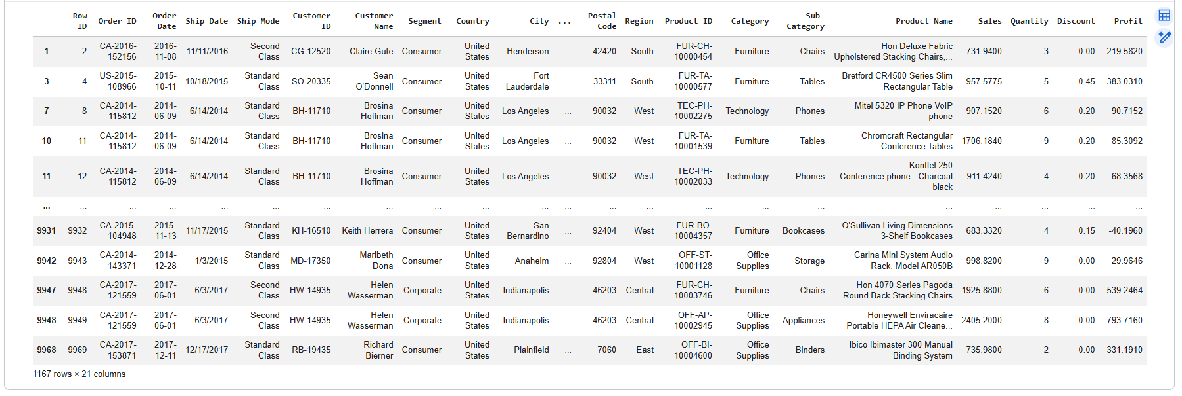
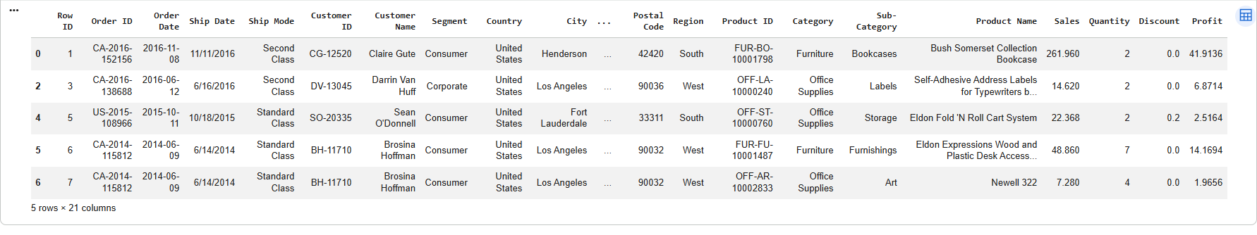
Sales values before and after scaling and discretization
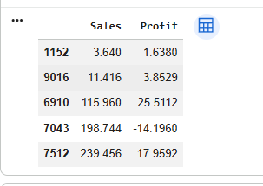
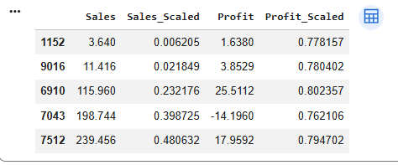
Step 4: Statistical Analysis
The statistical analysis was used in order to summarize and interpret the data. Counts and the descriptive statistics were obtained with the assistance of the .info() and .describe() functions to obtain the general data types. Minimum, maximum, mean, median and mode of Sales are measures of central tendency that were ascertained. Measures of dispersion including range, quartiles, IQR, variance, as well as standard deviation have been computed to know more about variability of data. Finally, a correlation was established to test the relationships between the numerical variables that showed a positive relationship between Sales and Profit and a negative relationship between discounts and profitability.
Screenshots
.info() output
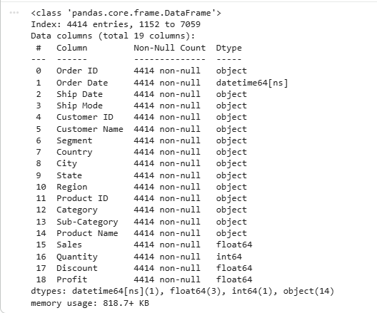
.describe() output
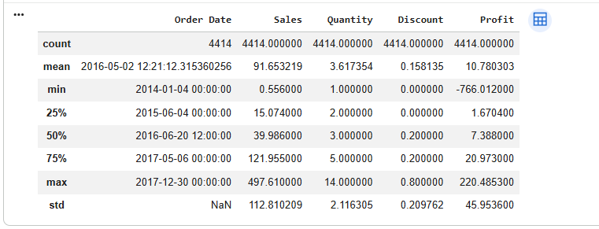
Central tendency and dispersion results
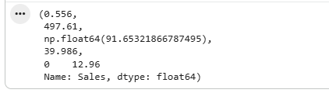
Correlation matrix output
