|  |  |
| --- | --- |
|  | МИНИСТЕРСТВО ОБРАЗОВАНИЯ И НАУКИ РЕСПУБЛИКИ ТАТАРСТАН **Государственное автономное профессиональное образовательное учреждение** **«ЗЕЛЕНОДОЛЬСКИЙ МЕХАНИЧЕСКИЙ КОЛЛЕДЖ»** (ГАПОУ «ЗМК») |

**09.02.07 «Информационные системы и программирование»**

# **МДК 07.01. УПРАВЛЕНИЕ И АВТОМАТИЗАЦИЯ БАЗ ДАННЫХ**

**Отчет о практических работах**

**Исполнитель**: Халилуллин Камиль Ильдарович

**Группа**: 215

**Преподаватель:** Алемасов Евгений Павлович

**Дата сдачи** 06.11.2023 **Оценка** ____________

**Подпись преподавателя**  _______________________

**ЗЕЛЕНОДОЛЬСК – 2023**

**Работа No3 Таблицы и связи между ними.**

**Цель:**

**создание таблиц и создание каскадных связей между ними**

**Задание:**

№1

Создание бд

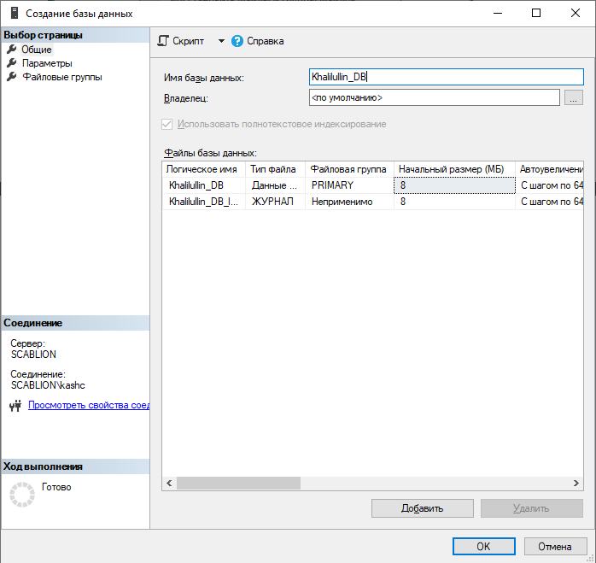

№2

Создание и заполнение таблицы

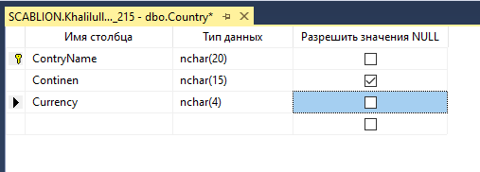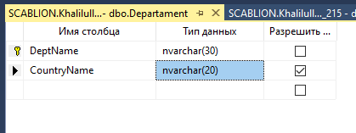

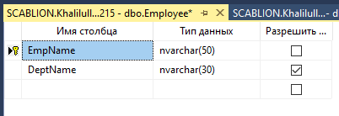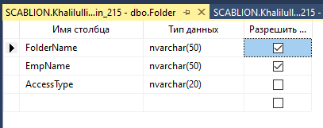

№3

Внесеие данных в таблицы

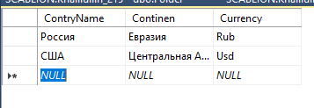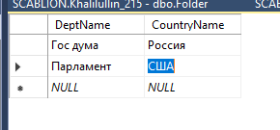

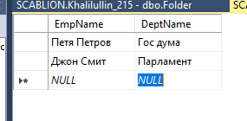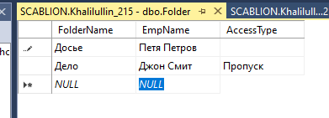

№4

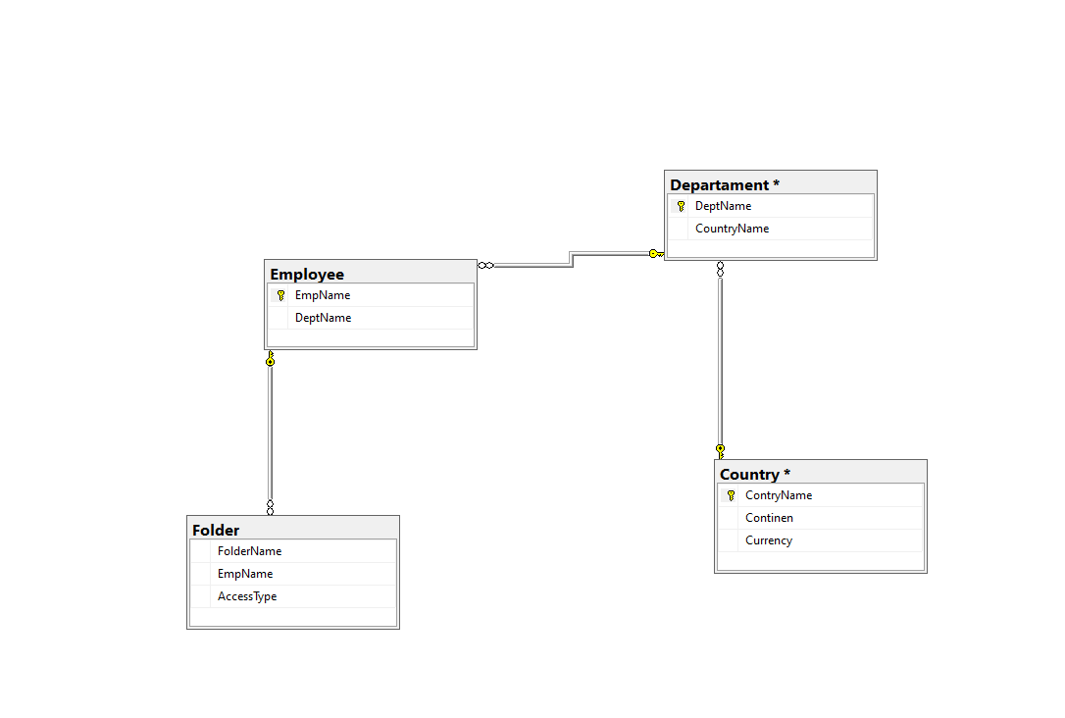Создание диаграммы бд и связей таблиц по ключу

№5

Проверка связи с первичным ключом при добавлении записи

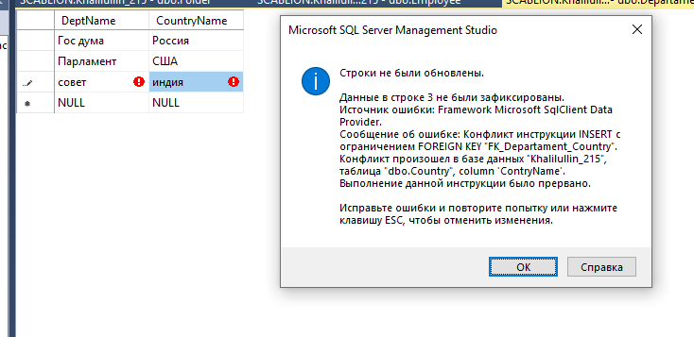

№6

Проверка каскадного удаления

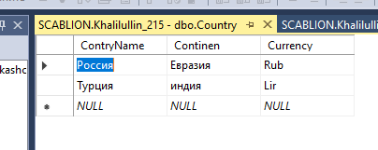

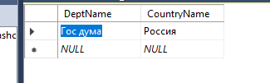

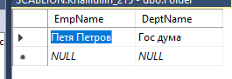

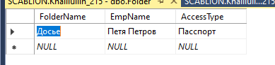

**Скрипт:**

USE [master]

GO

/****** Object: Database [Khalilullin_215] Script Date: 19.11.2023 13:04:41 ******/

CREATE DATABASE [Khalilullin_215]

CONTAINMENT = NONE

ON PRIMARY

( NAME = N'Khalilullin_215', FILENAME = N'C:\Program Files\Microsoft SQL Server\MSSQL15.MSSQLSERVER\MSSQL\DATA\Khalilullin_215.mdf' , SIZE = 8192KB , MAXSIZE = UNLIMITED, FILEGROWTH = 65536KB )

LOG ON

( NAME = N'Khalilullin_215_log', FILENAME = N'C:\Program Files\Microsoft SQL Server\MSSQL15.MSSQLSERVER\MSSQL\DATA\Khalilullin_215_log.ldf' , SIZE = 8192KB , MAXSIZE = 2048GB , FILEGROWTH = 65536KB )

WITH CATALOG_COLLATION = DATABASE_DEFAULT

GO

ALTER DATABASE [Khalilullin_215] SET COMPATIBILITY_LEVEL = 150

GO

IF (1 = FULLTEXTSERVICEPROPERTY('IsFullTextInstalled'))

begin

EXEC [Khalilullin_215].[dbo].[sp_fulltext_database] @action = 'enable'

end

GO

ALTER DATABASE [Khalilullin_215] SET ANSI_NULL_DEFAULT OFF

GO

ALTER DATABASE [Khalilullin_215] SET ANSI_NULLS OFF

GO

ALTER DATABASE [Khalilullin_215] SET ANSI_PADDING OFF

GO

ALTER DATABASE [Khalilullin_215] SET ANSI_WARNINGS OFF

GO

ALTER DATABASE [Khalilullin_215] SET ARITHABORT OFF

GO

ALTER DATABASE [Khalilullin_215] SET AUTO_CLOSE OFF

GO

ALTER DATABASE [Khalilullin_215] SET AUTO_SHRINK OFF

GO

ALTER DATABASE [Khalilullin_215] SET AUTO_UPDATE_STATISTICS ON

GO

ALTER DATABASE [Khalilullin_215] SET CURSOR_CLOSE_ON_COMMIT OFF

GO

ALTER DATABASE [Khalilullin_215] SET CURSOR_DEFAULT GLOBAL

GO

ALTER DATABASE [Khalilullin_215] SET CONCAT_NULL_YIELDS_NULL OFF

GO

ALTER DATABASE [Khalilullin_215] SET NUMERIC_ROUNDABORT OFF

GO

ALTER DATABASE [Khalilullin_215] SET QUOTED_IDENTIFIER OFF

GO

ALTER DATABASE [Khalilullin_215] SET RECURSIVE_TRIGGERS OFF

GO

ALTER DATABASE [Khalilullin_215] SET DISABLE_BROKER

GO

ALTER DATABASE [Khalilullin_215] SET AUTO_UPDATE_STATISTICS_ASYNC OFF

GO

ALTER DATABASE [Khalilullin_215] SET DATE_CORRELATION_OPTIMIZATION OFF

GO

ALTER DATABASE [Khalilullin_215] SET TRUSTWORTHY OFF

GO

ALTER DATABASE [Khalilullin_215] SET ALLOW_SNAPSHOT_ISOLATION OFF

GO

ALTER DATABASE [Khalilullin_215] SET PARAMETERIZATION SIMPLE

GO

ALTER DATABASE [Khalilullin_215] SET READ_COMMITTED_SNAPSHOT OFF

GO

ALTER DATABASE [Khalilullin_215] SET HONOR_BROKER_PRIORITY OFF

GO

ALTER DATABASE [Khalilullin_215] SET RECOVERY FULL

GO

ALTER DATABASE [Khalilullin_215] SET MULTI_USER

GO

ALTER DATABASE [Khalilullin_215] SET PAGE_VERIFY CHECKSUM

GO

ALTER DATABASE [Khalilullin_215] SET DB_CHAINING OFF

GO

ALTER DATABASE [Khalilullin_215] SET FILESTREAM( NON_TRANSACTED_ACCESS = OFF )

GO

ALTER DATABASE [Khalilullin_215] SET TARGET_RECOVERY_TIME = 60 SECONDS

GO

ALTER DATABASE [Khalilullin_215] SET DELAYED_DURABILITY = DISABLED

GO

ALTER DATABASE [Khalilullin_215] SET ACCELERATED_DATABASE_RECOVERY = OFF

GO

EXEC sys.sp_db_vardecimal_storage_format N'Khalilullin_215', N'ON'

GO

ALTER DATABASE [Khalilullin_215] SET QUERY_STORE = OFF

GO

USE [Khalilullin_215]

GO

/****** Object: User [User_215_23] Script Date: 19.11.2023 13:04:41 ******/

CREATE USER [User_215_23] FOR LOGIN [User_215_23] WITH DEFAULT_SCHEMA=[dbo]

GO

/****** Object: User [Admin_215_23] Script Date: 19.11.2023 13:04:41 ******/

CREATE USER [Admin_215_23] WITHOUT LOGIN WITH DEFAULT_SCHEMA=[dbo]

GO

/****** Object: Table [dbo].[Country] Script Date: 19.11.2023 13:04:41 ******/

SET ANSI_NULLS ON

GO

SET QUOTED_IDENTIFIER ON

GO

CREATE TABLE [dbo].[Country](

[ContryName] [nvarchar](50) NOT NULL,

[Continen] [nvarchar](50) NOT NULL,

[Currency] [nvarchar](50) NOT NULL,

CONSTRAINT [PK_Country] PRIMARY KEY CLUSTERED

(

[ContryName] ASC

)WITH (PAD_INDEX = OFF, STATISTICS_NORECOMPUTE = OFF, IGNORE_DUP_KEY = OFF, ALLOW_ROW_LOCKS = ON, ALLOW_PAGE_LOCKS = ON, OPTIMIZE_FOR_SEQUENTIAL_KEY = OFF) ON [PRIMARY]

) ON [PRIMARY]

GO

/****** Object: Table [dbo].[Departament] Script Date: 19.11.2023 13:04:41 ******/

SET ANSI_NULLS ON

GO

SET QUOTED_IDENTIFIER ON

GO

CREATE TABLE [dbo].[Departament](

[DeptName] [nvarchar](30) NOT NULL,

[CountryName] [nvarchar](50) NOT NULL,

CONSTRAINT [PK_Departament] PRIMARY KEY CLUSTERED

(

[DeptName] ASC

)WITH (PAD_INDEX = OFF, STATISTICS_NORECOMPUTE = OFF, IGNORE_DUP_KEY = OFF, ALLOW_ROW_LOCKS = ON, ALLOW_PAGE_LOCKS = ON, OPTIMIZE_FOR_SEQUENTIAL_KEY = OFF) ON [PRIMARY]

) ON [PRIMARY]

GO

/****** Object: Table [dbo].[Employee] Script Date: 19.11.2023 13:04:41 ******/

SET ANSI_NULLS ON

GO

SET QUOTED_IDENTIFIER ON

GO

CREATE TABLE [dbo].[Employee](

[EmpName] [nvarchar](50) NOT NULL,

[DeptName] [nvarchar](30) NOT NULL,

CONSTRAINT [PK_Employee] PRIMARY KEY CLUSTERED

(

[EmpName] ASC

)WITH (PAD_INDEX = OFF, STATISTICS_NORECOMPUTE = OFF, IGNORE_DUP_KEY = OFF, ALLOW_ROW_LOCKS = ON, ALLOW_PAGE_LOCKS = ON, OPTIMIZE_FOR_SEQUENTIAL_KEY = OFF) ON [PRIMARY]

) ON [PRIMARY]

GO

/****** Object: Table [dbo].[Folder] Script Date: 19.11.2023 13:04:41 ******/

SET ANSI_NULLS ON

GO

SET QUOTED_IDENTIFIER ON

GO

CREATE TABLE [dbo].[Folder](

[FolderName] [nvarchar](50) NOT NULL,

[EmpName] [nvarchar](50) NOT NULL,

[AccessType] [nvarchar](20) NOT NULL

) ON [PRIMARY]

GO

INSERT [dbo].[Country] ([ContryName], [Continen], [Currency]) VALUES (N'Россия', N'Евразия', N'Rub')

INSERT [dbo].[Country] ([ContryName], [Continen], [Currency]) VALUES (N'Турция', N'индия', N'Lir')

GO

INSERT [dbo].[Departament] ([DeptName], [CountryName]) VALUES (N'Гос дума', N'Россия')

GO

INSERT [dbo].[Employee] ([EmpName], [DeptName]) VALUES (N'Петя Петров', N'Гос дума')

GO

INSERT [dbo].[Folder] ([FolderName], [EmpName], [AccessType]) VALUES (N'Досье', N'Петя Петров', N'Пасспорт')

GO

ALTER TABLE [dbo].[Departament] WITH CHECK ADD CONSTRAINT [FK_Departament_Country] FOREIGN KEY([CountryName])

REFERENCES [dbo].[Country] ([ContryName])

ON UPDATE CASCADE

ON DELETE CASCADE

GO

ALTER TABLE [dbo].[Departament] CHECK CONSTRAINT [FK_Departament_Country]

GO

ALTER TABLE [dbo].[Employee] WITH CHECK ADD CONSTRAINT [FK_Employee_Departament] FOREIGN KEY([DeptName])

REFERENCES [dbo].[Departament] ([DeptName])

ON UPDATE CASCADE

ON DELETE CASCADE

GO

ALTER TABLE [dbo].[Employee] CHECK CONSTRAINT [FK_Employee_Departament]

GO

ALTER TABLE [dbo].[Folder] WITH CHECK ADD CONSTRAINT [FK_Folder_Employee] FOREIGN KEY([EmpName])

REFERENCES [dbo].[Employee] ([EmpName])

ON UPDATE CASCADE

ON DELETE CASCADE

GO

ALTER TABLE [dbo].[Folder] CHECK CONSTRAINT [FK_Folder_Employee]

GO

USE [master]

GO

ALTER DATABASE [Khalilullin_215] SET READ_WRITE

GO

**Результаты выполнения работы:**

Мы научились создавать бд и её таблицы, создвать каскадные связи между ними а так же проверять работу каскадных связей.