**Palaguta Maxim**

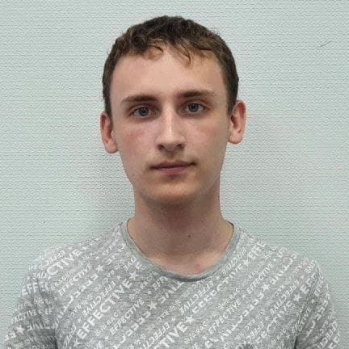

|  |  |
| --- | --- |
| Date of birth: 11.05.2001  City: Kharkiv  Mob. phone: +380999085617  E-mail: [maximpalaguta@gmail.com](mailto:maximpalaguta@gmail.com) |  |

**Education:**

September 2016 - August 2020, Kharkiv Patent and Computer College, specialty "Software Engineering", junior specialist diploma (technician-programmer).

September 2020, - I'm still studying at the moment., Kharkiv National University of Radio Electronics, Faculty of "Infocommunications", specialty "Information Security Management"

**Additional education:**

33-hour course on the Udemi website “WEB-developer 2021” from Ivan Petrichenko. After completing the course, I received a certificate.

course on the Udemi website “Complete course on JavaScript + React - from scratch to results”. At the moment, 30 hours out of 41 hours have passed.

**Work experience:**

***Freelance on the Kwork website***

*Functional responsibilities:*

- markup of the landing page using HTML, CSS, JS;

*Achievements:*

- Made up a couple of pages for the customer.

**Work at Ronis as a Frontend Developer (9-10 months)**

*Functional duties:*

- Work with online stores (page layout, bug fixes).

*Achievement:*

- Learned to work in a team;

- Learned to use the browserstack;

- Improved the ability to work with html + css + js + jquery;

- Learned to work with such cms systems as Wordpress and Magento;

- Improved git skills.

- Learned how to make emails for Wordpress and Magento;

**Internship at Phenomenon (1 month)**

*Functional duties:*

- Developed the front-end part of the site on wordpress https://phelix.phnmn.com/

**Professional skills:**

- Programming in Java, C ++, C #;

- Knowledge of document markup languages (websites): HTML, CSS, Javascript (JS);

- Knowledge of various technologies for layout: flex, grid.

- Knowledge of scss, sass technologies;

- Experience in adaptive layout (desktop first, mobile first);

- Database development using MySQL and SQLite.

- Confident work with Figma, Photoshop;

- I use Gulp technology for projects. Familiar with Webpack;

- Knowledge of the basics of BEM methodology;

- Work with Git;

- Basic knowledge of CSS animation;

- Ability to write structured and understandable code;

- Ability to find effective solutions, work for a result;

- Ability to work with a large amount of information;

**Professional skills (React):**

- Ability to use useState, useContext, useEffect hooks;

- Knowledge of the modular approach to connecting styles;

- Knowledge and use of axios and fetch;

- Ability to develop Skeleton and Pagination;

- Knowledge of React Router v6.

- Knowledge of Redux Toolkit.

- Knowledge of Typescript from one month (now I use it in React projects)

**Professional skills (Node js):**

- Understanding and working with Express

- Ability to connect and work with the basic functionality of mongo db

- Possession of express is at the basic level.

**Professional skills (Next js):**

- Knowledge of server rendering;

- Knowledge of architecture;

- Experience in building a site on this technology.

- Used getStaticProps and getServerSideProps.

**Professional skills (Nest js):**

- Building simple architecture;

- Basic knowledge;

- Ability to connect to database and frontend project on Next or React;

**Professional skills (Deply):**

**-** Deploy Nestproject.

- Deploy Nextproject.

- Deploy MERN project.

*Languages: Russian - fluent; Ukrainian - fluent; English - intermediate.*

**Personal qualities:**

Efficiency, purposefulness, resistance to stress, discipline, accuracy.

**Additional information:**

Marital status: Not maried.

There are no bad habits.

My portfolio site: <https://scalete.github.io>