AI-DRIVEN PRICE PREDICTION SYSTEM FOR NYC APARTMENTS
Team: Kristian, Lucas, Jonas, Kenneth
Kurs: AI3000R

1. INTRODUCTION

Team Presentation
- Kristian – Data analyst
- Lucas - Web design
- Jonas - Intern
- Kenneth - Coffee Facilitator

Problem Definition
Real estate agents in NYC struggle to provide fast and accurate price estimates for apartments. It should become easier for agents, buyers, and sellers to make assessments of correct pricing in relation to bedrooms and other variables.
Today, the market has wildly variating prices. A 2-bedroom apartment in Brooklyn may be priced anywhere from $500K to $750K by different agents, leaving buyers confused about fair value.
Main Challenges:
- Takes several days to get price estimates
- Professional appraisals cost $300-800
- Inconsistent prices from different agents

Objective
Create an AI system that provides instant, accurate price predictions for NYC apartments based on number of bedrooms, bathrooms, and size. The goal is 80% accuracy on our model.

Market and competition
Targets: Homebuyers who are financially conscious, young people, poor people
Competition: Real estate agents who sells for way over market, other vendors
Our advantage: Our model provides an estimate based in factual data from thousands of sales objects, instead of only a handful of sales objects from certain agents based on their own price evaluations. How fair is their assessment? How much is their markup? Are their markups in line with premiums such as location? Our model makes these considerations obsolete.

AI-benefits and risks:
Advantages: Time consuming (days→seconds), cost reduction, collects data,
Risks: Data dependency, marked volatile, bransje-motstand, safety, hallucinations,
There are always risks involved when using artifical intelligence as your main solution to solving a business problem. A major concern is data dependency and needing to have quality data to be able to produce a reliable output. Biased data or incomplete datasets can lead to inaccurate outcomes. Safety is also a concern. Relying heavily on automated systems to guide our customers financial or investment decisions can lead to substantial losses if the model fails to account for relevant factors like sudden market changes or external factors. These risks show the importance of combining AI insights with having a human in the loop and continuous data validation to ensure the reliability of our predictions.

2. AI-MODEL

Dataset
4,801 NYC apartments with 17 variables:
- Key variables: PRICE, BEDS, BATH, PROPERTYSQFT, TYPE, SUBLOCALITY
- Price range: $50k-$50M (after cleaning)
- Focus: 1-5 bedrooms (86% of data)

The algorithms we chose were Linear Regression and Random Forest.

Linear regression
Why: Easy to understand and explain to customers. Linear regression is often used as a starting point before considering more advanced models for analyzing the NYC housing data. Linear regression is efficient when trained using big amounts of data. However, at the expense of accuracy when data is too complex. This is because the method assumes that the connection between the variables is linear.
The linear regression method returns a R² value of 0.36 (36%), which is lower than the desired output of >0.8 (80%) accuracy. This drastic but somewhat expected output calls for us to sort out a different model for obtaining our goal in accuracy. Det
Model:
PRICE = β₀ + β₁×BEDS + β₂×BATH + β₃×SQFT + β₄×MANHATTAN + ...
Expected coeffisients:
- Extra bedroom: +$200k-400k
- Extra bath: +$100k-200k
- Manhattan-bonus: +$500k-1M

Random Forest
Why: As our initial linear regression model only could predict about 36% of the results, it would be better to simply guess the prices and estimates! According to the machine learning pipeline, we found out that we should reiterate and try some other algorithms. We had already prepared and segregated the data, and we evaluated the fact that the R² score of 0.36 was too low for any useful insight.
Random Forest however captures complex non-linear patterns and captures interactions. For example, it understands that price doesn’t increase linearly with square footage or that 4 bedrooms in a premium location is worth more than the sum of its parts.
Also, it creates natural groupings such as location (GPS coordinates, boroughs, type) through splits. Also, Random Forest is resistant to outliers, and it does not assume normal distribution, homoscedasticity or independence.

Data Processing
- Remove statistical outliers (>$50M, cells with 2184.207862 square feet, and null values)
- Make dummy-variables for city parts or real estate type
- Train/validation/test: 80 training/20 testing

Evaluation
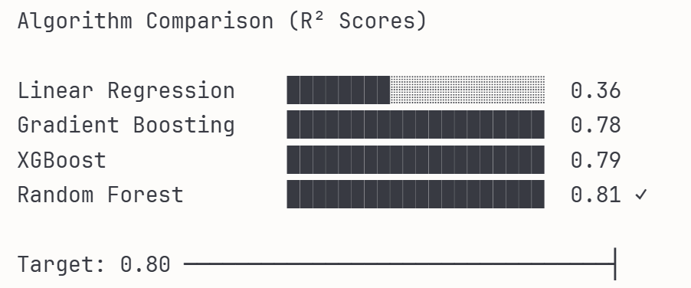
Features that was important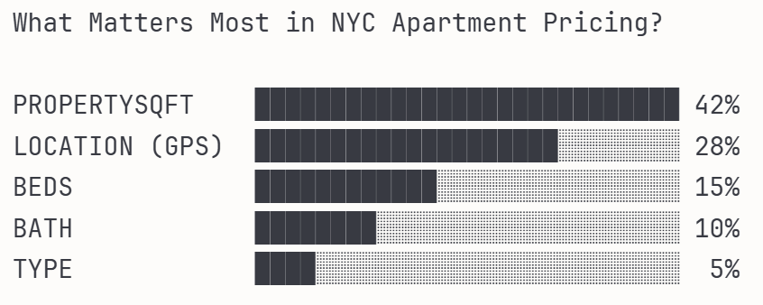
Target:
- R² Score: 0.80

The R² Score of the Linear Regression Model did not reach 0.80. It reached 0.36, despite the data cleaning and belonging re-data cleaning, including logarithmic calculations. So, practically useless. One would have better chances guesstimating. Considering the Linear Regression Model is often used as a starting point but lacks accuracy for more complex cases, this is where we understood that our use case was too complex for a simple linear regression algorithm. For example, if all our features scaled linearly, it would be better. But it does not, so we were in need of an algorithm better suited for our application. For fun, we tried the gradient boosting and XGBoost algorithms as well as the Random Forest. Gradient boosting gave a R² at 0.7792 and XGBoost gave 0.7937. These are ok, but they are not within our accepted threshold. When we tried the Random Forest algorithm, the R² value spiked to >0.80! 0.8140 ≫ 0.32. The key reasons for this spike is that real estate pricing has non-linear patterns, there’s feature interactions that linear regression misses, and random forest naturally isolate outliers into separate branches. Random forest naturally discovers this through the tree structure, while linear regression tries to fit one equation across all segments.

3. IMPLEMENTATION

Business model:
We are offering the customers bidding prices based on our data model, in order to counter the wildly variating pricing on living spaces in the New York area. Giving the potential buyer a reasonable price to offer the seller, and to level the playing field for the parts involved.

Tech Implementation

Challenges
Essentially, it is AI. It is artificial, and it is a prediction and an estimate. It is not a definite solution. Just because you get an estimate lower than what you thought, does not mean you cannot successfully sell your living space for more. It does not mean you can not get an apartment for lower than the estimate, but we also make this clear to the users this is the common limitation for all “prediction” services that use these methods.

4. Conclusion
The aim of our project is to develop an AI-driven price prediction system for New York properties and apartments. This addresses a real issue for many NY residents who want to make informed decisions when purchasing a home by understanding the true market value for a property. We chose this topic because pricing in the NYC real estate market is notoriously inconsistent. Getting a professional appraisal is costly and time-consuming, while brokers often provide estimates that can vary greatly. This creates uncertainty for both buyers and sellers.
Integrating AI can ease the appraisal process, reduce costs and improve market trust by offering a reliable and data-driven benchmark. The core concept is to apply machine learning, specifically the random forest algorithm to model apartment prices based on key features such as number of bedrooms, baths, square footage, location and such features. By doing it this way one can flatten the wild variance in pricing for evaluations instead of being left with a feeling of being tricked or having pulled the shortest straw.

Bibliography:
Elgiriyewithana, N. (2024, oct.). New York Hosing Market, version 1.
https://www.kaggle.com/datasets/nelgiriyewithana/new-york-housing-market

