**How to complete Sexual Harassment Prevention**

**&**

**Family Education Records and Privacy Act (FERPA) training**

Completion of Sexual Harassment Prevention and The Family Education Records and Privacy Act (FERPA) training is mandatory for those handling student information. It must be completed BEFORE turning in the completed PSY 4940 (Teaching Assistant) form for registration – no exceptions will be granted.

Thank you for your participation. If you have any questions, please read all the instructions first. Then, if you have privacy-related questions, please contact the Privacy Office 273-1212 or [privacy@ufl.edu](mailto:privacy@ufl.edu). If you have technical questions about the training through MyUFL, please call Jamie Cooke in HR Training - 273-1762.

**Step 1.** Log in to [MyUFL](https://my.ufl.edu/ps/signon.html)

**Step 2**. Go to My Self Service, then Training and Development, then myTraining"..

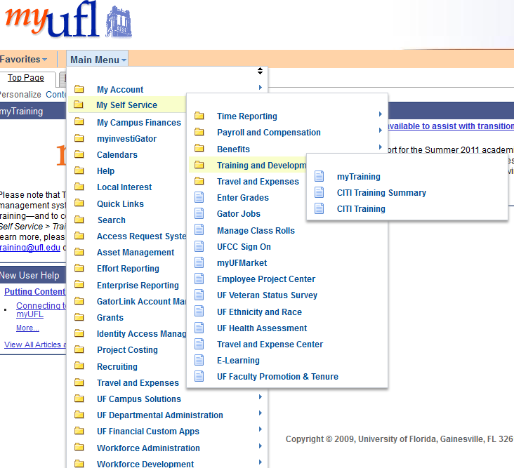

**Step 3**. Once on this page (see below), type in “FERPA” on the left side search box and register for FERPA BASICS and complete the course.

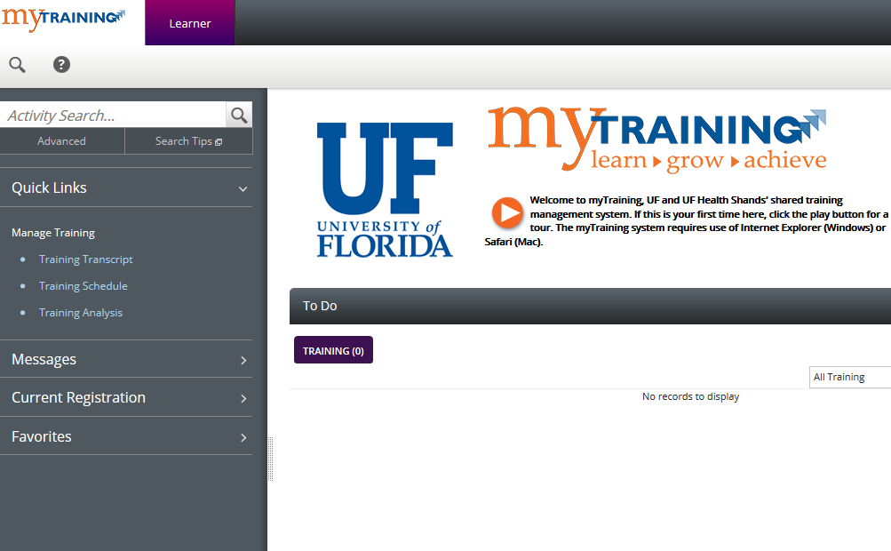

**Step 4**. Repeat for "Harassment”.

**Step 5**. You should print your Training Summary or Historical Profile page as proof of completion and staple it to your PSY 4940 form. The proof must have your name on it.