Strace with bash scan.sh
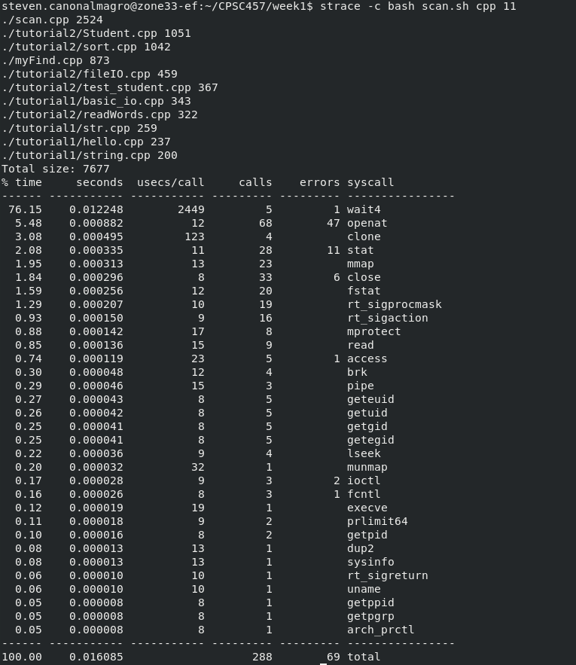

time with bash scan.sh
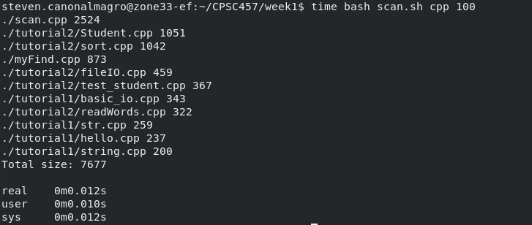

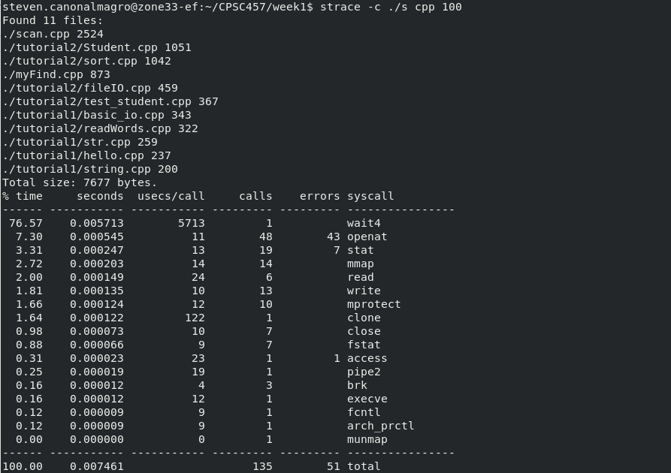
Strace with scan.cpp

time with scan.cpp
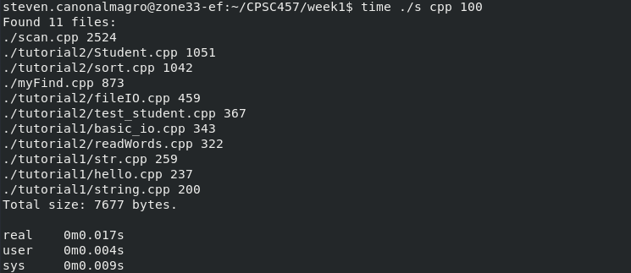

4. The scan.cpp file is faster than the bash scan.sh script file. The cpp scan file makes much fewer system calls as shown in the strace picture at 135 compared to the bash script file at 288. The bash script file spends a lot more time in kernel mode this is why its slower but the cpp uses both the user and kernel mode equally, making it the fastest.

