Computing Machinery II

ASSIGMENT 2 Steven Canon-Almagro

10155792

1. I am making a synchronous sequential logic circuit that implements a grey code counter each digit represented by a LED. The counter has two inputs, the En input is to start the counter, be it in any direction. The second input decides if the counter counts up or down, counting up when D is off and down when D is on.

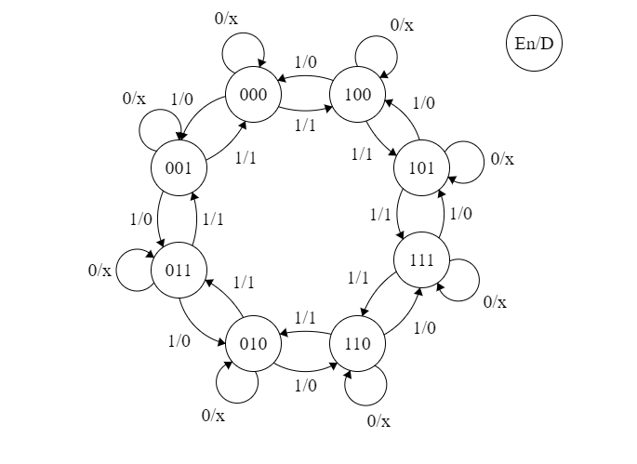

1. The Inputs are En and D, Enable and Direction. The outputs are A (First digit), B (Second digit), C (Third digit). I am using 3 JK flip-flops one for each output in order to produce the outputs.

|  |  |  |  |  |  |  |  |  |  |  |  |  |  |  |
| --- | --- | --- | --- | --- | --- | --- | --- | --- | --- | --- | --- | --- | --- | --- |
| A | B | C | F | R | A | B | C | JA | KA | JB | KB | JC | KC | A-B-C |
| 0 | 0 | 0 | 0 | 0 | 0 | 0 | 0 | 0 | x | 0 | x | 0 | x | 0-0-0 |
| 0 | 0 | 0 | 0 | 1 | 0 | 0 | 0 | 0 | x | 0 | x | 0 | x | 0-0-0 |
| 0 | 0 | 0 | 1 | 0 | 0 | 0 | 1 | 0 | x | 0 | x | 1 | x | 0-0-1 |
| 0 | 0 | 0 | 1 | 1 | 1 | 0 | 0 | 1 | x | 0 | x | 0 | x | 1-0-0 |
| 0 | 0 | 1 | 0 | 0 | 0 | 0 | 1 | 0 | x | 0 | x | x | 0 | 0-0-1 |
| 0 | 0 | 1 | 0 | 1 | 0 | 0 | 1 | 0 | x | 0 | x | x | 0 | 0-0-1 |
| 0 | 0 | 1 | 1 | 0 | 0 | 1 | 1 | 0 | x | 1 | x | x | 0 | 0-1-1 |
| 0 | 0 | 1 | 1 | 1 | 0 | 0 | 0 | 0 | x | 0 | x | x | 1 | 0-0-0 |
| 0 | 1 | 0 | 0 | 0 | 0 | 1 | 0 | 0 | x | x | 0 | 0 | x | 0-1-0 |
| 0 | 1 | 0 | 0 | 1 | 0 | 1 | 0 | 0 | x | x | 0 | 0 | x | 0-1-0 |
| 0 | 1 | 0 | 1 | 0 | 1 | 1 | 0 | 1 | x | x | 0 | 0 | x | 1-1-0 |
| 0 | 1 | 0 | 1 | 1 | 0 | 1 | 1 | 0 | x | x | 0 | 1 | x | 0-1-1 |
| 0 | 1 | 1 | 0 | 0 | 0 | 1 | 1 | 0 | x | x | 0 | x | 0 | 0-1-1 |
| 0 | 1 | 1 | 0 | 1 | 0 | 1 | 1 | 0 | x | x | 0 | x | 0 | 0-1-1 |
| 0 | 1 | 1 | 1 | 0 | 0 | 1 | 0 | 0 | x | x | 0 | x | 1 | 0-1-0 |
| 0 | 1 | 1 | 1 | 1 | 0 | 0 | 1 | 0 | x | x | 1 | x | 0 | 0-0-1 |
| 1 | 0 | 0 | 0 | 0 | 1 | 0 | 0 | x | 0 | 0 | x | 0 | x | 1-0-0 |
| 1 | 0 | 0 | 0 | 1 | 1 | 0 | 0 | x | 0 | 0 | x | 0 | x | 1-0-0 |
| 1 | 0 | 0 | 1 | 0 | 0 | 0 | 0 | x | 1 | 0 | x | 0 | x | 0-0-0 |
| 1 | 0 | 0 | 1 | 1 | 1 | 0 | 1 | x | 0 | 0 | x | 1 | x | 1-0-1 |
| 1 | 0 | 1 | 0 | 0 | 1 | 0 | 1 | x | 0 | 0 | x | x | 0 | 1-0-1 |
| 1 | 0 | 1 | 0 | 1 | 1 | 0 | 1 | x | 0 | 0 | x | x | 0 | 1-0-1 |
| 1 | 0 | 1 | 1 | 0 | 1 | 0 | 0 | x | 0 | 0 | x | x | 1 | 1-0-0 |
| 1 | 0 | 1 | 1 | 1 | 1 | 1 | 1 | x | 0 | 1 | x | x | 0 | 1-1-1 |
| 1 | 1 | 0 | 0 | 0 | 1 | 1 | 0 | x | 0 | x | 0 | 0 | x | 1-1-0 |
| 1 | 1 | 0 | 0 | 1 | 1 | 1 | 0 | x | 0 | x | 0 | 0 | x | 1-1-0 |
| 1 | 1 | 0 | 1 | 0 | 1 | 1 | 1 | x | 0 | x | 0 | 1 | x | 1-1-1 |
| 1 | 1 | 0 | 1 | 1 | 0 | 1 | 0 | x | 1 | x | 0 | 0 | x | 0-1-0 |
| 1 | 1 | 1 | 0 | 0 | 1 | 1 | 1 | x | 0 | x | 0 | x | 0 | 1-1-1 |
| 1 | 1 | 1 | 0 | 1 | 1 | 1 | 1 | x | 0 | x | 0 | x | 0 | 1-1-1 |
| 1 | 1 | 1 | 1 | 0 | 1 | 0 | 1 | x | 0 | x | 1 | x | 0 | 1-0-1 |
| 1 | 1 | 1 | 1 | 1 | 1 | 1 | 0 | x | 0 | x | 0 | x | 1 | 1-1-0 |

5.

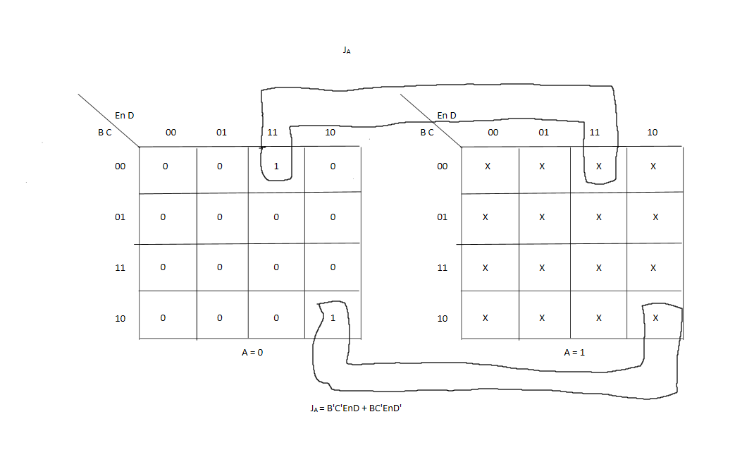 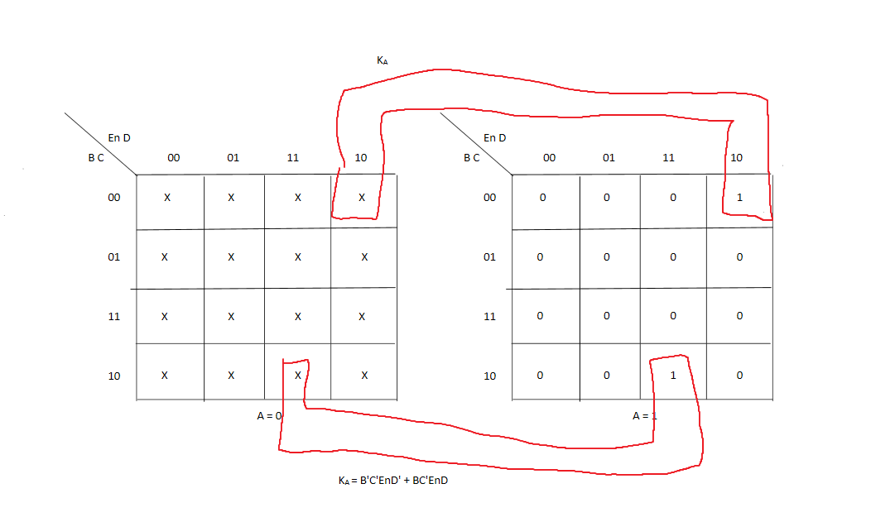 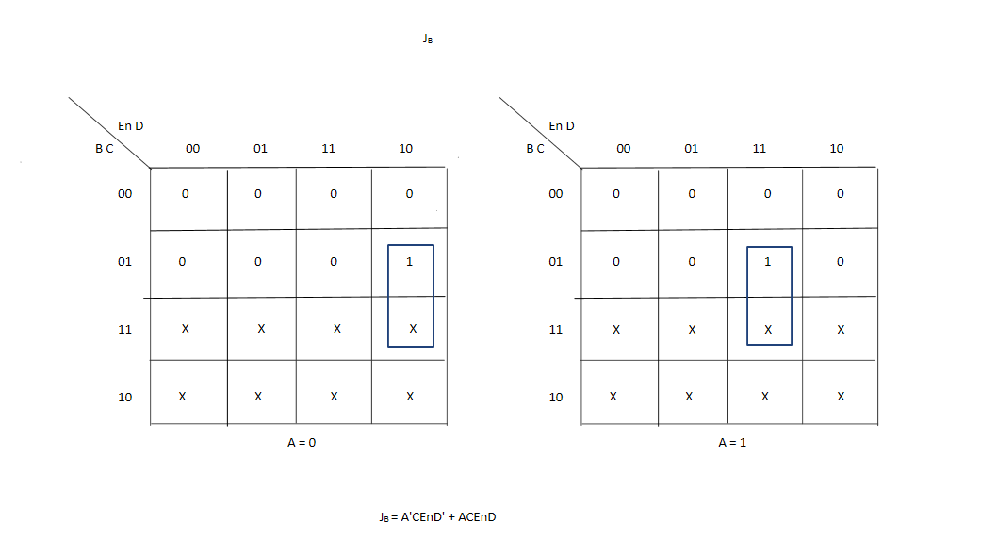 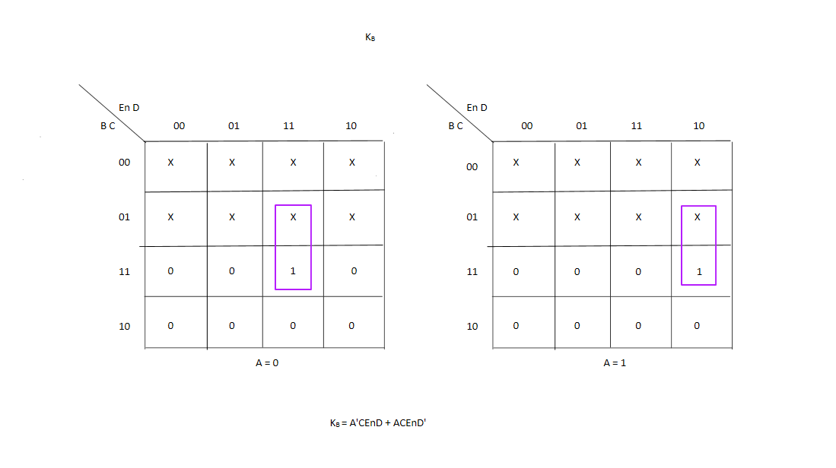

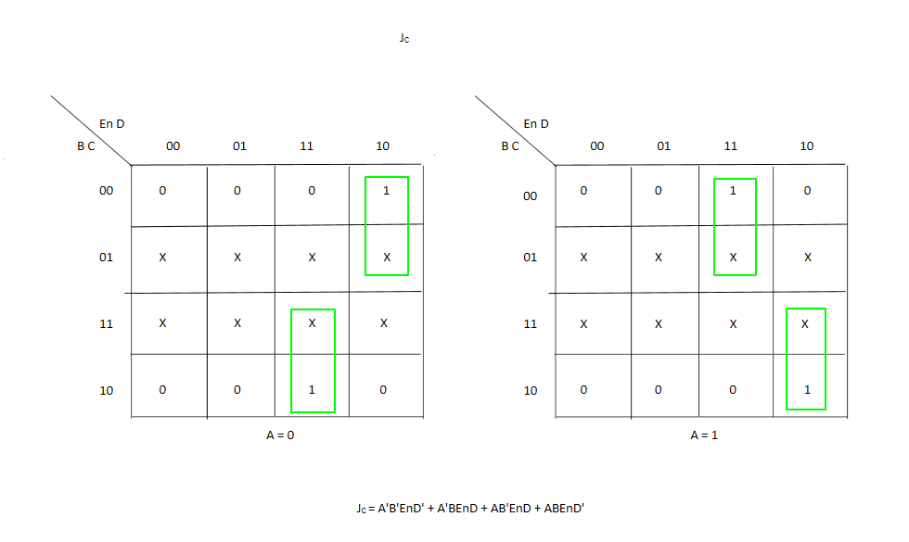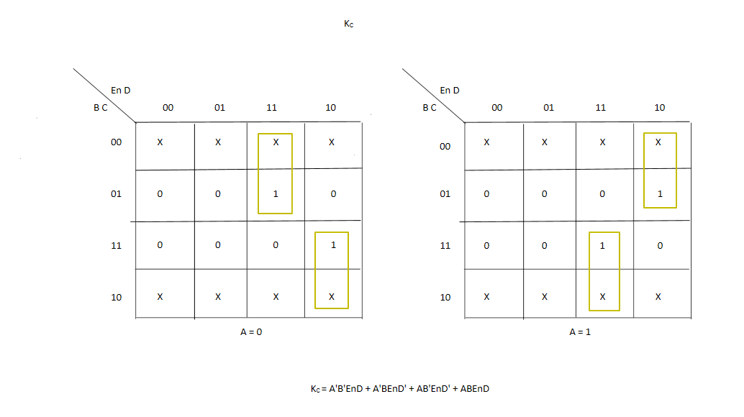6. 